ALGEBRA 1 · UNIT 2: SOLVING LINEAR EQUATIONS  Food Truck Startup  Use expressions and equations to plan a profitable festival food truck. | CP2  2–3 class periods

Name: ________________________________ Date: ______________ Period: ______
The Scenario
Your group has been chosen to run a taco truck at the town's summer festival. Before the festival, the town council wants a business plan that shows how many items you must sell to cover your costs and how much money you expect to make.
Every item costs money to make, and you also pay fixed costs that do not change no matter how much you sell. Your job is to model the business with expressions and equations and then pitch your plan.
Your truck uses the festival's power, so your only fixed cost is the $120 booth fee. You start by selling tacos.
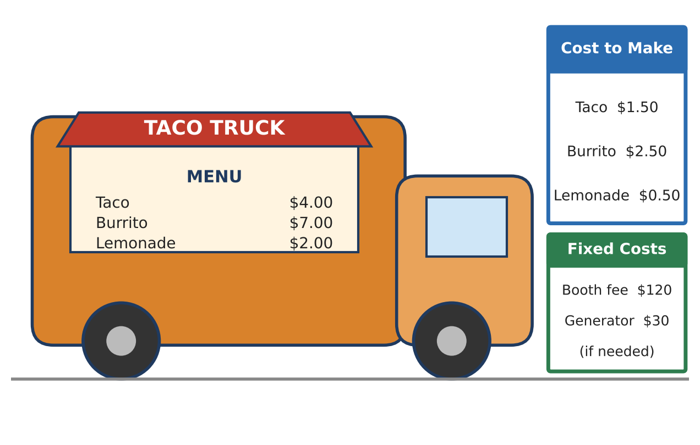
Learning Goals
- I can write expressions for cost, revenue, and profit.
- I can solve two-step equations to answer business questions.
- I can explain what my answer means in the situation.
Project Timeline
When | What you will do
Day 1 | Build the Business Model
Day 2 | Answer the Council's Questions
Day 3 | Design & Pitch
Final | Food Truck Pitch Poster + reflection

Part 1: Build the Business Model
Day 1 · Use the menu and cost cards to understand where money comes from and where it goes.
1. Complete the table. Total cost = $120 booth fee + $1.50 for each taco. Revenue = $4.00 for each taco. Profit = revenue − total cost.
Tacos sold (t) | Total cost ($) | Revenue ($) | Profit ($)
0 | 120 | 0 | −120
10 |  | 40
20 | 150
40
60

2. Write an expression for the total cost of making t tacos.
Starter: Total cost = 120 + ____ · t

3. Write an expression for the revenue from selling t tacos.

4. Profit = revenue − cost = 4t − (120 + 1.50t). Simplify this expression. Show each step.
Starter: Distribute the negative sign first, then combine like terms.

5. Use your profit expression to find the profit if you sell 100 tacos.

Part 2: Answer the Council's Questions
Day 2 · Set each profit expression equal to a goal and solve.
6. Break-even means profit = $0. Write and solve an equation to find how many tacos you must sell to break even.
Starter: 2.50t − 120 = 0

7. Your group wants to earn $300 in profit. How many tacos must you sell?

8. You add lemonade: it costs $0.50 to make and sells for $2.00. If you sell 40 tacos, how many cups of lemonade must you sell to reach a profit of $100?
Starter: Profit from tacos + profit from lemonade = 100

9. What if you raise the taco price to $4.50? Write a new profit expression and find the new break-even number of tacos. How many fewer tacos is that?

Part 3: Design & Pitch
Day 3 · Now invent your own menu item for the truck.
10. Create a new menu item. Choose its name, its cost to make, and its selling price.
Item name | Cost to make ($) | Selling price ($) | Profit per item ($)

11. If your new item had to pay the $120 booth fee by itself, how many would you need to sell to break even? Write and solve an equation.

12. Write 2–3 sentences recommending a plan to the town council. Use at least two numbers from your work.
Starter: We recommend selling at least ___ because ___.

Final Product: Food Truck Pitch Poster
Your final product must include:
- Truck name and a menu with prices (including your new item)
- Your cost, revenue, and profit expressions
- The break-even equation, solved, with a sentence explaining it
- Your recommendation to the town council
- A picture or logo for your truck
Reflection
R1. Why do you have to subtract the total cost (and not just the $120) to find profit?

R2. Which part of this project felt most like a real business decision? Why?

Scoring Rubric
Criteria | 4 – Exceeds | 3 – Meets | 2 – Approaching | 1 – Beginning
Mathematical Accuracy | All calculations and solutions are correct; answers include units and are checked. | Nearly all work is correct; minor errors do not change conclusions. | Several errors; some conclusions are affected. | Many errors or missing work.
Reasoning & Justification | Clear, complete explanations connect every answer to the situation; uses precise vocabulary. | Explanations are mostly clear and connected to the situation. | Explanations are brief or partly unclear. | Little or no explanation.
Application & Design | Original menu item has a realistic cost and price with a correct profit equation. Goes beyond the minimum with a creative, realistic choice. | Original menu item has a realistic cost and price with a correct profit equation. | Design is incomplete or only partly uses the math from the unit. | Design is missing or unrelated to the unit math.
Communication & Presentation | Pitch poster shows the menu, profit model, break-even point, and a recommendation. Polished, organized, and visually engaging. | Pitch poster shows the menu, profit model, break-even point, and a recommendation. Organized and easy to follow. | Product is missing required parts or is hard to follow. | Product is mostly missing.

