ALGEBRA 1 · UNIT 2: SOLVING LINEAR EQUATIONS  Food Truck Startup  Use expressions and equations to plan a profitable festival food truck. | Honors  2–3 class periods

Name: ________________________________ Date: ______________ Period: ______
The Scenario
Your group has been chosen to run a taco truck at the town's summer festival. Before the festival, the town council wants a business plan that shows how many items you must sell to cover your costs and how much money you expect to make.
Every item costs money to make, and you also pay fixed costs that do not change no matter how much you sell. Your job is to model the business with expressions and equations and then pitch your plan.
You sell tacos (t) and burritos (b). Fixed costs F are the $120 booth fee plus a $30 generator rental. Later, the festival will take a cut of your revenue.
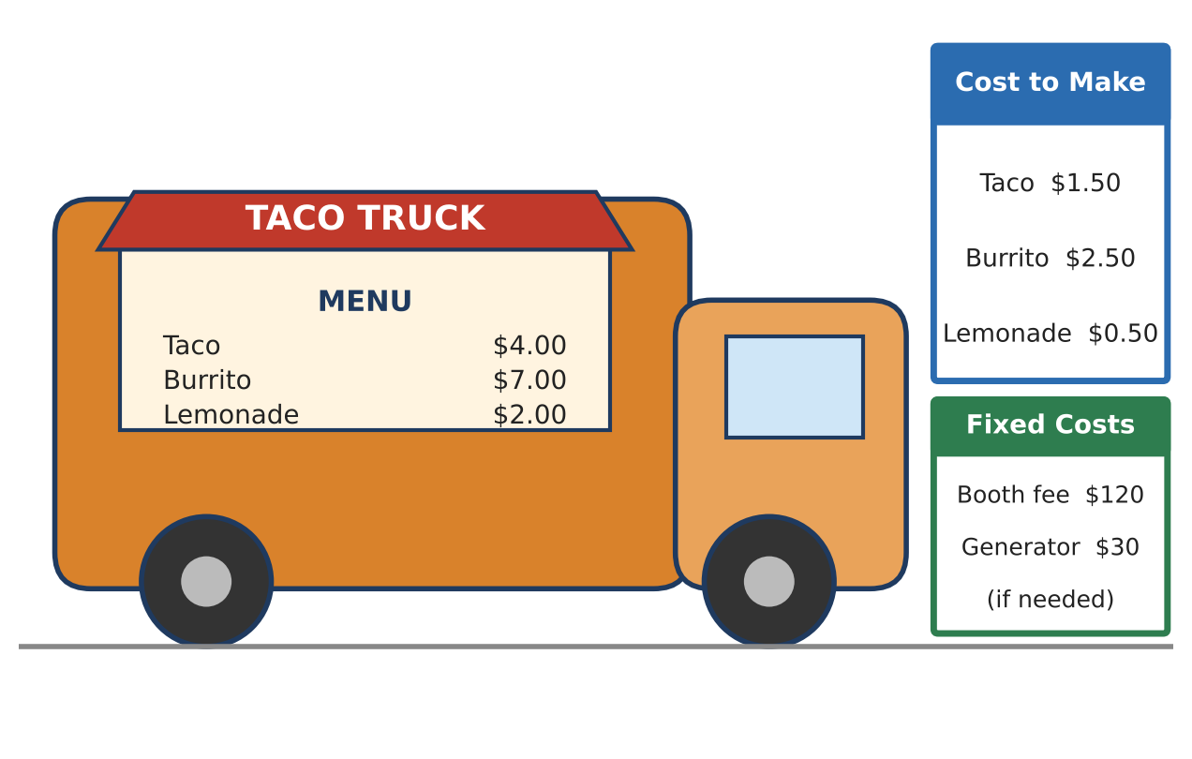
Learning Goals
- I can write a general profit formula and rearrange it to solve for any variable.
- I can model a business with percents, multiple items, and constraints.
- I can design conditions that produce a specific outcome and justify them algebraically.
Project Timeline
When | What you will do
Day 1 | Generalize the Model
Day 2 | Add the Festival Fee
Day 3 | Engineer the Competition
Final | Food Truck Pitch Poster + reflection

Part 1: Generalize the Model
Day 1 · Let s = selling price, c = cost to make one item, n = number sold, F = fixed costs, and P = profit.
1. Write a formula for the profit P from selling n items of one kind. Show that it can be written as P = (s − c)n − F.

2. Solve the formula for n.

3. Use your formula to find how many tacos must be sold for a profit of $600 (F = $150).

4. Explain why s − c must be positive for the business to work. What happens to your formula for n if s = c?

Part 2: Add the Festival Fee
Day 2 · The festival announces it will keep 10% of all revenue.
5. Write and simplify a profit expression for selling t tacos and b burritos after the 10% fee.

6. If t = 2b, rewrite the profit using only b and find how many of each item you must sell to make $650.

7. For a burrito-only truck with the fee, P = (0.90s − c)n − F. Solve this formula for s. Then find the burrito price needed to make $500 by selling 100 burritos (c = $2.50, F = $150).

Part 3: Engineer the Competition
Day 3 · Burger Barn has $90 in fixed costs and makes $2 profit per burger. Ignore the festival fee for this part.
8. Find the number of items at which your taco-only profit equals Burger Barn's profit.

9. The council will lower your fixed cost if it helps. What fixed cost F would make the two trucks tie at exactly 80 items? Show your equation.

10. Graph your original profit line, your new profit line (with the new F), and Burger Barn's line. Explain what changing F does to the graph.
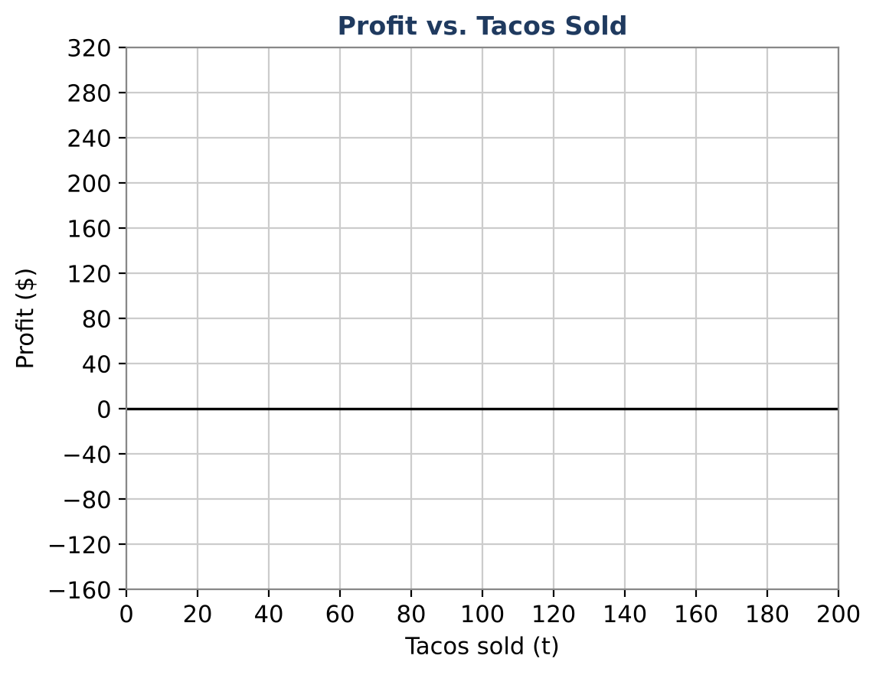

11. Design a two-item menu of your own (with the 10% fee). Write a general profit formula, choose prices, and show that your plan earns at least $500 at a realistic sales level. Justify why your sales numbers are realistic.

Final Product: Food Truck Pitch Poster
Your final product must include:
- A general profit formula and at least two rearranged versions
- Solutions to the fee-based goal questions
- The engineered tie with the rival and a labeled graph
- Your original two-item menu with a full profit analysis
- A one-paragraph pitch defending your prices
Reflection
R1. How does rearranging a formula save time compared with solving a new equation every time?

R2. The 10% fee changes the coefficients but not the structure of the model. Explain what that means.

Scoring Rubric
Criteria | 4 – Exceeds | 3 – Meets | 2 – Approaching | 1 – Beginning
Mathematical Accuracy | All calculations and solutions are correct; answers include units and are checked. | Nearly all work is correct; minor errors do not change conclusions. | Several errors; some conclusions are affected. | Many errors or missing work.
Reasoning & Justification | Clear, complete explanations connect every answer to the situation; uses precise vocabulary. | Explanations are mostly clear and connected to the situation. | Explanations are brief or partly unclear. | Little or no explanation.
Application & Design | Original menu item has a realistic cost and price with a correct profit equation. Goes beyond the minimum with a creative, realistic choice. | Original menu item has a realistic cost and price with a correct profit equation. | Design is incomplete or only partly uses the math from the unit. | Design is missing or unrelated to the unit math.
Communication & Presentation | Pitch poster shows the menu, profit model, break-even point, and a recommendation. Polished, organized, and visually engaging. | Pitch poster shows the menu, profit model, break-even point, and a recommendation. Organized and easy to follow. | Product is missing required parts or is hard to follow. | Product is mostly missing.

