ALGEBRA 1 · UNIT 1: FOUNDATIONS OF ALGEBRA  Game Score Designer  Build and test the scoring system for a video game using expressions. | CP1  2–3 class periods

Name: ________________________________ Date: ______________ Period: ______
The Scenario
A local studio is making a space game called Galaxy Dash, and it needs a scoring system before launch. Players collect coins and gems, lose points when an asteroid hits them, and earn a time bonus for finishing quickly.
Every score in the game is an algebraic expression. You will test the studio's scoring rules, find the mistakes on players' score cards, and then design the scoring for a game of your own.
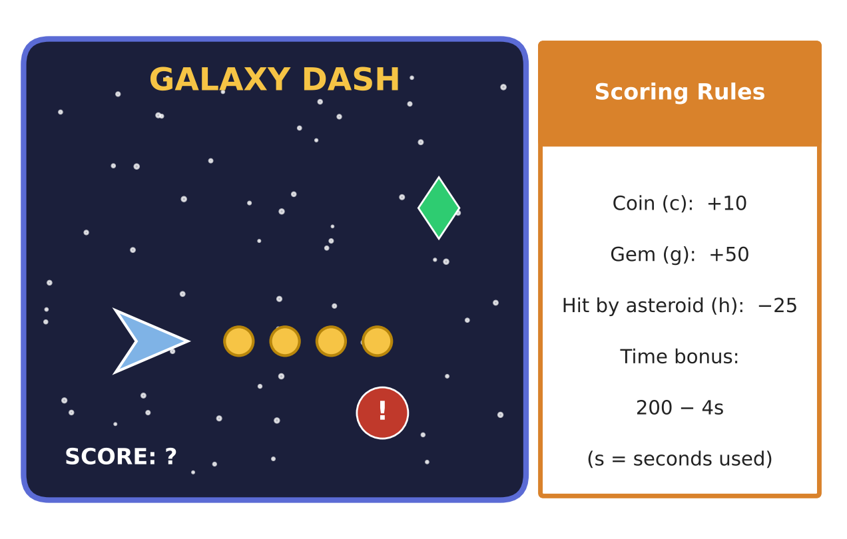
Learning Goals
- I can translate verbal descriptions into expressions and interpret their parts.
- I can evaluate and simplify expressions accurately, including integers and real numbers.
- I can use properties to rewrite expressions and justify each step.
Project Timeline
When | What you will do
Day 1 | Write the Score
Day 2 | Check the Score Cards
Day 3 | Design & Balance Your Game
Final | Game Design Pitch + reflection

Part 1: Write the Score
Day 1 · Use the Scoring Rules card. Let c = coins, g = gems, h = hits, and s = seconds used.
1. Write the full score expression, including the time bonus.

2. Translate: "Level 2 coins are worth 5 more than Level 1 coins, gems are worth 10 more, and hits cost 5 more." Write the Level 2 score expression (no time bonus).

3. Write and simplify the total score for a player who collects the same c, g, and h on Level 1 and Level 2.

4. Find the full Level 1 score for c = 15, g = 2, h = 4, s = 45.

Part 2: Check the Score Cards
Day 2 · Find and fix errors. Show every step.
5. Kai evaluated the time bonus 200 − 4(15 − 3)² ÷ 8 and got −88. Find the correct value and explain Kai's mistake.

6. A team score is 4(10c + 50g) − 25h. What could the 4 represent? What does (10c + 50g) represent?

7. Simplify 3(2c − g) + 2(c + 4g) − 5g and interpret the result as a scoring rule.

8. The studio adds a "pi power-up" worth π points and a half-gem worth 2.5 points. Classify each possible score as natural, whole, integer, rational, or irrational: 220, −30, 2.5, 0, 230 + π.
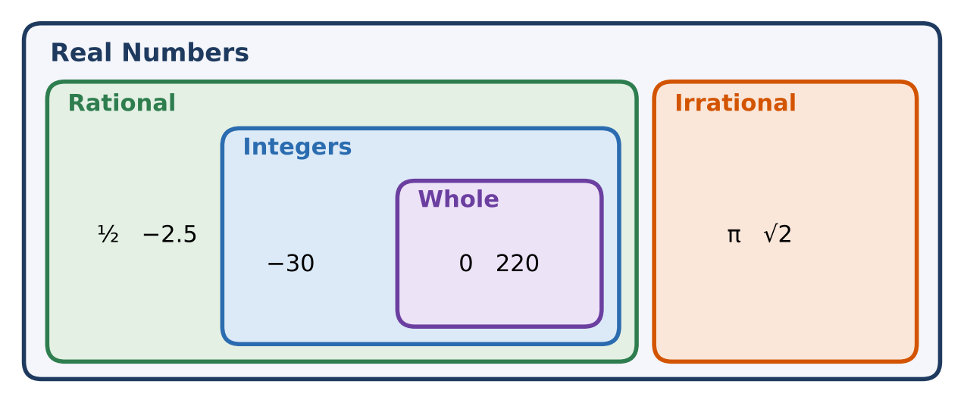

Part 3: Design & Balance Your Game
Day 3 · Design a game where two different strategies can earn the same score.
9. Write a score expression with at least three terms (one penalty) and a time bonus.

10. Describe two different players (strategies) and show with evaluation that they earn the same score.

11. Add a Level 2 or bonus round. Write the total score and simplify it. Explain one term of the simplified expression.

Final Product: Game Design Pitch
Your final product must include:
- Rules card and complete score expression
- Level 1 and Level 2 expressions and the simplified total
- Corrected score card with explanation
- Two balanced strategies with work
- Pitch slide or poster
Reflection
R1. How can the structure of an expression (like 4(10c + 50g)) tell you something without calculating?

R2. Why is 230 + π irrational even though 230 is rational?

Scoring Rubric
Criteria | 4 – Exceeds | 3 – Meets | 2 – Approaching | 1 – Beginning
Mathematical Accuracy | All calculations and solutions are correct; answers include units and are checked. | Nearly all work is correct; minor errors do not change conclusions. | Several errors; some conclusions are affected. | Many errors or missing work.
Reasoning & Justification | Clear, complete explanations connect every answer to the situation; uses precise vocabulary. | Explanations are mostly clear and connected to the situation. | Explanations are brief or partly unclear. | Little or no explanation.
Application & Design | Original scoring expression has at least three terms including a penalty, and it is evaluated and simplified correctly. Goes beyond the minimum with a creative, realistic choice. | Original scoring expression has at least three terms including a penalty, and it is evaluated and simplified correctly. | Design is incomplete or only partly uses the math from the unit. | Design is missing or unrelated to the unit math.
Communication & Presentation | Pitch shows the scoring rules, the score expression with each part explained, and sample scores for two players. Polished, organized, and visually engaging. | Pitch shows the scoring rules, the score expression with each part explained, and sample scores for two players. Organized and easy to follow. | Product is missing required parts or is hard to follow. | Product is mostly missing.

