ALGEBRA 1 · UNIT 1: FOUNDATIONS OF ALGEBRA  Game Score Designer  Build and test the scoring system for a video game using expressions. | CP2  2–3 class periods

Name: ________________________________ Date: ______________ Period: ______
The Scenario
A local studio is making a space game called Galaxy Dash, and it needs a scoring system before launch. Players collect coins and gems, lose points when an asteroid hits them, and earn a time bonus for finishing quickly.
Every score in the game is an algebraic expression. You will test the studio's scoring rules, find the mistakes on players' score cards, and then design the scoring for a game of your own.
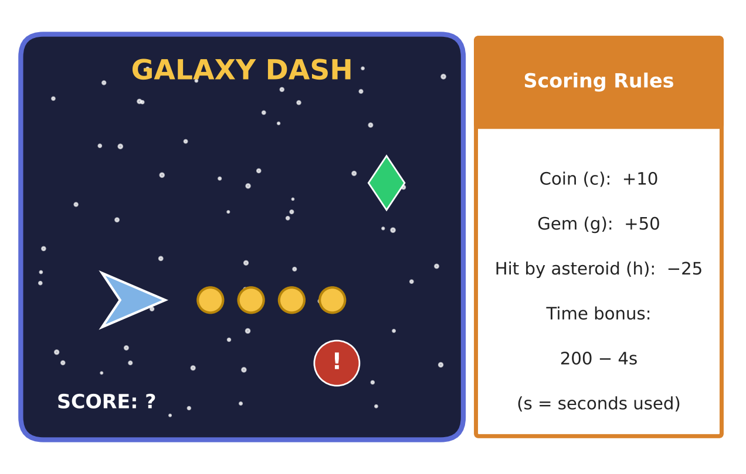
Learning Goals
- I can write expressions from words and rules.
- I can evaluate expressions using the order of operations and integer rules.
- I can use the distributive property and combine like terms.
Project Timeline
When | What you will do
Day 1 | Write the Score
Day 2 | Check the Score Cards
Day 3 | Design Your Game
Final | Game Design Pitch + reflection

Part 1: Write the Score
Day 1 · Use the Scoring Rules card. Let c = coins, g = gems, and h = hits.
1. Write an expression for the points from c coins.

2. Write an expression for a player's score from coins, gems, and hits (no time bonus yet).
Starter: 10c + ___g − ___h

3. Find the score for a player with 12 coins, 3 gems, and 2 hits.

4. The time bonus is 200 − 4s. Find the time bonus for a player who used 30 seconds. What happens to the bonus as s gets bigger?

5. In 10c + 50g − 25h, name the coefficient of g and explain what it means in the game.

Part 2: Check the Score Cards
Day 2 · Players turned in score cards. Check each one.
6. A score card says 3(10 · 4 + 50) − 25 · 2. Evaluate it using the order of operations.

7. In one round a player's points changed by +50, −25, −25, +10, and −40. What is the total change?

8. Double Points round: the score is 2(10c + 50g − 25h). Use the distributive property to rewrite it without parentheses.

9. Explain why 10c + 50g = 50g + 10c. Which property is this?

Part 3: Design Your Game
Day 3 · Invent your own game and scoring rules.
10. Name your game and list at least three scoring events, including one penalty. Choose a point value for each.

11. Write your score expression. Find the scores for two different players.

12. Add a bonus round that multiplies the score. Rewrite it with the distributive property.

Final Product: Game Design Pitch
Your final product must include:
- Game name, picture, and scoring rules
- The score expression with each term labeled
- Two sample players' scores with work
- A bonus round written two ways
- A short pitch: why your scoring is fair
Reflection
R1. Why does the order of operations matter when a computer calculates a score?

R2. How did the coefficients in your expression change how players will play your game?

Scoring Rubric
Criteria | 4 – Exceeds | 3 – Meets | 2 – Approaching | 1 – Beginning
Mathematical Accuracy | All calculations and solutions are correct; answers include units and are checked. | Nearly all work is correct; minor errors do not change conclusions. | Several errors; some conclusions are affected. | Many errors or missing work.
Reasoning & Justification | Clear, complete explanations connect every answer to the situation; uses precise vocabulary. | Explanations are mostly clear and connected to the situation. | Explanations are brief or partly unclear. | Little or no explanation.
Application & Design | Original scoring expression has at least three terms including a penalty, and it is evaluated and simplified correctly. Goes beyond the minimum with a creative, realistic choice. | Original scoring expression has at least three terms including a penalty, and it is evaluated and simplified correctly. | Design is incomplete or only partly uses the math from the unit. | Design is missing or unrelated to the unit math.
Communication & Presentation | Pitch shows the scoring rules, the score expression with each part explained, and sample scores for two players. Polished, organized, and visually engaging. | Pitch shows the scoring rules, the score expression with each part explained, and sample scores for two players. Organized and easy to follow. | Product is missing required parts or is hard to follow. | Product is mostly missing.

