ALGEBRA 1 · UNIT 1: FOUNDATIONS OF ALGEBRA  Game Score Designer  Build and test the scoring system for a video game using expressions. | Honors  2–3 class periods

Name: ________________________________ Date: ______________ Period: ______
The Scenario
A local studio is making a space game called Galaxy Dash, and it needs a scoring system before launch. Players collect coins and gems, lose points when an asteroid hits them, and earn a time bonus for finishing quickly.
Every score in the game is an algebraic expression. You will test the studio's scoring rules, find the mistakes on players' score cards, and then design the scoring for a game of your own.
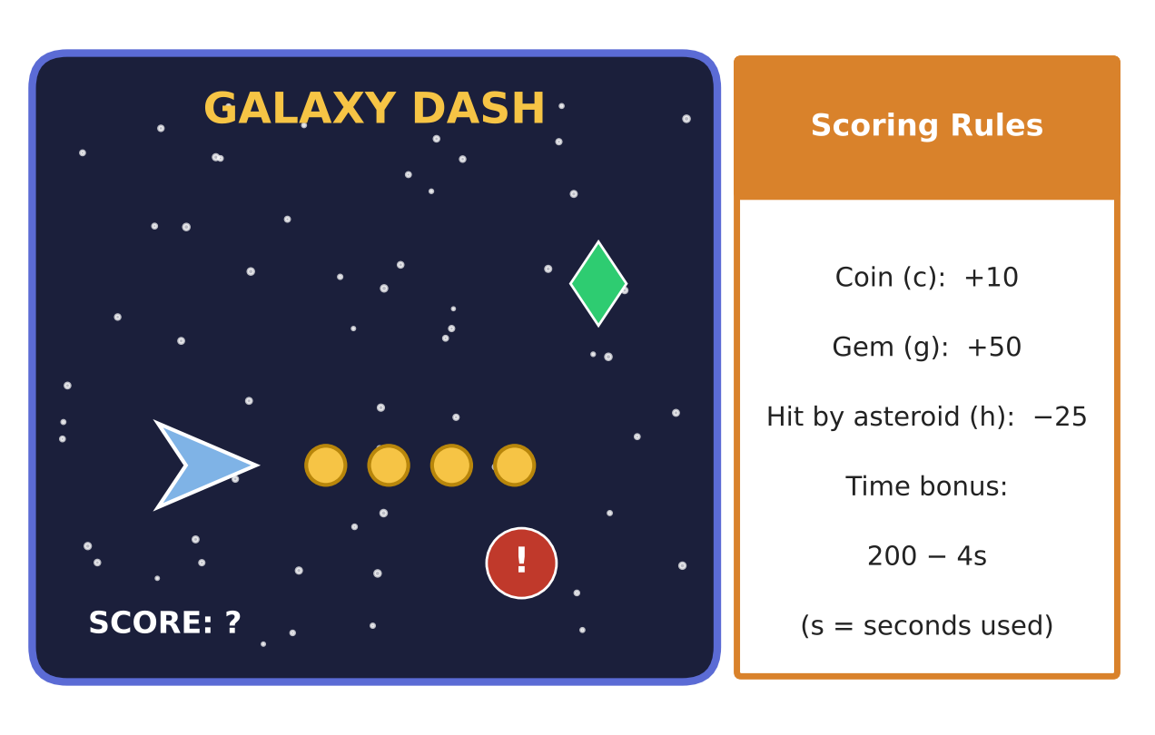
Learning Goals
- I can write and interpret general expressions with parameters.
- I can simplify nested expressions and prove equivalence with properties.
- I can reason about closure of rational and irrational numbers.
Project Timeline
When | What you will do
Day 1 | General Scoring
Day 2 | Bonus Rounds & Proofs
Day 3 | Design a Balanced Game
Final | Game Design Pitch + reflection

Part 1: General Scoring
Day 1 · Let each coin be worth p points, each gem q points, and each hit cost r points.
1. Write a general score expression S for c coins, g gems, and h hits. Then write Galaxy Dash's score by substituting p = 10, q = 50, r = 25.

2. Write an expression for the average score per player for a team of n players who each earn S. What happens to the expression when n = 1?

3. The time bonus is 200 − 4s, but it can never be negative. For which whole-number values of s is the bonus positive? Explain using the expression.

4. Find S for c = 15, g = 2, h = 4 with the time bonus at s = 45. Then show that changing the order of the terms does not change the answer, naming the property.

Part 2: Bonus Rounds & Proofs
Day 2 · Simplify and justify. Name a property for each step.
5. Simplify the bonus formula 2[3(c − 2g) + 4g] − 5(c − g). What does it mean for the game?

6. Prove that 5(2c + 10g) − 25h and 10c + 50g − 25h are equivalent. Name each property.

7. Evaluate 200 − 4(15 − 3)² ÷ 8. A classmate got −88. Rewrite the expression with grouping symbols so that −88 would be correct.

8. The pi power-up adds π points. Prove or disprove: (a) A rational score plus π is always irrational. (b) π times a nonzero rational score is irrational. (c) Two irrational scores always add to an irrational score.
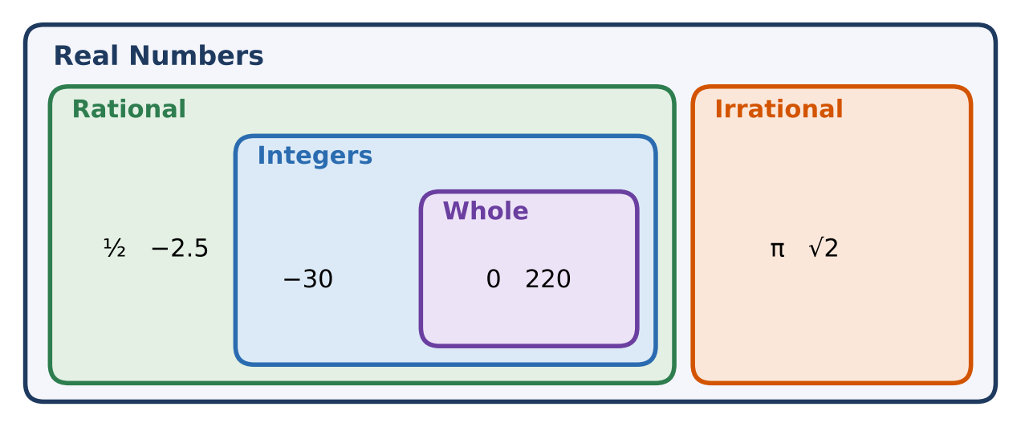

Part 3: Design a Balanced Game
Day 3 · Design a scoring system with parameters and a balance condition.
9. Write a general score expression with at least four terms using parameters, then choose values.

10. Find two different strategies that tie. Then write the condition (an equation in your parameters) that makes trading one item for another give the same score.

11. Write a nested bonus-round expression and simplify it, naming each property.

Final Product: Game Design Pitch
Your final product must include:
- General score expression and the Galaxy Dash version
- Simplified bonus formula with property justifications
- Closure arguments for π scores
- Balanced design with the parameter condition
- Pitch with sample players
Reflection
R1. How does writing p, q, and r instead of numbers help a game designer?

R2. Explain why the sum of a rational and an irrational number must be irrational.

Scoring Rubric
Criteria | 4 – Exceeds | 3 – Meets | 2 – Approaching | 1 – Beginning
Mathematical Accuracy | All calculations and solutions are correct; answers include units and are checked. | Nearly all work is correct; minor errors do not change conclusions. | Several errors; some conclusions are affected. | Many errors or missing work.
Reasoning & Justification | Clear, complete explanations connect every answer to the situation; uses precise vocabulary. | Explanations are mostly clear and connected to the situation. | Explanations are brief or partly unclear. | Little or no explanation.
Application & Design | Original scoring expression has at least three terms including a penalty, and it is evaluated and simplified correctly. Goes beyond the minimum with a creative, realistic choice. | Original scoring expression has at least three terms including a penalty, and it is evaluated and simplified correctly. | Design is incomplete or only partly uses the math from the unit. | Design is missing or unrelated to the unit math.
Communication & Presentation | Pitch shows the scoring rules, the score expression with each part explained, and sample scores for two players. Polished, organized, and visually engaging. | Pitch shows the scoring rules, the score expression with each part explained, and sample scores for two players. Organized and easy to follow. | Product is missing required parts or is hard to follow. | Product is mostly missing.

