ALGEBRA 1 · UNIT 9: POLYNOMIALS  Garden Designer  Design a community garden with polynomial areas, perimeters, and costs. | CP1  2–3 class periods

Name: ________________________________ Date: ______________ Period: ______
The Scenario
Your town is turning an empty lot into a community garden, and the planning board wants designs from students. Every garden bed will be a rectangle, and the beds will be surrounded by mulch paths.
The sizes are not decided yet, so the board wants your plan written with variables. Polynomials let you describe every possible size at once and calculate costs for any choice.
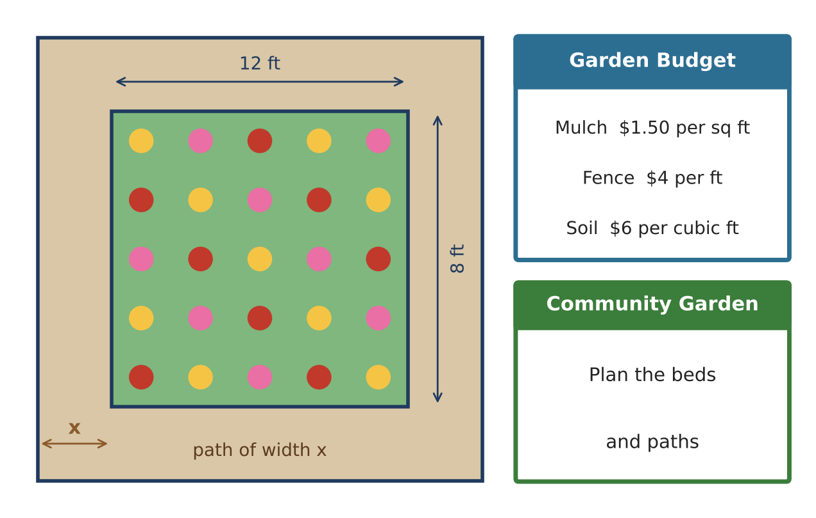
Learning Goals
- I can add, subtract, and multiply polynomials, including special products.
- I can model areas, paths, and costs with polynomials.
- I can explain closure and find errors in polynomial work.
Project Timeline
When | What you will do
Day 1 | Beds & Borders
Day 2 | Paths, Costs & Special Products
Day 3 | Design Your Garden
Final | Garden Plan + reflection

Part 1: Beds & Borders
Day 1 · Write every answer in standard form.
1. Classify 4x² + 40x + 96, x³ − 2x, and 7 by degree and number of terms.

2. A bed has sides (3x + 2) and (x + 5). Write its perimeter and its area.

3. Subtract: (5x² + 3x − 2) − (2x² − 4x + 6). Then explain what the result could mean if these are the areas of two beds.

4. Is the sum, difference, or product of two polynomials always a polynomial? Explain, and give an example of an expression that is not a polynomial.

Part 2: Paths, Costs & Special Products
Day 2 · The main garden is 12 ft by 8 ft with a path of width x around it.
5. Write the total area including the path, then subtract to find the path's area.

6. Mulch costs $1.50 per square foot. Write a polynomial for the cost of mulching the path. Find the cost when x = 2.5 feet.

7. A square bed is x by x. The board changes it to (x + 3) by (x − 3). Multiply and explain how the area changes.

8. Jada wrote (x + 5)² = x² + 25. Show that she is wrong using x = 1 and an area model, then write the correct product.

Part 3: Design Your Garden
Day 3 · Design a garden with at least three beds and a path around the whole garden.
9. Draw and label your beds with binomial side lengths. Include at least one square bed.

10. Write polynomials for the total bed area, the outside area including a path of width x, and the path area.

11. Choose x and find the total cost of mulch and fencing (fence the outside edge at $4 per foot).

Final Product: Garden Plan
Your final product must include:
- Labeled drawing with binomial dimensions
- Polynomials for bed area, total area, path area, and perimeter
- Cost polynomials and evaluated costs
- Corrected special-product error
- A pitch to the planning board
Reflection
R1. Why does (x + 3)(x − 3) have no middle term?

R2. How does closure help you trust that your final cost model is a polynomial?

Scoring Rubric
Criteria | 4 – Exceeds | 3 – Meets | 2 – Approaching | 1 – Beginning
Mathematical Accuracy | All calculations and solutions are correct; answers include units and are checked. | Nearly all work is correct; minor errors do not change conclusions. | Several errors; some conclusions are affected. | Many errors or missing work.
Reasoning & Justification | Clear, complete explanations connect every answer to the situation; uses precise vocabulary. | Explanations are mostly clear and connected to the situation. | Explanations are brief or partly unclear. | Little or no explanation.
Application & Design | Original garden uses at least three beds with correct polynomial area and perimeter models. Goes beyond the minimum with a creative, realistic choice. | Original garden uses at least three beds with correct polynomial area and perimeter models. | Design is incomplete or only partly uses the math from the unit. | Design is missing or unrelated to the unit math.
Communication & Presentation | Garden plan shows a labeled drawing, polynomial expressions for area, perimeter, and cost, and evaluated values. Polished, organized, and visually engaging. | Garden plan shows a labeled drawing, polynomial expressions for area, perimeter, and cost, and evaluated values. Organized and easy to follow. | Product is missing required parts or is hard to follow. | Product is mostly missing.

