ALGEBRA 1 · UNIT 9: POLYNOMIALS  Garden Designer  Design a community garden with polynomial areas, perimeters, and costs. | CP2  2–3 class periods

Name: ________________________________ Date: ______________ Period: ______
The Scenario
Your town is turning an empty lot into a community garden, and the planning board wants designs from students. Every garden bed will be a rectangle, and the beds will be surrounded by mulch paths.
The sizes are not decided yet, so the board wants your plan written with variables. Polynomials let you describe every possible size at once and calculate costs for any choice.
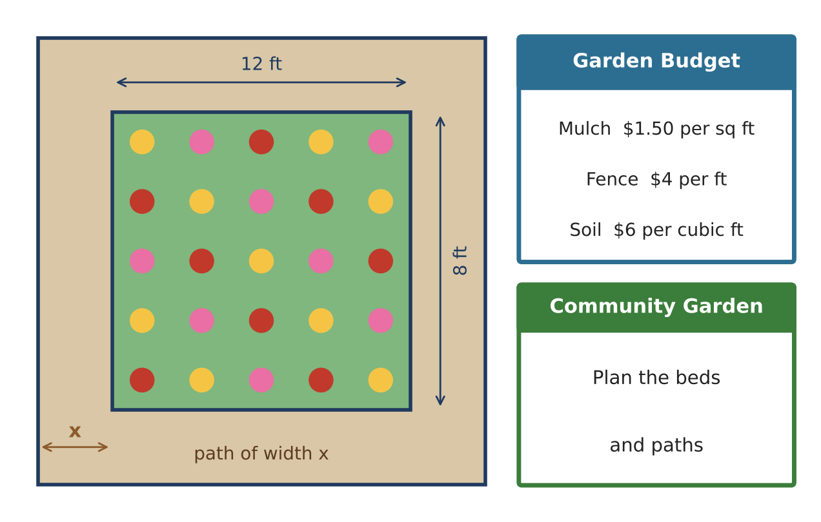
Learning Goals
- I can classify polynomials by degree and number of terms.
- I can add, subtract, and multiply polynomials.
- I can use polynomials to model area, perimeter, and cost.
Project Timeline
When | What you will do
Day 1 | Beds & Borders
Day 2 | Areas & Paths
Day 3 | Design Your Garden
Final | Garden Plan + reflection

Part 1: Beds & Borders
Day 1 · Write every answer in standard form.
1. Classify each polynomial by degree and number of terms: 8x + 14; 4x² + 40x + 96; 5; x³ − 2x.
Polynomial | Degree | Name by degree | Name by terms
8x + 14
4x² + 40x + 96
5
x³ − 2x

2. A bed has sides (3x + 2) feet and (x + 5) feet. Write and simplify its perimeter.

3. Two beds have areas (x² + 3x) and (2x² − x + 4) square feet. Find the total area.

4. Fencing bed A needs (6x + 10) feet and bed B needs (4x + 2) feet. How much more fencing does bed A need?
Starter: (6x + 10) − (4x + 2): subtract every term.

Part 2: Areas & Paths
Day 2 · Multiply to find areas.
5. An herb bed is x feet by (x + 4) feet. Write its area.

6. A vegetable bed is (x + 3) by (x + 5). Fill in the area model and write the area.
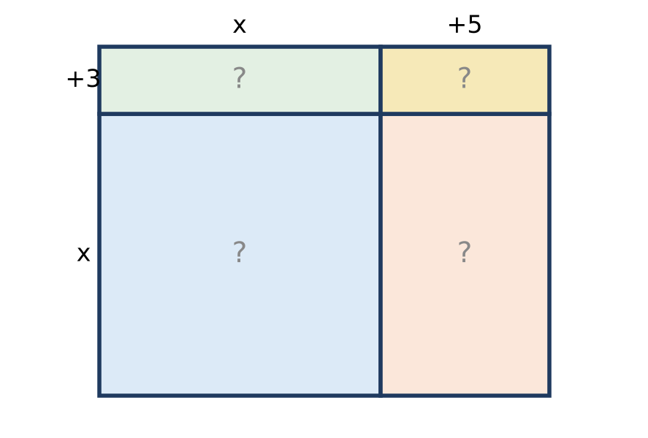

7. The main garden is 12 ft by 8 ft with a path of width x all the way around. The outside is (12 + 2x) by (8 + 2x). Multiply to find the total area.

8. The path's area is 4x² + 40x. Find the path's area when x = 3 feet. Mulch costs $1.50 per square foot. How much will the mulch cost?

Part 3: Design Your Garden
Day 3 · Design a garden with at least three beds.
9. A square flower bed has side (x + 2). Write its area as a product and in standard form.

10. Draw your garden. Label each bed with binomial side lengths like (x + 1) and (x + 6).

11. Write the total area of your beds as one polynomial. Evaluate it for x = 2 and find the mulch cost if the beds are covered.

Final Product: Garden Plan
Your final product must include:
- A labeled drawing of your garden
- Area of each bed and the total area polynomial
- One perimeter expression
- Evaluated values for x = 2 and the mulch cost
- A name and theme for your garden
Reflection
R1. How does an area model show why (x + 3)(x + 5) has four parts?

R2. Why is the outside length 12 + 2x and not 12 + x?

Scoring Rubric
Criteria | 4 – Exceeds | 3 – Meets | 2 – Approaching | 1 – Beginning
Mathematical Accuracy | All calculations and solutions are correct; answers include units and are checked. | Nearly all work is correct; minor errors do not change conclusions. | Several errors; some conclusions are affected. | Many errors or missing work.
Reasoning & Justification | Clear, complete explanations connect every answer to the situation; uses precise vocabulary. | Explanations are mostly clear and connected to the situation. | Explanations are brief or partly unclear. | Little or no explanation.
Application & Design | Original garden uses at least three beds with correct polynomial area and perimeter models. Goes beyond the minimum with a creative, realistic choice. | Original garden uses at least three beds with correct polynomial area and perimeter models. | Design is incomplete or only partly uses the math from the unit. | Design is missing or unrelated to the unit math.
Communication & Presentation | Garden plan shows a labeled drawing, polynomial expressions for area, perimeter, and cost, and evaluated values. Polished, organized, and visually engaging. | Garden plan shows a labeled drawing, polynomial expressions for area, perimeter, and cost, and evaluated values. Organized and easy to follow. | Product is missing required parts or is hard to follow. | Product is mostly missing.

