ALGEBRA 1 · UNIT 9: POLYNOMIALS  Garden Designer  Design a community garden with polynomial areas, perimeters, and costs. | Honors  2–3 class periods

Name: ________________________________ Date: ______________ Period: ______
The Scenario
Your town is turning an empty lot into a community garden, and the planning board wants designs from students. Every garden bed will be a rectangle, and the beds will be surrounded by mulch paths.
The sizes are not decided yet, so the board wants your plan written with variables. Polynomials let you describe every possible size at once and calculate costs for any choice.
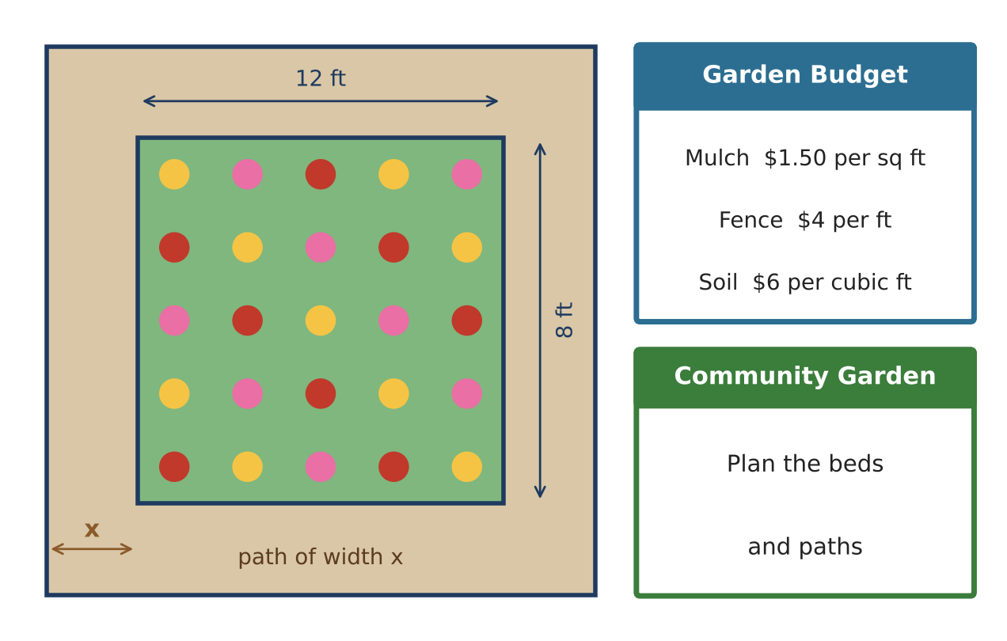
Learning Goals
- I can multiply polynomials, including trinomials and three factors.
- I can generalize patterns (path area, fixed perimeter) with polynomials.
- I can design a plan that meets a cost constraint and justify it algebraically.
Project Timeline
When | What you will do
Day 1 | Raised Beds
Day 2 | Paths & Perimeters
Day 3 | Design Within a Budget
Final | Garden Plan + reflection

Part 1: Raised Beds
Day 1 · Raised beds are boxes filled with soil.
1. A raised bed is x ft tall, (x + 2) ft wide, and (2x − 1) ft long. Write its volume in standard form and check your answer with x = 3.

2. Soil costs $6 per cubic foot. Write the cost polynomial and evaluate it when x = 1.5.

3. Multiply (x² + 2x − 3)(x + 4). Use a table (generic rectangle).

4. Explain why the product of a degree-2 and a degree-1 polynomial has degree 3. What is the degree of the product of polynomials with degrees m and n?

Part 2: Paths & Perimeters
Day 2 · Generalize the path problem.
5. A garden is a ft by b ft with a path of width x around it. Show that the path's area is 4x² + 2(a + b)x.

6. Explain why the path area depends only on the garden's perimeter P. Rewrite the path area using P. Which two gardens need the same path mulch: 12 × 8, 15 × 5, or 10 × 10?

7. Several gardens have perimeter 4x. A square garden is x by x and a rectangle is (x + k) by (x − k). Show which has more area and by how much.

8. Find and fix the error: (2x − 3)² = 4x² − 9.

Part 3: Design Within a Budget
Day 3 · Budget: $600 for mulch ($1.50 per sq ft) and fencing ($4 per ft) for a garden with a path of width x around it.
9. Choose your garden's length and width as polynomials or numbers. Write polynomials for path area, outside perimeter, and total cost.

10. Find the widest whole-number path width x that keeps the total cost within $600. Show your table of values.

11. Add raised beds and write their total soil volume as a polynomial. Present the full plan.

Final Product: Garden Plan
Your final product must include:
- Raised-bed volume and cost polynomials
- General path-area formula and the perimeter insight
- Fixed-perimeter comparison
- Budget-constrained design with a table
- Final plan with all polynomials
Reflection
R1. How did writing the path area in general (a, b, x) reveal something you could not see with numbers?

R2. Why does a square give the most area for a fixed perimeter in this project?

Scoring Rubric
Criteria | 4 – Exceeds | 3 – Meets | 2 – Approaching | 1 – Beginning
Mathematical Accuracy | All calculations and solutions are correct; answers include units and are checked. | Nearly all work is correct; minor errors do not change conclusions. | Several errors; some conclusions are affected. | Many errors or missing work.
Reasoning & Justification | Clear, complete explanations connect every answer to the situation; uses precise vocabulary. | Explanations are mostly clear and connected to the situation. | Explanations are brief or partly unclear. | Little or no explanation.
Application & Design | Original garden uses at least three beds with correct polynomial area and perimeter models. Goes beyond the minimum with a creative, realistic choice. | Original garden uses at least three beds with correct polynomial area and perimeter models. | Design is incomplete or only partly uses the math from the unit. | Design is missing or unrelated to the unit math.
Communication & Presentation | Garden plan shows a labeled drawing, polynomial expressions for area, perimeter, and cost, and evaluated values. Polished, organized, and visually engaging. | Garden plan shows a labeled drawing, polynomial expressions for area, perimeter, and cost, and evaluated values. Organized and easy to follow. | Product is missing required parts or is hard to follow. | Product is mostly missing.

