ALGEBRA 1 · UNIT 8: EXPONENTIAL FUNCTIONS  Going Viral  Model how a video spreads and compare exponential and linear growth. | CP1  2–3 class periods

Name: ________________________________ Date: ______________ Period: ______
The Scenario
Your school's robotics team just won the state championship, and the media club posted a video. The first 5 people who saw it each shared it, and each day the number of new views has tripled.
Meanwhile, the club also hung posters around town, which bring in about 400 new views per day. Which plan is better? And what happens after the video stops trending? You will model all of it and then design your own viral challenge.
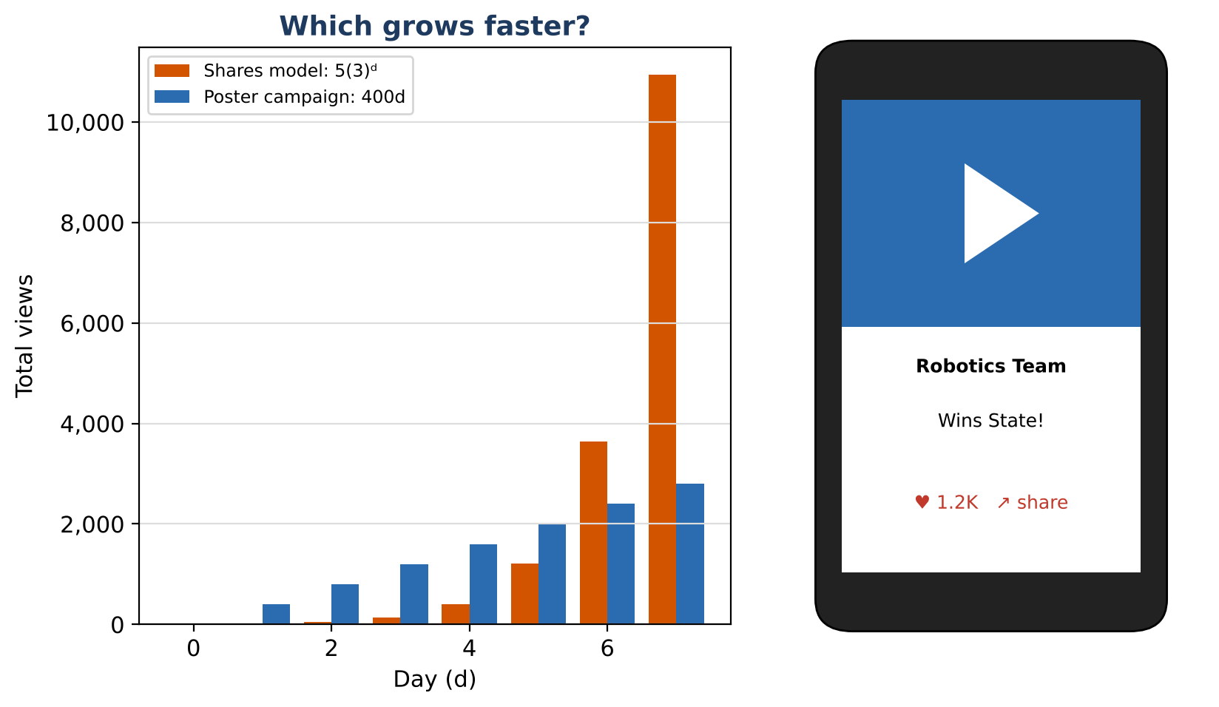
Learning Goals
- I can write exponential growth and decay models using percents.
- I can use exponent rules to simplify and interpret expressions.
- I can determine when exponential growth passes linear growth.
Project Timeline
When | What you will do
Day 1 | Shares vs. Posters
Day 2 | Exponent Rules & Decay
Day 3 | Design a Viral Challenge
Final | Viral Challenge Pitch + reflection

Part 1: Shares vs. Posters
Day 1 · Shares: start with 5 views and triple daily. Posters: 400 views per day.
1. Write both models. Complete the table for days 0 to 6.
Day (d) | 0 | 1 | 2 | 3 | 4 | 5 | 6
Shares model views | 5 | 15
Poster campaign views | 0 | 400

2. Graph both models and find the first day the shares model is ahead.
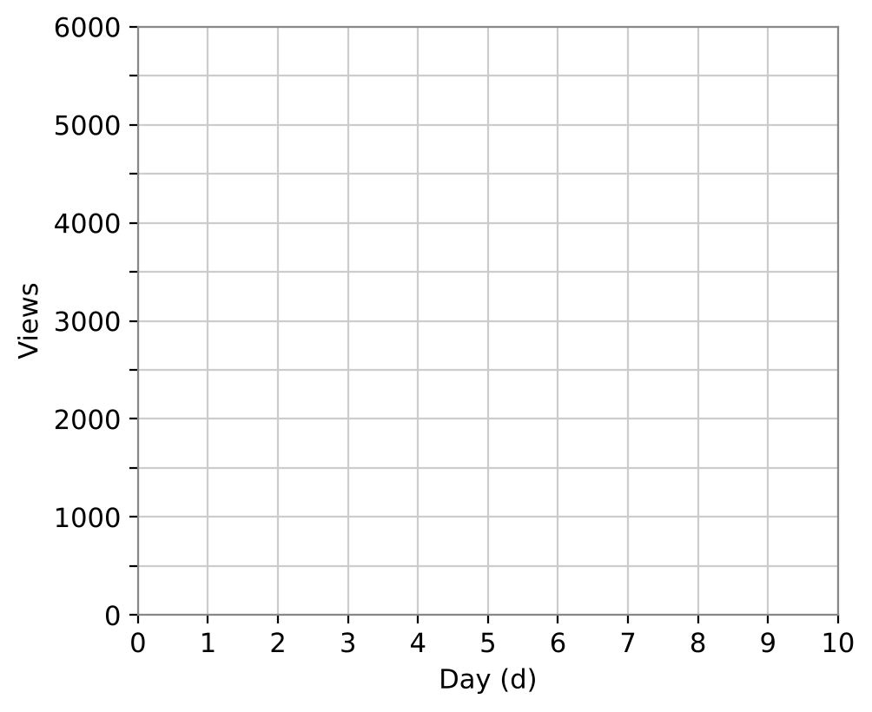

3. Explain the difference between adding 400 each day and multiplying by 3 each day, using the table.

4. The club's account had 800 followers and grows 12% per week. Write a model and find the number of followers after 8 weeks.

Part 2: Exponent Rules & Decay
Day 2 · Use exponent rules to simplify. Write answers with positive exponents.
5. Simplify V(5) ÷ V(2) for V(d) = 5(3)ᵈ. Interpret.

6. Simplify (5 · 3⁴)(3²) and (5 · 3⁸) ÷ (5 · 3⁸). What does the second result tell you?

7. After the peak (10,000 daily views), daily views decrease 40% per day. Write a model and find the first day with fewer than 1,000 daily views.

8. A different account adds 150 followers per week starting at 800. In what week does the 12% growth account pass it?

Part 3: Design a Viral Challenge
Day 3 · Design a challenge and plan for its rise and fall.
9. Write a growth model with a percent rate and a decay model for after the peak.

10. Make a table and graph for both phases (at least 10 days in all).

11. Compare your model to a linear plan of your choice. When does yours pass it?

Final Product: Viral Challenge Pitch
Your final product must include:
- Growth and decay models with percent rates
- A table and graph for the full rise and fall
- Comparison with a linear plan
- Exponent-rule simplifications that explain your model
- A pitch slide for your challenge
Reflection
R1. Why does a 40% decrease use a factor of 0.6, but a 12% increase uses 1.12?

R2. Explain why an exponential function with b > 1 eventually passes any linear function.

Scoring Rubric
Criteria | 4 – Exceeds | 3 – Meets | 2 – Approaching | 1 – Beginning
Mathematical Accuracy | All calculations and solutions are correct; answers include units and are checked. | Nearly all work is correct; minor errors do not change conclusions. | Several errors; some conclusions are affected. | Many errors or missing work.
Reasoning & Justification | Clear, complete explanations connect every answer to the situation; uses precise vocabulary. | Explanations are mostly clear and connected to the situation. | Explanations are brief or partly unclear. | Little or no explanation.
Application & Design | Original challenge uses a correct exponential model with a realistic growth factor. Goes beyond the minimum with a creative, realistic choice. | Original challenge uses a correct exponential model with a realistic growth factor. | Design is incomplete or only partly uses the math from the unit. | Design is missing or unrelated to the unit math.
Communication & Presentation | Pitch includes the model, a table and graph, a linear vs. exponential comparison, and a decay plan. Polished, organized, and visually engaging. | Pitch includes the model, a table and graph, a linear vs. exponential comparison, and a decay plan. Organized and easy to follow. | Product is missing required parts or is hard to follow. | Product is mostly missing.

