ALGEBRA 1 · UNIT 8: EXPONENTIAL FUNCTIONS  Going Viral  Model how a video spreads and compare exponential and linear growth. | CP2  2–3 class periods

Name: ________________________________ Date: ______________ Period: ______
The Scenario
Your school's robotics team just won the state championship, and the media club posted a video. The first 5 people who saw it each shared it, and each day the number of new views has tripled.
Meanwhile, the club also hung posters around town, which bring in about 400 new views per day. Which plan is better? And what happens after the video stops trending? You will model all of it and then design your own viral challenge.
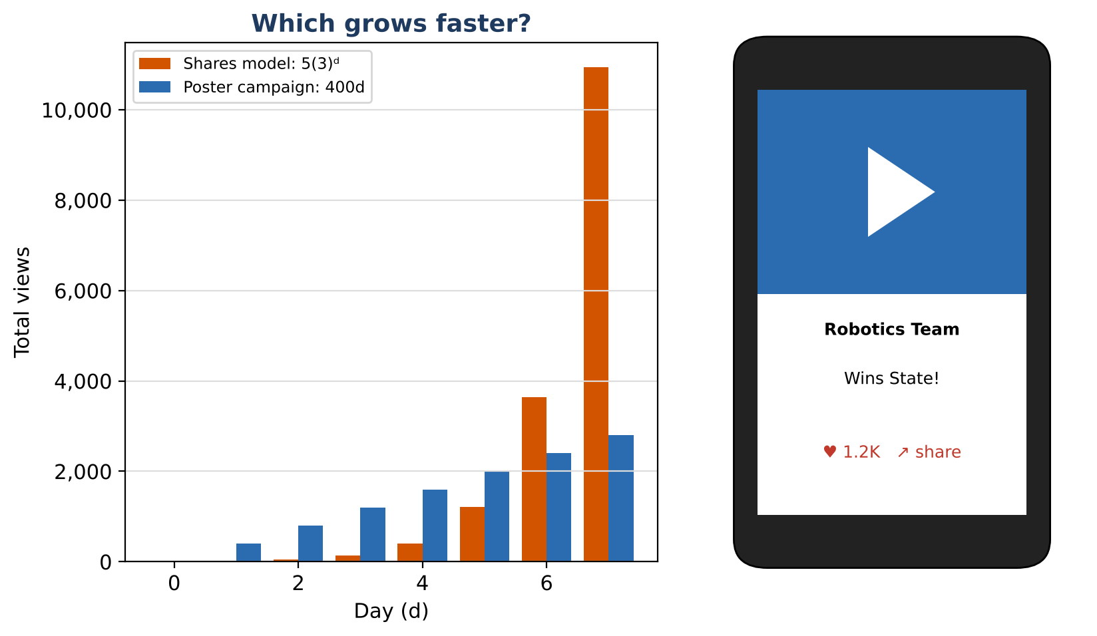
Learning Goals
- I can recognize exponential growth as repeated multiplication.
- I can write and use exponential functions y = a(b)ˣ.
- I can compare exponential and linear growth.
Project Timeline
When | What you will do
Day 1 | Shares vs. Posters
Day 2 | Growth Rules & the Fade
Day 3 | Design a Viral Challenge
Final | Viral Challenge Pitch + reflection

Part 1: Shares vs. Posters
Day 1 · Views from shares triple every day. Posters add 400 views every day.
1. Complete the table.
Day (d) | 0 | 1 | 2 | 3 | 4 | 5 | 6
Shares model views | 5 | 15
Poster campaign views | 0 | 400

2. What do you multiply by each day for shares? What do you add each day for posters?

3. Write an equation for the shares model and one for the poster campaign.
Starter: Shares: V = 5( ___ )ᵈ Posters: V = ___d

4. On which day do shares first have more views than posters?

5. Plot both models on the grid for days 0 to 6.
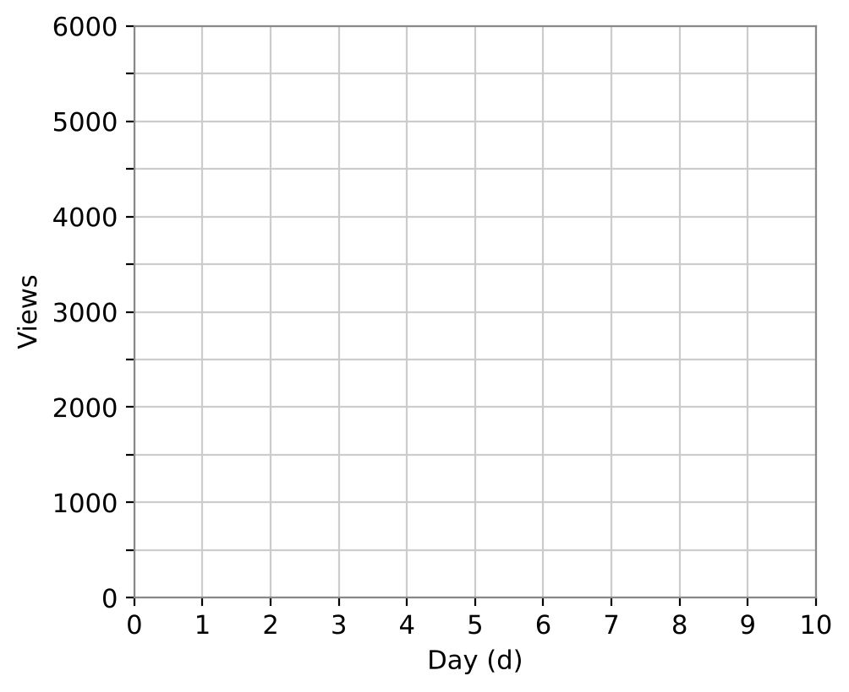

Part 2: Growth Rules & the Fade
Day 2 · Use exponent rules and your models.
6. On day d, the shares model gives 5 · 3ᵈ views. Two days later it gives 5 · 3ᵈ⁺². Use the rule 3ᵈ⁺² = 3ᵈ · 3² to explain how many times more views there are 2 days later.

7. Simplify 3⁴ · 3² and 3⁶ ÷ 3². What do these mean for the video?

8. After the video peaks at 10,000 daily views, daily views drop by 40% each day. What do you multiply by each day? Write an equation.
Starter: If 40% is lost, ___% is kept.

9. Find the daily views 3 days after the peak.

Part 3: Design a Viral Challenge
Day 3 · Invent a challenge (dance, kindness, recycling...) that spreads.
10. Choose how many people start it (a) and how many new people each person brings in (the multiplier b). Write your model.

11. Make a table for days 0 to 6. Using the 5(3)ᵈ model, on what day would a video pass 1,000,000 views? Use a calculator to extend the table.

12. Explain why the challenge can't keep growing this way forever.

Final Product: Viral Challenge Pitch
Your final product must include:
- Your challenge name and how it spreads
- The model y = a(b)ˣ with a table and graph
- A comparison with a linear plan
- The fade-out (decay) model
- A catchy pitch slide or poster
Reflection
R1. How can you tell from a table whether a pattern is linear or exponential?

R2. Why did the poster campaign lead at first but lose in the end?

Scoring Rubric
Criteria | 4 – Exceeds | 3 – Meets | 2 – Approaching | 1 – Beginning
Mathematical Accuracy | All calculations and solutions are correct; answers include units and are checked. | Nearly all work is correct; minor errors do not change conclusions. | Several errors; some conclusions are affected. | Many errors or missing work.
Reasoning & Justification | Clear, complete explanations connect every answer to the situation; uses precise vocabulary. | Explanations are mostly clear and connected to the situation. | Explanations are brief or partly unclear. | Little or no explanation.
Application & Design | Original challenge uses a correct exponential model with a realistic growth factor. Goes beyond the minimum with a creative, realistic choice. | Original challenge uses a correct exponential model with a realistic growth factor. | Design is incomplete or only partly uses the math from the unit. | Design is missing or unrelated to the unit math.
Communication & Presentation | Pitch includes the model, a table and graph, a linear vs. exponential comparison, and a decay plan. Polished, organized, and visually engaging. | Pitch includes the model, a table and graph, a linear vs. exponential comparison, and a decay plan. Organized and easy to follow. | Product is missing required parts or is hard to follow. | Product is mostly missing.

