ALGEBRA 1 · UNIT 8: EXPONENTIAL FUNCTIONS  Going Viral  Model how a video spreads and compare exponential and linear growth. | Honors  2–3 class periods

Name: ________________________________ Date: ______________ Period: ______
The Scenario
Your school's robotics team just won the state championship, and the media club posted a video. The first 5 people who saw it each shared it, and each day the number of new views has tripled.
Meanwhile, the club also hung posters around town, which bring in about 400 new views per day. Which plan is better? And what happens after the video stops trending? You will model all of it and then design your own viral challenge.
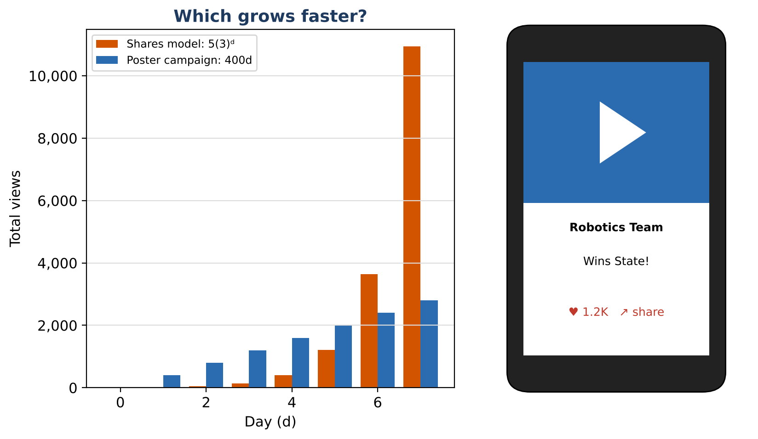
Learning Goals
- I can build exponential models from two data points.
- I can use exponent properties, including zero and negative exponents, to interpret models.
- I can design a model that meets numerical constraints.
Project Timeline
When | What you will do
Day 1 | Build the Model
Day 2 | Doubling & Half-Life
Day 3 | Engineer a Viral Challenge
Final | Viral Challenge Pitch + reflection

Part 1: Build the Model
Day 1 · A second video's total views follow V(d) = a(b)ᵈ.
1. On day 2 the video had 180 views and on day 5 it had 4,860. Find a and b. Show your algebra.

2. Show that V(d + k) ÷ V(d) = bᵏ for any d. What does this mean for the video?

3. Find V(−1). What could it mean? Is it a reasonable prediction?

4. Compare V(d) = 20(3)ᵈ with a linear campaign L(d) = 1,500d. On which day does V pass L, and when (if ever) does L lead?
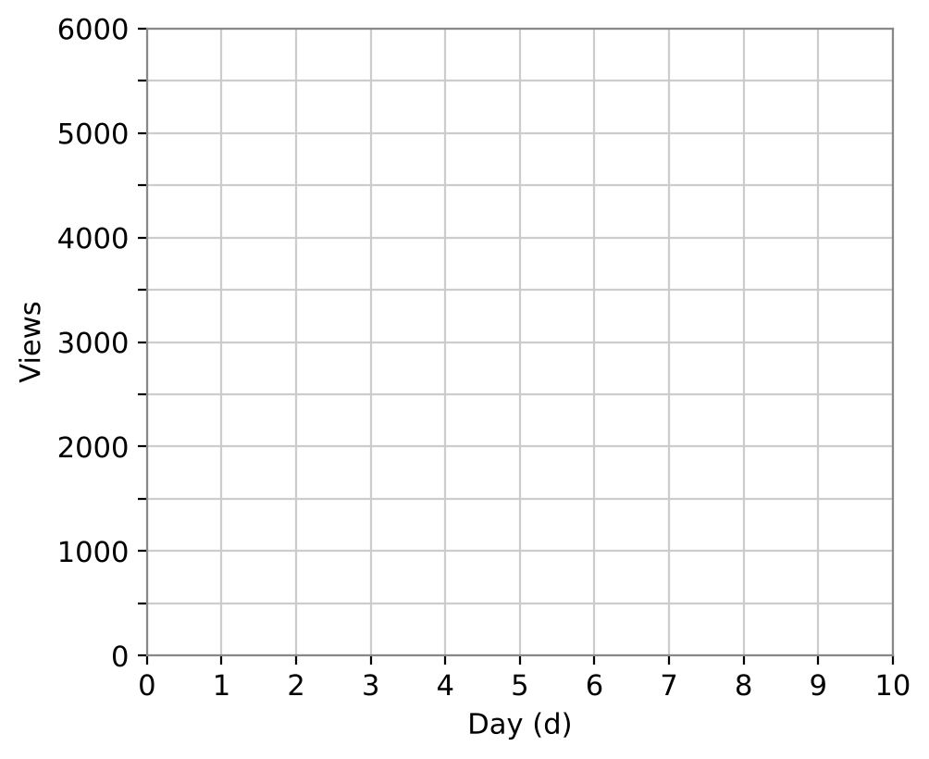

Part 2: Doubling & Half-Life
Day 2 · Use tables and a calculator.
5. Followers grow 12% per week from 800. Estimate the doubling time to the nearest week. Does the doubling time depend on the starting amount? Prove it.

6. After the peak, views fall 40% per day. Find the half-life (to the nearest tenth of a day) by testing values.

7. Write the 12% weekly growth as a daily growth factor (to 4 decimal places). Explain your method using exponent rules.

8. Simplify (2x³y⁻²)³ ÷ (4x⁵y⁻⁴) and explain how this skill helps you rewrite models.

Part 3: Engineer a Viral Challenge
Day 3 · Rule: your challenge must cross 1,000,000 total views on exactly day 10.
9. Choose a and b so that V(9) < 1,000,000 ≤ V(10). Show the calculations.

10. Add a decay phase after day 12 with a half-life between 2 and 3 days. Give the factor and show it meets the rule.

11. Present both phases on one graph and explain the meaning of a and b in your models.

Final Product: Viral Challenge Pitch
Your final product must include:
- Model from two points with full algebra
- Doubling time and half-life analysis
- Daily vs. weekly growth factor conversion
- Engineered challenge meeting the day-10 rule
- Two-phase graph and pitch
Reflection
R1. Why is the ratio of views k days apart always bᵏ? How does this make exponential models special?

R2. How did you use guess-and-check with exponents to meet the day-10 rule?

Scoring Rubric
Criteria | 4 – Exceeds | 3 – Meets | 2 – Approaching | 1 – Beginning
Mathematical Accuracy | All calculations and solutions are correct; answers include units and are checked. | Nearly all work is correct; minor errors do not change conclusions. | Several errors; some conclusions are affected. | Many errors or missing work.
Reasoning & Justification | Clear, complete explanations connect every answer to the situation; uses precise vocabulary. | Explanations are mostly clear and connected to the situation. | Explanations are brief or partly unclear. | Little or no explanation.
Application & Design | Original challenge uses a correct exponential model with a realistic growth factor. Goes beyond the minimum with a creative, realistic choice. | Original challenge uses a correct exponential model with a realistic growth factor. | Design is incomplete or only partly uses the math from the unit. | Design is missing or unrelated to the unit math.
Communication & Presentation | Pitch includes the model, a table and graph, a linear vs. exponential comparison, and a decay plan. Polished, organized, and visually engaging. | Pitch includes the model, a table and graph, a linear vs. exponential comparison, and a decay plan. Organized and easy to follow. | Product is missing required parts or is hard to follow. | Product is mostly missing.

