ALGEBRA 1 · UNIT 11: QUADRATIC FUNCTIONS AND EQUATIONS  Launch Lab  Model rockets and water balloons with quadratic functions. | CP1  2–3 class periods

Name: ________________________________ Date: ______________ Period: ______
The Scenario
The science club is running a Launch Lab at the school fair: model rockets, water balloons, and a giant slingshot. Visitors want to know how high things go and when they will land.
Gravity makes the height of a launched object a quadratic function of time: h(t) = −16t² + vt + h₀, where v is the launch speed (feet per second) and h₀ is the starting height (feet). You will analyze the launches and then design your own.
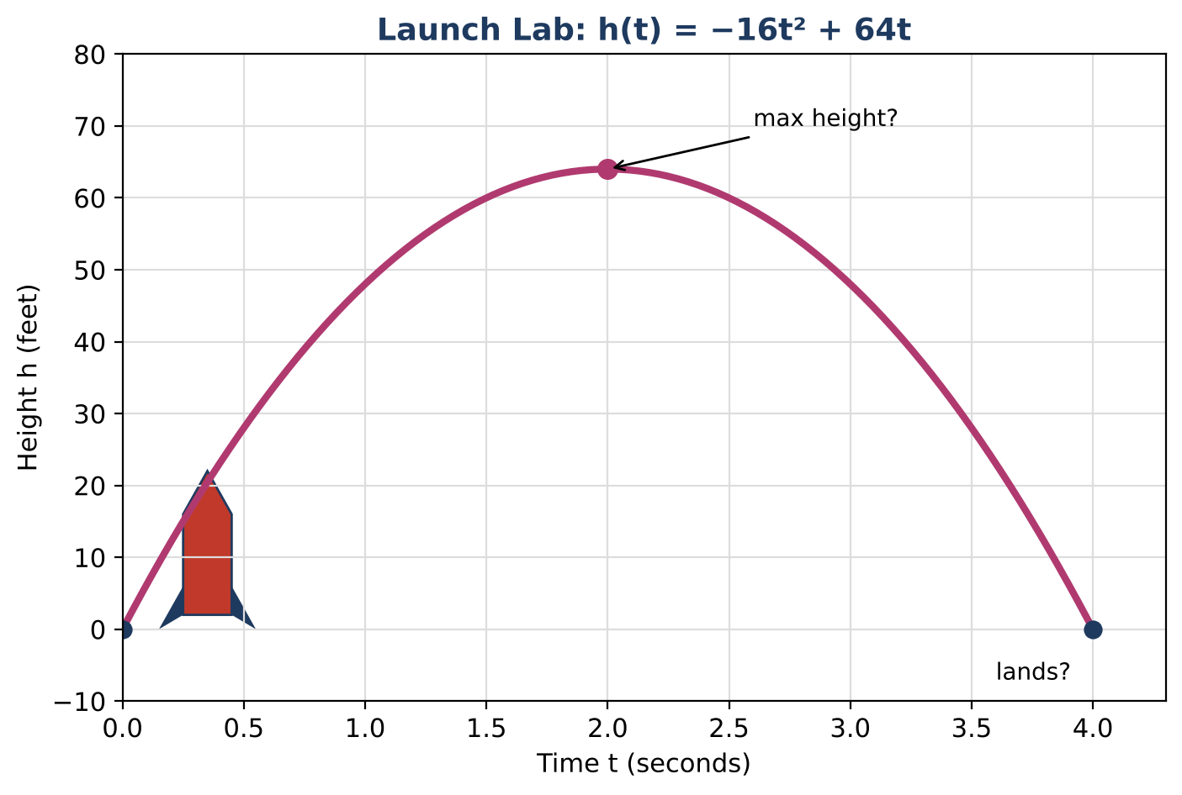
Learning Goals
- I can analyze quadratic functions in standard, vertex, and factored form.
- I can solve quadratic equations using the method that fits best, including the quadratic formula.
- I can use the discriminant to decide whether a height is ever reached.
Project Timeline
When | What you will do
Day 1 | Rocket from a Platform
Day 2 | Claims & Comparisons
Day 3 | Design a Launch
Final | Launch Report + reflection

Part 1: Rocket from a Platform
Day 1 · A rocket is launched at 64 ft per s from a 4-ft platform: h(t) = −16t² + 64t + 4.
1. Find the vertex and explain its meaning.
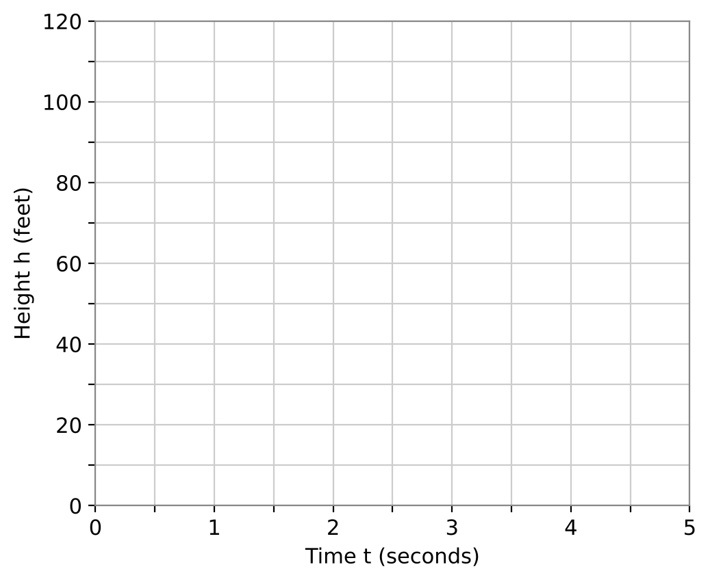

2. Write h(t) in vertex form and check that it matches your vertex.

3. Use the quadratic formula to find when the rocket lands. Round to the nearest hundredth.

4. Rocket B follows h(t) = −16(t − 1.5)² + 40. Which rocket goes higher? Which is in the air longer? Justify.

Part 2: Claims & Comparisons
Day 2 · Test each claim algebraically.
5. A visitor claims the platform rocket will reach 80 feet. Use the discriminant to decide.

6. When is the platform rocket exactly 60 feet high? Give answers to the nearest hundredth.

7. A water balloon follows h(t) = −16t² + 16t + 32. Solve by factoring to find when it lands.

8. Classify each model in the table as linear, exponential, or quadratic. Explain using differences or ratios.
x | 0 | 1 | 2 | 3
Model A | 3 | 7 | 11 | 15
Model B | 3 | 6 | 12 | 24
Model C | 3 | 6 | 11 | 18

Part 3: Design a Launch
Day 3 · Rule: from a 4-ft platform, the maximum height must be between 80 and 100 feet.
9. Choose a launch speed v and write h(t) = −16t² + vt + 4.

10. Find the vertex. Show that it follows the rule.

11. Find the landing time with the quadratic formula and present your launch with a graph.

Final Product: Launch Report
Your final product must include:
- Launch function in standard and vertex form
- Graph with vertex and landing time labeled
- Discriminant test of a claim
- Model classification
- Design that meets the rule
Reflection
R1. How does the discriminant tell you whether a height is reached without solving?

R2. Which solving method did you use most, and why?

Scoring Rubric
Criteria | 4 – Exceeds | 3 – Meets | 2 – Approaching | 1 – Beginning
Mathematical Accuracy | All calculations and solutions are correct; answers include units and are checked. | Nearly all work is correct; minor errors do not change conclusions. | Several errors; some conclusions are affected. | Many errors or missing work.
Reasoning & Justification | Clear, complete explanations connect every answer to the situation; uses precise vocabulary. | Explanations are mostly clear and connected to the situation. | Explanations are brief or partly unclear. | Little or no explanation.
Application & Design | Designed launch meets the height rule, with the vertex and zeros found algebraically. Goes beyond the minimum with a creative, realistic choice. | Designed launch meets the height rule, with the vertex and zeros found algebraically. | Design is incomplete or only partly uses the math from the unit. | Design is missing or unrelated to the unit math.
Communication & Presentation | Launch report shows the function, a labeled graph, maximum height, landing time, and a check of the park rule. Polished, organized, and visually engaging. | Launch report shows the function, a labeled graph, maximum height, landing time, and a check of the park rule. Organized and easy to follow. | Product is missing required parts or is hard to follow. | Product is mostly missing.

