ALGEBRA 1 · UNIT 11: QUADRATIC FUNCTIONS AND EQUATIONS  Launch Lab  Model rockets and water balloons with quadratic functions. | CP2  2–3 class periods

Name: ________________________________ Date: ______________ Period: ______
The Scenario
The science club is running a Launch Lab at the school fair: model rockets, water balloons, and a giant slingshot. Visitors want to know how high things go and when they will land.
Gravity makes the height of a launched object a quadratic function of time: h(t) = −16t² + vt + h₀, where v is the launch speed (feet per second) and h₀ is the starting height (feet). You will analyze the launches and then design your own.
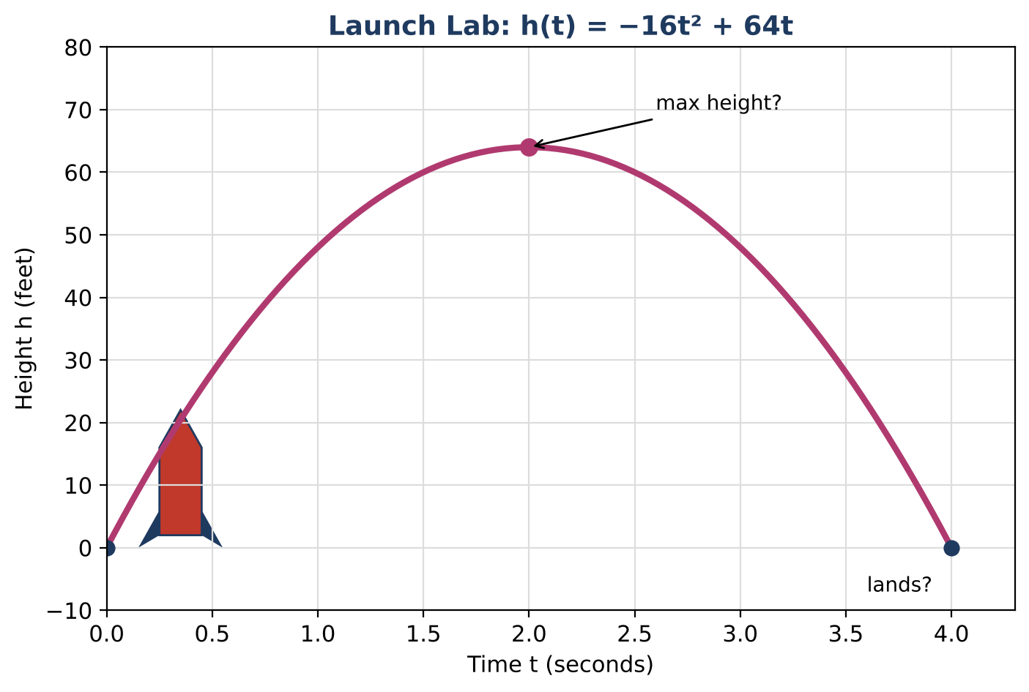
Learning Goals
- I can graph a quadratic function and identify its key features.
- I can solve quadratic equations by factoring in context.
- I can explain what the vertex and zeros mean for a launch.
Project Timeline
When | What you will do
Day 1 | Rocket on the Ground
Day 2 | Heights & Landings
Day 3 | Design a Launch
Final | Launch Report + reflection

Part 1: Rocket on the Ground
Day 1 · A rocket is launched from the ground at 64 feet per second: h(t) = −16t² + 64t.
1. Complete the table.
t (s) | 0 | 1 | 2 | 3 | 4
h(t) (ft) | 0

2. Graph the function on the grid.
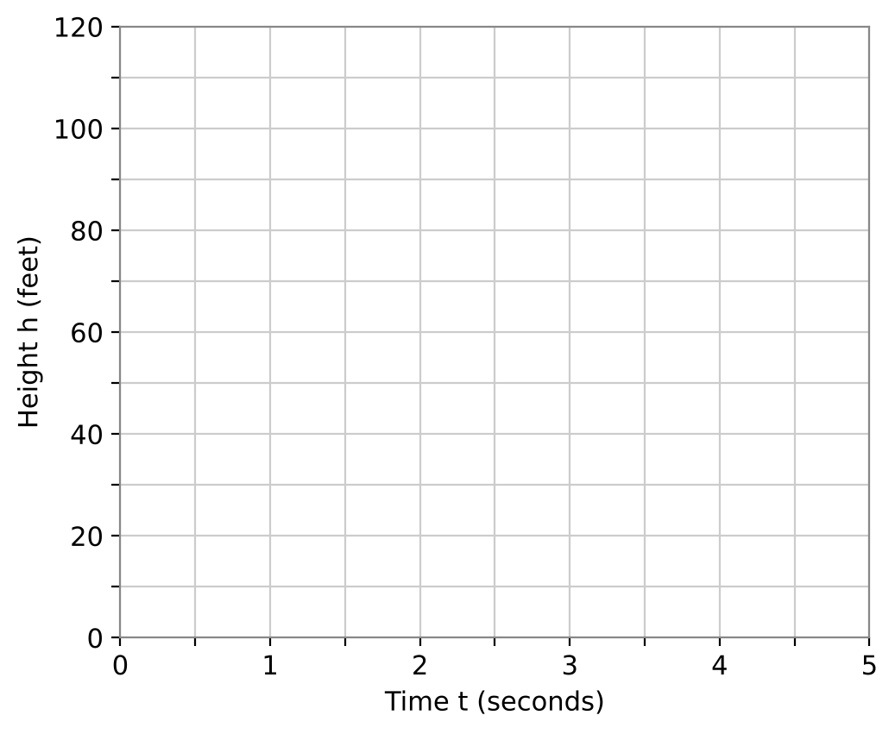
3. Find the vertex, the axis of symmetry, and the zeros. What does each mean for the rocket?

4. What are a reasonable domain and range for this launch?

Part 2: Heights & Landings
Day 2 · Solve by factoring.
5. Factor h(t) = −16t² + 64t. Use the factored form to explain when the rocket is on the ground.
Starter: GCF: −16t

6. When is the rocket 48 feet high? Solve −16t² + 64t = 48.
Starter: Move 48 to the left side, then divide every term by −16.

7. A water balloon is tossed up from a window: h(t) = −16t² + 16t + 32. Factor and find when it hits the ground.

8. Find the water balloon's maximum height. Use the axis of symmetry t = −b ÷ (2a).

Part 3: Design a Launch
Day 3 · Park rule: no launch may go higher than 100 feet. Your rocket launches from the ground.
9. Choose a launch speed v that is a multiple of 16. Write h(t) = −16t² + vt.

10. Find your rocket's maximum height and landing time. Does it follow the park rule?

11. Graph your launch and the original rocket on one grid. Compare the two.

Final Product: Launch Report
Your final product must include:
- Your launch function and graph
- Vertex, zeros, and their meanings
- The park-rule check
- A comparison with the 64 ft per second rocket
- A poster for the fair booth
Reflection
R1. Why does a rocket's height graph make a parabola even though the rocket goes straight up and down?

R2. Why do we ignore negative solutions for time?

Scoring Rubric
Criteria | 4 – Exceeds | 3 – Meets | 2 – Approaching | 1 – Beginning
Mathematical Accuracy | All calculations and solutions are correct; answers include units and are checked. | Nearly all work is correct; minor errors do not change conclusions. | Several errors; some conclusions are affected. | Many errors or missing work.
Reasoning & Justification | Clear, complete explanations connect every answer to the situation; uses precise vocabulary. | Explanations are mostly clear and connected to the situation. | Explanations are brief or partly unclear. | Little or no explanation.
Application & Design | Designed launch meets the height rule, with the vertex and zeros found algebraically. Goes beyond the minimum with a creative, realistic choice. | Designed launch meets the height rule, with the vertex and zeros found algebraically. | Design is incomplete or only partly uses the math from the unit. | Design is missing or unrelated to the unit math.
Communication & Presentation | Launch report shows the function, a labeled graph, maximum height, landing time, and a check of the park rule. Polished, organized, and visually engaging. | Launch report shows the function, a labeled graph, maximum height, landing time, and a check of the park rule. Organized and easy to follow. | Product is missing required parts or is hard to follow. | Product is mostly missing.

