ALGEBRA 1 · UNIT 11: QUADRATIC FUNCTIONS AND EQUATIONS  Launch Lab  Model rockets and water balloons with quadratic functions. | Honors  2–3 class periods

Name: ________________________________ Date: ______________ Period: ______
The Scenario
The science club is running a Launch Lab at the school fair: model rockets, water balloons, and a giant slingshot. Visitors want to know how high things go and when they will land.
Gravity makes the height of a launched object a quadratic function of time: h(t) = −16t² + vt + h₀, where v is the launch speed (feet per second) and h₀ is the starting height (feet). You will analyze the launches and then design your own.
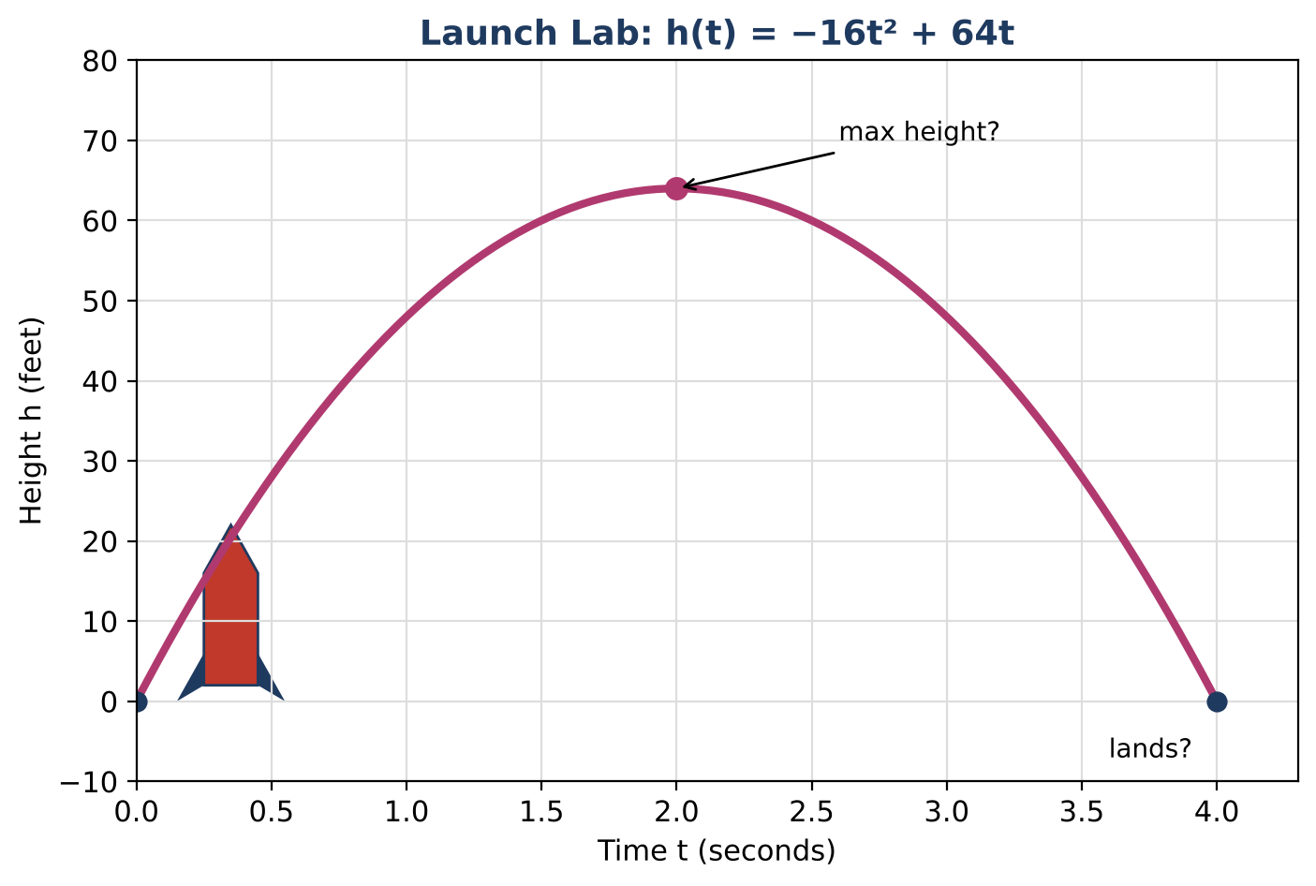
Learning Goals
- I can build a quadratic model from data and rewrite it in every form.
- I can find exact solutions using completing the square and the quadratic formula.
- I can use inequalities to describe all launches that meet a rule.
Project Timeline
When | What you will do
Day 1 | Model from Data
Day 2 | Claims, Mars & Models
Day 3 | Design Within the Rules
Final | Launch Report + reflection

Part 1: Model from Data
Day 1 · A slingshot launch was filmed. Heights: t = 0 s: 5 ft; t = 1 s: 69 ft; t = 2 s: 101 ft.
1. Use h(t) = at² + bt + c and the three data points to write and solve a system for a, b, and c.

2. Complete the square to write the model in vertex form. State the maximum height and when it occurs.

3. Find the exact landing time in simplest radical form, then approximate it.

4. Show that the data have constant second differences. Why does that confirm a quadratic model?

Part 2: Claims, Mars & Models
Day 2 · Answer each question with exact values when possible.
5. For what heights H does the equation h(t) = H have two solutions, one solution, and no solutions? Use the discriminant.

6. On Mars, gravity is weaker: h(t) = −6.1t² + 80t + 5 (same launch). Find the maximum height and compare it to Earth's.

7. Classify each model as linear, exponential, or quadratic and write an equation for each.
x | 0 | 1 | 2 | 3
Model A | 3 | 7 | 11 | 15
Model B | 3 | 6 | 12 | 24
Model C | 3 | 6 | 11 | 18

8. For large x, which model in the table eventually has the greatest values? Explain.

Part 3: Design Within the Rules
Day 3 · Rule: launches start 4 ft high and must reach a maximum height between 80 and 100 feet.
9. Show that the maximum height of h(t) = −16t² + vt + 4 is 4 + v² ÷ 64.

10. Write and solve a compound inequality for the speeds v that follow the rule.

11. Choose a speed, find its exact landing time, and present the launch with a graph and every key feature.
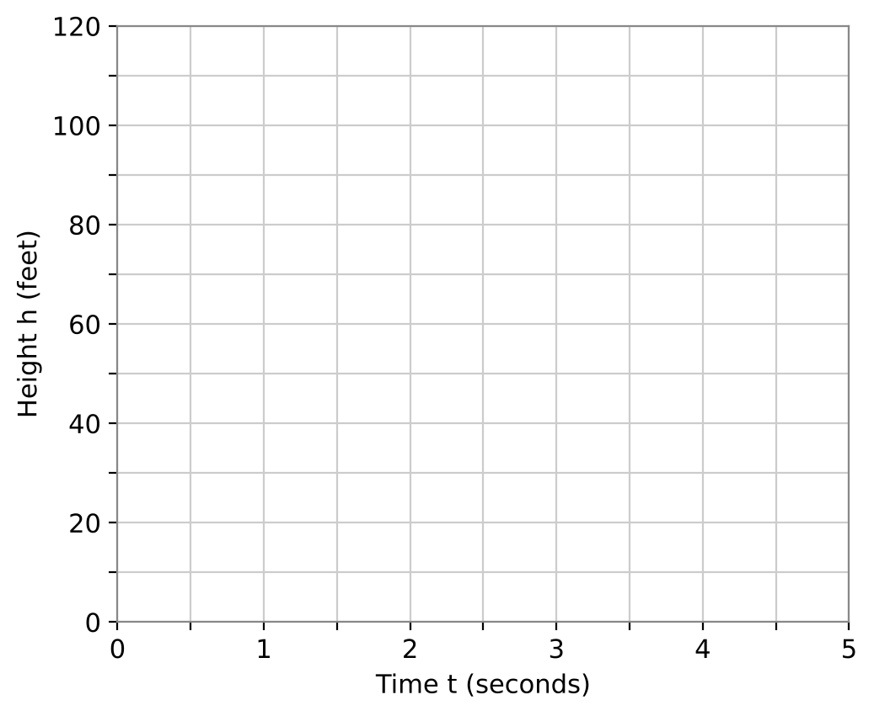

Final Product: Launch Report
Your final product must include:
- Model from data in standard, vertex, and factored-or-radical forms
- Discriminant analysis for any height H
- Mars comparison
- Speed inequality and your design
- Launch report
Reflection
R1. Why is completing the square useful for projectile models?

R2. How did the inequality for v give you every acceptable launch at once?

Scoring Rubric
Criteria | 4 – Exceeds | 3 – Meets | 2 – Approaching | 1 – Beginning
Mathematical Accuracy | All calculations and solutions are correct; answers include units and are checked. | Nearly all work is correct; minor errors do not change conclusions. | Several errors; some conclusions are affected. | Many errors or missing work.
Reasoning & Justification | Clear, complete explanations connect every answer to the situation; uses precise vocabulary. | Explanations are mostly clear and connected to the situation. | Explanations are brief or partly unclear. | Little or no explanation.
Application & Design | Designed launch meets the height rule, with the vertex and zeros found algebraically. Goes beyond the minimum with a creative, realistic choice. | Designed launch meets the height rule, with the vertex and zeros found algebraically. | Design is incomplete or only partly uses the math from the unit. | Design is missing or unrelated to the unit math.
Communication & Presentation | Launch report shows the function, a labeled graph, maximum height, landing time, and a check of the park rule. Polished, organized, and visually engaging. | Launch report shows the function, a labeled graph, maximum height, landing time, and a check of the park rule. Organized and easy to follow. | Product is missing required parts or is hard to follow. | Product is mostly missing.

