Lecture 1: Probability, Reliability and Quality
- Definition of Reliability: Understand reliability engineering as the application of scientific, engineering, statistical, and mathematical methods to reduce the likelihood or frequency and consequences of unwanted product or system behaviours. Distinguish reliability from the complete elimination of failure and recognise that reliability is evaluated under specified operating conditions and over a defined period of time.
- Fundamental Reliability Functions: Identify and interpret the cumulative probability of failure by time $t$ denoted $F\left(t\right)=P(T≤t)$ and the reliability function $R\left(t\right)=P\left(T>t\right)=1-F(t)$, where $T$ is the time to failure. Students should be able to visualise these functions and explain how the probability of failure increases, and reliability decreases, over time.
- Rated Life and Reliability-based Decisions: Understand rated life as the operating time up to which a specified minimum reliability, or maximum acceptable probability of failure, must be maintained. Students should be able to explain how rated life can inform product replacement, inspection, maintenance, and servicing decisions.
- Expressing a reliability requirement: Formulate a reliability requirement in terms of the maximum acceptable probability of failure, or minimum acceptable reliability, at a specified operating time and under a specified load or operating condition. Understand an escape as a defective or insufficiently reliable product that passes through the organisation’s quality controls and reaches a later production stage or the customer. In a reliability context, students should recognise failures occurring before the rated life as potential reliability escapes and identify why such failures require investigation.
- Failure types across the product life cycle: Distinguish between early-life, normal-life, and end-of-life failures. Students should associate early-life failures with causes such as manufacturing defects, assembly errors, or material flaws; normal-life failures with random events such as unexpected shock loads; and end-of-life failures with degradation mechanisms such as wear, corrosion, and fatigue.
- Definition of Quality: Understand quality engineering as the systematic design, control, assurance, and improvement of products and processes so that specified requirements are consistently met. Students should distinguish quality engineering from inspection alone and recognise that quality must be designed and controlled throughout the product and manufacturing life cycle. Total quality along 8 dimensions: performance, provided features, reliability, durability, conformance, serviceability, aesthetics, perceived quality.
- Turnbacks and Non-Conformance: Understand a turnback as a product, component, or process outcome that fails to satisfy an applicable quality criterion and must therefore be corrected, reworked, scrapped, or returned to an earlier stage.
- Tolerances and Yield: Understand that selected product characteristics or key performance indicators are measured and compared with upper and lower specification limits. Students should recognise the interval between the lower specification limit, (LSL), and upper specification limit, (USL), as the acceptable specification range and determine whether an individual manufactured unit conforms to the stated requirements.
Calculate and interpret the scrap rate ($\frac{\#defectives}{\#made}$) and the yield ($\frac{\#made-\#defectives}{\#made}$).
In the case of high-volume production, use the nomenclature of parts-per-million (PPM): $PPM=\frac{\#defectives}{\#made}{10}^{6}$.
- Manufacturing Outcome Distributions​: Understand that variation in manufacturing outcomes can be represented using a probability distribution fitted to measurements of a product characteristic. Students should be able to relate the position and spread of the distribution to the specification limits and identify the regions corresponding to conforming and non-conforming products. Understand short-term yield as the proportion of the fitted process distribution expected to fall within the specification limits under current process conditions.

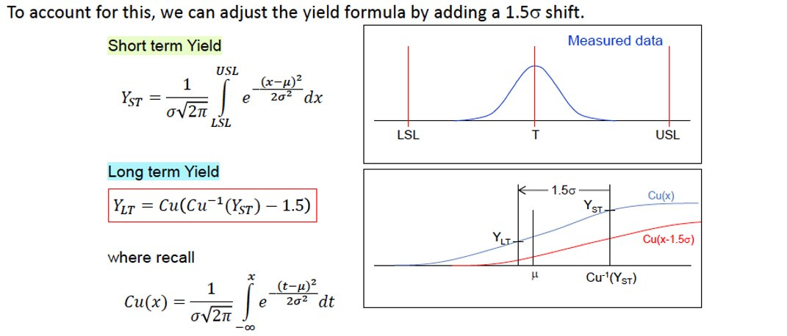
- Process Capability: Compare two approaches to preventing defective products from reaching customers: screening products through inspection and improving the underlying manufacturing process. Students should understand that 100% inspection does not necessarily guarantee zero escapes because inspection systems can produce measurement errors, false acceptances, false rejections, or missed defects.
Definitions of process potential index $C_{p}=\frac{USL-LSL}{6σ}$: continuous measure of ability to conform to a specification, understand it represents the allowable spread versus the process distribution spread.
Definitions of process capability index $C_{pk}$: continuous measure of ability to conform to a specification, accounting for mean shift. $C_{pk}=min⁡(C_{pu}, C_{pl})$ with $C_{pu}=\frac{USL-μ}{3σ}$, $C_{pl}=\frac{μ-LSL}{3σ}$.
As an indicative convention, students should recognise that values of $C_{pk}$ below (1.00) indicate that the process spread exceeds the available specification range; approximately (1.33) indicates limited or conventionally acceptable capability; approximately (1.67) indicates good capability; and approximately (2.00) indicates very high capability. Students should understand that the required threshold depends on the industry, product criticality, customer requirements, and consequences of failure.
Students should be able to read and interpret report cards such as below:
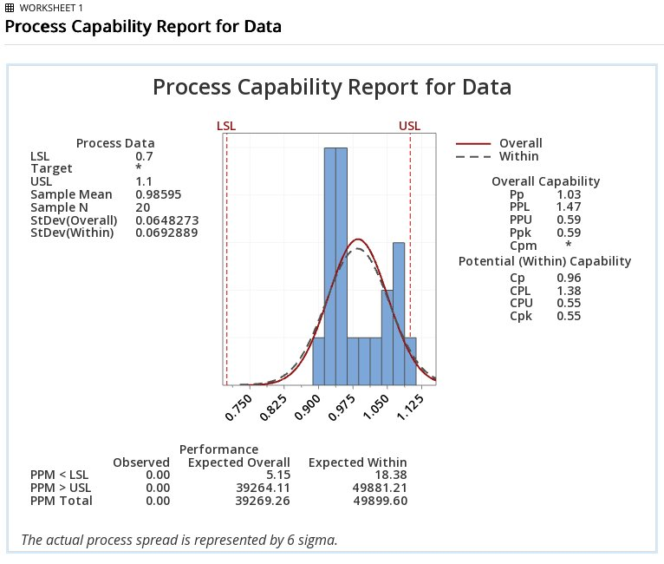
- Key Ideas: Understand that meeting specification limits does not necessarily mean that a product has high performance or provides high customer value. Quality includes both selecting appropriate performance requirements and consistently achieving them, whereas capability indices primarily evaluate how consistently a process conforms to its existing specifications. Recognise that capability indices based on short-term estimates of the process mean and standard deviation may not represent long-term production performance. Students should understand that process drift, tool wear, environmental changes, material variation, and systematic trends must be detected and controlled to maintain long-term quality.
Lecture 2: Inspections and Processes
- Inspections: Students must be able to give examples of inspection methods such as visual inspection, metrology or “go-no go” measurements. Students should be able to compare their advantages and limitations in terms of speed, cost, repeatability, measurement detail, and suitability for process control. Ex: Visual inspection is fast and sufficient for obvious features but is not repeatable nor sufficient to judge the amount of a variable. Go-no go gauges are an efficient mean of delivering zero defects for dimensional KPIs.
- Production Control: Understand that production control is a feedback process. Understand production control as a feedback process in which measured outputs are compared with desired values and corrective actions are applied. Students should recognise that correction will necessarily produce scraps if the only inspection methods are visual and go-no go and that only the direct measurement of a KPI can reveal trends and support earlier intervention. Students should understand control charts are useful tools in process control, on which measurements and control limits can be plotted.
- Manufacturing Data and Statistics: Understand the importance of collecting process inputs and outputs to investigate variation and identify potential causes of process shifts. Students should be able to interpret a correlation matrix and recognise that correlation can support investigation.
- Production System Metrics: Define production rate as the number of acceptable units produced per unit of time and takt time as the maximum available production time per unit required to satisfy customer demand. Students should understand that the net production rate must meet or exceed the demand rate, or equivalently that cycle time must remain below takt time.
- Sources of Defects in Production Systems: Identify common sources of manufacturing and assembly defects, including use of an incorrect part, omission of a part, incorrect installation, equipment malfunction, material variation, contamination, and handling damage. Students should be aware that increasing production speed may increase defect rates and reduce net production.
- Quality Philosophy: Understand that achieving high quality requires consistency, which rigorously applied standard operating procedures can help achieve. Students should distinguish an inspection-centred approach, which detects defective units after production, from a process-centred approach, which aims to prevent defects by controlling the factors and process inputs that generate them.
- Process Focus: Understand how process maps and Failure Mode and Effects Analysis support a process-centred approach to quality. Students should be able to identify key elements of a process map, such as activities, decisions, inputs, outputs, and rework loops, and key elements of an FMEA, such as failure modes, effects, causes, severity, occurrence, detection, existing controls, and recommended actions.
Lecture 3: ANOVA and Gauge Repeatability & Reproducibility
- ANOVA Generalities: Understand Analysis of Variance, or ANOVA, as a statistical method used to determine whether one or more categorical predictors have a statistically significant effect on a continuous response variable. Students should be able to:
  - Explain the meaning of the acronym ANOVA.
  - Identify situations in which ANOVA is appropriate, including comparing the mean performance of several groups, datasets, treatments, machines, materials, or operating conditions.
  - Recognise that ANOVA evaluates differences between group means by comparing variation associated with the predictors against unexplained or random variation.
  - Distinguish one-way, two-way, and higher-order ANOVA according to the number of predictors included.
  - Recognise that ANOVA can investigate both the individual effects of predictors and, when applicable, interactions between predictors.

- One-Way ANOVA: Understand one-way ANOVA as a model involving one categorical predictor and one continuous response variable. The observed response is represented as the combination of an overall mean, a treatment or group effect, and random error.
Students should be able to:
  - Identify the response variable, the categorical predictor, and the groups or treatment levels.
  - Formulate the null hypothesis that all population group means are equal means ($H_{0}$ as the equality of all group means).
  - Formulate the alternative hypothesis that at least one population mean differs from the others ($H_{A}$ as at least one mean is different to the others).
Students also need to express $α$ and $β$ risk levels and sample sizes used for the ANOVA.
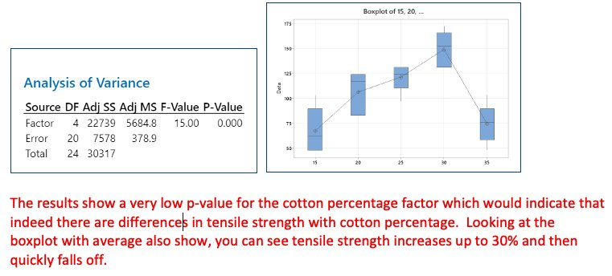
- ANOVA Table: Understand that ANOVA separates the total variation observed in the response into variation explained by differences between groups and variation remaining within the groups (noise). Students should be able to:
  - Interpret the principal components of an ANOVA table: source of variation, sum of squares, degrees of freedom, mean square, (F)-statistic, and (p)-value.
  - Understand sum of squares as a measure of variability around a reference mean.
  - Distinguish between-group variation, which represents the effect associated with the predictor, from within-group variation, which represents residual or unexplained variability.
  - Understand that the (F)-statistic compares explained variation with residual variation.
  - Compare the (p)-value with a selected significance level, commonly (0.05).
  - Reject the null hypothesis when the (p)-value is below the significance level.
  - State that there is insufficient evidence to reject the null hypothesis when the (p)-value is greater than or equal to the significance level. Students should not describe this result as proving or accepting the null hypothesis.
  - Recognise that a statistically significant ANOVA result indicates that at least one mean differs but does not identify which groups differ without further analysis, such as post-hoc comparisons.
- Model Adequacy and Residual Analysis: Students must be able to Assess the adequacy of an ANOVA model before drawing conclusions from its sums of squares, (F)-statistics, or (p)-values. Statistical conclusions are only reliable when the model provides a reasonable representation of the data.
Students should be able to:
  - Interpret residuals as the differences between observed and model-predicted values.
  - Examine residual plots to assess whether errors are randomly distributed around zero.
  - Check whether residual variability remains approximately constant across fitted values and groups.
  - Assess whether residuals are approximately normally distributed, while recognising that apparent non-normality may arise from a small sample size.
  - Check the independence of residuals, particularly when observations have been collected over time.
  - Identify outliers and understand that they require engineering and statistical investigation rather than automatic removal.
  - Recognise curved or systematic residual patterns as possible evidence of missing terms, incorrect model structure, transformations, or relationships not represented by the model.
  - Recognise residual trends over time as possible evidence of drift, degradation, environmental effects, or omitted time-related predictors.
  - Consider adding relevant factors or interactions when important sources of variation appear to be omitted.
  - Consider transformations, such as a natural logarithm or Box–Cox transformation, when variance or distributional assumptions are not satisfied.
  - Use the mean square error and adjusted coefficient of determination as supplementary indicators of model adequacy.
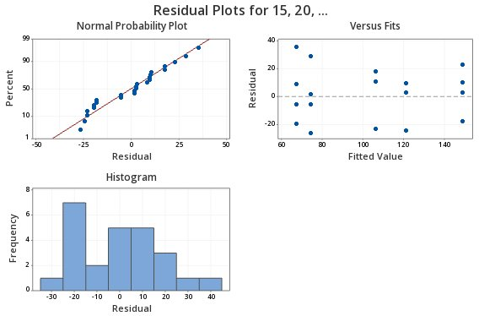
- Two-Way ANOVA: Understand two-way ANOVA as an extension of one-way ANOVA involving two categorical predictors and one continuous response variable.
Students should appreciate the possibility to include an interaction term in a Two-Way ANOVA.
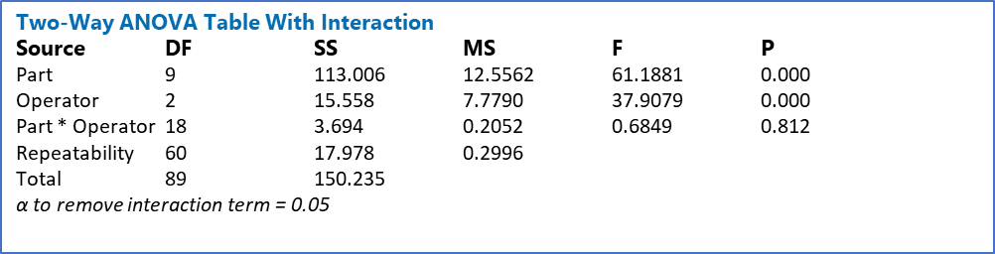
- Measurement Error: Understand that the variation observed in manufacturing or experimental data includes variation from the underlying process and variation introduced by the measurement system:
Observed Variability = Process Variability + Measurement Variability
Students should also appreciate that if the measurement variability is similar to the process variability, wrong decisions will be made. As such, the measurement systems must be analysed.
Outcomes of the measurement system analysis should outline the magnitude of the measurement error, its contributors, the stability of the measurement system and pathways to improvements.
- Measurement System Metrics: Understand the principal characteristics used to evaluate a measurement system and interpret the results of a Gauge Repeatability and Reproducibility study. Students should be able to distinguish:
  - Accuracy: the closeness of a measurement or average measurement to an accepted reference value.
  - Bias: the systematic difference between the average measured value and the accepted reference value.
  - Resolution: the smallest increment or change that the measurement system can display or distinguish.
  - Repeatability: variation observed when the same operator measures the same part repeatedly using the same instrument, method, and conditions.
  - Reproducibility: variation associated with changes in operators, instruments, laboratories, fixtures, or other measurement conditions.
  - Stability: changes in measurement bias or variation over time.
  - Linearity: changes in measurement bias across the operating range of the instrument.
Students should understand that a measurement system must be repeatable, i.e. having little standard deviation from successive measurements, of the same part, by the same person, using the same instrument. Students must also understand the need for reproducibility, which is having little standard deviation over different conditions. Reproducibility can be impacted by changing from one instrument to another, aging instruments, or from operator to operator.
- Precision: Students must understand the difference between accuracy and precision. Understand precision as the closeness of repeated measurements to one another, independently of whether those measurements are close to the true value.:
$$Precision= σ_{repeatability}^{2}+σ_{reproducibility}^{2}$$
Students understand Precision is also called Gage R&R or measurement error and is the primary metric of a measurement system analysis.
- Stability: Students must understand stability as the measurement system drift over time, which can impact either accuracy or precision. Stability is monitored using repeated GRR studies. Usually, $σ_{measurement}$ is plotted over time. A non-stable measurement is called inconsistent.
- Linearity: Students must understand linearity as the difference in accuracy or precision over the domain of the device. If the measurement is large, is the error bigger than when the measurement is small?
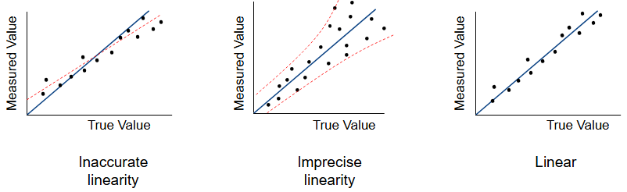
- Process Variation Based Metrics: Students should be familiar with concepts of Precision-to-total variation:
$$\frac{P}{TV}=\frac{σ_{meas}}{σ_{tot}}=\frac{σ_{meas}}{σ_{process}+σ_{meas}}$$
And Percent R&R:
$$\%R\&R=\frac{σ_{meas}^{2}}{σ_{total}^{2}}*100$$
Student should interpret both metrics as quantification of the total variation (observed variation) due to measurement error. %RR is better statistically.
Students should also be familiar with the concept of discrimination, as the number of distinct measurements system variances that can fit in the total variance:
$$Discrimination= \sqrt{2\frac{σ_{total}^{2}}{σ_{meas}^{2}}-1}$$
- Gauge Study Interpretation: Students should be able to interpret the results of a gage study:
Rating | P/TV | %RR | Discrimination
Unacceptable | >30% | >9% | <5
Bad | 10-30% | 2-9% | 5-10
Good | 0-10% | 0-2% | >10
The students should also be aware that to obtain reliable Gauge R&R study results, the experiment should be conducted over 3 operators, 3 repeats each, on 10 parts, leading to 90 total runs, which is an industry standard.
Students should be able to interpret the results of the Gauge R&R table:
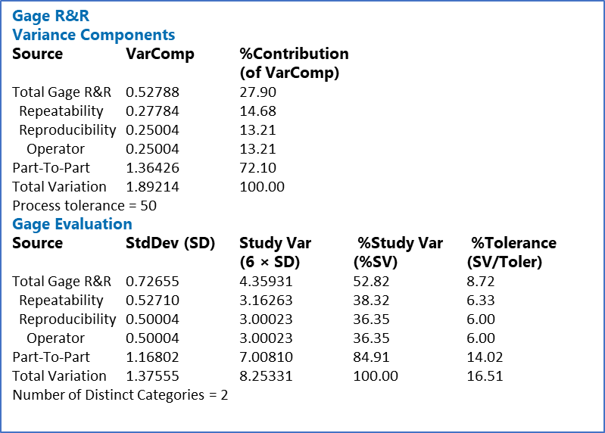
P/TV (SV/Tol) answers “Can I use the measurement system to inspect parts?”, the answer of which is relative to the tolerance specifications.
The %RR (%SV) answers “Can I use the measurement system to see a process shift?”, the answer of which is relative to the process shift.
The visual interpretation of the Gauge R&R is also important:
