MiniMart Manager
Software Documentation
RetailFlow — Retail Inventory & Sales Management System
Hayleys Aventura Software Engineering Internship — Technical Assignment

Application Overview
MiniMart Manager is a single-user, offline-first WPF desktop application that lets a store owner or cashier manage a product catalog, process sales at a point-of-sale style screen, track stock levels automatically, review past transactions, and get a live analytics view of the business — all backed by a local SQLite database with no external services or internet connection required.

Objectives
- Provide a simple, reliable way to manage a small retail store's inventory and sales digitally.
- Keep stock counts accurate automatically, without manual reconciliation.
- Give the store owner a quick, visual read on how the business is performing.
- Demonstrate a clean, maintainable desktop application architecture (MVVM, layered services, centralized business rules) rather than a script-like implementation.

Main Features
Feature | Description
Product Management | Add, edit, and deactivate products; search and filter the catalog.
Sales Processing (POS) | Build a cart from available stock, apply a discount, and complete a sale.
Stock Management | Stock is deducted atomically when a sale completes; reorder levels drive low-stock alerts.
Transaction History | Browse past sales by date range, with a full line-item receipt view.
Low Stock Alerts | Products at or below their reorder level are flagged across the app.
Interactive Dashboard | KPI cards and five charts (trend, category, top products, heatmap, stock-vs-sales) with date/category/product filters.
MiniMart Assistant | A rule-based chat assistant that answers stock/sales questions and can navigate the app on request.

Technology Stack
Layer | Technology
Language | C# 12
UI Framework | WPF (Windows Presentation Foundation), .NET 8 (net8.0-windows)
UI Pattern | MVVM (hand-rolled — no third-party MVVM framework)
Data Access | Entity Framework Core 8.0.11 (Code-First)
Database | SQLite (single local file, retailflow.db)
Charts | Native WPF drawing (Canvas, Polyline, Rectangle, Ellipse) — no charting library

Technology Selection Rationale
.NET 8 / WPF — a mature, long-term-supported desktop framework with strong data-binding support, well suited to a data-entry and reporting application like this one, and the natural choice for a Windows-only internal business tool.
SQLite — a zero-configuration, file-based database. It needs no separate server or installation step, which matches a single-user desktop app and keeps setup to "clone and run."
Entity Framework Core (Code-First) — lets the schema be expressed as plain C# classes (Product, Sale, SaleItem) and evolved through code rather than hand-written SQL, while EF Core's LINQ provider still allows aggregate queries (sums, group-by) to run in the database rather than in memory.
Hand-rolled MVVM (RelayCommand, ViewModelBase) — the application is small enough that a full MVVM framework (Prism, MVVM Toolkit, etc.) would add a dependency without a proportional benefit; a ~30-line command/base-class pair covers everything the app needs.
No charting library — the dashboard's charts (line, bar, heatmap, scatter) are simple enough to draw directly with WPF shapes. This avoids taking on a third-party package (and its native/version-compatibility risk) for functionality that a small amount of first-party code already covers cleanly.

System Architecture
The application follows a strict layered flow, with no data-access code ever placed in a View's code-behind. Each layer only ever talks to the one directly below it:

Architecture Diagram
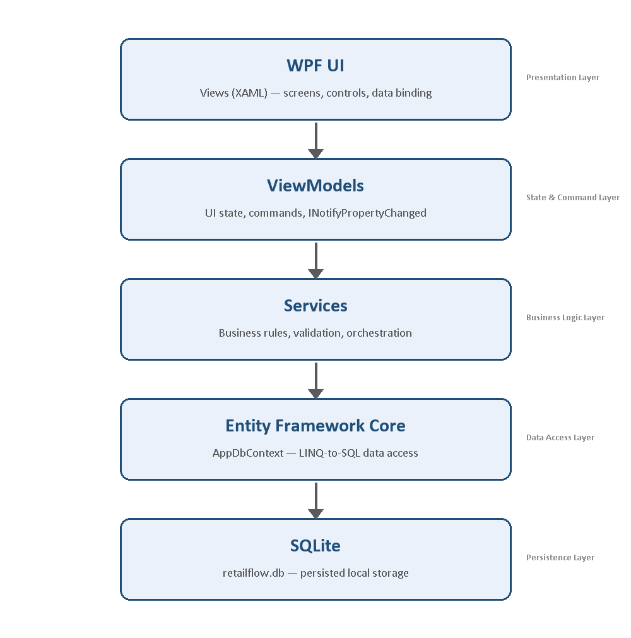

Layer Responsibilities
Layer | Responsibility
WPF UI  (Views / XAML) | Presents the screens and controls, and binds them to a ViewModel. Purely declarative — no business logic, validation, or database access ever lives in a .xaml.cs file.
ViewModels | Hold the UI state a screen is currently showing (search text, selected item, form fields) and expose Commands (RelayCommand) for its buttons. Implement INotifyPropertyChanged (via a shared ViewModelBase) so the UI updates automatically. Call into Services for anything that touches data — they never reference AppDbContext.
Services | Own all business rules and orchestration: validation (ValidationHelper), calculations (SaleCalculator), and multi-step operations such as completing a sale (deduct stock + write the Sale/SaleItem rows in one transaction). This is the single place a rule is defined, so the UI and the database can never disagree about it.
Entity Framework Core | The ORM layer (AppDbContext) that maps the Product/Sale/SaleItem C# classes to SQLite tables and translates LINQ queries into SQL. Services open a short-lived AppDbContext per call rather than sharing one long-lived instance.
SQLite | The persistence layer — a single local file (retailflow.db) that stores all data. Requires no separate server or setup step, matching a single-user desktop deployment.

Additional Architectural Notes
- Navigation is owned by MainWindow.xaml.cs, which keeps one cached instance of each screen and switches the visible one. Cross-screen requests (e.g., the Dashboard's "Low Stock" card jumping to a filtered Product list, or the Assistant navigating on a spoken request) are done through C# events rather than direct references, keeping screens decoupled from one another.
- Error handling is two-tiered: expected failures (insufficient stock, duplicate product code, etc.) are caught in the relevant Service and returned as a plain-language message; anything unexpected is caught by a global DispatcherUnhandledException handler in App.xaml.cs, logged to retailflow-error.log, and shown as a generic "please try again" dialog — the application is never allowed to crash to the desktop.

Database Design
The database has three tables, created and seeded automatically on first run (Data/DbInitializer.cs).

Product
Column | Type | Notes
Id | int | Primary key
ProductCode | string(30) | Unique
Name | string(100) | Required
Category | string(50)
Price | decimal(18,2)
StockQuantity | int
ReorderLevel | int | Low-stock threshold
IsActive | bool | Soft-delete flag — products are never hard-deleted
CreatedAt / UpdatedAt | DateTime

Sale
Column | Type | Notes
Id | int | Primary key
InvoiceNumber | string(30) | Unique, e.g. INV-20260909-001
SaleDate | DateTime
SubTotal / Discount / Total | decimal(18,2) | Total = SubTotal − Discount

SaleItem
Column | Type | Notes
Id | int | Primary key
SaleId | int → Sale | Cascade delete
ProductId | int → Product | Restrict delete (history is never allowed to become orphaned)
Quantity | int
UnitPrice / LineTotal | decimal(18,2) | Price is copied at sale time, so a later price change never rewrites history

Relationships: One Sale has many SaleItems; one Product has many SaleItems. Products are deactivated (IsActive = false), never deleted, so that historical sales always resolve correctly.

Entity-Relationship Diagram
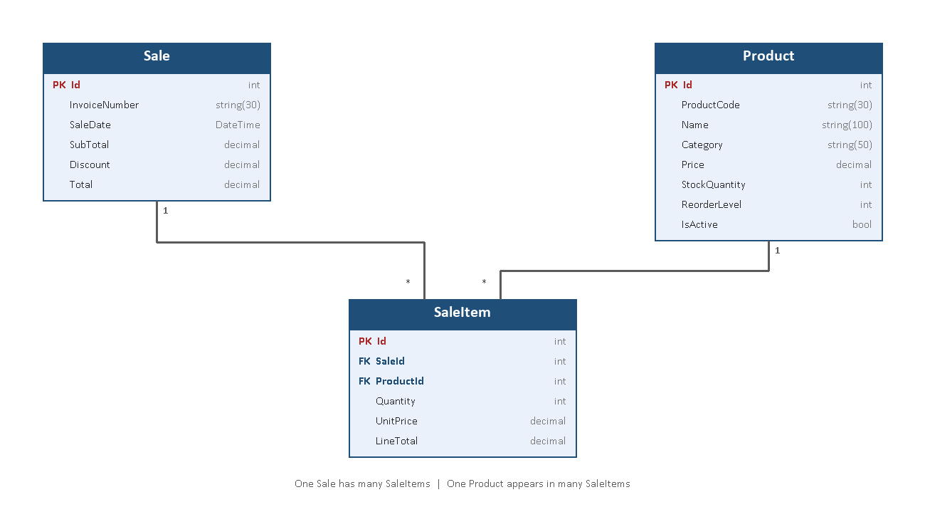

Why SaleItem Is Separated from Sale
SaleItem exists as its own table — rather than storing a sale's products as columns on Sale itself, or storing quantity/price directly against Product — for four reasons:
A sale can contain any number of products. Sale : SaleItem is a one-to-many relationship, and Product : SaleItem is also one-to-many — together they let one Sale reference any number of Products, and one Product appear on any number of Sales, without a fixed-width schema (e.g. Product1Id, Qty1, Product2Id, Qty2, …) that would cap how many items a sale can hold.
Historical prices must never change retroactively. UnitPrice and LineTotal are copied onto SaleItem at the moment of sale. If price lived only on Product, increasing a product's price next month would silently rewrite the revenue of every past sale that included it. Storing the price on the line item freezes history exactly as it happened.
Per-product reporting needs a queryable row per line. The Dashboard's Sales by Category, Top Selling Products, Sales Trend, and Stock vs. Sales aggregates all group and sum across SaleItem rows. That kind of reporting is only possible in SQL/LINQ when each product-within-a-sale is its own row — it cannot be done against a single flattened Sale row.
It keeps the schema normalized. Separating "what was sold" (SaleItem) from "the transaction it belongs to" (Sale) is the standard order-header / order-line pattern in relational database design — it avoids duplicating Sale-level fields (date, discount, total) once per product, and avoids the update anomalies that come with a denormalized table.
The database ships with realistic sample data for demonstration: 28 products across 7 categories (Groceries, Beverages, Dairy, Snacks, Household, Personal Care, Bakery), six of them deliberately at or below their reorder level, and 12 sales spanning today, yesterday, this week, and this month.

Application Screens

Dashboard
The landing screen. Four KPI cards (Sales for the selected period, Active Products, Low Stock, Best Selling Product) and five charts — Sales Trend, Sales by Category, Top Selling Products, a Sales Heatmap (day × hour), and Stock vs. Sales — all driven by a Date Range / Category / Product filter bar with a Reset and a manual Refresh. The whole layout fits one maximized screen with no scrolling.

Product Management
A searchable, filterable product list (by name/code/category, with "show inactive" and "low stock only" toggles) alongside an add/edit form. Deactivating a product hides it from sale without deleting its history.

Sales Processing
A point-of-sale style screen: search the active catalog, add items to a cart with a quantity, apply an optional flat discount, and complete the sale. Every line is re-validated against live stock at the moment of completion, not just when it was added to the cart.

Stock Management
There is no separate "stock" screen — stock is managed as part of Product Management (setting the initial/adjusted StockQuantity and ReorderLevel) and is then adjusted automatically:
- Completing a sale atomically decrements stock for every item in the cart (single database transaction — either the whole sale and every stock change save together, or none of them do).
- A product's ReorderLevel is what drives the Low Stock alert everywhere else in the app.

Transaction History
A read-only, most-recent-first list of completed sales, filterable by date range (with a one-click Reset back to the full list), with a receipt-style detail panel showing every line item of the selected sale.

Additional Feature — Low Stock Alert
Any active product with StockQuantity ≤ ReorderLevel is treated as low stock. This single rule (ValidationHelper.IsLowStock) surfaces consistently in three places: the Dashboard's "Low Stock" KPI, the Products screen's "Low stock only" filter, and the MiniMart Assistant's "show low stock products" answer — so the three views can never disagree with each other.

Additional Feature — MiniMart Assistant
A rule-based (non-AI) chat assistant (Services/AssistantQueryService.cs) that recognizes a small set of intents — stock lookups, sales totals, transaction history, and "go to Sales/Products/Transactions" — from typed natural-language input, and either answers directly or raises a navigation request that MainWindow acts on. It calls the same Services as the rest of the app, so its answers are always consistent with what the screens show.

Screenshots
The screenshots below all trace one real, connected scenario — selling three units of "Green Tea 250g" (starting stock 12, reorder level 10) — end to end: the sale reduces its stock to 9, which is at or below its reorder level, so it automatically appears in the Low Stock Alert immediately afterwards.

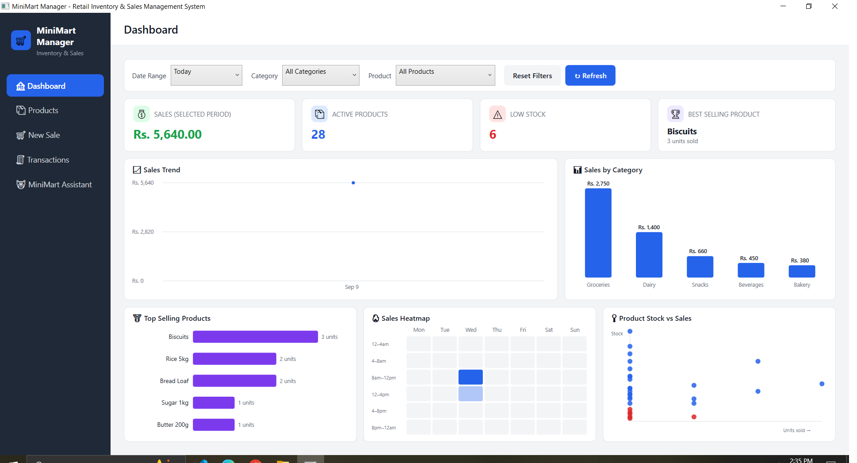
1. Dashboard — KPI cards and all five charts with live data

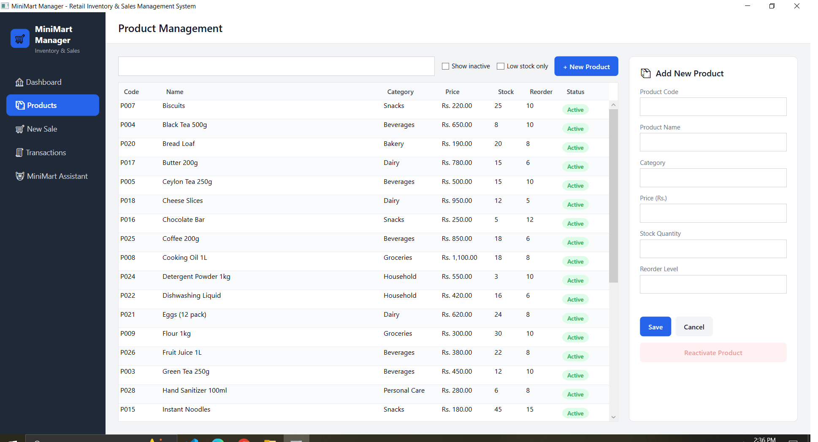
2. Product Management — searchable, filterable product catalog

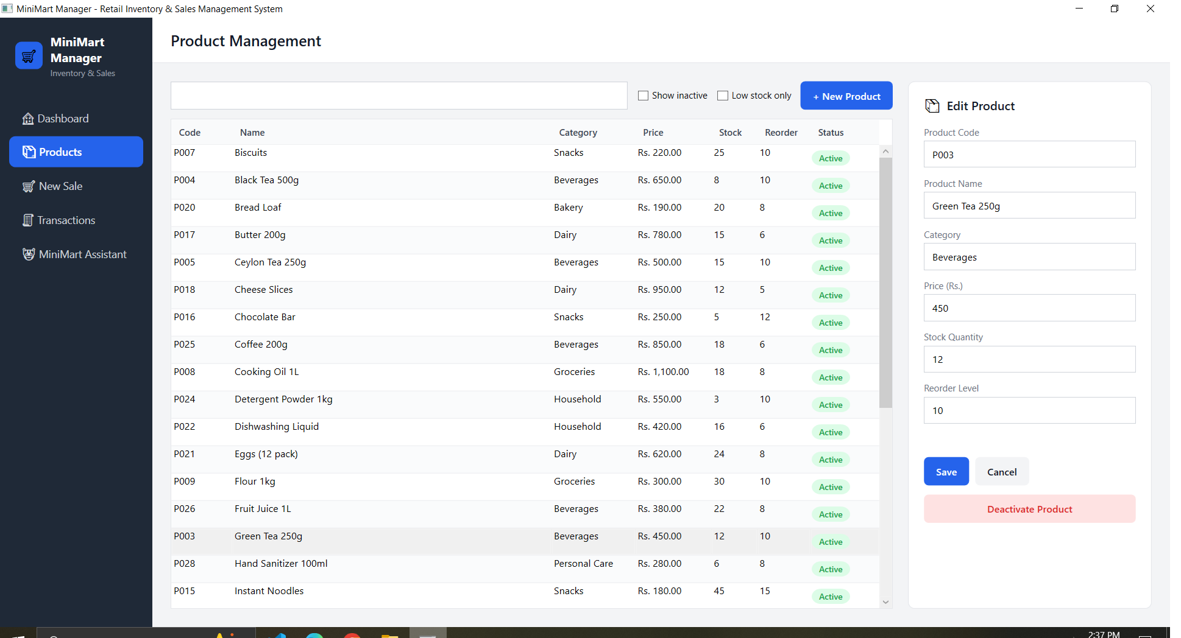
3. Add/Edit Product — editing "Green Tea 250g" (stock 12, reorder level 10)

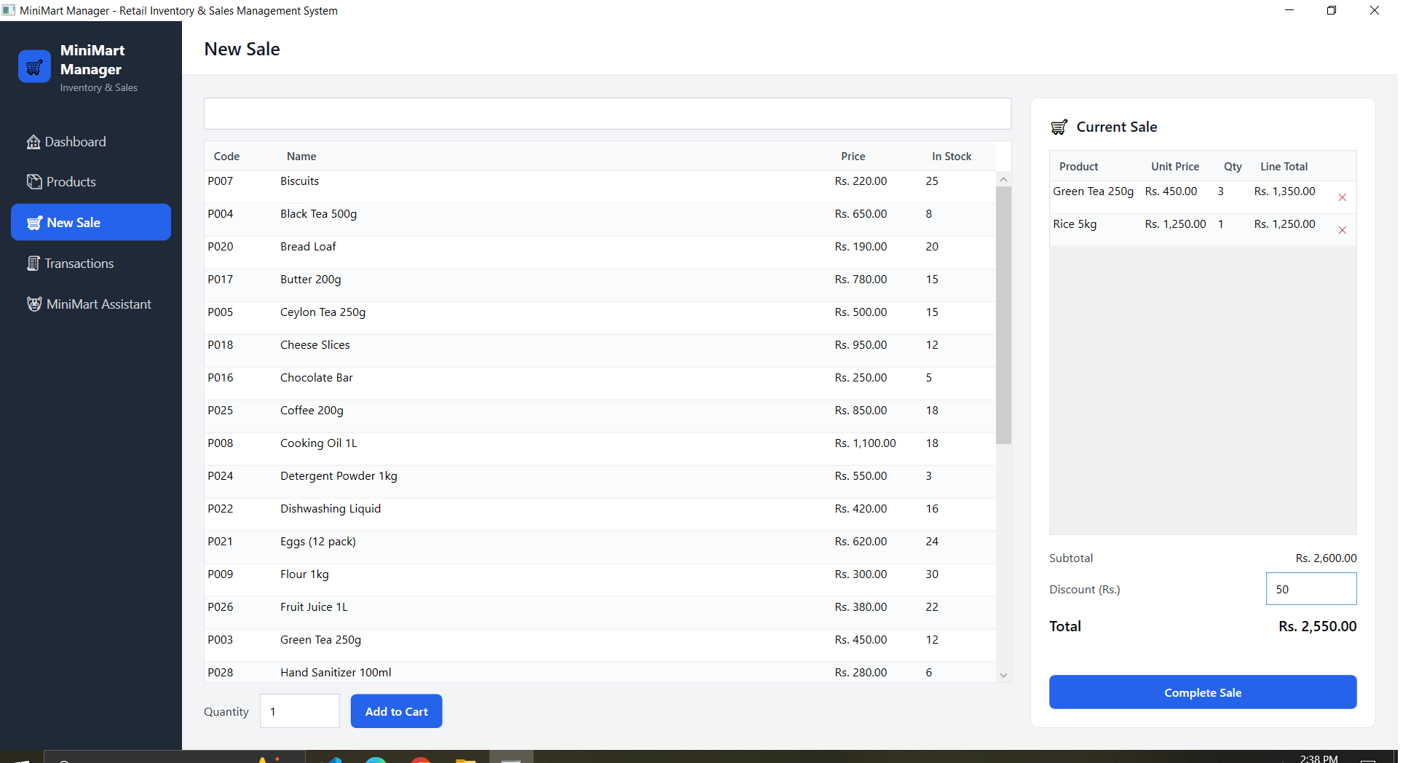
4. Sales Screen — cart with Green Tea 250g x3 and Rice 5kg x1, Rs. 50 discount applied

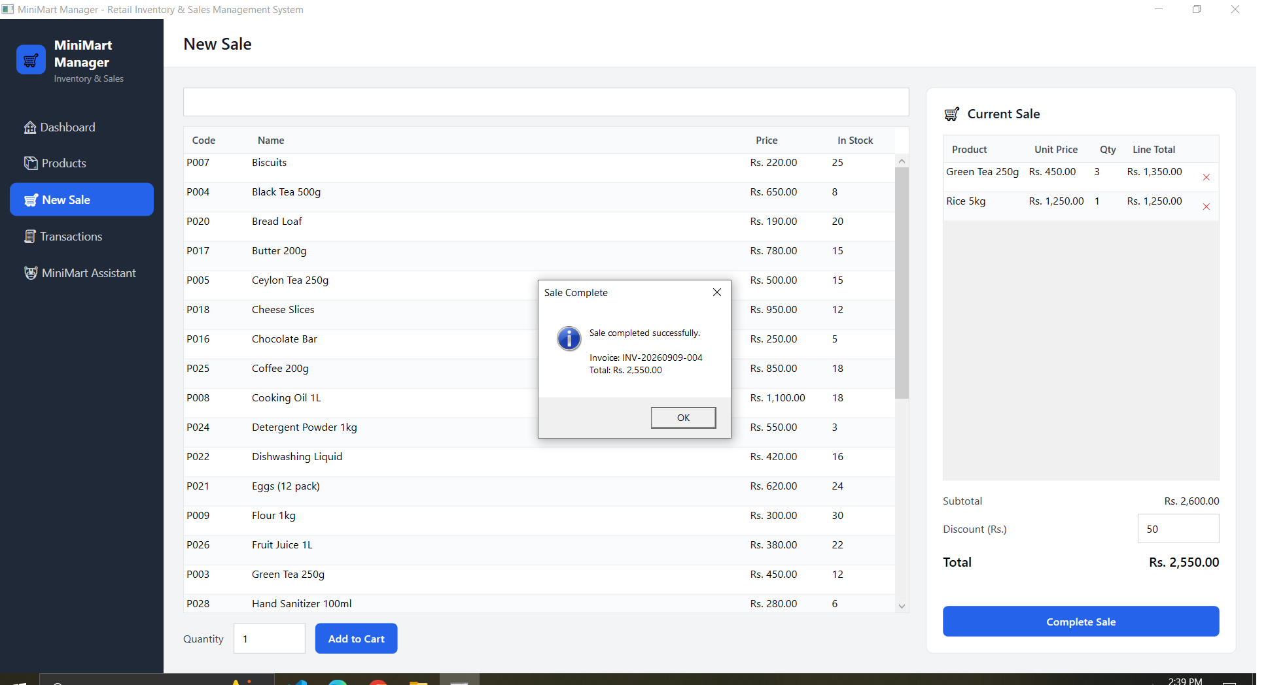
5. Completed Sale — confirmation dialog with invoice number and total

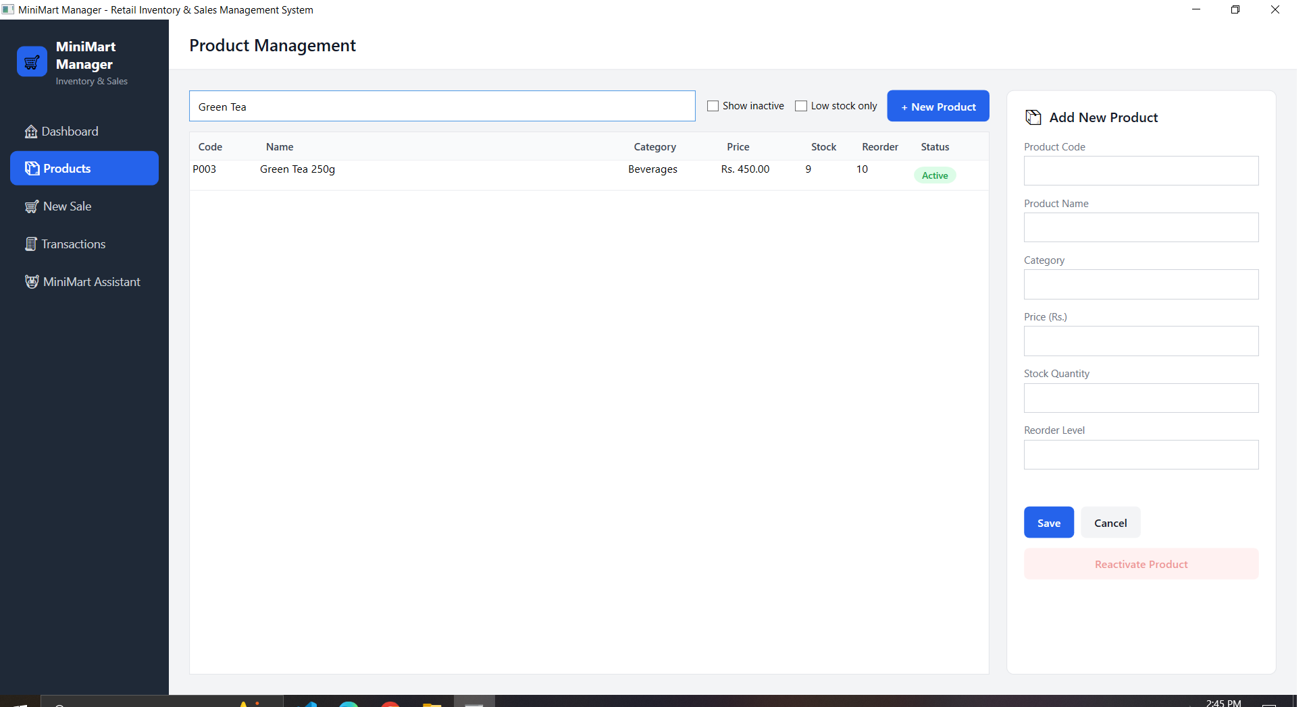
6. Stock Update — Green Tea 250g stock automatically reduced from 12 to 9

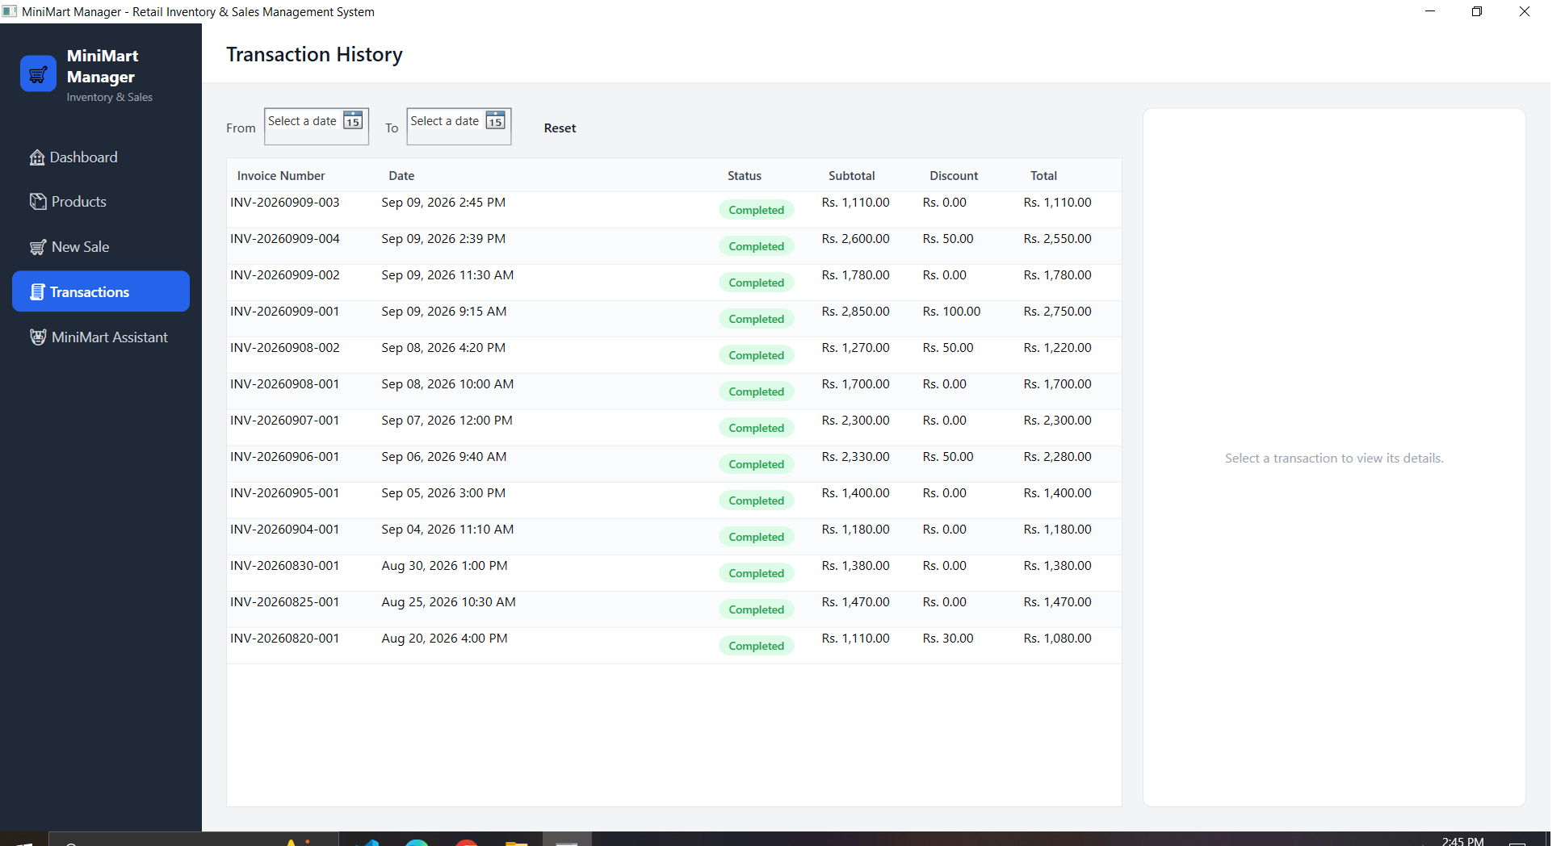
7. Transaction History — the new sale listed, most recent first

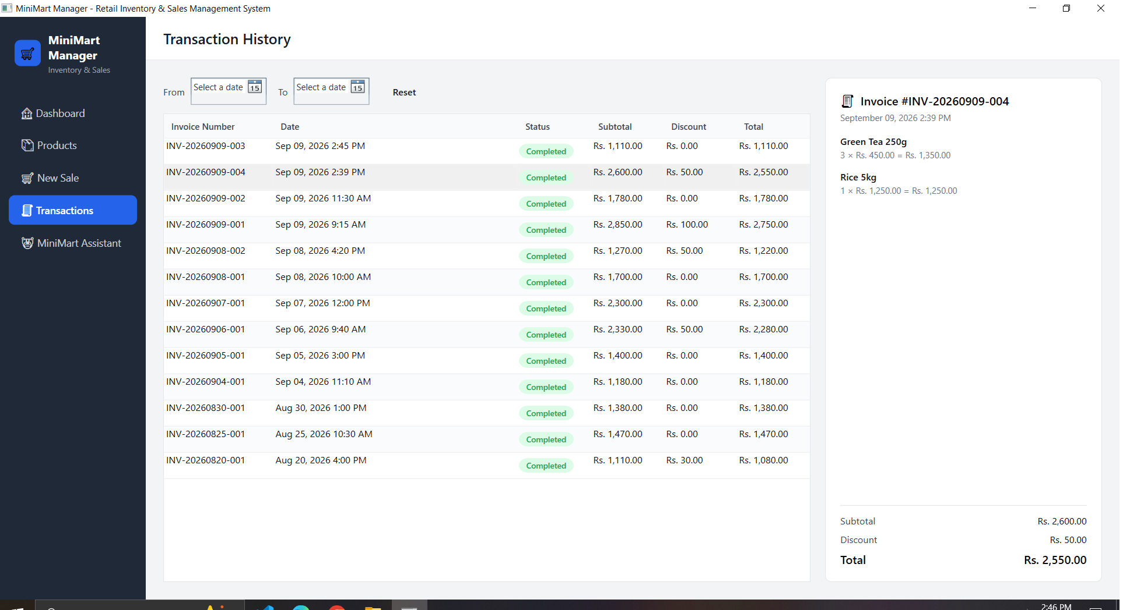
8. Transaction Details — line-item receipt for the new sale

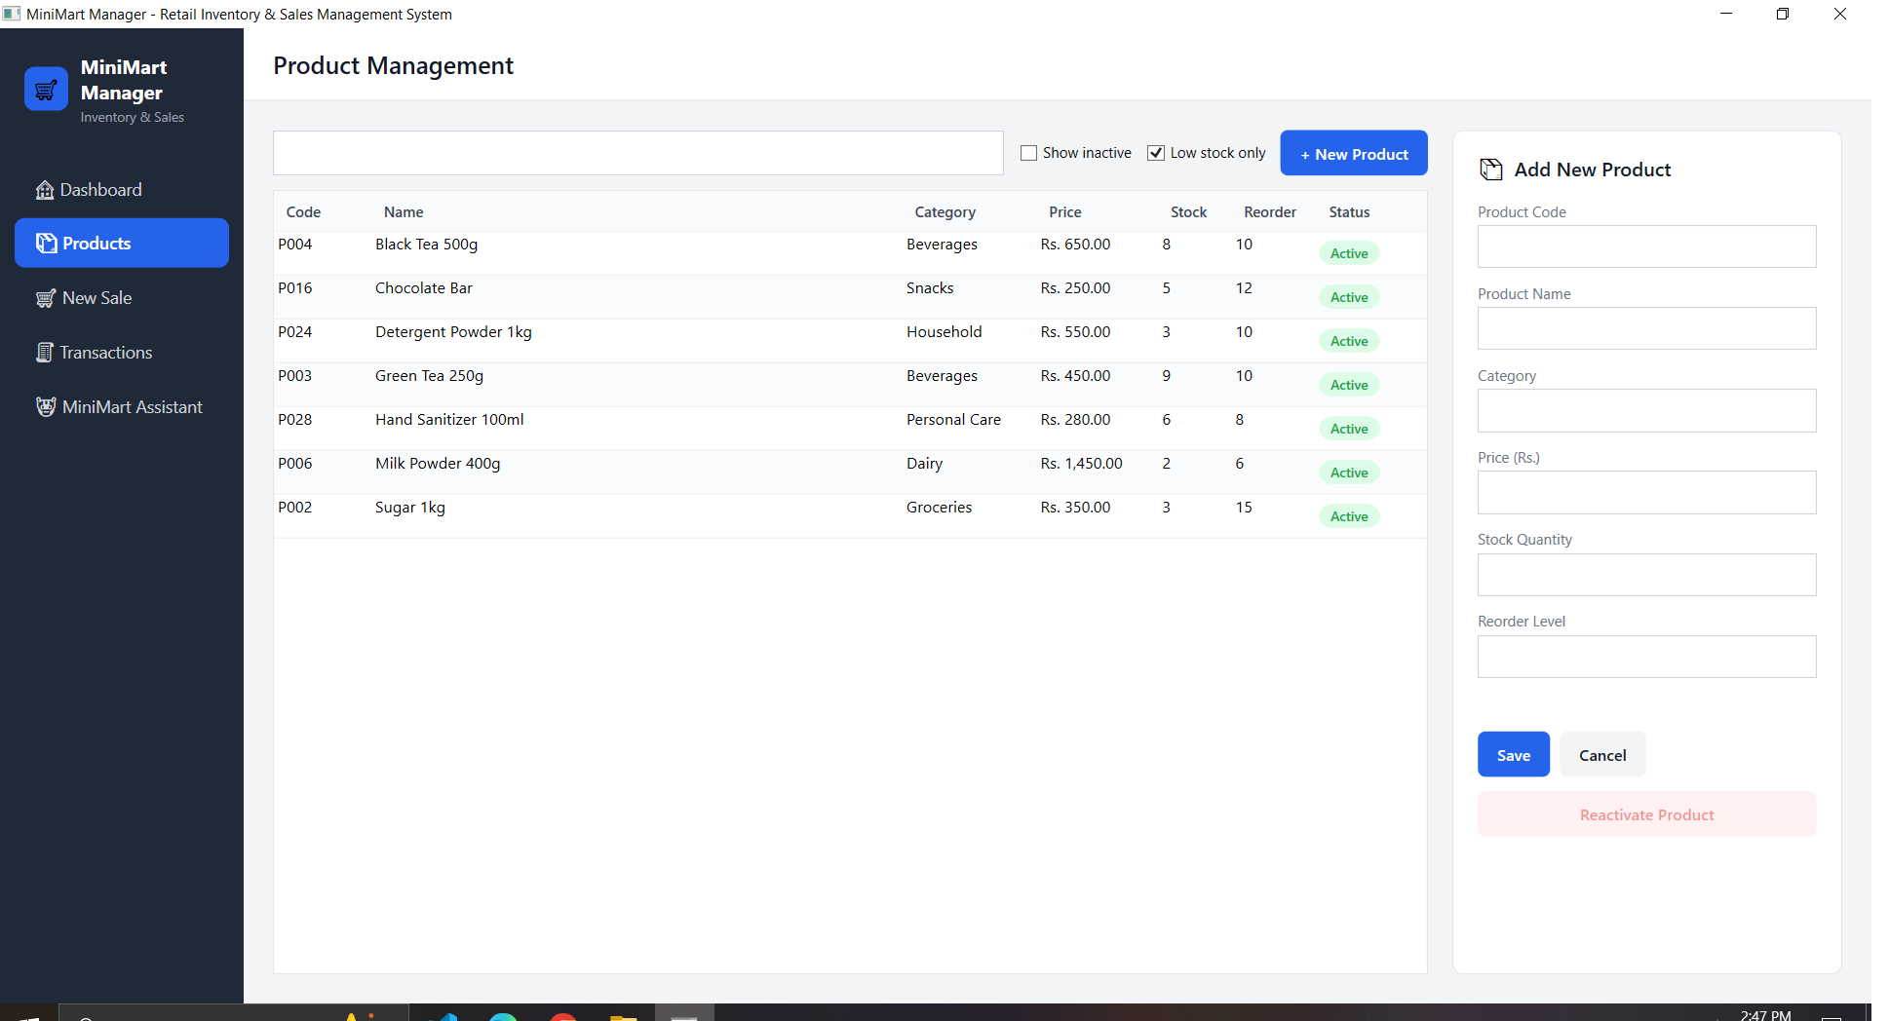
9. Low Stock Alert — Green Tea 250g now appears after crossing its reorder level

Validation and Error Handling

Product rules (Services/ProductService.cs)
- Product code and name are required; product code must be unique.
- Price must be greater than 0.
- Stock quantity and reorder level cannot be negative.

Sale rules (Services/SalesService.cs)
- A sale must contain at least one item.
- Every cart line is re-checked against the live database at completion time: the product must still exist and be active, and requested quantity must not exceed current stock.
- Discount must be between 0 and the cart subtotal.
- The sale, its line items, and every stock deduction are written in a single database transaction — a failure partway through rolls back everything, so stock is never left partially adjusted.

Error presentation
- Expected validation failures return a specific, plain-language message shown directly on the form (e.g., "Only 4 units of Sugar 1kg are currently available.").
- Unexpected failures (a locked file, a full disk, etc.) are caught, logged to retailflow-error.log next to the executable, and shown as a generic message — the raw exception is never surfaced to the user.
- A top-level DispatcherUnhandledException handler in App.xaml.cs catches anything that still escapes, logs it, and keeps the application running instead of crashing.

Setup and Installation
Prerequisites:
- Windows 10/11
- .NET 8 SDK
Steps:
- Clone or copy the repository.
- From the project folder, restore dependencies (see below).
- Build the project (see below).
dotnet restore
dotnet build
No database setup is required — retailflow.db is created automatically next to the executable on first launch, and seeded with sample data.

How to Run
From the project folder:
dotnet run
Or, after building, run the executable directly from bin/Debug/net8.0-windows/RetailFlow.exe. The application also opens directly from Visual Studio / Rider via Start (F5).
The window opens maximized by default. On first launch only, the app seeds itself with 28 sample products and 12 sample sales so every screen (including the Dashboard's charts and the Assistant) has real data to demonstrate immediately.

Assumptions
- Single user, single till, single location — there is no login/authentication, and no multi-user concurrency handling beyond what SQLite provides by default.
- All amounts are in a single currency (displayed as "Rs.").
- Discounts are entered as a flat amount per sale, not a percentage.
- The invoice numbering scheme (INV-YYYYMMDD-###, resetting daily) is adequate for a single-till setup.
- The user is trusted — there is no role-based restriction on any screen or action.

Limitations
- No authentication, authorization, or audit trail of who performed an action.
- No receipt printing or export (PDF/Excel/CSV) of any screen.
- No barcode scanner integration — products are looked up by typed search only.
- Invoice number generation is not safe under truly concurrent multi-till writes (acceptable for a single-user desktop app, not for a networked multi-till deployment).
- No automated test suite; correctness is verified through the manual scenarios in TESTING.md.
- Dashboard revenue figures allocate a sale's discount proportionally across its line items when a Category/Product filter is applied — an accurate approximation, not a stored per-line discount.

Future Improvements
- User accounts with role-based access (cashier vs. manager).
- Barcode scanner support for both product lookup and checkout.
- Receipt printing and export of transactions/reports (PDF/CSV).
- Percentage-based and item-level discounts and promotions.
- Supplier and purchase-order tracking to close the stock-replenishment loop.
- Automated unit/integration tests around the Services layer.
- Optional cloud/networked database for multi-till or multi-branch use.

Conclusion
MiniMart Manager delivers a complete, self-contained retail management workflow — product catalog, point-of-sale, automatic stock control, transaction history, and a live analytics dashboard — on a clean layered WPF/MVVM architecture with centralized business rules and no external dependencies beyond EF Core and SQLite. It is scoped deliberately for a single-store, single-user setting, with the limitations above marking the clearest next steps toward a larger deployment.

