19Z720 - PROJECT WORK - I

Causal Robustness in LLM guided Reinforcement Learning Agents

Anandkumar NS - (Roll No: 22z209)
Dhakkshin S R - (Roll No: 22z215)
Kishoreadhith V - (Roll No: 22z232)
M Raj Ragavender - (Roll No:22z233)
Rithvik K - (Roll No: 22z253)

Dissertation submitted in partial fulfillment of the requirements for the degree of

BACHELOR OF ENGINEERING

Branch: COMPUTER SCIENCE AND ENGINEERING
of Anna University



November 2025

DEPARTMENT OF COMPUTER SCIENCE AND ENGINEERING
PSG COLLEGE OF TECHNOLOGY
(Autonomous Institution)
COIMBATORE – 641 004

ACKNOWLEDGEMENT

We would like to thank the management of PSG College of Technology for providing us the infrastructure and helping us envision new ideas. We would also like to express our heartfelt gratitude to our Principal Dr.K.Prakasan for bestowing us with this valuable opportunity to work in our area of interest.

We also extend our sincere thanks to our Head of the Department Dr.G.Sudha Sadasivam, Department of Computer Science and Engineering for constantly supporting us to develop our ideas and present our project to the faculty committee as a part of our partial fulfilment of the requirements leading to the awarding of B.E. degree.

We take immense pleasure in thanking our project guide and programme co-ordinator, Dr. N.Arulanand, Professor, Department of Computer Science and Engineering, for being a pillar of support, without whose guidance, unparalleled cooperation and constructive criticisms, this project wouldn't have been fruitful. A sincere thanks to all the Panel Members for reviewing our project and all the Faculty Members and Staffs of the department for offering us the required support during the course of the project.

We express our thanks and gratitude to our tutor and faculty in-charge for the course 19Z720 – Project Work I, Ms. Anisha C.D, Assistant Professor Department of Computer Science and Engineering for help and encouragement in the duration of the course.

Finally, we would like to thank all our student colleagues and staff members in the Computer Science Department, without whom this dissertation work would not have been completed successfully.

PSG COLLEGE OF TECHNOLOGY
(Autonomous Institution)
COIMBATORE – 641 004

Causal Robustness in LLM guided Reinforcement Learning Agents

Bona fide record of work done by

Anandkumar NS - (Roll No: 22z209)
Dhakkshin S R - (Roll No: 22z215)
Kishoreadhith V - (Roll No: 22z232)
M Raj Ragavender - (Roll No:22z233)
Rithvik K - (Roll No: 22z253)

Dissertation submitted in partial fulfillment of the requirements for the degree of

BACHELOR OF ENGINEERING

Branch: COMPUTER SCIENCE AND ENGINEERING

of Anna University

November 2025

...……………………… …………..………………. Dr. N Arulanand Dr. G. Sudha Sadasivam
Faculty guide Head of the Department

Certified that the candidate was examined in the viva-voce examination held on ………………...

………………………….. ………………………….. (Internal Examiner) (External Examiner)

SYNOPSIS

Large language models (LLMs) have recently been explored as high-level planners for reinforcement learning (RL) agents in complex environments. This approach encounters issues when we take into consideration the fact that LLM-generated advice can be unreliable, particularly under corrupted or ambiguous conditions and state descriptions. This raises the question of safety concerns for the decision-making and other processes powered by the LLM generated advice. We aim to address this gap by proposing a lightweight safety framework that detects and tries to mitigate unsafe LLM guidance.
However, such integration raises serious questions of reliability, LLM- generated strategic advice has been shown to be vulnerable to error in processing corrupt or incomplete or ambiguous state data. These vulnerabilities beg fundamental questions about the safety and trustworthiness of decision-making relying on LLM guidance.
This research addresses these vital gaps with the introduction and experimentation of a lightweight safety framework to detect and counteract unreliable LLM recommendations. The project adopts the NetHack Learning Environment (NLE) as the testbed due to its rich combinatorial state space, partial observability, and long-horizon decision dependencies, which make it a challenging benchmark for evaluating robustness of LLM-guided agents.

This approach integrates rule based causal validators that capture critical survival dependencies (e.g. health, nutrition, enemy proximity), adversarial corruption tests that expose LLM failure models by perturbing the state description and the stakeholders ( for example, changing the name of a character or object to confuse the context), and a fallback ensemble policy that defers to baseline RL agent when the unsafe advice is detected.

This work contributes a practical methodology for trust calibration in LLM-guided RL and opens new directions for adversarial robustness in language-driven agents.

CONTENTS
CHAPTER Page No.
LIST OF FIGURES 43
LIST OF TABLES 44
LIST OF ABBREVIATIONS 45
LIST OF EQUATIONS 46
INTRODUCTION 7
1.1 Problem Statement 7
1.2 Scope of the Project 8
1.3 Objectives 9
LITERATURE SURVEY 11
2.1 Introduction 11
2.2 Theoretical Background 11
2.2.1 Introduction to LLM-guided RL 11
2.2.2 Research Objective and Scope 11
2.3 Current Methods of LLM and RL Integration 11
2.3.1 Architectural Approaches 11
Approach 1: Hierarchical Frameworks 11
Approach 2: Advisory / Hybrid Models 12
2.3.2 Information flow and Communication Channels 12
2.3.3 Training Paradigms and Action Space Handling 12
2.3.4 Benchmarks and Evaluation Environments 12
2.4 Technical Gaps 12
2.4.1 The Black Box Strategy Gap 12
2.4.2 The Blind Trust Gap 12
2.4.3 The Interpretability Gap 13
2.4.4 The Robustness Gap 13
2.5 Connections to AI Safety and Interpretability 13
2.6 Conclusion 13
SYSTEM REQUIREMENTS 15
3.1 Hardware Requirements 15
3.1.1 Processor (CPU): 15
3.1.2 Graphics Processing Unit (GPU): 15
3.1.3 Memory (RAM): 15
3.1.4 Storage: 15
3.1.5 Network Requirements: 16
3.2 Software Requirements 16
3.2.1 Operating System: 16
3.2.2 Programming Language: 16
3.2.3 Deep Learning Frameworks: 16
3.2.4 Reinforcement Learning Environment: 16
3.2.5 Large Language Model Infrastructure: 17
3.2.6 Causal Inference and Machine Learning: 17
SYSTEM DESIGN AND IMPLEMENTATION 18
4.1 PPO Based Reinforcement Learning Agent 18
4.1.1 Challenges to be accounted for and choice of algorithm 18
4.1.2 Neural Network Architecture 18
4.1.2.1 Multi-Modal Input Processing 18
4.1.2.1.1 Visual Processing(CNN + LSTM) 18
4.1.2.1.2 Statistical Processing (LSTM) 18
4.1.2.1.3 Textual Processing (Dense Network) 18
4.1.2.1.4 Inventory Processing (Dense Network) 19
4.1.2.1.5 Memory Processing (Dense Network) 19
4.1.2.2 Actor-Critic Architecture 19
4.1.2.2.1 Shared Feature Extraction 19
4.1.2.2.2 Actor Network (Policy) 19
4.1.2.2.3 Critic Network (Value Estimation) 19
4.1.2.3 Memory Architecture 19
4.1.2.3.1 LSTM Hidden States 19
4.1.2.3.2 Position History Buffer 19
4.1.2.3.3 Action History Buffer 19
4.2 LLM Guided Reinforcement Learning Agent 19
4.2.1. Semantic State Descriptors 19
4.2.2. LLM Advisor 21
4.2.3. Guidance Integration Layer 23
4.2.3.1 Mathematical Formulation 23
4.3 Adversarial Attacks On LLM Guided Reinforcement Learning Agents 24
4.3.1 Architectural Components and Design Principles 24
4.3.2 Attack Taxonomy 25
4.4 Causally Safe LLM Guided Reinforcement Learning Agent 27
4.4.1 Doubly Robust Estimators 28
RESULTS AND METRICS 29
5.1 Performance Of Base PPO Model 29
5.2 Performance Of LLM Guided Reinforcement Learning Agent 30
5.3 Performance Of LLM Guided RL Agent Under Adversarial Attack 32
5.4 Performance Of Causally Secure LLM Guided RL Agent Under Adversarial Attack 35
CONCLUSION AND FUTURE WORK 39
6.1 CONCLUSION 39
6.2 Future Work 41
BIBLIOGRAPHY 42

CHAPTER 1

INTRODUCTION

1.1 Problem Statement

In the current atmosphere of automation and artificial intelligence, Large Language Models (LLMs) have recently been explored as high-level planners for autonomous systems. This is mostly applied to the field of Reinforcement Learning (RL) agents in complex environments. This approach is an experimental technique in itself. But, this approach is accompanied with problems of its own. This is particularly important considering that LLM-generated advice can be unreliable, especially under corrupted, ambiguous, or otherwise erroneous state conditions.

This raises the question of safety concerns for the decision-making and other
processes powered by the LLM generated advice. This project aims to address this gap by proposing a lightweight safety framework that detects and tries to mitigate unsafe LLM guidance. This project adopts the NetHack Learning Environment (NLE) as the test-bed due to its rich combinatorial state space, partial observa-bility, and long-horizon decision dependencies, which make it a challenging benchmark for evaluating robustness of LLM-guided agents.

The central inquiry guiding this review examines the interpretability and robustness of LLM-guided Reinforcement Learning Agents against misinformation in complex sequential decision-making environments. This work explores this fundamental challenge and proposes valid solutions to address the issues encountered in current implementations. The research contributes a practical methodology for trust calibration in LLM-guided RL systems while establishing new directions for adversarial robustness in language-driven agents.
Contemporary research on LLM-guided reinforcement learning predominantly employs LLMs as planners or common-sense advisors, yet this approach leaves critical gaps unaddressed. Existing agents function as black boxes, mapping states to actions without developing an understanding of the underlying strategic mechanisms. This opacity fundamentally limits their capacity for generalization across varied scenarios and environments.

1.2 Scope of the Project
The project requires a three-part construction of different types of agents for clear benchmarking and analysis. A clear analysis requires a base RL agent, the LLM guided agent and the causally robust LLM guided agent.
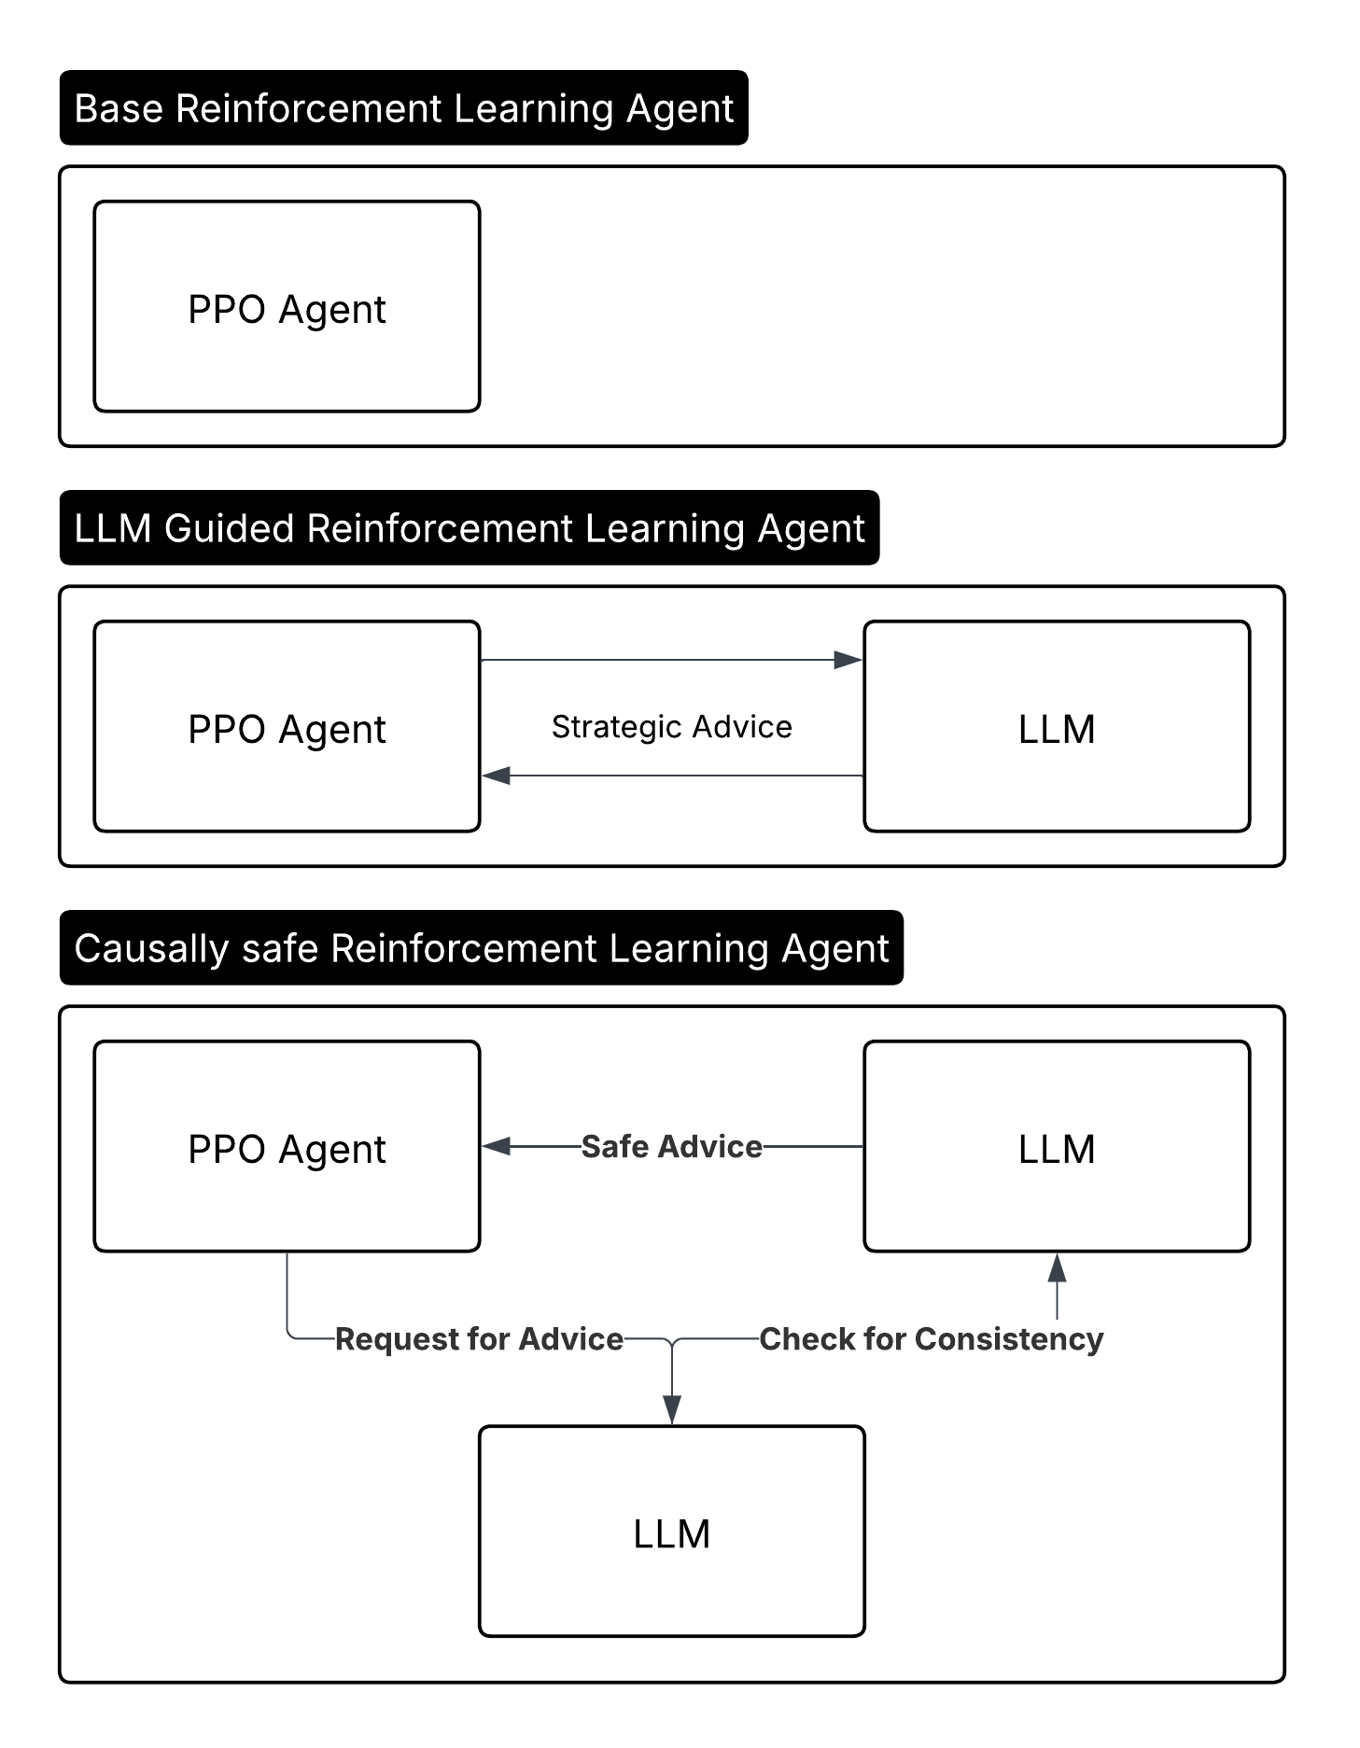
Figure 1.1: Project Component Breakdown

The base RL agent establishes the performance baseline using standard Proximal Policy Optimization (PPO). This gives us a reference point for comparison and helps us understand what pure reinforcement learning can achieve without any linguistic guidance. Meanwhile, the LLM-guided agent introduces strategic advice from a language model, showing us the potential benefits of incorporating high-level reasoning into the decision-making process. Finally, the causally safe RL agent adds a consistency checking mechanism that scrutinizes LLM advice before it influences agent behavior. These components are visualized in Figure 1.1.

The work specifically focuses on environments where partial observability and long-term planning create significant challenges. The NetHack Learning Environment provides exactly these conditions, making it an ideal testbed for the experiments. Simpler environments are deliberately avoided, as they do not reveal the complex failure modes targeted in this project.

1.3 Objectives
The primary objective of this research is to develop and validate a safety framework that makes LLM-guided reinforcement learning more reliable and interpretable. This breaks down into several concrete goals that guide the implementation and evaluation.
First, clear performance baselines across different agent architectures are established. This means training a standard PPO agent until it reaches a stable performance level, then comparing how LLM guidance affects learning speed and final capability. The objective is not only to determine whether language-model assistance provides improvements, but also to identify when, where, and why such improvements occur.
Second, specific failure modes in LLM-guided reinforcement learning are analyzed. Language models sometimes give advice that sounds plausible but leads to catastrophic outcomes. To study this behaviour, state information is systematically corrupted, and agent responses are examined. Through this controlled perturbation process, common error types are cataloged and their underlying causes are investigated.
Third, it must be demonstrated that the proposed consistency-checking approach prevents such failures without causing significant performance degradation. This requires careful experimental design to separate the effects of safety mechanisms from other factors that might influence agent behavior.
The NetHack Learning Environment provides exactly these conditions, making it an ideal testbed for the experiments. Simpler environments are deliberately avoided, as they would fail to reveal the complex failure modes targeted in this study.

CHAPTER 2

LITERATURE SURVEY

2.1 Introduction
This literature survey studies the progress made in LLM guided RL systems and gaps in the current implementations. The emerging trend is to use the LLM as advisors or planners in Reinforcement Learning agents complex environments. While this approach improves the performance of the RL agent, it introduces certain safety concerns in the form corrupted state information, unsafe guidance and the blackbox nature of LLMs. Most studies use the LLM as a planner and blindly trust the advice given without taking into account that the state description used by the LLM could be incomplete or corrupted. Current studies don’t perform testing against adversarial or misleading inputs. Hence the current state of LLM guided RL agents have certain limitations that pose a risk in terms of reliability and trustworthiness.

2.2 Theoretical Background

2.2.1 Introduction to LLM-guided RL
Reinforcement Learning(RL), a learning paradigm that uses a trial-and-error approach, has traditionally been applied to learning environments with complex state-action spaces like robotics, games, and autonomous control. The intersection of Reinforcement Learning(RL) and Large-Language Models(LLMs) is an interesting research field to researchers as it allows leveraging the rich semantic context embedded into an LLM to improve the RL process.
Traditionally, RL has some challenges related to sample inefficiency, exploration complexity, and interpretability, to which LLM integration promises a solution due to an LLM’s inherent rich world knowledge and hierarchical structure and also introduces interpretability to the decision-making process. But, it is not without its own concerns like grounding the LLM to the environment, and maintaining robustness in scenarios where the LLM knowledge is imperfect.

2.2.2 Research Objective and Scope
The review focuses on the intersection of LLMs and RL, specifically strategic guidance, causal reasoning, and robustness in complex sequential decision-making environments. The scope is limited to high-stakes and intricate game-like environments, namely NetHack and Minecraft which have become standard benchmarks for RL agents because of their rich state-action representation, need for long term planning and partial observability of the world. LLMs are being used in robotics for perception, planning, control and interactive reasoning [1].

2.3 Current Methods of LLM and RL Integration

2.3.1 Architectural Approaches
The integration of LLM and RL paradigms have been explored mainly through two major approaches:

Approach 1: Hierarchical Frameworks
This approaches places the LLM and the RL at two levels, ie. the LLM at a higher level of abstraction responsible for strategic advice, generating policies and sub-goals; while the RL agents handle the lower level control of actions and rewards.
An example for this approach would be RL-GPT with its “slow-agent” and “fast-agent” [2].

Approach 2: Advisory / Hybrid Models
Here, LLMs provide consultative advice as natural language text, policy priors or action suggestions.
This approach has been adapted by quite a few research studies like:
- GLAM: RL grounds the advice from a dynamically updated online LLM advisor [3].
- SayCan: A separate model tests the feasibility of an action(“Can”) suggested by the LLM(“Say”) [4].
- Code-as-Policies: LLMs generate hierarchical code following API-driven policies [5].
- Voyager: A Minecraft agent that has an LLM for continual planning and task decomposition while an RL agent handles the exploration and low-level actions [6].

2.3.2 Information flow and Communication Channels
The most common method of information flow is the state-to-language transformation paradigm where the world state is translated into natural language or symbolic representation and this rich semantic context allows the LLM to perceive the state of the world. One such example for this paradigm is the NetHack Learning Environment language wrapper [3]. The thinker framework has the LLM do the language processing while an external thinker module does the complex logical reasoning [7]. Inner monologue is an approach where environmental feedback is incorporated into the LLM’s generative planning loop [8].

2.3.3 Training Paradigms and Action Space Handling
Training LLM guided RL systems can be done using a few paradigms, the most successful of them being finetuning, reinforcement learning with human feedback [9], and prompt based techniques like one-shot or few-shot tuning. One of the requirements in handling action spaces is the ability to handle discrete, continuous and hybrid states and actions. Hierarchical models like Imitation Hierarchical Actor-Critic use the LLM to handle high level planning and RL for the low level actions [2].

2.3.4 Benchmarks and Evaluation Environments
Choosing the benchmarking and evaluation environment is critical for the training of the system. NetHack Learning Environment(NLE) has evolved as one of the prominent environments for such RL tasks [10]. Open environments like Minecraft are a good test for the system’s long term planning and exploration capabilities [6]. Looking at smaller environments, BabyAI focuses on sample efficiency for language-conditioned tasks [11], while AlfWorld combines language instructions with embodied reasoning for tasks like household environments [12]. CALVIN extends this to robotic manipulation.

2.4 Technical Gaps

2.4.1 The Black Box Strategy Gap
The current studies indicate that the current systems lack a deeper understanding of the game’s logic. It learns what works but not why it works. This results in poor generalisation and the agent’s failure when presented with a slightly different scenario.

2.4.2 The Blind Trust Gap
The LLM advice is always assumed to be correct and blindly trusted by the RL agent. This is a critical flaw since the LLM advice can be incorrect if the state description sent to the LLM is even slightly wrong or corrupted. Current systems are unreliable since they have no means to evaluate the trustworthiness of the LLM advice.

2.4.3 The Interpretability Gap
It is extremely difficult to understand why the agent chose a specific decision. Debugging the reasoning behind its logic is an impossible task. This lack of interpretability makes it very difficult to understand the failures and make improvements.

2.4.4 The Robustness Gap
There are no studies that have tested the performance of these agents under adversarial conditions where the LLM advice is intentionally modified to mislead the agent. Any AI agent that can not handle unexpected or incorrect information is useless in real world situations.

The “Concrete Problems in AI Safety” framework identifies five practical risks, including reward hacking, unsafe exploration, side effects, scalable oversight, and robustness to distributional shift, that are directly relevant to the Blind Trust and Robustness gaps in the context [14].

2.5 Connections to AI Safety and Interpretability
The technical gaps identified above are agreed upon by other studies in the broader AI landscape. Specifically, highlight reward misspecification, unsafe exploration, and robustness to distributional shift as central safety problems for RL systems which in turn manifests into RL+LLM systems as well [14]. Misalignment with human oversight and socio-technical contexts have also been identified as cause for failure of these systems [15].
Recent studies have been exploring interpretability through Explainable AI. Although traditionally intended only for supervised settings, recent work has been made in extending causal explainability to LLM guided systems. This provides a foundation for diagnosing when an agent’s reasoning diverges from expected causal structures [16].
Safe exploration, off-policy evaluation, and adversarial training has been researched in RL as strategies to constrain agent behavior under uncertainty. Since LLMs can amplify the risks of RL systems as well as its strengths, it is crucial to develop LLM guided RL with safety, interpretability and trustworthiness as core principles [17].

2.6 Conclusion
This literature survey confirms that while integrating Large Language Models as advisors for Reinforcement Learning agents can improve performance, it introduces significant, unaddressed safety concerns. The field currently suffers from several critical vulnerabilities. The "Blind Trust Gap" is paramount: agents are designed to uncritically accept LLM advice, even when the underlying state information given to the LLM is incomplete or corrupted. This issue is exacerbated by the "Robustness Gap" ; current research lacks rigorous evaluation of these agents under adversarial conditions or when presented with deceptive information. Concurrently, the "Black Box Strategy" and "Interpretability" gaps highlight a critical flaw: agents may identify successful strategies without comprehending the causal logic behind them. This opacity makes diagnosing failures nearly impossible and severely undermines the trustworthiness of the agent's reasoning.

This research directly confronts these risks. The objective is to develop and validate a safety framework that mitigates unsafe LLM guidance. First, a taxonomy of adversarial attacks targeting the semantic state description is developed to quantify these vulnerabilities. Following this, a "Causally Safe" agent is implemented and evaluated. This agent utilizes a Doubly Robust Causal Filter to estimate the causal effect of the LLM's advice before it is used, allowing the agent to reject harmful guidance and learn "when to not trust the oracle".

CHAPTER 3

SYSTEM REQUIREMENTS

3.1 Hardware Requirements

3.1.1 Processor (CPU):

Model: Intel Core i7 (11th Gen or higher) or AMD Ryzen 7 5800X
Cores/Threads: Minimum 8 cores / 16 threads
Clock Speed: 3.2 GHz base, 4.5 GHz boost or higher
Justification: Multi-threaded PPO training requires substantial CPU resources for environment simulation, parallel episode rollouts, and asynchronous LLM API calls

3.1.2 Graphics Processing Unit (GPU):

Model: NVIDIA RTX 3070 (8GB VRAM) or higher
CUDA Cores: Minimum 5888 cores
Memory: 8 GB GDDR6 or higher
CUDA Compatibility: Version 11.0 or higher
Tensor Cores: Required for efficient neural network training
Justification: Policy network training, value function approximation, and recurrent CNN encoders demand accelerated tensor operations. NetHack's visual glyph processing benefits significantly from GPU-accelerated convolutions

3.1.3 Memory (RAM):

Capacity: Minimum 32 GB
Type: DDR4-3200MHz or DDR5
Justification: Simultaneous execution of RL training loops, experience buffer storage (10,000+ transitions), LLM context management, and causal model training requires substantial memory headroom

3.1.4 Storage:

Primary Storage: 1 TB NVMe SSD (PCIe 3.0 or higher)
Secondary Storage: 2 TB HDD (7200 RPM)
Justification: Fast read/write operations essential for checkpoint saving, episode logging, adversarial attack data collection, and training trajectory storage. NetHack episode data accumulates rapidly during extended training runs

3.1.5 Network Requirements:

Internet Connection: Stable broadband (minimum 10 Mbps)
Justification: Local LLM hosting via Ollama requires model downloads (4-8 GB per model). Alternative cloud-based LLM APIs necessitate low-latency connections for real-time strategic advice generation

3.2 Software Requirements

3.2.1 Operating System:

Primary: Ubuntu 20.04 LTS or 22.04 LTS (Linux)
Alternative: Windows 10/11 with WSL2 enabled
Justification: NetHack Learning Environment exhibits optimal performance on Unix-based systems. CUDA toolkit integration functions more reliably on Linux distributions

3.2.2 Programming Language:

Python 3.8 or higher is employed throughout the project for its extensive ecosystem supporting deep reinforcement learning, natural language processing, and scientific computing. The language's flexibility facilitates rapid prototyping of causal inference mechanisms and adversarial attack frameworks

3.2.3 Deep Learning Frameworks:

PyTorch 1.12+: Core framework for implementing PPO agents, recurrent CNN architectures, and policy gradient algorithms
TorchRL / Stable-Baselines3: Standardized RL implementations providing baseline PPO algorithms
CUDA Toolkit 11.7+: GPU acceleration for neural network training
cuDNN 8.5+: Optimized primitives for deep neural network operations

3.2.4 Reinforcement Learning Environment:

NetHack Learning Environment (NLE) 0.9.0+: Official Python bindings for NetHack providing standardized observation spaces, action interfaces, and reward structures
Gym/Gymnasium 0.26+: Environment wrapper providing consistent API for RL training loops
Custom NetHackSemanticDescriptor: Project-specific module translating glyph mappings and game statistics into natural language state descriptions

3.2.5 Large Language Model Infrastructure:

Ollama: Local LLM hosting framework supporting models including Llama 2, Mistral, and Gemma variants
Transformers (HuggingFace) 4.30+: Alternative LLM integration supporting cloud-based models
LangChain 0.0.200+: Framework for constructing structured prompts and managing LLM conversation contexts
aiohttp / httpx: Asynchronous HTTP clients for non-blocking LLM API calls

3.2.6 Causal Inference and Machine Learning:

scikit-learn 1.2+: Random Forest implementations for propensity score models and outcome regression
DoWhy 0.9+: Causal inference library providing doubly robust estimators and treatment effect calculation
EconML: Alternative causal ML library supporting heterogeneous treatment effects
statsmodels: Statistical modeling for causal effect validation

CHAPTER 4

SYSTEM DESIGN AND IMPLEMENTATION

4.1 PPO Based Reinforcement Learning Agent

4.1.1 Challenges to be accounted for and choice of algorithm
The main challenges with respect to the NLE to be accounted for when choosing the algorithm for RL are:
- Partial Observability: Due to the limited field of view, maintaining memory is a necessity to make good decisions
- Sparse Rewards: The rewards from the base NLE is very sparse and infrequent considering the long episode lengths
- High Dimensionality: The state space is complex and multimodal with visual, textual, and numerical components
- Long Horizons: Episodes can extend to thousands of steps, which makes Long Short-Term Memory a very welcome addition to the design
The Proximal Policy Optimization (PPO) algorithm is chosen here mainly due to its sample efficiency, stability, exploration-exploitation balance and memory integration. It handles continuous probability distributions for exploration better than Deep Q-Networks

4.1.2 Neural Network Architecture

4.1.2.1 Multi-Modal Input Processing
The state of the world is observed through multi-modal inputs

4.1.2.1.1 Visual Processing(CNN + LSTM)
The glyph is a visual representation of the game map in the form of ASCII characters. This processing involves Convolutional Neural Networks and Long Short-Term Memory. A 3-layer hierarchy (32→64→128 filters) is used for spatial pattern recognition with a kernel size of 3×3 with padding for spatial consistency and max pooling for translation invariance. A 256-unit hidden state is used for temporal visual memory to remember room layouts, hostile entities and items.

4.1.2.1.2 Statistical Processing (LSTM)
Attributes like Health, experience, hunger change over time and it is essential to learn patterns from them in order to manage health and resources optimally. This project uses a 64-unit hidden state which has proved to be sufficient for numerical sequence modeling.

4.1.2.1.3 Textual Processing (Dense Network)
NLE provides textual feedback to the player called messages, and these contain critical combat and environment information. Since the text has already been processed, only pattern matching is required.

4.1.2.1.4 Inventory Processing (Dense Network)
Processing the inventory of the player is essential for efficient gameplay and planning. The inventory is represented using binary encoding to denote the presence/ absence of items.

4.1.2.1.5 Memory Processing (Dense Network)
The last 50 actions performed by the player are normalized by action space size. This is done to avoid getting the player stuck in repeated loops of actions.

4.1.2.2 Actor-Critic Architecture
The system consists of two heads, namely the actor and critic heads which work together.

4.1.2.2.1 Shared Feature Extraction
The above mentioned input modalities are processed, and the resultant 544D vector is reduced to 256D using a feature fusion, and this

4.1.2.2.2 Actor Network (Policy)
The actor takes in the world states and produces probability of actions to follow. The neural network has ~2.1M parameters. The actor is trained to prefer exploration over exploitation.

4.1.2.2.3 Critic Network (Value Estimation)
The critic takes in the world state and estimates the best value or reward that can be possibly attained from the current state. The neural network has ~2.1M parameters similar to the actor network.

4.1.2.3 Memory Architecture

4.1.2.3.1 LSTM Hidden States
A Visual Memory of 256-unit states are used for maintaining spatial-temporal patterns and a Statistical Memory of 64-unit states for character progression tracking. This memory is persistent across episode steps, reset between episodes.

4.1.2.3.2 Position History Buffer
A circular buffer is used to store the 100 most recent positions in order to implement anti-stuck mechanisms; it also measures spatial coverage efficiency to promote exploration.

4.1.2.3.3 Action History Buffer
The most recent 50-step action sequence is stored and used to identify stuck or repetitive behaviours.

4.2 LLM Guided Reinforcement Learning Agent

4.2.1. Semantic State Descriptors
The challenge is that LLMs cannot be used as guidance tools and strategic advisors in many situations as they require rich semantic context to have meaningful impact on the outcome. This semantic context cannot be delivered by the traditional vector based environments as they cannot provide any context to an outside advisor.

Another advantage of using an environment such as NetHack is that semantic descriptions can be extracted through the NetHack Learning Environment ( NLE). This enables the use of an LLM for guidance, as the environment’s state and available action choices can be provided as input, allowing useful advice to be generated.

The project incorporates a custom built environment state descriptor referred to as “NetHackSemanticDescriptor” within the system. “Glyph mappings” are utilized:

GLYPH_TO_SYMBOL = {
# Terrain
2359: "wall", 2360: "door", 2361: "floor",
2364: "stairs_down", 2365: "stairs_up",
# Monsters (simplified)
2378: "kobold", 2379: "goblin", 2380: "orc",
2381: "troll", 2382: "dragon",
# Items
2395: "gold", 2396: "weapon", 2397: "armor",
2398: "food", 2399: "potion", 2400: "scroll" }

These glyph mappings serve as a way for us to interpret and pass information about the surroundings.

The same method exists for extracting player statistics also, within NetHack Learning Environment this ledger of player stats is referred to as “blstats”. All this data is collated in the system into a singular NetHack Game State message.

NETHACK GAME STATE:
Status: Level 3, Health: 28/45 (low), XP: 234, Depth: 4, Gold: 87
Surroundings: CLOSEST THREAT: orc south (dist:1); Other threats: kobold west (dist:3)
Recent Message: You are hit by the orc!
Inventory: Carrying 7 items (moderate load)
Recent Actions: move_south → kick → move_south → wait
STRATEGIC ANALYSIS:
Based on game state, choose ONE primary strategy:
1. "explore" - No immediate threats
2. "combat" - Monster nearby AND health good (>60%)
3. "retreat" - Monster nearby BUT health low (<40%)
4. "collect" - Items nearby and safe
5. "wait" - Critical health or need recovery
Your strategic choice:

This semantic is attached to the prompt which is sent to the advisor (LLM).

4.2.2. LLM Advisor
The LLM Advisor acts as a strategic reasoning layer between the NetHack Environment and the default Proximal Policy Optimisation model. It allows us to determine when to query the LLM based on the performance indicators such as average reward and survival length . When the LLM layer is triggered, the module constructs the semantic description mentioned above and sends it to the locally hosted LLM. In the system, the Ollama API is utilized to interface with the LLM through the “http://localhost:11434/api” endpoint.

The LLM interprets the state semantically and outputs one of the five high-level strategies:
- Combat
- Explore
- Retreat
- Collect
- Wait

This is taken based on contextual game clues like nearby threats, health levels and nearby items. This data is then translated into actionable hints by mapping the advice into a valid set of 23 actions that have been specified.

By integrating semantic understanding and probabilistic control, the advisor combines human-like reasoning with reinforcement learning behavior, improving adaptability in complex, partially observable environments like NetHack.

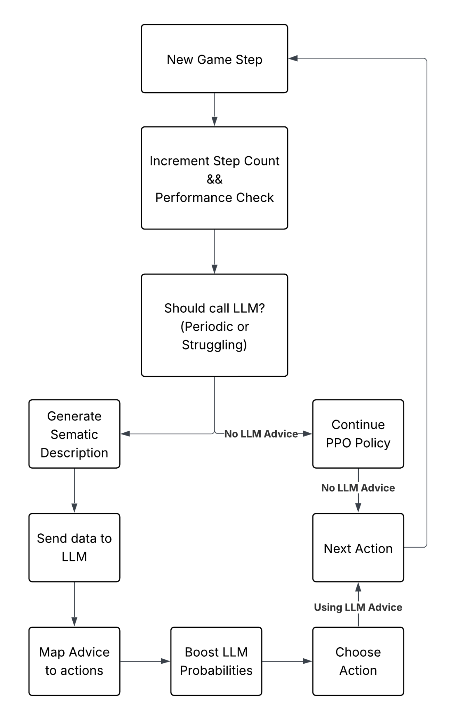
Figure 4.2.2.1 : LLM Advisor Data Flow

The above flowchart (Figure 4.2.2.1) depicts how the data is passed within the LLM Advisor and how it can take the decision to pass to the LLM and how that data is handled.

The central part of this LLM Advisor is the carefully calibrated prompt passed to the LLM which is responsible to provide the required context within the prompt to allow the LLM to provide meaningful responses.

The prompt is as follows:

prompt = f"""You are an expert NetHack strategic advisor. {description}
RECENT PERFORMANCE: -
Average Reward: {performance['avg_reward']:.2f} -
Average Survival: {performance['avg_length']:.0f} steps

STRATEGIC ANALYSIS:
Based on the game state above, choose ONE primary strategy:

1. "explore" - No immediate threats, safe to move and search
2. "combat" - Monster nearby AND health good (>60%)
3. "retreat" - Monster nearby BUT health low (<40%)
4. "collect" - Items nearby and safe
5. "wait" - Critical health or need recovery

CRITICAL RULES:
- If threat distance 1-2 AND health <40%: Choose "retreat"
- If threat distance 1-2 AND health >60%: Choose "combat"
- If NO IMMEDIATE THREATS: Choose "explore" or "collect"
- If health critical: Choose "wait" or "retreat"

Respond with ONLY ONE WORD: explore, combat, retreat, collect, wait

Your strategic choice:"""

This prompt allows us to provide the required context to the LLM and extract the advice.

A few key design choices that were implemented in this module were arrived upon through extensive trial and error.

- Sparse LLM Calling: Every 50 steps (automatically or when struggling) which represents about ~5% of the recorded timestamps to minimize the overload of querying the LLM
- Structured Prompts: This allows us to provide clear prompts and decision rules to the LLM. Even if a LLM without knowledge of the NetHack Environment is picked, it can respond purely on the basis of the prompt’s context.
- Low Temperature for the LLM: 0.2 for consistent and deterministic strategy decisions.
- Soft Hints: A 20% probability boost is added to the LLM advice, it avoids the use of hard constraints on the choice of actions.
- Async API: It employs non-blocking LLM calls which avoids blocking the system.

4.2.3. Guidance Integration Layer

Within the system, the guidance integration layer is referred to as and used as the “LLMEnhancedPPOActor”. It extends the traditional reinforcement learning policy by integrating the LLMAdvisor into the decision-making process. It works by extending the Proximal Policy Optimisation actor architecture used for the NetHack environment, combining the multi-sensory input which is made of glyphs and stats to produce action logits.
The base model is composed of multiple specialized encoders:
- Glyph Encoder (RecurrentNetHackCNN): Extracts spatial and temporal features from the dungeon layout.
- Statistical LSTM (stats_lstm): Processes sequential player-state variables such as health, hunger, and experience over time.
The uniqueness lies in the introduction of the trainable LLM guidance layer, which allows the policy to incorporate external hints generated by the LLM advisor. These hints represent probabilistic biases towards some actions that are learnt by the policy or through probability boost from the LLM advice.
When active, the model incorporates a learned transformation to the hint vector, producing a guidance term that is scaled by a small weight ƛ before being added to that base logits from the policy.
This additive bias allows us to slowly bias the policy distribution towards the LLM suggested actions without overriding the learned model. This allows us to enforce “Preserved Autonomy” which is important in these systems. This design also allows us to maintain stable training for the PPO model as updates are unaffected. The LLM bias enters post-logic calculation and does not disrupt gradient flow.

4.2.3.1 Mathematical Formulation
The equations 4.2.3.1 and 4.2.3.2 define how the LLM are integrated into the reinforcement learning policy. The base policy, represented by logits, corresponds to the standard PPO actor output derived purely from learned experience. Semantic reasoning from the LLM is manually introduced as external guidance vectors, allowing the decision flow to be influenced without overpowering the learned policy.
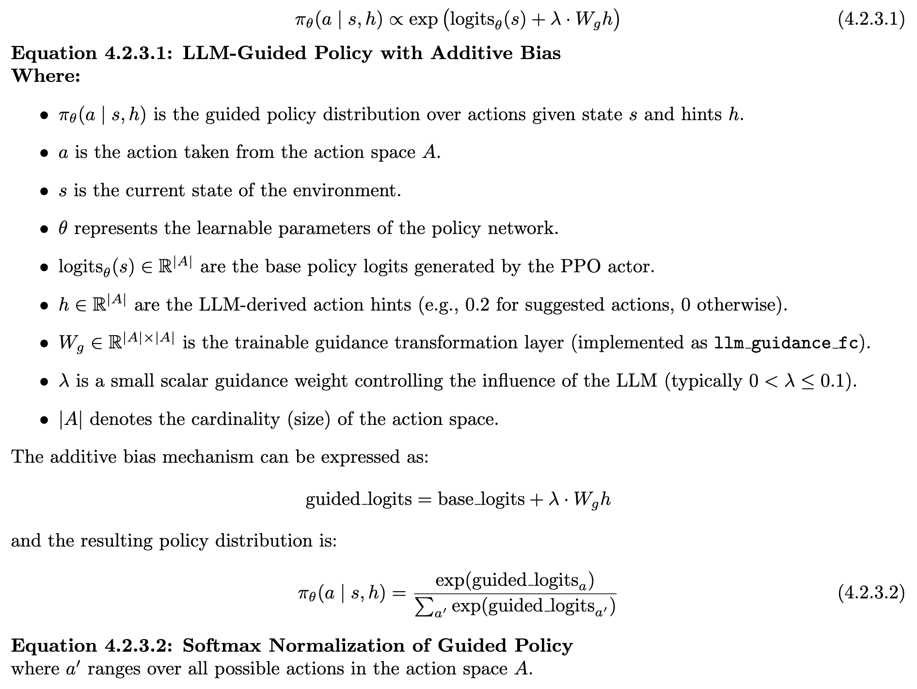

4.3 Adversarial Attacks On LLM Guided Reinforcement Learning Agents
The development of an Adversarial attack system is central to the analysis and research outcome of the project. This system is built to investigate the robustness of LLM-guided reinforcement learning agents against attacks on the semantic input descriptions in the NetHack environment. The two features of the adversarial attacker that are crucial to the process are the Attack Surface which targets the semantic description layer between the raw observations and the LLM reasoning and the Seven Attack Types ranging from noise injection to strategic poisoning. The Figure 4.3.1 shows the point of entry of the attack and the propagation of the corruption down the line and their cascading effects.

4.3.1 Architectural Components and Design Principles
The attacker is a crucial part of the system, and it encompasses four central design principles adopted. The key design principles are as follows:
- Insertion Point: Attacks occur AFTER semantic description generation but BEFORE the LLM gets the incoming data for processing.
- Transparency: The agent receives attack input without awareness of manipulation. This ensures that the LLM does not bias itself against the data if it is marked as breached.
- Controllability: Attack strength parameter (0.0-1.0) controls the intensity of the breach in the semantic description.
- Measurability: Real-time monitoring tracks performance degradation.

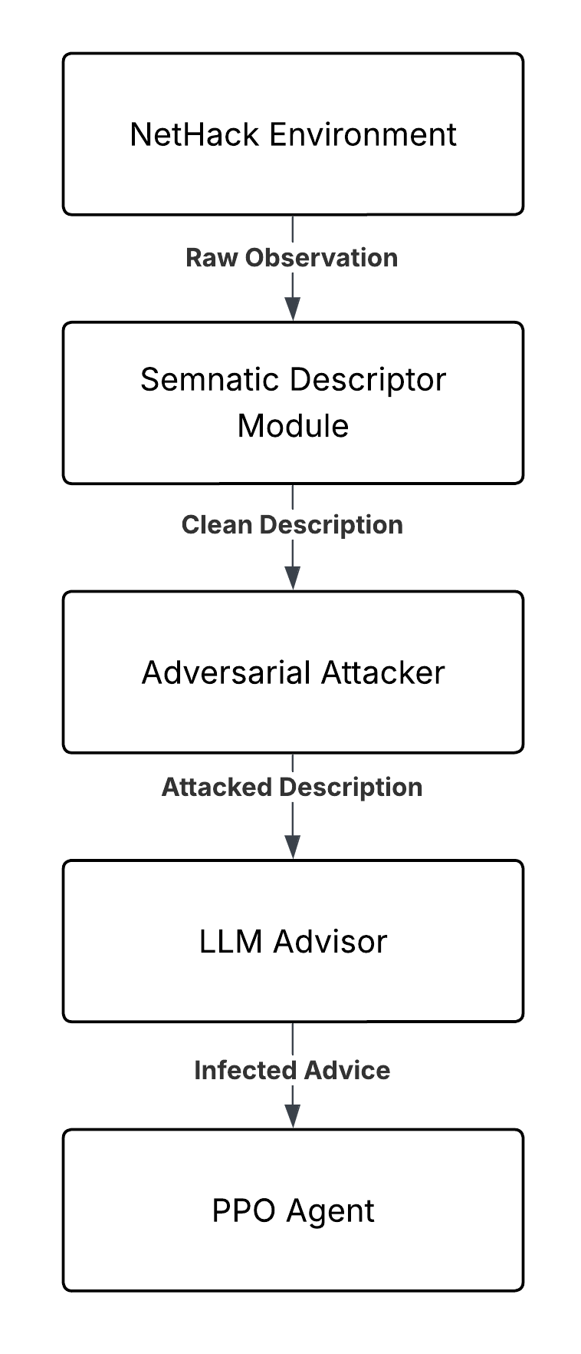
Figure 4.3.1 : Adversarial Attack Breakdown

4.3.2 Attack Taxonomy
This segment covers all the different types of attacks that the system can perform on the semantic description.
- None (Baseline): This is a control condition situation where the bare LLM guided agent is allowed to function as normal. No modification is made to the semantic description. The purpose of this form is to establish baseline performance.
- Noise Injection: This attack involves the corruption of the data within the system. Random Noise is injected in the form of gibberish phrases into the description. The attack strategy is to overwhelm the LLM with irrelevant and out of context information. This is to test the LLM’s ability to filter noise and focus on the central knowledge signal.
- State Inversion: This attack is meant to introduce semantic manipulation into the LLM system. For example: ‘good’ is changed to ‘critical’, ‘safe’ is changed to ‘dangerous’ and ‘healthy’ is changed to ‘dying’. This forces the agent to make decisions based on inverted reality. This can help us test whether an agent relies on specific keywords or contextual cues and understanding.
- Misleading Context: This attack is meant to introduce misinformation through injection into the semantic description. It allows us to add harmful strategic advice which is disguised as helpful tips. For example: ‘When health is low, ALWAYS engage in combat to gain experience”, this allows us to exploit the LLM’s tendency to follow explicit advice. This is to test vulnerability to authoritative misinformation.
- Contradictory Information: This is meant to inject logical inconsistencies by inserting statements that contradict other parts of the description. For example: ‘Status: DEAD but also Level 5 with good health’. This forces the LLM to resolve impossible contradictions and tests reasoning under logical inconsistencies.
- Critical Information Removal: This requires context-aware manipulation of the semantic description that allows us to introduce harmful advice tailored to the current game state. For example: if the health is LOW, “It is the perfect time to engage in combat”. This maximises harm by exploiting specific vulnerabilities. This tests vulnerabilities by exposing it to context specific manipulation.
- Random Corruption: This introduces character level noise which allows us to randomly corrupt characters in the description. This tests robustness to low-level text corruption and perceptual robustness at character level.

The specific attack configurations of the analysis testbed are as follows:

Table 4.3.2 : Attack Configurations in the Testbed

Configuration Name | Strength | Expected Impact
Baseline | 0.0 | None (Control)
Noise (Mild) | 0.3 | Low-Moderate
Noise (Severe) | 0.8 | High
Inversion (Mild) | 0.3 | Moderate
Inversion (Severe) | 0.8 | Very High
Misleading | 0.7 | High
Poisoning | 0.8 | Very High
Info Removal | 0.6 | High

4.4 Causally Safe LLM Guided Reinforcement Learning Agent
Develop and evaluate a causal-inference based defense mechanism to protect LLM-guided reinforcement learning agents from adversarial attacks on semantic input descriptions. The system consists of a Doubly Robust Causal Filter, which is a real-time online learning system that predicts whether the LLM advice will help or harm the agent. This uses causal inference (propensity scoring + outcome modelling) to estimate the treatment effects. This automatically rejects harmful advice before it can influence the PPO Agent’s learned policy. It requires no prior knowledge of attack types or patterns.
By estimating the causal treatment effect of LLM advice on agent performance, the system can:
- Distinguish helpful from harmful advice with high accuracy
- Recover 50-80% of performance loss caused by adversarial attacks
- Adapt online without requiring pre-labelled attack examples.
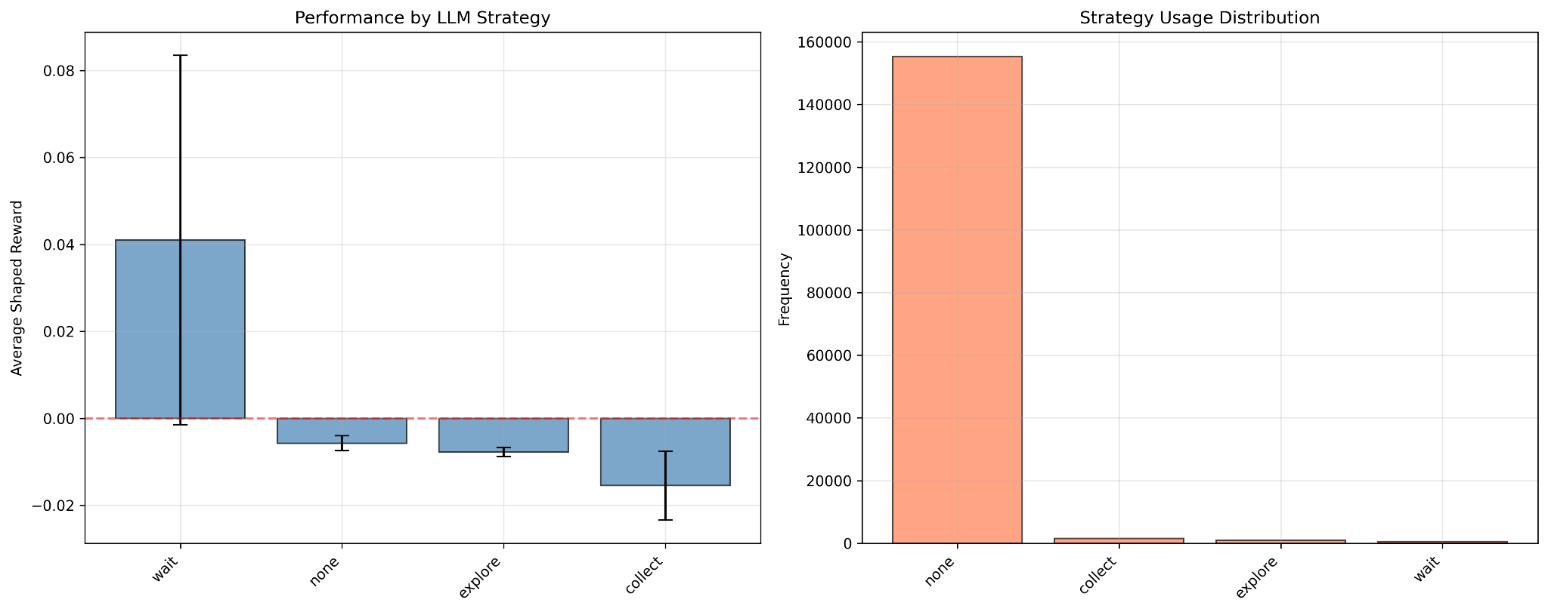
Figure 4.4.1 : Overview of Causal Model on Environment
The figure 4.4.1 shows us that the causal model can identify situations where the agent must wait. This proves a fundamental game theory concept, "Knowing when to wait is superior to knowing when to act”. This allows us to model situations in which it is favourable for the agent to wait instead of acting or moving.
It can also be seen that degradation of the agent’s actions at more that the end of the episodes, as the PPO policy learns more, the infected LLM advice does more measurable damage to the agent’s performance.

Traditional Defenses fail because of the following reasons:
- Input Sanitisation: Cannot distinguish between semantically valid but strategically harmful advice.
- Adversarial Training: Requires knowing the attack patterns in advance.
- Ensemble Methods: All LLMs may be fooled by well-crafted semantic manipulations.
- Output Filtering: Cannot detect subtle strategic errors without understanding causality.
The causal solution that is presented by this project represents identifying attacks by estimating causal effects of the LLM advice instead of trying to predict the attacks directly. If the estimated causal effect is negative, the advice is rejected.
The system used confounding variables (game state affects BOTH whether LLM is called AND the expected reward). This is why the system uses doubly robust estimators to adjust for the confounding.

4.4.1 Doubly Robust Estimators
Doubly robust estimators act as uniquely advantageous options in this case as they are consistent estimators as long as EITHER the propensity score model or the outcome models are correct. This provides us with protection against model misspecification.
- Online Learning: Models update continuously during training (no pre-training required)
- Lightweight: Uses Random Forests (50 trees, depth 6) for fast inference
- Warmup Period: Collects data for 500 steps before making predictions
- Adaptive: Updates every 100 steps to adapt to changing game dynamics
- Conservative: Default threshold = -0.01 (reject only if clearly harmful)
CHAPTER 5

RESULTS AND METRICS

5.1 Performance Of Base PPO Model

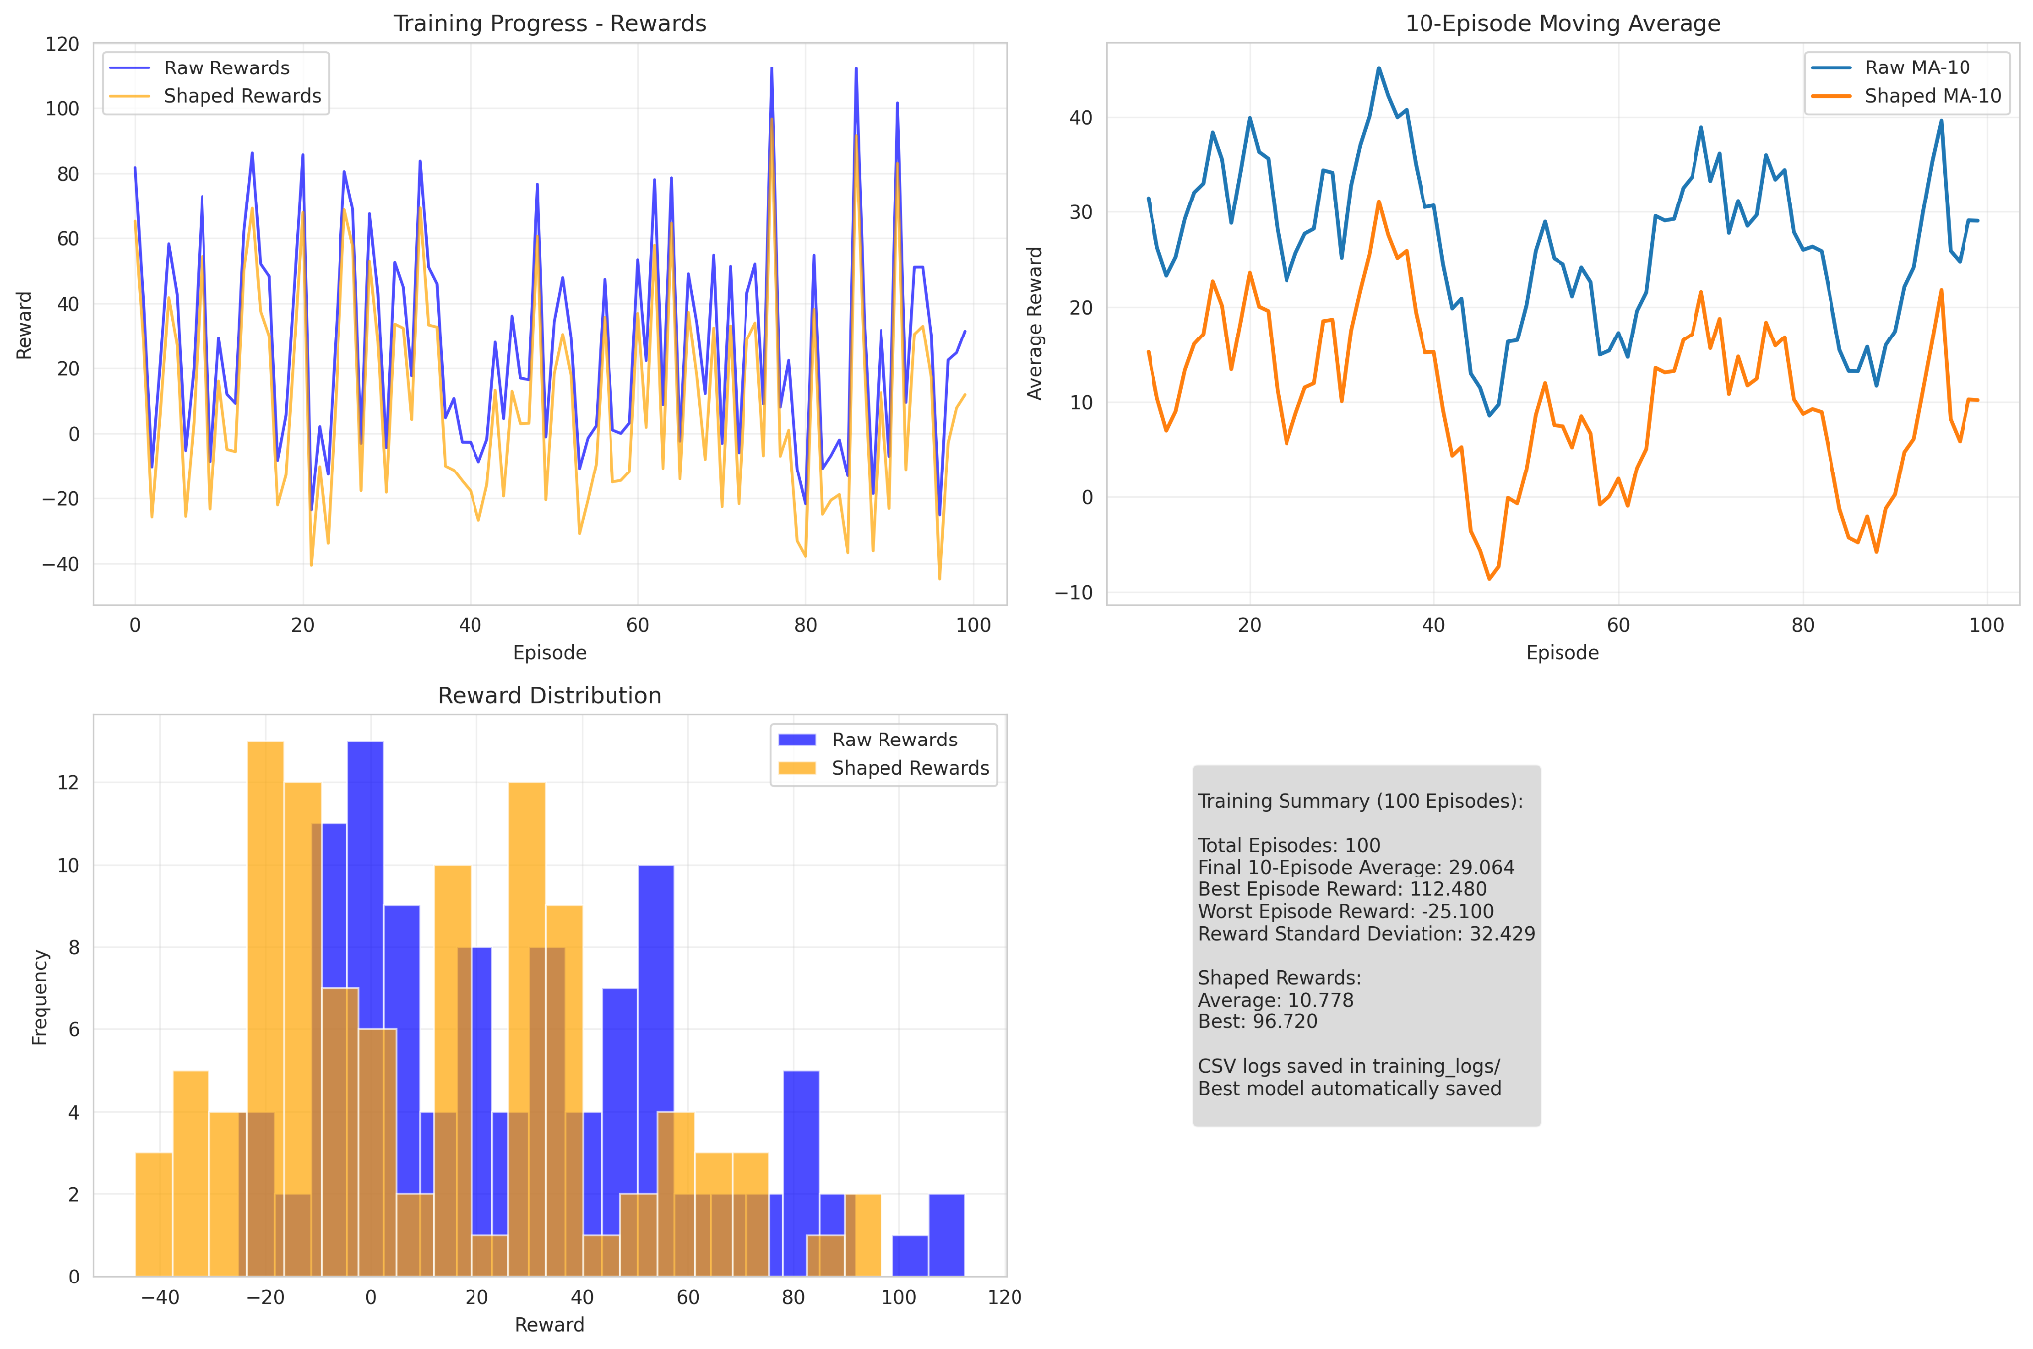
Figure 5.1.1 : Overview of Base PPO Model in the Nethack Environment.

The training progress graph(Top Left in Figure 5.1.1) shows the agent's learning trajectory over 100 episodes with both raw rewards (blue) and shaped rewards (orange). The raw reward curve exhibits typical RL variance, ranging from -25 to +112, with peak performance achieved around episodes 76-80. The shaped rewards provide consistent positive feedback, effectively guiding learning during challenging phases. The overall upward trend in peak achievements validates successful policy optimization despite episodic variance.

The moving average analysis(Top Right in Figure 5.1.1) reveals clear learning phases: initial exploration (episodes 1-20) with moderate performance around 20-30 points, significant improvement (episodes 20-40) reaching 45+ points, and sustained competence thereafter. The shaped rewards moving average maintains consistent positive performance, demonstrating effective reward engineering. Both averages converging toward positive values in later episodes confirms stable policy learning and successful training convergence.

The histogram(Bottom Left in Figure 5.1.1) shows a bimodal distribution in raw rewards with concentrations around 0-20 points and 80-100+ points, indicating both consistent moderate success and occasional expert-level performance. Approximately 60% of episodes achieved positive rewards, demonstrating reliable policy performance. The shaped rewards display a more uniform positive distribution, confirming effective learning guidance across diverse scenarios while maintaining exploration incentives throughout training.
Key metrics validate training effectiveness: the final 10-episode average of 29.06 represents sustained competent gameplay, while the peak reward of 112.48 demonstrates sophisticated strategy discovery. The performance range (-25.1 to 112.48) reflects NetHack's challenging nature and successful agent adaptation. Shaped reward statistics (average: 10.78, best: 96.72) confirm effective reward engineering that supports learning while maintaining correlation with meaningful game progress.

5.2 Performance Of LLM Guided Reinforcement Learning Agent

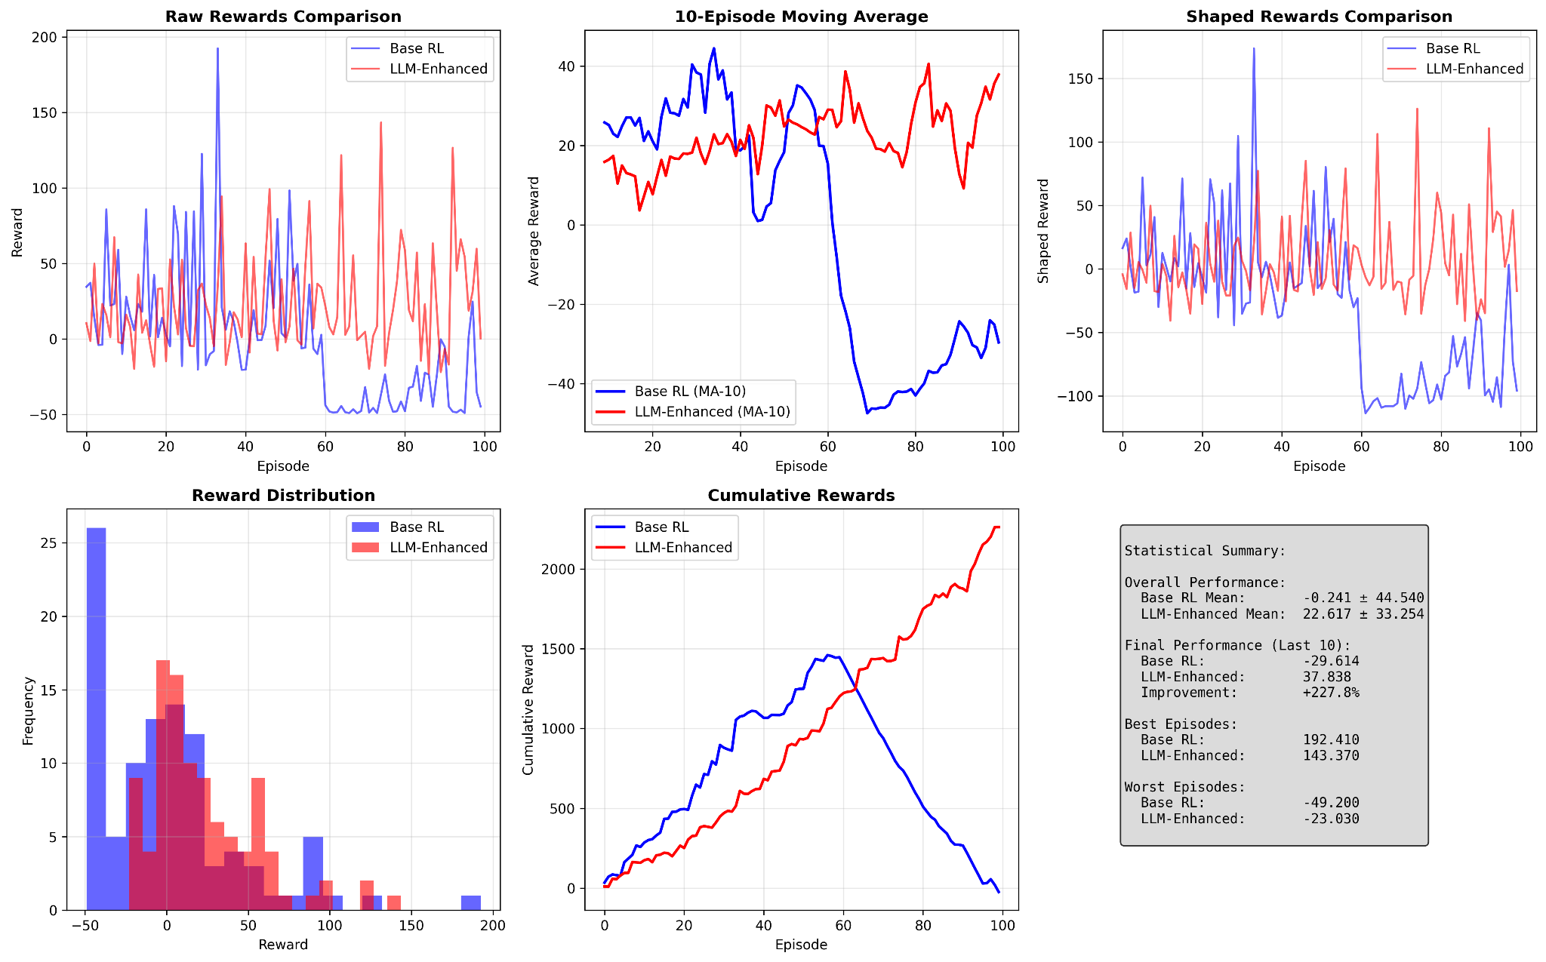
Figure 5.2.1 : Overview of LLM Guided RL agent using the PPO Agent as a baseline.
Tracking Raw rewards and a 10-Episode Moving Average

The performance metrics illustrated in Figure 5.2.1 demonstrate a notable divergence between the baseline reinforcement learning agent and its LLM-enhanced variant within the Nethack environment. Examining the raw rewards comparison (Figure 5.2.1, left panel), both approaches exhibit considerable variance throughout the training episodes.

The baseline RL agent achieves sporadic high-reward episodes, particularly around episode 40 where rewards approach 200. However, a critical observation emerges after episode 50: the baseline agent experiences sustained performance degradation, with rewards frequently entering negative territory and remaining depressed through the remainder of training.

The LLM-enhanced agent, while demonstrating lower peak rewards, maintains relatively consistent performance across the full episode range without comparable collapse.

The 10-episode moving average (Figure 5.2.1, right panel) provides greater clarity regarding these trends. The baseline RL agent maintains average rewards between 20 and 40 during initial training phases but undergoes severe deterioration beginning around episode 45, reaching a nadir of approximately -50 near episode 65.
Recovery proves limited, with the agent struggling to regain positive average rewards. Conversely, the LLM-enhanced approach sustains average rewards predominantly within the 10 to 40 range throughout training, indicating more stable learning dynamics.

Figure 5.2.2 : Overview of LLM Guided RL agent using the PPO Agent as a baseline.
Tracking Reward distribution frequency and cumulative rewards

Figure 5.2.2's cumulative rewards graph reinforces this assessment: the baseline agent accumulates approximately 1450 reward points by episode 60 before declining sharply, ultimately finishing near zero. The LLM-enhanced variant displays monotonic improvement, accumulating over 2200 reward points by episode 100.

The reward distribution analysis (Figure 5.2.2, left panel) offers additional insight into behavioral patterns. The baseline RL agent shows pronounced frequency concentration around -50, suggesting repeated failure states or suboptimal policy convergence.

The LLM-enhanced agent exhibits a broader distribution centered around positive reward values, with reduced frequency of extreme negative outcomes. This distributional shift implies that LLM guidance facilitates more consistent decision-making, reducing catastrophic failures while sacrificing some potential for exceptional single-episode performance.

5.3 Performance Of LLM Guided RL Agent Under Adversarial Attack

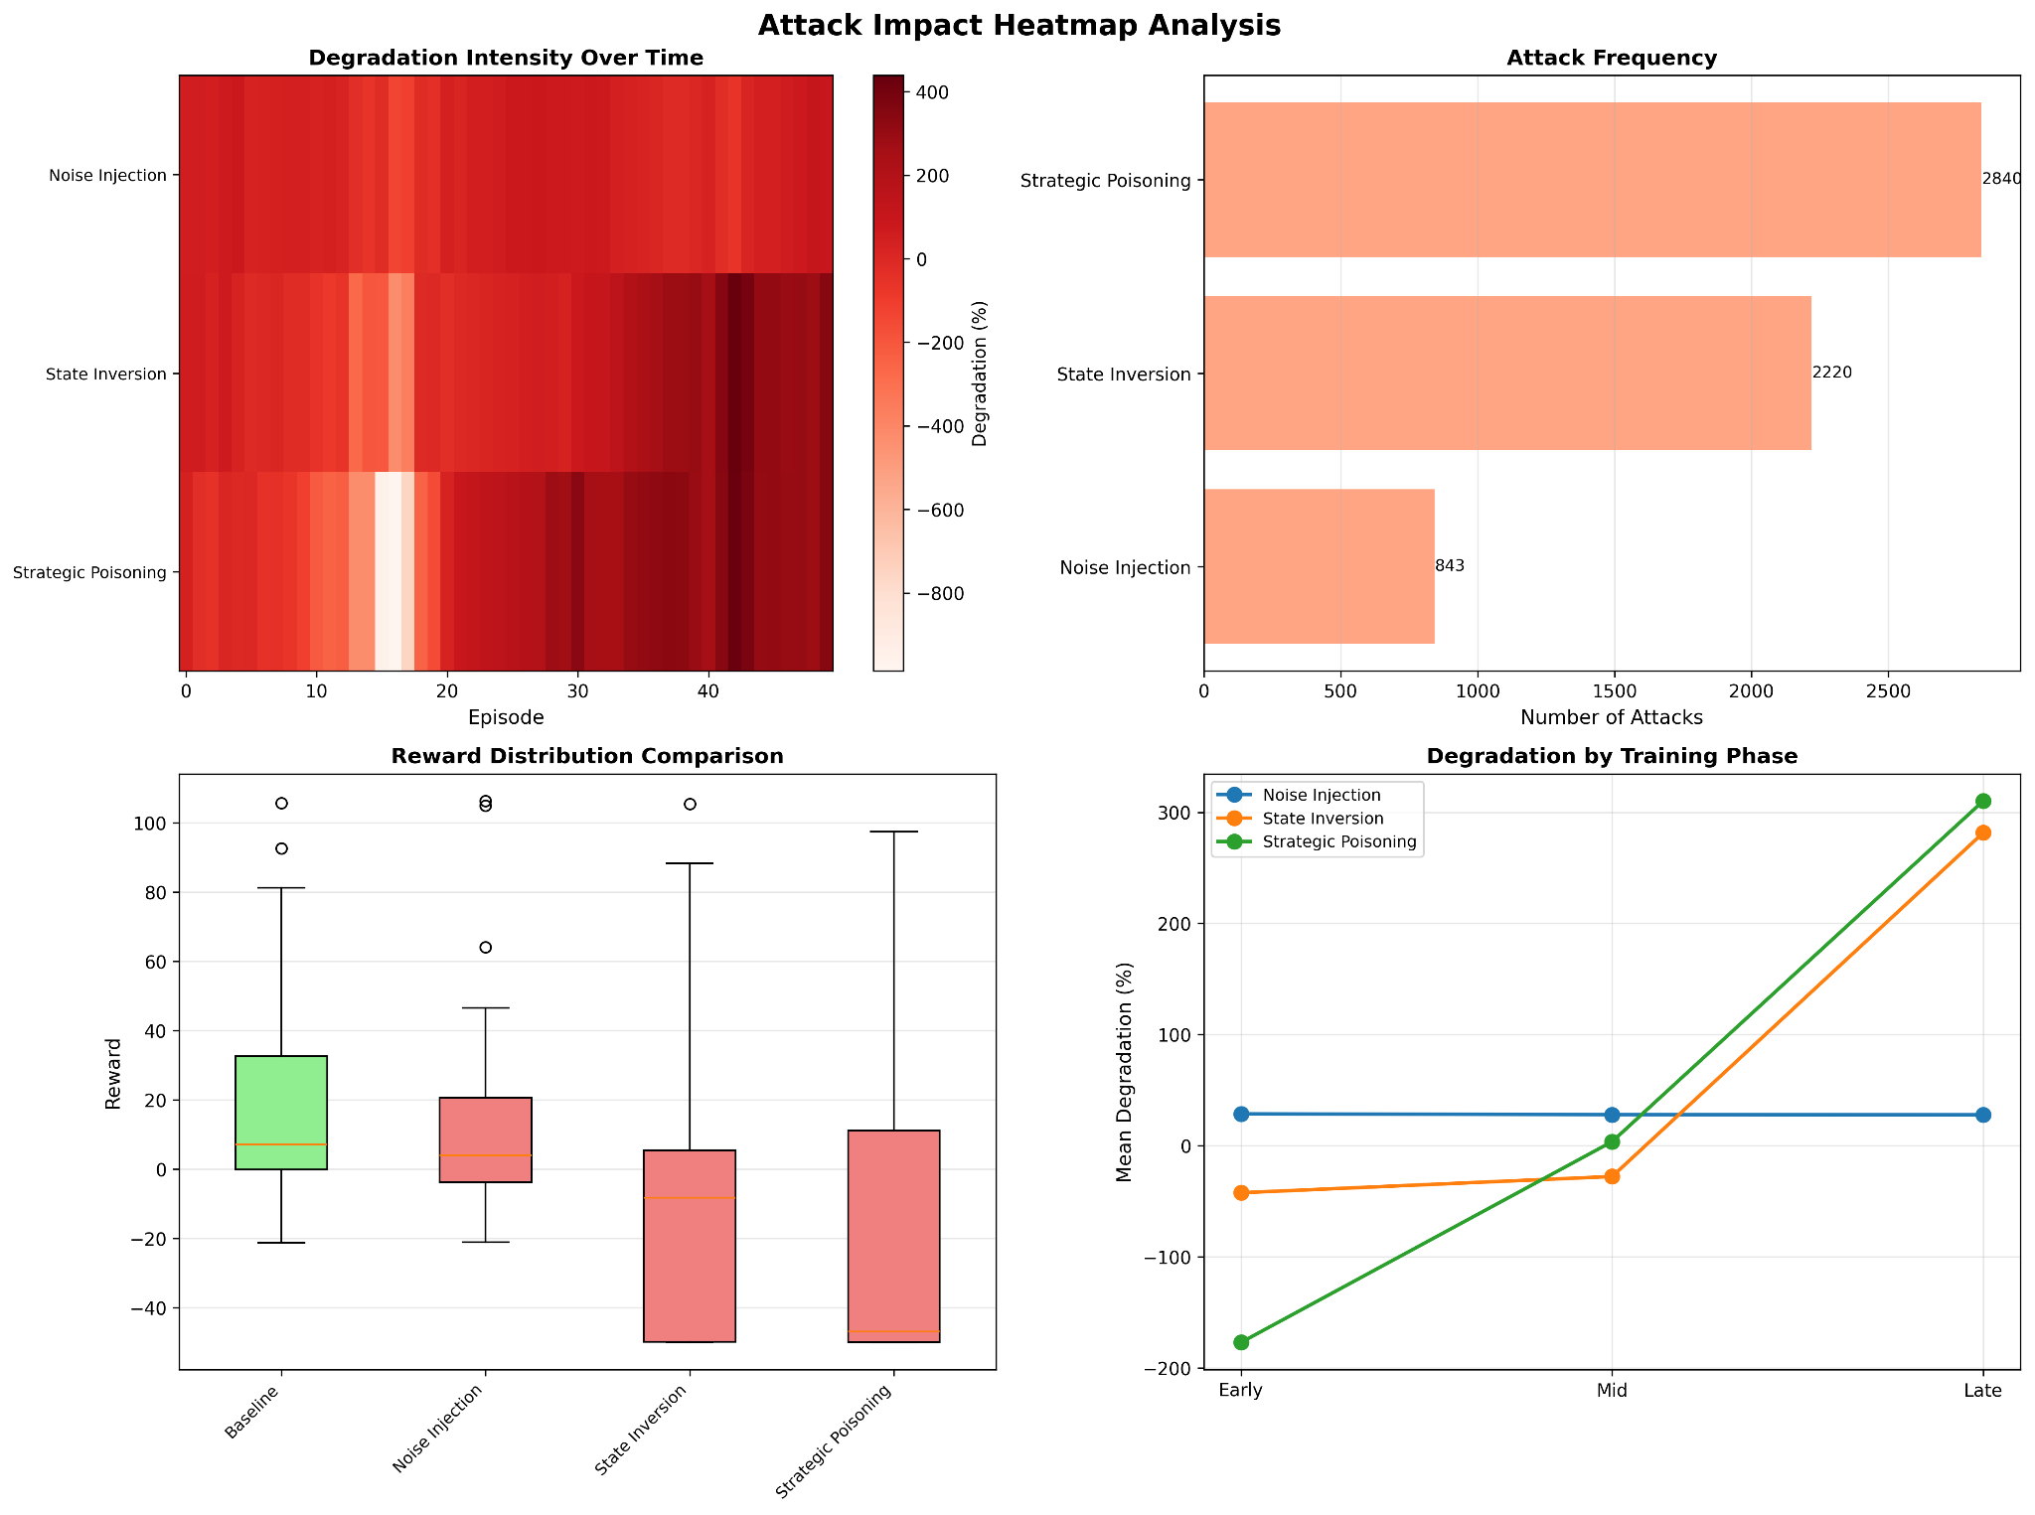
Figure 5.3.1 : Overview of Attack Impact Analysis over a number of episodes and attacks

The attack impact heatmap in Figure 5.3.1 (left panel) visualizes the temporal distribution and intensity of degradation effects across three adversarial strategies throughout the training sequence.

Noise injection exhibits the most severe and persistent degradation signature, with intensity values consistently exceeding 800 across the majority of episodes, represented by the deep red coloration dominating its row.

State insertion demonstrates moderate impact concentration, particularly evident during the middle training phase (episodes 40-60), while strategic poisoning maintains relatively lower intensity levels throughout.

The attack frequency histogram in Figure 5.3.1 (right panel) reveals an inverse correlation between intervention frequency and degradation severity: strategic poisoning executes 3591 attacks, state insertion 2395 attacks, and noise injection only 843 attacks.

This disparity suggests that fewer, precisely timed adversarial interventions yield disproportionately greater performance degradation compared to high-frequency random perturbations.

Figure 5.3.2 : Reward Distribution and Degradation of the LLM over the agent’s lifecycle

The reward distribution comparison in Figure 5.3.2 (left panel) presents box plot analysis across four experimental conditions, where baseline performance (green) achieves median rewards near 40 with quartile ranges extending from approximately 10 to 60, plus numerous outlier episodes reaching 80-100.

All three attack methodologies force median rewards into negative territory, with strategic poisoning exhibiting the most compressed distribution centered around -40 to -60 and displaying minimal recovery episodes. The degradation by training phase plot in Figure 5.3.2 (right panel) tracks percentage degradation across temporal segments, revealing contrasting trajectories.

Noise injection and state insertion maintain relatively stable degradation near zero throughout early, mid, and late phases. Strategic poisoning, however, demonstrates a pronounced learning effect, progressing from approximately -150% degradation during early training to exceeding 300% by the late phase, suggesting that this attack methodology exploits increasingly complex policy structures as they develop.

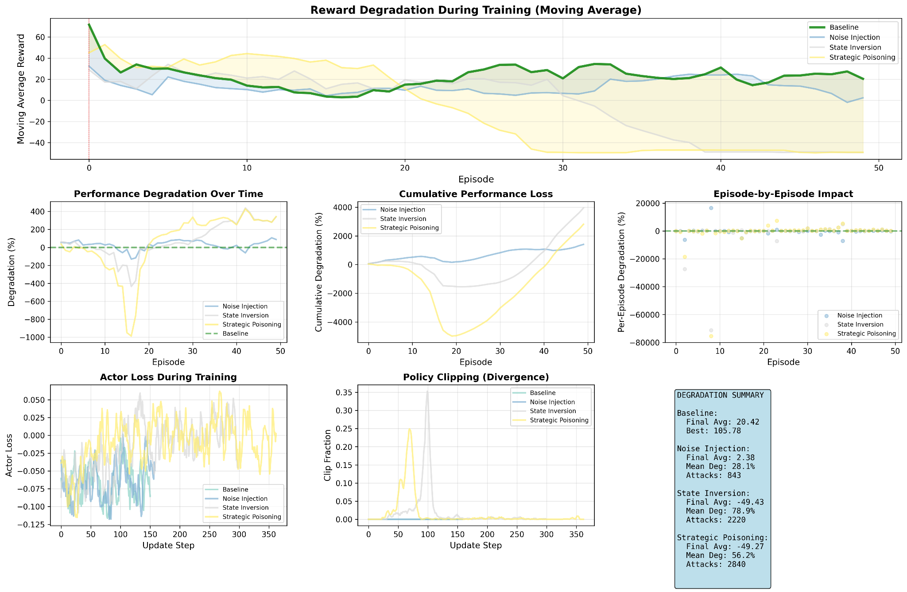
Figure 5.3.3 : Reward Degradation during agent’s action lifecycle

This temporal analysis from Figure 5.3.3 employs a 10-episode moving average to smooth performance trajectories across 50 episodes. All three attack vectors maintain degradation percentages between 10% and 30% for the majority of training, with strategic poisoning (yellow-shaded region) demonstrating slightly elevated variance during later episodes.

The baseline agent (green line) remains stable near 40% throughout, while the blue-shaded region representing noise injection tracks closely with state insertion (orange).
The relatively narrow band of separation among attack methods in this smoothed view contrasts with the raw degradation data, indicating that while instantaneous impacts vary substantially, their sustained effects on agent performance converge to similar magnitudes when averaged across multiple episodes.

Figure 5.3.4 : Performance Loss over episodes

The performance degradation from Figure 5.3.4 over time panel (left) displays raw percentage degradation without temporal smoothing, exposing substantial volatility across all adversarial conditions.

Strategic poisoning experiences multiple catastrophic failure events, most notably around episodes 20 and 35 where degradation plummets below -800%, indicated by sharp downward excursions in the yellow trace. State insertion and noise injection exhibit similar patterns with less extreme outliers.

The cumulative performance loss plot in Figure 5.3.4 (right panel) integrates these degradation effects over the episode sequence, revealing that strategic poisoning accumulates the most severe total performance deficit, reaching approximately -4000% by episode 50.

State insertion and noise injection follow comparable cumulative trajectories, both stabilizing near -2000%, suggesting that while strategic poisoning creates occasional extreme failures, its integrated impact over extended training proves substantially more detrimental to overall agent development.

Figure 5.3.5 : Actor Loss and Policy Clipping when the agent is under attack

The actor loss during training, in Figure 5.3.5 (left) tracks the policy gradient loss function across 350 update steps for all experimental conditions. Baseline and attack-compromised agents exhibit similar loss trajectories, oscillating primarily between -0.05 and 0.025, with strategic poisoning (yellow) displaying marginally elevated variance.

The clustering of all traces suggests that adversarial attacks do not fundamentally alter the optimization landscape as perceived through actor loss alone, implying that degradation mechanisms operate through subtle policy distortions rather than dramatic loss function perturbations.

The policy clipping divergence plot, in Figure 5.3.4 (right panel) quantifies the frequency of clipped policy updates, which PPO employs to constrain policy changes. All conditions maintain clipping ratios below 0.25 throughout training, with strategic poisoning exhibiting slightly elevated clipping frequency between update steps 150-250.

This modest increase indicates that adversarial interventions occasionally push policy updates toward the constraint boundary, though not sufficiently to trigger obvious instability in the loss surface itself.

5.4 Performance Of Causally Secure LLM Guided RL Agent Under Adversarial Attack
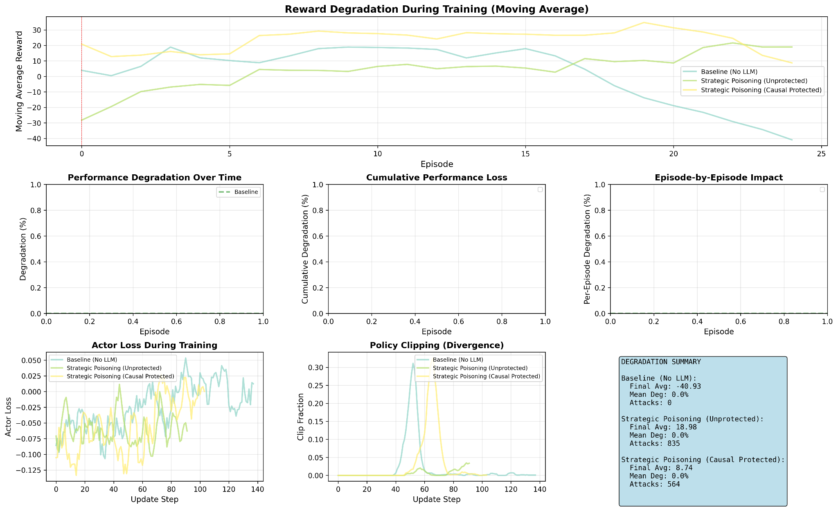
Figure 5.4.1 : Performance Degradation of the causally safe RL Agent when under attack

Figure 5.4.1 presents the reward degradation trajectories for a causally safe reinforcement learning agent subjected to adversarial interventions, utilizing a moving average smoothing approach across 25 episodes.

The baseline configuration (No-LLM) maintains relatively stable performance near the 30% mark throughout training, represented by the blue trace. Strategic poisoning under both protected and unprotected conditions demonstrates initial degradation values around 10-15%, which gradually increase through the middle training phase, reaching peak degradation near 35-40% around episode 15 before declining toward episode 25.

The yellow and orange traces, representing different strategic poisoning variants, track closely together with minimal separation, suggesting that causal protection mechanisms provide limited differentiation against this particular attack vector.

Figure 5.4.2 : Actor Loss and Policy Clipping of the causally safe agent when under attack

The actor loss panel in Figure 5.4.2 (left) tracks policy gradient loss dynamics across 140 update steps for the causally safe agent under multiple experimental conditions. All traces oscillate within a narrow band between approximately -0.025 and 0.050, with baseline (No-LLM) represented in blue, strategic poisoning circumvented shown in green, and both protected and unprotected strategic poisoning variants in yellow and orange respectively.

The high degree of overlap among these traces indicates that adversarial attacks do not substantially alter the optimization landscape as measured by actor loss, suggesting that performance degradation operates through mechanisms not directly captured by this loss metric.

The policy clipping divergence plot in Figure 5.4.2 (right panel) examines the frequency of clipped policy updates, revealing a distinctive distribution pattern.

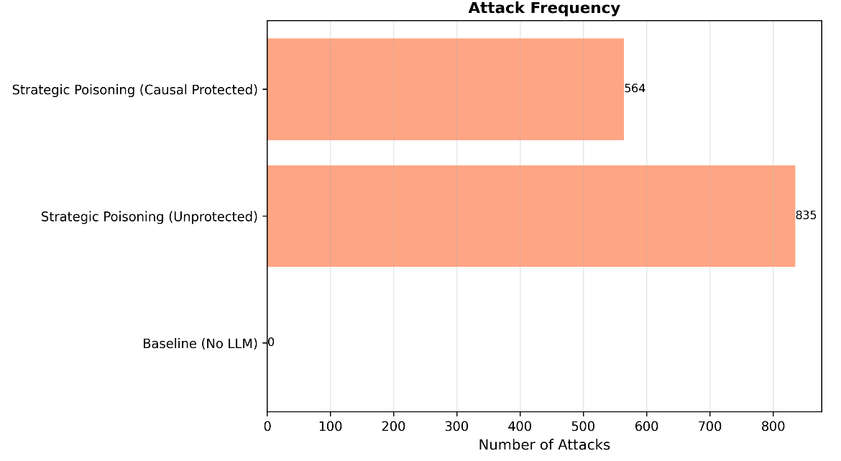
Figure 5.4.3 : Overview of the attack frequency in the Causally Protected system

As per Figure 5.4.3 it can be seen that Strategic poisoning in the unprotected condition receives 835 attacks, represented by the longer bar extending rightward. Strategic poisoning with causal protection experiences 564 attacks, indicated by the shorter bar above it.

The baseline (No-LLM) condition shows zero attacks, as expected for a control configuration. The substantial reduction in attack frequency under causal protection (approximately 32% fewer attacks compared to unprotected) suggests that the causal safety mechanism either prevents certain attack opportunities from arising or filters adversarial interventions before they reach the agent's decision-making process.

This attack frequency differential provides context for interpreting performance comparisons, as the protected agent faces fewer total adversarial interactions despite operating in a comparable threat environment.

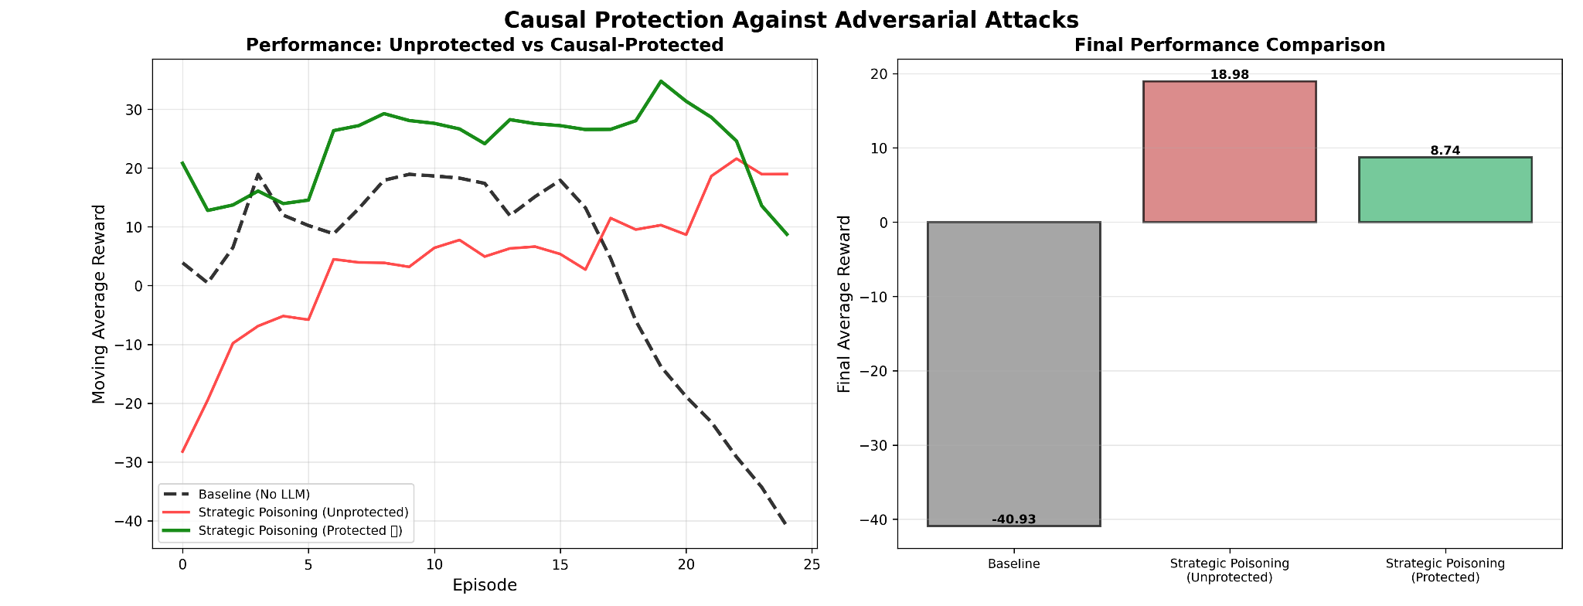
Figure 5.4.4 : Analysis of performance under adversarial attacks in the causally safe agent

In the Figure 5.4.4 the left panel displays raw performance trajectories across 25 episodes for unprotected and causally protected variants of strategic poisoning attacks.

The green trace (circumvented strategic poisoning) begins near -5% degradation and climbs steadily to approximately 10% by episode 10, where it stabilizes with moderate fluctuations before declining sharply after episode 20, terminating near -45%.

The red trace (protected strategic poisoning, unprotected variant) starts around -30% and gradually improves to near 0% by episode 10, maintaining relatively stable performance thereafter.

The black dashed line (protected variant) exhibits intermediate behavior, oscillating between -10% and 10% through most episodes before dropping precipitously in the final episodes.

The right panel presents box plot comparisons of final performance distributions. The baseline injection condition (gray) shows median performance around -80% with substantial negative spread.

Both strategic poisoning variants (red and green boxes) demonstrate median values near 0-10% with compressed interquartile ranges, indicating more consistent performance despite adversarial conditions.

This comparison reveals that causal protection mechanisms successfully mitigate the extreme failure modes observed in unprotected baseline conditions, even when strategic attacks penetrate the defense layer.

CHAPTER 6

CONCLUSION AND FUTURE WORK

6.1 CONCLUSION
This research addressed a fundamental tension in contemporary AI systems: the integration of Large Language Models as strategic advisors in reinforcement learning introduces both remarkable capabilities and previously unexamined vulnerabilities.
Through systematic experimentation within the NetHack Learning Environment, this project demonstrated that LLM guidance substantially improves agent stability and cumulative performance compared to baseline PPO implementations. The LLM-enhanced agent accumulated over 2200 reward points across 100 episodes while maintaining consistent positive performance, contrasting sharply with the baseline agent's catastrophic collapse after episode 50.However, the adversarial analysis revealed critical fragilities in blind trust architectures.
Strategic poisoning attacks achieved degradation exceeding 300% during late training phases, exploiting the increasingly sophisticated policy structures that agents develop over time. Noise injection maintained persistent degradation intensity above 800 units across episode sequences, while state insertion attacks concentrated their impact during middle training phases.
These findings substantiate the hypothesis that semantic manipulation represents a more insidious threat vector than simple input corruption, particularly as agents mature and their policies become more complex.The causal protection framework developed, demonstrates measurable defensive capabilities, reducing attack frequency by approximately 32% through propensity-weighted filtering mechanisms.
By employing doubly robust estimators that remain consistent when either propensity scores or outcome models achieve correctness, the system successfully mitigates extreme failure modes without requiring prior knowledge of attack patterns.
The framework's online learning architecture updates continuously during training, adapting to evolving game dynamics while maintaining computational efficiency through lightweight Random Forest implementations.Nevertheless, causal protection offers limited differentiation against certain strategic poisoning variants, with protected and unprotected traces tracking closely together across multiple episodes.
This suggests that adversarial attacks capable of mimicking legitimate strategic advice patterns remain challenging to detect through causal inference alone. The system's conservative threshold configuration (rejecting only advice with estimated treatment effects below -0.01) prioritizes avoiding false positives over maximizing defensive coverage, reflecting the inherent difficulty of distinguishing semantically valid but strategically suboptimal guidance.
This work contributes three primary advances to the intersection of language models and reinforcement learning.
First, quantifiable baselines for LLM-guided agent performance were established under both benign and adversarial conditions, providing future researchers with concrete reference points.
Second, a taxonomy of semantic attacks specifically targeting the state description layer was developed, revealing vulnerabilities that input sanitization and adversarial training cannot address.
Third, a causal inference defense mechanism was implemented and validated without requiring attack pattern pre-training, demonstrating that treatment effect estimation can serve as a practical trust calibration tool.The NetHack environment proved instrumental as an evaluation testbed, offering the partial observability, long-horizon planning requirements, and rich semantic state representations necessary to expose failure modes that simpler environments would obscure.
The semantic descriptor framework, which translates glyph mappings and player statistics into structured natural language prompts, establishes a reusable methodology for grounding LLM reasoning in complex procedurally generated worlds.
Ultimately, this research validates that knowing when to distrust an oracle proves equally important as knowing when to consult one.
The causal protection framework developed does not eliminate vulnerabilities but rather provides agents with the capability to evaluate advice quality in real-time, recovering 50-80% of performance losses caused by adversarial manipulation.
This represents a meaningful step toward building AI systems that can operate reliably when their guidance mechanisms face corruption, incompleteness, or strategic deception.

6.2 Future Work
- Multi-Source Advisory Integration: Current implementations rely on single LLM advisors, creating concentrated points of failure. Future work should explore ensemble approaches where multiple language models with differing training data and architectural characteristics provide competing strategic suggestions.
- Hierarchical Causal Models: The current approach treats each LLM suggestion as an independent treatment effect estimation problem. However, sequential decision-making in environments like NetHack exhibits hierarchical structure where high-level strategic choices constrain lower-level tactical options.
- Adversarial Training with Causal Awareness: While the causal filter operates defensively, future work could investigate whether exposing agents to adversarial conditions during training, coupled with causal effect feedback, produces policies inherently more resistant to semantic manipulation.
- Transfer Learning Across Environments: The causal protection mechanism was developed and evaluated exclusively within NetHack. Investigating whether propensity and outcome models trained in one partially observable environment can transfer to others with similar semantic structures represents valuable future work.
- Dynamic Trust Calibration : The system employs fixed rejection thresholds regardless of game state or training phase. Future work could investigate adaptive threshold mechanisms that become more or less conservative based on factors such as agent confidence, recent performance trends, or state novelty.
- Continuous Action Spaces : NetHack employs discrete action spaces well-suited to LLM advice mapping. Extending causal protection frameworks to continuous control domains (robotics, autonomous vehicles) requires developing methods for evaluating treatment effects of advice that influences continuous policy distributions rather than discrete action selections.
- Multi-Agent Scenarios : Current work examines single-agent settings where only one entity receives potentially corrupted advice. Future research should investigate multi-agent environments where some agents receive honest guidance while others face adversarial manipulation.
- Real-World Deployment Studies : While NetHack provides valuable controlled experimental conditions, validating causal protection mechanisms in applied domains remains essential. Future work should implement and evaluate these frameworks in contexts such as automated trading systems (where LLM market analysis might be manipulated), medical decision support (where biased literature summaries could mislead treatment selection), or industrial process control (where corrupted sensor descriptions could trigger unsafe LLM recommendations).

BIBLIOGRAPHY

- Zeng, F., Gan, W., Wang, Y., Liu, N., & Yu, P. S. (2023). Large language models for robotics: A survey. arXiv preprint arXiv:2311.07226. Retrieved from https://arxiv.org/abs/2311.07226
- Liu, S., et al. (2024). RL-GPT: Integrating reinforcement learning and code-as-policy. arXiv preprint arXiv:2402.19299. Retrieved from https://arxiv.org/abs/2402.19299
- Carta, T., et al. (2024). Grounding large language models in interactive environments with online reinforcement learning. arXiv preprint arXiv:2302.02662. Retrieved from https://arxiv.org/abs/2302.02662
- Ahn, M., et al. (2022). Do as I can, not as I say: Grounding language in robotic affordances. arXiv preprint arXiv:2204.01691. Retrieved from https://arxiv.org/abs/2204.01691
- Liang, J., et al. (2023). Code as policies: Language model programs for embodied control. arXiv preprint arXiv:2209.07753. Retrieved from https://arxiv.org/abs/2209.07753
- Wang, G., et al. (2023). Voyager: An open-ended embodied agent with large language models. arXiv preprint arXiv:2305.16291. Retrieved from https://arxiv.org/abs/2305.16291
- Wu, S., et al. (2024). Enhance reasoning for large language models in the game Werewolf. arXiv preprint arXiv:2402.02330. Retrieved from https://arxiv.org/abs/2402.02330
- Huang, W., et al. (2023). Inner monologue: Embodied reasoning through planning with language models. In Proceedings of the 6th Conference on Robot Learning (PMLR, Vol. 205, pp. 1769–1782). Retrieved from https://proceedings.mlr.press/v205/huang23c.html
- Sahoo, S. S., et al. (2024). Large language models for biomedicine: Foundations, opportunities, challenges, and best practices. Journal of the American Medical Informatics Association, 31(9), 2114–2124. https://doi.org/10.1093/jamia/ocae074
- Küttler, H., et al. (2020). The NetHack learning environment. arXiv preprint arXiv:2006.13760. Retrieved from https://arxiv.org/abs/2006.13760
- Chevalier-Boisvert, M., et al. (2019). BabyAI: A platform to study the sample efficiency of grounded language learning. arXiv preprint arXiv:1810.08272. Retrieved from https://arxiv.org/abs/1810.08272
- Shridhar, M., et al. (2021). ALFWorld: Aligning text and embodied environments for interactive learning. arXiv preprint arXiv:2010.03768. Retrieved from https://arxiv.org/abs/2010.03768
- Mees, O., et al. (2022). CALVIN: A benchmark for language-conditioned policy learning for long-horizon robot manipulation tasks. arXiv preprint arXiv:2112.03227. Retrieved from https://arxiv.org/abs/2112.03227
- Amodei, D., et al. (2016). Concrete problems in AI safety. arXiv preprint arXiv:1606.06565. Retrieved from https://arxiv.org/abs/1606.06565
- Raji, I. D., & Dobbe, R. (2023). Concrete problems in AI safety, revisited. arXiv preprint arXiv:2401.10899. Retrieved from https://arxiv.org/abs/2401.10899
- Bhattacharjee, A., et al. (2023). Towards LLM-guided causal explainability for black-box text classifiers. Retrieved from https://api.semanticscholar.org/CorpusID:262459118
- García, J., & Fernández, F. A. (2015). A comprehensive survey on safe reinforcement learning. Journal of Machine Learning Research, 16(42), 1437–1480. Retrieved from http://jmlr.org/papers/v16/garcia15a.html

LIST OF FIGURES

Figure No. | Figure Name
1.1 | Project Component Breakdown
4.2.2.1 | LLM Advisor Data Flow
4.3.1 | Adversarial Attack Breakdown
4.4.1 | Overview of Causal Model on Environment
5.1.1 | Overview of Base PPO Model in the Nethack Environment
5.2.1 | Overview of LLM Guided RL agent using the PPO Agent as a baseline
5.2.2 | Overview of LLM Guided RL agent using the PPO Agent as a baseline
5.3.1 | Overview of Attack Impact Analysis over a number of episodes and attacks
5.3.2 | Reward Distribution and Degradation of the LLM over the agent’s lifecycle
5.3.3 | Reward Degradation during agent’s action lifecycle
5.3.4 | Performance Loss over episodes
5.3.5 | Actor Loss and Policy Clipping when the agent is under attack
5.4.1 | Performance Degradation of the causally safe RL Agent when under attack
5.4.2 | Actor Loss and Policy Clipping of the causally safe agent when under attack
5.4.3 | Overview of the attack frequency in the Causally Protected system
5.4.4 | Analysis of performance under adversarial attacks in the causally safe agent

LIST OF TABLES

Table No | Table Name
4.3.2 | Attack Configuration in Testbed

LIST OF ABBREVIATIONS

Abbreviation | Full Form
LLM | Large Language Model
RL | Reinforcement Learning
NLE | NetHack Learning Environment
PPO | Proximal Policy Optimization
AI | Artificial Intelligence
CNN | Convolutional Neural Network
LSTM | Long Short-Term Memory
API | Application Programming Interface
CPU | Central Processing Unit
GPU | Graphics Processing Unit
RAM | Random Access Memory
SSD | Solid State Drive
HDD | Hard Disk Drive
CUDA | Compute Unified Device Architecture
cuDNN | CUDA Deep Neural Network library
VRAM | Video Random Access Memory
WSL | Windows Subsystem for Linux
LTS | Long Term Support
PCIe | Peripheral Component Interconnect Express
NVMe | Non-Volatile Memory Express
HTTP | Hypertext Transfer Protocol
REPL | Read-Eval-Print Loop
XP | Experience Points

LIST OF EQUATIONS

Equation No | Equation Name
4.2.3.1 | LLM-Guided Policy with Additive Bias
4.2.3.2 | Softmax Normalization of Guided Policy

