DIPLOMA PROJECT · FIRST SUBMISSION · ITEM 7 (PART)
Use Case Diagram
MedGuard: actors, use cases and their relation to requirements
Working name | MedGuard (earlier working name: MedSafe)
Section owner | Salemkan Aknur Seitkankyzy (SE-2414), Business Analyst
Version | v1.0, 22 October 2026. Replaces the Use Case diagram of package v0.9.
Editable source | diagrams/use-case-diagram.puml (PlantUML); rendered files use-case-diagram.svg and .png

1. Actors
Actor | Type | Description
Patient | Primary | Creates a profile, writes own history, books a free slot, sees own schedule, receives reminders.
Doctor | Primary | A physician of a clinic of any specialty. Publishes free slots, opens patient history, records the visit, runs the safety check, decides and approves the schedule.
Administrator | Primary | Observes the use of the application: clinics, doctors per clinic, login journal and event journal. Has no access to personal or clinical data.
Telegram bot | Secondary (external system) | Delivers reminders and the questionnaire dialogue to the patient.

The drug knowledge base and the synthetic database are prepared by the team before the application runs. They are not actors and have no use case in the product.

2. Diagram
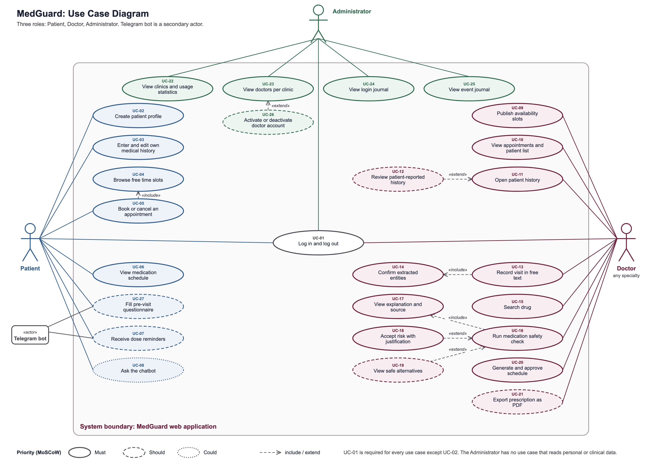
Figure 1. MedGuard use case diagram. Solid outline: Must; dashed: Should; dotted: Could. Dashed arrows are include and extend relations.

3. Reading the diagram
- Access. UC-01 (log in) is required for every use case except UC-02 (create profile).
- Include. Booking (UC-05) includes browsing free slots (UC-04). Recording a visit (UC-13) includes confirmation of extracted entities (UC-14). The safety check (UC-16) includes showing the explanation and source (UC-17).
- Extend. Reviewing patient-reported history (UC-12) extends opening the patient history (UC-11). Accepting a risk (UC-18) and viewing alternatives (UC-19) extend the safety check (UC-16). Deactivating a doctor account (UC-26) extends viewing doctors per clinic (UC-23).
- Administrator boundary. The Administrator is linked only to UC-01 and UC-22 to UC-26. None of them returns personal or clinical data.
- Patient and doctor meet through the data, not through a use case. What the patient writes in UC-03 and UC-27 is what the doctor reads in UC-11, with a "patient-reported" label.

4. Use case catalogue
ID | Use case | Actors | Priority | Description | Precondition | Requirements
UC-01 | Log in and log out | Patient, Doctor, Administrator | Must | The user signs in with login and password and is taken to the screen of the own role. The session ends by logout or timeout. | Account exists. | FR-01, FR-03, FR-46
UC-02 | Create patient profile | Patient | Must | A person who is not in the database registers and fills the basic profile. Booking is possible only after this step. | None. | FR-04
UC-03 | Enter and edit own medical history | Patient | Must | The patient records past illnesses, chronic conditions, allergies, current medicines and remarks. Entries are labelled patient-reported. | Signed in, profile exists. | FR-05, FR-08
UC-04 | Browse free time slots | Patient | Must | The patient filters free slots by clinic, specialty, doctor and date. Included by UC-05. | Signed in. | FR-10
UC-05 | Book or cancel an appointment | Patient | Must | The patient picks a free slot and books it; the slot is blocked for others. The patient can cancel, which releases the slot. | Profile exists; free slot exists. | FR-11, FR-14
UC-06 | View medication schedule | Patient | Must | The patient sees the approved schedule and active prescriptions. | Doctor approved a schedule. | FR-35
UC-07 | Receive dose reminders | Patient, Telegram bot | Should | The system sends reminders through Telegram; the patient marks doses as taken or skipped. | Patient linked a Telegram account. | FR-14, FR-36
UC-08 | Ask the chatbot | Patient | Could | The patient asks about the own schedule or general medicine information; the bot refuses diagnosis requests. | Signed in. | FR-37
UC-09 | Publish availability slots | Doctor | Must | The doctor of any specialty creates, edits and removes free time slots. | Signed in. | FR-09
UC-10 | View appointments and patient list | Doctor | Must | The doctor sees booked appointments, searches the patient list and filters by status. | Signed in. | FR-12, FR-13
UC-11 | Open patient history | Doctor | Must | The doctor opens conditions, allergies, medicines, visits and patient-reported remarks of a patient at the appointment. | Patient belongs to the doctor's clinic. | FR-06, FR-38
UC-12 | Review patient-reported history | Doctor | Should | The doctor confirms, corrects or rejects entries made by the patient. Extends UC-11. | UC-11 is open. | FR-07
UC-13 | Record visit in free text | Doctor | Must | The doctor writes the visit note; the system proposes structured entities. Includes UC-14. | UC-11 is open. | FR-08, FR-16, FR-17
UC-14 | Confirm extracted entities | Doctor | Must | The doctor confirms, edits or rejects each extracted condition, allergy and medicine before it is used. Included by UC-13. | Extraction ran. | FR-17, FR-18, FR-19
UC-15 | Search drug | Doctor | Must | The doctor searches a drug by brand or generic name and sees the active substance and label data. | Signed in. | FR-19, FR-20
UC-16 | Run medication safety check | Doctor | Must | The doctor enters a proposed medicine; the system checks interactions, allergy, contraindication, duplicate therapy and dose, and shows alerts by level. Includes UC-17. | UC-11 is open; entities confirmed. | FR-21, FR-22, FR-23, FR-24, FR-25, FR-26, FR-27, FR-28, FR-31
UC-17 | View explanation and source | Doctor | Must | For each alert the doctor sees reason, patient factor, recommended action and the source with version. Included by UC-16. | Alert exists. | FR-28, FR-32
UC-18 | Accept risk with justification | Doctor | Must | The doctor accepts a flagged risk and enters a mandatory comment. Extends UC-16. | Alert exists. | FR-29
UC-19 | View safe alternatives | Doctor | Should | The system offers one or two safer alternatives with justification. Extends UC-16. | Critical or review alert exists. | FR-30
UC-20 | Generate and approve schedule | Doctor | Must | The system builds a dosing schedule from the approved regimen; the doctor edits and approves it, after a repeat check. | Regimen decided. | FR-33
UC-21 | Export prescription as PDF | Doctor | Should | The doctor exports the prescription and schedule for printing. | Schedule approved. | FR-34
UC-22 | View clinics and usage statistics | Administrator | Must | The administrator sees the number of clinics, doctors and active users. No personal data. | Signed in. | FR-02, FR-39
UC-23 | View doctors per clinic | Administrator | Must | The administrator sees clinics and their doctors with specialty and status. | Signed in. | FR-02, FR-40
UC-24 | View login journal | Administrator | Must | The administrator sees login times, pseudonymous user IDs, roles and results; filters and exports. | Signed in. | FR-02, FR-41, FR-43
UC-25 | View event journal | Administrator | Must | The administrator sees the audit events without clinical content. | Signed in. | FR-02, FR-42, FR-43
UC-26 | Activate or deactivate doctor account | Administrator | Should | The administrator switches a doctor account on or off. Extends UC-23. | UC-23 is open. | FR-44
UC-27 | Fill pre-visit questionnaire | Patient, Telegram bot | Should | Before the appointment the patient answers questions about complaints in the application or in the bot; the doctor sees the answers in the visit record. | Booking exists. | FR-15

Every use case also produces an audit event (FR-45).

5. Key scenarios

UC-05 Book an appointment
Step | Patient | System
1 | Opens the list of free slots and sets filters: clinic, specialty, doctor, date. | Shows only unbooked future slots (UC-04).
2 | Selects a slot and confirms. | Checks that the patient has a profile and that the slot is still free.
3 |  | Books the slot, removes it from the free list, writes an audit event, sends a confirmation.
Alt A | No profile exists. | Blocks the booking and sends the patient to UC-02.
Alt B | Another patient took the slot first. | Rejects the request and refreshes the list.
Alt C | Cancels the booking. | Returns the slot to the free list and writes an audit event.

UC-16 Run medication safety check
Step | Doctor | System
1 | Opens the patient (UC-11) and enters a proposed medicine: drug, dose, frequency, duration. | Normalises the drug name to the active ingredient.
2 |  | Checks interaction, allergy, contraindication, duplicate therapy and dose against confirmed history; assigns critical, review or informational.
3 | Reads each alert: reason, patient factor, action, source (UC-17). | Shows alerts on one screen, informational items collapsed.
4a | Accepts the risk with a comment (UC-18). | Stores decision, user, time, comment; writes an audit event.
4b | Chooses a safer alternative (UC-19). | Re-runs the check with the new medicine.
Alt | Data are missing or the drug is not recognised. | Shows "insufficient data", never "no risk".

UC-22 to UC-25 Administrator overview
Step | Administrator | System
1 | Signs in (UC-01). | Opens the overview for the role Administrator.
2 | Looks at the number of clinics, doctors and active users (UC-22). | Shows counts only.
3 | Opens a clinic and sees its doctors (UC-23). | Shows doctor name, specialty, status. No patient fields.
4 | Opens the login journal and the event journal, filters, exports CSV (UC-24, UC-25). | Shows time, pseudonymous user ID, role, action type. No clinical content.
Rule | Tries to open any patient endpoint. | Returns 403 and writes an audit event.

