ASTANA IT UNIVERSITY
School of Software Engineering · Educational programme “Software Engineering”
DIPLOMA PROJECT — FIRST SUBMISSION PACKAGE
Development of an Intelligent System for Medication Safety Assessment Based on Patient Medical History
Разработка интеллектуальной системы оценки безопасности лекарственной терапии на основе анамнеза пациента
Пациенттің анамнезі негізінде дәрілік терапияның қауіпсіздігін бағалауға арналған интеллектуалды жүйені әзірлеу
Team: Yertay Altynay Talgatkyzy (SE-2416)
Salemkan Aknur Seitkankyzy (SE-2414)
Nuraly Nuray Bakytzhankyzy (SE-2416)
Supervisor: Orazova Arailym Zhanbolatkyzy, Senior Lecturer
Astana, 2026
Version 0.9 (draft for supervisor review) · 19 October 2026

Contents

How this document maps to the first-submission requirements
# | Required component | Section | Status
1 | Project proposal | 1 | Draft complete
2 | Evidence of relevance | 2 | Secondary evidence complete; interviews in progress
3 | Literature review (≥ 12 sources, ≥ 8 scientific) | 3 | Draft complete
4 | Existing system comparison (3–5 systems, 6–10 criteria) | 4 | Draft complete
5 | Technology comparison (≥ 3 decisions × 2–3 alternatives) | 5 | 6 decisions
6 | Requirements specification | 6 | 19 FR, 11 NFR with acceptance criteria
7 | Architecture and diagrams (context, use case, component) | 7 | Draft complete; sources in diagrams/
8 | UX / prototype | 8 | 4 scenarios + API example
9 | Verification and evaluation plan | 9 | Draft complete
10 | Project management and risks | 10 | Plan complete; GitHub repository and YouTrack created
11 | Supervisor feedback | 11 | Template — to be filled after review

1. Project Proposal

1.1 Project identification
Title (EN) | Development of an Intelligent System for Medication Safety Assessment Based on Patient Medical History
Title (RU) | Разработка интеллектуальной системы оценки безопасности лекарственной терапии на основе анамнеза пациента
Title (KZ) | Пациенттің анамнезі негізінде дәрілік терапияның қауіпсіздігін бағалауға арналған интеллектуалды жүйені әзірлеу
Working name | MedSafe
Programme | Software Engineering, School of Software Engineering, Astana IT University
Team | Yertay Altynay Talgatkyzy (SE-2416) - ML Engineer (lead), Research Head, Backend and Frontend Developer  Salemkan Aknur Seitkankyzy (SE-2414) - Head of Backend, DevOps, Business Analyst, ML Developer, UI/UX Designer  Nuraly Nuray Bakytzhankyzy (SE-2416) - Project Manager, Head of Frontend, QA Engineer, ML Developer
Supervisor | Orazova Arailym Zhanbolatkyzy, Senior Lecturer, School of Software Engineering, Astana IT University

1.2 Problem statement
Medication-related harm is one of the most frequent preventable causes of harm in healthcare. The World Health Organization estimates the global cost of medication errors at about USD 42 billion per year and launched the Global Patient Safety Challenge “Medication Without Harm” to reduce severe avoidable medication-related harm [1]. A large part of this harm is caused by combinations that could have been recognised from information already available about the patient: a documented drug allergy, a drug already taken that interacts with the new one, a chronic disease that is a contraindication, or a second drug of the same class.
Before prescribing, a physician must manually reconcile several sources: the medical history (often partly in free text), the list of current medications, allergies, chronic conditions and laboratory values, and the official drug label. Existing tools solve only parts of this task. Professional drug references (UpToDate Lexidrug, Micromedex) check interactions very well but require the clinician to enter the drug list and are licensed commercially; consumer applications (Medisafe, MyTherapy) focus on reminders for an already prescribed regimen; Kazakhstan’s medical information systems store the history but do not publicly state a systematic, evidence-linked safety check of the full medication list (Section 4). Interruptive alerts in electronic health records are also known to be overridden very often, largely because many are irrelevant or poorly explained (alert fatigue) [2, 3].
General-purpose large language models can read free-text histories, but they may produce plausible yet unsupported statements (hallucinations), which is unacceptable for safety decisions [4, 5]. The problem addressed by this project is therefore: how to automatically connect the data of a specific patient (structured and free-text history) with verifiable drug knowledge, so that the physician receives a small set of relevant, explained and source-linked warnings, and the approved therapy is turned into a clear intake schedule for the patient.

1.3 Target users
User | Need | How the system helps
Physician (primary user): general practitioner, internist, cardiologist | Check a new prescription against the whole patient history quickly; understand why a warning appears | Automatic extraction of history, four classes of checks, explained alerts with source, alternative re-check
Patient (secondary user) | Know what to take and when; not forget doses | Schedule generated from the physician-approved regimen, reminders, dose confirmation
Clinical administrator | Keep drug knowledge current and controlled | Versioned rule base, source dates, audit log
Researcher / developer | Measure whether the approach is reliable | Reproducible benchmark of four approaches

The system is a decision-support tool for medical specialists. Patients do not receive autonomous recommendations about what to take; they only see the schedule their physician approved.

1.4 Aim
To develop and evaluate an intelligent web system that assesses the safety of a proposed medication therapy from a patient’s medical history - detecting drug-drug interactions, drug-allergy conflicts, drug-disease contraindications and duplicate therapy with an evidence-based explanation for each warning - and generates a personalised medication intake schedule with reminders for the regimen approved by the physician.

1.5 Objectives
- Analyse existing medication-safety and adherence systems, clinical decision support literature and drug-knowledge sources; define requirements with acceptance criteria.
- Design the architecture and data model and integrate data sources: Synthea (synthetic EHR, FHIR), RxNorm/RxNav, openFDA and DailyMed labels, DDInter 2.0.
- Build a versioned medication-safety knowledge base for 4 selected drug groups, linked to RxNorm identifiers and official label sections.
- Implement an NLP module that extracts conditions, allergies, medications and observations from free-text anamnesis into a structured format.
- Implement the Drug Safety Engine with four check types and a three-level severity model.
- Implement a RAG module and explanation generator that justifies each alert only with retrieved evidence, including an automatic support check.
- Implement the intake schedule generator, reminders and adherence tracking.
- Build the clinician dashboard, patient PWA and administration console with role-based access and audit log.
- Evaluate the hybrid approach against rule-only, LLM-only and RAG-only baselines on a synthetic benchmark (precision, recall, F1, false-negative rate, hallucination rate, latency) and run a usability test.

1.6 Expected outcomes
- A working, Dockerised web prototype (clinician dashboard, patient PWA, admin console) with REST API and documentation.
- A versioned knowledge base of interaction, contraindication, allergy and duplication rules for the in-scope drug groups, each linked to a source.
- NLP extraction and RxNorm normalisation modules with measured quality.
- Explainable alert cards with evidence passages from official labels.
- An intake schedule generator with reminders and adherence report.
- A reproducible benchmark and a report comparing four approaches, with error analysis.
- Thesis, technical documentation, diagrams and a demonstration on synthetic patients.

1.7 Scope
In scope | Out of scope
Adult synthetic patients (Synthea) and manually created test cases | Real patient data; integration with a production hospital information system
4 drug groups: oral anticoagulants, NSAIDs, antihypertensives (ACEi/ARB/K-sparing diuretics), common antibiotics; statins as interaction partner | All drugs on the market; herbal products and supplements
Checks: drug–drug, drug–allergy (incl. class cross-reactivity), drug–disease, duplicate therapy | Dose calculation, renal/hepatic dose adjustment, pharmacokinetic modelling, paediatrics, pregnancy
Schedule from physician-approved dose and frequency; reminders; adherence | Choosing doses or prescribing autonomously; native iOS/Android apps (PWA instead)
English UI; Russian for patient screens (Could) | Kazakh-language NLP of clinical notes (possible future work)

1.8 Positioning and novelty
The project does not try to replace professional drug compendia. Its contribution is the integration of the full chain in one system: patient history (structured and free text) → current conditions → allergies → current medications → normalisation → four classes of safety checks → explanation with cited evidence → physician decision → intake schedule → reminders and adherence. In professional tools the first steps (gathering the history) are manual; in adherence apps the safety check is limited and comes after prescribing. The second contribution is methodological: an explicit comparison of rule-only, LLM-only, RAG and hybrid designs on the same benchmark, with hallucination and false-negative rates reported.
Why not “just ask an AI”? In MedSafe the decision whether to warn is made by explicit rules over standard codes (RxNorm, SNOMED CT) taken from verifiable sources; the language model reads the free-text history and explains the result using retrieved label text, and its statements are checked against that text. A general chatbot has no access to the patient’s structured record, no versioned rule base, no source for each claim and no audit trail.

1.9 Engineering complexity
- Integration of heterogeneous standards and APIs: FHIR R4, RxNorm/RxClass, SNOMED CT, LOINC, openFDA, DailyMed SPL.
- Design of a versioned knowledge base and a rule engine with severity logic and reproducible results.
- NLP information extraction and hybrid retrieval (BM25 + embeddings) with grounded generation and automatic support checking.
- A constraint-based schedule generator and an asynchronous reminder subsystem with retries.
- Security: role-based access control, audit log, secret management, privacy-preserving LLM deployment.
- Experimental evaluation with baselines, statistical testing and error analysis.

2. Evidence of Relevance
Requirements are informed by two kinds of evidence. Secondary evidence (published studies and official data) is already collected and verified (2.1). Primary evidence from potential users is being collected through 3-5 semi-structured interviews (2.2); until the interviews are completed, the related statements are treated as assumptions and marked as such in Table 2.2.

2.1 Secondary evidence (verified)
Table 2.1. Verified findings from published sources
Finding | Source | Implication for MedSafe
Medication errors cost about USD 42 billion per year worldwide; WHO aims to reduce severe avoidable medication-related harm by 50 %. | [1] | High societal relevance of medication-safety tools.
Preventable medication harm affects roughly 1 in 30 patients; a substantial share is severe, and much of it arises at prescribing and monitoring. | [6, 7] | The check is placed at the moment of prescribing.
About one in four hospital admissions in a recent U.S. study involved an adverse event; adverse drug events were the most common type. | [8] | Drug events remain frequent despite existing EHR alerts.
Clinicians override a large proportion of drug-safety alerts (49-96 % in early studies); many alerts are low-value, causing alert fatigue. | [2, 3, 9] | Three severity levels, few relevant alerts, reason shown for each.
DDI knowledge bases disagree strongly: only 10.7-18.3 % of interacting pairs overlapped between three major resources. | [10, 11] | Rule base must be versioned with the source of every rule.
General chatbots are unreliable DDI checkers (accuracy 0.47-0.79 vs. Micromedex; low specificity). | [5, 12] | LLM-only design rejected; used only as a baseline.
Retrieval augmentation improves the accuracy of medical LLM answers by up to about 18 %. | [13, 14] | Explanations are grounded in retrieved label text.
Medication-adherence apps improved adherence in all 14 RCTs of a recent meta-analysis. | [15] | Schedule and reminders module is justified.

2.2 Primary evidence: user interviews (in progress)
Participants (target 3–5): physicians of primary care or internal medicine, a clinical pharmacist, and, if possible, a nurse who explains prescriptions to patients. Format: 30–40 min, online or in person, notes with consent, no patient data discussed. Goal: confirm or reject assumptions A1–A6 and collect requirements for alert presentation and schedules.

Interview guide
- How do you currently check a new prescription for interactions, allergies and contraindications? Which tools or references do you use?
- How long does this check take for a patient with 5 or more medications? What is the most difficult part?
- Where is the information about current medications and allergies stored (DamuMed, other MIS, paper, patient’s words)? How complete is it?
- Have you seen situations where an interaction or allergy was missed? What was the reason?
- If a system shows warnings, what must a warning contain for you to trust it? (severity, reason, source, alternative…)
- How many warnings per prescription are acceptable before they become noise?
- How do patients usually learn when and how to take their medicines? What problems with adherence do you see?
- Would a schedule sent to the patient’s phone be useful? What should the physician be able to change?
- Which features of the mockups (Section 8) are useful, unclear or missing?

2.3 Interview findings log
To be filled by the team after each interview. One row per interview; anonymise participants (P1, P2…); store detailed notes in docs/interviews/.

ID | Role, experience | Date | Key findings | Assumptions confirmed / rejected | Resulting requirement change
P1
P2
P3
P4
P5

2.4 Verified findings versus assumptions
Table 2.2. Status of the statements that drive the requirements
ID | Statement | Status | Basis | Affects
V1 | Medication errors and adverse drug events are a major, costly and preventable source of harm. | Verified | [1, 6, 8] | Aim
V2 | Drug-interaction alerts are frequently overridden; irrelevant alerts cause alert fatigue. | Verified | [2, 3] | FR-08, severity model
V3 | Drug-interaction knowledge bases disagree with each other. | Verified | [10, 11] | Own versioned rule base, sources shown
V4 | LLMs can produce unsupported medical statements; retrieval improves factual grounding. | Verified | [4, 13] | NFR-02, FR-10
V5 | Reminder apps can improve medication adherence. | Verified | [15] | FR-12, FR-13
A1 | Physicians in Kazakhstan check interactions manually or with foreign web tools. | Assumption | To be checked in interviews (Q1) | Problem statement
A2 | Current medications and allergies are partly recorded as free text. | Assumption | Interviews (Q3) | FR-04
A3 | Physicians need the source of a warning to trust it. | Assumption (supported by literature) | Interviews (Q5); [16, 17] | FR-08
A4 | At most 3–5 warnings per prescription are acceptable. | Assumption | Interviews (Q6) | Severity model, UI
A5 | A physician-approved schedule with reminders is useful for patients with several drugs. | Assumption | Interviews (Q7–Q8) | FR-12, FR-13
A6 | Local MIS (DamuMed and others) do not provide an evidence-linked check of the full medication list. | Partly verified (public information only) | Section 4 | Positioning

3. Literature Review

3.1 Method
Sources were searched in PubMed, Google Scholar, the ACL Anthology and publisher sites with combinations of the terms “drug-drug interaction”, “clinical decision support”, “alert override”, “alert fatigue”, “medication extraction”, “large language model”, “retrieval-augmented generation”, “hallucination”, “synthetic EHR”, “RxNorm”, “medication adherence app” and “explainability”. Inclusion criteria: peer-reviewed or official sources; relevance to at least one component of the system; publication in 2020–2026 for fast-moving topics (LLM, RAG, adherence apps), while foundational works were kept for stable topics (RxNorm, Synthea, alert override, regimen complexity). Each source was read for its key result and its limitation for this project. The review draws on 25 peer-reviewed scientific publications (19 of them from 2020–2025) and 5 official documents and data-source specifications; Table 3.1 summarises the core ones.

3.2 Medication-related harm: the size of the problem
WHO’s Global Patient Safety Challenge estimates the global cost of medication errors at about USD 42 billion per year and targets a 50 % reduction of severe avoidable medication-related harm [1]. Meta-analyses show that preventable patient harm affects about 6 % of patients, with medication-related harm the largest category [7], and that preventable medication harm affects roughly one patient in thirty, a quarter of it severe, with prescribing and monitoring as the most frequent stages [6]. A 2023 study of U.S. hospitals found an adverse event in about one admission in four, with adverse drug events the most common type [8]. These studies justify placing the check at the moment of prescribing; their limitation for this project is that they measure the problem, not the effect of any particular software.

3.3 Drug-interaction alerts and alert fatigue
Computerised prescriber order entry with interaction alerts is the established response, but alerts are overridden very often — 49–96 % in the early review by van der Sijs et al. [2]. Later reviews confirm that overrides remain highly prevalent and that a large share of them is clinically appropriate, i.e. the alerts were low-value [3, 9]. The lesson for design is that more alerts are not better: alerts must be relevant to the specific patient, ranked by severity and explained, otherwise clinicians learn to ignore them. MedSafe therefore uses patient-specific checks, three severity levels with collapsed informational results, and shows the triggering patient factor for every alert. A limitation of this literature is that it comes from commercial hospital systems; whether the same patterns hold in Kazakhstan has to be confirmed in interviews (Section 2).

3.4 Drug-interaction knowledge sources
Interaction checkers depend on their knowledge base, and these differ substantially. Fung et al. found large disagreement between three commercial knowledge bases in which pairs interact and how severe they are [10]; Kontsioti et al. found only 6,970 pairs common to BNF, the French Thesaurus and Micromedex — an overlap of 10.7–18.3 % — with poor agreement on severity [11]. Free institutional APIs have also become scarcer: the NLM RxNav drug-interaction API was discontinued in January 2024 [18]. Open alternatives exist: DDInter 2.0 contains about 302,500 drug–drug interaction records with severity, plus drug–disease and therapeutic-duplication records, available under a non-commercial licence [19], and FDA drug labels expose contraindications, warnings and drug-interaction sections through openFDA and DailyMed [20, 21]. Implication: no single source is “the truth”; MedSafe stores the source and version of every rule and shows it to the physician.

3.5 Extracting medication information from clinical text
A large part of the history is free text. In the 2018 n2c2 shared task, the best systems reached F1 0.94 for medication concept extraction and 0.89 end-to-end, while reasons and adverse events were harder [22]. LLMs can extract clinical information in few-shot settings without task-specific training [23], and structured prompts with annotation guidelines significantly improve GPT models for clinical NER, although a fine-tuned domain model was still better [24]. Implication: an LLM with a fixed JSON schema is a practical extractor for a diploma project, but its output must be validated, normalised to RxNorm and confirmed by the physician; a non-LLM extractor is kept as a baseline. Limitation: these benchmarks use English hospital notes, which differ from synthetic notes and from local records.

3.6 Large language models for drug-interaction checking
Studies that asked general chatbots to check interactions found accuracy of 0.47–0.79 against Micromedex, with low specificity for ChatGPT [5], and answers that were often partially correct or inconclusive [12]. Hallucination — fluent text not supported by the source — is a known property of neural text generation [4]. Implication: an LLM must not be the component that decides whether a dangerous combination exists. In MedSafe, LLM-only checking is used only as an experimental baseline (approach B).

3.7 Retrieval-augmented generation in medicine
Retrieval-augmented generation combines a language model with retrieval from an external corpus [25]. In the MIRAGE benchmark, RAG improved the accuracy of six LLMs on medical questions by up to about 18 % over chain-of-thought prompting [13]; Almanac showed that grounding answers in retrieved clinical sources improved factuality and safety compared with a plain chatbot [14]. A 2025 systematic review notes that evaluation of medical RAG is not standardised and that most studies use proprietary models [26]. Implication: MedSafe uses RAG over official drug labels for explanations and defines its own measurable metrics (citation accuracy, hallucination rate). Limitation: these works evaluate question answering, not patient-specific interaction checking — the gap this project addresses.

3.8 Synthetic data and drug terminology
Synthea generates realistic but synthetic patient histories from care-pathway modules and exports them in FHIR, C-CDA and CSV [27], which allows development without real personal data. RxNorm provides normalised names and identifiers for clinical drugs and links between drug vocabularies [28]. Limitations: Synthea lacks the noise of real clinical text, and RxNorm covers U.S. products, so Kazakh brand names would need an additional mapping in future work.

3.9 Medication schedules and adherence
A 2025 meta-analysis of 14 randomised trials found that medication-adherence apps improved adherence in all studies, significantly in ten [15]. Simpler regimens with fewer daily doses are associated with better compliance [29], which motivates the soft constraint of the schedule generator to minimise reminder times. Limitation: adherence was mostly self-reported, and the diploma will measure technical correctness of schedules, not clinical adherence outcomes.

3.10 Explainability in clinical decision support
Explainability is required from technical, legal, medical and patient perspectives [16], yet few machine-learning CDSS evaluate their explanations with users [17]. The U.S. FDA’s revised Clinical Decision Support guidance (January 2026) distinguishes software that lets a professional independently review the basis of a recommendation from software that issues directive treatment outputs [30]. Implication: MedSafe shows the rule, the patient factor and the source passage for each alert, and the usability test includes questions on whether explanations are understandable.

3.11 Analysis table
Table 3.1. Structured analysis of core publications
# | Source | Approach / data | Key result | Limitation | Use in MedSafe
1 | WHO 2017 [1] | Global policy report | USD 42 bn/yr cost; −50 % harm target | Not empirical | Problem statement
2 | Hodkinson 2020 [6] | Meta-analysis | ~1 in 30 patients with preventable medication harm | Heterogeneous studies | Problem statement
3 | Bates 2023 [8] | 11 U.S. hospitals, record review | AE in ~1 in 4 admissions; ADE most common | Inpatients, one U.S. state | Problem statement
4 | van der Sijs 2006 [2] | Systematic review | Overrides 49–96 % | Older CPOE systems | Severity model
5 | Poly 2020 [3] | Systematic review | Many overrides clinically appropriate | Inconsistent measurement | Alert relevance
6 | Villa Zapata 2022 [9] | Scoping review, 34 studies | Override prevalence high; alert fatigue | No meta-analysis | Alert design
7 | Fung 2017 [10] | Comparison of 3 commercial KBs | Large disagreement | Commercial KBs only | Versioned rule base
8 | Kontsioti 2022 [11] | BNF vs Thesaurus vs Micromedex | Overlap 10.7–18.3 % | European resources | Source per rule
9 | Tian 2025 (DDInter 2.0) [19] | Open DDI database | ~302 k DDI, drug–disease, duplication | Non-commercial licence | Seed of rule base
10 | Henry 2020 (n2c2) [22] | Shared task, MIMIC-III | F1 0.94 concepts, 0.89 end-to-end | Pre-LLM; hospital notes | NLP targets
11 | Hu 2024 [24] | GPT-3.5/4 prompting for NER | Prompts improve; fine-tuned BERT still better | Proprietary models | Prompt design, baseline
12 | Al-Ashwal 2023 [5] | Chatbots vs Micromedex | Accuracy 0.47–0.79 | Small pair set | Reject LLM-only
13 | Ji 2023 [4] | Survey | Taxonomy and mitigation of hallucination | Not medical | Hallucination metric
14 | Xiong 2024 (MedRAG) [13] | Benchmark, 7,663 questions | RAG +18 % accuracy | QA, not DDI | RAG design
15 | Amugongo 2025 [26] | Systematic review | Evaluation not standardised | No pooled effect | Own metrics
16 | Walonoski 2018 (Synthea) [27] | Synthetic EHR generator | FHIR/CSV realistic histories | No real text noise | Test data
17 | Nelson 2011 (RxNorm) [28] | Terminology | Normalised drug names, links | U.S. products | Normalisation
18 | Lanke 2025 [15] | Meta-analysis, 14 RCTs | Apps improve adherence | Self-reported adherence | Schedule module
19 | Amann 2020 [16] | Multidisciplinary analysis | Explainability needed | Conceptual | Explained alerts
20 | Antoniadi 2021 [17] | Systematic review of XAI CDSS | Few user evaluations | Feature-attribution focus | Usability test

3.12 Gaps and how the project addresses them
Gap in existing work | How MedSafe addresses it
Interaction checkers require manual entry of the drug list; free-text history is not used. | NLP extraction + RxNorm normalisation feed the check automatically.
Alerts are numerous and poorly explained → overrides and alert fatigue. | Patient-specific checks, 3 severity levels, patient factor + source for each alert.
LLM-only checking is inaccurate and may hallucinate. | Rules decide; LLM only explains; support check; hallucination rate measured.
Medical RAG is evaluated on QA, not on patient-specific safety checks. | Benchmark with scenario classes, baselines A–D and safety-oriented metrics.
Safety checking and adherence support are separate products. | One flow from history to schedule and reminders, with re-check of the final regimen.

4. Existing System Comparison
Five systems were selected to cover the three groups of alternatives a physician or patient in Kazakhstan can use today: professional drug-decision-support references (UpToDate Lexidrug, Merative Micromedex), a free public interaction checker (Drugs.com), a patient adherence application (Medisafe) and the closest Kazakhstan AI health platform (EmAI). Three further systems (MyTherapy, Damumed, Documedica.ai) were reviewed and are summarised in Table 4.2. Evidence comes only from public official pages, product data sheets, app-store listings and, where stated, news articles; a feature that is not publicly described is marked NPS (not publicly stated) rather than “No”.

4.1 Criteria
ID | Criterion | Why it matters (link to requirements)
C1 | Drug–drug interaction check | Core safety check (FR-07a)
C2 | Drug–allergy check | FR-07b
C3 | Drug-disease / contraindication check | FR-07c
C4 | Duplicate therapy detection | FR-07d
C5 | Severity levels and explanation / evidence per alert | Trust and alert fatigue (FR-08)
C6 | Uses the patient’s history automatically (EHR / anamnesis) | No manual re-entry of data (FR-01, FR-02)
C7 | AI / NLP on patient free-text history | FR-04
C8 | Intake schedule generation | FR-12
C9 | Reminders and adherence tracking | FR-13, FR-16
C10 | Target user, cost, availability / language for Kazakhstan | Local applicability

4.2 Comparison
Table 4.1. Comparison of existing systems (Yes / Partial / No / NPS = not publicly stated)
Criterion | Lexidrug [31] | Micromedex [32] | Drugs.com [33] | Medisafe [34] | EmAI (KZ) [35] | MedSafe (planned)
C1 Drug–drug | Yes | Yes | Yes | Yes (warnings) | Partial (claimed in press only) | Yes
C2 Drug–allergy | Yes | Yes (higher tier) | Partial | NPS | NPS | Yes, incl. class cross-reactivity
C3 Drug–disease | Yes | Partial (contraindications listed) | Yes | NPS | NPS | Yes
C4 Duplicate therapy | Yes | Yes (higher tier) | NPS | NPS | NPS | Yes
C5 Severity + explanation | Yes (risk ratings A–X) | Yes (severity, documentation, management) | Yes (major / moderate / minor) | Partial | NPS | Yes: 3 levels, patient factor, cited label passage
C6 Uses patient history | Partial (EHR links; drugs entered by user) | Partial (EHR integration; auto-screening NPS) | No (manual entry) | NPS (patient enters regimen) | Partial (AI collects complaints and history) | Yes (FHIR import + notes)
C7 AI on free text | Partial (AI answers drug questions, not records) | Partial (AI search of own content) | NPS | Partial (adherence risk prediction) | Yes (AI assistant) | Yes (extraction + grounded explanation)
C8 Schedule generation | NPS | NPS | No | Partial (from patient-entered plan) | NPS | Yes (constraint-based, physician-approved)
C9 Reminders + adherence | NPS | NPS | Partial (basic reminders) | Yes (reminders, refills, reports) | Partial | Yes
C10 Users / cost / KZ | Clinicians; paid licence; RU/KZ NPS | Clinicians; subscription; 80+ countries; RU/KZ NPS | Public + professionals  (website/app); free; RU/KZ NPS | Patients; freemium; RU yes, KZ no | Patients, doctors; KZ/RU/EN; price NPS | Clinicians + patients; research prototype; EN, RU patient UI

4.3 Other systems reviewed
Table 4.2. Additional systems (summary)
System | What it offers | Relation to MedSafe
MyTherapy [36] | Free patient app: reminders, intake log (taken / skipped), health report; Russian interface. No safety checks are publicly stated. | Adherence benchmark for the patient view; no overlap with safety checks.
Damumed [37, 38] | National medical information system and patient app with the full medical history; AI voice-assistant prototype (2026) that structures doctor–patient conversations. Drug-safety decision support is not publicly stated. | Main data source and future integration target, not a competitor.
Documedica.ai [37, 39] | Registered Kazakhstan MIS with electronic records and appointment apps; AI features and drug-safety checks not publicly described. | Possible integration target.

4.4 Discussion
- Professional references (Lexidrug, Micromedex) have the most rigorous interaction knowledge and severity ratings. Their limitations relative to MedSafe: the clinician enters drugs and allergies, free-text history is not analysed, drug–disease screening is only partial, there is no patient schedule, and they are commercially licensed without stated Russian/Kazakh support.
- Drugs.com offers broad free checking including drug–disease and duplication, but every drug is typed by hand, allergy screening is not stated, alerts are not linked to official label passages, and schedules are not generated.
- Medisafe is strong on reminders, refills and adherence reports and warns about some drug–drug interactions, but the schedule is copied from what the patient enters; allergy, disease and duplication checks and use of clinical history are not stated.
- EmAI, the closest local platform, collects the history with an AI assistant; a drug-incompatibility warning is mentioned only in the press, with no stated severity, sources, allergy or disease checks, schedules or adherence tracking.
Conclusion. No reviewed system publicly offers the complete chain that MedSafe targets: automatic use of the patient’s structured and free-text history → four classes of safety checks → explanation with a cited official source for each alert → physician decision → generated intake schedule → reminders and adherence. The proposed system does not compete with the depth of commercial knowledge bases; its value lies in integrating these steps and in an evaluated, evidence-first use of AI. Claims about competitors are limited to public information and will be updated if interviews (Section 2) reveal other tools used in practice.

5. Technology Comparison
Each key technical decision below is compared against 2-3 realistic alternatives using criteria derived from the requirements in Section 6 (in brackets: the requirement that motivates the criterion). Each cell rates the fit as Strong, Partial or Weak, with a short reason. The selected option is marked in bold.

5.1 Decision 1 - Backend platform
Table 5.1. Backend framework alternatives
Criterion | FastAPI (Python) | Django REST Framework (Python) | Spring Boot (Java)
Direct use of the Python AI/NLP ecosystem (NFR-07, FR-04, FR-09) | Strong - same language as NLP/RAG code; no extra service boundary | Strong - same language | Weak - needs a separate Python service for AI
Async I/O for external APIs (RxNav, openFDA, LLM) (NFR-01) | Strong - native async/await | Partial - partial async support | Strong - WebFlux, but more boilerplate
Typed request/response schemas, OpenAPI out of the box (NFR-09) | Strong - Pydantic + auto OpenAPI | Partial - serializers; OpenAPI via add-ons | Strong - springdoc
Team experience | Strong | Partial | Weak
Built-in admin / auth | Partial - via libraries | Strong - built-in | Strong - Spring Security

Decision: FastAPI. The safety engine, NLP parser and RAG pipeline are Python code, and FastAPI lets them run in the same codebase with typed schemas and async calls to RxNav, openFDA and the LLM. Django’s built-in admin is the main thing given up; the admin console needs only a few screens and is built in the shared frontend.

5.2 Decision 2 - Data storage and vector search
Table 5.2. Storage alternatives
Criterion | PostgreSQL 16 + pgvector | PostgreSQL + separate vector DB (Qdrant) | MongoDB (+ Atlas Vector Search)
Relational integrity of clinical entities (patient → condition → medication → alert) (FR-01, NFR-05) | Strong - foreign keys, transactions | Strong | Partial - document model, weaker joins
Vector search for RAG (FR-09) | Strong - HNSW index, sufficient for ~10⁵ label chunks | Strong - specialised, fastest at scale | Strong - managed only in Atlas
Hybrid search (BM25 + vectors) in one query (FR-09) | Strong - tsvector + pgvector in SQL | Partial - two systems to merge | Partial
Operational simplicity (Docker Compose, NFR-10) | Strong - one database | Weak - two stateful services | Partial
Audit log and reproducibility (FR-15) | Strong - same transaction as the alert | Partial | Partial

Decision: PostgreSQL with pgvector. The label corpus for 4 drug groups is small (thousands of chunks), so a dedicated vector database adds an extra service without measurable gain. Keeping patient data, knowledge base, alerts and audit log in one transactional store makes every alert reproducible.

5.3 Decision 3 - Source of drug-interaction knowledge (“own knowledge base”)
Table 5.3. Knowledge source alternatives
Criterion | RxNav Drug Interaction API (NLM) | Commercial compendium (Lexidrug, Micromedex, DrugBank) | Own curated rule base seeded from DDInter 2.0 + FDA labels
Availability in 2026 | Weak - discontinued in January 2024 [18] | Partial - paid licence; not available to a student team | Strong - DDInter 2.0 free under CC BY-NC-SA 4.0 [19]; labels public domain [20]
Coverage of required check types (DDI, drug–disease, duplication, allergy) | Weak - DDI only | Strong - product/module dependent | Strong - DDInter has DDI, drug–disease and duplication records; allergy rules via RxClass
Traceable evidence per alert (FR-08) | Partial | Strong | Strong - each rule stores its label section / DDInter record id
Control over severity mapping and versioning (FR-14) | Weak | Partial - licensing budget unknown | Strong - potentially suitable for noncommercial research, subject to exact terms
Effort | - | Partial - professional curation but limited control | Partial - curation effort limited by scope (4 selected drug groups)

Decision: an own versioned rule base. Interaction pairs, drug–disease records and duplication classes are imported from DDInter 2.0, filtered to the drug groups in scope, mapped to RxNorm ingredient identifiers, and linked to the corresponding section of the official FDA label (openFDA / DailyMed). The label text is also the corpus for RAG explanations. This also answers the question “why not just ask an AI?”: the decision to raise an alert is made by checkable rules over structured data, and the LLM only explains it.

5.4 Decision 4 - Language model for extraction and explanation
Table 5.4. LLM alternatives
Criterion | Hosted frontier LLM API (e.g. GPT-4o-class, Claude) | Open-weight LLM served locally (e.g. Llama 3.1 8B / Qwen2.5 7B via Ollama or vLLM) | Specialised clinical NER (scispaCy / Med7) without LLM
Extraction quality on free text (FR-04) | Strong | Partial - good with JSON-schema prompting | Partial - medications strong; allergies/negation weaker
Data privacy (no patient text leaves the server) (NFR-05) | Weak - acceptable only for synthetic data | Strong | Strong
Cost and reproducibility of experiments (NFR-08) | Partial - per-token cost; model versions change | Strong - fixed weights, repeatable runs | Strong
Grounded explanation generation (FR-10) | Strong | Partial | Weak - cannot generate text
Hardware | - | Partial - needs a GPU or quantised CPU inference | Strong - CPU

Decision: a provider-agnostic LLM interface with a locally served open-weight model as the default, and a hosted API used only on synthetic data as a comparison point in the experiment. scispaCy/Med7 extraction is kept as the non-LLM baseline for the NLP module. Final model choice will be made after the pilot extraction test (task in Section 10).

5.5 Decision 5 — Frontend
Table 5.5. Frontend alternatives
Criterion | React + Next.js (TypeScript) | Angular | Vue 3 + Nuxt
Complex dashboard with many states (alerts, evidence, decisions) (FR-08, FR-11) | Strong | Strong | Strong
PWA for patient reminders on mobile (FR-13) | Strong — next-pwa / service workers | Partial | Strong
Component libraries for clinical UI (tables, forms) | Strong — large ecosystem (shadcn/ui, MUI) | Strong — Angular Material | Partial
Team experience | Strong | Weak | Weak

Decision: React + Next.js with TypeScript. One codebase serves the clinician dashboard, admin console and a responsive patient view installable as a PWA, so a separate native mobile application is not needed for the diploma.

5.6 Decision 6 - Component interaction and background jobs
Table 5.6. Interaction alternatives
Criterion | REST/JSON + Celery workers with Redis | Event streaming (Kafka / RabbitMQ microservices) | Synchronous REST only (FastAPI BackgroundTasks)
Scheduled reminders at exact times, retries (FR-13) | Strong - Celery beat + retry policy | Strong | Weak - lost on restart
Long jobs: label ingestion, benchmark runs (FR-16, FR-17) | Strong | Strong | Weak
Complexity for a 3-person team | Partial | Weak - heavy infrastructure | Strong
Synchronous response for the safety check (NFR-01) | Strong - REST | Partial - request/response over events is awkward | Strong

Decision: a modular monolith exposing REST/JSON (documented with OpenAPI) for interactive requests, plus Celery workers with Redis for reminders, ingestion and benchmark jobs. Modules have clear interfaces (Figure 7.3), so they can be split into services later if needed.

6. Requirements Specification
Requirements are prioritised with MoSCoW (Must / Should / Could). Every Must requirement has an acceptance criterion that can be checked by a test or a demonstration. Requirements are traced to use cases (UC, Figure 7.2) and will be imported into YouTrack as tasks.

6.1 User roles
Role | Description | Main permissions
Physician | Primary user. Reviews patient history, proposes therapy, decides on alerts, approves the intake schedule. | Read/write clinical data of own patients; run checks; decide on alerts; publish schedules.
Patient | Receives the approved schedule and reminders; confirms doses. | Read own schedule; record dose events. No access to alerts or clinical reasoning.
Clinical administrator | Maintains users, rule base, source versions. | Manage users/roles, rule base, ingestion; read audit log. No default access to clinical content.
Researcher | Runs and analyses the evaluation benchmark. | Run benchmark on the synthetic test set; read metrics.

6.2 Functional requirements
Table 6.1. Functional requirements with acceptance criteria
ID | Requirement | Priority | Acceptance criterion | UC
FR-01 | Import patients from Synthea (FHIR R4 bundles and CSV): demographics, conditions, allergies, medications, observations. | Must | Importing the 1,000-patient Synthea sample creates the expected number of records for each entity (compared with source counts); re-import is idempotent. | UC3
FR-02 | Display the patient profile: active conditions, allergies, current medications, recent observations, history timeline. | Must | For 10 randomly selected patients, all active entities in the source bundle are visible in the profile. | UC2
FR-03 | Role-based authentication and authorisation (Physician, Patient, Administrator, Researcher). | Must | Automated tests: each role can call only the endpoints in its permission matrix; all other calls return 403. | UC1
FR-04 | Extract conditions, allergies (with reaction), medications (with dose/frequency) and key observations from free-text anamnesis into a fixed JSON schema. | Must | On the held-out synthetic notes set, entity-level F1 ≥ 0.80 for medications and allergies; output always validates against the JSON schema. | UC4
FR-05 | Normalise medication names (brand, generic, misspelled) to RxNorm concepts and ingredients; map ingredients to classes (RxClass). | Must | ≥ 95 % of medications in the test set are mapped to the correct ingredient RxCUI; unmapped names are flagged, never silently dropped. | UC5
FR-06 | Physician can propose a new medication (drug, dose, frequency, duration, intake conditions) for a patient. | Must | A proposal is stored with all fields and triggers FR-07 automatically. | UC6
FR-07 | Run the safety check of the proposed medication against the patient profile: (a) drug–drug interaction, (b) drug–allergy incl. class cross-reactivity, (c) drug–disease contraindication, (d) duplicate therapy (same ingredient or class). | Must | All 4 check types pass the unit test suite of curated positive and negative cases (≥ 20 per type); recall for critical scenarios on the test set ≥ 0.95. | UC7
FR-08 | Each alert shows: type, severity (critical / review / informational), the patient factor that caused it, the rule id, and a link to the evidence passage. | Must | 100 % of alerts in the test run contain all five fields; every evidence link opens the cited label section. | UC8
FR-09 | Retrieve relevant passages (contraindications, warnings, drug interactions) from official labels via hybrid search (BM25 + embeddings). | Must | Recall@5 of the correct label section ≥ 0.85 on the retrieval test set. | UC8
FR-10 | Generate a short natural-language explanation using only the rule output and retrieved passages; refuse (“insufficient evidence”) if no supporting passage is found. | Must | Hallucination rate (statements unsupported by evidence) ≤ 5 % on the evaluated sample; abstention is triggered in 100 % of “no evidence” test cases. | UC8
FR-11 | Physician accepts, overrides (with mandatory reason) or cancels; the proposal can be replaced by an alternative and re-checked. | Must | Override without reason is rejected; every decision is visible in the audit log. | UC9
FR-12 | Generate a daily intake schedule from the approved regimen (frequency, time of day, relation to meals, interval constraints, course duration) and the patient’s routine; physician can edit and approve. | Must | For the 30 schedule test cases, 100 % of hard constraints are satisfied (min. interval, meal relation, fixed-time drugs, course end date). | UC10, UC11
FR-13 | Send reminders to the patient at scheduled times (web push / e-mail / Telegram) and let the patient mark each dose as taken, skipped or missed. | Should | In a 48-hour simulated run, ≥ 99 % of reminders are sent within 60 s of the scheduled time; dose events are stored. | UC12, UC13
FR-14 | Administrator manages the rule base (add/edit/disable rules, severity) and records the version and date of each imported source. | Should | Every alert stores the rule-base version and source date; changing a rule creates a new version. | UC16
FR-15 | Audit log of all checks, alerts, decisions and schedule changes (who, what, when). | Must | For a scripted session of 20 actions, 20 audit entries with correct user and timestamp exist. | UC17
FR-16 | Adherence report per patient and per drug (taken on time, late, missed); highlight missed doses of high-risk drugs. | Should | Report values match a hand-computed example of 7 days of dose events. | UC14
FR-17 | Run the evaluation benchmark (approaches A–D, Section 9) and show precision, recall, F1, FNR, hallucination and latency. | Should | One command reproduces the metrics table from a fixed random seed and data version. | UC18
FR-18 | Interface language: English; Russian localisation of patient-facing screens. | Could | All patient screens available in RU. | —
FR-19 | Re-check of the full regimen when any medication or condition changes. | Could | Changing a condition triggers a new check within 5 s. | UC7

6.3 Non-functional requirements
Table 6.2. Non-functional requirements
ID | Category | Requirement and measurable criterion | Priority
NFR-01 | Performance | Safety check for a patient with ≤ 15 medications: p95 latency ≤ 3 s without LLM explanation, ≤ 10 s with explanation (local deployment, 1 concurrent user). | Must
NFR-02 | Safety | The LLM never creates or removes an alert; alerts are produced only by the rule engine. Verified by design review and a test that disables the LLM and compares alert sets. | Must
NFR-03 | Safety | Missing or unmapped data produces an explicit “insufficient data” state, not a “no risk” result. | Must
NFR-04 | Decision support boundary | The system does not choose doses or prescribe; it shows information and the basis for it, so the physician can review it independently [30]. | Must
NFR-05 | Security & privacy | Only synthetic data; passwords hashed (Argon2/bcrypt); JWT with expiry; HTTPS; secrets only in environment variables; no patient text sent to external APIs in default configuration. | Must
NFR-06 | Auditability | All alerts are reproducible from stored inputs, rule-base version and source dates. | Must
NFR-07 | Maintainability | Modular structure (Figure 7.3); ≥ 70 % unit-test coverage of the safety engine and schedule generator; linting in CI. | Should
NFR-08 | Reproducibility | Benchmark runs are deterministic for a fixed seed, model version and data version. | Should
NFR-09 | Interoperability | FHIR R4 input; RxNorm, SNOMED CT and LOINC codes kept from source; OpenAPI 3 specification of the backend. | Should
NFR-10 | Deployability | Whole system starts with one docker compose command on a laptop with 16 GB RAM. | Must
NFR-11 | Usability | System Usability Scale (SUS) ≥ 70 in testing with ≥ 5 participants; critical alerts distinguishable without colour (icon + label). | Should

6.4 Scope boundaries
In scope for the diploma prototype: 4 drug groups — oral anticoagulants (warfarin, apixaban, rivaroxaban), NSAIDs (ibuprofen, naproxen, diclofenac), antihypertensives (ACE inhibitors, ARBs, potassium-sparing diuretics) and common antibiotics (penicillins, cephalosporins, macrolides, fluoroquinolones); plus statins as a frequent interaction partner. Out of scope: dose calculation, pharmacokinetic modelling, paediatric and pregnancy rules, real patient data, integration with a production hospital information system. These limits are deliberate (see risks R1, R2 in Section 10).

7. Architecture and Diagrams

7.1 Architectural principles
- Rules decide, AI explains. Alerts are generated by the deterministic Drug Safety Engine over normalised codes; NLP and LLM components prepare inputs and explain outputs, but cannot add or remove alerts (NFR-02).
- Evidence first. Every rule and every explanation is linked to a stored source passage with source date and version (FR-08, NFR-06).
- Fail safe. Unknown or unmapped data produces “insufficient data”, never “no risk” (NFR-03).
- Human in the loop. The physician confirms extracted entities, decides on alerts and approves the schedule before it reaches the patient (NFR-04).
- Modular monolith. One deployable backend with clear module boundaries, plus asynchronous workers; simple to run, easy to split later.

7.2 System context
Figure 7.1 shows MedSafe (working name) with its four human actors and six external systems. Patient records come from Synthea; drug identity from RxNorm; label text from openFDA and DailyMed; the LLM is used for extraction and explanation; reminders go out through a notification channel.
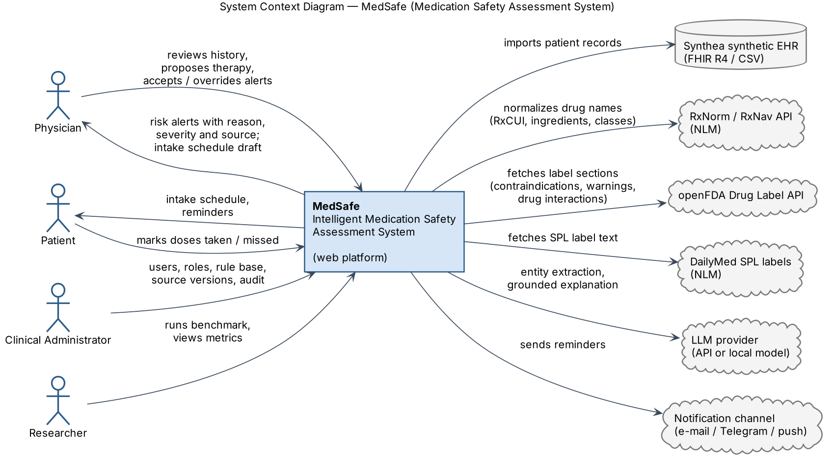
Figure 7.1. System context diagram (source: diagrams/01_context.puml)

7.3 Use cases
Figure 7.2 shows 18 use cases. The central one is UC7 “Run medication safety check”, which includes the four check types and is itself included by proposing therapy (UC6), generating a schedule (UC10, the final regimen is re-checked) and the evaluation benchmark (UC18).
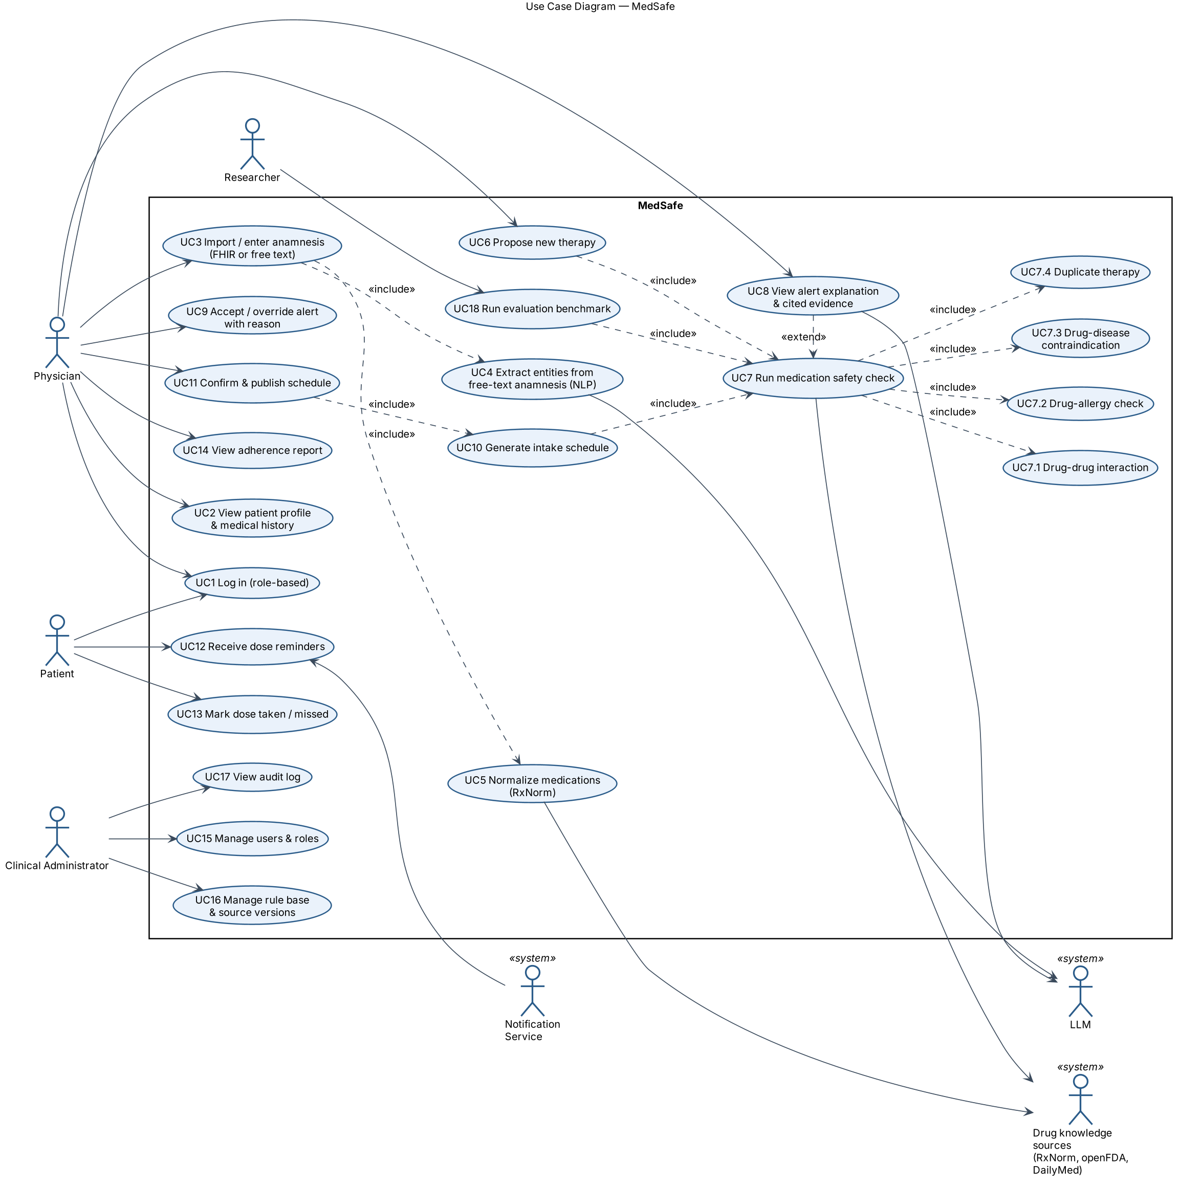
Figure 7.2. Use case diagram (source: diagrams/02_usecase.puml)

7.4 Components (draft)
Figure 7.3 groups components into four layers: presentation (React/Next.js), backend API (FastAPI), AI services (Python) and data/integration (importers, ingestion, reminder workers), over PostgreSQL with pgvector and Redis.
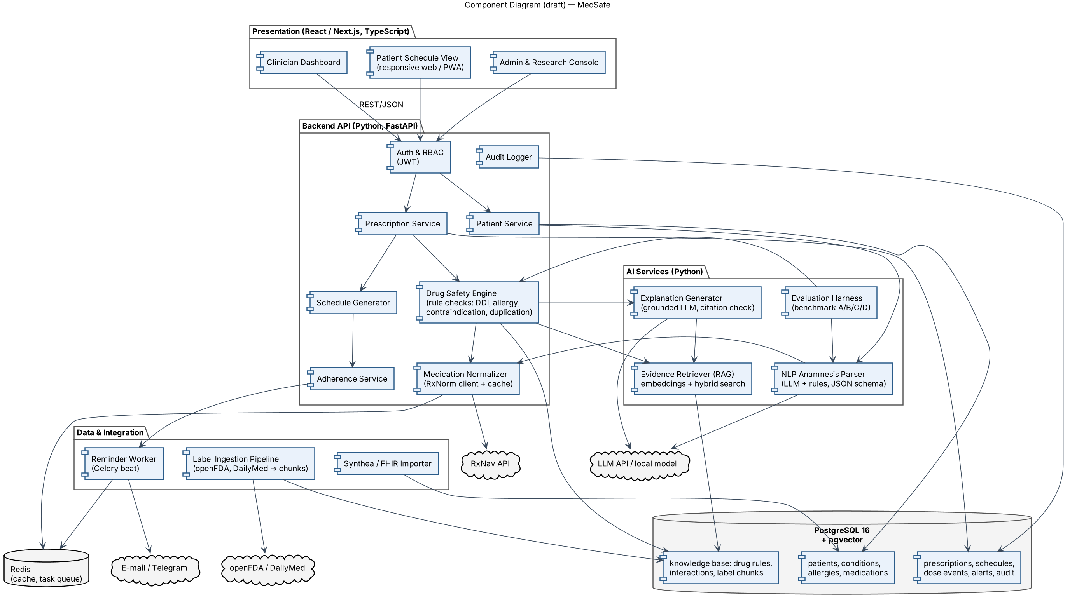
Figure 7.3. Component diagram, draft (source: diagrams/03_component.puml)

7.5 Main processing pipeline
- Collect. Load the structured profile (FHIR) and, if present, free-text notes.
- Extract. The NLP parser returns entities in a JSON schema; the physician confirms them (UC4).
- Normalise. Medication names → RxNorm concept → ingredient RxCUI(s) → classes (RxClass); conditions keep SNOMED CT codes; allergies are mapped to ingredient or class.
- Check. The Drug Safety Engine evaluates the proposed drug against every current drug, allergy and condition using the rule base (DDI, drug–allergy, drug–disease, duplication) and assigns severity.
- Retrieve. For each alert, the RAG module retrieves the matching label passage (filtered by drug and section, ranked by hybrid search).
- Explain. The LLM writes a 1–3 sentence explanation using only the alert and the passage; an automatic check verifies that each statement is supported, otherwise the explanation is replaced by the raw rule text.
- Decide. The physician accepts, overrides (with reason) or chooses an alternative; everything is logged.
- Schedule. The approved regimen is converted into dose times using the patient’s routine and constraints; the final regimen is re-checked; reminders are queued.

7.6 Core data model (outline)
Entity | Key attributes
Patient | id, synthetic_source_id, birth_date, sex, weight
Condition / Allergy / Observation | patient_id, code (SNOMED / RxNorm / LOINC), text, status, onset, reaction
MedicationStatement | patient_id, rxcui, ingredient_rxcuis[], dose, frequency, route, start, end, source (FHIR / note)
Proposal | patient_id, physician_id, rxcui, dose, frequency, duration, intake_condition, status
Rule | id, type (DDI / ALLERGY / DISEASE / DUP), subject, object, severity, mechanism, source_ref, version, active
LabelChunk | set_id, drug_rxcui, section, text, embedding (vector), tsv, retrieved_at
Alert | proposal_id, rule_id, severity, patient_factor, evidence_chunk_id, explanation, explanation_check
Decision | alert_id, physician_id, action (accept / override / cancel), reason, timestamp
Schedule / DoseSlot / DoseEvent | regimen, time, drug, instructions; event status (taken / skipped / missed), timestamp
AuditEntry | user_id, action, entity, payload_hash, timestamp

7.7 Severity model
Level | Meaning | Examples of rule mapping | UI behaviour
Critical | Combination is contraindicated or carries a major risk. | DDInter “Major”; label CONTRAINDICATIONS; allergy to the same ingredient | Red, top of list; override needs a reason
Review | Clinically relevant; monitoring or alternative may be needed. | DDInter “Moderate”; label WARNINGS; duplicate class; allergy class cross-reactivity | Amber; acknowledge
Informational | Low risk or no conflict found, shown for transparency. | DDInter “Minor”; explicit “no conflict” results | Blue; collapsed by default

Keeping only three levels and collapsing informational alerts addresses alert fatigue, one of the main reasons alerts are overridden in practice (Section 3).

7.8 Schedule generation
The schedule generator is a small constraint-satisfaction problem. Inputs: each drug’s frequency (e.g. 3× daily), relation to meals (before / with / after / independent), time-of-day preference (morning / evening / fixed), minimum interval, course start and end; and the patient’s routine (wake, meals, sleep). Hard constraints: minimum interval, meal relation, fixed-time drugs, awake hours, course dates. Soft constraint: minimise the number of distinct reminder times per day, because simpler regimens with fewer daily doses are associated with better adherence [29]. A greedy assignment to anchor times (meals, wake, bedtime) followed by local search is sufficient at this size; the result is shown to the physician for approval. The generator does not change doses or frequencies.

8. UX and Prototype
The mockups below cover the four key scenarios: (1) safety check of a proposed drug, (2) extraction of entities from free-text anamnesis, (3) generation of the intake schedule, (4) the patient’s reminders and adherence view. All data on the mockups are synthetic. The demonstration patient (67-year-old with atrial fibrillation on warfarin, hypertension on lisinopril, CKD stage 3, penicillin allergy, occasional naproxen) is used throughout the document and the defence. The interactions shown (NSAID + warfarin, NSAID + CKD, two NSAIDs) are documented in official ibuprofen labelling; exact label wording will be quoted from the downloaded label version in the implementation. The HTML source of the mockups is in prototype/mockups.html.

8.1 Scenario 1 — Safety check of a proposed medication
The physician proposes ibuprofen 400 mg three times daily. The system shows one critical alert (drug–drug interaction with warfarin), two review alerts (duplicate NSAID therapy with naproxen found in a free-text note; NSAID with chronic kidney disease) and one informational result (no conflict with the penicillin allergy). Each alert shows the patient factor, rule id and source; the right panel shows the retrieved label passage and the result of the automatic explanation check.
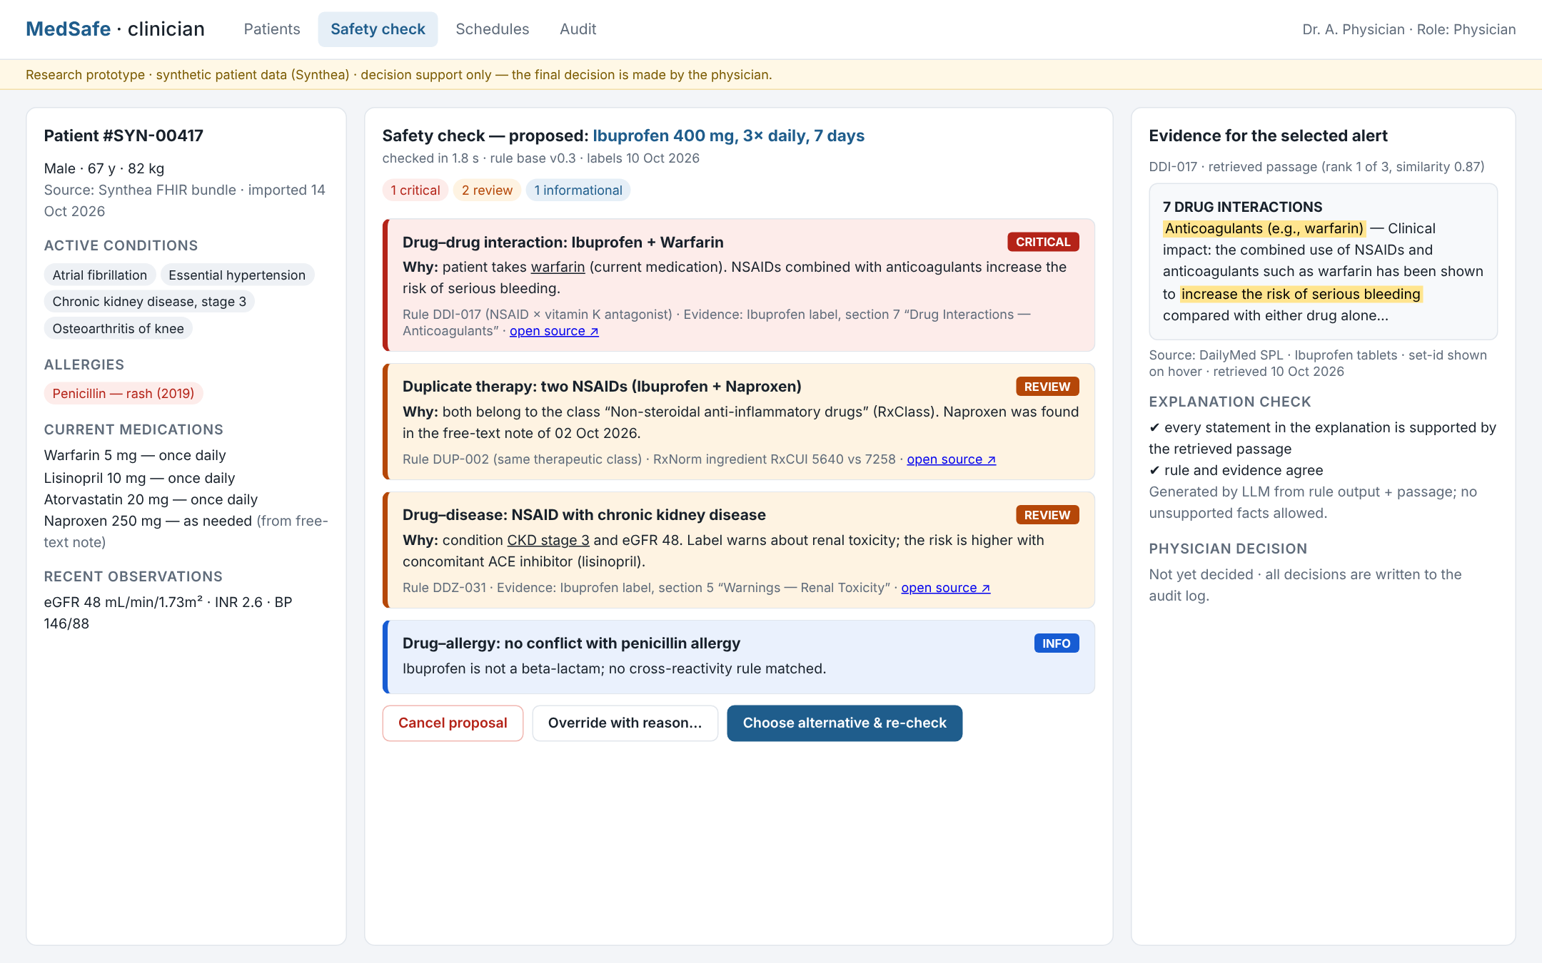
Figure 8.1. Clinician dashboard — safety check with explainable alert cards and evidence panel

8.2 Scenario 2 — Structuring free-text anamnesis
Entities are highlighted in the note and listed with the normalised concept, code and confidence. Ambiguous items (here “knee pain”) are not saved automatically; the physician confirms the list first.
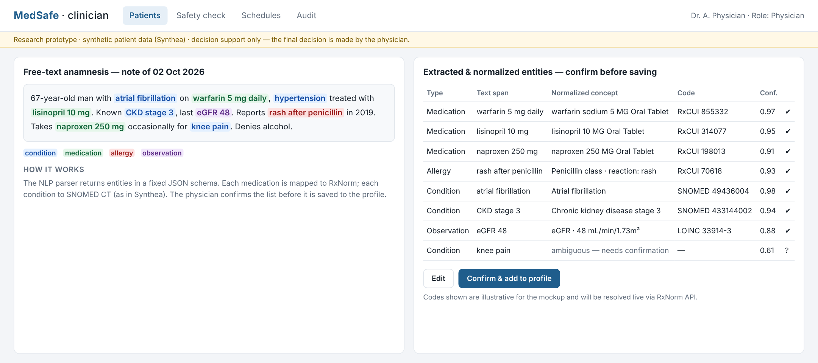
Figure 8.2. NLP extraction and normalisation with physician confirmation

8.3 Scenario 3 — Intake schedule
After the physician replaces ibuprofen with paracetamol, the regimen is re-checked and turned into a schedule with three reminder slots: 08:30 (lisinopril, paracetamol after breakfast), 13:30 (paracetamol after lunch) and 19:30 (paracetamol after dinner, atorvastatin, warfarin). The physician can edit the routine and approves the schedule before it is sent to the patient.
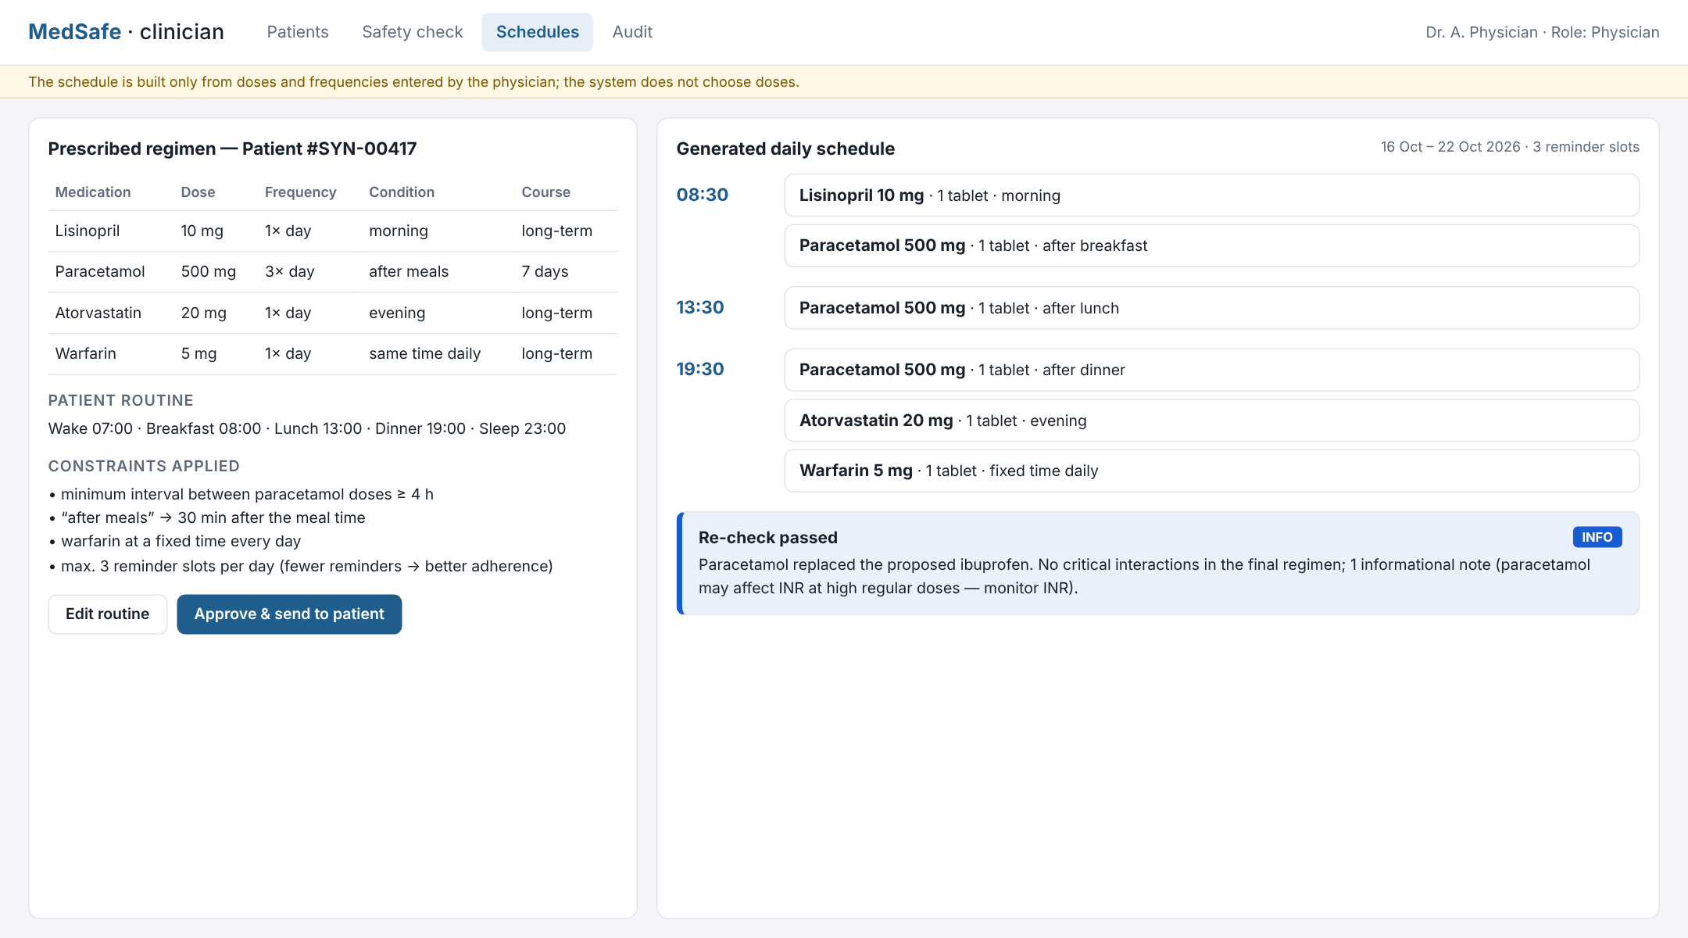
Figure 8.3. Schedule generator — prescribed regimen, constraints, generated schedule

8.4 Scenario 4 — Patient reminders and adherence
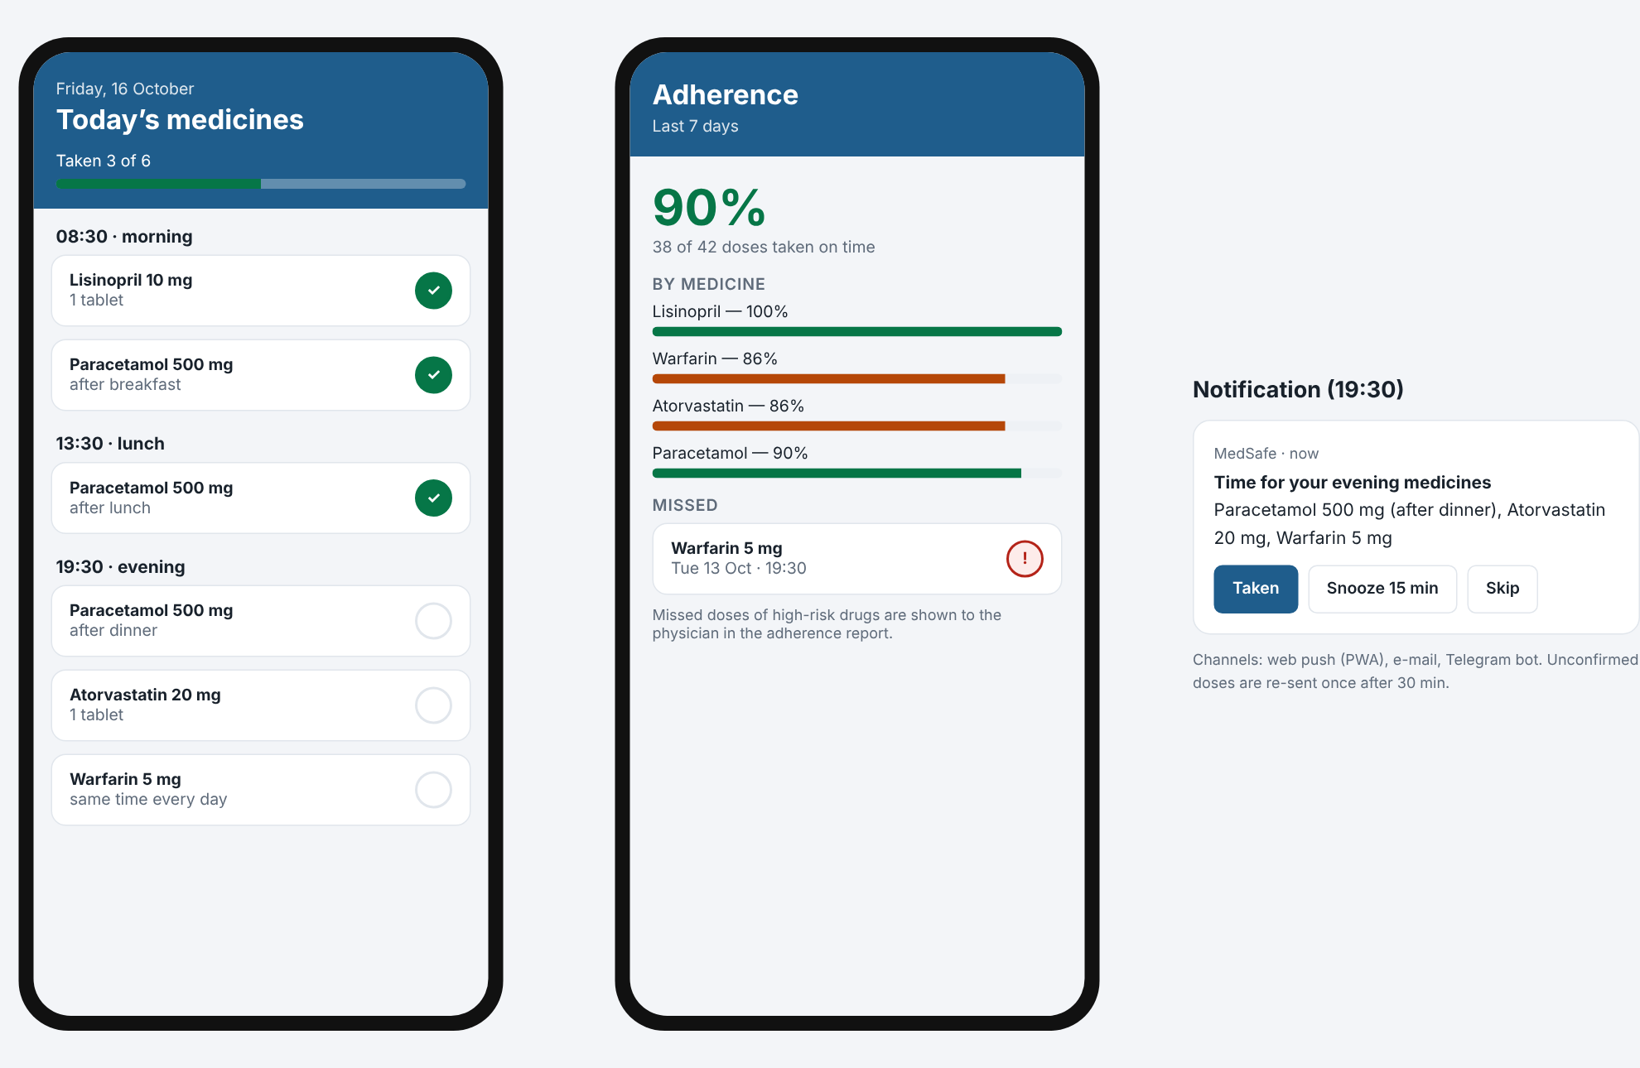
Figure 8.4. Patient view (PWA): today’s doses, adherence for 7 days, reminder notification

8.5 API example — safety check
The frontend and the benchmark use the same endpoint. Example request and (shortened) response:
POST /api/v1/patients/SYN-00417/safety-check
{ "proposed": { "name": "ibuprofen 400 mg tablet", "frequency": "3/day",
"duration_days": 7, "intake": "after_meal" },
"explain": true }

200 OK
{ "check_id": "chk_8f21", "rule_base_version": "0.3", "sources_date": "2026-10-10",
"normalized": { "rxcui": "<resolved via RxNorm>", "ingredients": ["ibuprofen"],
"classes": ["NSAID"] },
"status": "alerts_found",
"alerts": [
{ "type": "DRUG_DRUG", "severity": "critical", "rule_id": "DDI-017",
"patient_factor": { "kind": "medication", "name": "warfarin" },
"evidence": { "source": "DailyMed SPL", "section": "7 DRUG INTERACTIONS",
"chunk_id": "lbl_ibu_7_03", "score": 0.87 },
"explanation": "NSAIDs used with warfarin increase the risk of serious bleeding.",
"explanation_check": "supported" },
{ "type": "DUPLICATE_THERAPY", "severity": "review", "rule_id": "DUP-002", ... },
{ "type": "DRUG_DISEASE", "severity": "review", "rule_id": "DDZ-031", ... } ],
"insufficient_data": [] }

9. Verification and Evaluation Plan
The aim is achieved if the system (a) detects the defined medication risks from patient history more completely and with fewer unsupported statements than simpler approaches, and (b) produces correct intake schedules, while meeting the Must requirements. The evaluation is technical (correct detection of pre-defined risks), not a clinical-outcome study.

9.1 Research question and hypotheses
RQ: Does a hybrid system that combines a deterministic rule base over normalised codes, retrieval from official drug labels and an LLM for extraction and explanation detect relevant medication risks from patient history more accurately and reliably than rule-only or LLM-only approaches?
- H1: The hybrid approach (D) has higher recall than LLM-only (B) and higher recall than keyword rules (A) on scenarios that require information from free-text notes.
- H2: The hybrid approach has a lower hallucination rate in explanations than RAG + LLM without rules (C) and LLM-only (B).
- H3: The false-negative rate on critical scenarios is lowest for D.

9.2 Compared approaches (baselines)
ID | Approach | Description
A | Rules + keyword matching (baseline) | String matching of drug names against the rule base; no normalisation, no free-text extraction.
B | LLM-only (research baseline) | The patient summary and proposed drug are given to the LLM, which lists risks without retrieval.
C | RAG + LLM | The LLM receives retrieved label passages and decides on risks and explanations.
D | Hybrid (proposed) | NLP extraction → RxNorm normalisation → rule engine decides alerts → RAG + LLM explains, with support check.

9.3 Test data
- Patients: 1,000 synthetic patients generated with Synthea (fixed seed), filtered to adults with ≥ 1 chronic condition and ≥ 2 active medications.
- Scenarios: for each patient, a proposed drug from the in-scope groups is added by a scenario generator. Scenario classes: (S1) known drug allergy or class cross-reactivity; (S2) drug–drug interaction; (S3) drug–disease contraindication; (S4) duplicate therapy; (S5) several risks at once; (S6) safe combination — no alert expected; (S7) incomplete data — “insufficient data” expected; (S8) risk factor present only in free text.
- Free-text notes: generated from the structured Synthea record by templates and an LLM paraphraser; because the notes are produced from known structured data, the entity ground truth is known exactly.
- Gold standard: derived from the curated rule base and label sections; a stratified sample of ≥ 100 scenarios is reviewed manually by the team, and by a pharmacist or physician if available (see Section 2). Disagreements are documented.
- Split: development 60 % (rule and prompt tuning), validation 20 % (thresholds), test 20 % (used once for final results). Target size of the test split: ≥ 600 scenarios, ≥ 50 per class.

9.4 Metrics
Metric | What it measures | Target for D
Precision, Recall, F1 (per check type and overall) | Correctness and completeness of alerts vs gold standard | F1 ≥ 0.85
False-negative rate on critical scenarios | Missed dangerous combinations | ≤ 5 %
Severity accuracy | Alert assigned the correct level | ≥ 0.85
Specificity on safe scenarios (S6) | Avoiding unnecessary alerts (alert fatigue) | ≥ 0.90
Abstention accuracy (S7) | “Insufficient data” returned when expected | ≥ 0.90
Entity extraction F1 | NLP module quality (medications, allergies, conditions) | ≥ 0.80
Normalisation accuracy | Correct ingredient RxCUI | ≥ 0.95
Retrieval Recall@5 | Correct label section among top-5 passages | ≥ 0.85
Citation accuracy | Cited passage actually supports the alert | ≥ 0.95
Hallucination rate | Explanation statements not supported by the evidence | ≤ 5 %
Schedule constraint satisfaction | Hard constraints met on 30 schedule test cases | 100 %
Latency p50 / p95 | Response time of safety check | p95 ≤ 3 s (no LLM), ≤ 10 s (with LLM)
SUS score | Perceived usability, ≥ 5 participants | ≥ 70

9.5 Measurement conditions
- Single machine, Docker Compose, fixed versions of model weights, rule base, label download date and Synthea seed; all recorded in the results file.
- Each approach runs on the identical test split; LLM temperature 0; 3 repeated runs for LLM-based approaches, mean and standard deviation reported.
- Statistical comparison of D vs each baseline with McNemar’s test on paired per-scenario outcomes (α = 0.05).
- Hallucination and citation accuracy: automatic NLI-style support check on all explanations plus manual review of a random sample of 100 explanations by two team members (agreement reported).
- Error analysis: every false negative on critical scenarios is categorised (extraction, normalisation, missing rule, retrieval, other).

9.6 Software testing
Level | Scope | Tools
Unit | Rule engine (each check type, ≥ 20 positive and negative cases), normaliser, schedule constraints | pytest, hypothesis
Integration | API + database + RxNav/openFDA clients (recorded responses), Celery reminders | pytest, testcontainers, VCR.py
End-to-end | Scenarios of Section 8 in the browser | Playwright
Non-functional | Latency (NFR-01), role permissions (FR-03), secrets scanning | Locust, pytest, gitleaks
Usability | Task-based test with SUS questionnaire, ≥ 5 participants (medical students / clinicians) | Moderated sessions

10. Project Management and Risks

10.1 Repository and tools
- Git repository: GitHub, private, access for supervisor and committee; branch protection on main; changes via pull requests reviewed by another team member; each submission tagged as required by the department (first submission: prob-period-1); tags are never moved.
- YouTrack project: key MSA; every task has an owner, acceptance criteria, deadline and priority; branch and commit names contain the task id (e.g. MSA-12-context-diagram).
- CI: GitHub Actions - lint, tests, diagram rendering check.

Repository structure
medsafe/
├── README.md project, team, scope, status, links
├── docs/ proposal, reviews, requirements
│ └── adr/ architecture decision records
├── diagrams/ *.puml sources + PNG/SVG
├── prototype/ HTML mockups, screenshots
├── backend/ FastAPI application
├── ai/ NLP parser, RAG, explainer, eval
├── frontend/ Next.js application
├── data/ download scripts (no data)
├── tests/ unit, integration, e2e
├── docker-compose.yml
├── .env.example placeholder values only
└── .gitignore

10.2 Roles and responsibilities
Each member holds several roles: one leading role in a technical area and supporting roles in others. Every pull request is reviewed by the lead of the corresponding area.
Member | Roles | Primary responsibility | Reviews
Yertay Altynay | ML Engineer (lead), Research Head, Backend Developer, Frontend Developer | NLP anamnesis parser, RAG retrieval, explanation generator and support check, rule-base content and severity mapping, literature review, evaluation harness and experiments (Section 9); implements assigned backend endpoints and UI screens | ML and research pull requests
Salemkan Aknur | Head of Backend, DevOps, Business Analyst, UI/UX Designer, ML Developer | Backend architecture, database schema, FastAPI REST API, Synthea/FHIR import, RxNorm normaliser, Drug Safety Engine core, schedule generator, auth/RBAC, audit; Docker and CI; requirements and user interviews; integration of AI modules into the API | Backend and DevOps pull requests
Nuraly Nuray | Project Manager, Head of Frontend, QA Engineer, ML Developer | Project planning, YouTrack, supervisor communication; clinician dashboard, patient PWA, admin console, reminders UI; test plan, end-to-end and usability testing; labelling of test scenarios | Frontend pull requests and documentation

10.3 Milestones
# | Milestone | Target | Exit criterion
M1 | Analysis & design package (this document), repository, YouTrack | 24 Oct 2026 (first submission) | All 11 components submitted; tag prob-period-1
M2 | Data layer: Synthea import, RxNorm normaliser, rule base v0.1 (DDInter + labels for in-scope groups) | Nov 2026 | FR-01, FR-02, FR-05 accepted
M3 | Drug Safety Engine (4 check types) + REST API + basic dashboard | Dec 2026 | FR-06–FR-08, FR-11 accepted; unit suite green
M4 | NLP parser + RAG + explanations; test-set generator | Jan–Feb 2027 | FR-04, FR-09, FR-10 accepted
M5 | Schedule generator, reminders, adherence; integration | Feb–Mar 2027 | FR-12, FR-13, FR-16 accepted; second submission
M6 | Experiments A–D, error analysis, usability test | Mar–Apr 2027 | Metrics table and SUS results
M7 | Hardening, documentation, thesis text | Apr–May 2027 | Final submission tag; thesis submitted

Submission dates after M1 follow the department schedule; targets will be aligned when the schedule is published. Each submission is tagged in Git with the name required by the department (first submission: prob-period-1).

10.4 Task plan until 24 October 2026
Task | Owner | Due | Acceptance criterion
MSA-1 Create GitHub repo, structure, .gitignore, README; invite team and supervisor | Aknur and Nuray | 22 Oct | Supervisor has access; README has all required sections
MSA-2 Set up YouTrack project and board; create tasks with owners, priorities, deadlines | Aknur and Altynay | 19 Oct | Link in README; all tasks assigned
MSA-3 Proposal and scope (Section 1) | Nuray | 20 Oct | Reviewed by supervisor
MSA-4 Interview guide; conduct 3–5 interviews with clinicians/pharmacists | Aknur | 23 Oct | Notes in docs/interviews; findings table (Section 2.3) filled
MSA-5 Literature review and analysis table | Altynay | 21 Oct | ≥ 12 sources, ≥ 8 scientific, table complete
MSA-6 Existing system comparison | Nuray | 21 Oct | 5 systems × 10 criteria with source links
MSA-7 Technology comparison + ADRs | Nuray | 21 Oct | 6 decisions documented as ADRs
MSA-8 Requirements and acceptance criteria | Aknur | 22 Oct | FR/NFR tables approved by supervisor
MSA-9 Context, use case, component diagrams (sources + exports) | Altynay | 22 Oct | .puml + PNG in diagrams/
MSA-10 Mockups of 4 key scenarios | Aknur | 23 Oct | HTML + PNG in prototype/
MSA-11 Verification and evaluation plan | Altynay | 22 Oct | Section 9 approved; testing part reviewed by QA
MSA-12 Pilot: download Synthea sample; normalise 10 drug names via RxNorm API | Aknur | 23 Oct | Script in data/ runs; short report
MSA-13 Rule-base pilot: DDInter records for in-scope drug groups | Altynay | 23 Oct | 20+ records with severity and source; Rule format agreed with backend
MSA-14 Supervisor review, feedback log, tag prob-period-1, submission form | Nuray | 24 Oct, 18:00 | Tag created; feedback table (Section 11) filled; form submitted

10.5 Risks
Table 10.1. Risk register
ID | Risk | Probability | Impact | Mitigation
R1 | Medical complexity exceeds team expertise; incorrect rules | High | High | Narrow scope to 4 drug groups; rules come only from DDInter and labels, never invented; expert review of a sample; position as decision support
R2 | No access to clinicians for interviews or expert review | Medium | High | Start contacts now (university clinic, pharmacy faculty, family members in healthcare); fallback: published survey/interview studies, clearly labelled as secondary evidence
R3 | LLM hallucinations in explanations | High | Medium | LLM cannot create alerts; support check; fallback to rule text; measured hallucination rate
R4 | External APIs unavailable or rate-limited (RxNav, openFDA) | Medium | Medium | Local cache and snapshot of all used data; recorded responses for tests
R5 | Insufficient hardware for local LLM | Medium | Medium | Quantised 7–8B models; hosted API for synthetic data only; smaller models for extraction
R6 | Synthetic notes too simple; NLP results overestimated | Medium | Medium | LLM paraphrasing, abbreviations and typos added; manual realistic notes subset; report limitation
R7 | Licensing of knowledge sources | Low | High | Use DDInter (CC BY-NC-SA, non-commercial), public-domain FDA labels, NLM terms; attribute sources in UI and thesis
R8 | Uneven workload or member unavailable | Medium | Medium | Weekly sync; YouTrack board; each module has a secondary owner; pull-request reviews
R9 | Scope creep (more drugs, mobile app, real EHR integration) | Medium | Medium | Changes only via supervisor-approved change request; PWA instead of native app

10.6 Dependencies
- Synthea generator / sample datasets (Apache 2.0) - patients.
- RxNorm and RxNav APIs (NLM) - drug normalisation and classes; NLM terms of service.
- openFDA Drug Label API and DailyMed - label sections; local snapshot with date.
- DDInter 2.0 - seed for the rule base (CC BY-NC-SA 4.0).
- LLM runtime (Ollama/vLLM) and hardware with GPU or sufficient RAM.
- Access to 3–5 clinicians or pharmacists for interviews and expert review.
- Supervisor availability for weekly reviews.

11. Supervisor Feedback
Table 11.1. Supervisor feedback log
# | Date | Deliverable reviewed | Supervisor comment | Decision / action | Evidence (task, commit)
1 |  | Proposal and scope
2 |  | Requirements
3 |  | Architecture diagrams
4 |  | Evaluation plan
5

Suggested questions to discuss with the supervisor: (1) is the 4-group scope sufficient for the engineering complexity expected; (2) is a technical evaluation on synthetic data acceptable, or is an expert-reviewed subset mandatory; (3) can the hosted LLM be used for synthetic data; (4) which dates are set for the second submission.

References
[1] World Health Organization. Medication Without Harm — WHO Global Patient Safety Challenge on Medication Safety. Geneva: WHO; 2017 (WHO/HIS/SDS/2017.6). https://www.who.int/initiatives/medication-without-harm
[2] van der Sijs H, Aarts J, Vulto A, Berg M. Overriding of drug safety alerts in computerized physician order entry. Journal of the American Medical Informatics Association. 2006;13(2):138–147. doi:10.1197/jamia.M1809
[3] Poly TN, Islam MM, Yang HC, Li YC. Appropriateness of overridden alerts in computerized physician order entry: systematic review. JMIR Medical Informatics. 2020;8(7):e15653. doi:10.2196/15653
[4] Ji Z, Lee N, Frieske R, et al. Survey of hallucination in natural language generation. ACM Computing Surveys. 2023;55(12):Article 248. doi:10.1145/3571730
[5] Al-Ashwal FY, Zawiah M, Gharaibeh L, Abu-Farha R, Bitar AN. Evaluating the sensitivity, specificity, and accuracy of ChatGPT-3.5, ChatGPT-4, Bing AI, and Bard against conventional drug-drug interactions clinical tools. Drug, Healthcare and Patient Safety. 2023;15:137–147. doi:10.2147/DHPS.S425858
[6] Hodkinson A, Tyler N, Ashcroft DM, et al. Preventable medication harm across health care settings: a systematic review and meta-analysis. BMC Medicine. 2020;18:313. doi:10.1186/s12916-020-01774-9
[7] Panagioti M, Khan K, Keers RN, et al. Prevalence, severity, and nature of preventable patient harm across medical care settings: systematic review and meta-analysis. BMJ. 2019;366:l4185. doi:10.1136/bmj.l4185
[8] Bates DW, Levine DM, Salmasian H, et al. The safety of inpatient health care. New England Journal of Medicine. 2023;388(2):142–153. doi:10.1056/NEJMsa2206117
[9] Villa Zapata L, Subbian V, Boyce RD, et al. Overriding drug-drug interaction alerts in clinical decision support systems: a scoping review. Studies in Health Technology and Informatics. 2022;290:380–384. doi:10.3233/SHTI220101
[10] Fung KW, Kapusnik-Uner J, Cunningham J, Higby-Baker S, Bodenreider O. Comparison of three commercial knowledge bases for detection of drug-drug interactions in clinical decision support. Journal of the American Medical Informatics Association. 2017;24(4):806–812. doi:10.1093/jamia/ocw159
[11] Kontsioti E, Maskell S, Bensalem A, Dutta B, Pirmohamed M. Similarity and consistency assessment of three major online drug–drug interaction resources. British Journal of Clinical Pharmacology. 2022;88(9):4067–4079. doi:10.1111/bcp.15341
[12] Juhi A, Pipil N, Santra S, et al. The capability of ChatGPT in predicting and explaining common drug-drug interactions. Cureus. 2023;15(3):e36272. doi:10.7759/cureus.36272
[13] Xiong G, Jin Q, Lu Z, Zhang A. Benchmarking retrieval-augmented generation for medicine. In: Findings of the Association for Computational Linguistics: ACL 2024. 2024:6233–6251. doi:10.18653/v1/2024.findings-acl.372
[14] Zakka C, Shad R, Chaurasia A, et al. Almanac — retrieval-augmented language models for clinical medicine. NEJM AI. 2024;1(2). doi:10.1056/AIoa2300068
[15] Lanke V, Trimm K, Habib B, Tamblyn R. Evaluating the effectiveness of mobile apps on medication adherence for chronic conditions: systematic review and meta-analysis. Journal of Medical Internet Research. 2025;27:e60822. doi:10.2196/60822
[16] Amann J, Blasimme A, Vayena E, Frey D, Madai VI. Explainability for artificial intelligence in healthcare: a multidisciplinary perspective. BMC Medical Informatics and Decision Making. 2020;20:310. doi:10.1186/s12911-020-01332-6
[17] Antoniadi AM, Du Y, Guendouz Y, et al. Current challenges and future opportunities for XAI in machine learning-based clinical decision support systems: a systematic review. Applied Sciences. 2021;11(11):5088. doi:10.3390/app11115088
[18] U.S. National Library of Medicine. RxNav Drug Interaction API — discontinuation notice (“will be discontinued on or about January 2, 2024”). https://lhncbc.nlm.nih.gov/RxNav/APIs/InteractionAPIs.html (accessed 16 Oct 2026)
[19] Tian Y, Yi J, Wang N, et al. DDInter 2.0: an enhanced drug interaction resource with expanded data coverage, new interaction types, and improved user interface. Nucleic Acids Research. 2025;53(D1):D1356–D1362. doi:10.1093/nar/gkae726
[20] openFDA. Drug Label API — searchable fields (contraindications, warnings, drug_interactions, boxed_warning). https://open.fda.gov/apis/drug/label/ (accessed 16 Oct 2026)
[21] U.S. National Library of Medicine. DailyMed. https://dailymed.nlm.nih.gov/dailymed/ (accessed 16 Oct 2026)
[22] Henry S, Buchan K, Filannino M, Stubbs A, Uzuner Ö. 2018 n2c2 shared task on adverse drug events and medication extraction in electronic health records. Journal of the American Medical Informatics Association. 2020;27(1):3–12. doi:10.1093/jamia/ocz166
[23] Agrawal M, Hegselmann S, Lang H, Kim Y, Sontag D. Large language models are few-shot clinical information extractors. In: Proceedings of EMNLP 2022. 2022:1998–2022. doi:10.18653/v1/2022.emnlp-main.130
[24] Hu Y, Chen Q, Du J, et al. Improving large language models for clinical named entity recognition via prompt engineering. Journal of the American Medical Informatics Association. 2024;31(9):1812–1820. doi:10.1093/jamia/ocad259
[25] Lewis P, Perez E, Piktus A, et al. Retrieval-augmented generation for knowledge-intensive NLP tasks. In: Advances in Neural Information Processing Systems 33 (NeurIPS 2020). 2020:9459–9474.
[26] Amugongo LM, Mascheroni P, Brooks S, Doering S, Seidel J. Retrieval augmented generation for large language models in healthcare: a systematic review. PLOS Digital Health. 2025;4(6):e0000877. doi:10.1371/journal.pdig.0000877
[27] Walonoski J, Kramer M, Nichols J, et al. Synthea: an approach, method, and software mechanism for generating synthetic patients and the synthetic electronic health care record. Journal of the American Medical Informatics Association. 2018;25(3):230–238. doi:10.1093/jamia/ocx079
[28] Nelson SJ, Zeng K, Kilbourne J, Powell T, Moore R. Normalized names for clinical drugs: RxNorm at 6 years. Journal of the American Medical Informatics Association. 2011;18(4):441–448. doi:10.1136/amiajnl-2011-000116
[29] Claxton AJ, Cramer J, Pierce C. A systematic review of the associations between dose regimens and medication compliance. Clinical Therapeutics. 2001;23(8):1296–1310. doi:10.1016/S0149-2918(01)80109-0
[30] U.S. Food and Drug Administration. Clinical Decision Support Software: Guidance for Industry and Food and Drug Administration Staff (revised final guidance). January 2026. https://www.fda.gov/regulatory-information/search-fda-guidance-documents/clinical-decision-support-software
[31] Wolters Kluwer. UpToDate Lexidrug — clinical modules (interactions, allergy and duplicate therapy screening, risk ratings A–X). https://wolterskluwer.com/en/solutions/uptodate/resources/lexidrug-user-academy/clinical-modules; EHR integration: https://www.wolterskluwer.com/en/solutions/uptodate/about/ehr-integration (accessed 16 Oct 2026)
[32] Merative. Micromedex Core Drug Reference — data sheet; Drug Interactions editorial policy; AI-powered search data sheet. https://assets.merative.com/m/1a0c4de488d44d85/original/Micromedex_Core-Drug-Reference_Data-Sheet.pdf; https://assets.merative.com/m/4ca06ad3981a94ab/original/MDX_Drug_Interactions_Policy.pdf (accessed 16 Oct 2026)
[33] Drugs.com. Drug Interaction Checker. https://www.drugs.com/drug_interactions.html (accessed 16 Oct 2026)
[34] Medisafe. Platform and Medisafe Pill Reminder app listing (App Store). https://medisafe.com/platform; https://apps.apple.com/app/id573916946 (accessed 16 Oct 2026)
[35] EmAI. Official website https://emai.kz; Digital Business, 9 Oct 2025, article on EmAI online clinic https://digitalbusiness.kz/2025-10-09/kazahstanka-otkazalas-ot-uspeshnoy-kareri-chtobi-zapustit-onlayn-kliniku-vot-kak-ona-rabotaet/ (accessed 16 Oct 2026)
[36] smartpatient GmbH. MyTherapy medication reminder. https://www.mytherapyapp.com/ (accessed 16 Oct 2026)
[37] Republican Center for Electronic Health (RCEZ). Register of medical information systems of the Republic of Kazakhstan (Damumed; Documedica.ai). https://rcez.kz/mis (accessed 16 Oct 2026)
[38] Damumed patient app (App Store listing) https://apps.apple.com/us/app/-/id1238801709; ISSAI. ISSAI and Damumed presented an AI-powered voice assistant to help physicians reduce administrative burden, 16 June 2026 https://issai.nu.edu.kz/2026/06/16/issai-and-damumed-presented-an-ai-powered-voice-assistant-to-help-physicians-reduce-administrative-burden/ (accessed 16 Oct 2026)
[39] Documedica.ai. Official website https://documedica.ai/ru/; patient app (Google Play) https://play.google.com/store/apps/details?id=kz.documedica.client (accessed 16 Oct 2026)

