Development of an Intelligent System for Medication Safety Assessment Based on Patient Medical History

7. Architecture and Diagrams

Architectural principles
- Rules decide, AI explains. Alerts are generated by the deterministic Drug Safety Engine over normalised codes; NLP and LLM components prepare inputs and explain outputs, but cannot add or remove alerts (NFR-03).
- Evidence first. Every rule and every explanation is linked to a stored source passage with source date and version (FR-28, NFR-10).
- Fail safe. Unknown or unmapped data produces “insufficient data”, never “no risk” (NFR-04).
- Human in the loop. The doctor confirms extracted entities, decides on alerts and approves the schedule before it reaches the patient (FR-18, NFR-05).
- Modular monolith. One deployable backend with clear module boundaries, plus asynchronous workers; simple to run, easy to split later.
- Privacy by design. The Administrator sees only counts, clinics, doctors and pseudonymised journals; patient data and the language model stay inside the clinic deployment (FR-02, NFR-08).

7.1 System context diagram
Figure 7.1 is drawn in C4-model notation (level 1, system context): people in dark blue, the system in scope in blue, external systems in grey; every relationship states its purpose and technology. MedGuard has three user roles. The Patient creates a profile, writes the own medical history and books an appointment in a free slot. The Doctor, of any specialty, publishes free slots, reviews the history at the appointment, checks the own prescription and approves the intake schedule. The Administrator only views the number of clinics, the doctors of each clinic and the login and event journals, without any personal data. Five external systems are involved: the Telegram Bot API delivers reminders, the pre-visit questionnaire and bot replies to the patient; RxNorm/RxNav is used to normalise drug names (with a local cache); openFDA, DailyMed and DDInter 2.0 are sources of label text and rule-base data that are loaded by the team’s scripts before run time (dashed arrows), so at run time the application reads only its own database. The language model runs locally inside the system boundary.

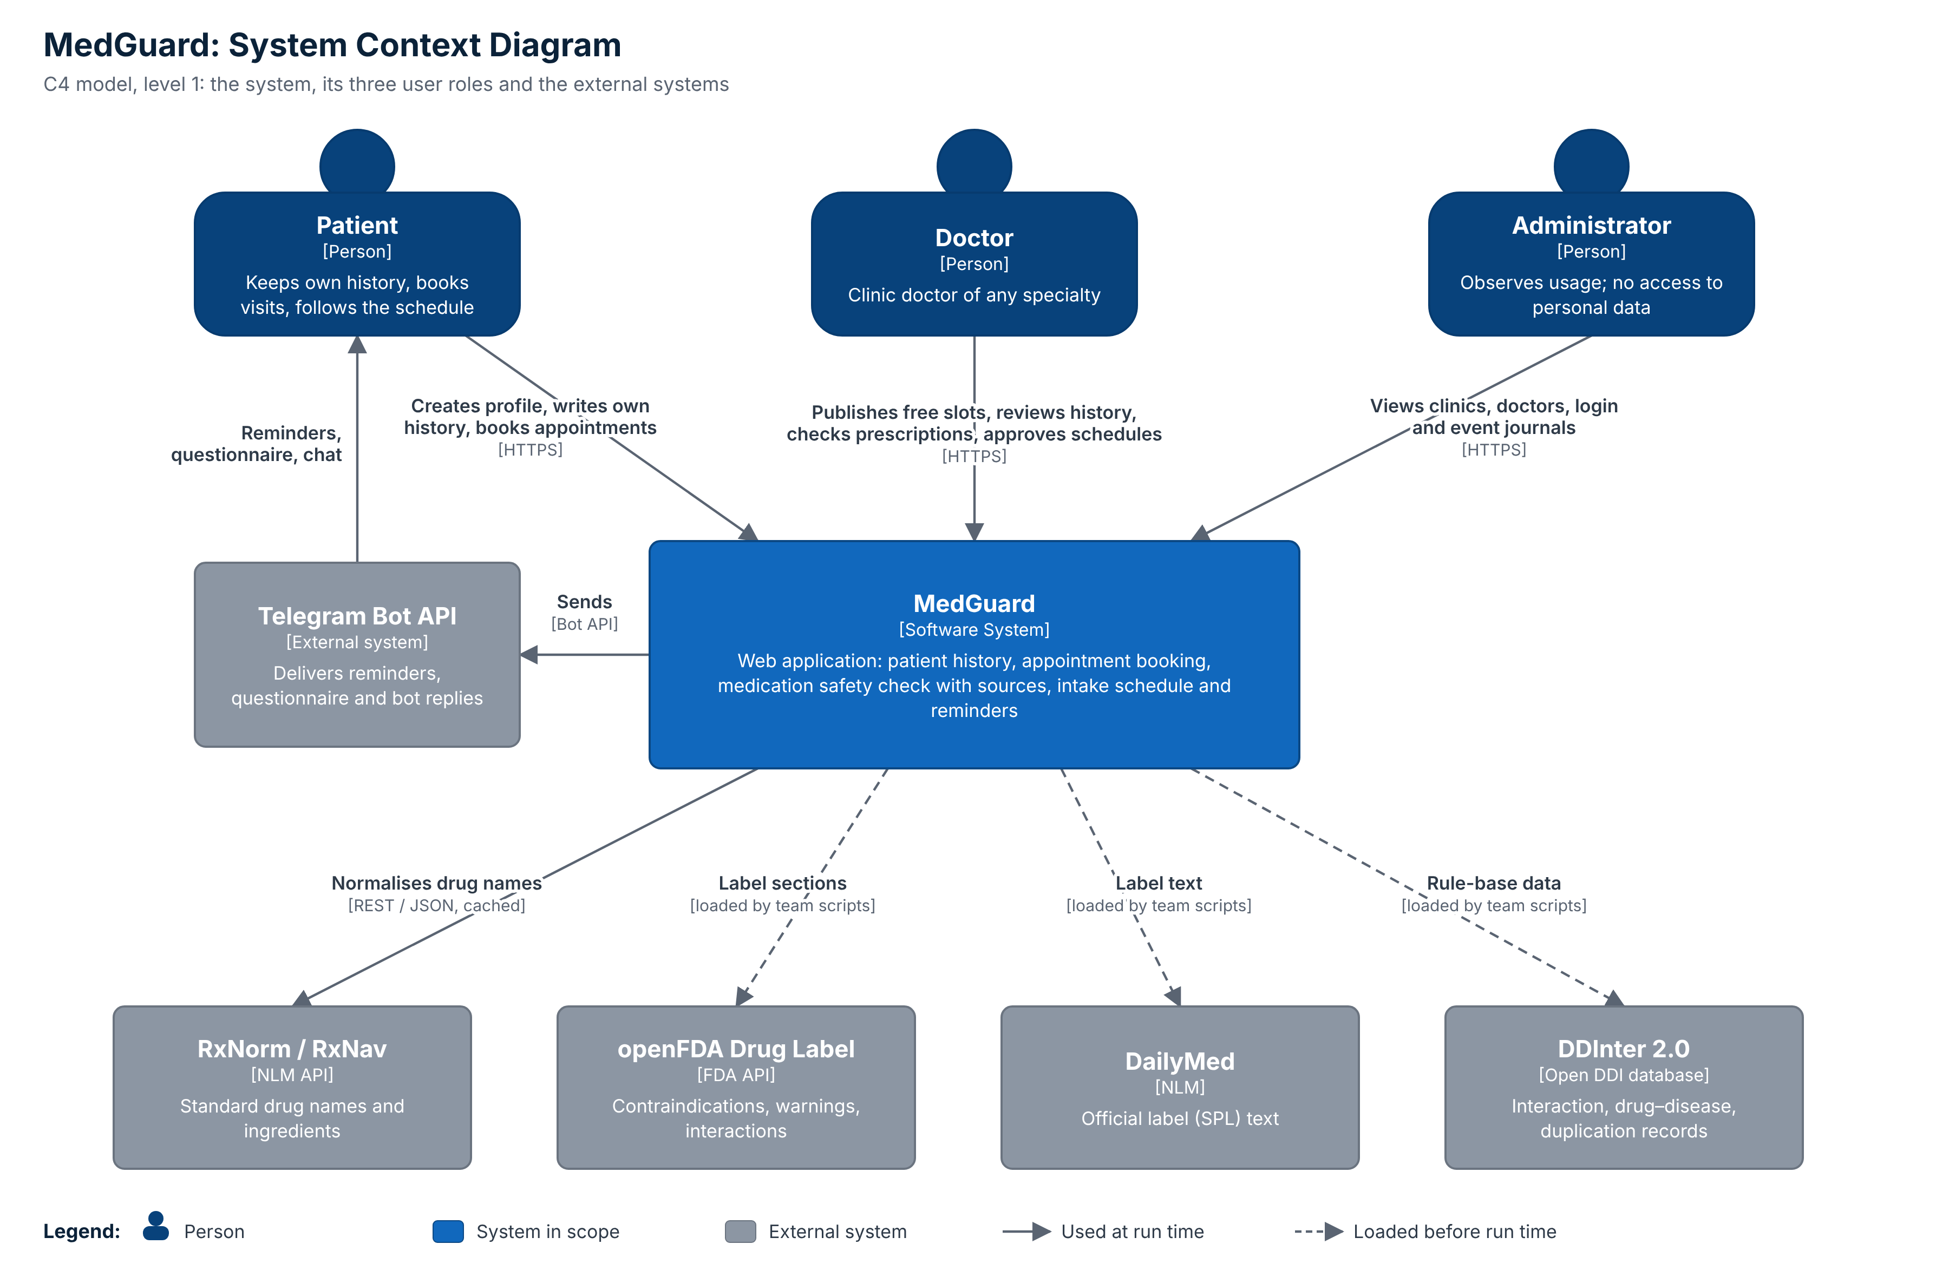
Figure 7.1. System context diagram (editable source: diagrams/context-diagram.drawio)

7.3 Component diagram (draft)
Figure 7.3 uses C4-model notation (level 3, components): containers are dark blue, components light blue, data stores are cylinders and external systems grey; dashed frames mark boundaries. Three web front ends (Patient Web Interface, Doctor Workspace and a read-only Administrator Dashboard) call one API Application. Its components serve the three roles: Profile & History, Scheduling & Booking and Visit & Prescription for patients and doctors; Clinic Directory and Usage & Log Reader for the Administrator, returning only counts, clinics, doctors and pseudonymised journals (FR-02, FR-39 to FR-42). The Drug Safety Engine checks a proposed medicine for interactions, allergy, contraindication, duplicate therapy and dose range (FR-22 to FR-26) after the Medication Normalizer has mapped brand and generic names to active ingredients (FR-19). The AI Service runs the NLP parser, the explanation generator with evidence support check and the evidence retriever on a local model. Background workers send reminders and run the Telegram bot. The Audit Logger records sign-ins, record openings, checks, accepted risks, bookings, cancellations and profile changes (FR-45). Offline data preparation scripts (synthetic data generator, rule-base importer, label ingestion) run before deployment and are not part of the running application.

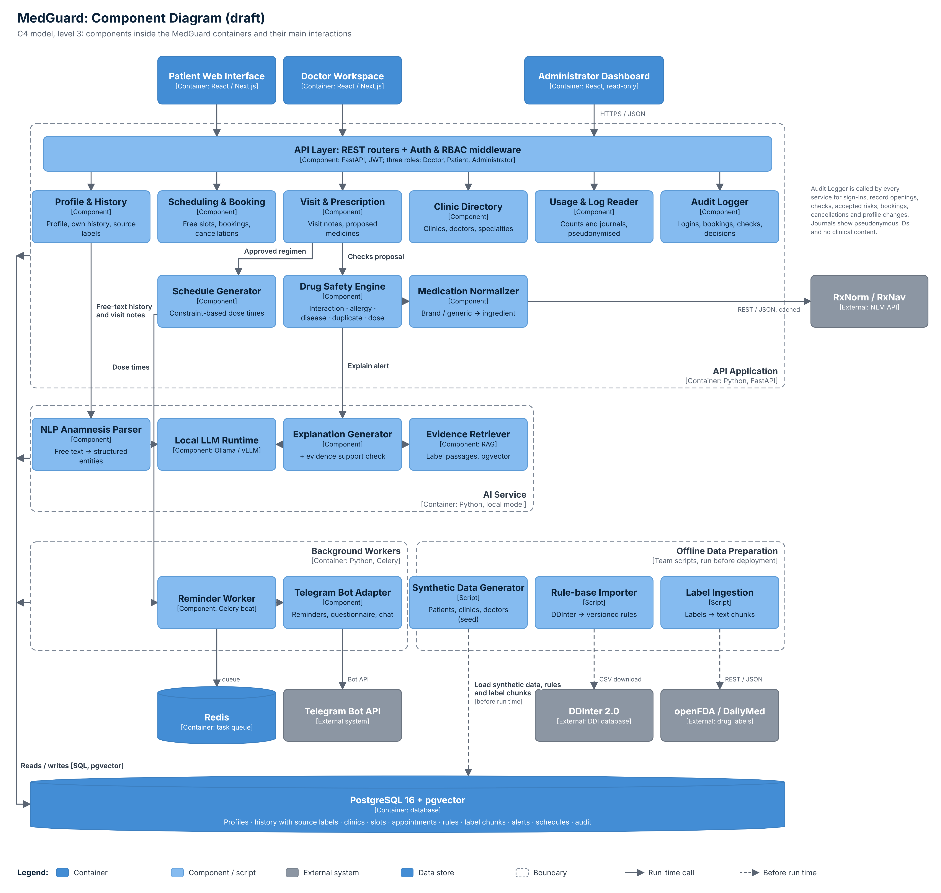
Figure 7.3. Component diagram, draft (editable source: diagrams/component-diagram.drawio)

Main processing pipeline across components
- Collect. Load the patient profile and history (patient-reported and doctor-confirmed entries) and the free-text visit note.
- Extract. The NLP parser returns entities in a JSON schema; the doctor confirms them (UC-14).
- Normalise. Medication names → RxNorm concept → ingredient RxCUI(s) → classes (RxClass); conditions keep ICD-10 codes (FR-08); allergies are mapped to ingredient or class.
- Check. The Drug Safety Engine evaluates the proposed drug against every confirmed drug, allergy and condition using the rule base (interaction, allergy, contraindication, duplication, dose range) and assigns a level (UC-16).
- Retrieve. For each alert, the RAG module retrieves the matching label passage (filtered by drug and section, ranked by hybrid search).
- Explain. The LLM writes a 1–3 sentence explanation using only the alert and the passage; an automatic check verifies that each statement is supported, otherwise the explanation is replaced by the raw rule text.
- Decide. The doctor accepts a risk with a mandatory comment or chooses an alternative (UC-18, UC-19); everything is logged.
- Schedule. The approved regimen is converted into dose times using the patient’s routine and constraints; the final regimen is re-checked; reminders are sent through Telegram (UC-20, UC-07).

