


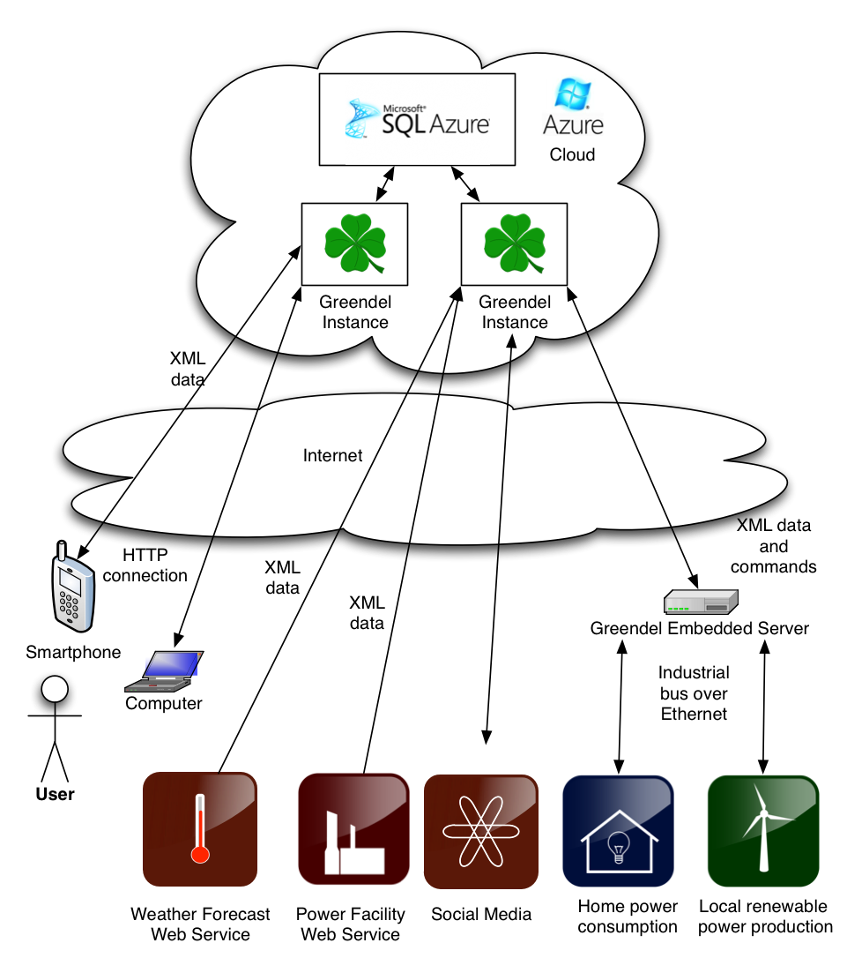
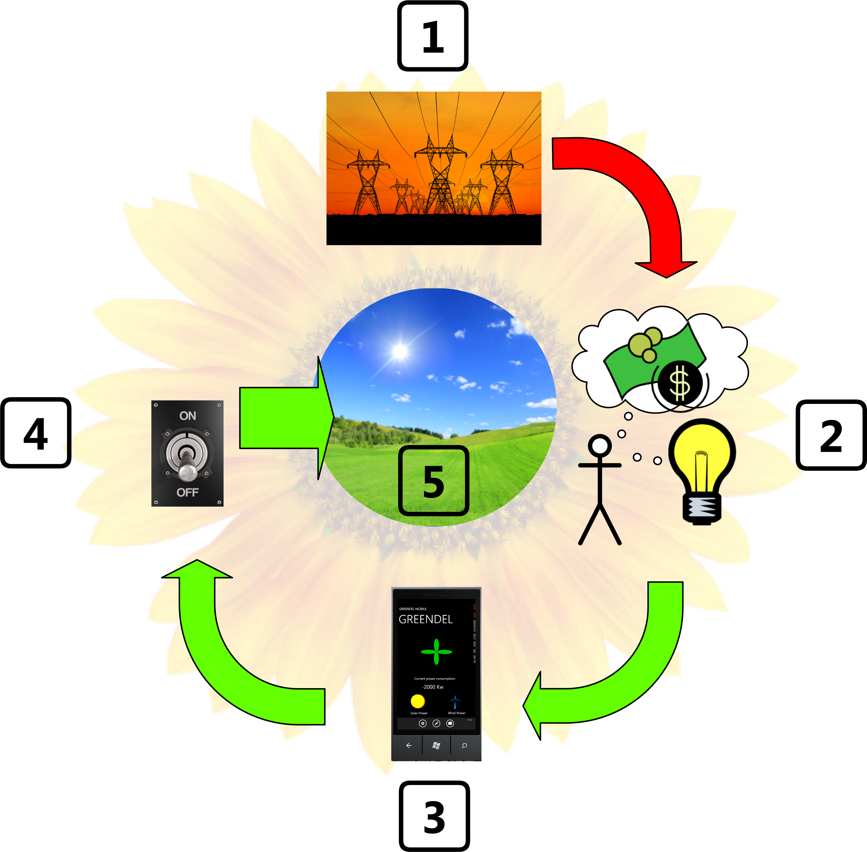
Current problem
When people consume resources in a household, they are not immediately aware of the consequences of their actions. Especially when it comes to consuming electricity, the feedback for consumption can come months later. When people are not aware of the exact relation of using electrical devices and the power consumption, they might accidentally consume more resources than necessary and at the same time get a larger electrical bill. When fossil fuels start to run out and more households are starting to turn to using local renewable resources for power generation, they are not used to regulating their own power consumption despite being responsible for producing a part of their own electricity.
Solution
Our solution is to provide a full system for monitoring power consumption and local power production by leveraging the latest mobile technologies. We hope that by showing the link between different actions and energy consumption we encourage users of the system to regulate their energy usage. This leads to increased savings to the user and conservation of natural resources. In case using local renewable resources will become more common in households, users of the system will already have the proper mindset of thinking about energy usage.
Greendel system
The Greendel system combines several different components into one service by using a centralized web service that harnesses the power of Azure cloud hosting. The scalable web service retrieves power consumption data from several different providers and feeds it to one of the graphical interfaces. In addition to having a web interface, the system has a phone application for providing all the data for the user on the go. It can interact with other online systems, retrieving weather data or publishing savings data to social media.
greendel
Greendel system structure
Project Greendel vision
economical incentive to save non-renewable resources
Imagine Cup 2011
Competition entry
Software Design
Interoperability Award
Team Clover
Janne Ariluoto
Harri Johansson
Antti Knutas
Tommi Kähkönen

