INTRODUCTION

1.1 INTERNET BANKING
Banks have traditionally been in the forefront of harnessing technology to improve their products, services and efficiency. They have, over a long time, been using electronic and telecommunication networks for delivering a wide range of value added products and services. The delivery channels include direct dial – up connections, private networks, public networks etc and the devices include telephone, Personal Computers including the Automated Teller Machines, etc. With the popularity of PCs, easy access to Internet and World Wide Web (WWW), Internet is increasingly used by banks as a channel for receiving instructions and delivering their products and services to their customers. This form of banking is generally referred to as Internet Banking, although the range of products and services offered by different banks vary widely both in their content and sophistication.

1.2 WHAT IS JAVA

JAVA is a high level programming language which evolved from the earlier versions like C++.The Java programming language consists out of a Java compiler, the Java virtual machine, and the Java class libraries. The Java virtual machine (JVM) is a software implementation of a computer that executes programs like a real machine.The Java compiler translates Java coding into so-called byte-code. The Java virtual machine interprets this byte-code and runs the program.The Java virtual machine is written specifically for a specific operating system.The Java runtime environment (JRE) consists of the JVM and the Java class libraries. The target of Java is to write a program once and then run this program on multiple operating systems.
Java has the following properties:
- Platform independent
- Object-orientated programming language
- Strongly-typed programming language
- Interpreted and compiled language
- Automatic memory management.

REQUIREMENTS

HARDWARE:
SOFTWARE:
1.)Windows platform.
2).MY-SQL installed on windows platform.
3).Eclipse 3.3 installed on windows platform.
4).Apache tomcat installed on windows platform.
5).mysql connector 5.1.8 installed on windows platform.

OVERVIEW OF THE PROJECT

System Description:
The proposed system is used to maintain a account record of all the customers of a Bank (RR) by storing entries for customer(i.e. account details),investments and showing their account summary. It also allows the customer to view their account without going to the bank and transaction can be done online.
The customer need to login to his account by the provided username and id through the bank.
The project has the following parts:
- The user login, through which the customer logs in his/her account to view his account.
- After login the customer can view his account summary, download forms online.
- A customer can open a new account online through his previous account.
- Customer can transfer the money from his account to the other customer’s account.
- The changed username and password can be send through the sms.
- He/she can change his profile details.

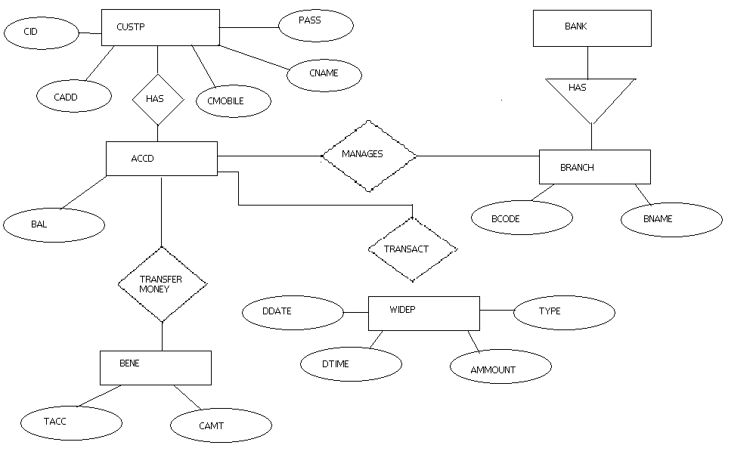
E-R DIAGRAM

CODE
=====================================================================================
MAIN PAGE (1ST.JSP)
<%@ page language="java" contentType="text/html; charset=ISO-8859-1"
pageEncoding="ISO-8859-1"%>
<!DOCTYPE html PUBLIC "-//W3C//DTD HTML 4.01 Transitional//EN" "http://www.w3.org/TR/html4/loose.dtd">
<html>
<head>
<meta http-equiv="Content-Type" content="text/html; charset=ISO-8859-1">
<title>Insert title here</title>
<style type="text/css">

body{
margin:0;
padding:0;
line-height: 1.5em;
}

b{font-size: 110%;}
em{color: red;}

#maincontainer{
width: 840px; /*Width of main container*/
margin: 0 auto; /*Center container on page*/
}

#topsection{
background: #CCCCFF;
height: 90px; /*Height of top section*/
}

#topsection h1{
margin: 0;
padding-top: 15px;
}

#contentwrapper{
float: left;
width: 100%;
background: #3399FF;
height:500px;
}

#contentcolumn{
margin-left: 200px; /*Set left margin to LeftColumnWidth*/
}

#leftcolumn{
float: left;
width: 200px; /*Width of left column*/
height:500px;
margin-left: -840px; /*Set left margin to -(MainContainerWidth)*/
background: #C8FC98;

}

#footer{
clear: left;
width: 100%;
background: black;
color: #FFF;
text-align: center;
padding: 4px 0;
}

#footer a{
color: #FFFF80;
}

.innertube{
margin: 10px; /*Margins for inner DIV inside each column (to provide padding)*/
margin-top: 0;

}
li {display:inline;}
</style>

<script type="text/javascript">
/*** Temporary text filler function. Remove when deploying template. ***/
var gibberish=["This is just some filler text", "Welcome to Dynamic Drive CSS Library", "Demo content nothing to read here"]
function filltext(words){
for (var i=0; i<words; i++)
document.write(gibberish[Math.floor(Math.random()*3)]+" ")
}
</script>
<SCRIPT type="text/javascript">
window.history.forward();
function noBack()
{ window.history.forward(); }
</SCRIPT>
</head>
<body>
<div id="maincontainer">

<div id="topsection"><div class="innertube"><h1><ul>
<li><a href="1st.jsp" rel="gotsubmenu[selected]"><img src="home.jpg" alt="Home" width="70" height="55" border="0" ></a></li>
<li><a href="contact.jsp" rel="gotsubmenu"><img src="contact.jpg" alt="Contact Us" width="70" height="55" border="0" /></a></li>
<li><a href="registration.jsp"><img src="registration.jpg" alt="REGITRATION" width="70" height="55" border="0" /></a></li>
</ul></h1></div></div>

<div id="contentwrapper">
<div id="contentcolumn">
<div class="innertube"><form method="post" action="Controller">
<img src="login.jpg" width="225" height="150" />
<h3><i>Welcome to the world of internet banking...</i></h3>
<em><h4><font face="Times New Roman" size="+2" color="black">Logins</font></h4></em>

<font face="Times New Roman" size="+1" color="black">

<button type=submit name="action" value="Personal Banking">Personal Banking</button>
</font></div>
</div>
</div>

<div id="leftcolumn">
<div class="innertube"><em><h4><font face="Times New Roman" size="+2" color="grey">Service Offerings</font></h4></em>
<font face="Times New Roman" size="+1" color="black">
<ol type="disc">

<li>Netbanking</li><br>
<li>Bill Payment</li><br>
<li>Online Shopping</li><br>
<li>Mobile Banking Services</li><br>
<li><a href="services.jsp"><h2>More About Products And Services</h2></a></li><br>
</ol></div>
</div>

<div id="footer">INTERNET BANKING OF RR</div>

</div>
</body>
</html>
=====================================================================================

LOGIN PAGE(AS.JSP)
<%@ page language="java" contentType="text/html; charset=ISO-8859-1"
pageEncoding="ISO-8859-1"%>
<!DOCTYPE html PUBLIC "-//W3C//DTD HTML 4.01 Transitional//EN" "http://www.w3.org/TR/html4/loose.dtd">
<html>
<head>
<SCRIPT type="text/javascript" src="rightclick.js"></SCRIPT>
<title> New Document </title>
<script type="text/javascript">
function validateForm()
{
var x=document.forms["login"]["logid"].value
if (x==null || x=="")
{
alert("LOGIN ID must be filled out");

return false;
}
x=document.forms["login"]["pass"].value
if (x==null || x=="")
{
alert("PASSWORD must be filled out");
return false;
}
return true;
}
function validateUser()
{
var x=document.forms["login"]["logid"].value
if (x==null || x=="")
{
alert("LOGIN ID must be filled out");

return false;
}

return true;
}
</script>

<SCRIPT type="text/javascript" src="vkboard.js"></SCRIPT>
<SCRIPT>

// This example shows the very basic installation
// of the Virtual Keyboard.
//
// 'keyb_change' and 'keyb_callback' functions
// do all the job here.

var opened = false, vkb = null, text = null;

function keyb_change()
{
document.getElementById("switch").innerHTML = (opened ? "Show keyboard" : "Hide keyboard");
opened = !opened;

if(opened && !vkb)
{
// Note: all parameters, starting with 3rd, in the following
// expression are equal to the default parameters for the
// VKeyboard object. The only exception is 15th parameter
// (flash switch), which is false by default.

vkb = new VKeyboard("keyboard", // container's id
keyb_callback, // reference to the callback function
true, // create the arrow keys or not? (this and the following params are optional)
true, // create up and down arrow keys?
false, // reserved
true, // create the numpad or not?
"", // font name ("" == system default)
"14px", // font size in px
"#000", // font color
"#F00", // font color for the dead keys
"#FFF", // keyboard base background color
"#FFF", // keys' background color
"#DDD", // background color of switched/selected item
"#777", // border color
"#CCC", // border/font color of "inactive" key (key with no value/disabled)
"#FFF", // background color of "inactive" key (key with no value/disabled)
"#F77", // border color of the language selector's cell
true, // show key flash on click? (false by default)
"#CC3300", // font color during flash
"#FF9966", // key background color during flash
"#CC3300", // key border color during flash
false, // embed VKeyboard into the page?
true, // use 1-pixel gap between the keys?
0); // index(0-based) of the initial layout
}
else
vkb.Show(opened);

text = document.getElementById("textfield");
text.focus();

if(document.attachEvent)
text.attachEvent("onblur", backFocus);
}

function backFocus()
{
if(opened)
{
var l = text.value.length;

setRange(text, l, l);

text.focus();
}
}

// Callback function:
function keyb_callback(ch)
{
var val = text.value;

switch(ch)
{
case "BackSpace":
var min = (val.charCodeAt(val.length - 1) == 10) ? 2 : 1;
text.value = val.substr(0, val.length - min);
break;

case "Enter":
text.value += "\n";
break;

default:
text.value += ch;
}
}

function setRange(ctrl, start, end)
{
if(ctrl.setSelectionRange) // Standard way (Mozilla, Opera, ...)
{
ctrl.setSelectionRange(start, end);
}
else // MS IE
{
var range;

try
{
range = ctrl.createTextRange();
}
catch(e)
{
try
{
range = document.body.createTextRange();
range.moveToElementText(ctrl);
}
catch(e)
{
range = null;
}
}

if(!range) return;

range.collapse(true);
range.moveStart("character", start);
range.moveEnd("character", end - start);
range.select();
}
}

</SCRIPT>
</head>
<body background="1.jpg">
<MARQUEE>
<span style="color:green"><i><H1>LOGIN PAGE OF BANK OF RR</H1></i></span>

</MARQUEE>

<center>
<form method="post" action="Controller" name="login" onsubmit="return validateForm()" >

<br> <br> <br> <br> <br> <br>
<br>

<table border="0" cellpadding="0" cellspacing="0" width="100%">
<tr><td ><h1>LOG-ON DETAILS</h1></td></tr>
<tr><table border="1">
<tr style="height:50px">
<td ><strong>LOGIN ID* </strong></td>
<td ><input name=logid type="text" id="username" value="" tabindex="1" size="20" maxlength="20" ></td>
</tr>
<tr style="height:50px">
<td><strong>PASSWORD* </strong></td>
<td ><input type=password id="textfield" name=pass tabindex="2" title="password" size="20"></td>
</tr>

</table></tr>

<%if((String)request.getAttribute("wrong")!=null)
{
%>
<script type="text/javascript">alert("LOGIN ID OR PASSWORD IS WRONG")</script>

<%} %>

</table>
<A href="javascript:keyb_change()" onclick="javascript:blur()" id="switch" style="font-family:Tahoma;font-size:14px;text-decoration:none;border-bottom: 1px dashed #0000F0;color:#0000F0">Show keyboard</A>
<DIV id="keyboard"></DIV>
<input type=submit name="action" value=LOGIN >
<input type=reset name=RESET ><br>
<a href="Controller?action=forget" onClick="return validateUser()">FORGOT PASSWORD</a>
</form>
</center>
</body>
</html>
=====================================================================================

AFTER LOGIN PAGE (AFTERLOGIN.JSP)
<%@ page language="java" contentType="text/html; charset=ISO-8859-1"
pageEncoding="ISO-8859-1"
import= "java.util.*" import="p.*"%>
<!DOCTYPE html PUBLIC "-//W3C//DTD HTML 4.01 Transitional//EN" "http://www.w3.org/TR/html4/loose.dtd">
<html>
<head>
<meta http-equiv="Content-Type" content="text/html; charset=ISO-8859-1">
<title>Insert title here</title>
<style type="text/css">

body{
margin:0;
padding:0;
line-height: 1.5em;
}

b{font-size: 110%;}
em{color: red;}

#maincontainer{
width: 840px; /*Width of main container*/
margin: 0 auto; /*Center container on page*/
}

#topsection{
background: #EAEAEA;
height: 200px; /*Height of top section*/
}

#topsection h1{
margin: 0;
padding-top: 15px;
}

#contentwrapper{
float: left;
width: 100%;
}

#contentcolumn{
margin-left: 200px; /*Set left margin to LeftColumnWidth*/
}

#leftcolumn{
float: left;
width: 200px; /*Width of left column*/
margin-left: -840px; /*Set left margin to -(MainContainerWidth)*/
background: #C8FC98;
}

#footer{
clear: left;
width: 100%;
background: black;
color: #FFF;
text-align: center;
padding: 4px 0;
}

#footer a{
color: #FFFF80;
}

.innertube{
margin: 10px; /*Margins for inner DIV inside each column (to provide padding)*/
margin-top: 0;
}

</style>

<script type="text/javascript">
/*** Temporary text filler function. Remove when deploying template. ***/
var gibberish=["This is just some filler text", "Welcome to Dynamic Drive CSS Library", "Demo content nothing to read here"]
function filltext(words){
for (var i=0; i<words; i++)
document.write(gibberish[Math.floor(Math.random()*3)]+" ")
}
</script>

<SCRIPT type="text/javascript" src="rightclick.js"></SCRIPT>
<script type="text/javascript" src="http://ajax.googleapis.com/ajax/libs/jquery/1.4.2/jquery.min.js"></script>

<script type="text/javascript" src="ddaccordion.js"></script>
<script type="text/javascript">
ddaccordion.init({
headerclass: "expandable", //Shared CSS class name of headers group that are expandable
contentclass: "categoryitems", //Shared CSS class name of contents group
revealtype: "click", //Reveal content when user clicks or onmouseover the header? Valid value: "click", "clickgo", or "mouseover"
mouseoverdelay: 200, //if revealtype="mouseover", set delay in milliseconds before header expands onMouseover
collapseprev: true, //Collapse previous content (so only one open at any time)? true/false
defaultexpanded: [0], //index of content(s) open by default [index1, index2, etc]. [] denotes no content
onemustopen: false, //Specify whether at least one header should be open always (so never all headers closed)
animatedefault: false, //Should contents open by default be animated into view?
persiststate: true, //persist state of opened contents within browser session?
toggleclass: ["", "openheader"], //Two CSS classes to be applied to the header when it's collapsed and expanded, respectively ["class1", "class2"]
togglehtml: ["prefix", "", ""], //Additional HTML added to the header when it's collapsed and expanded, respectively ["position", "html1", "html2"] (see docs)
animatespeed: "fast", //speed of animation: integer in milliseconds (ie: 200), or keywords "fast", "normal", or "slow"
oninit:function(headers, expandedindices){ //custom code to run when headers have initalized
//do nothing
},
onopenclose:function(header, index, state, isuseractivated){ //custom code to run whenever a header is opened or closed
//do nothing
}
})
</script>

<style type="text/css">
.arrowlistmenu{
width: 180px; /*width of accordion menu*/
}

.arrowlistmenu .menuheader{ /*CSS class for menu headers in general (expanding or not!)*/
font: bold 14px Arial;
color: white;
background: black url(titlebar.png) repeat-x center left;
margin-bottom: 10px; /*bottom spacing between header and rest of content*/
text-transform: uppercase;
padding: 4px 0 4px 10px; /*header text is indented 10px*/
cursor: hand;
cursor: pointer;
}

.arrowlistmenu .openheader{ /*CSS class to apply to expandable header when it's expanded*/
background-image: url(titlebar-active.png);
}

.arrowlistmenu ul{ /*CSS for UL of each sub menu*/
list-style-type: none;
margin: 0;
padding: 0;
margin-bottom: 8px; /*bottom spacing between each UL and rest of content*/
}

.arrowlistmenu ul li{
padding-bottom: 2px; /*bottom spacing between menu items*/
}

.arrowlistmenu ul li a{
color: #A70303;
background: url(arrowbullet.png) no-repeat center left; /*custom bullet list image*/
display: block;
padding: 2px 0;
padding-left: 19px; /*link text is indented 19px*/
text-decoration: none;
font-weight: bold;
border-bottom: 1px solid #dadada;
font-size: 90%;
}

.arrowlistmenu ul li a:visited{
color: #A70303;
}

.arrowlistmenu ul li a:hover{ /*hover state CSS*/
color: #A70303;
background-color: #F3F3F3;
}
</style>
<SCRIPT type="text/javascript">
window.history.forward();
function noBack()
{ window.history.forward(); }
</SCRIPT>
</head>
<body>
<form method="post" action="Controller">
<div id="maincontainer">
<div id="topsection"><div class="innertube"><jsp:include page="include.jsp" flush="true"/></div></div>
<div id="contentwrapper">
<div id="contentcolumn">
<div class="innertube">
<br>
<br>
<br><b>
<font face="Times New Roman" size="+1" color="#292929"><p><h3><I>RR</I> or any of its representatives never sends you email/SMS or calls you over phone to get your personal information, password or one time SMS (high security) password. Any such e-mail/SMS or phone call is an attempt to fraudulently withdraw money from your account through Internet Banking. Never respond to such email/SMS or phone call. Change your passwords immediately if you have accidentally revealed your credentials.</h3></font>
<%
PersonInfo per=null;
ArrayList person=(ArrayList)session.getAttribute("ATT");
per=(PersonInfo)person.get(0);
%>
<table width="100%" border="0" cellpadding="0" cellspacing="0">
<tr>
<td width="200" align="left" valign="top"><h3>A/C no:<%= per.getcac() %></h3></td>
<td width="200" align="left" valign="top"><h3>Branch:<%= per.getbcode() %></h3></td>
</table>
</div>
</div>
</div>
<div id="leftcolumn">
<div class="innertube"><br>
<br>
<br><b>
<div class="arrowlistmenu">
<h3 class="menuheader expandable">RR MENU</h3>
<ul class="categoryitems">
<li><a href="afterlogin.jsp">HOME</a></li>
<li><a href="afterenquery.jsp">ACCOUNT STATEMENT</a></li>
<li><a href="ministat.jsp">MINI STATEMENT</a></li>
<li><a href="TRANSFERMONEY.jsp">TRANSFER MONEY</a></li>
<li><a href="loan.jsp">LOANS</a></li>
<li><a href="profile.jsp">PROFILE</a></li>
<li><a href="bal.jsp">BALANCE</a></li>
<li><a href="beneficiery.jsp">BENEFICIERY</a></li>
<li><a href="transbill.jsp">BILL PAY</a></li>
<li><a href="newregistration.jsp">REGISTRATION NEW ACCOUNT</a></li>
</ul>
<h3 class="menuheader expandable">IP ADDRESS</h3>
<ul class="categoryitems">
<li>
<script language="JavaScript">
VIH_BackColor = "palegreen";
VIH_ForeColor = "navy";
VIH_FontPix = "16";
VIH_DisplayFormat = "You are visiting from:<br>IP Address: %%IP%%<br>Host: %%HOST%%";
VIH_DisplayOnPage = "yes";
</script>
<script language="JavaScript" src="http://scripts.hashemian.com/js/visitorIPHOST.js.php"></script>
</li>
</ul>
</div>
</div>
</div>
</form>
</body>
</html>
=====================================================================================

ACCOUNT STATEMENT(AFTERENQUERY.JSP)
<%@ page language="java" contentType="text/html; charset=ISO-8859-1"
pageEncoding="ISO-8859-1"
import= "java.util.*" import="p.*" import= "java.sql.*"%>
<!DOCTYPE html PUBLIC "-//W3C//DTD HTML 4.01 Transitional//EN" "http://www.w3.org/TR/html4/loose.dtd">
<html>
<head>
<meta http-equiv="Content-Type" content="text/html; charset=ISO-8859-1">
<title>Insert title here</title>
</head>
<body>
<jsp:include page="enqueries.jsp" flush="true"/>
<table column=4 border=5 width=800>
<tr><td><B>DATE<td><B>TYPE<td><B>AMOUNT</td>
<% ArrayList person=(ArrayList)session.getAttribute("ATT");
PersonInfo per=null;
per=(PersonInfo)person.get(0);
Integer a=per.getcac();
try
{

Connection con=null ;
Class.forName("sun.jdbc.odbc.JdbcOdbcDriver");
con =DriverManager.getConnection("jdbc:odbc:abc","root","root");
String sql="select * from widep where cac="+a+" and ddate>='"+request.getParameter("orderdate")+"' and ddate<='"+request.getParameter("ordedate")+"'";
Statement stmt=con.createStatement();
ResultSet rs=stmt.executeQuery(sql);
while(rs.next())
{
%>
<TR>
<TD> <%= rs.getString(2) %></TD>
<TD> <%= rs.getString(4) %></TD>
<TD> <%= rs.getFloat(5) %></TD></TR>
<%

}
}catch(Exception e){System.out.println(e);}
%>

</body>
</html>
=====================================================================================

MINISTATEMENT (MINISTAT.JSP)
<%@ page language="java" contentType="text/html; charset=ISO-8859-1"
pageEncoding="ISO-8859-1"
import= "java.util.*" import="p.*"%>
<!DOCTYPE html PUBLIC "-//W3C//DTD HTML 4.01 Transitional//EN" "http://www.w3.org/TR/html4/loose.dtd">
<html>
<head>
<meta http-equiv="Content-Type" content="text/html; charset=ISO-8859-1">
<title>Insert title here</title>
<SCRIPT type="text/javascript" src="rightclick.js"></SCRIPT>
</head>
<body>
<jsp:include page="afterlogin.jsp" flush="true"/>

<%
ArrayList person=(ArrayList)session.getAttribute("ATT");
PersonInfo per=null;
per=(PersonInfo)person.get(0);
%>

<table column=4 border=5 width=800>
<tr><td><B>DATE<td><B>TYPE<td><B>AMOUNT</td>
<%
person=(ArrayList)session.getAttribute("ATT");
per=null;
for(int i=0;i<person.size();i++){
per=(PersonInfo)person.get(i);

%>
<TR>
<TD> <%= per.getdadate() %></TD>
<TD> <%= per.gettype() %></TD>
<TD> <%= per.getamount() %></TD></TR>
<% } %>
</table>
</body>
</html>
=====================================================================================

TRANSFER MONEY(TRANSFERMONEY.JSP)
<%@ page language="java" contentType="text/html; charset=ISO-8859-1"
pageEncoding="ISO-8859-1"
import= "java.sql.*" import= "java.util.*" import="p.*"
import ="java.text.*"%>
<!DOCTYPE html PUBLIC "-//W3C//DTD HTML 4.01 Transitional//EN" "http://www.w3.org/TR/html4/loose.dtd">
<html>
<head>
<meta http-equiv="Content-Type" content="text/html; charset=ISO-8859-1">
<title>Insert title here</title>
</head>
<body>
<jsp:include page="include.jsp" flush="true"/>
<img src="beneficiary.jpg" width="300" height="150" border="0" />
<span style="background-color: #FFCCCC"> <em><h3><font face="Times New Roman" size="+2" color="#000033">TRANSFER MONEY</font></h3></em></span>
<form action="TRANSFERMONEY1.jsp" method="post" name="n">
Select benificiay :
<select name="AA" class="toolheader">
<%
ArrayList person=(ArrayList)session.getAttribute("ATT");
PersonInfo per=null;
per=(PersonInfo)person.get(0);
Integer a=per.getcac();
Connection con=null ;

try{

Class.forName("sun.jdbc.odbc.JdbcOdbcDriver");
con =DriverManager.getConnection("jdbc:odbc:abc","root","root");
String sql="Select * from bene where cac="+a;
Statement stmt=con.createStatement();
ResultSet rs=stmt.executeQuery(sql);
if(rs.next()){

do
{

%>
<option ><%=rs.getInt(2) %></option>
<%
}while(rs.next());

}
else
{
%>
<script type="text/javascript">alert("NO BENIFICIERY EXIST")</script>
<%

}
}
catch(Exception e){
System.out.println(e);
}
finally{
if(con!=null)
{
con.close();
}
}

%>
</select><br>
<input type="submit" value="PROCEED">
<center>

</form>

</body>
</html>
=====================================================================================
TRANSFER MONEY(TRANSFERMONEY1.JSP)
<%@ page language="java" contentType="text/html; charset=ISO-8859-1"
pageEncoding="ISO-8859-1"
import= "java.sql.*" import= "java.util.*" import="p.*"
import ="java.text.*"%>
<!DOCTYPE html PUBLIC "-//W3C//DTD HTML 4.01 Transitional//EN" "http://www.w3.org/TR/html4/loose.dtd">
<html>
<head>
<meta http-equiv="Content-Type" content="text/html; charset=ISO-8859-1">
<title>Insert title here</title>
<script type="text/javascript">

function validateName()
{
var x=document.forms["price"]["amt"].value
var y=document.forms["price"]["lim"].value
var z=document.forms["price"]["balance"].value
if (x==null || x=="")
{
alert("ENTER THE AMOUNT");

return false;
}
if(parseFloat(x) <= 0)
{
alert("Amount Should be greater than 0");
return false;
}

if(isNaN(x))
{
alert("Enter the valid Amount");
return false;
}
if (parseFloat(x)>parseFloat(y))
{
alert("AMOUNT EXCEEDING LIMITS");

return false;
}
if (parseFloat(x)>parseFloat(z))
{
alert("AMOUNT EXCEEDING ACCOUNT BALANCE");

return false;
}
return true;
}

</script>
</head>
<body>
<jsp:include page="include.jsp" flush="true"/>
<form action="Controller" method="post" name="price">
<INPUT TYPE="hidden" name="option" VALUE=<%=request.getParameter("AA") %>>
<script type="text/javascript">
document.forms["price"]["amt"].value=document.forms["n"]["option"].value
</script>

ENTER THE AMOUNT:<input type="text" name="amt">
THE LIMIT:
<%
ArrayList person=(ArrayList)session.getAttribute("ATT");
PersonInfo per=null;
per=(PersonInfo)person.get(0);
Integer a=per.getcac();
Connection con=null ;

String tacc=request.getParameter("AA");

try{

Class.forName("sun.jdbc.odbc.JdbcOdbcDriver");
con =DriverManager.getConnection("jdbc:odbc:abc","root","root");
String sql="Select * from bene where tacc="+tacc+" and cac="+a;
Statement stmt=con.createStatement();
ResultSet rs=stmt.executeQuery(sql);
if(rs.next()){

%>
<INPUT TYPE="TEXT" readonly="true" name="lim" VALUE=<%=rs.getFloat(5) %>>

<%

}
sql="Select * from accd where cac="+a;
stmt=con.createStatement();
rs=stmt.executeQuery(sql);
if(rs.next()){

%>
<INPUT TYPE="hidden" name="balance" VALUE=<%=rs.getFloat(2) %>>

<%

}
}
catch(Exception e){
System.out.println(e);
}
finally{
if(con!=null)
{
con.close();
}
}

%>
<input type="Submit" value="TRANSFER" name="action" onClick="return validateName()">
</form>
</body>
</html>
=====================================================================================

LOAN (LOAN.JSP)
<%@ page language="java" contentType="text/html; charset=ISO-8859-1"
pageEncoding="ISO-8859-1"%>
<!DOCTYPE html PUBLIC "-//W3C//DTD HTML 4.01 Transitional//EN" "http://www.w3.org/TR/html4/loose.dtd">
<html>
<head>
<meta http-equiv="Content-Type" content="text/html; charset=ISO-8859-1">
<title>Insert title here</title>
<SCRIPT type="text/javascript" src="rightclick.js"></SCRIPT>
</head>
<body>
<jsp:include page="include.jsp" flush="true"/>
<SCRIPT type="text/javascript" src="rightclick.js"></SCRIPT>

<span style="background-color: #FFCCCC"> <em><h3><font face="Times New Roman" size="+2" color="#000033">LOANS</font></h3></em></span>
<p> A simple and convenient service for getting loans.</p>
<img src="loan1.jpg" width="1300" height="150" border="0" />
<font face="Times New Roman" size="+1" color="black">
<ol type="disc">
<li><a href ="LOAN.doc">Home Loan</a> <img src="homloan.jpg" width="300" height="150" border="0" /></li>
<li><a href="LOAN.doc">Education Loan</a> <img src="eduloan.jpg" width="300" height="150" border="0" /></li>
<li><a href="LOAN.doc">Vehical Loan</a> <img src="vecloan.jpg" width="300" height="150" border="0" /></li>
</ol>
</font>
</body>
</html>
=====================================================================================

CHANGING THE NAME (NAME.JSP)
<%@ page language="java" contentType="text/html; charset=ISO-8859-1"
pageEncoding="ISO-8859-1"%>
<!DOCTYPE html PUBLIC "-//W3C//DTD HTML 4.01 Transitional//EN" "http://www.w3.org/TR/html4/loose.dtd">
<html>
<head>
<meta http-equiv="Content-Type" content="text/html; charset=ISO-8859-1">
<title>Insert title here</title>
<SCRIPT type="text/javascript" src="rightclick.js"></SCRIPT>
<script type="text/javascript">
function validateName()
{
var x=document.forms["login"]["cname"].value
var re = /^[A-Za-z]+$/;
if(!re.test(x))
{
alert("Not a Valid Name");
return false;
}
if (x==null || x=="")
{
alert("ENTER THE NAME");

return false;
}
return true;
}

</script>
</head>
<body>
<jsp:include page="include.jsp" flush="true"/>
<form method="post" action="Controller" name="login">
<img src="profile1.jpg" width="1200" height="150" border="0" />
<span style="background-color: #FFCCCC"> <em><h3><font face="Times New Roman" size="+2" color="#000033">PROFILE</font></h3></em></span>
<BR> ENTER THE NAME <INPUT TYPE="TEXT" name="cname">
<input type=submit value="CHANGE NAME" name="action" onClick="return validateName()" >
</form>
</body>
</html>
=====================================================================================

CHANGING THE PASSWORD (PASS.JSP)

<%@ page language="java" contentType="text/html; charset=ISO-8859-1"
pageEncoding="ISO-8859-1"%>
<!DOCTYPE html PUBLIC "-//W3C//DTD HTML 4.01 Transitional//EN" "http://www.w3.org/TR/html4/loose.dtd">
<html>
<head>
<meta http-equiv="Content-Type" content="text/html; charset=ISO-8859-1">
<title>Insert title here</title>
<SCRIPT type="text/javascript" src="rightclick.js"></SCRIPT>
</head>
<body>
<jsp:include page="include.jsp" flush="true"/>
<form method="post" action="Controller">
<img src="profile1.jpg" width="1200" height="150" border="0" />
<span style="background-color: #FFCCCC"> <em><h3><font face="Times New Roman" size="+2" color="#000033">PROFILE</font></h3></em></span>
<BR> ENTER NEW PASSWORD <INPUT TYPE="PASSWORD" name="cpass">
<input type=submit value="CHANGE PASSWORD" name="action" >
</form>
</body>
</html>
=====================================================================================

CHANGING THE MOBILE NUMBER (MOBILE.JSP)

<%@ page language="java" contentType="text/html; charset=ISO-8859-1"
pageEncoding="ISO-8859-1"%>
<!DOCTYPE html PUBLIC "-//W3C//DTD HTML 4.01 Transitional//EN" "http://www.w3.org/TR/html4/loose.dtd">
<html>
<head>
<meta http-equiv="Content-Type" content="text/html; charset=ISO-8859-1">
<title>Insert title here</title>
<SCRIPT type="text/javascript" src="rightclick.js"></SCRIPT>
<script type="text/javascript">
function validateMobile()
{
var x=document.forms["login"]["mobile"].value

if (x==null || x=="")
{
alert("ENTER THE MOBILE NO");

return false;
}
if(isNaN(x))
{
alert("Enter the valid Mobile Number(Like : 9566137117)");
return false;
}

if(x.length!=10)
{
alert("Mobile No. Should Be of 10 Digits");
return false;
}
if (x.charAt(0)!="9"&&x.charAt(0)!="8"&&x.charAt(0)!="7")
{
alert("Mobile No. should start with 9,8 or 7 ");
return false
}

return true;
}

</script>

</head>
<body>
<jsp:include page="include.jsp" flush="true"/>
<form method="post" action="Controller" name="login">
<img src="profile1.jpg" width="1200" height="150" border="0" />
<span style="background-color: #FFCCCC"> <em><h3><font face="Times New Roman" size="+2" color="#000033">PROFILE</font></h3></em></span>
<BR> ENTER THE MOBILE NUMBER <INPUT TYPE="TEXT" name="mobile">
<input type=submit value="CHANGE MOBILE" name="action" onClick="return validateMobile()">
</form>
</body>
</html>
=====================================================================================
ADDING BENEFICIARY (BENEFICIERY.JSP)

<%@ page language="java" contentType="text/html; charset=ISO-8859-1"
pageEncoding="ISO-8859-1"
import= "java.sql.*" import= "java.util.*" import="p.*" import="java.lang.*"%>
<!DOCTYPE html PUBLIC "-//W3C//DTD HTML 4.01 Transitional//EN" "http://www.w3.org/TR/html4/loose.dtd">
<html>
<head>
<meta http-equiv="Content-Type" content="text/html; charset=ISO-8859-1">
<title>Insert title here</title>
<script type="text/javascript">

function validateName()
{

var x=document.forms["bene"]["acno"].value
var y=document.forms["bene"]["limit"].value
document.forms["bene"]["chk"].value="false"
if (x==null || x=="" || y==null || y=="")
{
alert("ALL Fields Should Be filled");
return false;
}
if(parseFloat(y) <= 0)
{
alert("Limits Should be greater than 0");
return false;
}

if(isNaN(x))
{
alert("Enter the Accno");
return false;
}
if(isNaN(y))
{
alert("Enter the valid Limit");
return false;
}
document.forms["bene"]["chk"].value="true"
return true;
}

</script>
</head>
<body>
<jsp:include page="include.jsp" flush="true"/>
<img src="beneficiary.jpg" width="300" height="150" border="0" />
<span style="background-color: #FFCCCC"> <em><h3><font face="Times New Roman" size="+2" color="#000033">BENEFICIARY</font></h3></em></span>
<table width="100%" border="0" cellpadding="0" cellspacing="0" id="logo">
<tr>

<td width="100" align="left" valign="top"><a href="beneficiery.jsp"><img src="add.jpg" alt="ADD" width="70" height="55" border="0" /></a></td>
<td width="100" align="left" valign="top"><a href="benemodify2.jsp"><img src="modify.jpg" alt="MODIFY" width="70" height="55" border="0" /></a></td>
<td width="180" align="left" valign="top"><a href="removebene.jsp"><img src="remove.jpg" alt="REMOVE" width="70" height="55" border="0" /></a></td>

<td align="left" valign="top"><img src="line1.jpg" width="1" height="55" /></td>

</tr>
</table>
<form method="post" action="" name="bene">
<input type="hidden" value="false" name="chk"><br>
A/C No: <input type="text" name="acno" id="a"><br>
SET THE LIMITS:<input type="text" name="limit" id="s"><br>
<input type="submit" value="ADD" onClick="return validateName()">
</form>

<%
ArrayList person=(ArrayList)session.getAttribute("ATT");
PersonInfo per=null;
per=(PersonInfo)person.get(0);
Integer a=per.getcac();
Connection con=null ;
String tacc=request.getParameter("acno");
String lim=request.getParameter("limit");
String chk=request.getParameter("chk");
if(tacc!=null && lim!=null&& lim!="" &&tacc!="")
{
if(Integer.parseInt(tacc)== a){
%>
<script type="text/javascript">alert("OWNER OF ACCOUNT NO IS SAME")</script>
<%
}

else if(chk.compareTo("true") == 0)
{

try{

Class.forName("sun.jdbc.odbc.JdbcOdbcDriver");
con =DriverManager.getConnection("jdbc:odbc:abc","root","root");
String sql="Select * from accd where cac="+Integer.parseInt(tacc);
Statement stmt=con.createStatement();
ResultSet rs=stmt.executeQuery(sql);
if(rs.next()){
sql="insert into bene values("+a+","+Integer.parseInt(tacc)+","+Float.parseFloat(lim)+")";
stmt=con.createStatement();
stmt.executeUpdate(sql);
}
else
{
%>
<script type="text/javascript">alert("ACCOUNT NO IS NOT EXIST")</script>
<%
}
}
catch(Exception e){
System.out.println(e);
}
finally{
if(con!=null)
{
con.close();
}
}
}
}

%>
</body>
</html>
=====================================================================================
MODIFY BENEFICIARY (BENEFICIERY1.JSP)
<%@ page language="java" contentType="text/html; charset=ISO-8859-1"
pageEncoding="ISO-8859-1"
import= "java.sql.*" import= "java.util.*" import="p.*"%>
<!DOCTYPE html PUBLIC "-//W3C//DTD HTML 4.01 Transitional//EN" "http://www.w3.org/TR/html4/loose.dtd">
<html>
<head>
<meta http-equiv="Content-Type" content="text/html; charset=ISO-8859-1">
<title>Insert title here</title>
</head>
<body>
<jsp:include page="include.jsp" flush="true"/>
<form action="benemodify2.jsp" method="post">
<img src="beneficiary.jpg" width="300" height="150" border="0" />
<span style="background-color: #FFCCCC"> <em><h3><font face="Times New Roman" size="+2" color="#000033"><center>BENEFICIARY</font></h3></em></span>
<table width="100%" border="0" cellpadding="0" cellspacing="0" id="logo">
<tr>

<td width="100" align="left" valign="top"><a href="controller?action=beneficiery.html"><img src="add.jpg" alt="ADD" width="70" height="55" border="0" /></a></td>
<td width="100" align="left" valign="top"><a href="benemodify1.jsp"><img src="modify.jpg" alt="MODIFY" width="70" height="55" border="0" /></a></td>
<td width="180" align="left" valign="top"><a href="removebene.jsp.jsp"><img src="remove.jpg" alt="REMOVE" width="70" height="55" border="0" /></a></td>

<td align="left" valign="top"><img src="line1.jpg" width="1" height="55" /></td>

</tr>
</table>
<h2>Select benificiay to modify</h2><select name="BB">

<%
ArrayList person=(ArrayList)session.getAttribute("ATT");
PersonInfo per=null;
per=(PersonInfo)person.get(0);
Integer a=per.getcac();
Connection con=null ;
try{

Class.forName("sun.jdbc.odbc.JdbcOdbcDriver");
con =DriverManager.getConnection("jdbc:odbc:abc","root","root");
String sql="Select * from bene where cac="+a;
Statement stmt=con.createStatement();
ResultSet rs=stmt.executeQuery(sql);
if(rs.next()){

do
{

%>
<option ><%=rs.getInt(2) %></option>
<%
}while(rs.next());

}
else
{
%>
<script type="text/javascript">alert("NO BENIFICIERY EXIST")</script>
<%

}
}
catch(Exception e){
System.out.println(e);
}
finally{
if(con!=null)
{
con.close();
}
}

%>
</select><br>

<input type="Submit" value="Modify Beneficiary">
</form>
</body>
</html>
=====================================================================================
MODIFY BENEFICIARY (BENEFICIERY2.JSP)

<%@ page language="java" contentType="text/html; charset=ISO-8859-1"
pageEncoding="ISO-8859-1"
import= "java.sql.*" import= "java.util.*" import="p.*"%>
<!DOCTYPE html PUBLIC "-//W3C//DTD HTML 4.01 Transitional//EN" "http://www.w3.org/TR/html4/loose.dtd">
<html>
<head>
<meta http-equiv="Content-Type" content="text/html; charset=ISO-8859-1">
<title>Insert title here</title>
</head>
<body>
<jsp:include page="include.jsp" flush="true"/>
<%
ArrayList person=(ArrayList)session.getAttribute("ATT");
PersonInfo per=null;
per=(PersonInfo)person.get(0);
Integer a=per.getcac();
Connection con=null ;
String tacc=request.getParameter("BB");
String lim=request.getParameter("limit");
System.out.println(tacc);
System.out.println(lim);
if( lim!=null&& lim!="" && tacc!=null && tacc!="")
{
try{

Class.forName("sun.jdbc.odbc.JdbcOdbcDriver");
con =DriverManager.getConnection("jdbc:odbc:abc","root","root");
String sql="update bene set camt="+Float.parseFloat(lim)+" where tacc="+Integer.parseInt(tacc)+"&& cac="+a;
Statement stmt=con.createStatement();
stmt.executeUpdate(sql);
}
catch(Exception e){
System.out.println(e);
}
finally{
if(con!=null)
{
con.close();
}
}
}
%>
<form action="benemodify2.jsp" method="post">
<img src="beneficiary.jpg" width="300" height="150" border="0" />
<span style="background-color: #FFCCCC"> <em><h3><font face="Times New Roman" size="+2" color="#000033"><center>BENEFICIARY</font></h3></em></span>
<table width="100%" border="0" cellpadding="0" cellspacing="0" id="logo">
<tr>

<td width="100" align="left" valign="top"><a href="beneficiery.jsp"><img src="add.jpg" alt="ADD" width="70" height="55" border="0" /></a></td>
<td width="100" align="left" valign="top"><a href="benemodify2.jsp"><img src="modify.jpg" alt="MODIFY" width="70" height="55" border="0" /></a></td>
<td width="180" align="left" valign="top"><a href="removebene.jsp"><img src="remove.jpg" alt="REMOVE" width="70" height="55" border="0" /></a></td>

<td align="left" valign="top"><img src="line1.jpg" width="1" height="55" /></td>

</tr>
</table>
<h2>Select benificiay to modify</h2><select name="BB">

<%

con=null ;
try{

Class.forName("sun.jdbc.odbc.JdbcOdbcDriver");
con =DriverManager.getConnection("jdbc:odbc:abc","root","root");
String sql="Select * from bene where cac="+a;
Statement stmt=con.createStatement();
ResultSet rs=stmt.executeQuery(sql);
if(rs.next()){

do
{

%>
<option ><%=rs.getInt(2) %></option>
<%
}while(rs.next());

}
else
{
%>
<script type="text/javascript">alert("NO BENIFICIERY EXIST")</script>
<%

}
}
catch(Exception e){
System.out.println(e);
}
finally{
if(con!=null)
{
con.close();
}
}

%>
</select><br>
<form action="benemodify2.jsp">
SET THE LIMITS:<input type="text" name="limit" /><br />
<input type="submit" value="CHANGE" />
</form>
</body>
</html>
=====================================================================================
REMOVE BENEFICIARY (BENEFICIERY2.JSP)

<%@ page language="java" contentType="text/html; charset=ISO-8859-1"
pageEncoding="ISO-8859-1"
import= "java.sql.*" import= "java.util.*" import="p.*"%>
<!DOCTYPE html PUBLIC "-//W3C//DTD HTML 4.01 Transitional//EN" "http://www.w3.org/TR/html4/loose.dtd">
<html>
<head>
<meta http-equiv="Content-Type" content="text/html; charset=ISO-8859-1">
<title>Insert title here</title>
<style type="text/css">
.toolheader{
width: 25em;
}
li { display:inline;font-size:30px;font-weight:bold}
</style>
</head>
<body>
<jsp:include page="include.jsp" flush="true"/>
<%
ArrayList person=(ArrayList)session.getAttribute("ATT");
PersonInfo per=null;
per=(PersonInfo)person.get(0);
Integer a=per.getcac();
Connection con=null ;
String tacc=request.getParameter("AA");
if(tacc!=null &&tacc!="")
{
try{

Class.forName("sun.jdbc.odbc.JdbcOdbcDriver");
con =DriverManager.getConnection("jdbc:odbc:abc","root","root");
String sql="delete from bene where tacc="+Integer.parseInt(tacc);
Statement stmt=con.createStatement();
stmt.executeUpdate(sql);
}
catch(Exception e){
System.out.println(e);
}
finally{
if(con!=null)
{
con.close();
}
}
}
%>
<form action="removebene.jsp" method="post">
<img src="beneficiary.jpg" width="300" height="150" border="0" />
<span style="background-color: #FFCCCC"> <em><h3><font face="Times New Roman" size="+2" color="#000033"><center>BENEFICIARY</center></font></h3></em></span>
<center>
<table width="100%" border="0" cellpadding="0" cellspacing="0" id="logo" >
<tr>
<td width="33%" align="center" valign="top"><a href="beneficiery.jsp"><img src="add.jpg" alt="ADD" width="500" height="55" border="0" /></a></td>
<td width="33%" align="center" valign="top"><a href=""><img src="modify.jpg" alt="MODIFY" width="500" height="55" border="0" /></a></td>
<td width="33%" align="center" valign="top"><a href=""><img src="remove.jpg" alt="REMOVE" width="500" height="55" border="0" /></a></td>
<td align="left" valign="top"><img src="line1.jpg" width="1" height="55" /></td>
</tr>
</table>
</center><br>

<li>Select benificiay to remove:</li>
<li><select name="AA" class="toolheader">
<option ></option>
<%

con=null ;
try{

Class.forName("sun.jdbc.odbc.JdbcOdbcDriver");
con =DriverManager.getConnection("jdbc:odbc:abc","root","root");
String sql="Select * from bene where cac="+a;
Statement stmt=con.createStatement();
ResultSet rs=stmt.executeQuery(sql);
if(rs.next()){
System.out.println(rs.getInt(2));
do
{

%>
<option ><%=rs.getInt(2) %></option>
<%
}while(rs.next());

}
else
{
%>
<script type="text/javascript">alert("NO BENIFICIERY EXIST")</script>
<%

}
}
catch(Exception e){
System.out.println(e);
}
finally{
if(con!=null)
{
con.close();
}
}

%>
</select><li><br>
<center><input type="Submit" value="Remove Beneficiary"></center>

</form>

</body>
</html>

=====================================================================================
BILLPAYMENTS (TRANSBILL.JSP)

<%@ page language="java" contentType="text/html; charset=ISO-8859-1"
pageEncoding="ISO-8859-1"%>
<!DOCTYPE html PUBLIC "-//W3C//DTD HTML 4.01 Transitional//EN" "http://www.w3.org/TR/html4/loose.dtd">
<html>
<head>
<meta http-equiv="Content-Type" content="text/html; charset=ISO-8859-1">
<title>Insert title here</title>
<script type="text/javascript">

function validateName()
{
var x=document.forms["bill"]["PayAmount"].value
if (x==null || x=="")
{
alert("ENTER THE AMOUNT");

return false;
}
if(parseFloat(x) <= 0)
{
alert("Amount Should be greater than 0");
return false;
}

if(isNaN(x))
{
alert("Enter the valid Amount");
return false;
}
return true;
}

</script>
</head>
<body>
<jsp:include page="include.jsp" flush="true"/>
<form method="post" action="Controller" name="bill">
<span style="background-color: #FFCCCC"> <em><h3><font face="Times New Roman" size="+2" color="#000033"><center>BILL PAYMENTS/TRANSFER</center></font></h3></em></span>
<img src="bill_pay.jpg" width="600" height="150" border="0" />

<p>Using the bill payment you can view and Pay Various bills online, directly from your account. You can pay telephone,electricity, insurance,credit cards and other bills from the comfort of your house or office, 24 hours a day, 365 days a year.</p>

<img src="transbill.jpg" width="300" height="150" border="0" />
<form action="form_action.asp" align ="center">
<h3>Select the company you want to pay the bill for</h3><select>
<option SELECTED>Reliance Comm.</option>
<option>TATA Indicom</option>
</select><br>
<br>
Enter the payable amount: <input type="text" name="PayAmount" /><br />
<input type="submit" value="PAY" name="action" onClick="return validateName()"/>
<input type="reset" value="RESET" />
</form>
</body>
</html>
=====================================================================================
NEW ACCOUNT OPENING PAGE (NEWREGISTRATION.JSP)
<%@ page language="java" contentType="text/html; charset=ISO-8859-1"
pageEncoding="ISO-8859-1"
import= "java.sql.*" import= "java.util.*" import="p.*" import="java.lang.*"%>
<!DOCTYPE html PUBLIC "-//W3C//DTD HTML 4.01 Transitional//EN" "http://www.w3.org/TR/html4/loose.dtd">
<html>
<head>
<meta http-equiv="Content-Type" content="text/html; charset=ISO-8859-1">
<title>Insert title here</title>
<script type="text/javascript">
function validateName()
{
var z=document.forms["reg"]["pas"].value
var w=document.forms["reg"]["rpas"].value

if (z==null ||z==""||w==null||w=="")
{
alert("ALL Fields Should Be filled");
return false;
}
if(z!=w)
{
alert("Password Didnt match");
return false;
}

return true;
}

</script>
</head>
<body bgcolor="#E6E6FA">
<jsp:include page="include.jsp" flush="true"/>
<%
Integer i=(Integer)session.getAttribute("A");
if(i==0)
{
%>
<script type="text/javascript">alert("LOGIN ID ALREADY EXIST")</script>
<%
}
session.setAttribute("A",1);
%>
<span style="background-color: #FFCCCC"> <em><h3><font face="Times New Roman" size="+2" color="#000033">OPEN A NEW ACCOUNT</font></h3></em></span>
<div class="menu" align="center">
<span><img src="nwac.jpg" width="150" height="70" border="0" /></span>
<span><img src="reg_ac.jpg" width="350" height="70" border="0" /></span>
<span><img src="reg1.jpg" width="150" height="70" border="0" /></span>

</div>

<form method="post" action="Controller" name="reg" >
<BR>LOGIN ID: <input type="text" name="log" ><br>
<BR>PASSWORD: <input type="password" name="pas" ><br>
<BR>RETYPE PASSWORD: <input type="password" name="rpas"><br>

<BR><font face="Times New Roman" size="+2" color="#660033">Your New Account No. is:</font>
<%
Connection con=null;
try{

Class.forName("sun.jdbc.odbc.JdbcOdbcDriver");
con =DriverManager.getConnection("jdbc:odbc:abc","root","root");
String sql="Select * from acc ";
Statement stmt=con.createStatement();
ResultSet rs=stmt.executeQuery(sql);
rs.next();
Integer a=rs.getInt(1)+1;
%>
<INPUT TYPE="text" disabled="disabled" name="ac" VALUE="<%=a %>">
<INPUT TYPE="hidden" name="acn" VALUE="<%=a %>">
<%
}
catch(Exception e){
System.out.println(e);
}
finally{
if(con!=null)
{
con.close();
}
}
%>

<br>
<BR><input type="submit" value="OPEN ACCOUNT" name="action" onClick="return validateName()">
<input type="RESET" value="RESET" >
</form>
</body>
</html>
=====================================================================================
CONTROLLER
import java.io.IOException;
import java.util.*;
import javax.servlet.RequestDispatcher;
import javax.servlet.ServletException;
import javax.servlet.http.*;
import p.*;
import javax.servlet.*;
import javax.servlet.http.*;
public class Controller extends javax.servlet.http.HttpServlet implements javax.servlet.Servlet {
static final long serialVersionUID = 1L;
public Controller() {
super();
}
protected void function(HttpServletRequest req, HttpServletResponse res) throws ServletException, IOException {
String userAction=req.getParameter("action");

if(userAction.equals("LOGIN")){
search(req,res);
}
else if(userAction.equals("OPEN ACCOUNT")){
open(req,res);
}
else if(userAction.equals("PAY")){
pay(req,res);
}
else if(userAction.equals("TRANSFER")){
transfer(req,res);
}
else if(userAction.equals("CHANGE NAME")){
nameu(req,res);
}
else if(userAction.equals("CHANGE PASSWORD")){
emailu(req,res);
}
else if(userAction.equals("CHANGE MOBILE")){
mobileu(req,res);
}
else
{ RequestDispatcher rd=req.getRequestDispatcher("main.jsp");
if(userAction.equals("reg")){
rd=req.getRequestDispatcher("main.jsp");
}
if(userAction.equals("Personal Banking")){
rd=req.getRequestDispatcher("as.jsp");
}
else if(userAction.equals("forget")){
rd=req.getRequestDispatcher("forget.jsp");
}
else if(userAction.equals("mini")){
ArrayList person=(ArrayList)req.getAttribute("list");
PersonInfo per=null;
rd=req.getRequestDispatcher("2.jsp");
}
else if(userAction.equals("home")){
req.setAttribute("file","login.jsp");
rd=req.getRequestDispatcher("BAAP.jsp");
}
else if(userAction.equals("contact")){
req.setAttribute("file","contact.jsp");
rd=req.getRequestDispatcher("contact.jsp");
}
else if(userAction.equals("registration")){
req.setAttribute("file","registration.jsp");
rd=req.getRequestDispatcher("registration.jsp");
}
else if(userAction.equals("TYPE HERE TO PROCEED")){
req.setAttribute("file","login.jsp");
rd=req.getRequestDispatcher("main.jsp");

}
rd.forward(req,res);
}
}
protected void doGet(HttpServletRequest request, HttpServletResponse response) throws ServletException, IOException {
function(request,response);
}
protected void doPost(HttpServletRequest request, HttpServletResponse response) throws ServletException, IOException {
function(request,response);
}
protected void open(HttpServletRequest req,HttpServletResponse res)throws ServletException, IOException {
try{
String log=req.getParameter("log");
String pas=req.getParameter("pas");

Integer nwac=Integer.parseInt(req.getParameter("acn"));

HttpSession session=req.getSession(true);
ArrayList personn=(ArrayList)session.getAttribute("ATT");
PDAO pdao=new PDAO();
Integer i=pdao.reg(personn,log,pas,nwac);
PDAOU pdaou=new PDAOU();
session.setAttribute("A",i);
PersonInfo person=new PersonInfo();

RequestDispatcher rd=req.getRequestDispatcher("newregistration.jsp");
rd.forward(req,res);
}catch(Exception e){System.out.println(e);}
}
protected void transfer(HttpServletRequest req,HttpServletResponse res)throws ServletException, IOException {
try{
PDAOU pdaou=new PDAOU();
PDAO pdao=new PDAO();
PersonInfo person=new PersonInfo();
float name=Float.parseFloat(req.getParameter("amt"));
Integer nam=Integer.parseInt(req.getParameter("option"));
HttpSession session=req.getSession(true);
ArrayList personn=(ArrayList)session.getAttribute("ATT");
PersonInfo per=null;
person=(PersonInfo)personn.get(0);

personn=pdaou.transfer(person.getcac(),name,personn,nam);
ArrayList personlist=pdao.retrieve(person.getid(),person.getpass());
session.setAttribute("ATT", personlist);
RequestDispatcher rd=req.getRequestDispatcher("TRANSFERMONEY.jsp");
rd.forward(req,res);
}catch(Exception e){System.out.println(e);}
}
protected void pay(HttpServletRequest req,HttpServletResponse res)throws ServletException, IOException {
try{
PDAOU pdaou=new PDAOU();
PDAO pdao=new PDAO();
PersonInfo person=new PersonInfo();
float name=Float.parseFloat(req.getParameter("PayAmount"));
HttpSession session=req.getSession(true);
ArrayList personn=(ArrayList)session.getAttribute("ATT");
PersonInfo per=null;
person=(PersonInfo)personn.get(0);
personn=pdaou.uppay(person.getcac(),name,personn);
ArrayList personlist=pdao.retrieve(person.getid(),person.getpass());
session.setAttribute("ATT", personlist);
RequestDispatcher rd=req.getRequestDispatcher("afterlogin.jsp");
rd.forward(req,res);
}catch(Exception e){System.out.println(e);}
}
protected void emailu(HttpServletRequest req,HttpServletResponse res)throws ServletException, IOException {
try{
PDAOU pdaou=new PDAOU();
PersonInfo person=new PersonInfo();
String name=req.getParameter("cpass");
HttpSession session=req.getSession(true);
ArrayList personn=(ArrayList)session.getAttribute("ATT");
PersonInfo per=null;
person=(PersonInfo)personn.get(0);
pdaou.emailupd(person.getid(),name);
Integer i=personn.size();
for(Integer j=0;j<i;j++)
{
person=(PersonInfo)personn.get(j);
person.setpass(name);
personn.set(j, person);
}
session.setAttribute("ATT", personn);
RequestDispatcher rd=req.getRequestDispatcher("afterlogin.jsp");
rd.forward(req,res);
}catch(Exception e){System.out.println(e);}
}
protected void mobileu(HttpServletRequest req,HttpServletResponse res)throws ServletException, IOException {
try{
PDAOU pdaou=new PDAOU();
PersonInfo person=new PersonInfo();
String name=req.getParameter("mobile");
HttpSession session=req.getSession(true);
ArrayList personn=(ArrayList)session.getAttribute("ATT");
PersonInfo per=null;
person=(PersonInfo)personn.get(0);
pdaou.mobileupd(person.getid(),Long.parseLong(name));

Integer i=personn.size();
for(Integer j=0;j<i;j++)
{
person=(PersonInfo)personn.get(j);
person.setmobile(Long.parseLong(name));
personn.set(j, person);
}
session.setAttribute("ATT", personn);
RequestDispatcher rd=req.getRequestDispatcher("afterlogin.jsp");
rd.forward(req,res);
}catch(Exception e){System.out.println(e);}
}
protected void nameu(HttpServletRequest req,HttpServletResponse res)throws ServletException, IOException {
try{
PDAOU pdaou=new PDAOU();
PersonInfo person=new PersonInfo();
String name=req.getParameter("cname");
HttpSession session=req.getSession(true);
ArrayList personn=(ArrayList)session.getAttribute("ATT");
PersonInfo per=null;
person=(PersonInfo)personn.get(0);
pdaou.nameupd(person.getid(),name);

Integer i=personn.size();
for(Integer j=0;j<i;j++)
{
person=(PersonInfo)personn.get(j);
person.setname(name);
personn.set(j, person);
}
session.setAttribute("ATT", personn);
RequestDispatcher rd=req.getRequestDispatcher("afterlogin.jsp");
rd.forward(req,res);
}catch(Exception e){System.out.println(e);}
}
protected void search(HttpServletRequest req, HttpServletResponse res) throws ServletException, IOException {
try{
PDAO pdao=new PDAO();
PersonInfo person=new PersonInfo();
String logid=req.getParameter("logid");
String password=req.getParameter("pass");
ArrayList personlist=pdao.retrieve(logid,password);
HttpSession session=req.getSession(true);
session.setAttribute("ATT", personlist);
RequestDispatcher rd=null;
if(personlist.size()==0){
req.setAttribute("wrong","AA");
rd=req.getRequestDispatcher("as.jsp");
}
else{
req.setAttribute("wrong",null);
session.setAttribute("A",1);
rd=req.getRequestDispatcher("afterlogin.jsp");
}
rd.forward(req,res);

}catch(Exception e){System.out.println(e);}
}

}

=====================================================================================

PDAO.JAVA

package p;
import java.io.Serializable;
import java.sql.Connection;
import java.sql.ResultSet;
import java.sql.SQLException;
import java.util.ArrayList;
import java.sql.*;
public class PDAO implements Serializable {

private Connection con;
public PDAO()
{
estabcon();
}
private void estabcon()
{
try{
Class.forName("sun.jdbc.odbc.JdbcOdbcDriver");
con =DriverManager.getConnection("jdbc:odbc:abc","root","root");

}catch(Exception e){ }
}
public int reg(ArrayList a,String log,String pass,Integer nwac) throws SQLException
{
Integer i=0;
try{

String sql="Select * from custp where cid='"+log +"'";
Statement stmt=con.createStatement();
ResultSet rs=stmt.executeQuery(sql);

if(!rs.next())
{
PersonInfo per=(PersonInfo)a.get(0);
sql="insert into custp values('"+log+"','"+pass+"')";
stmt=con.createStatement();

stmt.executeUpdate(sql);
sql="insert into cust values("+nwac+",'"+log+"')";
stmt=con.createStatement();

stmt.executeUpdate(sql);
sql="insert into custd values('"+log+"','"+per.getcname()+"','"+per.getcadd()+"',"+per.getcmobile()+")";
stmt=con.createStatement();

stmt.executeUpdate(sql);
sql="insert into accd values("+nwac+",0,"+per.getbcode()+")";
stmt=con.createStatement();

stmt.executeUpdate(sql);
sql="update acc set cac=cac+1";
stmt=con.createStatement();

stmt.executeUpdate(sql);
i= 1;
}

} catch(Exception e){
System.out.println(e);
}
finally{
if(con!=null)
{
con.close();
}
}
return i;

}
public ArrayList<PersonInfo> retrieve(String id,String pass) throws SQLException
{
ArrayList<PersonInfo> a=new ArrayList<PersonInfo>();
try{

String sql="Select * from custp where cid='" +id + "' and pass='" +pass+"'";
Statement stmt=con.createStatement();
ResultSet rs=stmt.executeQuery(sql);
String name;
String psd;
String cname=null,cadd=null,dadate=null,type=null;
Integer cac,bcode;
Long cmobile;
Float amount,bal;
if(rs.next()){
name=rs.getString("cid");
psd=rs.getString("pass");
con =DriverManager.getConnection("jdbc:odbc:abc","root","root");
try{

sql="Select * from cust where cid=" + id;
stmt = con.createStatement();
rs=stmt.executeQuery(sql);
rs.next();
name=rs.getString("cid");
cac=rs.getInt("cac");
try{
sql="Select * from custd where cid="+id;
stmt = con.createStatement();
rs=stmt.executeQuery(sql);
rs.next();
cname=rs.getString("cname");
cadd=rs.getString("cadd");
cmobile=rs.getLong("cmobile");
try{
sql="Select * from accd where cac="+cac;
stmt = con.createStatement();
rs=stmt.executeQuery(sql);
rs.next();
bal=rs.getFloat("bal");
bcode=rs.getInt("bcode");
try{
sql="Select * from widep where cac="+cac;
stmt = con.createStatement();
rs=stmt.executeQuery(sql);
while(rs.next()){
dadate=rs.getString("ddate");
type=rs.getString("type");
amount=rs.getFloat("amount");
PersonInfo p=new PersonInfo();
p.setall(name,cac,cadd,bal,bcode,dadate,type,amount);
p.setname(cname);
p.setpass(psd);
p.setmobile(cmobile);
a.add(p);
}
}
catch(Exception e){
System.out.println(e);
}
}
catch(Exception e){
System.out.println(e);
}
}
catch(Exception e){
System.out.println(e);
}
}
catch(Exception e){
System.out.println(e);
}

}
} catch(Exception e){
System.out.println(e);
}
finally{
if(con!=null)
{
con.close();
}
}
return a;
}
}

=====================================================================================
PDAOU.JAVA
package p;
import java.io.Serializable;
import java.sql.Connection;
import java.sql.DriverManager;
import java.sql.ResultSet;
import java.sql.SQLException;
import java.sql.Statement;
import java.util.*;
import java.text.*;
public class PDAOU implements Serializable{

private Connection con;
public PDAOU()
{
estabcon();
}
private void estabcon()
{
try{
Class.forName("sun.jdbc.odbc.JdbcOdbcDriver");
con =DriverManager.getConnection("jdbc:odbc:abc","root","root");

}catch(Exception e){ }
}
/*
*
mysql> create table accd(cac integer(14),bal float(10,2),bcode integer(5));
create table widep(cac integer(14),ddate date,dtime time,type varchar(1),
amount float(10,2)
*/
public ArrayList transfer(Integer nname,Float name,ArrayList a,Integer rec) throws SQLException
{

try{
String sql="update accd set bal=bal-"+name+" where cac=" + nname;
Statement stmt=con.createStatement();
stmt.executeUpdate(sql);
DateFormat dateFormat = new SimpleDateFormat("yyyy-MM-dd");
Date date = new Date();
String dat=dateFormat.format(date);
dateFormat = new SimpleDateFormat("HH:mm:ss");
String tim=dateFormat.format(date);
sql="insert into widep values("+nname+",'"+dat+"','"+tim+"','W',"+name+")";
stmt=con.createStatement();
stmt.executeUpdate(sql);
sql="update accd set bal=bal+"+name+" where cac=" + rec;
stmt=con.createStatement();
stmt.executeUpdate(sql);
dateFormat = new SimpleDateFormat("yyyy-MM-dd");
date = new Date();
dat=dateFormat.format(date);
dateFormat = new SimpleDateFormat("HH:mm:ss");
tim=dateFormat.format(date);
sql="insert into widep values("+rec+",'"+dat+"','"+tim+"','D',"+name+")";
stmt=con.createStatement();
stmt.executeUpdate(sql);
} catch(Exception e){
System.out.println(e);
}
finally{
if(con!=null)
{
con.close();
}
}
return a;

}
public ArrayList uppay(Integer nname,Float name,ArrayList a) throws SQLException
{

try{
String sql="update accd set bal=bal-"+name+" where cac=" + nname;
Statement stmt=con.createStatement();
stmt.executeUpdate(sql);
DateFormat dateFormat = new SimpleDateFormat("yyyy-MM-dd");
Date date = new Date();
String dat=dateFormat.format(date);
dateFormat = new SimpleDateFormat("HH:mm:ss");
String tim=dateFormat.format(date);
sql="insert into widep values("+nname+",'"+dat+"','"+tim+"','W',"+name+")";
stmt=con.createStatement();
stmt.executeUpdate(sql);
} catch(Exception e){
System.out.println(e);
}
finally{
if(con!=null)
{
con.close();
}
}
return a;

}
public void emailupd(String nname,String name) throws SQLException
{

try{
String sql="update custp set pass='"+name+"' where cid=" + nname;
Statement stmt=con.createStatement();
stmt.executeUpdate(sql);
} catch(Exception e){
System.out.println(e);
}
finally{
if(con!=null)
{
con.close();
}
}

}
public void nameupd(String nname,String name) throws SQLException
{

try{
String sql="update custd set cname='"+name+"' where cid=" + nname;
Statement stmt=con.createStatement();
stmt.executeUpdate(sql);
} catch(Exception e){
System.out.println(e);
}
finally{
if(con!=null)
{
con.close();
}
}

}
public void mobileupd(String nname,Long name) throws SQLException
{

try{
String sql="update custd set cmobile="+name+" where cid=" + nname;
Statement stmt=con.createStatement();
stmt.executeUpdate(sql);
} catch(Exception e){
System.out.println(e);
}
finally{
if(con!=null)
{
con.close();
}
}

}

}

SNAP SHOTS
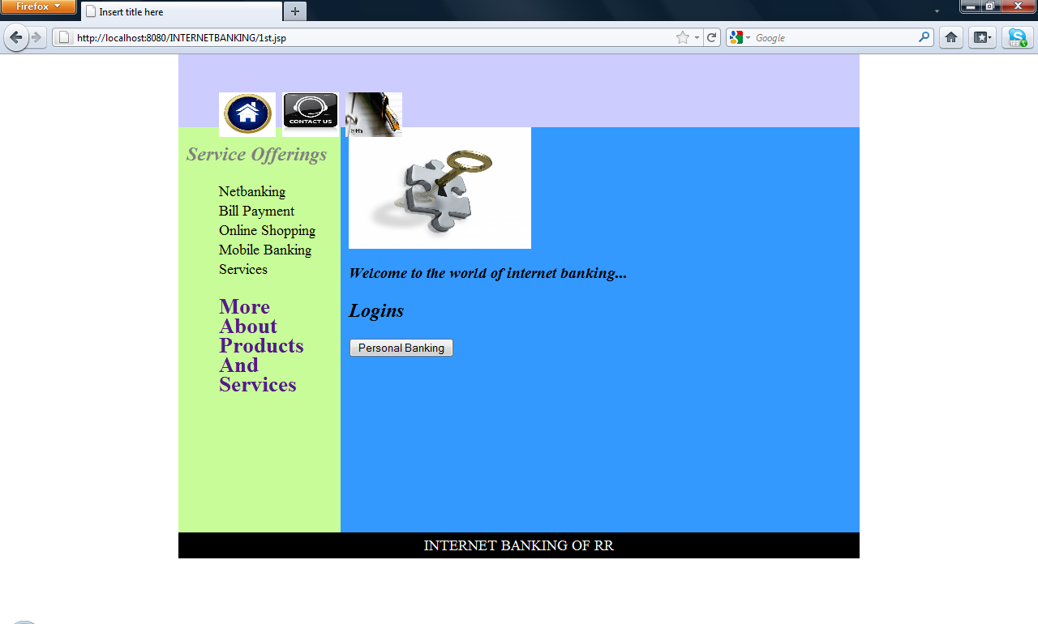

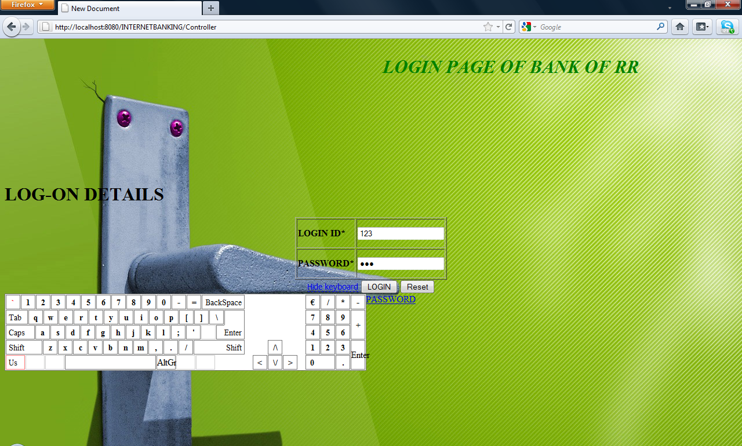
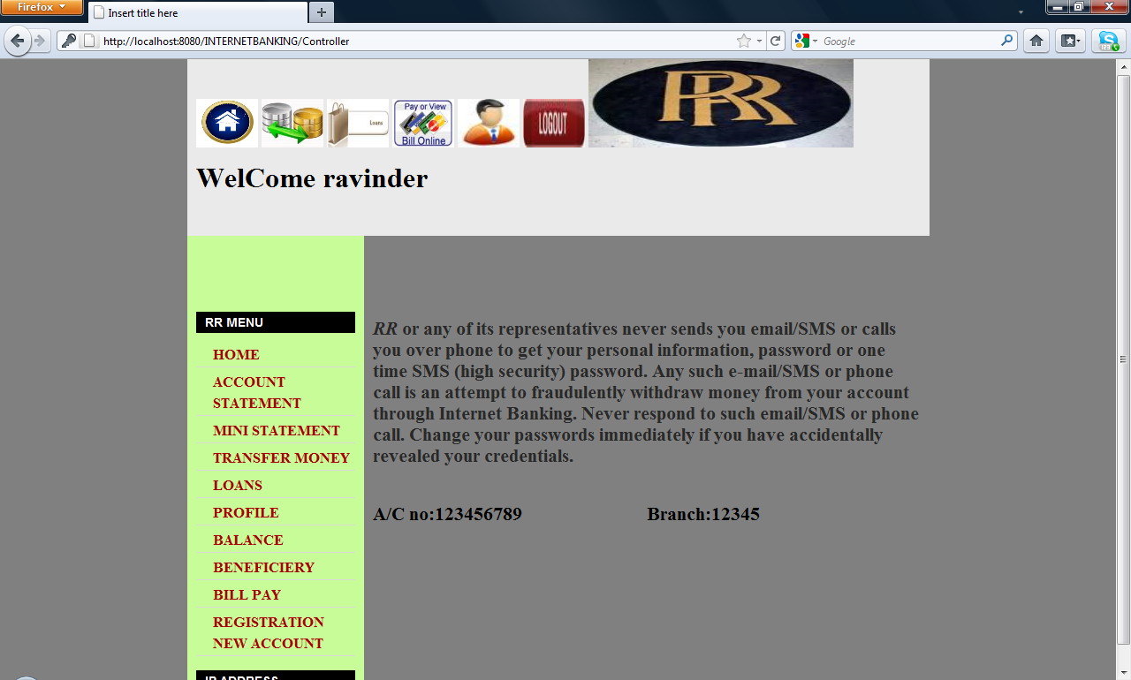

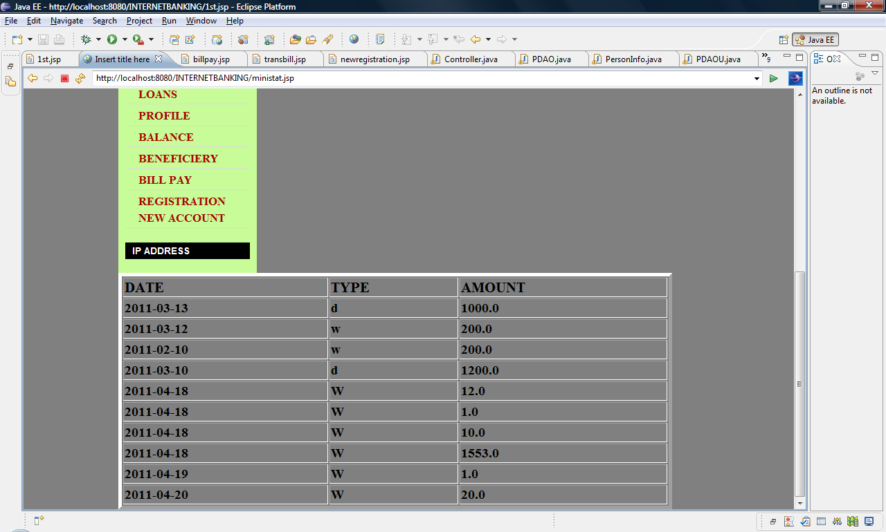

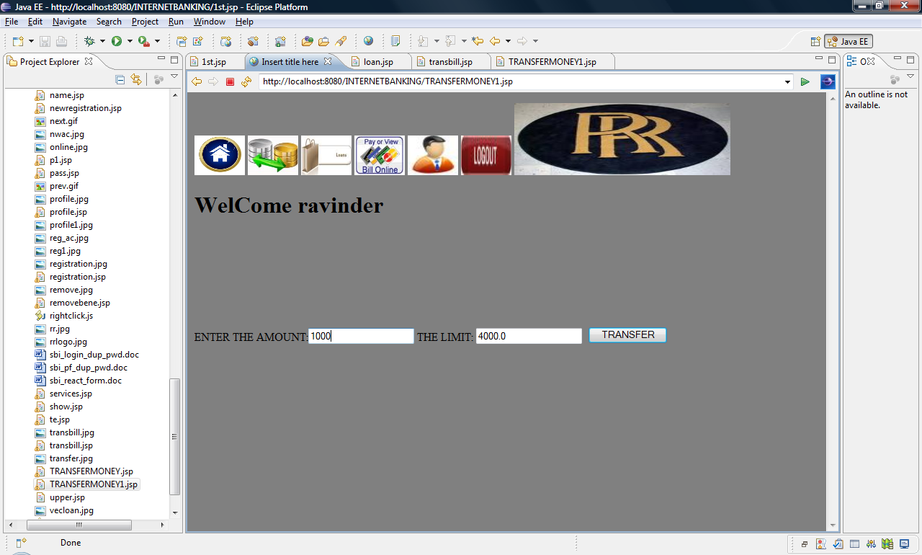

SCOPE OF ENHANCEMENT

The system may be updated or modified owing to its simple structure. This can further be used for maintenance of the ACCOUNT details for the customers and make the transaction easy for the customers.

CONCLUSION

A INTERNET BANKING SYSYTEM has been developed and the system was tested with sample data.
The system results in regular timely preparations of required outputs.The system provides a user friendly environment for the customers to do banking without going to the bank itself, allows the facility like opening the new account, transferring the money and downloading the forms.

