LABORATORY EXERCISE 9

SEARCH AND FILTERING SYSTEM

Learning Objectives
By the end of this laboratory exercise, students should be able to:
- Implement client-side search filtering using jQuery for dynamic user experience.
- Develop server-side search functionality using CodeIgniter's database queries.
- Create a responsive search interface using Bootstrap components.
- Integrate AJAX techniques to display search results without page reload.
- Understand the differences between client-side and server-side search approaches.

Prerequisite student experiences and knowledge
Before starting this exercise, students should have:
- Completed Laboratory Exercise 8 (Real-time Notifications with jQuery).
- Solid understanding of CodeIgniter's MVC architecture and database operations.
- Proficiency in writing jQuery and JavaScript code for DOM manipulation.
- Experience with AJAX requests and handling JSON responses.
- Familiarity with Bootstrap form components and grid system.
- Knowledge of SQL queries, particularly LIKE operators for search functionality.

Background
An effective search system is crucial for any Learning Management System (LMS) to help users quickly find relevant courses and content. This exercise focuses on implementing a dual-approach search system: client-side filtering for immediate feedback and server-side searching for comprehensive results. jQuery provides the tools for dynamic client-side filtering, while CodeIgniter's database class enables efficient server-side search using SQL LIKE queries. The combination creates a seamless user experience where search results update in real-time without page refreshes, enhancing the overall usability of the application.

Materials/Resources
- Personal Computer with Internet Access
- XAMPP/WAMP/LAMP server installed
- CodeIgniter Framework
- Visual Studio Code or any code editor
- Git and GitHub Account
- Web Browser (Chrome, Firefox, etc.)
Laboratory Activity
Step 1: Project Setup
- Open your existing ITE311-LASTNAME CodeIgniter project.
- Ensure your database has a courses table with sample data for testing search functionality.
- Verify that your course listing page is functional from previous exercises.

Step 2: Create Search Controller Method
- Navigate to your Course.php controller in app/Controllers/.
- Add a new method named search():
  - This method should accept GET or POST requests with a search term parameter.
  - Use CodeIgniter's Query Builder to search the courses table using LIKE queries.
  - Return the results as JSON for AJAX requests or render a view for regular requests.
- Implement the search logic
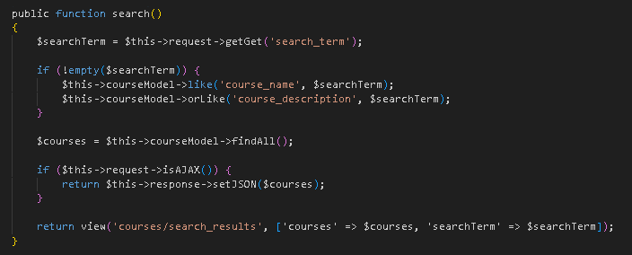

Step 3: Add Search Route
- Open app/Config/Routes.php.
- Add routes for the search functionality:
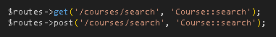

Step 4: Create Search Interface
- Modify your courses view file (app/Views/courses/index.php).
- Add a search form with Bootstrap styling
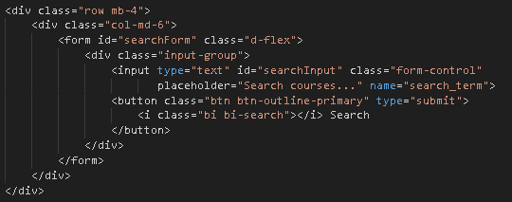

Step 5: Implement Client-Side Filtering with jQuery
- Add jQuery script for instant client-side filtering
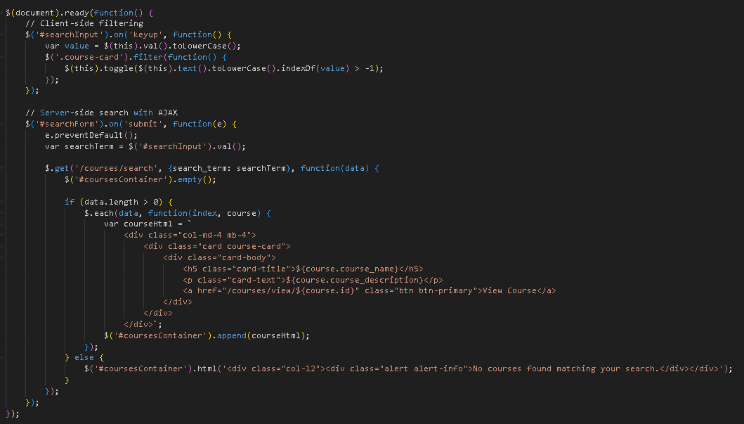

Step 6: Update Courses View Structure
- Modify your courses listing to work with the search functionality
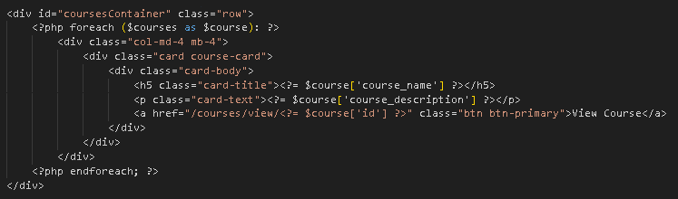
- To simulate real-time updates, you can set an interval to fetch notifications every 60 seconds (optional advanced task).

Step 7: Test the Search Functionality
- Load the courses page in your browser.
- Test the client-side filtering by typing in the search box courses should filter instantly.
- Test the server-side search by submitting the form results should load via AJAX without page refresh.
- Verify that both empty search results and successful searches display appropriate messages.

Step 9: Push to GitHub
- Stage and commit your search functionality
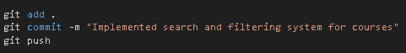

Output / Results
- Screenshot of the courses page with the search interface implemented.
- Screenshot showing filtered courses during client-side search.
- Screenshot of browser Developer Tools Network tab showing AJAX request to server-side search.
- Screenshot of search results displaying when no courses match the search term.
- Screenshot of GitHub repository with the latest commit.

QUESTIONS:
- What are the advantages and limitations of client-side filtering compared to server-side search?
Client-Side Filtering vs Server-Side Search
Client-Side Filtering
Client-side filtering runs in the browser using data already on the page. It’s fast because there’s no network wait, and it reduces server load. It also works offline once data is loaded.
It only searches what’s already displayed, so it misses data not on the page. With many items, it can slow down. It can’t use database features like full-text search or advanced matching.
Server-Side Search
Server-side search queries the database, so it covers all records. It can use database features for better matching, scales well, and always uses current data.
It requires a network request, so there’s a delay. It increases server load and needs an active connection.
Best Approach
Use both: client-side for instant feedback on loaded data, and server-side for complete, accurate results.
- How does using AJAX for search improve the user experience compared to traditional form submission?
AJAX Improves Search Experience
Traditional form submission reloads the entire page, causing a delay, losing scroll position, and interrupting the user.
AJAX updates only the results area without a full reload. This feels faster, preserves scroll position and form state, enables real-time search as you type, and provides smoother feedback.
In our implementation, typing triggers a search after a short pause, updates results instantly, and shows a loading indicator—all without reloading the page.
- What security considerations should be taken when implementing search functionality with user input?

Security Considerations
Input Validation
Validate and sanitize user input. Use parameterized queries (CodeIgniter Query Builder) to prevent SQL injection. Escape output to prevent XSS. Limit input length to avoid abuse.
Access Control
Require login and check permissions. Limit search rate per user to prevent abuse.
Data Protection
Don’t expose sensitive data in results. Return only what the user should see. Use generic error messages that don’t reveal system details.
Our Implementation
We check login status, use Query Builder for safe queries, escape output, detect AJAX requests properly, and handle errors without exposing details.

Output / Results

Screenshot of the courses page with the search interface implemented.
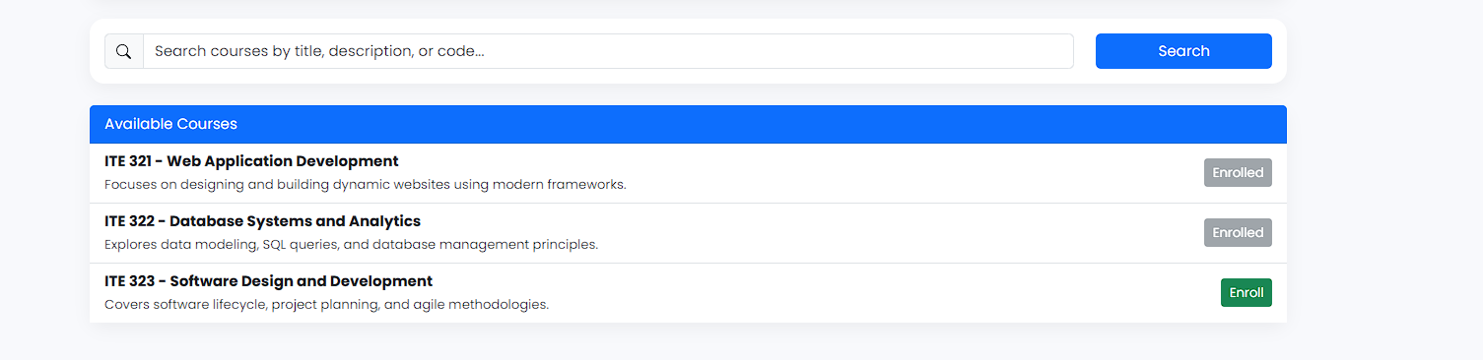

Screenshot showing filtered courses during client-side search
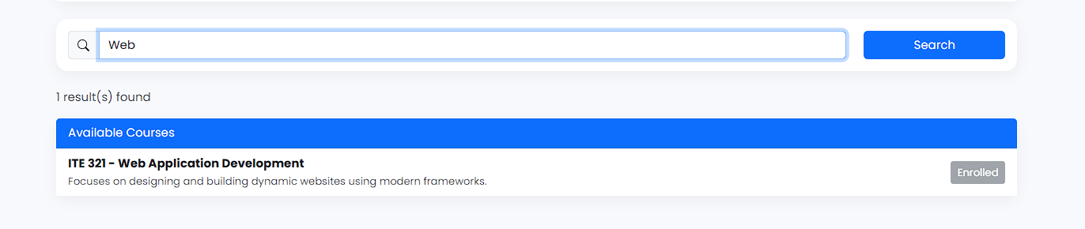

Screenshot of browser Developer Tools Network tab showing AJAX request to server-side search.
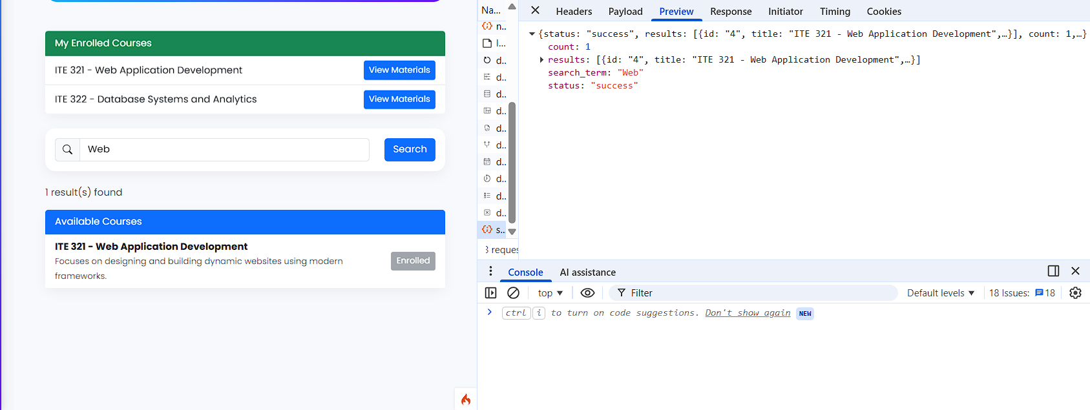

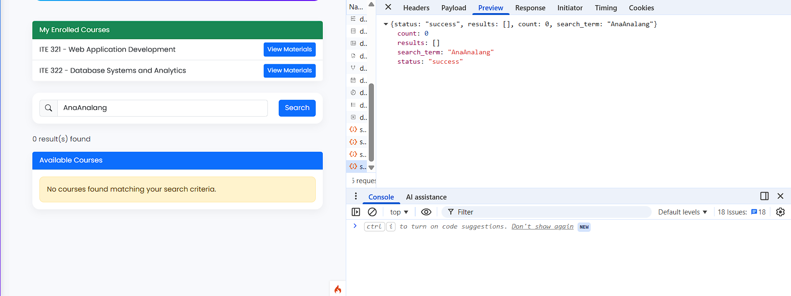

Screenshot of search results displaying when no courses match the search term.

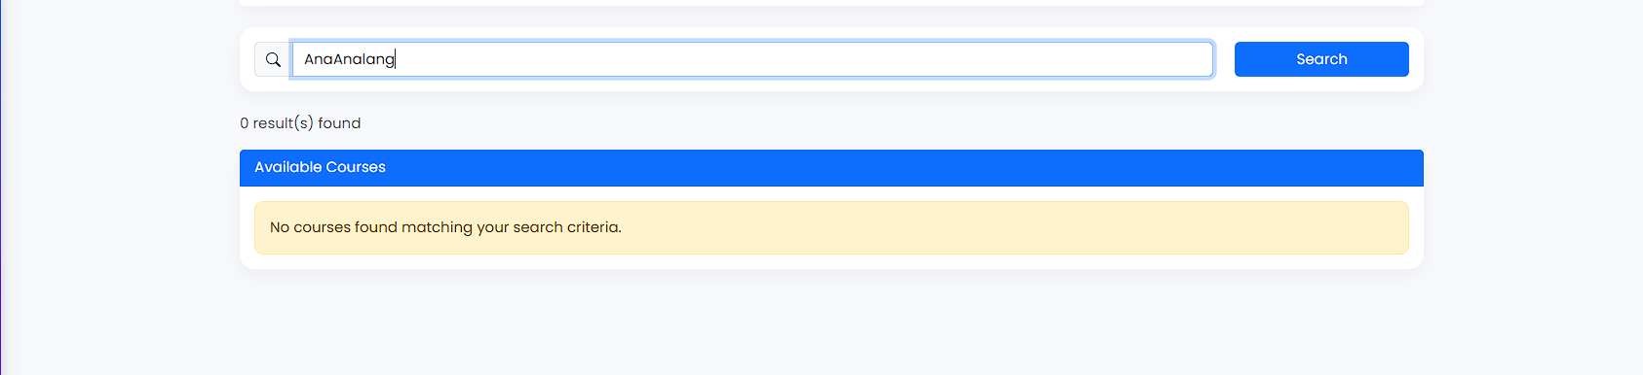

Screenshot of GitHub repository with the latest commit.
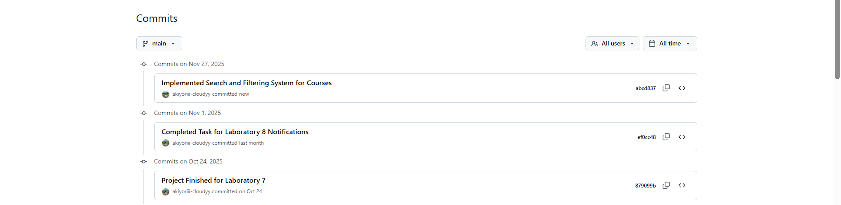

Conclusion
I have combined client-side filtering and server-side search with AJAX. Users get instant feedback while typing, and results come from the full database. Security is handled through validation, safe queries, and access control. This approach balances speed, accuracy, and security for a better search experience.

