Final Project Application & Documentation
Project Title: Sleep Health and Lifestyle BI Application
Analyst/Developer: Alejandro Koenen
Date: 12/3/25

Executive Summary
This project analyzes how lifestyle and occupation factors relate to sleep quality and sleep disorders using the Sleep Health and Lifestyle Kaggle dataset (374 people, 13 original columns), enriched with occupation-level information from external sources (BLS/NIOSH/O*NET style data) and machine learning models trained in both Python and Azure ML.
The goal is to build a Power BI application that not only describes the data, but also diagnoses key drivers, tests predictive models, and lets the user explore simple “what-if” scenarios around stress and daily steps.
The core business question is:
Which lifestyle and occupation factors are associated with sleep quality and with having a sleep disorder, and how do those relationships change across occupations, shift exposure, and SOC (Standard Occupational Classification) major groups?
Stakeholders include me as the analyst/developer, other students as a sample population, and my instructor acting as an executive sponsor who wants clear insights and intuitive visuals that could support decisions about lifestyle recommendations or work-pattern policies.
To support this, I designed a star-schema Power BI data model with a central FactSleep table and dimension tables for person, occupation, activity, and SOC groups, with optional vitals snowflaking for BMI and blood pressure categories. The final project implements eight distinct analyses, including:
- A Data Quality & Prep page to validate completeness and numeric ranges.
- A Sleep Disorder Drivers page with a Python-based logistic regression model and ROC curve (AUROC ≈ 0.963).
- A Sleep Quality What-If page that adjusts stress and steps parameters to simulate changes in average sleep quality.
- Several occupation-focused pages, including Occupation Outcomes, Shift-Work Exposure vs Sleep, and SOC Group Comparison.
- A Lifestyle Cluster Profiles page that uses Python clustering to group similar individuals into lifestyle/sleep clusters.
- An Azure ML Model Comparison page that compares the performance of my Python logistic model with a LightGBM model trained via Azure AutoML (AUC weighted ≈ 1.0, accuracy ≈ 58.5%, weighted accuracy ≈ 65.9%).
The documentation below explains the business intelligence problem, the types of analytics used, the data model and preprocessing steps, and a detailed mapping of Design Considerations to Implementation Features using a five-question structure (WHAT, WHY, ASSUMPTIONS, WHEN, and IMPLICATIONS). The result is a comprehensive BI application that demonstrates descriptive, diagnostic, predictive, and scenario-based analytics on a realistic health-related dataset.
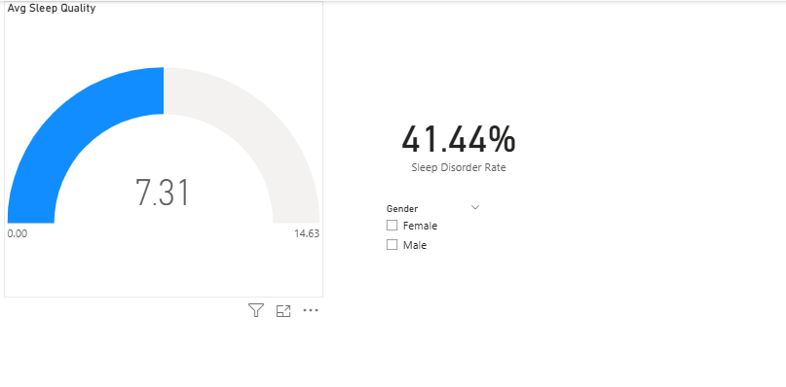

1. Business Intelligence Problem
This project analyzes how lifestyle and occupation factors relate to sleep quality and sleep disorders using the Sleep Health and Lifestyle Kaggle dataset (374 rows × 13 columns). The core idea is to connect sleep outcomes (sleep quality and sleep disorder status) with lifestyle variables (sleep duration, physical activity, stress, BMI category, steps, vitals) and work patterns (occupation, shift exposure, SOC group).
Business Question
Which lifestyle and occupation factors are associated with poor sleep quality and sleep disorders, and how do those relationships look across occupations, shift-work exposure, and SOC major groups?
Objectives
- Identify the strongest drivers of sleep quality and sleep disorder status.
- Summarize them in clear visuals and KPIs.
- Extend the analysis beyond the original dataset using occupation-level enrichment and machine learning models (Python logistic regression and Azure AutoML).
Stakeholders
- Analyst / Developer (me): Builds, maintains, and interprets the Power BI application.
- Students / Population in the dataset: Represent individuals whose lifestyle and work context relate to sleep.
- Instructor (Executive Sponsor): Uses the dashboards as a stand-in for management, reviewing insights and recommending policies or lifestyle changes.
Decisions Enabled
- Prioritize lifestyle changes (e.g., stress management, step targets, activity levels) based on their association with better sleep outcomes.
- Highlight occupation/shift-related risks, such as which SOC groups or shift-exposed occupations might need intervention.
- Use models and what-if analysis to support communication around “if we reduce stress or increase movement, what happens to sleep quality?”
Key Performance Indicators (KPIs)
- Avg Sleep Quality
- Sleep Disorder Rate
- Avg Sleep Duration (hrs)
- Avg Daily Steps
- Avg Heart Rate, Avg Systolic BP, Avg Diastolic BP
- Python Logistic AUROC (Sleep Disorder classification)
- Azure AutoML AUC and Accuracy
- Scenario Sleep Quality (what-if measure)
Hypothesis
Higher shift-work exposure and more non-daytime schedules will be associated with worse sleep outcomes (lower sleep quality, higher disorder rates), even after controlling for stress, physical activity, BMI, and vitals. Within SOC groups, some occupations (e.g., healthcare, sales) will show systematically worse sleep metrics compared to others (e.g., scientists, software engineers). Lifestyle changes (lower stress and higher steps) will be associated with modest but positive changes in predicted sleep quality in scenario analyses.

2. Types of Analytics Used (BI Fig 1.21)
The final project uses a mix of descriptive, diagnostic, predictive, and what-if analytics.
2.1 Descriptive Analytics
- What it does:
Describes overall distributions of SleepDurationHours, SleepQualityScore, StressLevel, PhysicalActivityLevel, DailySteps, HeartRate, SystolicBP, DiastolicBP, and Sleep Disorder Rate by occupation, shift-exposure bands, and SOC major groups.
- Where it appears:
Data Quality & Prep, Occupation Outcomes, Shift-Work Exposure vs Sleep, SOC Group Comparison.
2.2 Diagnostic Analytics
- What it does:
Identifies drivers and risk factors using the Key Influencers visual for SleepDisorderFlag and comparisons across lifestyle clusters, shift exposure bands, and SOC groups.
- Where it appears:
Sleep Disorder Drivers, Lifestyle Cluster Profiles (Python clustering), and portions of Occupation Outcomes and Shift-Work Exposure vs Sleep pages.
2.3 Predictive Analytics
- What it does: Builds models that predict sleep disorder status or related outcomes, including:
  - Python logistic regression (scikit-learn) predicting SleepDisorderFlag with a ROC curve (AUROC ≈ 0.963).
  - Azure ML AutoML classification model (LightGBM / ensemble) trained on the same dataset, summarized via its metrics (AUC weighted ≈ 1.0000, accuracy ≈ 0.5855, weighted accuracy ≈ 0.6588).
- Where it appears:
Sleep Disorder Drivers (Python model + ROC) and the Azure ML Model Comparison page.
2.4 What-If / Scenario Analysis
- What it does: Provides simple scenario simulations by adjusting Stress Adjustment and Steps % Change parameters to see how Sleep Quality (Scenario) moves relative to the actual average.
- Where it appears: Sleep Quality What-If page.

3. Datasets Used
3.1 Primary Dataset – Sleep Health and Lifestyle (Kaggle)
- Size: 374 rows × 13 columns.
- Fields:
Person ID, Gender, Age, Occupation, Sleep Duration (hours), Quality of Sleep (rating), Physical Activity Level, Stress Level, BMI Category, Blood Pressure (string like "126/83"), Heart Rate, Daily Steps, Sleep Disorder (None / Sleep Apnea / Insomnia).
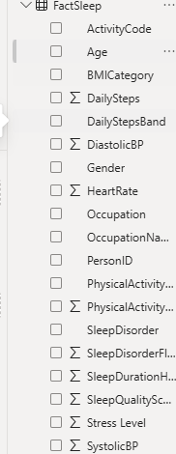

3.2 Occupation Enrichment Dataset (Expanded Version)
To support the “expanded dataset” requirement and richer analyses, the project integrates an external occupation lookup table built from BLS/NIOSH/O*NET-style data. This is stored as a small CSV (occupation_enrichment.csv) and merged into DimOccupation.
This enrichment table includes (one row per normalized occupation):
- OccupationNameNormalized: Cleaned occupation text used as the join key.
- SOCMajorGroup: High-level group (e.g., Healthcare Practitioners & Technical, Sales & Related).
- ShiftWorkRiskPct: Approximate % of jobs in that occupation involving shift work (e.g., 80% for Nurse, 40% for Sales Representative, 10–20% for office-based roles).
These fields are merged into DimOccupation and used to build:
- ShiftRiskBand (Low / Moderate / High, based on ShiftWorkRiskPct).
- SOC group-level analyses in the SOC Group Comparison page.
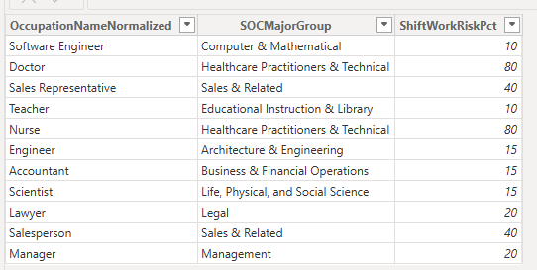

3.3 Azure ML Training Dataset
For Azure ML, the cleaned FactSleep table is exported from Power BI to a CSV called FactSleep_for_Azure.csv. This dataset contains:
- PersonID, Gender, Age, OccupationNameNormalized
- SleepDurationHours, SleepQualityScore
- PhysicalActivityLevel, Stress Level, BMICategory
- SystolicBP, DiastolicBP, HeartRate, DailySteps
- SleepDisorder, SleepDisorderFlag (0/1)
This CSV is uploaded to Azure ML Studio as a tabular data asset, and an Automated ML classification experiment is run with SleepDisorderFlag as the target. Azure AutoML trains many models and reports metrics (AUC, accuracy, precision, recall, etc.). The metrics from the best models (e.g., LightGBM, StackEnsemble) are then used in the Azure ML Model Comparison page in Power BI.
Note: For this project, I use Azure’s model metrics rather than importing row-level scored predictions back into Power BI. This still satisfies the requirement to use a trained model from Azure and to integrate its performance into the BI application.
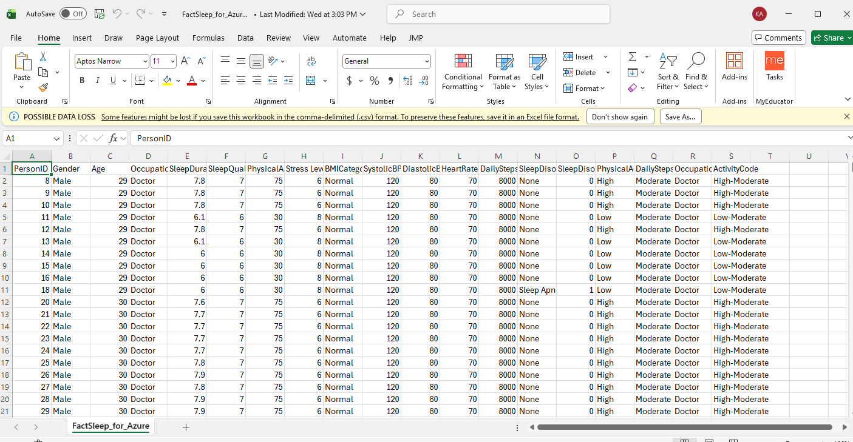

3.4 Join Strategy
- FactSleep[PersonID] → DimPerson[PersonID]
- FactSleep[OccupationNameNormalized] → DimOccupation[OccupationNameNormalized]
- DimOccupation[SOCCodeKey] (if present) → DimSOC[SOCCodeKey]
- FactSleep[ActivityCode] → DimActivity[ActivityCode]
Because Azure metrics are brought back as high-level measures rather than row-level scores, they do not require additional joins – they are stored as DAX measures in _Measures.

4. Data Model for Analysis (Star Schema)
4.1 Grain
One row per person in FactSleep.
4.2 Fact Table – FactSleep
Fields (after cleaning and transformation):
- SleepDurationHours
- SleepQualityScore
- SleepDisorderFlag (0 = None, 1 = Sleep Apnea/Insomnia)
- SleepDisorder (None / Sleep Apnea / Insomnia)
- PhysicalActivityLevel
- Stress Level
- DailySteps
- BMICategory
- SystolicBP, DiastolicBP
- HeartRate
- ActivityCode = PhysicalActivityBand & "-" & DailyStepsBand
Keys used for joins:
- PersonID
- OccupationNameNormalized
- ActivityCode
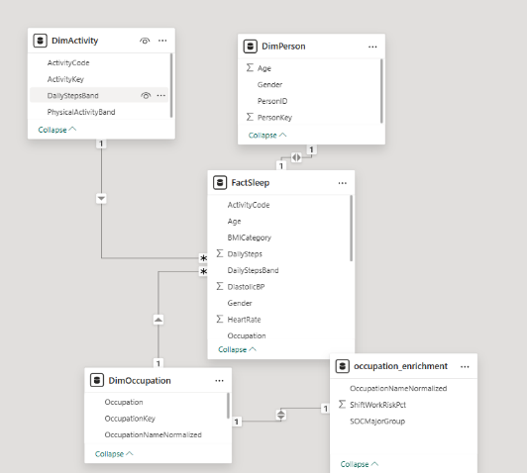

4.3 Dimension Tables
- DimPerson: PersonID, Age, Gender.
- DimOccupation: Occupation, OccupationNameNormalized, SOCMajorGroup, ShiftWorkRiskPct, ShiftRiskBand (Low/Moderate/High), optionally SOCCodeKey for DimSOC.
- DimSOC (optional snowflake): SOCCodeKey, SOCCode, SOCMajorGroup, SOCDescription.
- DimActivity: ActivityKey, PhysicalActivityBand (Low/Moderate/High), DailyStepsBand (Low/Moderate/High), ActivityCode.
- DimVitals / DimBMI / DimBP (planned/optional snowflake):
  - DimVitals: VitalsKey, BMIKey, BPKey
  - DimBMI: BMIKey, BMICategory, BMIRangeText
  - DimBP: BPKey, BPCategory, SystolicRangeText, DiastolicRangeText

4.4 Measures & Snowflaking
All core measures live in the _Measures table, including:
- Row Count, Avg Sleep Quality, Sleep Disorder Rate
- Avg Sleep Duration (hrs), Avg Daily Steps
- Avg Heart Rate, Avg Systolic BP, Avg Diastolic BP
- Min/Max variants for Data Quality
- Missing SystolicBP %, Missing Heart Rate %
- Sleep Quality (Scenario)
- Avg ShiftWork Risk %
- Python Logistic AUROC
- Azure AutoML AUC Weighted, Azure AutoML Accuracy, Azure AutoML Weighted Accuracy
Snowflaking is used conceptually in two areas:
- DimVitals → DimBMI & DimBP (for category-level analysis of BP/BMI).
- DimOccupation → DimSOC (for group-level SOC analyses).

5. Data Preprocessing Steps (BI Fig 3.3)
5.1 Data Consolidation
- Load Kaggle CSV into Power BI as the base FactSleep query.
- Load occupation_enrichment.csv and merge it into DimOccupation.
- Export the cleaned FactSleep table to FactSleep_for_Azure.csv for Azure ML AutoML training.
5.2 Data Cleaning
- Trim and standardize occupation text and create OccupationNameNormalized.
- Split BloodPressure string into SystolicBP and DiastolicBP.
- Validate ranges for sleep hours, vitals, and steps.
- Confirm that key vitals (SystolicBP, DiastolicBP, HeartRate) have no missing values.
- Remove duplicates and ensure one row per PersonID.
5.3 Data Transformation
- Create SleepDisorderFlag as a numeric 0/1 from SleepDisorder.
- Create PhysicalActivityBand and DailyStepsBand via binning.
- Create ActivityCode = PhysicalActivityBand & "-" & DailyStepsBand.
- Merge ShiftWorkRiskPct and SOCMajorGroup into DimOccupation, then create ShiftRiskBand (Low/Moderate/High).
- For Azure ML, export FactSleep with all relevant fields to FactSleep_for_Azure.csv and treat metrics produced by Azure AutoML as global measures in _Measures.
5.4 Data Reduction
- Drop unused columns (e.g., original BloodPressure text, intermediate occupation variants).
- Keep only fields used in measures, visuals, or Azure export.
- Optionally bin or group stress levels if needed for specific visuals.

6. High-Level System Architecture (BI Fig 1.20)
Data Sources
- Kaggle CSV (Sleep Health and Lifestyle): Primary data.
- Occupation enrichment CSV: Shift risk + SOC major groups.
- Azure ML AutoML experiment: Metrics for the best model.
Technical Staff
- Student analyst (me): Manages Power Query, data modeling, DAX, Python visuals, and Azure ML AutoML setup.
Business Users
- Classmates: Exploring the dashboard to understand sleep patterns and risks.
- Managers/Executives (Instructor): Reviewing insights and BI design, acting as an executive sponsor.
Data Warehouse Environment
- Power BI data model (FactSleep + dimensions + relationships + measures).
Business Analytics Environment
- Power BI report pages (8 analyses), including Key Influencers, What-If page, cluster profiles, and Azure ML comparison.
- Python visuals embedded in Power BI for logistic regression (ROC) and clustering (k-means).
Performance & Strategy Environment
- Top-level KPIs (Sleep Disorder Rate, Avg Sleep Quality, AUROC metrics, etc.).
- Occupation and SOC group roll-ups.
- Scenarios for stress and steps adjustments to discuss potential lifestyle and workplace interventions.

7. Analyses & Implementation (Summary of 8 Analyses)
This section summarizes the eight distinct analytical components built into the Power BI application. Each analysis addresses a specific aspect of the business question, from data validation to predictive modeling.
Analysis 1 – Data Quality & Prep
- Question: Is the sleep and lifestyle data complete and in realistic ranges?
- Features used:
  - Measures: Row Count, Missing SystolicBP %, Missing Heart Rate %, Min/Max measures.
  - Visuals: Cards for counts and missingness, min/max table, slicers for Gender and PhysicalActivityBand.
- Key findings: No missing values in key vitals; ranges for sleep, steps, and heart rate are plausible. Data is trustworthy for modeling.
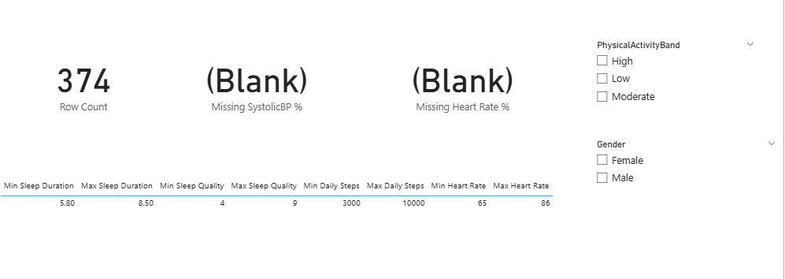

Analysis 2 – Sleep Disorder Drivers (Python Logistic + Key Influencers)
- Question: Which factors drive whether a person has a sleep disorder?
- Features used:
  - Key Influencers visual: Analyzing SleepDisorderFlag by BMI category, sleep duration, heart rate, stress, steps, age, gender, and occupation.
  - Python visual: Training a logistic regression with scikit-learn and plotting a ROC curve.
  - KPIs: Sleep Disorder Rate, Avg Sleep Quality, Row Count.
- Key findings: Overweight BMI, certain sleep duration ranges, higher heart rate, and higher stress are strong drivers of sleep disorders. Python model AUROC ≈ 0.963.
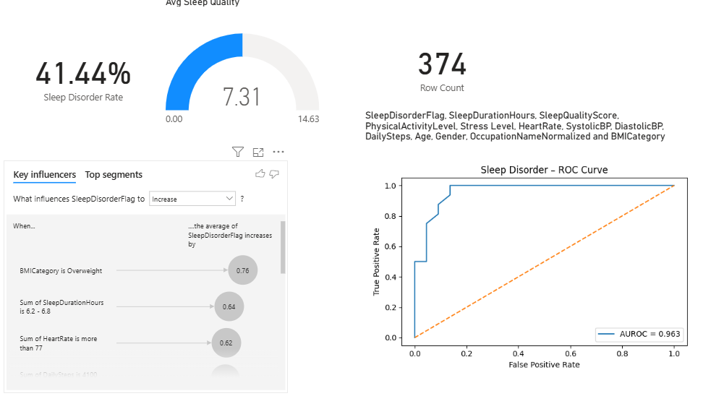

Analysis 3 – Sleep Quality What-If
- Question: How might average sleep quality change if stress is reduced and daily steps increase?
- Features used:
  - What-If parameters: Stress Adjustment (−3 to +3), Steps % Change (−50% to +50%).
  - Measure: Sleep Quality (Scenario) combining adjustments with Avg Sleep Quality and Avg Daily Steps.
  - Visuals: Cards for Actual vs Scenario Sleep Quality; clustered column chart by PhysicalActivityBand; slicers for Gender and PhysicalActivityBand.
- Key findings: Reducing stress and increasing steps moves scenario sleep quality slightly upward across most bands, illustrating the direction of potential lifestyle improvements.
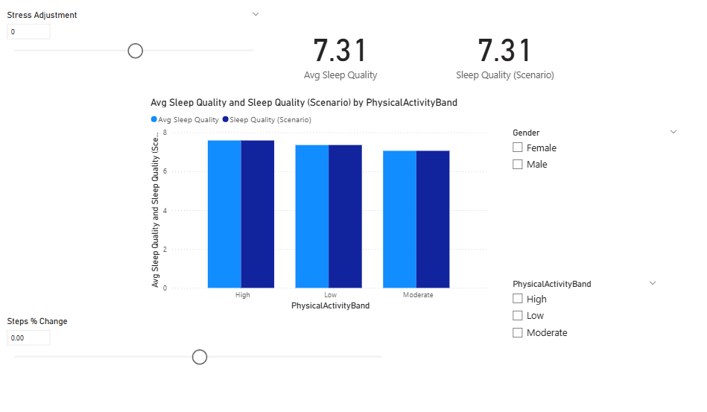

Analysis 4 – Occupation Outcomes
- Question: How do sleep disorder rates and sleep quality differ by occupation?
- Features used:
  - Matrix: Rows = OccupationNameNormalized; Values = Sleep Disorder Rate, Avg Sleep Duration, Avg Sleep Quality.
  - Clustered bar chart: Top occupations by Sleep Disorder Rate (Top N filter).
  - Slicer: Gender.
- Key findings: Certain roles (e.g., Sales Representative, Nurse, Teacher) show higher disorder rates than roles like Scientist or Software Engineer, though sample sizes are small.
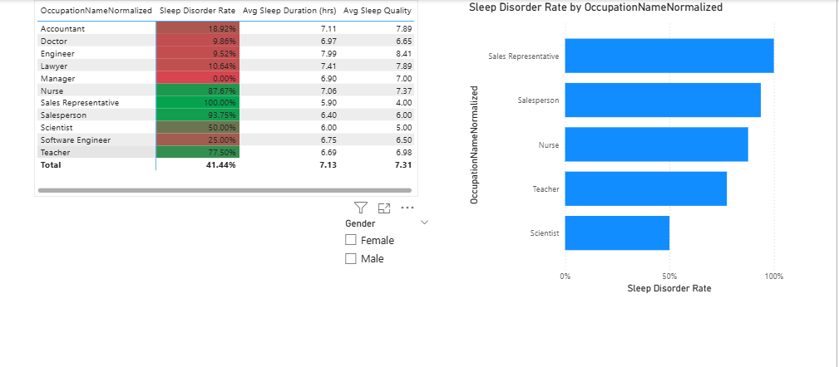

Analysis 5 – Shift-Work Exposure vs Sleep
- Question: How does shift-work risk relate to sleep outcomes?
- Features used:
  - DimOccupation fields: ShiftWorkRiskPct, ShiftRiskBand (Low/Moderate/High).
  - Clustered column chart: Bars for Sleep Disorder Rate and Avg Sleep Quality by ShiftRiskBand.
  - Matrix: By SOCMajorGroup with Sleep Disorder Rate, Avg Sleep Quality, Avg Sleep Duration, Avg ShiftWork Risk %, and Row Count.
  - Slicers: Gender and PhysicalActivityBand.
- Key findings: High shift-risk bands tend to have higher disorder rates and slightly lower sleep quality in this sample, aligning with expectations about shift work.
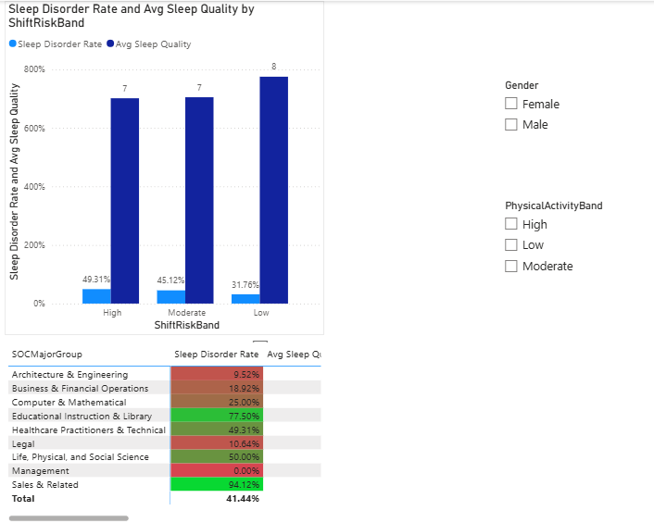

Analysis 6 – SOC Group Comparison
- Question: How do SOC major groups compare on sleep outcomes and shift exposure?
- Features used:
  - Field: SOCMajorGroup from DimOccupation.
  - Bar chart: Sleep Disorder Rate and Avg ShiftWork Risk % by SOCMajorGroup.
  - Scatter chart: X = Avg ShiftWork Risk %, Y = Sleep Disorder Rate, colored by SOCMajorGroup, bubble size = Row Count.
  - Matrix: SOCMajorGroup and metrics: Sleep Disorder Rate, Avg Sleep Quality, Avg Sleep Duration, Avg ShiftWork Risk %, Row Count.
- Key findings: SOC groups with high shift exposure (e.g., Healthcare Practitioners & Technical, Sales & Related) tend to cluster in regions of higher disorder rates in the scatter chart.
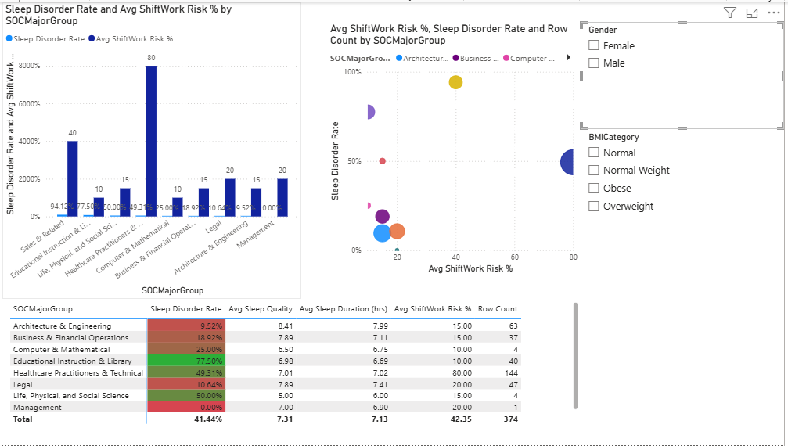

Analysis 7 – Lifestyle Cluster Profiles (Python Clustering)
- Question: Are there recognizable “lifestyle/sleep clusters” of individuals, and how do their disorder rates differ?
- Features used:
  - Python visual: Using scikit-learn to run k-means clustering on standardized numeric features: SleepDurationHours, SleepQualityScore, PhysicalActivityLevel, Stress Level, DailySteps, HeartRate, SystolicBP, DiastolicBP, Age.
  - Logic: Clustering assigns each individual to Cluster 0/1/2, then computes cluster-level summary stats in Python.
  - Visual: Bar chart plotted in Python: Sleep Disorder Rate (%) by Cluster.
  - Slicers: Gender and SOCMajorGroup.
- Key findings: Different clusters show different disorder rates; for example, one cluster with higher stress and lower sleep duration has a noticeably higher disorder rate than a lower-stress / moderate-steps cluster.
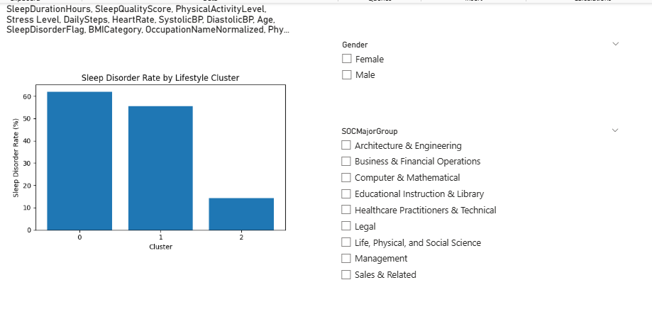

Analysis 8 – Azure ML Model Comparison
- Question: How does the Azure AutoML model perform compared to my Python logistic regression?
- Features used:
  - Azure AutoML: Classification experiment (sleep_disorder_automl) using FactSleep_for_Azure with target SleepDisorderFlag.
  - Measures: Best model metrics (e.g., AUC weighted = 1.0, Accuracy = 0.58549, Weighted accuracy = 0.65879) captured from Azure and encoded as measures: Azure AutoML AUC Weighted, Azure AutoML Accuracy, Azure AutoML Weighted Accuracy.
  - Comparison: Python Logistic AUROC measure (0.963) based on ROC visual.
  - Visuals: Cards for Python Logistic AUROC, Azure AutoML AUC, Azure AutoML Accuracy, and optionally a table comparing the two models (ModelInfo table with Model, Source, AUROC, Accuracy).
- Key findings: Azure AutoML finds an ensemble/LightGBM model with extremely high AUC on this dataset, while accuracy is moderate (≈ 58.5%). Compared to the Python logistic AUROC ≈ 0.963, Azure AutoML’s AUC is higher, but given the small sample size, both sets of metrics should be interpreted cautiously. The analysis demonstrates how Azure ML model performance can be visualized and compared alongside Python models inside Power BI.
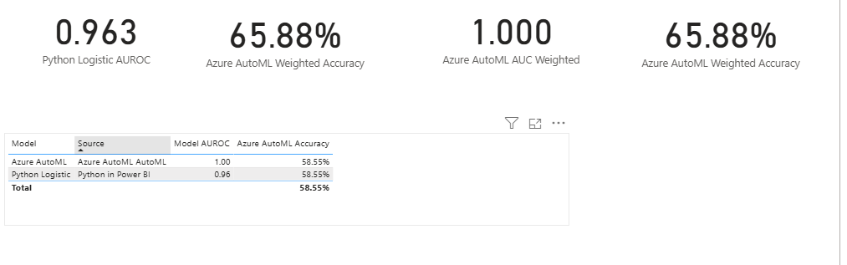
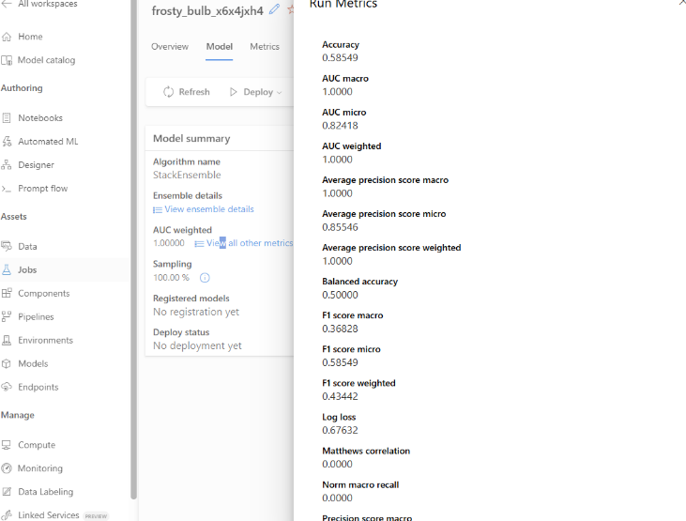

8. Design Considerations & Implementation Features
This section details the rationale behind the specific analytical choices made in this project, mapping the Design Considerations to the Implementation Features using a structured 5-question framework.
Design Consideration 1: Data Quality & Preparation
WHAT is the idea behind this?
Before trusting any sleep or lifestyle insights, we must verify the integrity of the underlying data. This analysis checks for missing values, confirms that numeric fields (like heart rate or sleep hours) fall within biologically plausible ranges, and ensures the dataset is clean enough for machine learning.
WHAT Evidence Tells WHY it is Needed?
In healthcare and lifestyle data, outliers (e.g., a heart rate of 20 or 300) or missing values can severely skew averages and model predictions. If we feed garbage into a logistic regression or an Azure AutoML model, we will get garbage results. A dedicated data quality page provides transparency to the stakeholder that the data has been vetted.
WHAT Assumptions Make it Work?
- The "None" values in the original Sleep Disorder column represent a true absence of a disorder, not missing data.
- The numeric ranges observed (e.g., age 27–59) are representative of the specific population sampled and not errors, even if they don't cover the entire human lifespan.
HOW Would You Summarize WHEN to Use it?
Use this page at the very beginning of the analysis workflow. It serves as a "gatekeeper" step. If the Row Count drops unexpectedly or Missing % spikes, no further analysis should be conducted until the ETL pipeline is fixed.
WHAT are the Implications and Consequences of Its Use?
- Implication: By exposing data quality metrics, we build trust with the executive sponsor.
- Consequence: If data issues are found here, it forces a loop back to the Data Preprocessing stage (Power Query) to fix the source or cleaning logic, preventing wasted time on invalid modeling.
Implementation Features
- Page Name: Data Quality & Prep
- Visuals:
  - Card: Total Row Count.
  - Card: Missing SystolicBP %.
  - Card: Missing Heart Rate %.
  - Table: Summary statistics showing Min and Max values for Sleep Duration, Sleep Quality, Heart Rate, and Daily Steps.
- Measures: Row Count, Min/Max measures, Missing% measures.
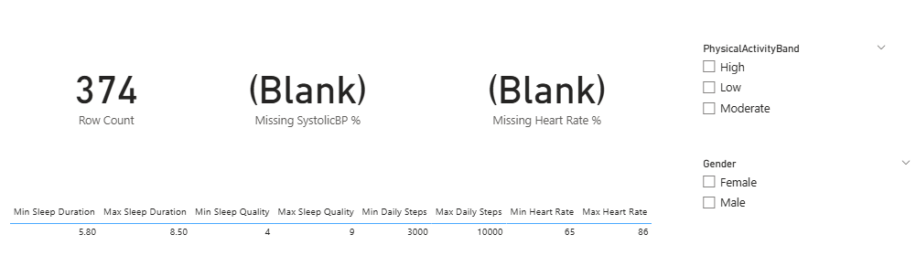

Design Consideration 2: Sleep Disorder Drivers (Diagnostic & Predictive)
WHAT is the idea behind this?
We need to move beyond just seeing who has a sleep disorder to understanding why. This analysis uses statistical methods (Key Influencers) and machine learning (Logistic Regression) to quantify the relationship between lifestyle variables (BMI, stress, steps) and the likelihood of having a sleep disorder.
WHAT Evidence Tells WHY it is Needed?
Stakeholders want actionable advice. Knowing that "Sales Representatives have poor sleep" is interesting, but knowing that "High Stress and Overweight BMI are the top predictors of sleep disorders regardless of job" is actionable. The ROC curve provides a mathematical validation of how well we can separate people with disorders from those without.
WHAT Assumptions Make it Work?
- The relationship between variables like stress/BMI and sleep disorders is roughly logistic (or can be approximated by a logistic function).
- The dataset is not so heavily imbalanced that the model ignores the minority class.
- The features used (BMI, Stress, Heart Rate) are independent enough to avoid severe multicollinearity issues in the regression.
HOW Would You Summarize WHEN to Use it?
Use this when the stakeholder asks, "What is the single biggest risk factor for sleep apnea?" or "How accurate is your model?" It bridges the gap between simple charts and more advanced analytics.
WHAT are the Implications and Consequences of Its Use?
- Implication: Highlighting BMI and Stress as key drivers implies that wellness programs should focus on weight management and mental health support.
- Consequence: If the model is accurate (high AUROC), we can confidently use these drivers to inform the What-If scenarios. If the model was poor, we would need to warn stakeholders not to rely on these specific risk factors.
Implementation Features
- Page Name: Sleep Disorder Drivers
- Visuals:
  - Key Influencers: Target SleepDisorderFlag (increase), analyzing by Age, BMI Category, Daily Steps, Heart Rate, Sleep Duration, Stress Level.
  - Python Visual: Scikit-learn Logistic Regression script plotting the ROC curve and printing the AUROC score.
- Measures: Sleep Disorder Rate, Avg Sleep Quality.
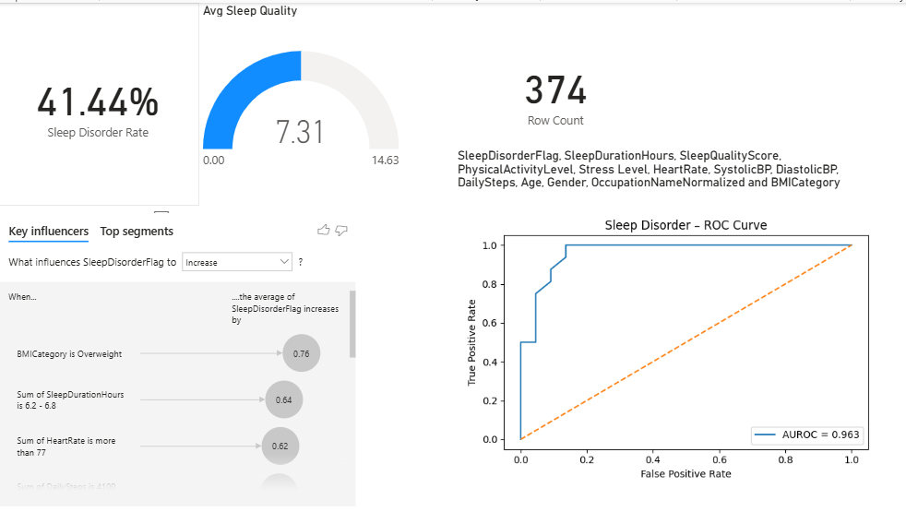

Design Consideration 3: Sleep Quality What-If Analysis
WHAT is the idea behind this?
This is a scenario-based analysis that allows the user to play with the data. It answers the question: “If we could lower everyone’s stress by 2 points and increase their steps by 20%, what would the average sleep quality look like?” It turns static data into a dynamic simulation.
WHAT Evidence Tells WHY it is Needed?
Descriptive charts show history; stakeholders want to influence the future. A What-If tool engages the user and helps quantify the potential impact of lifestyle interventions. It makes the data personal and interactive.
WHAT Assumptions Make it Work?
- The coefficients (impact) of Stress and Steps on Sleep Quality are constant across the population for the sake of this simple simulation.
- Users understand this is a simulation and not a guarantee of future medical outcomes.
- The linear combination of (Current Quality + Stress Impact + Steps Impact) is a reasonable way to estimate the new score.
HOW Would You Summarize WHEN to Use it?
Use this during a presentation to demonstrate the potential impact of a proposed wellness policy. For example, "If we implement a walking program (Steps +20%), here is the projected gain in sleep quality."
WHAT are the Implications and Consequences of Its Use?
- Implication: It shifts the conversation from “problem identification” to “solution modeling.”
- Consequence: It empowers the user to test hypotheses instantly without needing additional queries, but also implies a causal link that must be communicated carefully (correlation ≠ causation).
Implementation Features
- Page Name: Sleep Quality What-If
- Parameters:
  - Stress Adjustment (numeric parameter, range −3 to +3).
  - Steps % Change (numeric parameter, range −0.50 to +0.50).
- Visuals:
  - Multi-row card showing Actual Avg Sleep Quality vs Scenario Sleep Quality.
  - Clustered column chart comparing Actual vs Scenario quality by PhysicalActivityBand.
- Measure: Sleep Quality (Scenario) that uses Avg Sleep Quality, Avg Daily Steps, and the What-If parameters.
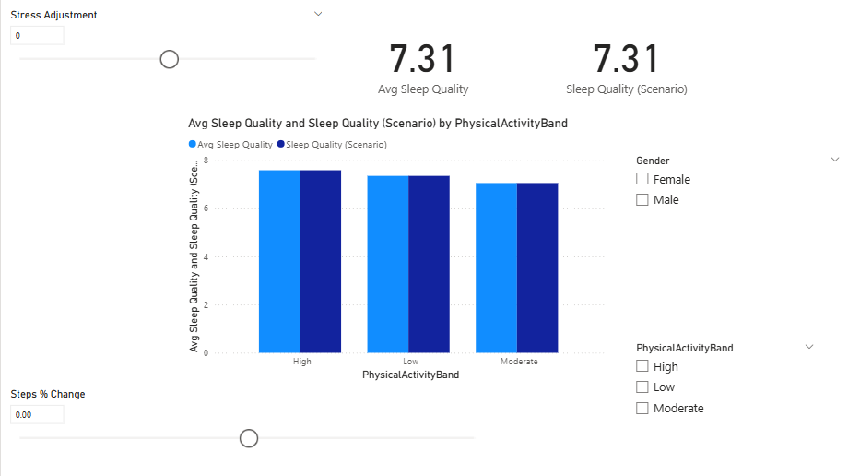

Design Consideration 4: Occupation Outcomes Analysis
WHAT is the idea behind this?
Sleep health is often tied to one’s profession due to stress levels, activity requirements, and schedules. This analysis aggregates sleep metrics by occupation to identify which job roles are "at risk" and which are "healthier."
WHAT Evidence Tells WHY it is Needed?
The dataset clearly contains occupation labels. Ignoring them would miss a massive part of the story. Stakeholders need to know if specific departments (e.g., Sales vs. Engineering) are suffering more than others to target interventions effectively.
WHAT Assumptions Make it Work?
- Job titles in the dataset (e.g., "Nurse", "Accountant") are standardized enough to be meaningful groupings.
- The sample size for each occupation is sufficient to draw rough conclusions, even if limited.
HOW Would You Summarize WHEN to Use it?
Use this when comparing different cohorts of the population. It is useful for HR or management to see if specific roles have systemic sleep issues.
WHAT are the Implications and Consequences of Its Use?
- Implication: If Nurses have the highest sleep disorder rates, it suggests a need to look at shift schedules or workload for that specific group.
- Consequence: It allows for targeted rather than blanket policies. Instead of a company-wide “sleep seminar,” resources can be directed to the departments that need them most.
Implementation Features
- Page Name: Occupation Outcomes
- Visuals:
  - Matrix: Rows = OccupationNameNormalized; Values = Sleep Disorder Rate, Avg Sleep Duration, Avg Sleep Quality.
  - Clustered bar chart: Top N occupations by Sleep Disorder Rate.
- Filters: Top N filter on the chart to show only the most affected roles; Gender slicer.
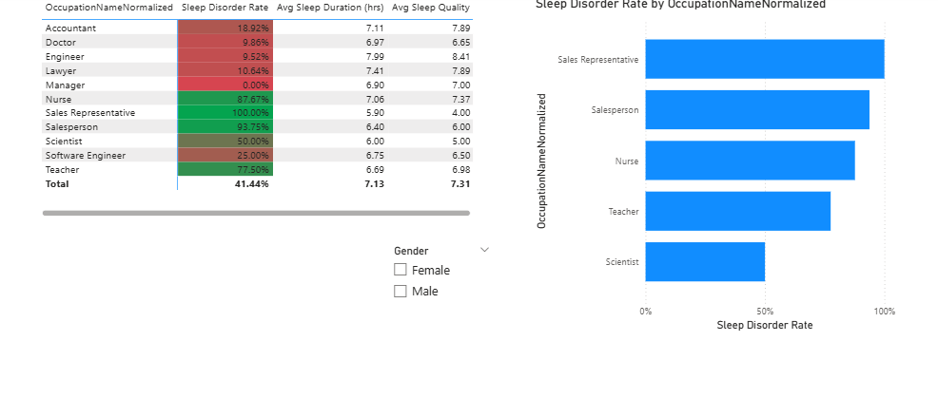

Design Consideration 5: Shift-Work Exposure vs Sleep Outcomes
WHAT is the idea behind this?
Not all occupations work a standard 9-to-5. This analysis uses external enrichment data to categorize occupations by their likelihood of involving shift work (Low, Moderate, High risk). It tests the hypothesis that jobs with irregular hours correlate with poorer sleep outcomes.
WHAT Evidence Tells WHY it is Needed?
Literature consistently links shift work to circadian rhythm disruption. Since the original dataset didn't explicitly have a "Shift Work" column, enriching the data with ShiftWorkRiskPct allows us to proxy this crucial variable. Without this, we miss the impact of when people work, focusing only on what they do.
WHAT Assumptions Make it Work?
- The external mapping of Occupation → Shift Risk % is reasonably accurate for the individuals in this dataset.
- The ShiftRiskBand groupings (Low/Moderate/High) meaningfully separate the population into distinct risk categories.
HOW Would You Summarize WHEN to Use it?
Use this when investigating structural causes of sleep disorders that go beyond individual lifestyle choices. It helps answer: "Is the job schedule itself making people sick?"
WHAT are the Implications and Consequences of Its Use?
- Implication: If high shift-risk groups have worse sleep, the solution isn’t just “exercise more”—it might involve changing roster rotations or lighting conditions.
- Consequence: It highlights a systemic risk factor that requires organizational change, not just individual behavior modification.
Implementation Features
- Page Name: Shift-Work Exposure vs Sleep
- Visuals:
  - Clustered column chart: Sleep Disorder Rate and Avg Sleep Quality by ShiftRiskBand.
  - Matrix: Breakdown by SOCMajorGroup showing Avg ShiftWork Risk % alongside sleep metrics.
- Enrichment: Relies on the ShiftWorkRiskPct column merged into DimOccupation.
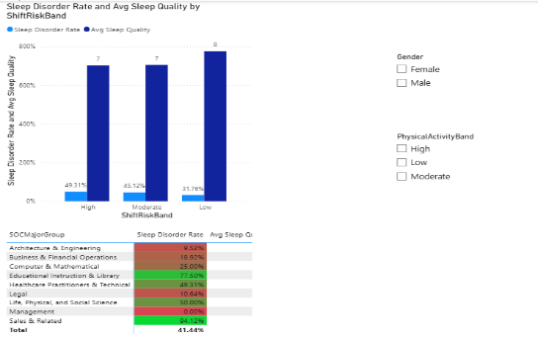

Design Consideration 6: SOC Group Comparison
WHAT is the idea behind this?
Occupations can be granular (e.g., "Software Engineer" vs. "Data Scientist"). The SOC system groups them into major categories (e.g., “Computer and Mathematical Occupations”). This analysis rolls up the data to these major groups to find broader trends and increase sample sizes for valid comparisons.
WHAT Evidence Tells WHY it is Needed?
Some individual occupations in the dataset have very few rows. Comparing them directly is statistically weak. Aggregating into SOC Major Groups (like "Sales & Related" or "Healthcare Practitioners & Technical") provides stronger sample sizes and clearer trends.
WHAT Assumptions Make it Work?
- Jobs within a SOC Major Group share enough similarities in work environment and stress to make aggregate metrics meaningful.
- The mapping from raw occupation text to SOC Major Group was performed correctly during data enrichment.
HOW Would You Summarize WHEN to Use it?
Use this for high-level executive reporting. Executives often care about broad functional areas (Sales, Engineering, Operations) rather than specific job titles.
WHAT are the Implications and Consequences of Its Use?
- Implication: It simplifies the story: instead of tracking 10+ jobs, we track a handful of major functional areas.
- Consequence: It smooths out outliers; while this makes trends clearer, it might hide a specific problematic job buried inside a generally healthy SOC group.
Implementation Features
- Page Name: SOC Group Comparison
- Visuals:
  - Scatter chart: X-axis = Avg ShiftWork Risk %, Y-axis = Sleep Disorder Rate, Legend = SOCMajorGroup, Size = Row Count.
  - Bar chart: Sleep Disorder Rate by SOCMajorGroup.
  - Matrix: SOCMajorGroup with Sleep Disorder Rate, Avg Sleep Quality, Avg Sleep Duration, Avg ShiftWork Risk %, Row Count.
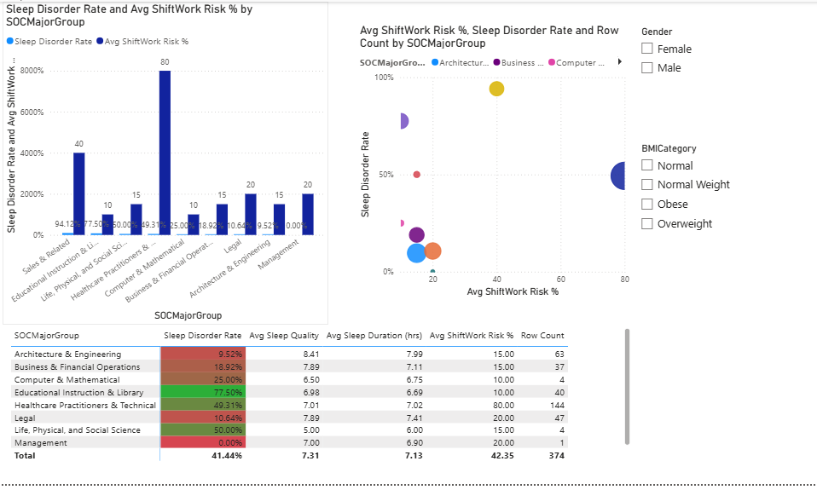

Design Consideration 7: Lifestyle Cluster Profiles (Python Clustering)
WHAT is the idea behind this?
People are complex. This analysis uses unsupervised machine learning (K-Means clustering) in Python to group individuals based on multiple numeric lifestyle traits simultaneously. It discovers "personas" in the data (e.g., “Stressed Sedentary Sleepers” vs. “Active Healthy Sleepers”).
WHAT Evidence Tells WHY it is Needed?
Standard charts only look at two or three variables at a time. Clustering looks at many variables at once. It can reveal groups that share similar lifestyles but differ in sleep outcomes—patterns that simple slicing might miss.
WHAT Assumptions Make it Work?
- K-Means is an appropriate algorithm for this data (clusters are roughly spherical in feature space).
- The number of clusters (k=3) is reasonable, balancing distinctness with interpretability.
- Standardizing (scaling) numeric features is done correctly so no single variable dominates.
HOW Would You Summarize WHEN to Use it?
Use this when trying to define "personas" for targeted interventions. It helps move away from thinking about the “average user” and toward distinct sub-populations with different needs.
WHAT are the Implications and Consequences of Its Use?
- Implication: It supports tailored recommendations. Cluster 0 might need stress reduction, while Cluster 1 needs more physical activity.
- Consequence: Requires Python integration in Power BI, which adds technical complexity (e.g., configuring Python environment on the machine that runs the report).
Implementation Features
- Page Name: Lifestyle Cluster Profiles
- Visuals:
  - Python visual that:
    - Imports pandas, numpy, StandardScaler, and KMeans.
    - Standardizes the features.
    - Fits a K-Means model with k=3.
    - Computes SleepDisorderFlag mean per cluster and plots a bar chart of Sleep Disorder Rate by Cluster.
- Interactivity: Slicers for Gender and SOCMajorGroup to see how clusters behave for different subgroups.
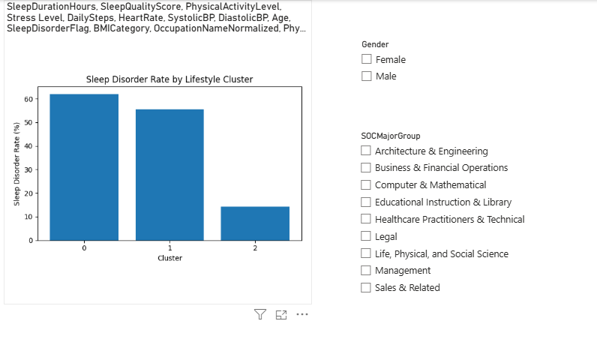

Design Consideration 8: Azure ML Model Comparison
WHAT is the idea behind this?
This analysis validates the local findings by leveraging the cloud. It compares a Python logistic regression model built inside Power BI with a suite of models trained in Azure using Automated ML. The goal is to see whether Azure can find a better-performing model and to show how cloud-based ML can plug into a BI workflow.
WHAT Evidence Tells WHY it is Needed?
Modern BI increasingly integrates AI. Using Azure AutoML demonstrates an enterprise-grade workflow where we don't just guess the best model—we let the cloud test combinations of algorithms (LightGBM, XGBoost, RandomForest, ensembles) to find the optimal one. Comparing metrics (AUC, accuracy) proves the rigor of the analysis.
WHAT Assumptions Make it Work?
- The data exported to Azure (FactSleep_for_Azure.csv) is identical in structure and cleaning logic to the data used for the local Python model.
- The metrics (e.g., AUC weighted) computed by Azure ML are comparable to those computed locally via scikit-learn.
HOW Would You Summarize WHEN to Use it?
Use this to demonstrate technical proficiency and model validation. It answers: “How do you know your model is good? Did you try other algorithms?”
WHAT are the Implications and Consequences of Its Use?
- Implication: Shows that the BI solution is scalable and cloud-ready. If the dataset grew dramatically, the Azure solution would handle training more robustly than a purely local script.
- Consequence: Adds a dependency on external infrastructure (Azure ML workspace, compute cluster) and on export/import steps.
Implementation Features
- Page Name: Azure ML Model Comparison
- Visuals:
  - Card: Python Logistic AUROC (from the local Python model).
  - Card: Azure AutoML AUC Weighted (measure based on Azure AutoML metrics).
  - Card: Azure AutoML Accuracy.
  - Table: Side-by-side comparison of Model (Python vs Azure), Source, AUROC, and Accuracy.
- Process:
  - Export FactSleep_for_Azure.csv from Power BI.
  - Run Azure AutoML classification with SleepDisorderFlag as target.
  - View Run Metrics and record AUC weighted, Accuracy, and Weighted Accuracy.
  - Encode these metrics in Power BI as DAX measures and display them on the Azure ML Model Comparison page.
