**Architecture Document**

**Finite State Sensor Logging Array**

Codename: senseame

|  |  |  |  |
| --- | --- | --- | --- |
| **Version** | **Description of Change** | **Author** | **Date** |
| 1 | Initial creation | Andrew Koerner | 10/31/2012 |
|  |  |  |  |

CONTENTS

1 INTRODUCTION

2 BLOCK DIAGRAM

3 DATA PATH

4 DATABASE ENTITY RELATIONSHIPS

# 1. INTRODUCTION

This document is geared at outlining the functional architecture of the *senseame* system. This includes block diagrams, entity relationships and the flow of data within the program

# 2. BLOCK DIAGRAM

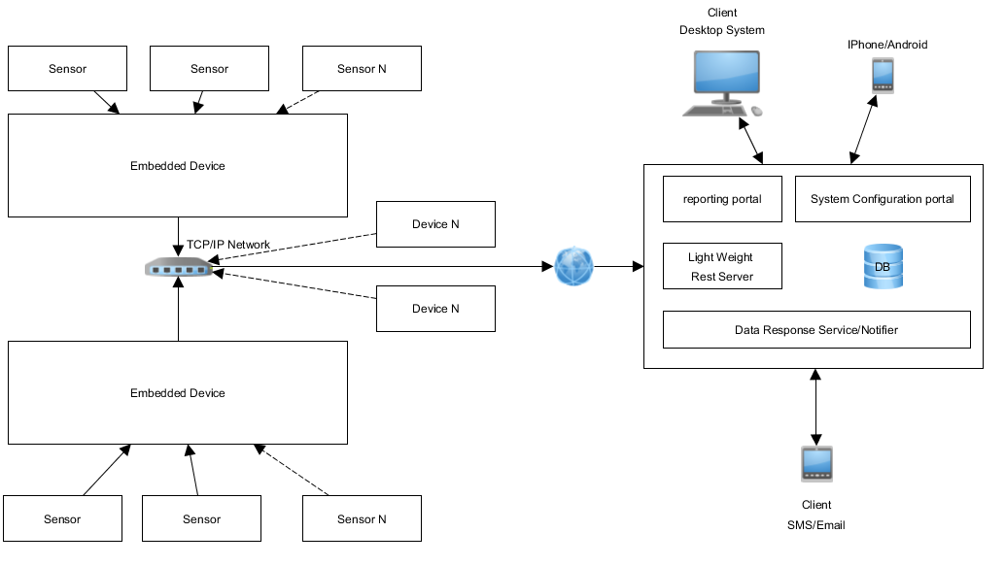

# 1. DATA PATH

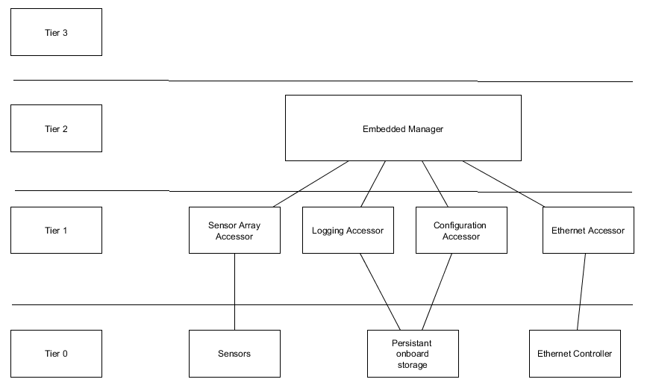Embedded System Data Path

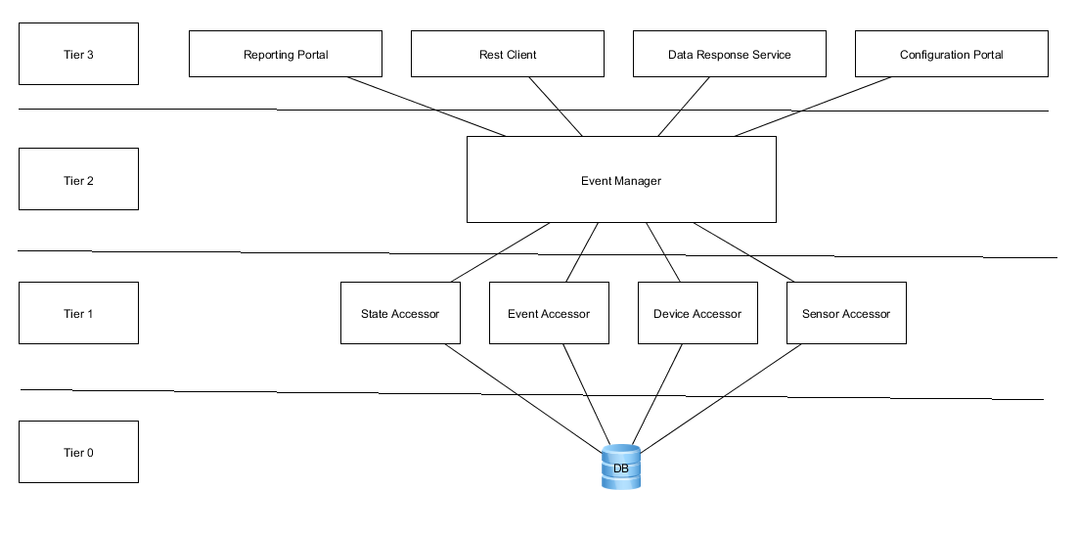Server Stack Data Path

# 1. DATABASE ENTITY RELATIONSHIPS

