Police Dispatch Application
Software Design Specification

Date: 06/29/2014
Version: 0.01

.

Prepared for:

Clifford Bigler, Chief of Police
Utica Police Department

Prepared by:

William Kofod, Lieutenant
Utica Police Department

Revisions
Version | Primary Author(s) | Description of Version | Date Completed
Draft v0.01 | William Kofod | First draft of the design specification for the Police Dispatch Application | 06/29/14

Contents

Revisions i
Contents ii
1 Introduction 1
2 Design Considerations 3
3 Architecture 4
4 High Level Design 5
5 Low Level Design 7
6 User Interface Design 10

Introduction

System Overview
The Utica Police Department is in need of a software application for tracking dispatch information. The application will be used to log all incoming calls to the Dispatch Center, either by telephone or radio communication, as well as for generating various forms that are used in the Dispatch Center on a regular basis. The current application being used by the department is poorly designed, and has received a large number of complaints from users since its introduction. The proposed system will provide an improved user interface, and will include a redesigned database model to provide better statistical information.

Design Map
This document presents the information necessary to implement the Utica Police Department Dispatch Application. Section one of this document presents overall system design information including an overview of the project and definitions of terms used in the project.
Section two contains information related to the overall architecture of the system, including system constraints and the production environment for the finalized project. This section also describes the methodology used in the design of the project, and risk areas that must be addressed.
Section three contains a detailed overview of the system architecture, and the rationale for choosing this architecture.
Section four details the high-level design of the project. This section describes the package-level division of the classes used in the system.
Section five describes the low-level design of the project. This section provides the details needed to create application. The specific functions of each module are described in detail.
Section six provides the information needed to develop the user interface for the system. This section describes each screen view that will be used in the application, and the form fields and buttons needed in each screen. This section also details the overall look of the system, including the color scheme and navigation of the system.

Supporting Materials
There are no supporting materials for this project.

Definitions and Acronyms
Call Record – any communication received by the dispatcher, whether by phone, in person, or by radio.

Incident – any call to which an officer responds, and for which an official police report is made.

Time Received – The actual time that a call is received.

Dispatch Time – The time that the dispatcher notifies the officer of the pending call.

Arrival Time – The time that the officer arrives at a call location.

Clearance Time – The time that an officer completes a call for service and returns to regular patrol.

Design Considerations

Assumptions
This project assumes that a server is operational, with web server and database server software installed and configured.

Constraints
The application must interact with a MySQL database.

System Environment
The client-side interface will operate on a desktop PC running the Windows 8 operating system. The server-side application will operate on a server running Ubuntu Server 14.04.

Design Methodology
This application will utilize an object-oriented design using UML.

Risks and Volatile Areas
The system must incorporate a secondary means of storing data in case of a failure in the database connection.

Architecture

Overview
This system is designed using a Model-View-Controller architecture. This architecture divides the system into three high-level components. The View component contains the screen views that are seen by the user. This module is composed of .jsp pages that will receive information from the Controller module, and format and display that information in a way that is useful to the end user.
The Controller component contains the system's logic. This module is responsible for receiving information entered by the user in the View module, processing that information, storing the information, retrieving additional information, and returning the results to the View module.
The Model component represents the objects used in the system. Each database table is represented by a Model class. These objects are used by both the Controller module for processing, and the View module for displaying the information to the user.

Rationale
The Model-View-Controller architecture was chosen for this system because it provides a logical separation of concerns between the program's objects, the processing of those objects, and the way the results are displayed to the user. Since this project will be built as a Java Web Application, the use of the MVC pattern is natural, due to the nature of Java servlets. The .jsp pages form the View module, the servlets make up the controller module, and the object classes comprise the Model module.

High Level Design

Conceptual View
The system is divided into three packages based on the Model-View- Controller architecture described in Section 3.1. The View package contains all of the pages needed for displaying information to the user. The diagram for the View module can be seen in Figure 1.

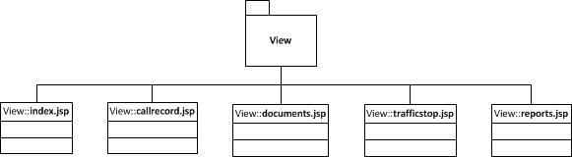
Figure 1: UML Diagram of View package
The Controller package contains the servlet classes that are needed to process information passed in by the user from the View module, and to return information to the View module. The UML diagram for the Controller module can be seen in Figure 2.

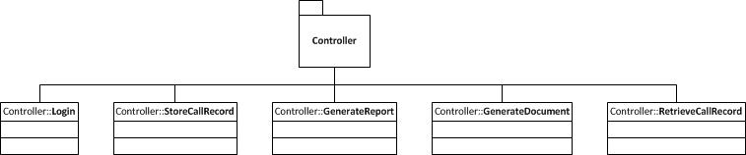
Figure 2: UML Diagram of Controller Package
The Model package contains classes that represent the objects used by the system. These classes are further divided into four functional areas. The CallRecord class is a composition containing several other objects that make up a call record in the system. The Employee, Document and Report classes are abstract classes that each contain other concrete classes that represent the unique objects within each class. The UML diagram for the Model package can be seen in Figure 3.

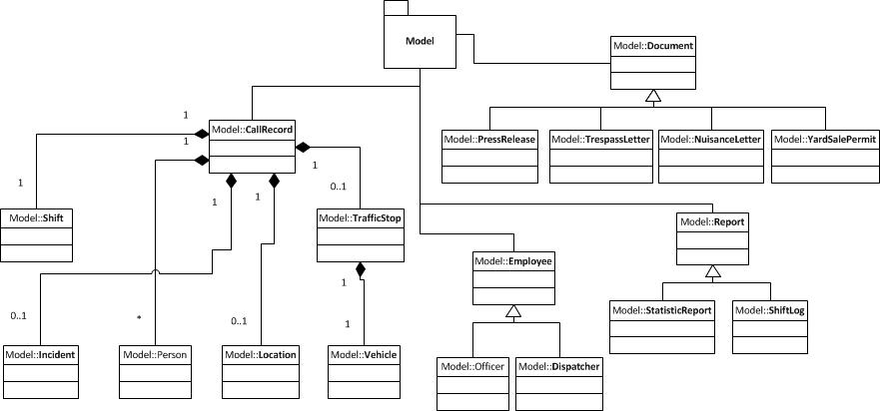
Figure 3: UML Diagram of Model Package

Low Level Design

Module 1 : View Module
The View module contains the .jsp files that describe the presentation information which will be used by the browser to present the user interface to the user. This module consists of five .jsp pages, as seen in the package digram (Figure 1) in Section 4. The first page that will be displayed when the program starts is index.jsp. This page will allow the user to login to the system.
Once the user is logged in to the system, they will be redirected to the callrecord.jsp page. This is the default page for a user that is logged into the system. On this page, the user will have the ability to create new call records. Each call record will be presented as a separate tab so that one record does not have to be completed before another can be started. Each call record will have a save record button, that will submit the information input into the text fields to the server for processing and storage in the database. This page will also display a menu that allows the user to navigate to other areas of the user interface.
The third view page is the documents.jsp page. This page allows the user to select a document to be created, and presents the necessary fields for that document. Once submitted the server will use the submitted information to generate the document as a pdf file that can then be printed. The navigation menu will also be displayed on this page.
The next view is the trafficstop.jsp page. This page will be displayed when a call record is marked as a traffic stop, and allows the user to enter additional information for the call that pertains only to traffic stops. This page will be implemented as a popup screen which will overlay the call record page. When this pop-up is closed, it will store the information until the entire call record is transmitted to the database.
The final view is the reports.jsp page. In this view, the user can select the report to be generated. The reports available will include a daily log for a specific date and shift, a report that provides general statistics on calls received for specific dates, and a search feature that will search the database for the input value which could be a name, address, phone number, license plate number, or any other information stored in the database.
This section provides a general overview of the View Module. Additional details for each view can be found in Section 6, which describes the user interface design.

Module 2: Controller Module
The Controller module contains the classes that receive, process, store and return information between the user interface and the database system. This project contains five classes within the controller package. The first class is the Login class. This class will receive username and password information from the user interface, and will compare that information against the database to determine if the user is authorized to access the system. The class will then store the result of that check as a session parameter, and will then redirect the user interface to the proper view, if the user is authorized.
The second class in the controller package is the StoreCallRecord class. This class receives information from the user interface, processes that information and stores it in the database. Processing includes populating various model objects using the information received, adding additional information automatically (such as assigning an incident number), and calling the model object methods that store the information to the database.
The third class in the controller package is the GenerateDocument class. Based on the type of document requested by the user, this class will receive information from the user interface, and use that information to populate a template for the proper document. The document will then be returned to the user as a pdf file, which will be displayed on the client machine, and will allow the user to print or save the file.
The fourth class is the GenerateReport class. Based on the type of report requested, this class will generate a report for the user. There are several types of reports that will be available in the first version of this program. First, the user will be able to print a Shift Log which will give a list of all call records for a specific shift. When the user selects this option in the user interface, they will be asked to provide the date and shift for the report they are requesting. The GenerateReport class will then query the database for all call records entered during that shift, and will create a report as a pdf document. Second, this class will generate a report of all activity occurring during a given time period. When this option is selected, the user will be asked to select a begin and end date. The GenerateReport class will query the database for all call records entered between the two dates, and will generate a statistical report displaying information on the types of calls received, the time and day when most calls are received, the number of calls broken down by geo-code, and the number of calls broken down by responding officer. Finally, this class will allow the user to search the entire database for a word, name, address, or phone number. The user will enter the search criteria into the user interface, and the GenerateReport class will receive this data, and query the database tables for any record that contains the search term. The class will then return a list of all records found to the user interface, where they will be presented to the user.
The final class in the controller package is the RetrieveCallRecord class, this class will receive a request from the user, through navigation buttons on the call record screen, and will query the database for the requested record. The record will then be returned to the user interface, where it will be displayed to the user.

Module 3: Model Module
The Model module contains all of the classes that represent objects within the system. The model package contains 18 classes for representing the various business objects that will be used by the other two packages. This package consists of three abstract classes, Employee, Report and Document, which each have subclasses that represent more specific roles, and one composite class, CallRecord, which has six component classes that will make up a full call record.
The components of the call record are: Shift, Incident, Person, Location, TrafficStop and Vehicle. All of the model classes will have getter and setter methods for each of their attributes. Additionally, the CallRecord class will have methods for creating, retrieving, updating and deleting records in the database.
The Document and Report classes will have methods for querying the database for the information needed by each of the concrete subclasses, while each of the subclasses will be responsible for maintaining the template information needed for the document or report.
The Employee subclasses, Officer and Dispatcher, will have methods for retrieving an Employee from the database only. The create, update and delete methods will not be used by these classes, as these functions will be executed directly on the database by the system administrator when necessary.

User Interface Design

Application Control
The overall color scheme for this application will be a combination of navy blue and red, with various shades of gray for accent. Each view will contain a header, with the name of the department, at the top of the screen. Additionally, a menu will be displayed directly below the header, which will allow the user to navigate to different views of the system. Links will be provided to the call record page, the reports page, and the documents page. A logout link will be available on each screen to allow the user to log out of the system at any time. Figure 4 shows a prototype of the user interface design. The image shows the call record screen, but it illustrates the header and navigation menu that will be seen on all screens.
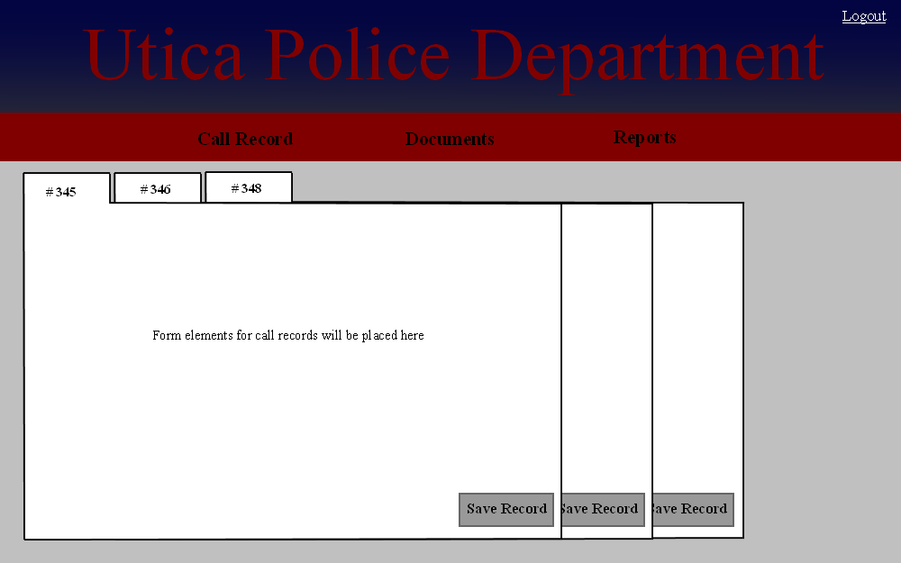
Figure 4: User Interface Design Prototype

Screen 1: Login Screen
The login screen will present the user with two text boxes, with labels, for entering username and password. The screen will also contain a single button for submitting the data entered. An additional link will be provided, which will allow the user to recover a forgotten password. This link will send an email to the user's department email address with a new password. An email will also be sent to the system administrator notifying him of the changed password. After successfully entering their login information, the user will be redirected to the call record screen.

Screen 2: Call Record Screen
The call record screen will present the user with all of the data fields, with labels, needed to enter a call record. First, the form will contain fields for entering the time of call, time dispatched, time of arrival, and time cleared. Next the form will contain fields for entering the caller's first name, last name, and phone number. The form will then present fields for selecting the type of complaint, location, officer assigned, manner in which the call was received, and the result of the call. The form will also contain a checkbox for selecting if the call is an incident, for which an incident number should be created. Finally, the form will contain a text field for entering notes about the call. Additionally, the form will contain fields to record the date, shift and dispatcher will be autopopulated by the system.
The call record screen will hold call record forms inside containers. The screen will have the ability to display multiple form containers in tabs, which the user can navigate between, allowing multiple calls to be entered concurrently. When the user submits the call record, the record will be sent to the server, processed and saved. The form tab for that record will then be removed from the screen. The prototype for this screen can be seen in Figure 4 above.

Screen 3: Documents Screen
The document screen will display buttons for each of the available documents that can be generated by the system. The documents available are: Trespass Letter, Nuisance Letter, Yard Sale Permit, and Press Release. When selected a pop-up box will appear, with fields for entering the necessary information to complete the document.
The pop-up for the trespass letter will present fields for the complainant's name and address, the address of the property for which the letter is being issued, and the name and address of the subject of the letter. When submitted, the server will use the information entered to populate a template document with the entered information, as well as the date that the letter was created. The document will then be returned to the user as a pdf file.
When the user selects the nuisance letter, the pop-up will contain fields for the property address, and the issue to be addressed. When the user submits the information, the system will insert the date of the letter, as well as the date by which the offense must be corrected. The document will then be returned to the user as a pdf file.
Selecting the yard sale permit will display a pop-up with fields for the user to input the sale holder's name, the address of the sale, and the dates of the sale. Once submitted, the system will input the date that the permit was issued, and will ensure that the sale dates are limited to a maximum of three days. The document will then be returned to the user as a pdf file.
Finally, the press release document will present the user with a text field to enter the information to be released. Upon submission, the information input will be used to populate a template with the date of the release on department letterhead. The document will then be returned to the user as a pdf file. This file may be printed for fax transmission, or can be emailed directly to media outlets.

Screen 4: Reports Screen
The reports screen will present the user with buttons to generate a shift log, or a statistical report. Selecting the shift log will present a pop-up allowing the user to select the date and shift to be included in the log. The system will then query the database for all call records entered during the selected shift. The records will then be inserted into a template document, which will be returned to the user as a pdf document.
Selecting the statistical report will present the user with a pop-up to select a range of dates. Once the dates are entered, the system will query the database for all records entered between the selected dates. The system will then use the returned records to create visual displays showing the time of day and day of week that calls are received. It will also present the total number of calls of each type, and the calls assigned to each officer.
A search box will also be displayed on the page, which will allow the user to enter any search term. After the term is submitted, the system will query all tables in the database for the requested term. The term may be a name, address, phone number, license plate number, or any other data that is stored in the database. The user will then be presented with a list of all records containing the search term. When the user selects one of these records, the display will show the entire call record selected.

