SECURE LIFE GENERAL HOSPITAL

INTRODUCTION.
This project focuses on analyzing hospital patient and billing data using Microsoft Excel to provide meaningful insights into hospital operations and financial performance.
The dashboard was developed to present important information about patient visits, hospital departments, diagnosis, billing, payment status and insurance coverage. Through data analysis and visualization, the project aims to make complex hospital data easier to understand and support better decision making and resource management.

About the Dataset.
The dataset used for this project contains hospital patient and billing records. It consists of information relating to patient demographics, hospital admissions, medical departments, diagnosis, billing amounts and insurance coverage.
The dataset includes the following variables:
- Patient ID
- Patient Name
- Age
- Gender
- Admission Date
- Discharge date
- Department
- Diagnosis
- Total Bill Amount
- Insurance Coverage (%)
- Payment Status
Microsoft Excel was used to clean, organize, analyze and visualize the data. Pivot tables, formulas, charts and interactive filters were used to develop the dashboard.

Problem Statement
Hospitals generate large amounts of patient and billing data, but understanding this information can be difficult without proper analysis and presentation.
This project addresses the need for a clear and organized way to monitor patient visits, department activities, billing, payment status and insurance coverage. The Excel dashboard brings these details together to help users identify patterns, understand hospital performance and support informed management decisions.

Dashboard Visualization
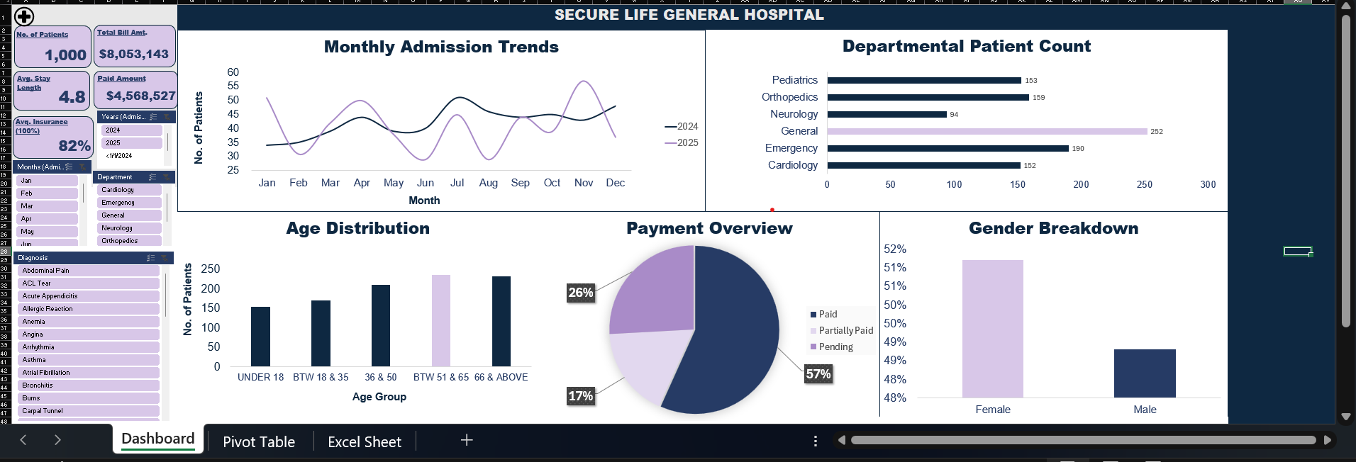

Key Insights
The analysis of the hospital dataset revealed the following key findings:
- Total Number of Patients: 1,000 patients were recorded in the dataset.
- Total Bill Amount: The total amount billed to patients was $8,053,143.
- Average Length of Stay: Patients spent an average of 4.8 days in the hospital.
- Paid Amount: A total of $4,568,527 was recorded as paid.
- Average Insurance Coverage: The average insurance coverage across the dataset was 82%.
These findings provide an overview of patient activity, hospital billing, payment performance and insurance coverage. They can help hospital management understand important operational and financial patterns.

Chart Analysis
The dashboard contains five visualizations that provide further insights into the hospital dataset:
- Payment Status Chart: Illustrates the percentage of patients with paid, partially paid and pending bills.
- Department Chart: Shows the number of patients across the different hospital departments, making it easier to compare departmental activity.
- Age Category Chart: Presents the distribution of patients across different age groups.
- Gender Chart: Shows the proportion of male and female patients recorded in the dataset.
- Admission Trend Chart: Illustrates changes in patient admissions over time and help identify admission patterns.

Recommendations

Based on the findings from the analysis, the following recommendations are suggested:

1. Hospital management should regularly monitor pending and partially paid bills to improve payment collection.
2. The hospital should review its billing and insurance processes to ensure accurate billing and timely insurance coverage.
3. Patient admission trends and average length of stay should be monitored to support better resource allocation and planning.
4. Management should use the dashboard regularly to monitor hospital performance and support informed decision-making.
Conclusion
This project demonstrates how Microsoft Excel can be used to analyze and visualize hospital patient and billing data. The dashboard presents important information about patient admissions, departmental activities, billing, payment status and insurance coverage in an organized and understandable format.
The analysis provides useful insights that can support hospital monitoring, financial planning and informed decision making. It also highlights the value of data analysis and visualization in improving the understanding of healthcare operations.

