**Rating the important factors**

My thought about the rating of the parameters that add up for myEcho infographic is that the highest someone can score is 1 (or 100%).

As we can see from the myEcho website, there are different sub-parameters which we need to be rated before we produce a rating for the academic, economic, self development and social development parameters.

**Academic**



One way to rate one’s academic achievements is to come up with a formula with 6 variables, one for each sub-parameter. If we want all of these parameters to have equal importance for the academic achievements, our formula should look something like this:

$$0≤\frac{1}{6}*a+\frac{1}{6}*b+\frac{1}{6}*c+\frac{1}{6}*d+\frac{1}{6}*e+\frac{1}{6}*f≤1,$$

$Where a,b,c,d,e,f <= 1$.

This equation just assumes that each of the sub-parameters is equally important, which is not the case for our projects. A-levels for instance are much more difficult than GCSE’s.

**Economic**

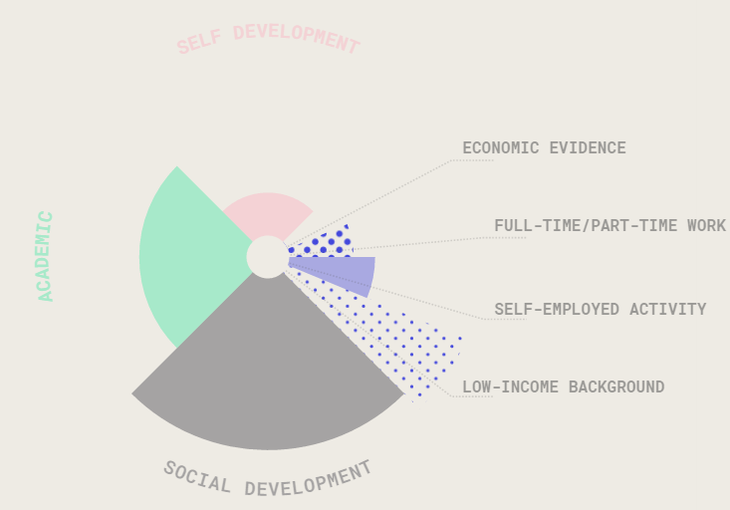

Same could apply here as well considering all the parameters are equal:

$$0≤\frac{1}{4}*a+\frac{1}{4}*b+\frac{1}{4}*c+\frac{1}{4}*d≤1,$$

$Where a,b,c,d <= 1$.

Grading the sub-parameters

1. Economic Evidence:
2. Full-time/Part-time work: It will be dependent on the nature of previous work and on the amount of years someone has worked for. Someone who has worked full-time for two years will get 0,7 (standard for full time) + 1,5 (standard multiplier)* 0.2 (0.1 for each year). We just need to alter the numbers for part-time.
3. Self-employed activity should be automatically given 1, considering the fact that they are just graduates, so it shows great ambition and maturity to have been self-employed at such a young age.
4. Here it is obvious that the lower the income background for the graduate’s family, the higher the score he should be given in myEcho. We can easily measure it by designing some income tiers.

**Self-development**

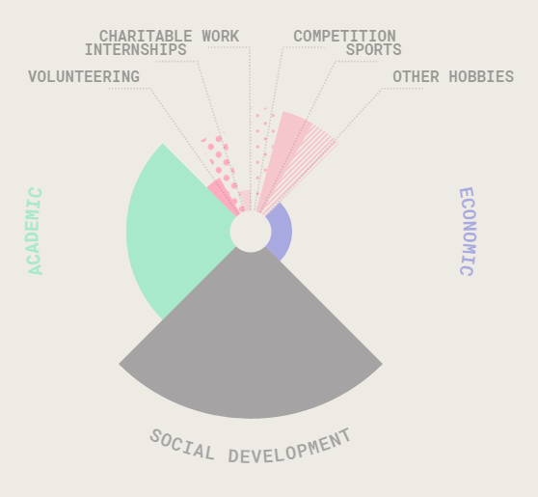

We must come up with an idea about rating with the answers provided by graduates from the relevant questions about hobbies, charities and internships. In my opinion, hobbies should not count as much as the latter two, unless the graduate has scored really high in a reputable competition.

**Social development**



1. The disability should be measured according to the type of disability, but also the amount of years it has affected someone. In my opinion, we should have a list with all the known disabilities and assign a certain score to each one of them. After that, we should also take into consideration the amount of years someone has been suffering from this.
2. One of our questions can regard someone’s family stability. If someone’s parents were divorced for instance they should take a bigger score than someone who was living with both his parents during childhood.
3. As for geographic location, it is covered already in our questions. We can rate it, based on deprivation indexes. From this indices we can make several categories and assign a different score to each one of them. For example if we have a CSV file with 40000 location deprivation ratings we can split it into 5 categories like the following:

|  |  |
| --- | --- |
| 1-2000 | 0,15 |
| 2001-8000 | 0,35 |
| 8001-20000 | 0,55 |
| 20001-35000 | 0,75 |
| 35001-40000 | 1 |