INTEGRATION GUIDE: SONICWALL CAPTURE CLIENT AND CONNECTWISE AUTOMATE

**July 2020**

This document describes how SonicWall Capture Client helps integrate ConnectWise Automate RMM tool. This integration helps: Detect devices which don’t have Capture Client installed, install capture client on the endpoint via automate tool and displays that capture client is installed on the device details in the monitor and in device list page.

**ConnectWise Automate** (Formerly LabTech) is a cloud-based and on-premise IT **automation** solution that helps companies track and manage IT assets from a single location.

Table of Contents

DOWNLOAD THE PACKAGE 1

IMPORT SCRIPTS AND SQL 2

Scripts 2

SQL 2

RUN COMMANDS 5

Troubleshooting 5

# DOWNLOAD THE PACKAGE

* Download the “CW Automate packaging.zip” shared with you.
* Extract the zip file. The zip file contains

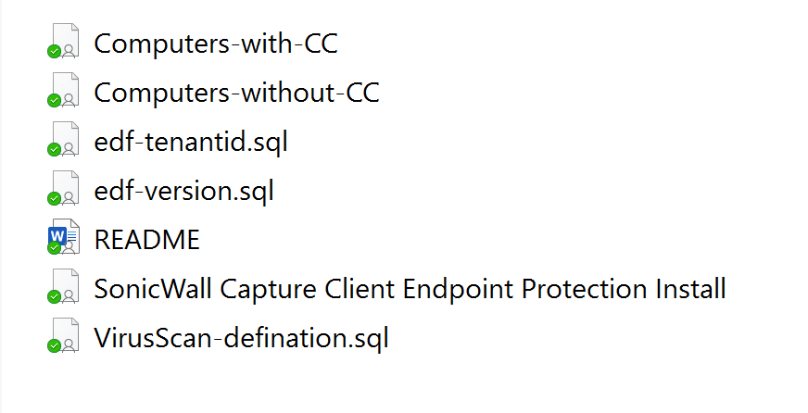

# IMPORT SCRIPTS AND SQL

## SCRIPTS

* Open ConnectWise Automate, navigate to **Tools > Import > LT XML Expansion**, and import the  below files from extracted folder
* “SonicWall Capture Client Endpoint Protection Install.xml”
* Computers-with-CC.xml
* Computers-without-CC.xml
* A new folder **Antinvirus -> SonicWall Capture Client** is created under Scripts which lists the client install script.
* A couple of new search items will be added under search **Automation > Searches > AntiVirus Software** namely ‘Antivirus – Non SonicWall Capture Client Endpoints’ and ‘Antivirus – SonicWall Capture Client’

## SQL

* Next, navigate to **Tools > Import > SQL File**, and import the below SQL files from the extracted folder.
* edf-tenantid.sql
* edf-version.sql
* VirusScan-defination.sql

When you import the script, the following updates are made in ConnectWise Automate.

* You should be able to see the below 2 custom fields registered under **System > Configuration > Dashboard > Config**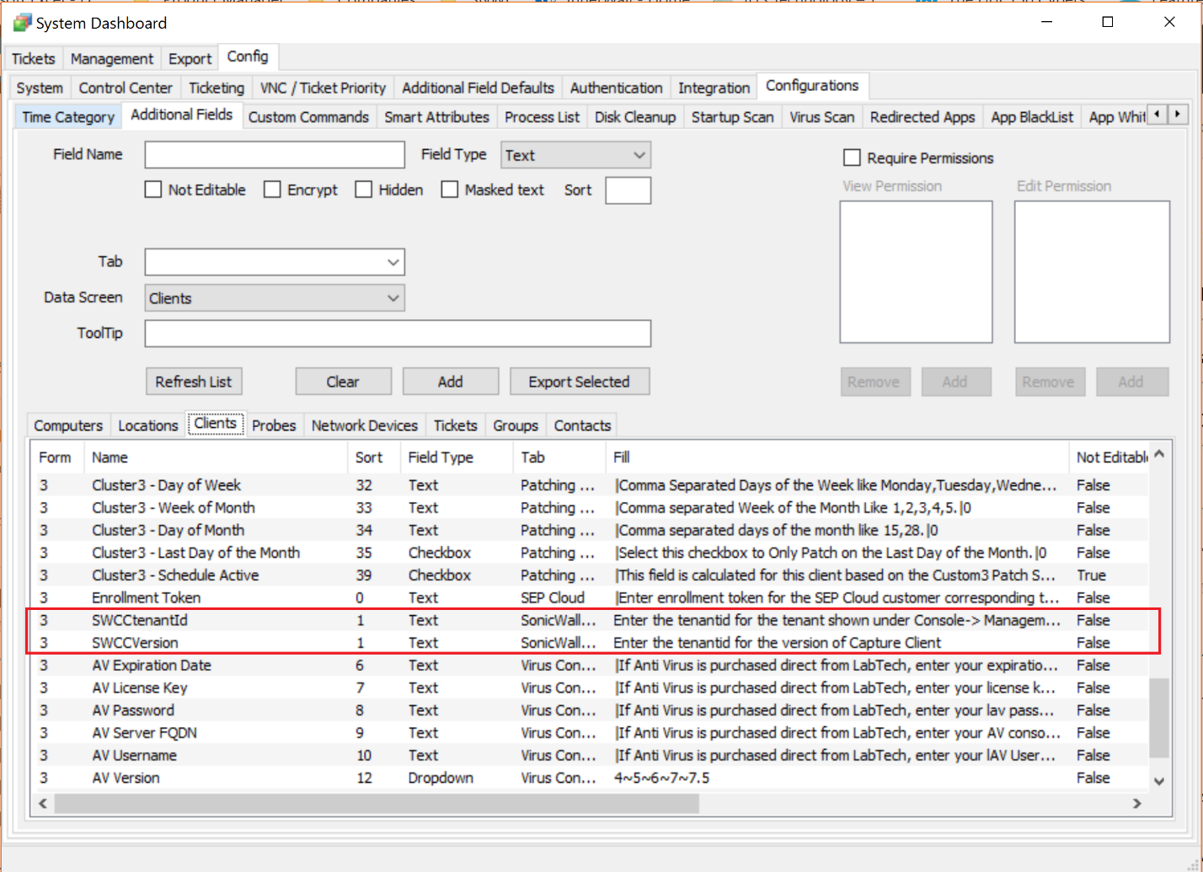
* You should be able to see a new tab **SonicWall Capture Client** and 2 custom fields when you right-click on **client > open > Info**.

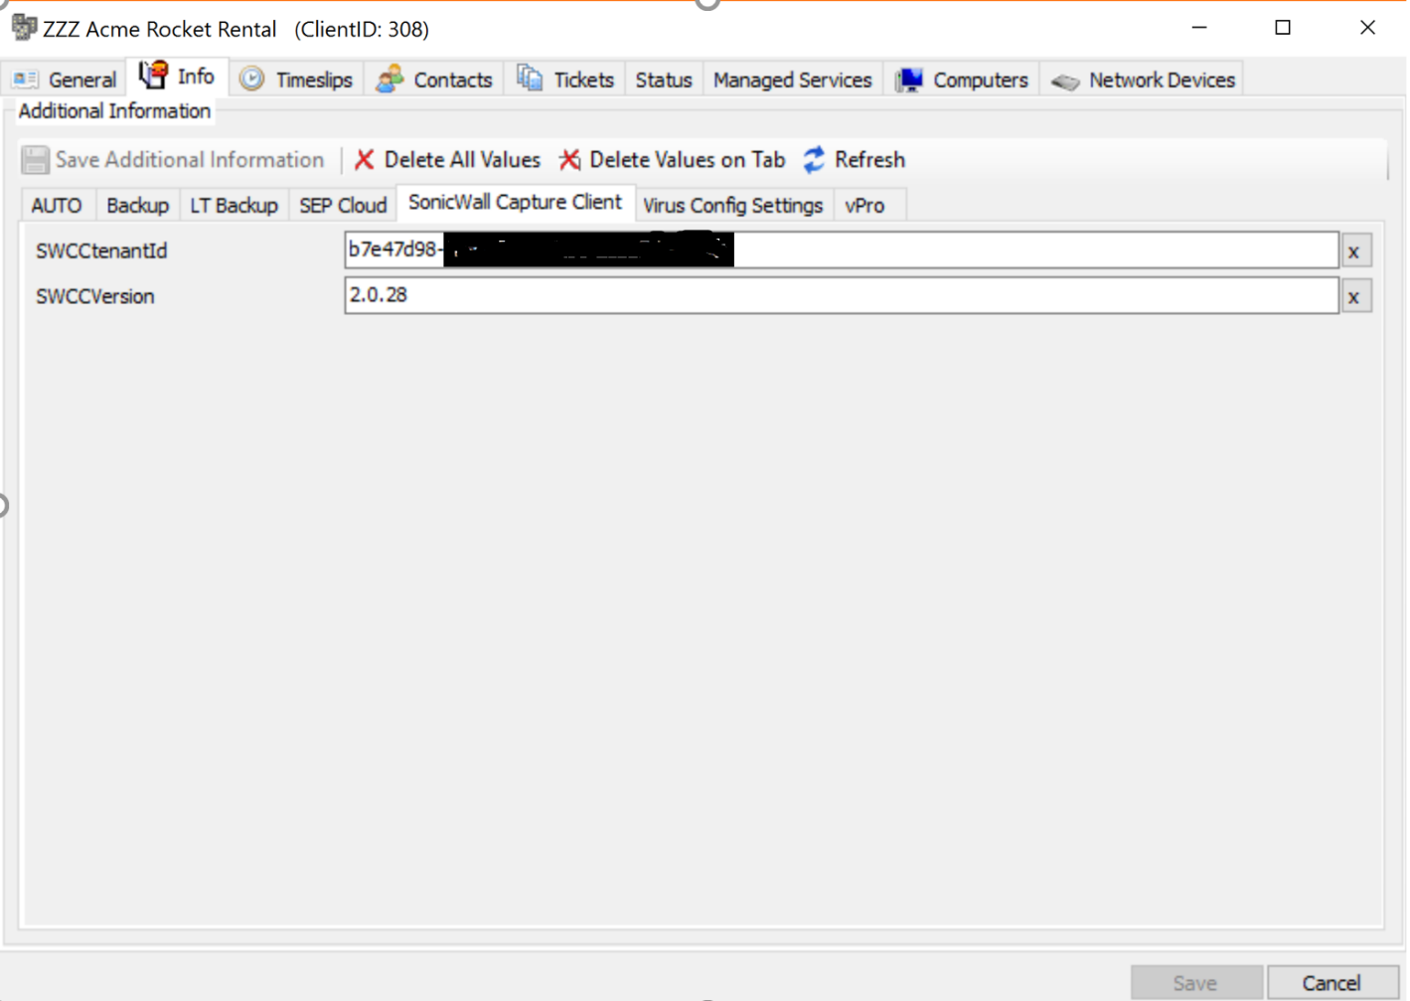

* You should be able to see the new virus definition for Capture Client registered under **System > Configuration > Dashboard > Config**  
  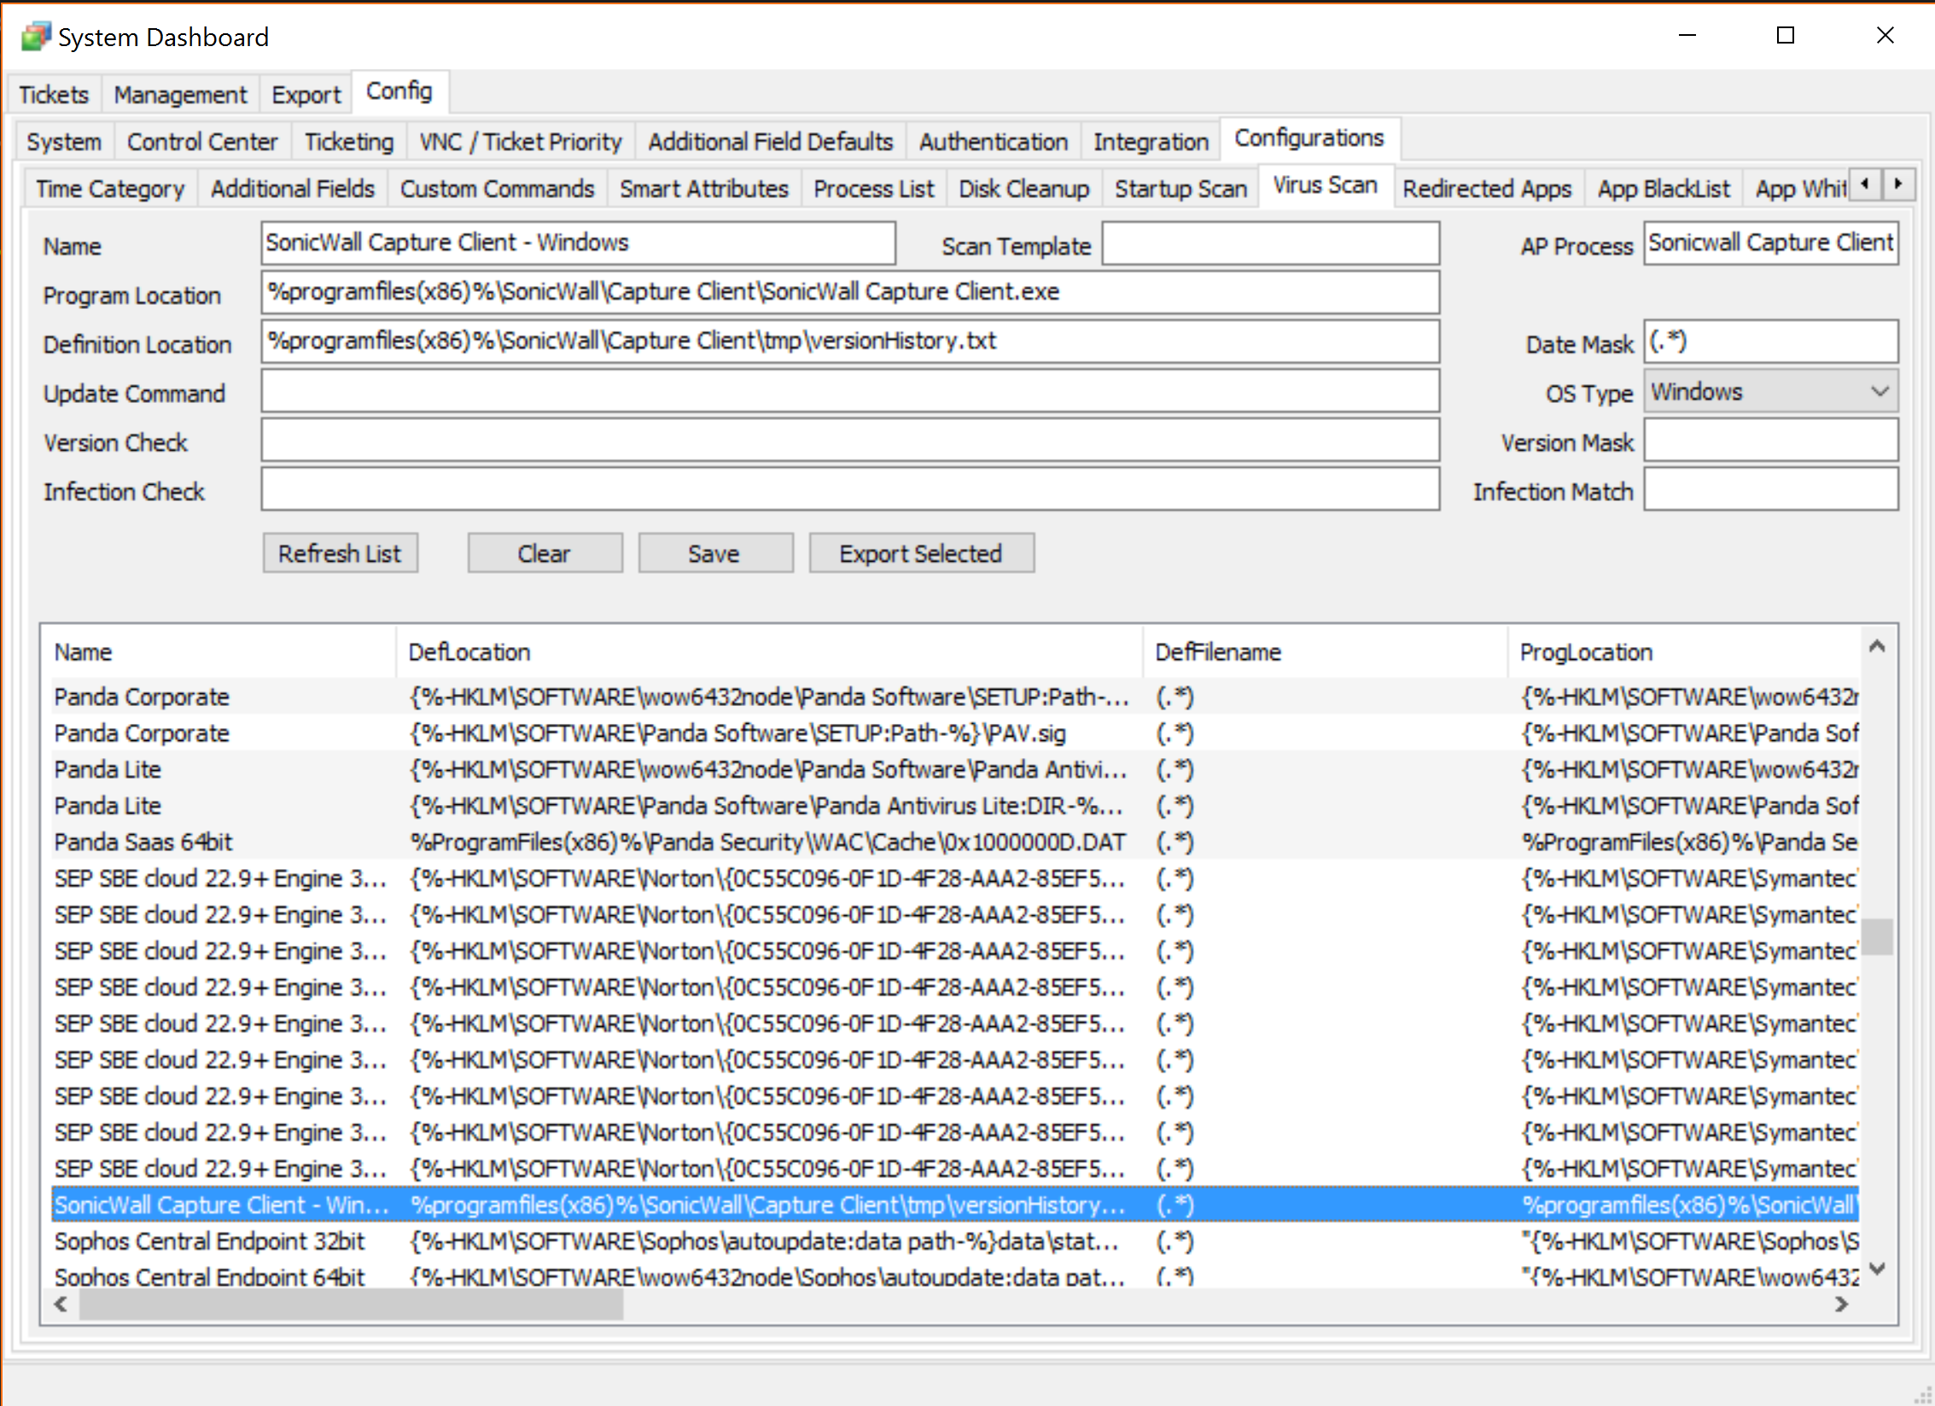

# RUN COMMANDS

You must issue the following commands from Commands > Inventory to all the ConnectWise Automate clients:

* Update Config
* Resend System info
* Resend Software Info LT

# TROUBLESHOOTING

Check logs in ConnectWise Automate for the script output and please reach out to SonicWall support.