**Test Case 1:** The max size of Alert list is 5 and we are trying to add new alerts and alert list has reached its max size.

Outcome: New alert should be added to alert list and oldest alert should be removed from the list.

**Evidences:**

The Current Alert List is :

-----------------------------------------------------------------------------------------------------

Alert{rootCause='DB1_DOWN', alertMessage='database 1 is down', serviceName='serviceC', timeStamp=2021-01-16T17:31:02.466}

-----------------------------------------------------------------------------------------------------

Alert{rootCause='DB2_DOWN', alertMessage='database 2 is down', serviceName='serviceB', timeStamp=2021-01-16T17:31:02.466}

-----------------------------------------------------------------------------------------------------

Alert{rootCause='DB1_DOWN', alertMessage='database 1 is down', serviceName='serviceA', timeStamp=2021-01-16T17:32:33.729}

-----------------------------------------------------------------------------------------------------

Alert{rootCause='', alertMessage='Kafka Down', serviceName='MAP', timeStamp=2021-01-16T17:31:09.441}

-----------------------------------------------------------------------------------------------------

Alert{rootCause='MQ Down', alertMessage='MQ is Down', serviceName='PFI', timeStamp=2021-01-16T17:33:23.273}

-----------------------------------------------------------------------------------------------------

The Current Alert List size is : 5

Scenario 1:

Input: n=5, x=600

**Console Output:**

Do you want to add one more alert?(Y/N)

y

Enter information for new Alert -

Enter rootCause -

TWS Down

Enter alertMessage -

TWS is Down

Enter serviceName -

MAP

Alert list has reached max size hence removing oldest alert from list

Below alert removed from Alert List

-----------------------------------------------------------------------------------------------------

Alert{rootCause='DB1_DOWN', alertMessage='database 1 is down', serviceName='serviceC', timeStamp=2021-01-16T17:31:02.466}

-----------------------------------------------------------------------------------------------------

New alert is added in Alert's List

The newly added alert qualifies the resendIntervalInSeconds criteria hence printing

-----------------------------------------------------------------------------------------------------

Alert{rootCause='TWS Down', alertMessage='TWS is Down', serviceName='MAP', timeStamp=2021-01-16T17:38:26.557}

-----------------------------------------------------------------------------------------------------

The Current Alert List is :

-----------------------------------------------------------------------------------------------------

Alert{rootCause='DB1_DOWN', alertMessage='database 1 is down', serviceName='serviceA', timeStamp=2021-01-16T17:32:33.729}

-----------------------------------------------------------------------------------------------------

Alert{rootCause='DB2_DOWN', alertMessage='database 2 is down', serviceName='serviceB', timeStamp=2021-01-16T17:31:02.466}

-----------------------------------------------------------------------------------------------------

Alert{rootCause='MQ Down', alertMessage='MQ is Down', serviceName='PFI', timeStamp=2021-01-16T17:33:23.273}

-----------------------------------------------------------------------------------------------------

Alert{rootCause='', alertMessage='Kafka Down', serviceName='MAP', timeStamp=2021-01-16T17:31:09.441}

-----------------------------------------------------------------------------------------------------

Alert{rootCause='TWS Down', alertMessage='TWS is Down', serviceName='MAP', timeStamp=2021-01-16T17:38:26.557}

-----------------------------------------------------------------------------------------------------

The Current Alert List size is : 5

Do you want to add one more alert?(Y/N)

**Eclipse Screenshots:**

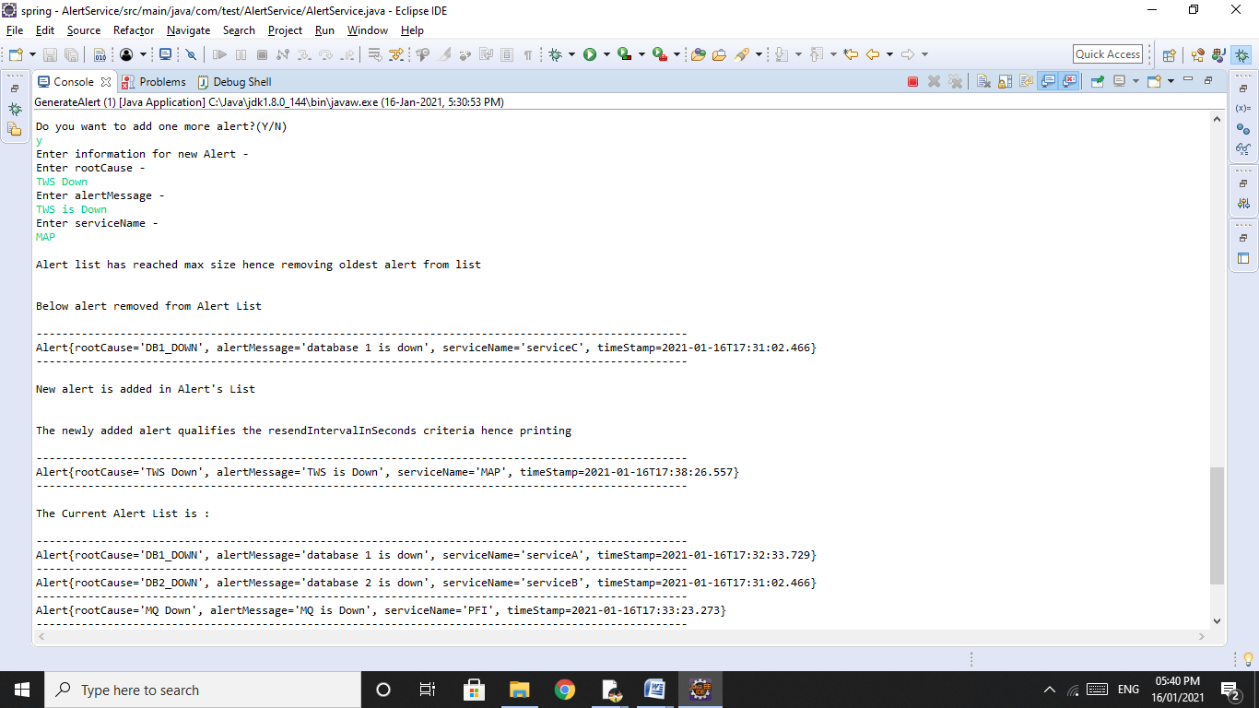

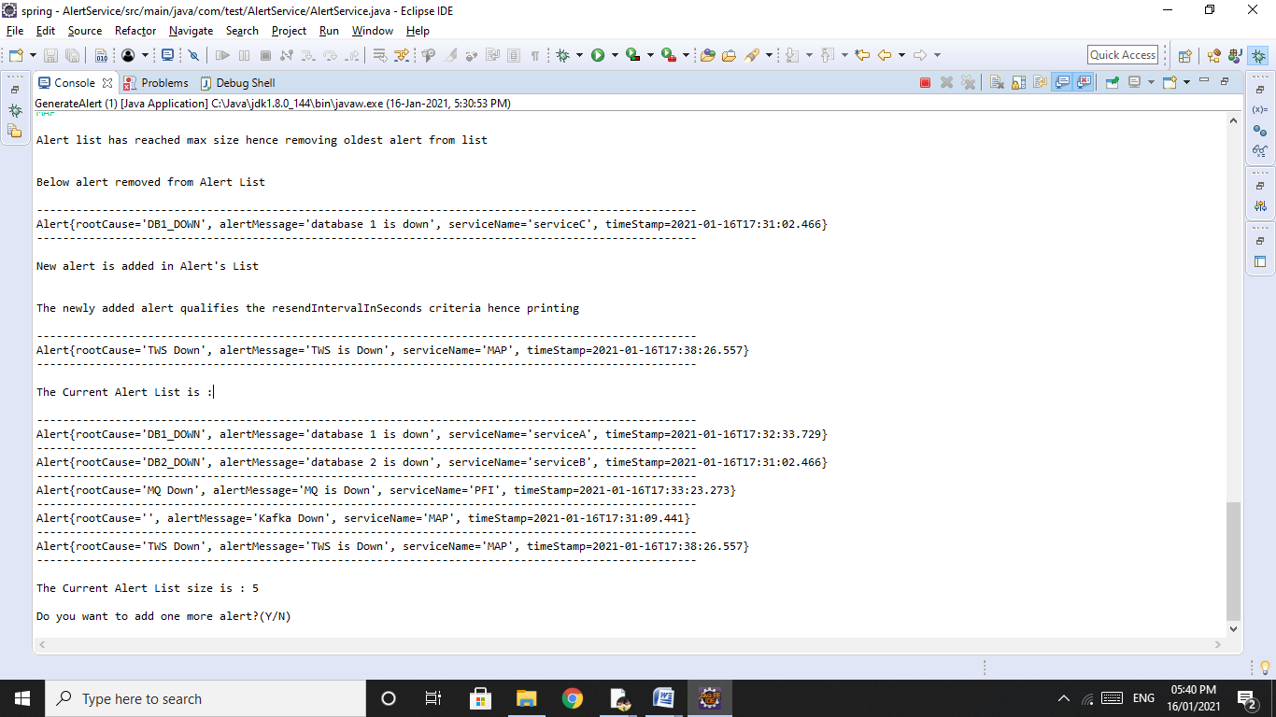

**Test Case 2:** We give input of new alert and an alert with same route cause haa already been published within resend Interval In Seconds.

Outcome: As the alert with same root cause was published within 600 seconds window, the new alert should not be printed on console.

**Evidences:**

The Current Alert List is :

-----------------------------------------------------------------------------------------------------

Alert{rootCause='DB1_DOWN', alertMessage='database 1 is down', serviceName='serviceA', timeStamp=2021-01-16T17:32:33.729}

-----------------------------------------------------------------------------------------------------

Alert{rootCause='DB2_DOWN', alertMessage='database 2 is down', serviceName='serviceB', timeStamp=2021-01-16T17:31:02.466}

-----------------------------------------------------------------------------------------------------

Alert{rootCause='MQ Down', alertMessage='MQ is Down', serviceName='PFI', timeStamp=2021-01-16T17:33:23.273}

-----------------------------------------------------------------------------------------------------

Alert{rootCause='', alertMessage='Kafka Down', serviceName='MAP', timeStamp=2021-01-16T17:31:09.441}

-----------------------------------------------------------------------------------------------------

Alert{rootCause='TWS Down', alertMessage='TWS is Down', serviceName='MAP', timeStamp=2021-01-16T17:38:26.557}

-----------------------------------------------------------------------------------------------------

The Current Alert List size is : 5

Input: n=5, x=600

**Console Output:**

Do you want to add one more alert?(Y/N)

y

Enter information for new Alert -

Enter rootCause -

TWS Down

Enter alertMessage -

TWS is Down

Enter serviceName -

MAP

Alert list has reached max size hence removing oldest alert from list

Below alert removed from Alert List

-----------------------------------------------------------------------------------------------------

Alert{rootCause='DB1_DOWN', alertMessage='database 1 is down', serviceName='serviceA', timeStamp=2021-01-16T17:32:33.729}

-----------------------------------------------------------------------------------------------------

New alert is added in Alert's List

The newly added alert doesnt qualify the resendIntervalInSeconds criteria hence can not be printed

The Current Alert List is :

-----------------------------------------------------------------------------------------------------

Alert{rootCause='MQ Down', alertMessage='MQ is Down', serviceName='PFI', timeStamp=2021-01-16T17:33:23.273}

-----------------------------------------------------------------------------------------------------

Alert{rootCause='DB2_DOWN', alertMessage='database 2 is down', serviceName='serviceB', timeStamp=2021-01-16T17:31:02.466}

-----------------------------------------------------------------------------------------------------

Alert{rootCause='TWS Down', alertMessage='TWS is Down', serviceName='MAP', timeStamp=2021-01-16T17:38:26.557}

-----------------------------------------------------------------------------------------------------

Alert{rootCause='', alertMessage='Kafka Down', serviceName='MAP', timeStamp=2021-01-16T17:31:09.441}

-----------------------------------------------------------------------------------------------------

Alert{rootCause='TWS Down', alertMessage='TWS is Down', serviceName='MAP', timeStamp=2021-01-16T17:41:52.961}

-----------------------------------------------------------------------------------------------------

The Current Alert List size is : 5

Do you want to add one more alert?(Y/N)

**Eclipse Screenshots:**

