**Evidences of Junit executed during Maven Install:**

**Eclipse Screenshots :**

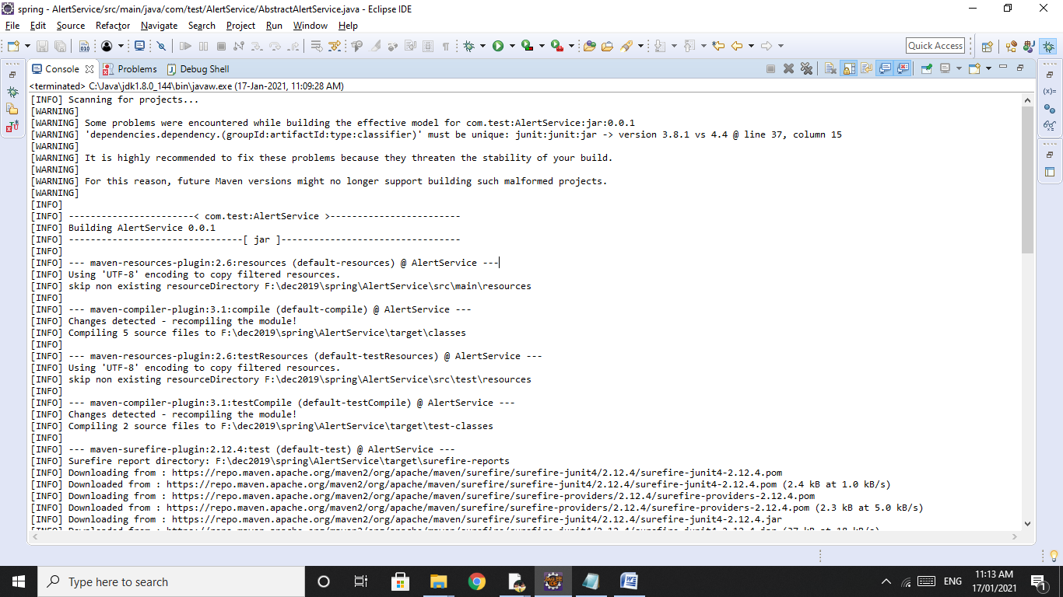

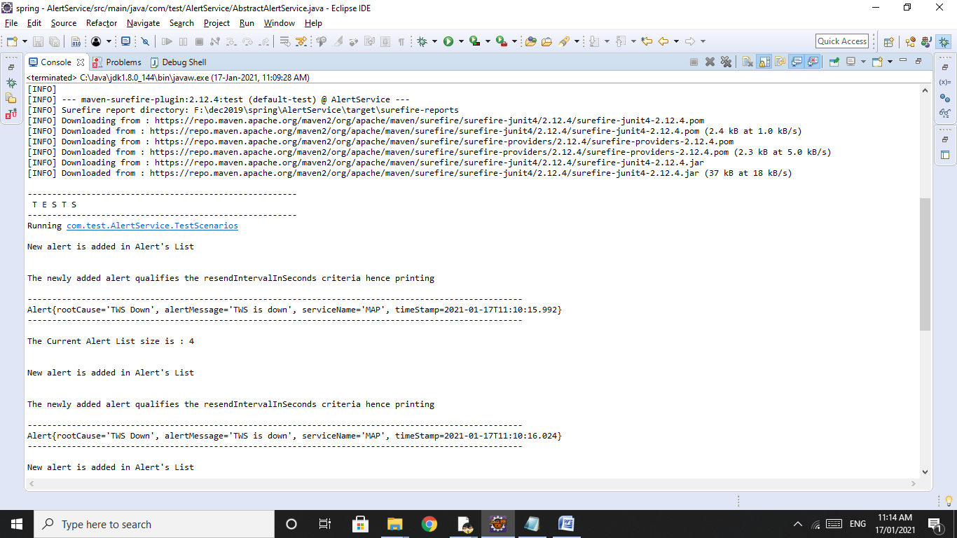

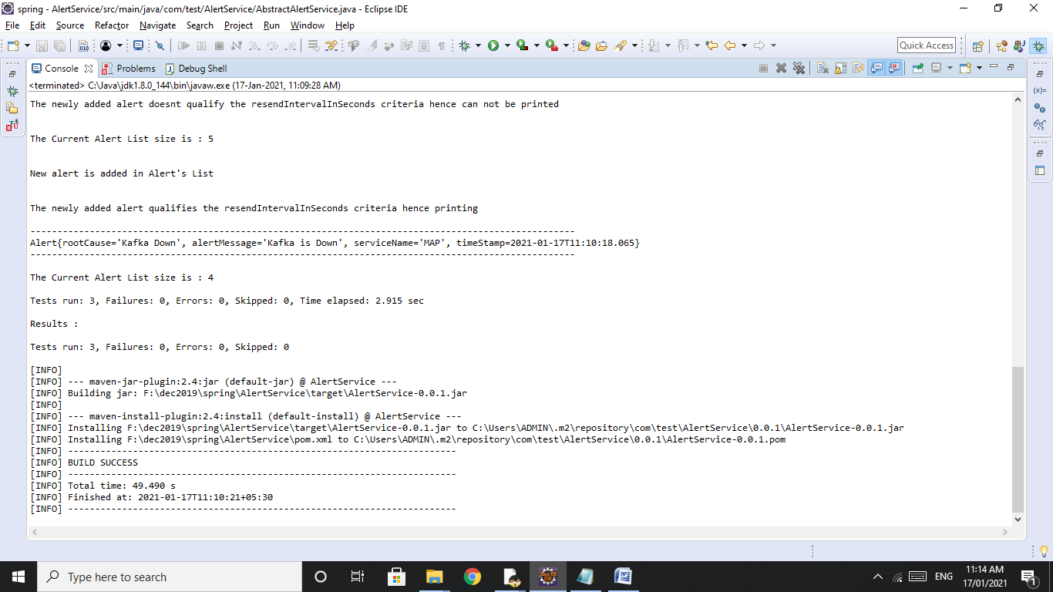

**Console Output in text format:**

[INFO] Scanning for projects...

[WARNING]

[WARNING] Some problems were encountered while building the effective model for com.test:AlertService:jar:0.0.1

[WARNING] 'dependencies.dependency.(groupId:artifactId:type:classifier)' must be unique: junit:junit:jar -> version 3.8.1 vs 4.4 @ line 37, column 15

[WARNING]

[WARNING] It is highly recommended to fix these problems because they threaten the stability of your build.

[WARNING]

[WARNING] For this reason, future Maven versions might no longer support building such malformed projects.

[WARNING]

[INFO]

[INFO] -----------------------< com.test:AlertService >------------------------

[INFO] Building AlertService 0.0.1

[INFO] --------------------------------[ jar ]---------------------------------

[INFO]

[INFO] --- maven-resources-plugin:2.6:resources (default-resources) @ AlertService ---

[INFO] Using 'UTF-8' encoding to copy filtered resources.

[INFO] skip non existing resourceDirectory F:\dec2019\spring\AlertService\src\main\resources

[INFO]

[INFO] --- maven-compiler-plugin:3.1:compile (default-compile) @ AlertService ---

[INFO] Changes detected - recompiling the module!

[INFO] Compiling 5 source files to F:\dec2019\spring\AlertService\target\classes

[INFO]

[INFO] --- maven-resources-plugin:2.6:testResources (default-testResources) @ AlertService ---

[INFO] Using 'UTF-8' encoding to copy filtered resources.

[INFO] skip non existing resourceDirectory F:\dec2019\spring\AlertService\src\test\resources

[INFO]

[INFO] --- maven-compiler-plugin:3.1:testCompile (default-testCompile) @ AlertService ---

[INFO] Changes detected - recompiling the module!

[INFO] Compiling 2 source files to F:\dec2019\spring\AlertService\target\test-classes

[INFO]

[INFO] --- maven-surefire-plugin:2.12.4:test (default-test) @ AlertService ---

[INFO] Surefire report directory: F:\dec2019\spring\AlertService\target\surefire-reports

[INFO] Downloading from : https://repo.maven.apache.org/maven2/org/apache/maven/surefire/surefire-junit4/2.12.4/surefire-junit4-2.12.4.pom

[INFO] Downloaded from : https://repo.maven.apache.org/maven2/org/apache/maven/surefire/surefire-junit4/2.12.4/surefire-junit4-2.12.4.pom (2.4 kB at 1.0 kB/s)

[INFO] Downloading from : https://repo.maven.apache.org/maven2/org/apache/maven/surefire/surefire-providers/2.12.4/surefire-providers-2.12.4.pom

[INFO] Downloaded from : https://repo.maven.apache.org/maven2/org/apache/maven/surefire/surefire-providers/2.12.4/surefire-providers-2.12.4.pom (2.3 kB at 5.0 kB/s)

[INFO] Downloading from : https://repo.maven.apache.org/maven2/org/apache/maven/surefire/surefire-junit4/2.12.4/surefire-junit4-2.12.4.jar

[INFO] Downloaded from : https://repo.maven.apache.org/maven2/org/apache/maven/surefire/surefire-junit4/2.12.4/surefire-junit4-2.12.4.jar (37 kB at 18 kB/s)

-------------------------------------------------------

T E S T S

-------------------------------------------------------

Running com.test.AlertService.TestScenarios

New alert is added in Alert's List

The newly added alert qualifies the resendIntervalInSeconds criteria hence printing

-----------------------------------------------------------------------------------------------------

Alert{rootCause='TWS Down', alertMessage='TWS is down', serviceName='MAP', timeStamp=2021-01-17T11:10:15.992}

-----------------------------------------------------------------------------------------------------

The Current Alert List size is : 4

New alert is added in Alert's List

The newly added alert qualifies the resendIntervalInSeconds criteria hence printing

-----------------------------------------------------------------------------------------------------

Alert{rootCause='TWS Down', alertMessage='TWS is down', serviceName='MAP', timeStamp=2021-01-17T11:10:16.024}

-----------------------------------------------------------------------------------------------------

New alert is added in Alert's List

The newly added alert doesnt qualify the resendIntervalInSeconds criteria hence can not be printed

The Current Alert List size is : 5

New alert is added in Alert's List

The newly added alert qualifies the resendIntervalInSeconds criteria hence printing

-----------------------------------------------------------------------------------------------------

Alert{rootCause='Kafka Down', alertMessage='Kafka is Down', serviceName='MAP', timeStamp=2021-01-17T11:10:18.065}

-----------------------------------------------------------------------------------------------------

The Current Alert List size is : 4

Tests run: 3, Failures: 0, Errors: 0, Skipped: 0, Time elapsed: 2.915 sec

Results :

Tests run: 3, Failures: 0, Errors: 0, Skipped: 0

[INFO]

[INFO] --- maven-jar-plugin:2.4:jar (default-jar) @ AlertService ---

[INFO] Building jar: F:\dec2019\spring\AlertService\target\AlertService-0.0.1.jar

[INFO]

[INFO] --- maven-install-plugin:2.4:install (default-install) @ AlertService ---

[INFO] Installing F:\dec2019\spring\AlertService\target\AlertService-0.0.1.jar to C:\Users\ADMIN\.m2\repository\com\test\AlertService\0.0.1\AlertService-0.0.1.jar

[INFO] Installing F:\dec2019\spring\AlertService\pom.xml to C:\Users\ADMIN\.m2\repository\com\test\AlertService\0.0.1\AlertService-0.0.1.pom

[INFO] ------------------------------------------------------------------------

[INFO] BUILD SUCCESS

[INFO] ------------------------------------------------------------------------

[INFO] Total time: 49.490 s

[INFO] Finished at: 2021-01-17T11:10:21+05:30

[INFO] ------------------------------------------------------------------------