Frontend Unit Testing Report

Secure Healthcare – Clinical Decision Support System (CDSS)

1. Project Information
Project Name: Secure Healthcare – Clinical Decision Support System
Sprint: Sprint 1 (Frontend Implementation – 50%)
Date: February 9, 2026
Repository Branch: bhkr

2. Testing Overview
This document presents the Frontend Unit and Integration Testing conducted during Sprint 1.
Scope includes authentication context, route protection, API client, email service, booking component, and UI behavior validation.

3. Testing Tools Used
• Vitest – Test Runner
• jest-dom – DOM Assertions
• jsdom – Browser Simulation Environment

4. Test Execution Summary
All frontend test cases executed successfully with 100% pass rate and zero failures.

5. Test Result Screenshots
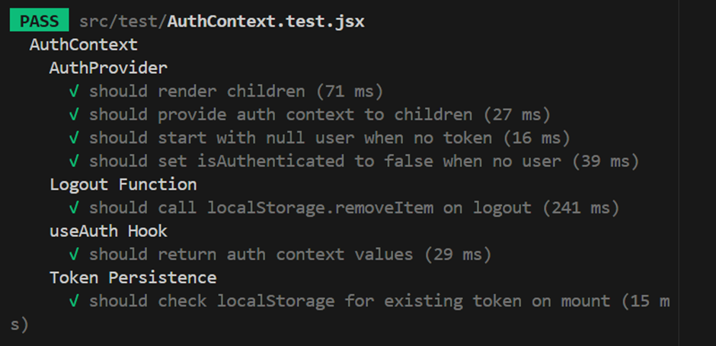

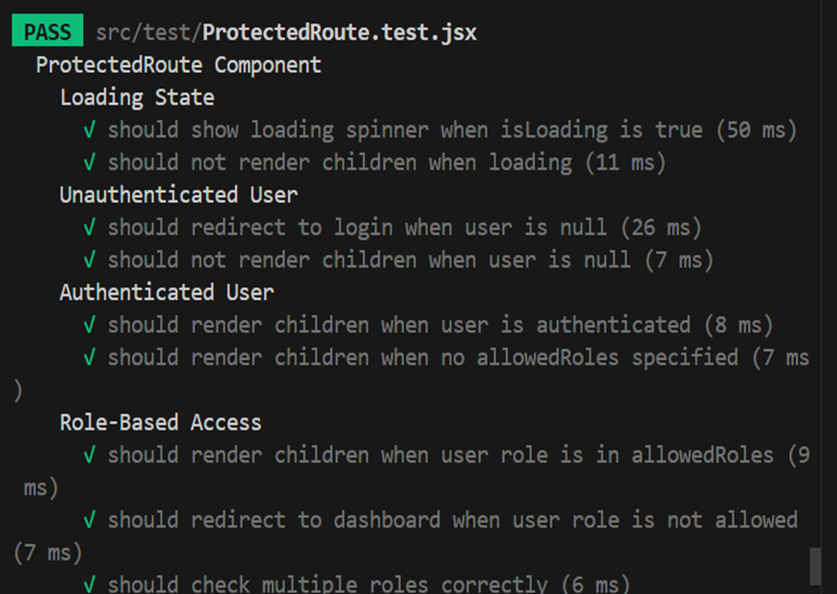

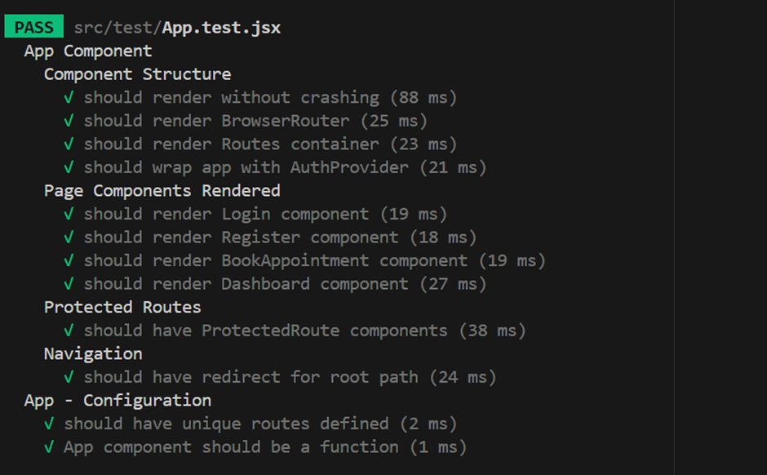

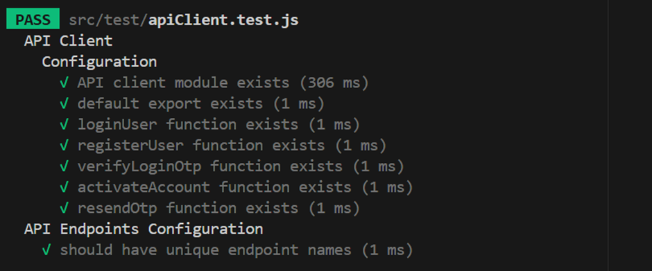

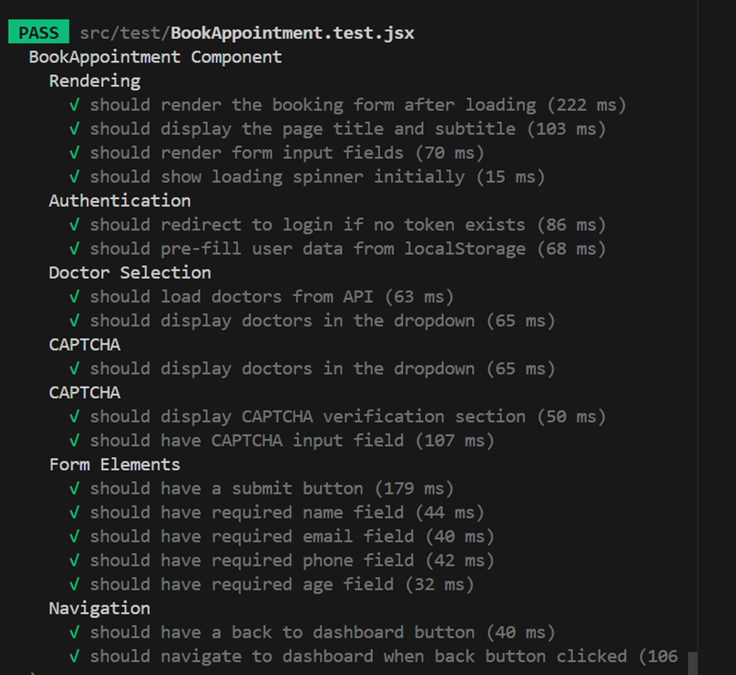

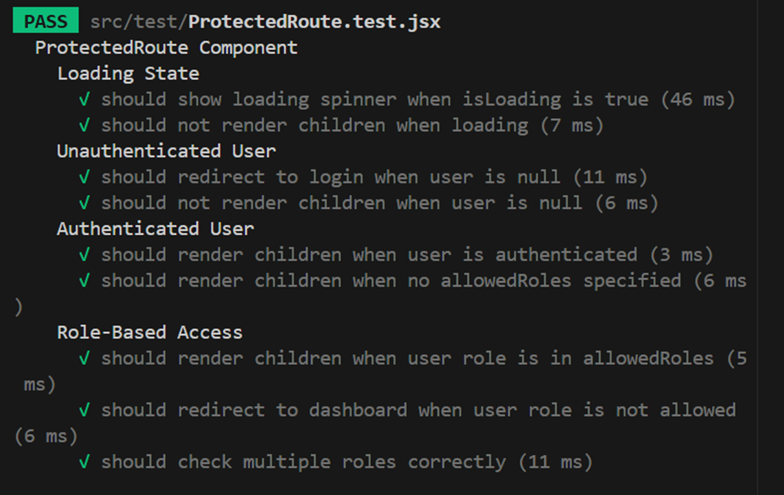

6. Conclusion
Frontend Unit Testing for Sprint 1 has been successfully completed for :
Authentication logic, route protection, API client, and bookingappointment and app were validated.

