<NEON> Design
Revision History
Date | Issue | Description | Author
<dd/mmm/yy> | <x.x> | <details> | <name>

Table of Contents
1. Introduction 4
1.1 Purpose 4
2. Requirements - Use-Case – Usage Scenarios 4
3. High Level Design 4
4. Detailed Design 5
4.1 <Object.Name> Usage 5
4.2 Interaction Diagram 5
5. Issues, Risk and Dependencies 5
6. Design Alternatives 5
7. References 5

Introduction

This project basically creates a website to communicate employers and freelancer. Employers can hire freelancers to do work in areas such as software development, writing, data entry and design right through to engineering, the sciences, sales and marketing, accounting and legal services.

Purpose

A Freelance Management System (FMS) is a web-based workforce solution that helps businesses manage their independent contractor and freelancer workforces. FMS, empowers businesses of all sizes to manage the end-to-end freelance work stream, all from one centralized dashboard.

Requirements - Use-Case – Usage Scenarios

- Employer sign up and login
- Freelancer sign up and login
- Employer CRUD projects
- Employer emails freelancer for an interview
- Spring Security
- Validation and AOP
- Freelancer searches for projects and applies
- JMS for freelancer application for project

High Level Design
User Entity: super class for Employer and Freelancer classes and they have common attributes like: first Name, last Name, address …...
Employer and Freelancer classes extends User and they have some extra like “project Completed” field in Employer and “job Completed” in Freelancer classes.
Address: holds addresses of Users
Profile: hold profiles of all user’s like
Credentials: to hold user’s user name, password
Authority: holds what is the role of the user.
Every details of freelancer saved in Classes Skills, Education, Certification and Experience.
Project: This entity holds all projects which is posted by Employer.

Figure 1 < High Level Design Diagram >

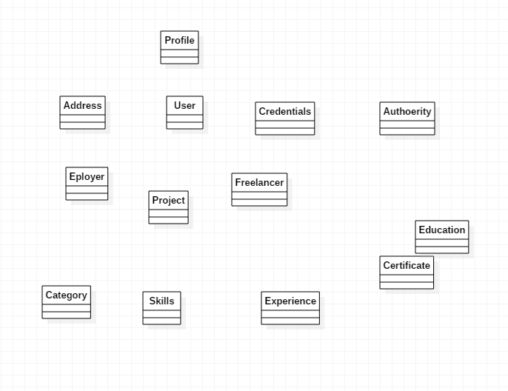

Detailed Design

<Object.Name> Usage

User Object: super class for Employer and Freelancer classes and they have common attributes like: first Name, last Name, address …...
Employer and Freelancer objects extends User and they have some extra like “project Completed” field in Employer and “job Completed” in Freelancer classes.
Address: holds addresses of Users
Profile: hold profiles of all user’s like
Credentials: to hold user’s user name, password
Authority: holds what is the role of the user.
Every details of freelancer saved in Classes Skills, Education, Certification and Experience.
Project: This object holds all projects which is posted by Employer.

Figure 2 <ClassDiagram.Name>

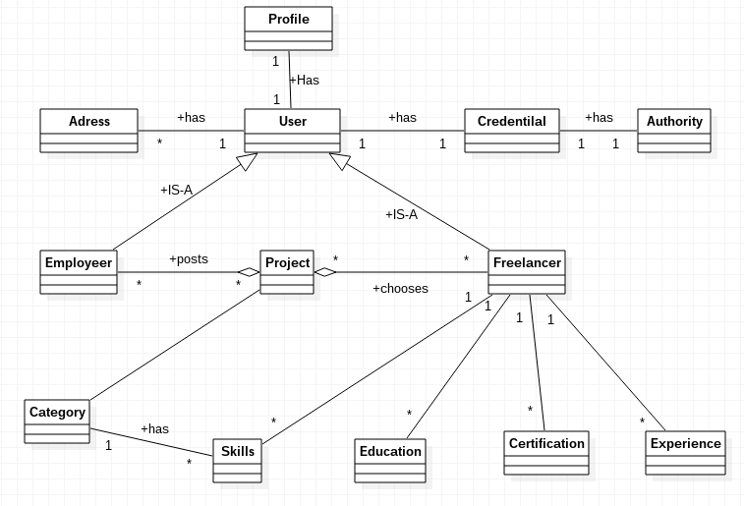

Interaction Diagram

Figure 3 <InteractionDiagram.Name>

Sequence Diagram Sign Up and Sign in Users

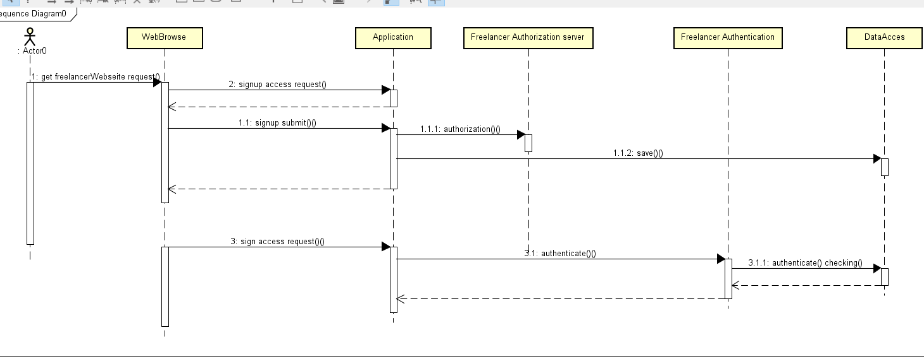

Design Alternatives

Issues, Risk and Dependencies
We face a problem association relationship between credentials and authority. Because at first we tried credential and authority one to one relationship it was out fault. Later we modify credentials and authority many to one relationship and it worked well.

Future Considerations
Payment method, and shipment of the bill for the freelancer.

References
Freelancer.com for designing domain object and relationship, bootstrap for front end designing, spring IO for spring configuration.

