**Created two Amazon RDS MySQL databases for student-write-db and student-read-db (read replica of student-write-db)**

**student-write-db**

**student-read-db**

**Created EC2 instance in AWS console to connect to MySql Database.**

**Created Simple Queue Service in AWS console**

**

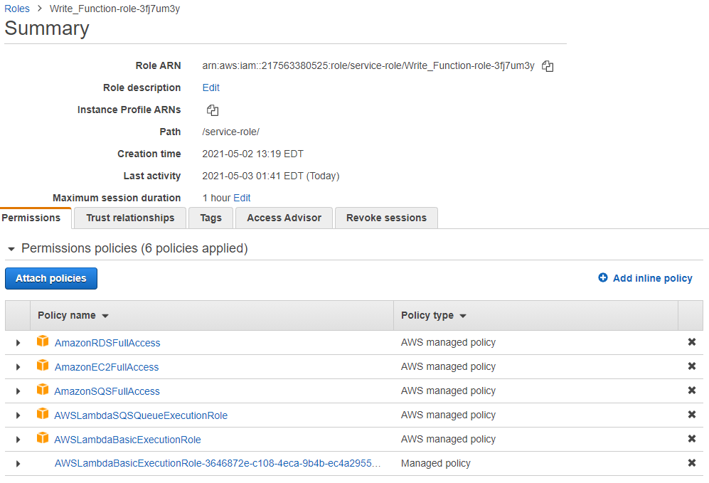

**Created two Lambda Functions. One is to perform Insert, Update and Delete commands and the other is to retrieve the data from the tables.**

**Write_function (to perform DML commands)**

**Created SQS trigger for this function to receive messages from Simple Queue Service**

**Read-function (to fetch the reports data from the database tables)**

**Created new collection and requests in postman and provided access key, secret key, region and service name.**

