1. For operational report:

Billing Activity Detail, Billing Trial Balance, Payment Detail, Policy Transaction Activity Details & Policy Trial Balance, premium earned/unearned

1. Set server time to last set time-point
2. Hit this url changing the initial prefix as per instance in [____http://dev2aaa3was404.eqxdev.exigengroup.com:9084/operational-reports-app/log](_http:/dev2aaa3was404.eqxdev.exigengroup.com:9084/operational-reports-app/login.xhtml)in.xhtmlin.xhtml
3. Change name/type based on the 6 reports as seen below.
4. Note- Accounting Date from should always be the effective date of policy (or when suite ran)

Screenshots-

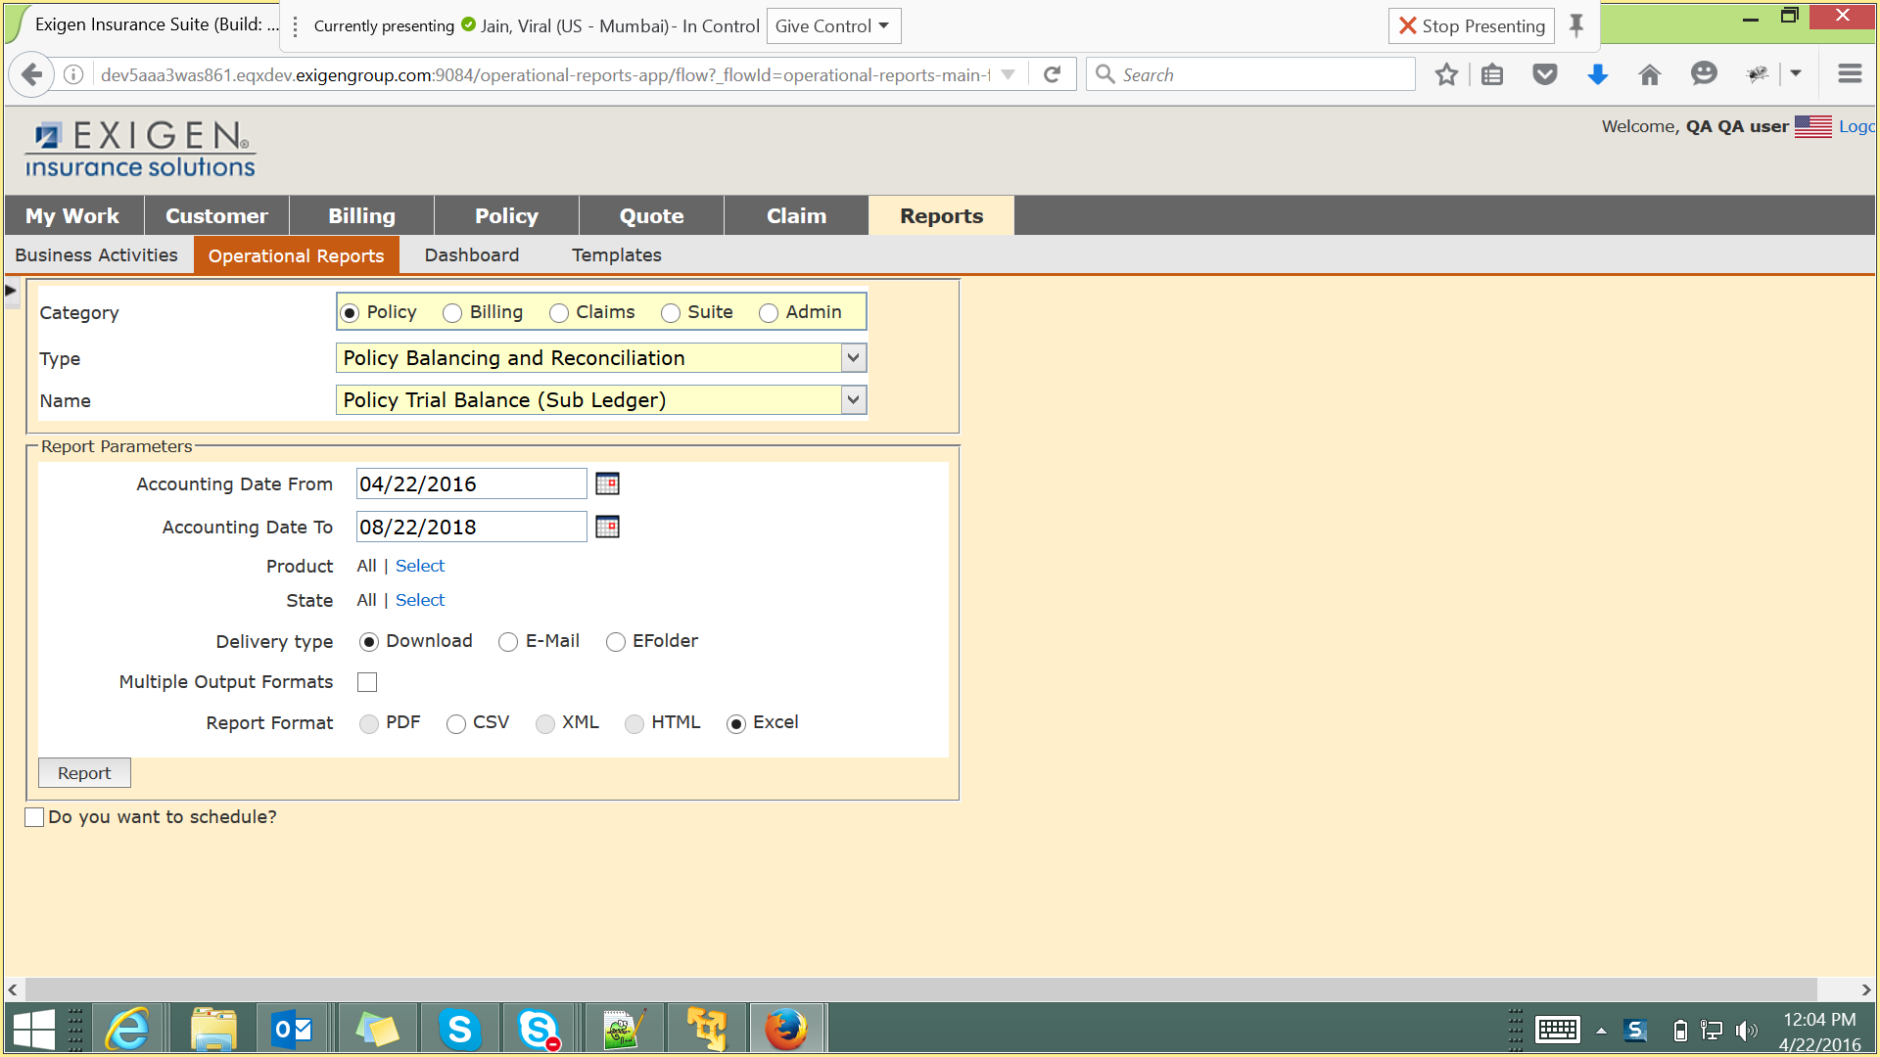

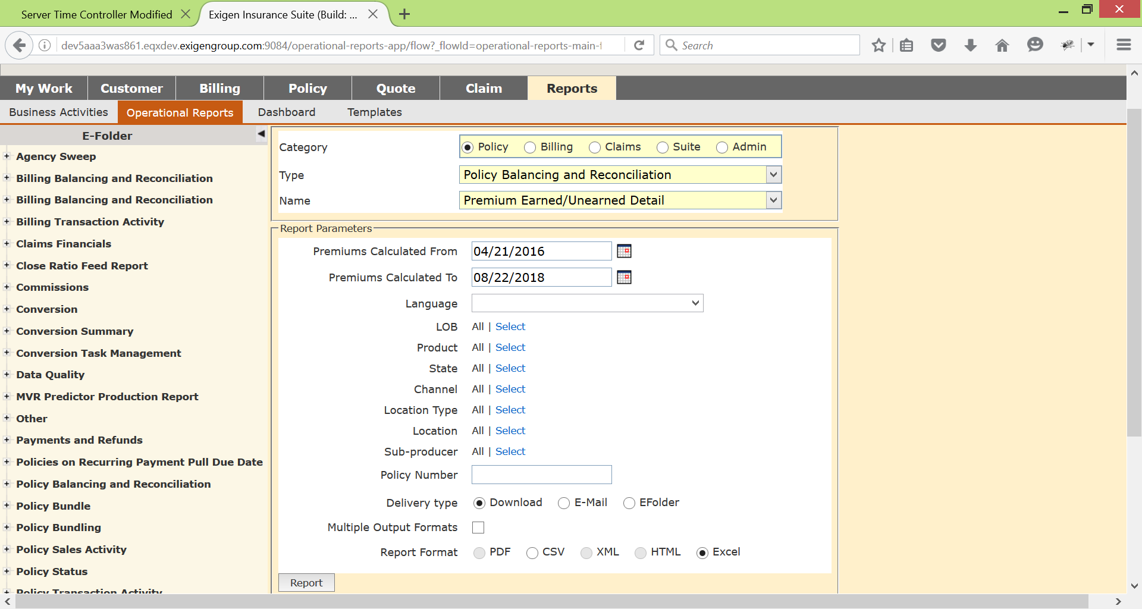

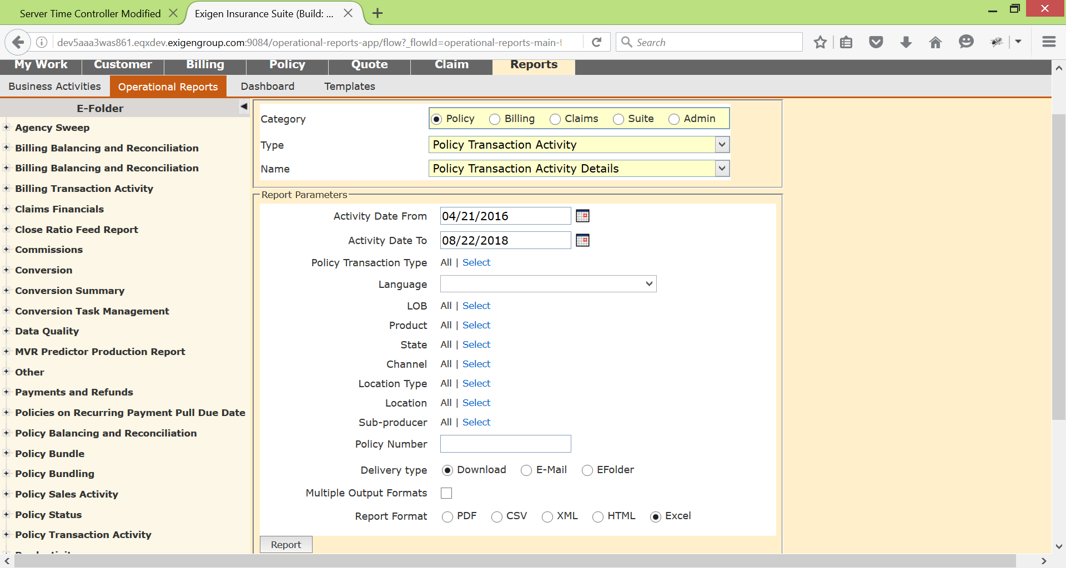

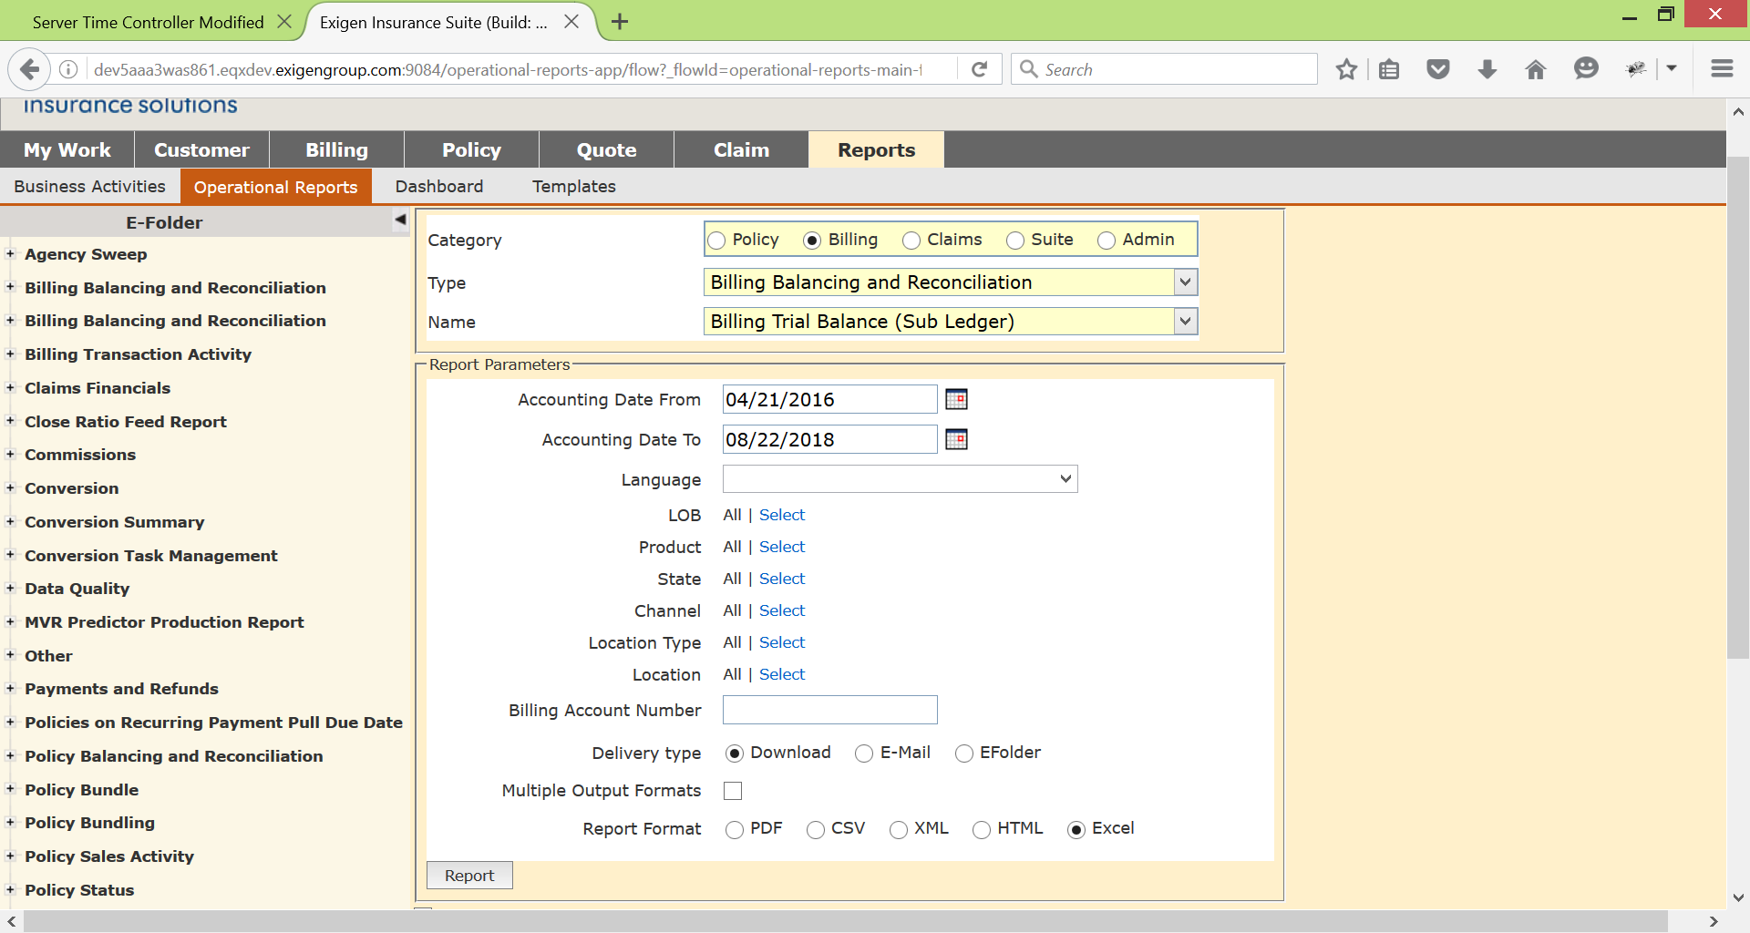

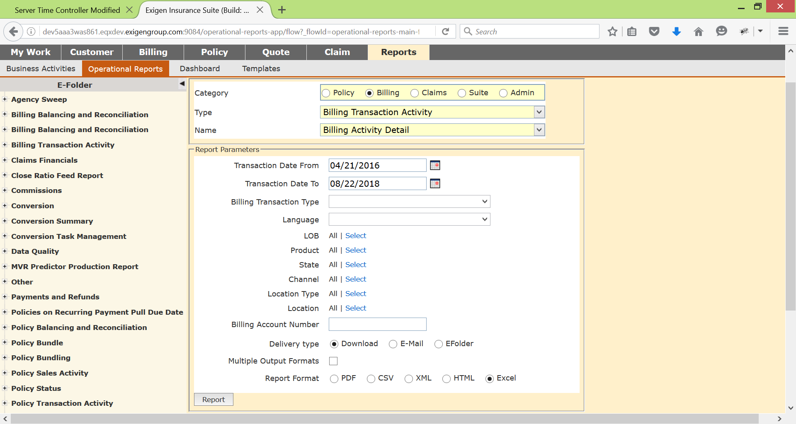

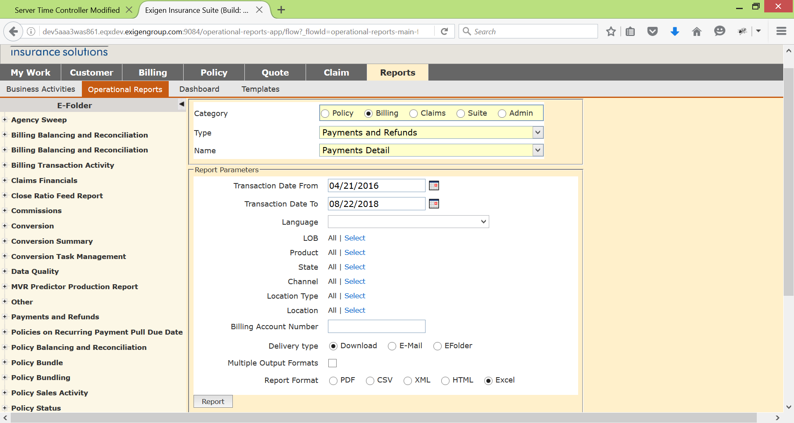

1. General Ledger reports-

a. set server time to last shifted time-point.

b. Feed file details-

Execute batch job policyTransactionLedgerJob and retrieve file from: /home/mp2/pas/sit/FIN_E_EXGPAS_PSFTGL_7000_D/outbound

Execute batch job aaaBlckLnLedgerJob and retrieve file from: /home/mp2/pas/sit/FIN_B_EXGPAS_BLCKLN_5180/outbound

1. Incase if any of the operational reports have not data then run this on the instance-

<http://dev5aaa3jnk601.eqxdev.exigengroup.com:8080/job/AAA-operational_report_fix/build?delay=0sec>

And re-run the reports.