After importing into PAS -PASS107000119

Driver page-

Driver#1-

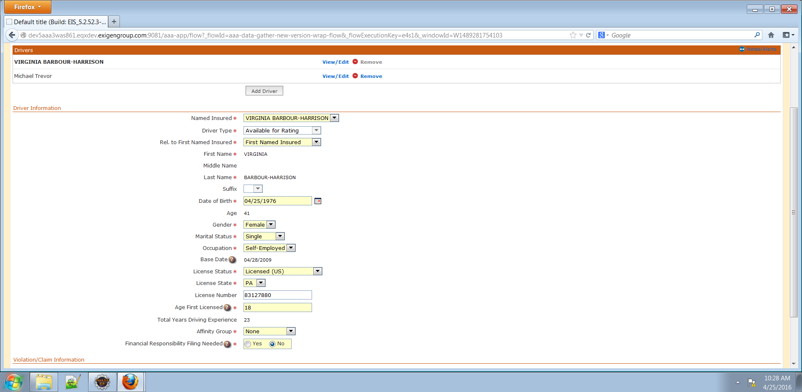

Driver#2-

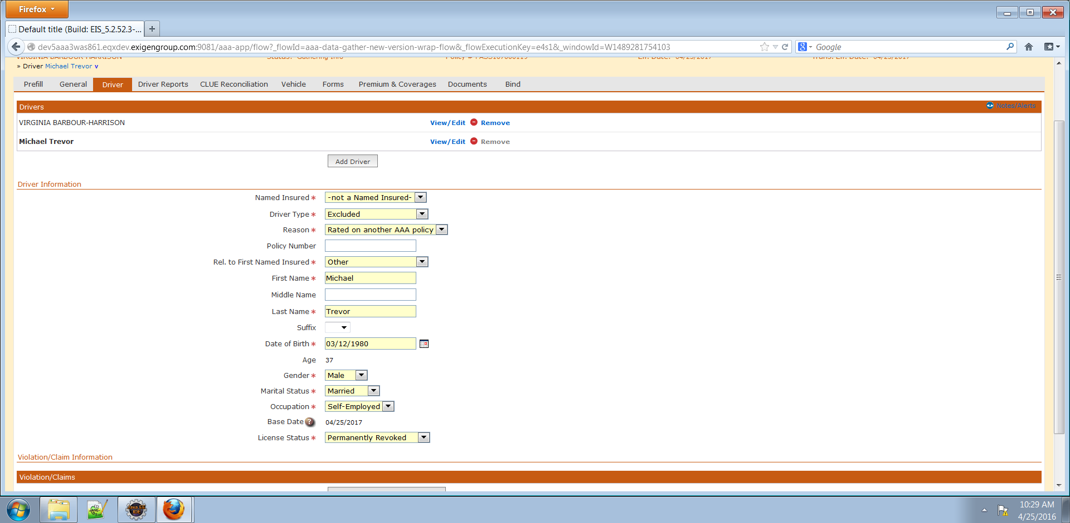

Vehicle- **Error 500- Issue not reproducible**

Vehicle#1-

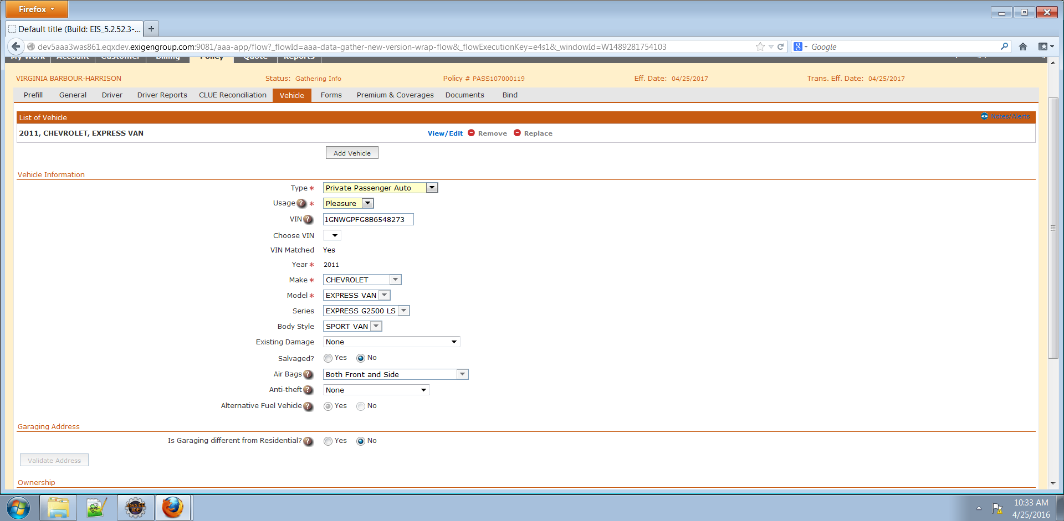

Vehicle#2-

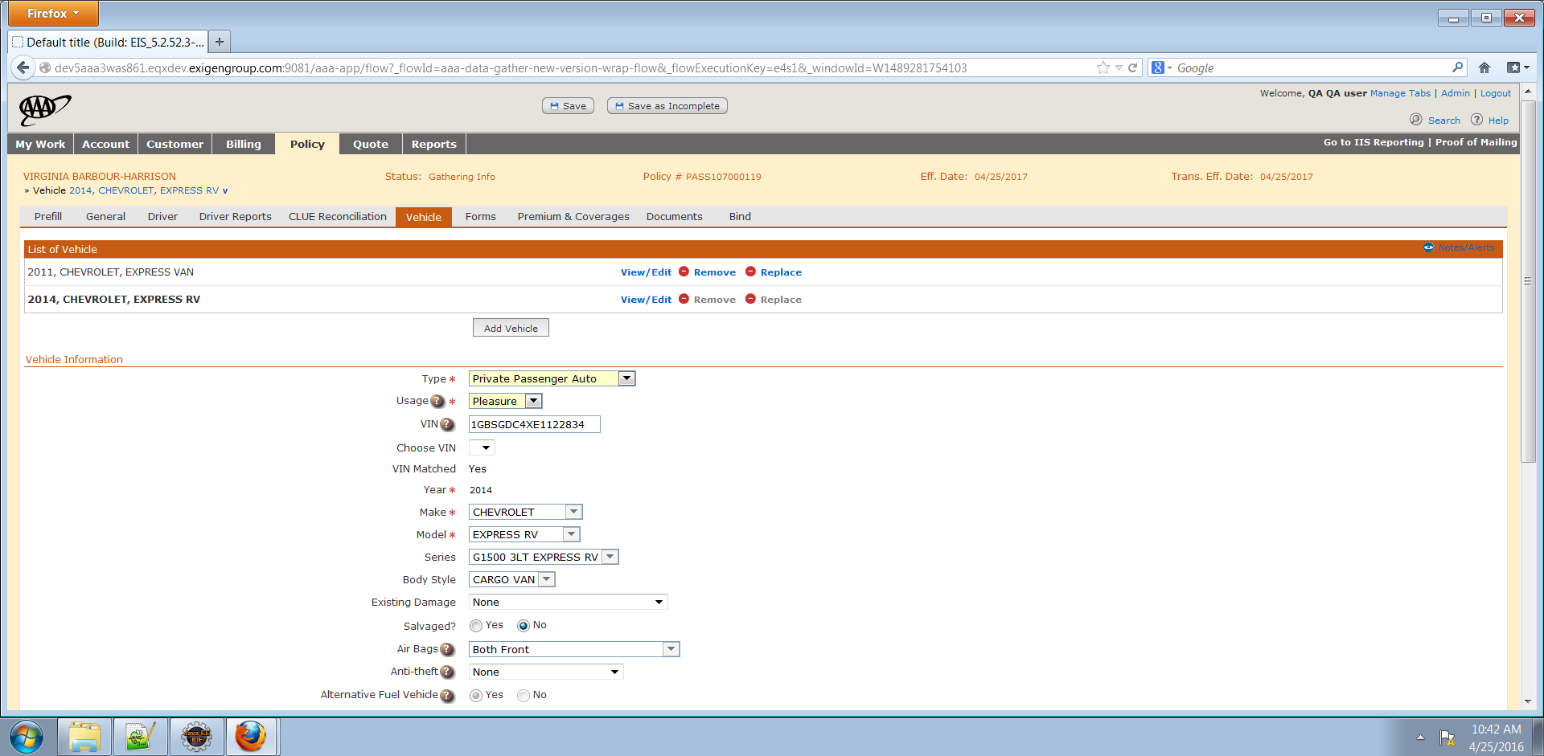

After vehicle1 is removed-

