Instance 405: http://dev2aaa3was405.eqxdev.exigengroup.com:9081/aaa-app/

Quote#: QCAD3910091924

Screenshots-

General tab:

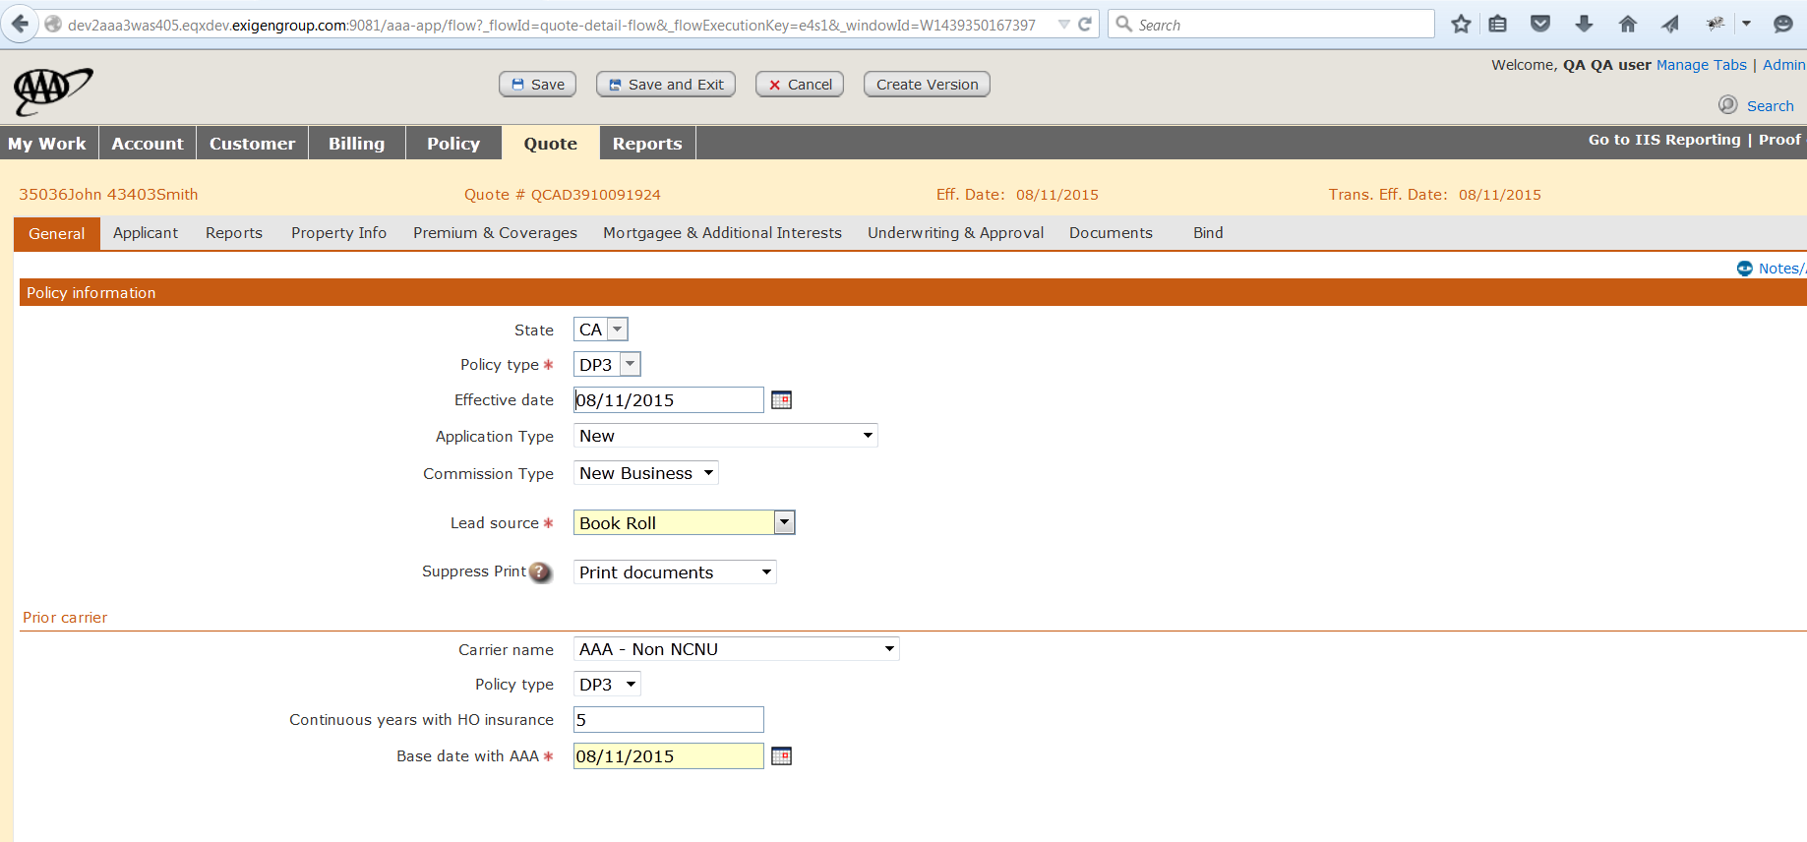

Applicant: <on the following page>

Field values have been highlighted

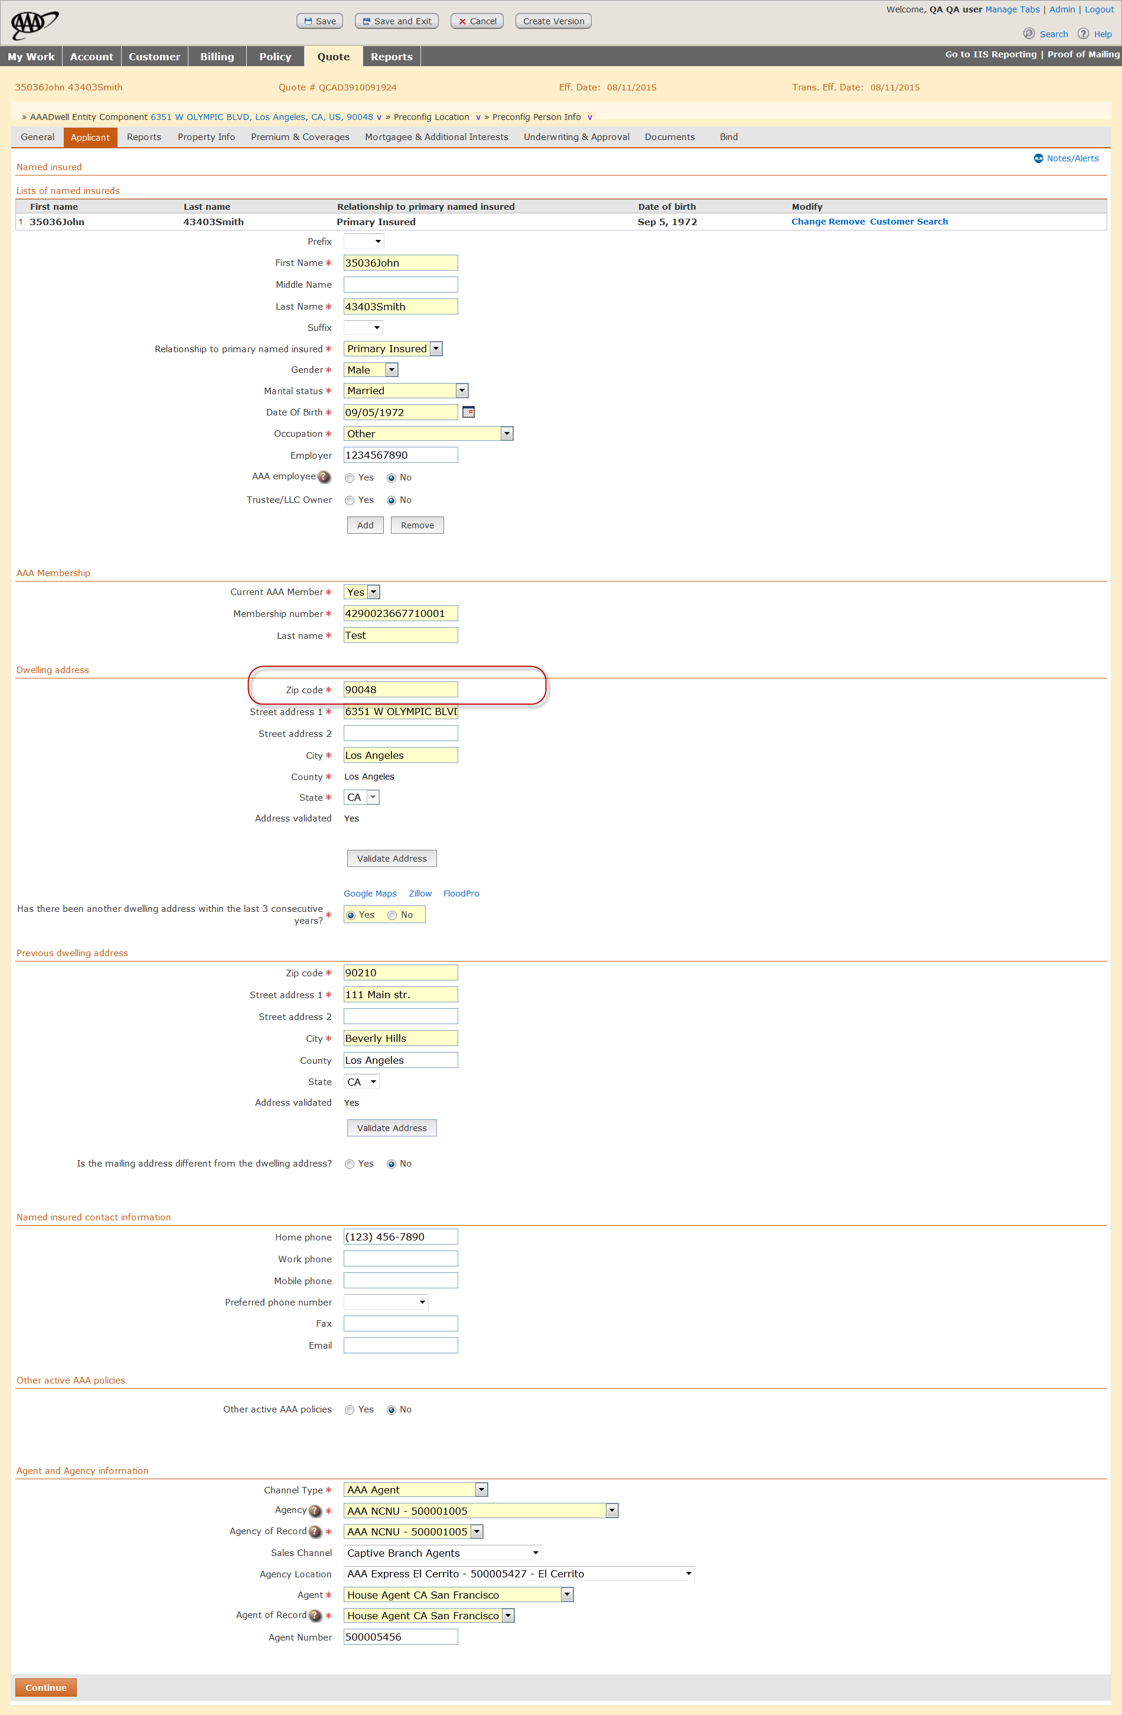PropertyInfo: <on next page>

Field values have been highlighted

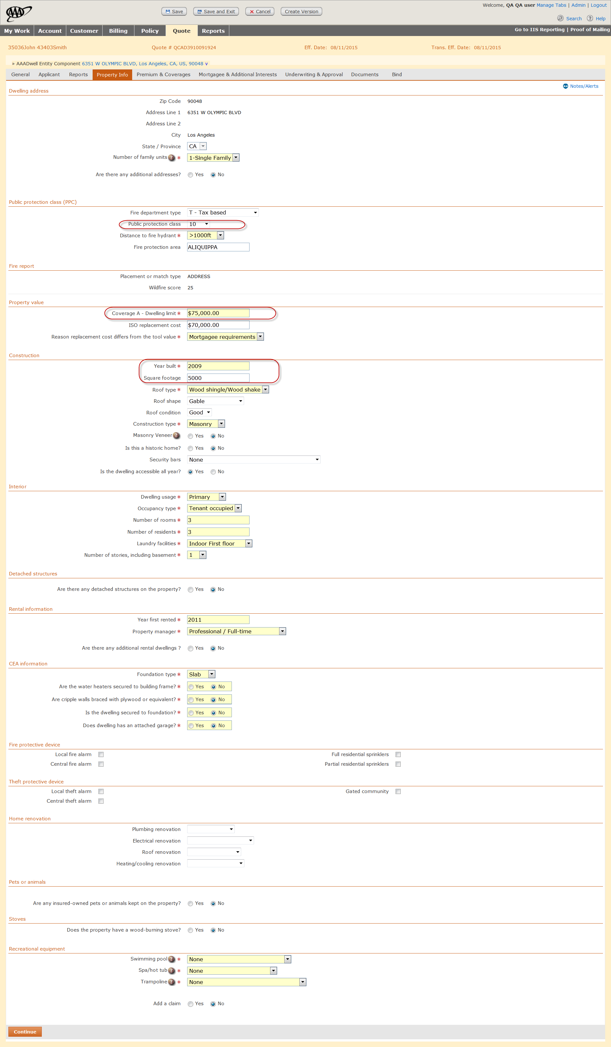

Endorsement:

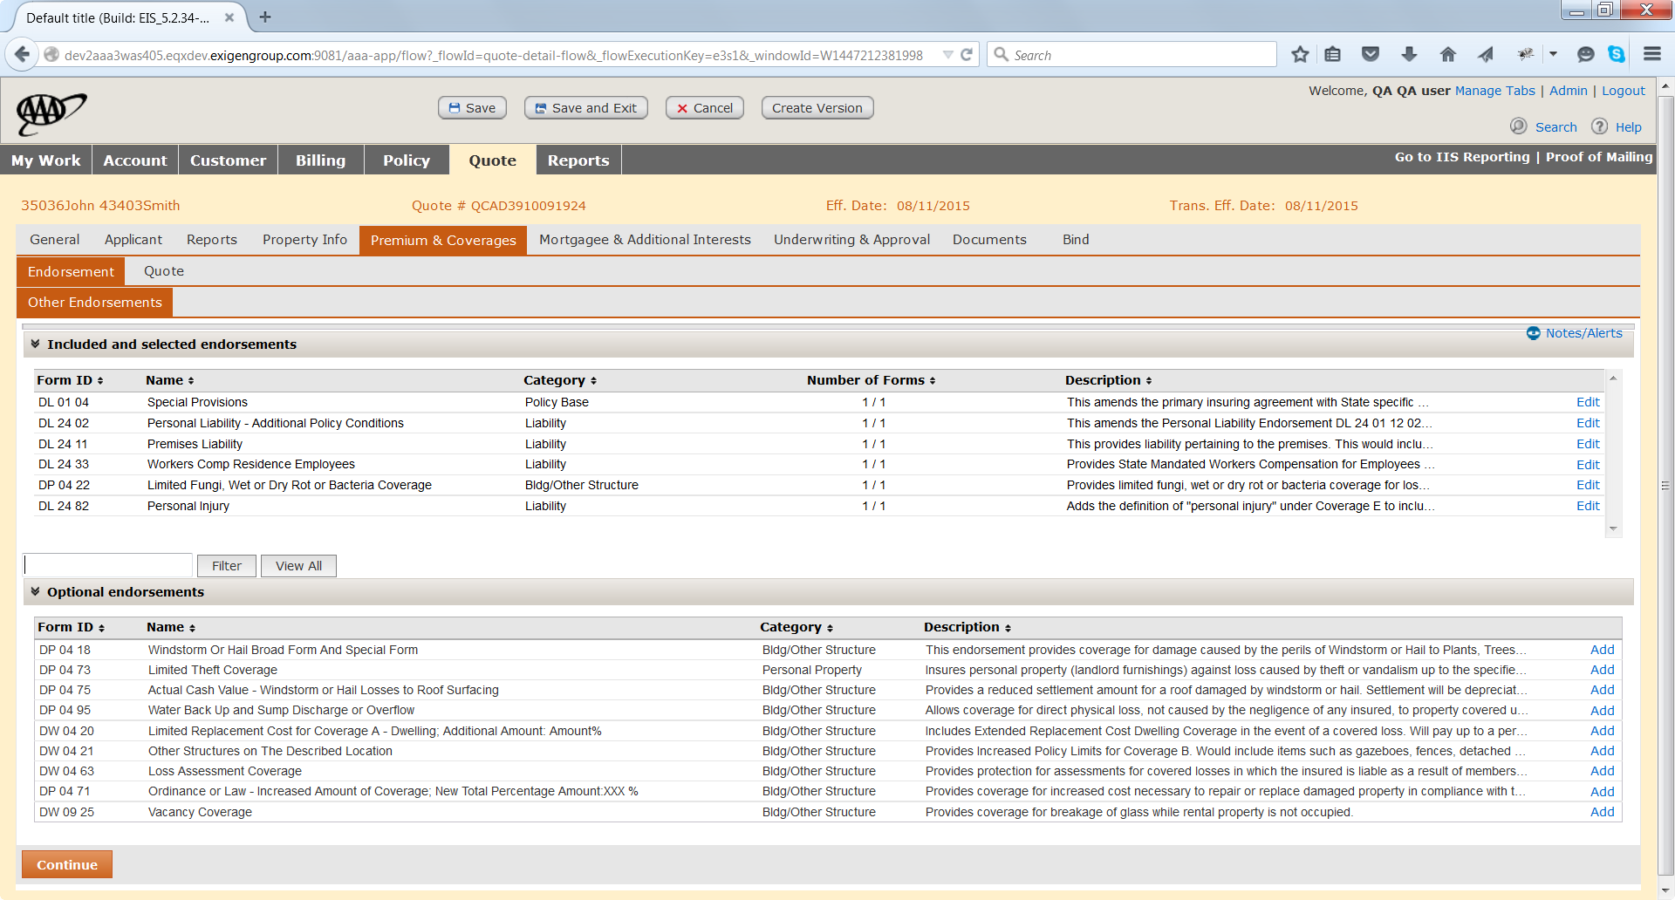

P&C/ quote

