


Installation and Configuration Guide

Exigen® Insurance Suite™

Author | Ilga Kovalevska
Status | Draft
Document Number | TP_EIS_Install_1.8_LSh
Document Version | 1.31
Last Revision Date | 08-24-2016
History of Revisions
Delete this table in the final version of the guide.
History of revisions
Revision date | Version | Author | Description
Jul 2,  2010 | 0.5 | Ilga Kovalevska | Initial version.
July 7, 2010 | 1.0 | Lubova Sinka | Formatting completed, comments implemented.
Sep 1,  2010 | 1.1 | Aiga Romane | Added TDE Encryption section.
Sep 17,  2010 | 1.2 | Aiga  Romane | Added single-sign-on, PolicyTransactionLedgerJob, Operational Reports system configuration.
Sep 22,  2010 | 1.3 | Aiga  Romane | Added correction to Creating Database Schemas for Operational Reports Subsystems.
Oct 06,  2010 | 1.4 | Aiga  Romane | Added database privilege requirements.
Oct 15,  2010 | 1.5 | Dmitry Izumskiy | Added gather database stats command after DB installation or update.
Oct 24,  2010 | 1.6 | Dmitry Izumskiy | Added log detail levels configuration.
Oct 25,  2010 | 1.7 | Aiga Romane | Removed highlight for old changes.
Oct 26, 2010 | 1.8 | Olga Kakse | Updates made by Juozas Baliuka implemented.  Formatting completed.
Oct 29,  2010 | 1.9 | Aiga Romane | Added E-folder deployment instructions.
Nov 16,  2010 | 1.10 | Aiga Romane | Updated TDE Encryption section. Added information about directory creation script
Nov 18,  2010 | 1.11 | Aiga Romane | Updated TDE Encryption section
Dec 01,  2010 | 1.12 | Aiga Romane | Added information about Billing Schedule generation
Jan 04, 2011 | 1.13 | Roberts Vartins | Modified property section. Removed obsolete properties and added new based on existing properties in document.
Jan 18, 2011 | 1.14 | Modris Eglajs | Added “Configuring Application Session Management” section.
Feb 11, 2011 | 1.15 | Sergejs Matuzis | Added “Configuring activityHistoryJob parameters” section.
Feb 14, 2011 | 1.16 | Sergejs Matuzis | Updated section “Updating the Database”.
May 2, 2011 | 1.17 | Roberts Vartins | Updated section “Configuring BOAReconciliationService and RemittanceFeed Service”.
May 10,  2011 | 1.18 | Arturs Razmuss | Added mail session configuration section for Operational Reports
June 07,  2011 | 1.19 | Aiga Romane | Updated Liquibase command
June 15, 2011 | 1.20 | Aiga Romane | Updated Liquibase command to use new liquibase-1.9.5-hf1.jar
June 17, 2011 | 1.21 | Juris Caics | Added property for PCI CC Storage service endpoint URL
July 07, 2011 | 1.22 | Aiga Romane | Updated SS product name for import
July 14,  2011 | 1.23 | Aiga Romane | Updated property configuration mechanism, section “Folder Paths Configuration”
Feb 10,  2012 | 1.24 | Ilga Kovalevska | Added new rating application. Changed sections: Deploying Exigen Insurance Suite Modules on WebSphere Application Servers (page 25) and Configuring Rating Engine (page 36)
Feb 14,  2012 | 1.25 | Ilga Kovalevska | Changed section: Preparing the Application Environment (page 33, 34)
Feb 17,  2012 | 1.26 | Ilga Kovalevska | Changed section: Preparing the Application Environment (page 33, 34) – removed temporary solution
May 27, 2012 | 1.27 | Aiga Romane | Added Dlocal=on property description for operational reports deployment
Nov 14,  2012 | 1.28 | Modris  Eglajs | Reworked chapter “Deploying Exigen BPM Engine Processes and Workflows”, describing processes and workflows deployment using BPM Engine Processes Import utility
Nov 19,  2012 | 1.29 | Ilga Kovalevska | Updated section “Creating New Clusters and Servers”. Item 18 (page 16): “Generic JVM arguments” (item 18) need to be set also for aaa-admin server.
May01,  2013 | 1.29 | Saravanakumar,C | Updated Section “Configuring Application Session Management” (Page 18): changed the cookie name from session ID to PAS_JSESSION ID
May01,  2013 | 1.30 | Saravanakumar,C | Added Additional Data source creation for Bill due Batch Job
May01,  2013 | 1.31 | Saravanakumar,C | Added Additional JNDI configuration for Docgen Syn Call fix for Webservices
May07,  2013 | 1.32 | Uldis Ancans | Updated JNDI settings, memory settings, used libraries, rating urls in propertyconfigurentity table, added DCS configuration
Nov 11, 2014 | 1.33 | Peteris Gulans | Updated WebSphere version requirement, memory setting, jvm arguments, application deployment, WS deployment manager

Document number: TP_EIS_Install_1.8_LSh
Revised: 08-24-2016
EXIGEN CONFIDENTIAL – FOR AUTHORIZED USERS ONLY
Important Notice
Information in this document, as well as the software products and programs described in it, is furnished by Exigen Insurance Solutions, Inc. and/or affiliates (Exigen) under license and may be used or copied only in accordance with the terms of such license. This document, the information contained in it, as well as the software products and programs described herein are considered confidential, proprietary, trade secrets of Exigen. You may not copy, create derivatives, decipher, decompile, develop, or otherwise reverse engineer this document, the information contained in it, or the software products and programs described. Exigen and its licensors retain all intellectual property and ownership rights to the information contained herein, as well as the software products and programs (including, but not limited to, software libraries, interfaces, source codes, documentation and training materials) described herein.
The content of this document is furnished for informational use only, is subject to change without notice, may contain technical inaccuracies or typographical errors, and should not be construed as a representation, warranty or commitment by Exigen or any other person or entity. Exigen may make improvements and/or changes in the software products and programs described in this document at any time without notice. Exigen is not responsible or liable for any changes made to this document. In particular, modifications in or to the data model described herein may have occurred or may occur in a new product release after publication of this documentation. In accordance with Exigen standard support policy, any issues arising as a result of such modifications shall not be considered support issues and shall not be covered by Exigen maintenance and support. To be clear, Exigen is providing this document and the information contained in it, "as is" without any representations, covenants, or warranties, including those of merchantability or fitness for a particular purpose. Some jurisdictions do not allow disclaimer of express or implied warranties in certain transactions; in that case, this notice may not apply.
Information published by Exigen on the Internet or World Wide Web may contain references or cross-references to Exigen software products and programs, as well as Exigen services that are not announced or available in your country. Such references do not imply that Exigen intends to announce such software products programs or such services in your country. Consult your local Exigen business contact for information regarding the Exigen software products and programs and Exigen services that may be available to you.
By using this document, you agree that, in no event will Exigen or its licensors be liable to any party for any direct, indirect, special or other consequential damages for any use of this document, the information contained herein, or the software products and programs described herein, including, without limitation, any lost profits, business interruption, loss of programs or other data on your information handling system or otherwise, even if Exigen were expressly advised of the possibility of such damages.
Trademark
Exigen, the Exigen logo, Exigen Process Backbone, Business Process Utility, Insurance Suite, Lending Process Backbone, and Communication Process Backbone are registered trademarks and trademarks of Exigen Insurance Solutions, Inc. in the United States and/or other countries.
Microsoft, Windows, Internet Explorer, SQL Server are either registered trademarks or trademarks of Microsoft Corporation in the United States and/or other countries.
All other trademarks, service marks, or registered trademarks are the property of their respective companies.
Support contact information
Telephone:  1-866-4EXIGEN North America  1-506-674-6922 All other countries | Website: http://www.exigeninsurance.com/  Fax: 1-415-402-2022  Email: support@exigeninsurance.com
Table of Contents
Updated section “Creating New Clusters and Servers”. Item 18 (page 16): “Generic JVM arguments” (item 18) need to be set also for aaa-admin server. iii
Updated Section “Configuring Application Session Management” (Page 18): changed the cookie name from session ID to PAS_JSESSION ID iii
Added Additional Data source creation for Bill due Batch Job iv
Added Additional JNDI configuration for Docgen Syn Call fix for Webservices iv
Updated JNDI settings, memory settings, used libraries, rating urls in propertyconfigurentity table, added DCS configuration iv
Preface 8
Audience 8
How to Use This Guide 8
Typographic Conventions 9
Chapter 1: Introducing Exigen Insurance Suite 10
System Requirements 10
Installation and Configuration Overview 10
Chapter 2: Preparing the Environment for Exigen Insurance Suite 12
Creating New Clusters and Servers 12
Configuring Application Session Management 18
Changing the Log Detail Level 19
Creating the Asynchronous Beans 20
Configuring Data Sources 21
Creating a J2C Authentication Configuration 21
Installing the Oracle Database Driver 21
Creating an Oracle JDBC Provider 22
Creating an Oracle JDBC Data Source 22
Creating an Oracle Additional JDBC Replica Data Source for Bill Due feed JOB 24
Configuring the Oracle JDBC Data Source Connection Pools 25
Configuring JNDI Resources for the Operational Reports Subsystem 25
Configuring JNDI Resources for the aaa-app aaa-admin Subsystems 26
Configuring Mail Session for the Operational Reports Subsystem 27
Configuring JNDI Resources for Docgen Syn Call fix for Web services 28
Document Generation Certificate Setup 30
Chapter 3: Deploying and Configuring the Exigen Insurance Suite Components 31
Deploying Exigen Insurance Suite Modules on WebSphere Application Servers 31
Performing the Database Cleanup, Update and Encryption 33
Performing the Existing Database Cleanup 34
Updating the Database 34
Performing TDE Encryption 34
Dropping and Creating Database Schemas for the Operational Reports Subsystem 36
Deploying E-Folder 36
Performing the Existing Billing Schedule Cleanup 37
Preparing the Application Environment 37
Starting an Application in WebSphere Application Server 39
Importing a Product 39
Performing the Configuration 40
Folder Paths Configuration 40
Automatic Directories Creation 40
Defining URL Values to the ChoicePoint Endpoints 41
Defining the AccountId and ClientId Properties for ChoicePoint 41
Defining the Endpoint URL for External Services 42
Configuring Doc Gen 43
Configuring Rating Engine 43
Configuring the IIS Reporting URL 43
Configuring BOAReconciliationService and RemittanceFeed Service 43
Configuring Additional Services 44
Configuring Additional Services for Bill Due Feed 44
Configuring Membership WS 45
Configuring Collection Job Feed 45
Configuring Policy Transaction Ledger Jobs 45
Configuring Single Sign-On 45
Configuring the Operational Reports URL 46
Configuring activityHistoryJob parameters 46
Configuring ZIP resolver parameters 46
Configuring membership Renewal jobs parameters 46
Deploying Exigen BPM Engine Processes and Workflows 47
BPM Engine Processes Import Utility Setup 47
BPM Engine Processes and Workflows Deployment Using BPM Engine Processes Import Utility 48
Upgrading an Application 48
Stopping Application Servers 49
Upgrading the Database 49
Redeploying Processes 49
Updating Application Modules 49
Starting Application Servers 49
Importing Products 50
Performing Configuration from the Administration Application 50
Configuring the Renewal Batch 50
Configuring the Activity Summarization Job 52
Configuring the Operational Reports Feature and Importing Report Templates 53
Configuring the Billing Schedule 55

Preface
This preface is an introduction to the Exigen Insurance Suite Installation and Configuration Guide.
The following topics are included in this preface:
- Audience
- How to Use This Guide
- Typographic Conventions

Audience
This guide is intended for the following audience:
- Exigen Support Services
- Exigen Insurance Suite customer support technical staff
- EIS deployment and support technical staff
To effectively use this guide, knowledge of the following is required:
- WebSphere Application Server installation and configuration
- Oracle installation
- Oracle database 11g creation and configuration

How to Use This Guide
The following table lists the content of this guide:
Information on how to use this guide
Section | Description
Chapter 1: Introducing Exigen Insurance Suite | Explains Exigen Insurance Suite, lists system requirements for Exigen Insurance Suite installation, and describes the major Exigen Insurance Suite architecture components.
Chapter 2: Preparing the Environment for Exigen Insurance Suite | Explains preparing the environment for Exigen Insurance Suite.
Chapter 3: Deploying and Configuring the Exigen Insurance Suite Components | Provides procedures for configuring and deploying Exigen Insurance Suite components.

Typographic Conventions
The following styles and conventions are used in this guide:
Typographic styles and conventions
Convention | Description
Bold | - Represents user interface items such as check boxes, command buttons, dialog boxes, drop-down list values, field names, menu commands, menus, option buttons, perspectives, tabs, tooltip labels, tree elements, views, and windows.  - Represents keys, such as F9 or CTRL+A.  - Represents a term the first time it is defined.
Courier | Represents file and directory names, code, system messages, and command-line commands.
Courier Bold | Represents emphasized text in code.
Select File > Save As | Represents a command to perform, such as opening the File menu and selecting Save As.
Italic | - Represents any information to be entered in a field.  - Represents documentation titles.
< > | Represents placeholder values to be substituted with user specific values.
Hyperlink | Represents a hyperlink. Clicking a hyperlink displays the information topic or external source.

Chapter 1: Introducing Exigen Insurance Suite
This guide explains installing and configuring Exigen Insurance Suite.
This section includes the following topics:
- System Requirements
- Installation and Configuration Overview

System Requirements
The following software must be installed before installing Exigen Insurance Suite:
Software to install before installing Exigen Insurance Suite
Software product or software product type | Products, versions, and service packs
Requirements for servers
Oracle database | Oracle 11g  Required for the Exigen Insurance Suite database.
Oracle JDBC driver | Oracle 11g
WebSphere Application Server Network Deployment | Version 7.0.0.27, 64 bit  For information on installing WebSphere Application Server, see the product documentation.
Internet Explorer | Version 7  Internet Explorer can be installed from the Microsoft homepage.
Requirements for the computer used to deploy Exigen BPM Engine processes and workflows
Processor | Intel Core 2 Duo 1.8 GHz or similar
RAM | 2 GB
Disk space | 1 GB
Windows® (or Linux) | XP  For information on installing Windows XP, see the product documentation.
J2SE JDK | Version 1.6
Ant | Version is 1.6.2.  To download, visit the following website:  http://ant.apache.org/

Installation and Configuration Overview
The Exigen Insurance Suite is a set of the following J2EE application modules, also known as Web applications:
- Exigen Insurance Suite application module
- Exigen Insurance Suite administration module
- rating engine Web services
- external services stub application
- Operational Reports application
The above mentioned Exigen Insurance Suite modules must be deployed on several clusters and separate servers. The Exigen Insurance Suite application module must be deployed on no less than two separate servers in order to balance the load.

Chapter 2: Preparing the Environment for Exigen Insurance Suite
Exigen Insurance SuiteThis section explains preparing the environment for the Exigen Insurance Suite by configuring a WebSphere Application Server instance.
The following topics are included in this section:
- Creating New Clusters and Servers
- Changing the Log Detail Level
- Creating the Asynchronous Beans
- Configuring Data Sources
- Configuring JNDI Settings

Creating New Clusters and Servers
To create new clusters and servers, proceed as follows:
- In the navigation tree, select Servers > Clusters > WebSphere application server.
- In the right panel, click New.
- In the Cluster name field, enter the name for the cluster.
Example: CLUSTER_APP
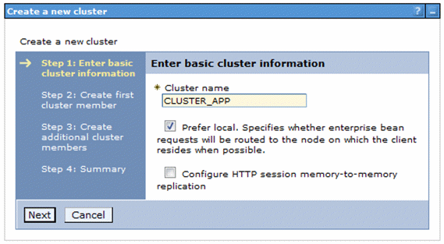
Figure 1: Specifying cluster name
- Click Next.
- In the Member name field, enter the member name for the server.
Example: cluster_app_server
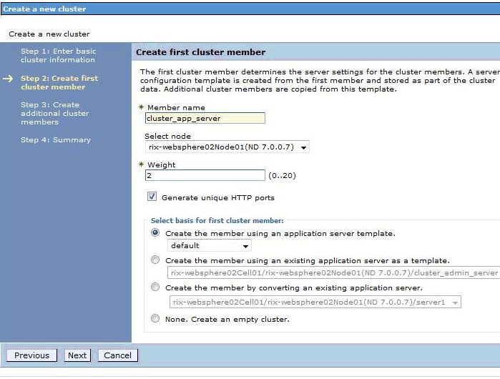
Figure 2: Creating the first cluster member
- Click Next.
- In the Member name field, enter the member name for the second server applicable only to the cluster where aaa-app will be installed.
Example: cluster_app_server2
- Click Add Member.
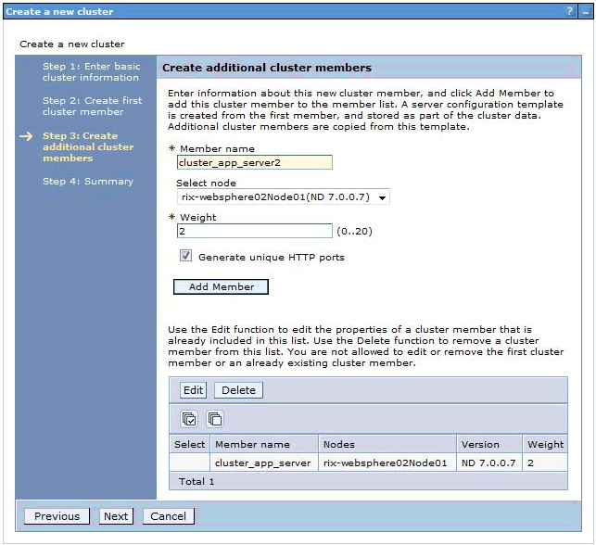
Figure 3: Creating additional cluster members
- Click Next.
- Click Finish.
- Save directly to the master configuration.
- To open the created cluster, click the cluster link, such as CLUSTER_APP.
- On the right, in the Configuration tab, in the Additional Properties section, expand Cluster members.
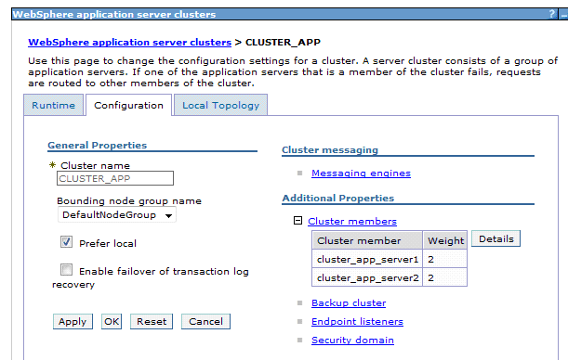
Figure 4: Expanding cluster member information
- Click Details.
- To open a server, click the member name, such as cluster_app_server1.
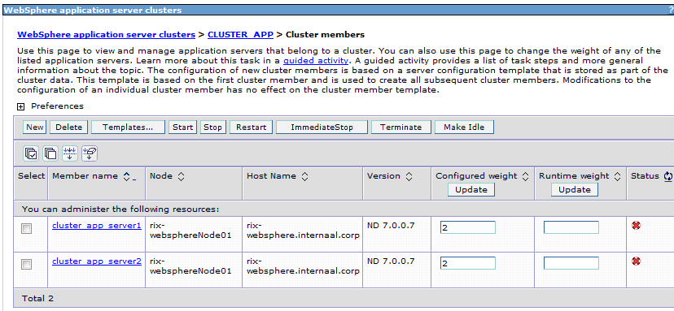
Figure 5: Displaying server information
- In the panel on the right, expand Java and Process Management and select Process definition.
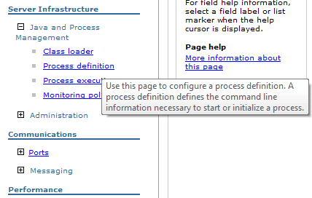
Figure 6: Selecting process definition
- Select Additional Properties > Java Virtual Machine.
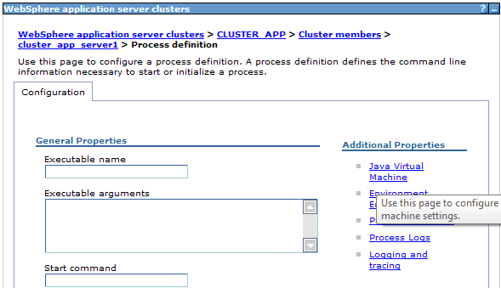
Figure 7: Selecting Java Virtual Machine
- Set the field values as described in the following table:
Java Virtual Machine settings
Field | Value
Initial heap size | 512
Maximum heap size | For aaa-external-stub-services-app-ear the value is 1024  For aaa-admin, aaa-rating-engine-app the value is 3072. For aaa-app the value is 5120.
Generic JVM arguments | For aaa-rating-engine-app and aaa-external-stub-services-app:  -Dcom.ibm.websphere.webservices.DisableIBMJAXWSEngine=true  For aaa-admin:  -Dcom.ibm.websphere.webservices.DisableIBMJAXWSEngine=true -Djavax.xml.rpc.ServiceFactory=com.sun.xml.rpc.client.ServiceFactoryImpl -Deis.config.root=<path to folder for EIS config root> -Dspring.profiles.active=aaa-vm-jms,basic-security,prec-interface,prec-um-real,prec-auto-real,prec-home-real,clustered-cache,jms-client-activemq,jms-embedded-broker,efolder-jcr,async-tasks-db,webservices,batch-enabled -Dapplication.node.id=aaa-admin -Deis.party.index.location=<relative path (from WebSphere owner home folder) to KahaDB for admin> -DENVIRONMENT_APP_TYPE=admin -Xgcpolicy:gencon  Fro aaa-app:  -Djavax.xml.rpc.ServiceFactory=com.sun.xml.rpc.client.ServiceFactoryImpl -Dcom.ibm.websphere.webservices.DisableIBMJAXWSEngine=true -Deis.config.root=<path to folder for EIS config root> -Dspring.profiles.active=aaa-vm-jms,basic-security,prec-interface,prec-um-real,prec-auto-real,prec-home-real,clustered-cache,jms-client-activemq,jms-embedded-broker,efolder-jcr,batch-disabled,aaa-async-tasks-client-db -Dapplication.node.id=aaa-app -Deis.party.index.location=<relative path (from WebSphere owner home folder) to KahaDB for app> -Xgcpolicy:gencon
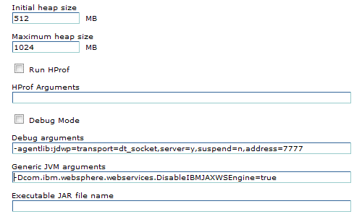
Figure 8: Java Virtual Machine settings
- Click OK.
- Select Additional Properties > Java Virtual Machine > Additional Properties > Custom Properties.
- Click New.
- In the Name field, enter org.eclipse.emf.common.util.URI.archiveSchemes.
- In the Value field, enter wsjar wszip jar zip.
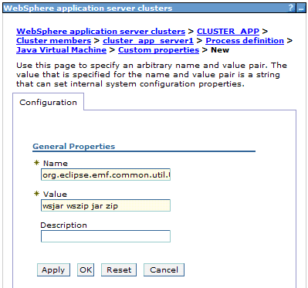
Figure 9: Defining Java Virtual Machine custom properties
- Click OK.
- Save directly to the master configuration.
- If a cluster has other server, for this server, repeat steps 15 through 25.
- Repeat the whole procedure for any other clusters.
Note: Steps 7 through 8 are required only for the cluster where the aaa-app application must be installed.

Configuring Application Session Management
To allow simultaneous work with aaa-app and aaa-admin applications from the same workstation their browser sessions must be separated using different session “cookie” names. To configure different session “cookie” names for each application proceed as follows:
- Click Applications > Application Types > WebSphere enterprise applications in the console navigation tree, and select aaa-admin-ear.
- Select Session management > Enable Cookies, getting screen
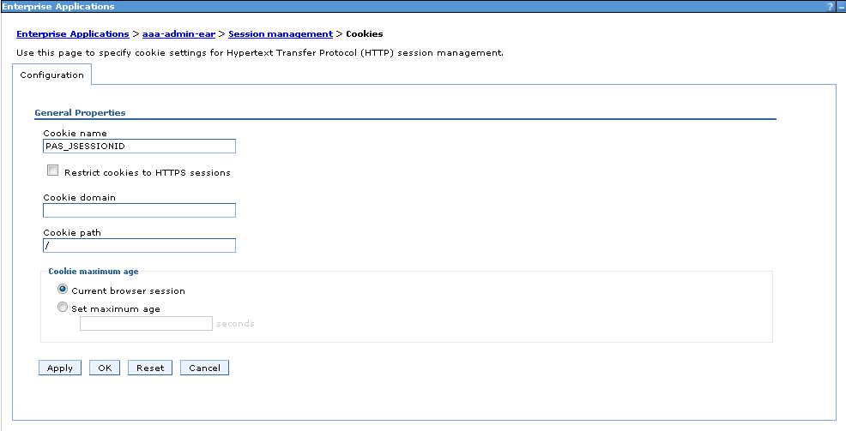
Figure 10 Setting session cookie name
- Change default cookie name PAS_JSESSIONID to distinct name for given application
- Click OK.
- Click Save directly to master configuration.
- In General properties tab select Override session management
- Click OK.
- Click Save directly to master configuration.

Changing the Log Detail Level
To change the log detail level, proceed as follows:
- Click Troubleshooting > Logs and Trace in the console navigation tree, then click server > Change log detail levels.
- Select the Runtime tab.
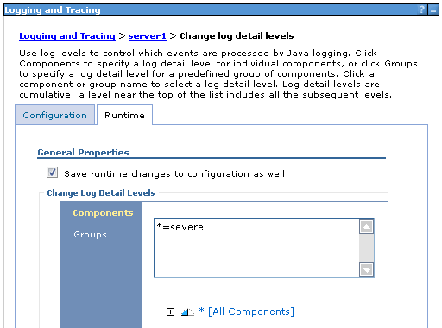
Figure 11: Changing the log detail level
- Select the Save runtime changes to configuration as well check box.
- Change the existing trace state by entering the following state in the trace specification:
*=severe
This log detail level is required for the production environment.
- Click OK.

Changes in Deployment Manager
In WebSphere console following change must be done:
System administration > Deployment manager > Process definition > Java Virtual Machine
maximum heap size should be increased to 2048.
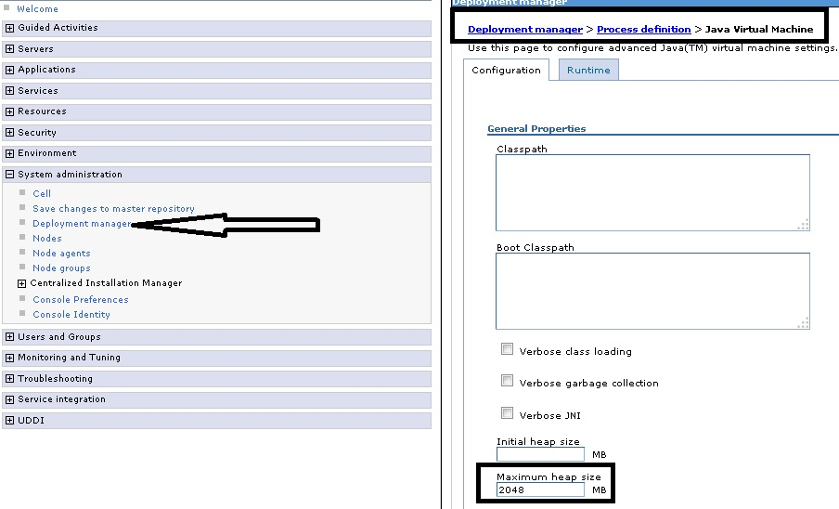
Figure 12 Max heap for Deployment manager
Another change is in filesystem – in file <ws install path>/WebSphere/AppServer/bin/wsadmin.sh there is following text (for each OS type).

PERF_JVM_OPTIONS="-Xms256m –Xmx256m -Xj9 -Xquickstart" ;;

Parameter –Xmx256m should be increased to 2024m for your OS type.
Creating the Asynchronous Beans
Creating the following asynchronous beans is required for each cluster:
- TimerManager
- WorkManager
To create asynchronous beans, proceed as follows:
- To configure the TimerManager asynchronous bean, in the WebSphere Administrative Console navigation tree, click Resources > Asynchronous beans > Timer managers.
- In the scope selection list, select the scope with a cluster and click New.
- In the Name field, type TimerManager.
- In the JNDI name field, type tm/TimerManager.
- Click OK.
- Click Save directly to master configuration.
- To configure the WorkManager asynchronous bean, in the WebSphere Administrative Console navigation tree, click Resources > Asynchronous beans > Work managers.
- In the scope selection list, select the scope with a cluster and click New.
- In the Name field, type WorkManager.
- In the JNDI name field, type wm/WorkManager.
- Click OK.
- Click Save directly to master configuration.
- Repeat steps 1 to 12 for each cluster.

Configuring Data Sources
This section explains configuring data sources.
The following topics are included in this section:
- Creating a J2C Authentication Configuration
- Installing the Oracle Database Driver
- Creating an Oracle JDBC Provider
- Creating an Oracle JDBC Data Source
- Configuring the Oracle JDBC Data Source Connection Pools
- Configuring JNDI Resources for the Operational Reports Subsystem

Creating a J2C Authentication Configuration
A J2C authentication configuration must be created and assigned to the data source.
To create a J2C authentication configuration for a data source, proceed as follows:
- In the navigation tree, click Security > Global Security.
- In the right pane, under Authentication, click Java Authentication and Authorization Service > J2C authentication data.
- Click New.
- Provide the appropriate information in the following boxes :
J2C authentication data
Box | Description
Alias | Appropriate name for the database user.  Example: IpbDB/oracle-ipbuser for the IpbDB data source, or IpbDataMartDb/oracle-ipbdatamartuser for the IpbDataMartDb data source.
User ID | User ID.  This ID is the login credential used to access whichever database is used with the IpbDB or IpbDataMartDb data source.  Example: ipbuser
Password | Password for this user.
- Click OK or Apply.
- In the Messages box, click Save directly to master configuration.

Installing the Oracle Database Driver
To install the Oracle 11g database driver, create a directory named db_driver in the WebSphere
Application Server root directory and copy the Oracle JDBC driver file ojdbc6.jar to that directory.

Creating an Oracle JDBC Provider
To create an Oracle JDBC provider, proceed as follows:
- In the WebSphere Administrative Console navigation tree, click Environment > Websphere Variables and, in the right pane, click ORACLE_JDBC_DRIVER_PATH.
- Under General Properties, in the Value box, type the path to the ojdbc6.jar file created in Installing the Oracle Database Driver.
- Click OK.
- Click Save directly to master configuration.
- In the navigation tree, click Resources > JDBC > JDBC Providers.
- In the drop-down list in the right pane, select a server as the level, and then click New.
Ensure a node without a server is selected.
- In the Step 1 pane, set the following configuration:
- In the Database type list, select Oracle.
- In the Provider type list, select Oracle JDBC Driver.
- In the Implementation type list, select Connection pool data source.
- Click Next.
- In the Step 2 pane, accept the default database class path and click Next.
- In the Step 3 pane, click Finish.
- Click Save directly to master configuration.
- Repeat steps 5 to 11 of this procedure for all servers.

Creating an Oracle JDBC Data Source
To create an Oracle JDBC data source, proceed as follows:
- In the navigation tree, click Resources > JDBC > JDBC Providers and, in the right pane, click the provider created in Installing the Oracle Database Driver.
- Under Additional Properties, click Data sources and then click New.
- In the Step 1 pane, in Data source name, enter IpbDB.
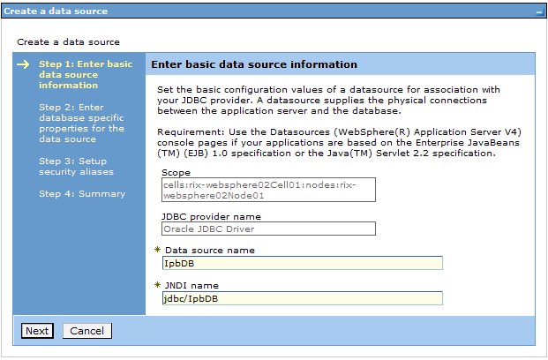
Figure 13: Creating a data source
- Click Next.
- In the Step 2 pane, in the URL field, type the following line:
jdbc:oracle:thin:@<server_host>:<port>:<SID>
where <server_host> is the IP address of the database server, <port> is the port on which the database is listening, and <SID> is the service ID of the database. The default port on which the database is listening is 1521.
- In the list, for Data store helper class name, select Oracle11g data store helper.
- Click Next.
- In the Step 3 pane, set the following configurations:
- In the list, for Component-managed authentication alias, select the authentication alias created for this data source as described in Creating a J2C Authentication Configuration.
- In the Mapping-configuration alias list, select DefaultPrincipalMapping.
- In the Container-managed authentication alias list, select the authentication alias created for this data source in Creating a J2C Authentication Configuration.
- Click Finish.
- Click Save directly to master configuration.
- Repeat this procedure for all servers.
- For the server that will contain operational-reports-app application, create an additional JDBC data source IpbDataMartDB.
Creating the IpbDataMartDB in the same as creating the IpbDB data source explained in steps 1 through 10 of this procedure.

Creating an Oracle Additional JDBC Replica Data Source for Bill Due feed JOB

- In the navigation tree, click Resources > JDBC > JDBC Providers and, in the right pane, click the provider created in Installing the Oracle Database Driver.
- Under Additional Properties, click Data sources and then click New.
- In the Step 13 pane, in Data source name, enter PAS_REPLICADB

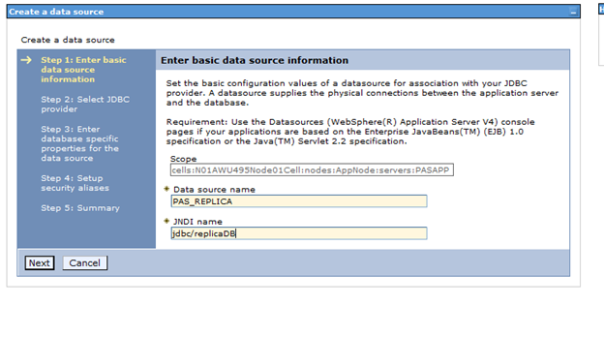

- Click Next.
- In the Step 14 pane Select an existing JDBC Provider option and Click Next
- In the Step 15 pane, in the URL field, type the following line:
jdbc:oracle:thin:@<server_host>:<port>:<SID>
where <server_host> is the IP address of the database server, <port> is the port on which the database is listening, and <SID> is the service ID of the database. The default port on which the database is listening is 1521.
- In the list, for Data store helper class name, select Oracle11g data store helper.
- Click Next.
- In the Step 5 pane, set the following configurations:
- In the list, for Component-managed authentication alias, select the authentication alias created for this data source as described in Creating a J2C Authentication Configuration.
- In the Mapping-configuration alias list, select DefaultPrincipalMapping.
- In the Container-managed authentication alias list, select the authentication alias created for this data source in Creating a J2C Authentication Configuration.
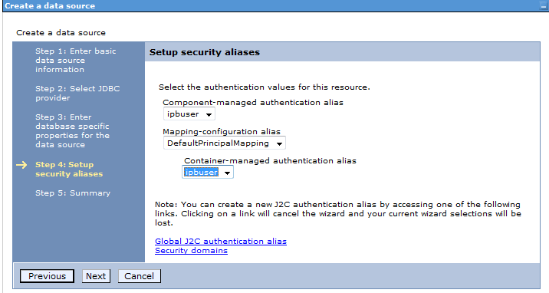
- Click Next and Finish.

Configuring the Oracle JDBC Data Source Connection Pools
To configure the Oracle JDBC data source connection pools, proceed as follows:
- In the navigation tree, click Resources > JDBC > JDBC Providers and, in the right pane, click the Oracle JDBC data source created in Creating an Oracle JDBC Data Source.
- Under Additional Properties, click Data sources and then select IpbDB.
- On the next screen, under Additional Properties, click Connection Pool Properties and in the Maximum connections box, type 100.
- Click OK or Apply.
- Click Save directly to master configuration.

Configuring JNDI Resources for the Operational Reports Subsystem
The Operational Reports subsystem requires the following JNDI properties, which are basically URLs, configured:
JNDI properties for Operational Reports
Property | Value
appContext/ipbAdminUrl | http://host:port/aaa-admin  where host:port represent the location where the aaa-admin application is deployed.
appContext/ipbAppUrl | http://host:port/aaa-app  where host:port represent the location where the aaa-app application is deployed.
appContext/operationalReportsUrl | http://host:port/operational-reports-app  where host:port represent the location where the operational-reports-app application is deployed.
appContext/ssoUrl | /operational-reports-app/login.xhtml?logout=1
To configure JNDI resources for Operational Reports, proceed as follows:
- In the navigation tree, select Environment > Naming > Name Space Bindings.
- From the scope selection drop-down, select server that contains the deployed operational-reports-app.
- Click New.
- In Binding type, select String.
- Click Next.
- In Binding identifier, Name in name space, enter one of the JNDI property names mentioned earlier in this section.
Example: appContext/ipbAdminUrl
- In String value, enter the URL corresponding to this JNDI property.
- Click Next.
- Click Finish.
- Repeat steps 3 through 9 for all other JNDI properties mentioned earlier in this section.
- Click Save directly to master configuration.

Configuring JNDI Resources for the aaa-app aaa-admin Subsystems
The aaa-app and aaa-admin requires the following JNDI properties, which are basically URLs, configured:
JNDI properties for aaa-app and aaa-admin
Property | Value
appContext/ssoUrl | /<application name>/login.xhtml?logout=1  where <application name> is aaa-app or aaa-admin
appContext/operationalReportsUrl | http://host:port/operational-reports-app  where host:port represent the location where the operational-reports-app application is deployed.
To configure JNDI resources for aaa-app and aaa-admin, proceed as follows:
- In the navigation tree, select Environment > Naming > Name Space Bindings.
- From the scope selection drop-down, select cluster that contains the deployed aaa-app or aaa-admin.
- Click New.
- In Binding type, select String.
- Click Next.
- In Binding identifier, Name in name space, enter one of the JNDI property names mentioned earlier in this section.
Example: appContext/ssoUrl
- In String value, enter the URL corresponding to this JNDI property.
- Click Next.
- Click Finish.
- Repeat steps 3 through 9 for all other JNDI properties mentioned earlier in this section.
- Click Save directly to master configuration.

Configuring Mail Session for the Operational Reports Subsystem
The Operational Reports subsystem requires mail session configured to enable the ability to deliver operational reports through e-mail. Mail session has to be:
Mail Session for Operational Reports
JNDI name | Type
mail/Session | javax.mail.Session  Mail session configuration is required to start operational reports application, but it can be just a place holder if it’s not planned to send reports via e-mail (error will occur when attempt will be made to send e-mail)
To configure mail session for Operational Reports, proceed as follows:
- In navigation tree, select Resources > Mail > Mail Sessions.
- From the scope selection drop-down, select server that contains the deployed operational-reports-app.
- Click New.
- In Provider, select Build-in Mail Provider
- In Name enter name describing this mail session, so you can identify it later on
- In JNDI name section enter mail/Session
- Enter following properties for Outgoing Mail Server:
Outgoing Mail Server file properties
Property | Description
Server | Specifies the server to connect to when sending mail.  Example:  localhost
Protocol | Protocol which is used to send mail.  Example:  smtp
User | User of the mail account when the outgoing mail server requires authentication.  The following is an example:  test
Password | Password for the user specified in the User section.  The following is an example:  test
Verify Password | Field to verify Password has been entered correctly.  The following is an example:  test
Return e-mail address | Specifies the internet address that is displayed in message as the mail originator  Example:  reporter@exigen.com
- Press Apply when all information have above information have been entered
- Click Save directly to master configuration.

Configuring JNDI Resources for Docgen Syn Call fix for Web services

Properties | Values
Binding type | String
Binding identifier | property/isItSoaAdminApllication
Name in name space relative to lookup name prefix | property/isItSoaAdminApllication
String value | true
To configure JNDI resources for SOA-Admin Server’s only.
- In the navigation tree, select Environment > Naming > Name Space Bindings.
- From the scope selection drop-down, select server that contains the deployed Admin

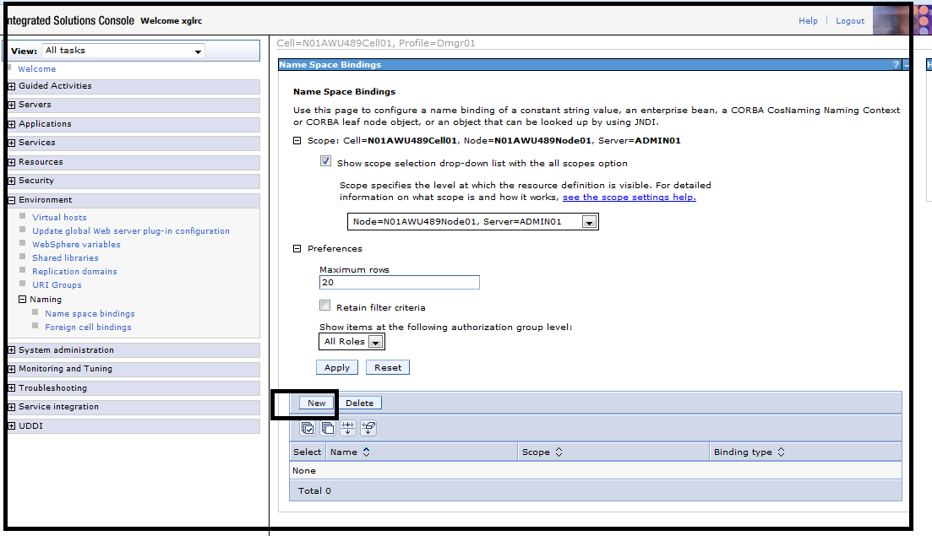
- Click New.
- In Binding type, select String.
- Click Next.
- In Binding identifier, Name in name space, enter one of the JNDI property names mentioned earlier in this section.
- In String value, enter the URL corresponding to this JNDI property.

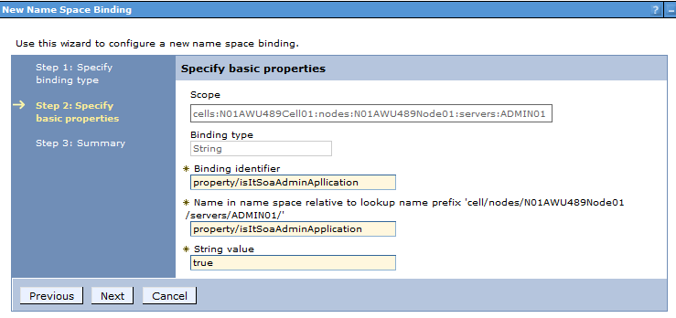
- Click Next.
- Click Finish.
- Repeat steps 3 through 9 for all other JNDI properties mentioned earlier in this section.
- Click Save directly to master configuration.

Document Generation Certificate Setup
For PDF document generation WEB services AAA currently uses 2 signer certificates:
AAA internal certificate e1.pncie.com.cer
Verisign certificate Verisign.cer
Both of them should be added to WebSphere CellDefaultTrustStore and NodeDefaultTrustStore
Document Generation Certificates
Property | Description
e1.pncie.com | Path to certificate  Example: /usr/aaa/e1.pncie.com.cer
Verisign | Path to certificate  Example:/usr/aaa/Verisign.cer

- Coppy certificates to server
- In the navigation tree, select Security > SSL certificate and key management > Key stores and certificates > CellDefaultTrustStore > Signer certificates .
- Click Add.
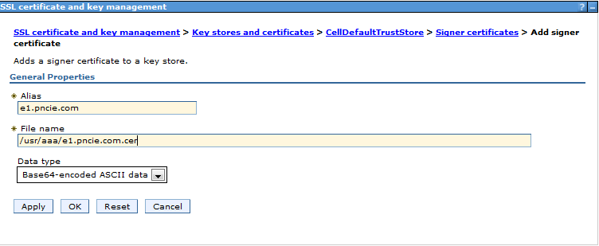
- In Alias enter one of the Document Generation Certificates mentioned earlier in this section.
- Click OK.
- Repeat steps 3 through 5 for both certificates.
- Repeat steps 2 through 6 for NodeDefaultTrustStore.

Chapter 3: Deploying and Configuring the Exigen Insurance Suite Components
Exigen Insurance SuiteExigen Insurance SuiteThis section explains configuring and deploying the Exigen Insurance Suite components in the preliminary configured environment. For more information on preparing the environment, see Installation and Configuration Overview.
The following topics are included in this section:
- Deploying Exigen Insurance Suite Modules on WebSphere Application Servers
- Performing the Database Cleanup and Update
- Preparing the Application Environment
- Configuring the Applications
- Starting an Application in WebSphere Application Server
- Importing a Product
- Performing the Configuration
- Deploying Exigen BPM Engine Processes and Workflows
- Upgrading an Application
- Performing Configuration from the Administration Application

Deploying Exigen Insurance Suite Modules on WebSphere Application Servers
Exigen Insurance Suite is a set of the following J2EE application modules, also known as Web applications:
- Exigen Insurance Suite application module
- Exigen Insurance Suite administration module
- rating engine Web services
- External Services stub application
Exigen Insurance SuiteExigen Insurance SuiteExigen Insurance SuiteExigen Insurance Suite modules are packed in Enterprise Archive (EAR) files. The following EAR files must be deployed to WebSphere Application Server instances:
- aaa-app-ear.ear (this ear file will be deployed twice – as app and as admin)

- aaa-rating-engine-app-ear.ear
- aaa-external-stub-services-app-ear.ear
- operational-reports-app-ear.ear

WebSphere Administrative Console is used for performing deployment of EAR files to WebSphere Application Server instances.
To deploy an Exigen Insurance Suite module EAR file on WebSphere Application Server instances, proceed as follows:
- In the WebSphere Administrative Console navigation tree, click Applications > Install New Application.
- In the right pane, select the local file system.
- Click Browse and navigate to an EAR file to deploy.
- Select the EAR file and then click OK.
- Select Detailed - Show all installation options and parameters.
- Expand the Choose to generate default bindings and mappings node.
- Select Generate Default Bindings.
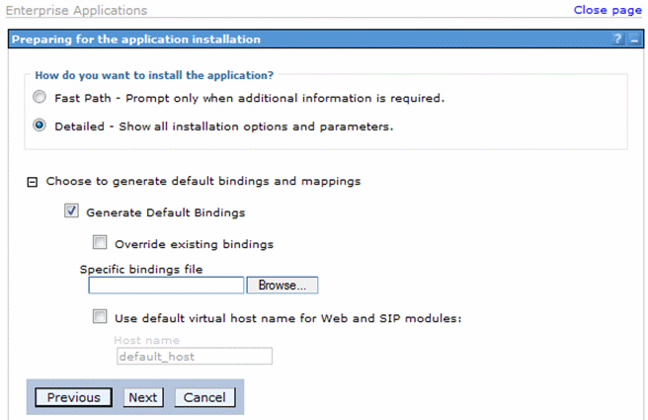
Figure 14: Preparing for the application installation
- Click Next.
- Since PAS04 (EIS 5.2) aaa-app-ear.ear must be installed twice – as app and as admin. When it is installed as admin then application name must be changed from default one to aaa-admin-ear.
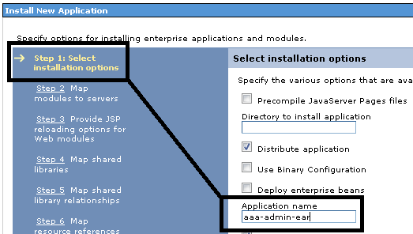
Figure 15: Application name change
- Click Next.
- Apply the cluster to use for the current module by selecting cluster and module.
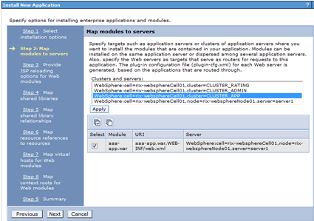
Figure 16: Mapping modules to servers
- Click Apply.
- Click Next until Step 6: Map resource references to resources.
- Ensure all resource references are mapped.
- Click Next until Step 9: Summary.
- Click Finish.
- Click Save directly to master configuration.
- In the WebSphere Administrative Console navigation tree, click Applications > Enterprise Applications.
- In the list of deployed applications, click the installed application.
- Under Detailed properties, click Class loading and update detection.
- In the Class loader order group, ensure the Classes loaded with application class loader first (parent last) option is selected.
- Ensure that Single class loader for application option is selected in the WAR class loader policy group for aaa-rating-engine- -app-ear.
- Click OK.
- Click Save directly to master configuration.
- Repeat steps of this procedure for each EAR file to deploy.
- Start deployed applications as explained in Starting an Application in WebSphere Application Server.

Performing the Database Cleanup, Update and Encryption
This section describes how to perform the existing database cleanup and update and includes the following topics:
- Performing the Existing Database Cleanup
- Updating the Database
- Performing TDE Encryption
- Creating Database Schemas for the Operational Reports Subsystem

Performing the Existing Database Cleanup
To perform the existing database cleanup, proceed as follows:
- Prior to data import, create a new schema or clean the existing schema.
- Create the DATA_PUMP_DIR directory.
- Extract the aaa_ora_dump_1.zip archive and save the aaa_ora_dump_1.dmp file in the DATA_PUMP_DIR directory.
- To import the dump, use the following command:
impdp <username>/<password> directory=DATA_PUMP_DIR dumpfile=aaa_ora_dump_1.dmp remap_schema=AAAQA:newOwner.
- Since EIS 5.2 aaaDocGenSerializer.exportDocumentLocation property shouldn’t have schema (file://) in front of the path. In almost all cases the following query should do the update automatically:
update propertyconfigurerentity set VALUE = substr(value,8)
where propertyname = 'aaaDocGenSerializer.exportDocumentLocation'
and substr(value,1,7) = 'file://';
In case 0 rows are updated, please investigate and update this property manually. Normal scenario would be 1 rows updated. Example:
- Before 5.2 - file:///home/DocGen
- After 5.2 - /home/DocGen

Updating the Database
Liquibase scripts are used for database update. Proceed as follows:
- Database user who executes database update should have a privilege to create views:
GRANT CREATE VIEW TO "<db user>";
- Create a directory or locate the existing directory.
- Unzip contents of file aaa-deploy-dist.zip into this directory.

- Run the following command:
ant db.liquibase -DdbUrl=<database_url> -DdbLogin=<login> -DdbPassword=<password>

- If the check-sum validation error occurs, run the following commands sequentially:
ant clearCheckSums db.liquibase -DdbUrl=<database_url> -DdbLogin=<login> -DdbPassword=<password>
ant db.liquibase -DdbUrl=<database_url> -DdbLogin=<login> -DdbPassword=<password>

- To gather schema statistics, run the following Oracle command:
EXEC DBMS_STATS.gather_schema_stats (ownname => sys_context('userenv', 'current_schema'), cascade =>true,estimate_percent => dbms_stats.auto_sample_size);
It affects newly created indexes.

Please note that --logLevel=info option (in steps 5 and 6) allows seeing detailed log of liquibase update script execution. Usually messages are written into log with level info and severe, however, following log levels are valid: finest, finer, fine, info, warning, severe. Log produced by executing liquibase scripts with logging turned on is vital for solving problems, that is why consider saving logs in a safe please after execution.

Performing TDE Encryption
The following columns and tables must be encrypted utilizing Oracle Transparent Data Encryption (TDE):
Columns and tables to be encrypted
Field type | Table name | Column name | Data type | Nullable | Column ID
Licence | CACHE_LICENSE | LICENSEPERMITNUMBER | VARCHAR2 | Yes | 4
Licence | LICENSE | LICENSEPERMITNUMBER | VARCHAR2 | Yes | 2
Licence | AAAREPORTORDERENTITY | LICENSEPERMITNUMBER | VARCHAR2 | Yes | 12
Licence | DRIVER | LICENSEPERMITNUMBER | VARCHAR2 | Yes | 27
Licence | DRIVINGLICENSEENTITY | LICENSEPERMITNUMBER | VARCHAR2 | Yes | 9
SSN | CACHE_REQUEST_SUBJECT | SSN | VARCHAR2 | Yes | 12
SSN | CLAIMSPAYMENT | SSN | VARCHAR2 | Yes | 25
SSN | CUSTOMERINDIVIDUAL | SSN | VARCHAR2 | Yes | 15
BankAccounts | CACHE_REQUEST | ACCOUNTNUMBER | VARCHAR2 | Yes | 5
BankAccounts | BILLINGINFO | BILLINGACCOUNTNO | VARCHAR2 | Yes | 7
BankAccounts | BILLINGACCOUNT | ACCOUNTNUMBER | VARCHAR2 | No | 2
BankAccounts | BASESTATRECORD | ACCOUNTNUMBER | VARCHAR2 | Yes | 4
BankAccounts | ACTIVITY_HISTORY | ACCOUNTNUMBER | VARCHAR2 | Yes | 73
BankAccounts | ADDITIONALINTEREST | ACCOUNTNUMBER | VARCHAR2 | Yes | 5
BankAccounts | ACTIVITY | ACCOUNTNUMBER | VARCHAR2 | Yes | 73
BankAccounts | PAYMENTDETAILS | BANKACCOUNTNUMBER | VARCHAR2 | Yes | 3
BankAccounts | PAYMENTDETAILS | ACCOUNTNUMBER | VARCHAR2 | Yes | 32
BankAccounts | PAYMENTITEMALLOCATION | ACCOUNTNUMBER | VARCHAR2 | Yes | 4
BankAccounts | VENDORFINANCIALINFO | ACCOUNTNUMBER | VARCHAR2 | Yes | 3
BankAccounts | POLICYBILLINGINFO | BILLINGACCOUNTNO | VARCHAR2 | Yes | 7
BankAccounts | CLAIMSPAYMENT | ACCOUNTNUMBER | VARCHAR2 | Yes | 6
BankAccounts | CLAIMSRECOVERY | ACCOUNTNUMBER | VARCHAR2 | Yes | 6
BankAccounts | CUSTOMERACCOUNT | ACCOUNTNUMBER | VARCHAR2 | Yes | 7
BankAccounts | AAAPENDINGPAYMENTENTITY | ACCOUNTNUMBER | VARCHAR2 | Yes | 4
DebitCreditCard | PAYMENTDETAILS | CARDNUMBER** | VARCHAR2 | Yes | 11
** Not required: IPB Base encrypts this data.

Dropping and Creating Database Schemas for the Operational Reports Subsystem
To maintain (create, drop) database schemas for the Operational Reports subsystem, proceed as follows:
- Ensure that Ant of version 1.8.1+ is installed on the machine.
- Unzip provided operational-reports-deploy.jar.
- Navigate to the install.properties configuration file and provide properties relevant to the database.
It is important to note the following:
- In case when the Oracle database host has multiple operational service names, settings.mainDbHost property must define a full Oracle connection string, not only the host name of the Oracle database. In other cases, providing only the host name of the Oracle database is sufficient.
Full oracle connection string example:
(DESCRIPTION=(ADDRESS_LIST=(ADDRESS=(PROTOCOL=TCP)(HOST=172.28.1.74)(PORT=1521)))(CONNECT_DATA=(SERVICE_NAME=aaadb02)))
- Full oracle connection string definition is space sensitive and adding excessive spaces can result in failure to execute all scripts executed by operationa_reports_oracle_installer.
- Values provided for properties datamart.user and datamart.password are used for configuring the IpbDataMartDB JDBC data source in the manner explained in Creating a J2C Authentication Configuration.
- Dropping old operational reports schema (skip this step if installing a new schema, proceed if schemas need to be recreated). Execute the following console command from the folder where the install.properties file is located:
ant drop
Wait until process finishes and move on to the next step (if creating of a new schema is needed).
- Creating a new operational reports schema. Execute the following console command from the folder where the install.properties file is located:
ant
Wait until process finishes, operational-reports-app can be installed on WebSphere.
Optional property for this command “-Dlocal=on”.
ant -Dlocal=on
-Dlocal=on property replaces all materialized views with regular views and causes scripts to ignore replication options. This option can be used if source data storage is mirrored and optimized externally or it can be useful for development mode to deploy database without time consuming slave DB initialization. This option is not supported on SQL Server. This property can be used with EIS 4.1.9 builds.

Deploying E-Folder
To create proper Efolder configuration Efolder deployment to any database that is being used is needed. This has to be done only once on any database unless major changes are requested in Efolder structure which might require redeployment.

Actions that Efolder deployer does are:
- Drops all tables, triggers, sequence numbers related to E-folder usage;
- Recreates all tables, triggers,sequence numbers required for E-folder;
- Loads folder structure for each of views that has E-folder functionality.

WARNING! Efolder deployer destroys all the data that has been stored in E-folder.
Reminder, only data manually uploaded to Efolder are stored in PAS database. Generated documents are stored externally so they should be unaffected.
- Extract the provided deploy-efolder-bin.zip archive in the following directory:
- on Windows, in C:/
- on Linux, in /
- Open the orm.properties file.
- Configure the following properties:
orm.properties file properties
Property | Description
jdbc.url | JDBC URL for the Exigen Insurance Suite database.  Example:  jdbc:oracle:thin:@<database_server>:<port>:<database_SID>
jdbc.username | Exigen Insurance Suite database owner name.  The following is an example:  jdbc.username=ipbdev
jdbc.password | Exigen Insurance Suite database owner password.  The following is an example:  jdbc.password=trewq321
- Launch deployer:
- On Windows, launch the deploy-efolder.bat file.
- On Linux, execute the following command:
./ deploy-efolder.sh run
- Confirmation will be required before all E-folder data is deleted.
- E-folder structure is created in database.

Performing the Existing Billing Schedule Cleanup
To perform the existing Billing Schedule cleanup (see Configuring the Billing Schedule), proceed as follows:
- Execute the following SQL scripts:
delete from scheduleactivityentry;
delete from scheduleactivity;

NOTE! Please perform this cleanup only when you are sure you need it or on fresh installation. Do not perform it on every deployment.

Preparing the Application Environment
To prepare application environment, proceed as follows:
- Create a directory for Exigen Product Factory business rules.
The default value is /ipb/pf-business-rules/runtime on the drive where WebSphere resides.
- Create a directory for properties.
Example: /opt/ipb/
- Copy the following files to this directory:
- BLS.properties
- com-exigen-ipb-pf-product-deploy-service-config.properties
- In the BLS.properties file, modify the bls.deployment.directory property.
This property must point to the directory where OpenL Tablets rules will be deployed. The directory must exist and be the same for all applications.
- In the com-exigen-ipb-pf-product-deploy-service-config.properties
file, modify the following properties:
- productLifecycle.runtimePath
- productLifecycle.designtimePath
These properties must point to the directory where Exigen Product Factory rules will be deployed. The directory must exist and be the same for all applications.
- Verify the bls.deployment.directory and productLifecycle.runtimePath properties.
These properties can point to the same directory for AAA applications, but must be unique within the whole AAA applications environment.
- Add path to created directory to Generic JVM arguments for all servers in the following way:
- Select a server.
- In the panel on the right, expand Java and Process Management and select Process definition.
- Select Additional Properties > Java Virtual Machine.
- In Generic JVM arguments field enter path to the created directory in the following way:
-Deis.config.root=/opt/ipb/
- For rating server in Generic JVM arguments field add path to the created directory in the following way:
-Druleservice.tmp.dir=<patch to openl folder>/openl/rules-deploy -Druleservice.datasource.dir=<patch to openl folder>/openl/aaa-rating-engine-ss-app/datasource
- Click OK.
- Click Save directly to master configuration.
- Copy the following JAR files to the lib/ext folder of the installed WebSphere application server:
- jaxb-api-2.2.jar
- jaxb-impl-2.1.9.jar
- jaxp-ri-1.4.2-exg.jar
- saaj-api-1.3.4.jar
- saaj-impl-1.3.15.jar
- wsdl4j-1.6.1.jar
- xalan-2.7.0.jar
- xercesImpl-2.8.1.jar
An example of the directory location is /opt/IBM/WebSphere/AppServer1/lib/ext.
- Copy the following JAR file to the /opt/IBM/WebSphere/AppServer/java/jre/lib/endorsed folder of the installed WebSphere application server: XmlSchema-1.4.5.jar. This is temporary solution and jar will be removed in future.
- Remove /opt/IBM/WebSphere/AppServer/java/jre/lib/endorsed/XmlSchema-1.4.5.jar

Starting an Application in WebSphere Application Server
Applications in WebSphere Application Server must be started after deploying EAR files. The application is deployed and started successfully when the red mark next to the name of the application changes to the green mark . WebSphere displays an error message if it cannot start the application.
For information about WebSphere error messages, see WebSphere Application Server documentation.
To start an application in WebSphere Application Server, proceed as follows:
- In the WebSphere Administrative Console navigation tree, click Servers > Server Types > WebSphere application servers.
- Select any or all servers to start and click Start.
The red mark next to the status of each server changes to the green mark , indicating that the server is running.
- In the WebSphere Administrative Console navigation tree, click Applications > Enterprise Applications.
- Select any or all Exigen Insurance Suite applications to start and click Start.
The red mark next to the status of each application changes to the green mark , indicating that the application is running.

Importing a Product
To import a product, proceed as follows:
- To rename an already imported product, execute the following SQL scripts for the database:
update PRODUCTDEFINITION set PRODUCTCD = 'AAA_CSA_Deprecated', PRODUCTSTATUS = 'deactivated' where PRODUCTCD = 'AAA_CSA'
update ENTITYCONFIGURATION set ENTITYCD = 'AAA_CSA_Deprecated' where ENTITYCD = 'AAA_CSA'
update BUSINESSRULE set ENTITYCODEVERSION = 'AAA_CSA1.0_Depracated' where ENTITYCODEVERSION = 'AAA_CSA1.0';

update PRODUCTDEFINITION set PRODUCTCD = 'AAA_SS_ Deprecated', PRODUCTSTATUS = 'deactivated' where PRODUCTCD = 'AAA_SS'
update ENTITYCONFIGURATION set ENTITYCD = 'AAA_SS_ Deprecated' where ENTITYCD = 'AAA_SS'
update BUSINESSRULE set ENTITYCODEVERSION = 'AAA_SS1.0_Depracated' where ENTITYCODEVERSION = 'AAA_SS1.0';

If the AAA_CSA_Deprecated, AAA_CSA1.0_Depracated, AAA_SS_ Deprecated, AAA_SS1.0_Depracated code already exists, any other unique one must be used.
- Start administrative application.
An example of the startup link is http://host-name:9080/aaa-admin.
- Enter logon information and click Login.
- To start importing, in the Product tab, click Import.
- Locate the product zip file aaa-auto-ca-product.zip and click Import.
- If the product is active, to deactivate it, select Move to: Deactivate and click GO.
- To deploy the imported product, select Move to: Deploy and click GO.
- To activate the product, select Move to: Activate and click GO.
- Repeat import procedure steps for the aaa-auto-ss-product.zip product file.

Performing the Configuration
This section contains SQL scripts for updating database values for property configuration. The following topics are included:
- Folder Paths Configuration
- Automatic Directories Creation
- Defining URL Values to the ChoicePoint Endpoints
- Defining the AccountId and ClientId Properties for ChoicePoint
- Defining the Endpoint URL for External Services
- Configuring Doc Gen
- Configuring Rating Engine
- Configuring IIS Reporting URL
- Configuring BOAReconciliationService and RemittanceFeed Service
- Configuring Additional Services
- Configuring Additional Services for Bill Due Feed
- Configuring Additional Services
- Configuring Membership WS
- Configuring Collection Job Feed
- Configuring Single Sign-On
- Configuring the Operational Reports URL

Folder Paths Configuration
All folder paths are configured in PropertyConfigurerEntity and starts with prefix “${batch.root_folder}”.

New environment setting must be configured, for example,
SET batch.root_folder=/home/mp2/pas/pit/ (or any other folder, like C:\JobFolders)

To create all required folders and subfolders you can set environment setting for development mode.
SET batch.dev_mode=true
(To create required directory structure you can use also directory creation script Automatic Directories Creation)

Automatic Directories Creation
To create required directory structure use provided bash script:
- Extract the provided DirectoryCreatorScript.zip archive in the following directory:
- on Linux, in /
- on Windows, in C:/
- Open the READ_ME.txt file and review it to follow instructions.
- Open and verify that directories_to_create.txt contains desirable directory structure
- Launch deployer:
- On Windows, launch the create_directories.bat file.
- On Linux, execute the following command:
./create_directories.sh
Directory structure can be created also manually.
WARNING! Property paths should match appropriate records in database. For example, with this script path „/home/mp2/pas/sit/BIL_B_EXGBLL_REGULUS_3008_D/outbound/” is created for „aaaStopCheckServiceIO.path” property, so the property „aaaStopCheckServiceIO.path” must exist with the same value also in database PropertyConfigurerEntity table.

Defining URL Values to the ChoicePoint Endpoints
For the database, execute the following commands:
update PropertyConfigurerEntity set value='http://<host>:<port>/aaa-external-stub-services-app/ws/choicepoint/CLUE' where propertyname='choicePointEndpoints.clueEndpointCA';

update PropertyConfigurerEntity set value='http://<host>:<port>/aaa-external-stub-services-app/ws/choicepoint/NCF' where propertyname='choicePointEndpoints.ncfEndpointCA';

update PropertyConfigurerEntity set value='http://<host>:<port>/aaa-external-stub-services-app/ws/choicepoint/PREFILL' where propertyname='choicePointEndpoints.prefillEndpointCA';

update PropertyConfigurerEntity set value='http://<host>:<port>/aaa-external-stub-services-app/ws/choicepoint/MVR' where propertyname='choicePointEndpoints.mvrEndpointCA';

update PropertyConfigurerEntity set value='http://<host>:<port>/aaa-external-stub-services-app/ws/choicepoint/MVR' where propertyname='choicePointEndpoints.mvrEndpointAZ';

update PropertyConfigurerEntity set value='http://<host>:<port>/aaa-external-stub-services-app/ws/choicepoint/CLUE' where propertyname='choicePointEndpoints.clueEndpointAZ';

update PropertyConfigurerEntity set value='http://<host>:<port>/aaa-external-stub-services-app/ws/choicepoint/NCF' where propertyname='choicePointEndpoints.ncfEndpointAZ';

update PropertyConfigurerEntity set value='http://<host>:<port>/aaa-external-stub-services-app/ws/choicepoint/PREFILL' where propertyname='choicePointEndpoints.prefillEndpointAZ';

Defining the AccountId and ClientId Properties for ChoicePoint
To define the AccountId and ClientId properties for ChoicePoint, proceed as follows:
- For Prefill, set Account Number as follows:
update PropertyConfigurerEntity set value='501344TST'
where propertyname='prefillCacheMappingService.accountNumber';

- For MVR/CLUE/NCF, set Account Number as follows:
update PropertyConfigurerEntity set value='501344BTS'
where propertyname=' mvrCacheMappingService.accountNumber';

update PropertyConfigurerEntity set value='501344BTS'
where propertyname=' clueCacheMappingService.accountNumber';

update PropertyConfigurerEntity set value='501344BTS'
where propertyname=' ncfCacheMappingService.accountNumber';

update PropertyConfigurerEntity set value='Account Number for batch MVR service'
where propertyname='mvrCacheMappingService.batchAccountNumber';

- For Prefill, set Client Id as follows:
update PropertyConfigurerEntity set value='IP0572300'
where propertyname=' prefillCacheMappingService.clientId';

- For MVR/CLUE/NCF, set Client Id as follows:

update PropertyConfigurerEntity set value='D05808FTP'
where propertyname='mvrCacheMappingService.clientId';

update PropertyConfigurerEntity set value= 'Client Id for batch MVR service' where propertyname='mvrCacheMappingService.batchClientId';

update PropertyConfigurerEntity set value='D05808FTP'
where propertyname='clueCacheMappingService.clientId';

update PropertyConfigurerEntity set value='D05808FTP' where
propertyname='ncfCacheMappingService.clientId';

- For MVR, Set Application Id and Destination Id as follows:

update PropertyConfigurerEntity set value='Application ID parameter for MVR batch request'
where propertyname='mvrCacheMappingService.applicationId';

update PropertyConfigurerEntity set value='Destination ID parameter for MVR batch request'
where propertyname='mvrCacheMappingService.destinationId';

Defining the Endpoint URL for External Services
To define the endpoint URL for external services, proceed as follows:
- Define the address validation service endpoint URL as follows:
update PropertyConfigurerEntity set value='http://<host>:<port>/aaa-external-stub-services-app/ws/address'
where propertyname='addressValidationIntegrationServiceImpl.endpointAddressValidationUri';
- Define the record lead activity service endpoint URL as follows:
update PropertyConfigurerEntity set value='http://<host>:<port>/aaa-external-stub-services-app/ws/leadactivity'
where propertyname= ‘recordLeadWebServiceImpl.endpointRecordLeadUri’;
- Set the CSA Claims service endpoint URL as follows:
update PropertyConfigurerEntity set value='http://<host>:<port>/aaa-external-stub-services-app/ws/claim'
where propertyname='claimIntegrationServiceImpl.endpointClaimUri';
- Set the PCI CC Storage service endpoint URL as follows:
update PropertyConfigurerEntity set value='http://<host>:<port>/aaa-external-stub-services-app/creditcard'
where propertyname='aaaPurchaseFlowBeanHolder.ccStorateEndpointURL';
update PropertyConfigurerEntity set value='http://<host>:<port>/aaa-external-stub-services-app/creditcard'
where propertyname='aaaBillingActionBean.ccStorateEndpointURL';

Configuring Doc Gen
Set the Doc Gen configuration as follows:
update propertyconfigurerentity
set value = '<webserviceUrl>'
where propertyname = '<webserviceUrl>' ;

update propertyconfigurerentity
set value = '<webserviceUrl>'
where propertyname = 'aaaRetrieveDocumentWebClient.endpointUri' ;

update propertyconfigurerentity
set value = '<webserviceUrl>'
where propertyname = 'docGenwebClient.endpointUri' ;

update propertyconfigurerentity
set value = 'true'
where propertyname in ('aaaDocGenSerializer.callDCSInstant', 'aaaDocGenSerializer.saveToEfolder', 'aaaDocumentServices.callDCSInst') ;

Configuring Rating Engine
Set the Rating Engine configuration as follows:
update PropertyConfigurerEntity set value='http://<host>:<port>/aaa-rating-engine-app/ws/ca' where propertyname='aaaAutoRatingService.endpointUri';
update PropertyConfigurerEntity set value='http://<host>:<port>/aaa-rating-engine-app/ws/ss' where propertyname='aaaAutoRulesClientProxyFactoryBean.address';

Configuring the IIS Reporting URL
Set the IIS Reporting Application URL as follows:
update propertyconfigurerentity set value='<reportingUrl>'
where propertyname='iisReportingConfig.url'

Configuring BOAReconciliationService and RemittanceFeed Service
Configure BOAReconciliationService and RemittanceFeed Service as follows:
update PropertyConfigurerEntity set value='<path to outbound folder>'
where propertyname=' boaCheckReconciliationServiceIO.path ';

update PropertyConfigurerEntity set value='<path to inbound folder>'
where propertyname='aaaRemittanceFeedServiceIO.path';

update PropertyConfigurerEntity set value='BOA'
where propertyname='aaaRemittanceFeedService.bankName';

update PropertyConfigurerEntity set value='00000000'
where propertyname='aaaRemittanceFeedService.bankAccountNumber';

update PropertyConfigurerEntity set value='<path to outbound folder>'
where propertyname=' boaCheckReconciliationServiceIO.path';

update PropertyConfigurerEntity set value='<bank account number for CheckReconciliationFeed element>'
where propertyname='boaCheckReconciliationService.bankAccountNumberForCheckReconciliationFeed';

update PropertyConfigurerEntity set value='<boaCheckReconciliationBatchReceiveJob batch job input directory >'
where propertyname= boaCheckRecnclnReceiveServiceIO.path';

Configuring Additional Services
Configure additional services as follows:

update PropertyConfigurerEntity set value='<path to inbound folder>'
where propertyname= ' bofaRejectionPaymentIO.path';

update PropertyConfigurerEntity set value='<path to inbound folder>'
where propertyname= ' bofaRecurringPaymentServiceIO.path';

update PropertyConfigurerEntity set value='http://<host>:<port>/aaa-external-stub-services-app/ws/issuedirectpayment'
where propertyname=' issueDirectPaymentServiceImpl.endpointIssueDirectPaymentUri';

update PropertyConfigurerEntity set value='http://<host>:<port>/aaa-external-stub-services-app/ws/customermaster’ where propertyname='customerMasterServiceImpl.findCustomerUri’;

update PropertyConfigurerEntity set value='http://<host>:<port>/aaa-external-stub-services-app/ws/customermaster’ where propertyname=' customerMasterServiceImpl.retrieveCustomerDetailsUri’;
update PropertyConfigurerEntity set value='http://<host>:<port>/aaa-external-stub-services-app/ws/customermaster’ where propertyname=' customerMasterServiceImpl.recordCustomerDetailsUri’;

update PropertyConfigurerEntity set value='http://<host>:<port>/aaa-external-stub-services-app/ws/recordpayment’
where propertyname='recordPaymentReceiptServiceImpl.endpointRecordPaymentUri’;

update PropertyConfigurerEntity set value='DEV’
where propertyname='aaaBillDueFeedMapping.batchEnvEnum’;

update PropertyConfigurerEntity set value ='http://<host>:<port>/aaa-external-stub-services-app/ws/recordCardStatus'
where propertyname='aaaRecordCardStatusService.endpointRecordCardStatusPaymentUri';

update PropertyConfigurerEntity set value='MVR batch request file name format’
where propertyname='renewalMVRReportService.mvrFileNameFormat’;

update PropertyConfigurerEntity set value='MVR batch request file name format for choicePointBatchService'
where propertyname='choicePointBatchService.mvrFileNameFormat';

Configuring Additional Services for Bill Due Feed
Configure additional services for bill due feed as follows:

GRANT SELECT ON v_$instance TO <USER>;
GRANT EXECUTE ON UTL_FILE TO <USER>;
CREATE DIRECTORY BIL_B_EXGBLL_EBPHUB_4000_D AS '<path to existing directory>';
CREATE DIRECTORY BIL_B_EXGBLL_EBPHUB_4000_D_OB AS '<path to existing directory>';
GRANT READ ON DIRECTORY BIL_B_EXGBLL_EBPHUB_4000_D TO <USER>;
GRANT READ ON DIRECTORY BIL_B_EXGBLL_EBPHUB_4000_D_OB TO <USER>;
GRANT WRITE ON DIRECTORY BIL_B_EXGBLL_EBPHUB_4000_D TO <USER>;
GRANT WRITE ON DIRECTORY BIL_B_EXGBLL_EBPHUB_4000_D_OB TO <USER>;
CREATE DIRECTORY PMT_E_PASSYS_PMTCTRL_4037_D AS '<path to existing directory>';
CREATE DIRECTORY PMT_E_PASSYS_PMTCTRL_4037_D_OB AS '<path to existing directory>';
GRANT READ,WRITE ON DIRECTORY PMT_E_PASSYS_PMTCTRL_4037_D TO <USER>;
GRANT READ,WRITE ON DIRECTORY PMT_E_PASSYS_PMTCTRL_4037_D_OB TO <USER>;

<path to existing directory> must point to existing directory on oracle server file system.

Configuring Membership WS
Configure membership web service as follows:
update PropertyConfigurerEntity set value='<host>:<port>/aaa-external-stub-services-app/ws/membership’ where propertyname='retrieveMembershipIntegrationServiceImpl. endpointRetrieveMembershipUri’;

Configuring Collection Job Feed
Configure collection job feed as follows:
update propertyconfigurerentity set value ='DEV'
where propertyname='aaaCollectionFeedMapping.batchEnvEnum';

update propertyconfigurerentity set value ='100'
where propertyname='aaaCollectionFeedMapping.collectionDueLimit';

update propertyconfigurerentity set value ='60'
where propertyname='aaaCollectionFeedMapping.duePendingDays';

update propertyconfigurerentity set value ='NCO'
where propertyname='aaaCollectionFeedMapping.collectionAgencyCode';

update propertyconfigurerentity set value ='<path to outbound folder>'
where propertyname='aaaCollectionFeedService.fileDir';

update propertyconfigurerentity set value ='_BIL_E_EXGBLL_NCOCOL_3012_W.xml'
where propertyname='aaaCollectionFeedService.fileName ';

Configuring Policy Transaction Ledger Jobs
Configure the directory for billing and financial transactions as follows:
update propertyconfigurerentity set value ='<path to folder>'
where propertyname='psLedgerIo.path';

update propertyconfigurerentity set value ='smtp host for error notifications'
where propertyname='psLedgerMailSender.host';

update propertyconfigurerentity set value ='Error notifications mailing address'
where propertyname='peopleSoftGLLedgerExportService.notificationMailTo';

Configuring Single Sign-On
To configure single sign-on, proceed as follows:
- Save the agent-config.txt file in the agent configuration directory.
- Set the pingAgentWrapper.configFile database property to point to the file created above:
update PropertyConfigurerEntity set value='<path to agent config directory>/agent-config.txt' where propertyname= 'pingAgentWrapper.configFile';
- Set the pingAgentWrapper.pingUrl database property to point to the stub application with original URL parameter at the end:
update PropertyConfigurerEntity set value='https://pit-sso1.tent.trt.csaa.pri/idp/startSSO.ping?PartnerSpId=localhost:default:entityId&TargetResource=' where propertyname= 'pingAgentWrapper.pingUrl';
- Set the pingAgentWrapper.originalUrlParam database property value to either of the following:
- TargetResource
- parameter name in the URL set in step 3.
Example:
update PropertyConfigurerEntity set value='TargetResource' where propertyname= 'pingAgentWrapper.originalUrlParam';

Configuring the Operational Reports URL
Set the URL of the Operational Reports application as follows:
update propertyconfigurerentity set value='<opeartionalReportsUrl>' where propertyname='operationalReportsConfig.url'
<opeartionalReportsUrl> is the location where operating-reports-app is deployed, for example, http://localhost:8080/operational-reports-app.

Configuring activityHistoryJob parameters
There are 2 activityHistoryJob parameters which both are defined in database with default value equal to 366 and can be altered when needed:
- Activities expiration period in days parameter can be updated this way:
update PROPERTYCONFIGURERENTITY pce set pce.value = 'any numeric value here' where pce.propertyname = 'activityHistoryJob.activitiesOlderThanDays';
- Notes expiration period in days parameter can be updated this way:
update PROPERTYCONFIGURERENTITY pce set pce.value = 'any numeric value here' where pce.propertyname = 'activityHistoryJob.notesOlderThanDays';
Please note that aaa-admin application must be restarted to load new parameter values.

Configuring ZIP resolver parameters
Set the URL of the ZIP resolver application as follows:
update propertyconfigurerentity set value='<zipresolverUrl>' where propertyname='zipResolverServiceImpl.zipResolverUri'

Configuring membership Renewal jobs parameters
New properties for membershipRenewalBatchOrderJob:
Directory to store arrived batch membership response:
update propertyconfigurerentity set value='${batch.root_folder}/PAS_B_EXGPAS_PASHUB_4004_D/' where propertyname='offlineMembershipSummaryProcessingRequestService.outputResponseDir';
Directory for stored requests, which should be read and sent to network:
update propertyconfigurerentity set value='${batch.root_folder}/PAS_B_PASHUB_EXGPAS_4004_D/' where propertyname='offlineMembershipSummaryProcessingRequestService.inputRequestDir';
Suffix for stored response:
update propertyconfigurerentity set value='_PAS_B_PASHUB_EXGPAS_4004_D.XML' where propertyname='offlineMembershipSummaryProcessingRequestService.fileNameSuffix';
Application name:
update propertyconfigurerentity set value='<applicationName>' where propertyname='membershipBatchRetriveService.applicationName';
Job name:
update propertyconfigurerentity set value='<jobName>' where propertyname='membershipBatchRetriveService.jobName';
Job server name:
update propertyconfigurerentity set value='<jobServerName>' where propertyname='membershipBatchRetriveService.jobServerName';
Type of environment like DEV, PROD,...:
update propertyconfigurerentity set value='<PROD>' where propertyname='membershipBatchRetriveService.environmentType';
IP address of web server:
update propertyconfigurerentity set value='<ipAddress>' where propertyname='membershipBatchRetriveService.ipAddress';

New properties for membershipRenewalBatchReceiveJob:
File path for membership order report request:
update propertyconfigurerentity set value='${batch.root_folder}//PAS_B_EXGPAS_PASHUB_4004_D/' where propertyname='renewalMembershipBatchReportService.outputDir';
File path for membership order report response:
update propertyconfigurerentity set value='${batch.root_folder}//PAS_B_PASHUB_EXGPAS_4004_D/' where propertyname='renewalMembershipBatchReportService.inputDir';
Suffix for membership order request batch file:
update propertyconfigurerentity set value='_PAS_B_PASHUB_EXGPAS_4004_D.XML' where propertyname='renewalMembershipBatchReportService.fileNameSuffix';

Deploying Exigen BPM Engine Processes and Workflows
This section explains deploying all processes and workflows defined for Exigen Insurance Suite. The following topics are included in this section:
- BPM Engine Processes Import Utility Setup
- BPM Engine Processes and Workflows Deployment Using BPM Engine Processes Import Utility

BPM Engine Processes Import Utility Setup
To prepare workable copy of BPM Engine Processes Import Utility, proceed as follows
- Extract provided BPM_PROCESS_IMPORT.zip archive in some working folder
- If sub-folder ipb-bpm-admin-<eis_version> (where <eis_version> is EIS version, used in the build) is not present in the working folder, then download ipb-bpm-admin-<eis_version>.war artifact from the maven site
https://vnosvn-proxy.exigenservices.com/maven/com/exigen/ipb/applications/ipb-bpm-admin/
and extract required sub-folder from downloaded WAR archive.

NOTE! Download from Maven site is a temporary solution (if you cannot access it please get required versions from the Wiki page Command+Line+BPM+Processes+Import+Utility -> Attachments). In future there will be added the option to automatically download the correct version during build process.

- Under folder schemas create subfolder <your_schema_name> and copy to it file ..\BPM_PROCESS_IMPORT\schemas\TEST\orm.properties,
- Adjust parameters jdbc.url, jdbc.username, jdbc.password in copied file

BPM Engine Processes and Workflows Deployment Using BPM Engine Processes Import Utility
To deploy Exigen BPM Engine processes and workflows using BPM Engine Processes Import Utility, proceed as follows:
- Under folder builds create subfolder <your_build_number>\solution-deployer and unzip into it build artifact solution-deployer.zip
- Switch to folder ..\BPM_PROCESS_IMPORT and execute a command
ant -Dbpm-version=<eis_version> -Dschema=<your_schema_name> -Dbuild=<your_build_number>

If all goes well, processes will be imported and there will be console log, ending with text
…
[java] DEPLOYMENT IS SUCCEEDED
[java]
BUILD SUCCESSFUL
Total time: 1 minute 56 seconds

If there is no text “DEPLOYMENT IS SUCCEEDED” in console output then need to consult error log

Note: According to EIS documentation can disregard exception: org.springframework.beans.factory.NoSuchBeanDefinitionException: No bean named 'com.exigen.common.security.directory.IdentityFactory' is defined

Upgrading an Application
This section introduces the typical process of upgrading an application.
The following topics are included in this section:
- Stopping Application Servers
- Upgrading the Database
- Redeploying Processes
- Updating Application Modules
- Starting Application Servers
- Importing Products

Stopping Application Servers
Application servers on which the application is running must be stopped before upgrading an application.
To stop application servers, proceed as follows:
- In the WebSphere Administrative Console navigation tree, click Servers > Application Servers.
- In the table, select servers on which Exigen Insurance Suite modules are deployed, and click Stop.
- To confirm stopping servers, click OK.

Upgrading the Database
To upgrade the database, proceed as follows:
- Perform steps explained in Updating the Database.
- Check if columns and tables are encrypted utilizing Oracle TDE as explained in Performing TDE Encryption.
- Check the configuration and run missing scripts as explained in Performing the Configuration.

Redeploying Processes
Redeploying processes is required if the folder in the build package contains tomcatapache-tomcat-5.5.27-bpm.zip and solution-deployer.zip files.
To redeploy processes, perform steps explained in Deploying Exigen BPM Engine Processes and Workflows.

Updating Application Modules
To update application modules, proceed as follows:
- In the WebSphere Administrative Console navigation tree, click Applications > Enterprise Applications.
- Select application module to update and click Update.
- In the Application update options group, select the Replace entire application option.
- In the Specify the path to the replacement ear file group, select the local file system, click Browse, and navigate to the EAR file to deploy.
- Select the EAR file and click OK.
- Click Next
- In the How do you want to install the application group, select Detailed - Show me all installation options and parameters.
- Expand Choose to generate default bindings and mappings, select Generate Default Bindings (applicable only if using "new" or "merged" bindings) and click Next.
- In the left column of the right pane, click Step 9 Summary and click Finish.
- Click Save directly to master configuration.

Starting Application Servers
To start application servers, proceed as follows:
- In the WebSphere Administrative Console navigation tree, click Servers > Application Servers.
- In the table, select servers on which Exigen Insurance Suite modules are deployed and click Start.
Note: It is useful to clean up, or backup, the WebSphere log directory before starting servers.

Importing Products
To import a product, perform steps explained in Importing a Product.

Performing Configuration from the Administration Application
Configuration explained in this section is performed in the Exigen Insurance Suite administration application.
The following topics are included in this section:
- Privilege update
- Configuring the Renewal Batch
- Configuring the Activity Summarization Job
- Configuring the Operational Reports Feature and Importing Report Templates

Privilege update
- Navigate to Admin -> Security - Roles
- Select the role of your user (for example, role "xxx" which is assigned to "yyy" user) and add all available privileges

Configuring the Renewal Batch
To configure the renewal batch, proceed as follows:
- Start the Exigen Insurance Suite administration application.
An example of the startup link is http://host-name:9080/aaa-admin.
- Enter logon information and click Login.
- In the General tab, in the left column, click Scheduler.
- In Scheduled Jobs section, click Add.
- In the Name field, enter the batch name Renewal Offer Generation (Part1).
- Click Add Job.
- In the drop-down list, select the mvrRenewBachOrderJob job.
- Click Add Job.
- In second drop-down list, select the claimsRenewBatchOrderJob job.
Note that order and names in steps 7 through 9 are important.
- Check Enabled and enter start and end date and time.
- Click Save.
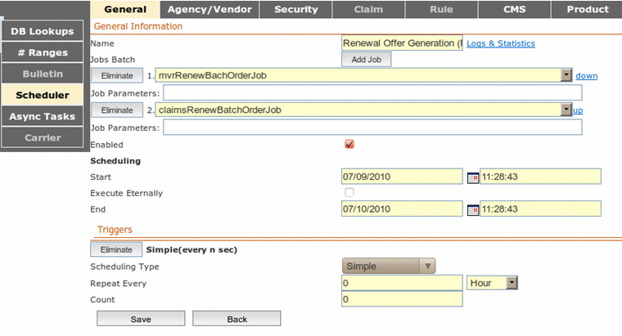
Figure 17: Scheduling jobs
- Create a batch named Renewal Offer Generation (Part2) as explained in steps 4 through 5.
- Add the following jobs to the batch: (order and names are important):
- mvrRenewBatchReceiveJob
- claimsRenewBatchReceiveJob
- policyAutomatedRenewalGenerationJob
- policyAutomatedRenewalRenewJob
- renewalImageRatingJob
- renewalOfferJob
It is important that the specified names and order of jobs is used.
- For the renewalImageRatingJob job, in the Job Parameter field, enter mileage value for the renewal image.
The parameter is optional for this job. If no value is entered, the default value 0 is used.
- Check Enabled and enter the start and end date and time.
- Click Save.
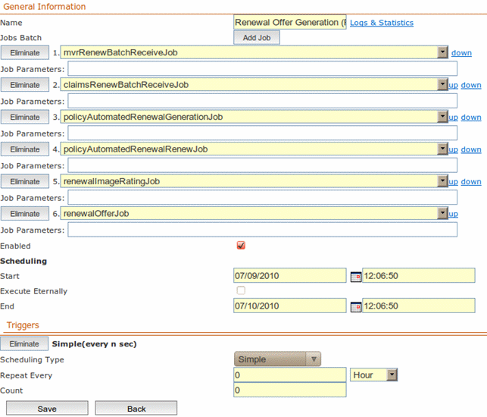
Figure 18: Scheduling other renewal jobs

Configuring the Activity Summarization Job
To configure the activity summarization job, proceed as follows:
- Log into the Exigen Insurance Suite administration application.
An example of the startup link is http://host-name:9080/aaa-admin.
- In the General tab, click Scheduler in the left side menu.
- Click Add.
- On the next screen, click Add Job and select the job named activitySummarizationJob.
- Select the Enable check box.
- To specify when to activate and deactivate the job schedule, enter values in the Start field and the End field.
- In Triggers section, select the scheduling type.
The available values are Simple, Daily, Weekly, Monthly or Cron expression.
Simple scheduling allows running a job for a defined number of times with an interval specified in seconds, minutes or hours. Other scheduling types allow running a job periodically.
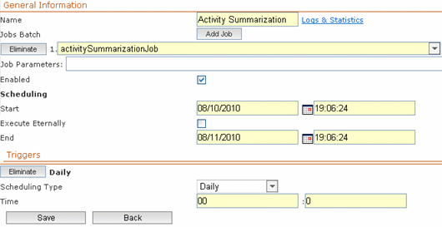
Figure 19: Scheduling activitySummarizationJob
- Click Save.
- On the job detail screen, find the newly created job schedule and check its status.
A job is successfully finished when its state is Idle and the result is Success.
- To view detailed information about the job execution process, click the Logs & Statistics link.
After successful job execution, activity reports appear in the Reports tab of the Exigen Insurance Suite user application. An example of a link to the Exigen Insurance Suite user application is http://host-name:9080/aaa-app.

Configuring the Operational Reports Feature and Importing Report Templates
The following topics are included in this section:
- Configuring the Electronic Folder
- Uploading Report Templates
- Understanding Privileges for Working with Reports

Configuring the Electronic Folder
To configure an electronic folder for storing generated documents, proceed as follows:
- In the Exigen Insurance Suite administration application, select the CMS tab.
- In the left side menu, select Efolder.
- Next to the Report node, click View.
- Select a folder and then create a new subfolder.
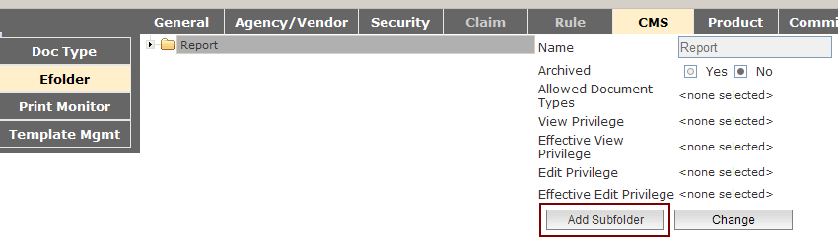
Figure 20: Adding a subfolder
- In the Name field, enter the required name.
- Ensure Operational Report is selected in the Allowed Document Types list.
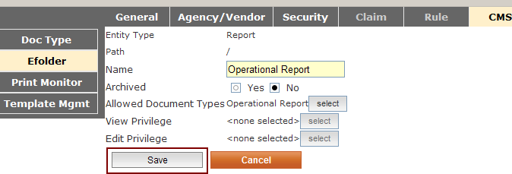
Figure 21: Saving subfolder information

Uploading Report Templates
To upload report templates, proceed as follows:
- In the Exigen Insurance Suite administration application, select the Reports tab.
This tab provides access to the operational-reports-app instance.
- In the Reports tab, click Import.
The operational report template uploading window appears.
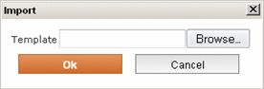
Figure 22: Operational report template uploading window
- Click Browse and provide path to the templates.zip file provided with delivery.
- Click Ok.
After templates are uploaded, the current screen is closed.

Understanding Privileges for Working with Reports
Operational Reports use common Exigen Insurance Suite security infrastructure to manage user permissions. New permissions Report:Operational:${reportName}:View and Report:Operational:${reportName}:Schedule are created during report template import.

Configuring the Billing Schedule
To configure the billing schedule, proceed as follows:
- In the Exigen Insurance Suite administration application, select the Billing tab.
- In the left side menu, select Schedule.
- Enter the date to which schedule will be generated.
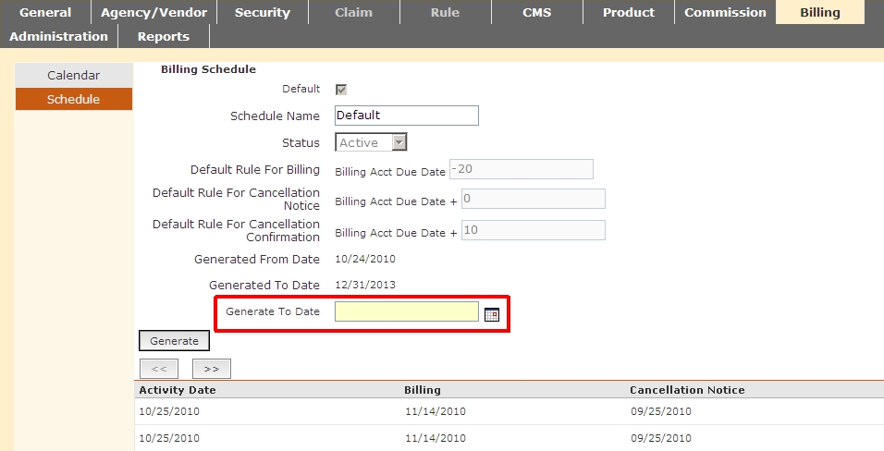
Figure 23: Billing Schedule generation
- Click Generate.

