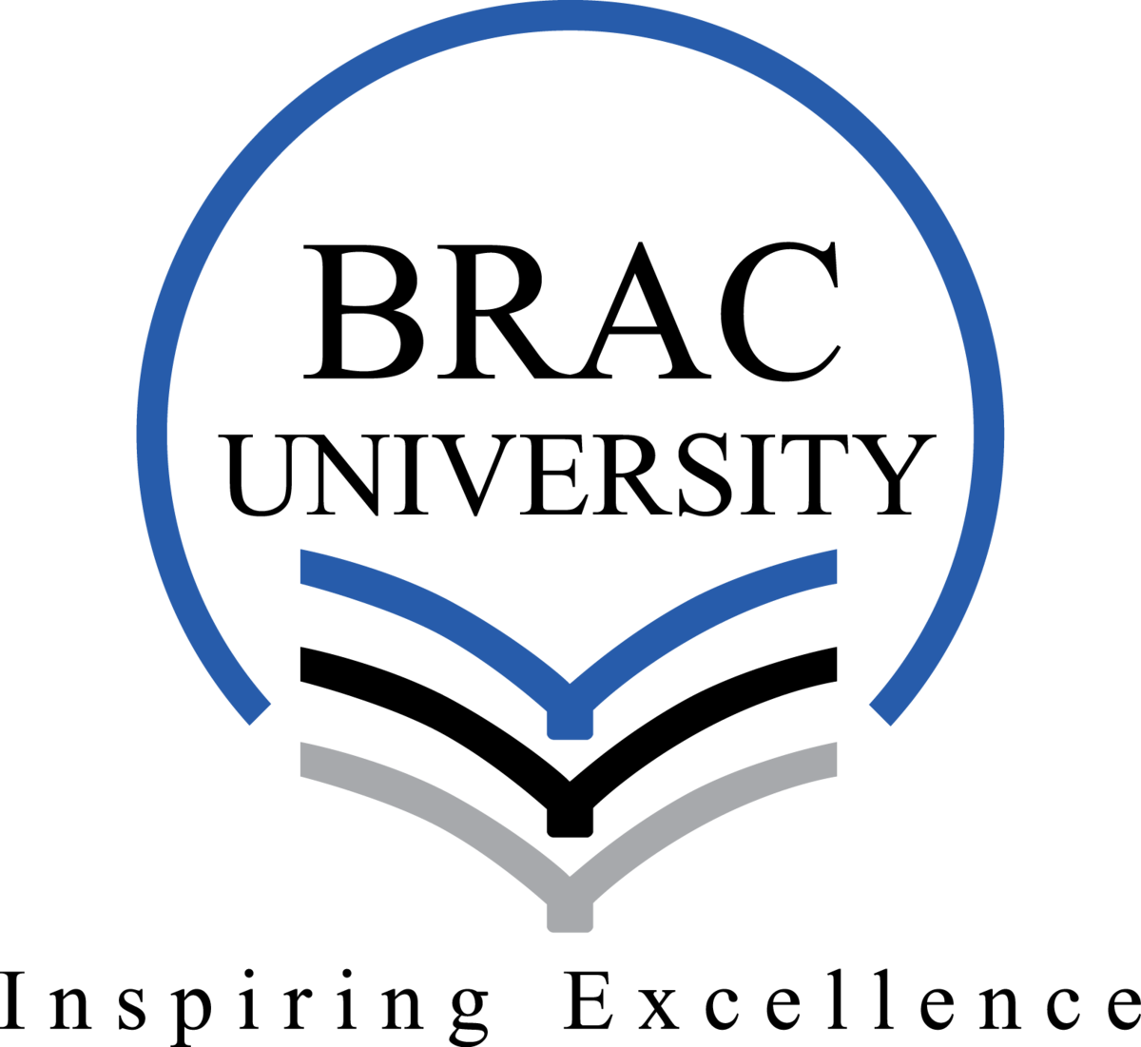

CSE471: System Analysis and Design
Assignment on Functional Requirements
Proposed Project Title: Nextern

Group No: 05, CSE471 Lab Section: 01,
Spring 2026
SL | ID | Name
1 | 22301206 | Samia Tabassum Chowdhury
2 | 22301242 | Md. Sabbir Akon
3 | 22301342 | Jauad Ahmed Sadik

Submission Date: 4th March, 2026

Project Overview
"Nextern" is a Next.js 15 full-stack web platform built exclusively for university students, campus recruiters, university advisors, and department heads. It connects students with relevant internships and part-time roles while giving employers a streamlined way to hire directly from campuses, and providing universities with an intelligent decision-support layer to guide career readiness at scale.
A common problem in today's job market is the disconnect between fresh graduates and recruiters. Recruiters struggle to find eligible candidates while graduates struggle to get hired due to lack of experience. The two sides often only meet at the interview stage, where recruiters express their actual demands and graduates realize they were unprepared. Many companies require 2 to 3 years of experience even for entry-level roles, automatically excluding fresh graduates before they get a chance.
Universities face an equally serious challenge: they cannot accurately advise students on preparation because they lack real-time data on skill gaps and internship requirements. Students apply randomly to internships and get rejected due to missing skills. Advisors have no systematic way to prioritize students for opportunities. Employers receive unqualified applicants, increasing screening workload.
Nextern solves all of these interconnected problems. Students get smart job matching, application tracking, AI-powered skill gap analysis, internship fit prediction, and direct alumni mentorship. Employers post campus drives, input internship requirement profiles for student matching, and manage their entire hiring pipeline. University Advisors receive AI-generated student readiness scores and personalized training pathway recommendations. Department Heads gain department-wide skill analytics and readiness visualizations for strategic career planning.
Graduating students receive a verified Graduation Evaluation Report, a data-backed achievement document reflecting their entire university career on the platform, shareable directly with recruiters as proof of readiness.

Tech Stack:
- Language: JavaScript / TypeScript
- Framework: Next.js 15 with App Router
- Styling: Tailwind CSS v3
- Database: MongoDB Atlas
- ORM: Mongoose
- Authentication: NextAuth.js v5
- PDF Generation: pdfkit
- Deployment: Vercel
- External APIs:
  - Google Gemini 1.5 Flash: Skill gap analysis, internship fit scoring, resume suggestions, career advice, training path generation
  - Groq API (LLaMA 3): Real-time mock interview simulation, low-latency inference for natural conversation flow
  - Google Calendar API: Deadline and interview schedule sync to student personal calendar
  - Pusher: Real-time messaging, live notifications, application status updates
  - Gmail API : For sending verification emails, OTP confirmation, and automated notifications.
  - Uploadthing: Resume PDFs, profile photos, portfolio work samples- Vercel-compatible cloud storage
  - Bkash API : For processing premium subscription, salary and freelance escrow payments.

User Roles

Student: The primary users. They register, create academic profiles, submit GPA, completed courses, skills, certifications, and projects for internship readiness scoring, search and apply for jobs and internships, track applications, receive AI-powered skill gap analysis and preparation pathways, connect with mentors, and access personalized job recommendations.

Employer: A verified business user. They manage their company profile, post jobs and campus drives, input structured internship requirement profiles (required skills, minimum GPA, course completion, experience expectations) for student fit scoring, run batch hiring campaigns across multiple universities, and manage their entire applicant pipeline from shortlisting to hiring.
- University Advisor: A university-verified staff member who accesses the Advisor view within the Profile Opportunity Score & Analytics System. Advisors view individual student readiness scores, skill gap breakdowns, and AI-generated training pathways. They endorse or customize training plans, recommend targeted courses or projects, prioritize students for internship slots, and export per-student Advisor Reports for institutional records.
- Department Head: A senior university administrator who monitors department-wide career readiness trends and skill gap analytics through the Department Analytics Panel. Sets readiness benchmarks for cohorts, receives automated alerts when averages fall below thresholds, and exports strategic readiness reports for curriculum review and accreditation documentation.

Admin: The system super-user. Verifies employer and student registrations, reviews university verification requests, approves University Advisor and Department Head accounts, monitors platform activity, and manages the scoring and leaderboard system.

Functional Requirements
SL | Common Workflows
1 | Registration and Login System: Users create an account by selecting their role — Student, Employer, University Advisor, or Department Head — and providing name, email, university or company name, and password. Students complete an academic profile form including university, department, and year of study. Employers complete a multi-step verification form with company name, industry, and business details. University Advisors and Department Heads register with institutional credentials and await admin approval. Once registered, all users log in securely via email/password or Google One-Tap sign-in powered by NextAuth.js v5 to access their role-specific dashboard.
2 | User Profile Management: Students build and update their academic profile including GPA, completed courses, skills, certifications, projects, and resume — all data feeds into the internship readiness scoring engine. Employers manage company profile, branding, job listings, and internship requirement profiles. University Advisors manage their advisory student groups and notes. Department Heads configure department benchmarks and reporting preferences. All roles update personal information, change passwords, and control notification preferences from their settings page.
3 | Admin Role & Access Management: An authorized administrator signs in to a dedicated panel to review pending employer registrations, verify company details, and approve or reject them. Only approved employers can post jobs. The admin also approves University Advisor and Department Head accounts, monitors student verification requests, manages platform activity, and oversees the leaderboard and scoring system.

Module 1
Member | Feature Description
1 | Job, Recruitment & Career Events System: Employers, universities, and verified professionals publish job listings, internship roles, full-scale campus recruitment drives, webinars, and workshops from a single unified dashboard. Each posting is precisely targeted by university, department, and academic year. Employers input structured Internship Requirement Profiles such as listing required skills, minimum GPA, minimum course completion, and experience expectations, which feed directly into the AI Skill Gap and Internship Fit Engine in Module 2. Batch Hiring Mode lets employers distribute one role across multiple universities simultaneously, tracking applicants through university-wise analytics in one centralized panel. Students see a personalized feed of all relevant postings based on their profile. They can apply to roles, register for events and track all participation without leaving the platform. Application deadlines and event dates are stored in the database for later calendar integration in Module 3.
2 | Smart Integration & Premium Access System: A unified external integration layer establishing all AI and payment capabilities that power the rest of the platform. Gemini 1.5 Flash API and Groq API (LLaMA 3) are integrated as reusable service wrappers. Gemini for career advice, skill analysis, and training path generation. Groq for low-latency mock interview simulation. NextAuth.js v5 is configured with Google OAuth and email/password credentials, providing role-based session management for all user types. bKash, Visa and Mastercard payment processing is implemented for premium subscription plans, students and employers can subscribe to premium tiers unlocking advanced AI features, priority job recommendations, unlimited mentorship requests and detailed analytics. All AI wrappers and payment utilities are committed as shared library functions available to other modules from Week 2 onward.
3 | Verified Trust & Achievement Badge System: A credibility and recognition system rewarding both students and employers for platform activity. Badge award logic is built against a shared event hook interface (lib/events.js) agreed on Day 1, so the badge triggers fire automatically when other features emit events.  Students earn: Top Applicant (consistent relevant applications), Skill Champion (multiple skill gaps closed), Verified Scholar (strong academic standing), Community Leader (writing reviews and helping peers), Mentor's Pick (positive mentor endorsements) and Rising Star (rapid Opportunity Score growth).  Employers earn: Trusted Recruiter (high student satisfaction), Campus Favorite (top internship reviews), Fast Responder (timely application status updates) and Active Hirer (consistent quality listings).  All badges are permanently displayed on profiles and factored into the AI recommendation engine. Stronger badge profiles rank higher in searches on both sides. All earned badges are compiled into the Graduation Evaluation Report(GER) under the Peer Recognition category.

Module 2
Member | Feature Description
1 | In-Platform Resume Builder and Graduation Evaluation Report (GER): The Resume Builder is a guided, student-friendly tool that generates a professional PDF resume from the student's profile data using pdfkit. Students complete structured sections such as Education, Projects, Skills, Certifications, and Experience. Three pre-designed templates are available with a live preview before download. Generated PDF files are stored via Uploadthing cloud storage and linked to the student's MongoDB record for future edits. Students with no work experience produce a clean, employer-ready resume in minutes. The Graduation Evaluation Report (GER) is a comprehensive auto-generated document, scored out of 100, produced once the student marks their graduation. It evaluates their entire university journey across 8 weighted professional categories: Academic Performance, Skill Growth (from the gap engine), Platform Engagement, Mentorship Activity, Freelance Work Experience, Peer Recognition (badges), Employer Endorsements and Opportunity Score Trajectory. The Opportunity Score category reads from the opportunityScore field in MongoDB. This field is populated by the scoring engine built in Module 3 and defaults to zero until then, allowing the GER to generate correctly in both weeks. The GER is stored via Uploadthing and shareable directly with recruiters and University Advisors.
2 | AI-Powered Job Recommendations, Skill Gap Analysis & Internship Fit Prediction Engine: An intelligent unified engine handling three tightly connected functions, built using the Gemini and Groq API wrappers from Module 1:  1. Smart Job Recommendations: Learns from student behavior such as views, saves, applications to surface increasingly relevant opportunities. On first use, recommendations are based on profile data (major, skills, GPA, location). As the student engages, the system adjusts weights and ranks similar roles higher. Every suggestion shows a 'Why Recommended' tag such as 'Matches your React skill' or 'Suits your academic year'.  2. Skill Gap Analysis: When a student views or applies for an internship, the engine compares their normalized academic profile against the employer's Internship Requirement Profile from Module 1. Gaps are classified as Hard Gaps (missing required skills or courses) or Soft Gaps (partially met expectations). For each gap, Gemini AI generates a Suggested Preparation Path recommending specific courses, projects, or certifications.  3. Internship Fit Score: A percentage-based readiness score computed for each student against each opportunity. Scores update dynamically as the student closes skill gaps or earns new certifications. Fit scores are stored in MongoDB and read by the University Advisor Dashboard in Module 3.
3 | In-Platform Messaging & Direct Communication System: A built-in real-time messaging system allowing students, employers, and mentors to communicate entirely within Nextern without sharing personal contact details. Built using Pusher for real-time delivery. Pusher's managed WebSocket service works correctly with Vercel serverless functions. Employers initiate conversations with shortlisted or hired candidates to share interview details, follow-up questions, or onboarding information from their hiring dashboard. Students reach out to employers to express interest, ask questions or follow up on applications directly from the job listing or application tracker. All conversations are organized in a clean inbox with separate threads per contact. The system supports automated message templates for employers, interview invitations, rejection notices, offer letters sent in one click and personalized before sending. Mentors and mentees from the Alumni Mentorship Network use this same inbox, keeping all career conversations in one unified place. All messages are stored in MongoDB and monitored at the platform level to ensure professional conduct.

Module 3
Member | Feature Description
1 | Smart Notifications & Deadline Calendar: An automated notification and calendar system keeping students fully informed throughout their job search journey. Built using Pusher (configured in Module 2) for real-time in-app bell notifications, and Gmail API for optional email reminders. Students receive instant alerts for upcoming application deadlines, new job matches, employer application status updates, platform events, and advisor training plan recommendations. Three days before any saved job's deadline, an automated reminder fires. When an employer updates an application status, the student is notified in real time. Google Calendar API integration syncs all saved job deadlines, interview schedules and recruitment events to the student's personal Google Calendar, giving them a single timeline of their entire career schedule. Students control notification preferences from their settings panel.
1 | [Faculty Feedback] Profile Opportunity Score, University Leaderboard, Advisor Dashboard & Department Analytics Panel: A combined gamification and university decision-support system serving three audiences from one feature: from Student Side, Opportunity Score & Leaderboard: Students earn points for completing profile sections, getting university verified, adding skills, uploading a resume, applying to jobs, closing skill gaps, attending webinars, writing company reviews, and receiving positive employer feedback. A cumulative Opportunity Score out of 100 displays on their profile and updates in real time via Upstash Redis caching. This score wires into the GER's Opportunity Score Trajectory category (resolving the Module 2 placeholder). A university leaderboard ranks top-scoring students within their institution. University Advisor Dashboard: Advisors see a ranked list of students in their advisory group sorted by Internship Readiness Score (from Module 2). Drilling into a student reveals their full skill gap breakdown, AI-generated Suggested Preparation Path, academic history, and Opportunity Score trend chart. Advisors endorse or modify the AI training plan, add personalized course or workshop recommendations, flag students for priority internship slots, and export a per-student Advisor Report as a PDF via Uploadthing. Department Head Analytics Panel: Department Heads access a strategic analytics dashboard showing a Readiness Distribution Chart (percentage of students ready, partially ready, or not ready by semester), a Skill Heatmap showing the most commonly missing skills across the department, an Industry Demand Alignment Chart comparing student skills against what Nextern recruiters require and a semester-over-semester trend line. Department Heads set readiness benchmarks per cohort and receive automated alerts when averages fall below thresholds. Strategic Career Readiness Reports are auto-generated as exportable PDFs.
2 | Student Freelance & Verified Work Portfolio Board: A dedicated freelance marketplace where students offer professional services such as web development, graphic design, content writing, data analysis to employers and other students, earning real income while studying. Students create a freelance profile listing services, rate, delivery time and sample work. Portfolio files and work samples are uploaded via Uploadthing cloud storage. Employers and students browse the board, filter by skill or budget and place orders directly through the platform. Payments are processed via bKash, Visa, and Mastercard (using the payment infrastructure from Module 1), with Nextern holding payment in escrow and releasing it only after the client confirms satisfactory delivery. Both sides leave verified reviews after completion, building a tamper-proof work history. Every completed project is automatically added to the student's Portfolio Builder as a verified work sample, strengthening their resume and Opportunity Score simultaneously. Students who consistently deliver quality work earn the Verified Freelancer badge. All freelance activity is reflected in the Graduation Evaluation Report under the Work Experience category.
2 | Integrated Online Assessment & Interview Suite: A fully built-in recruitment evaluation system allowing employers to assess and interview candidates entirely within Nextern. Employers create custom assessments such as multiple choice questions, short answer tests, coding challenges with live execution via Judge0 CE API and case study submissions assigned directly to shortlisted candidates from the hiring dashboard. Timed assessments support auto-submission, plagiarism detection on text answers, and automated scoring for objective tests. For live evaluation, employers initiate one-on-one or panel video interviews using the Agora.io SDK, with screen sharing, live note taking and candidate recording with prior consent. Each candidate's assessment results, interview notes and scores are stored in MongoDB against their applicant profile, visible only to the hiring team for side-by-side comparison. Students receive Pusher notifications when an assessment or interview is scheduled, join directly from their application tracker and receive automated reminders before each session.
3 | Verified Review & Reputation Intelligence System: A two-way verified review system where students and employers rate each other based on real hiring experiences. Only students genuinely marked as Hired can leave a company review covering overall rating, work environment, learning opportunity and written comment ensuring authenticity. Employers rate hired students on professionalism, punctuality, skill performance and overall work quality, building a verified work reputation that goes beyond a traditional resume. Employers write formal written recommendations for outstanding hires, permanently displayed on the student's profile as a verified endorsement. All reviews and recommendations are publicly displayed on both company and student profiles, creating a two-way accountability system where both sides are motivated to perform their best. Students with strong review histories and written recommendations earn the Verified Work Record badge, factored into the AI recommendation engine. All review and recommendation data is compiled into the Graduation Evaluation Report and accessible to University Advisors through the analytics panel for evidence-based career planning.
3 | Alumni Mentorship & Professional Guidance Network: A structured mentorship system connecting current students with alumni and working professionals volunteering for real-world career guidance. Mentors create a profile listing expertise, industry, current role, years of experience and monthly availability. Students browse and filter mentors by domain or skill area and send personalized mentorship requests. Once accepted, a dedicated chat thread opens through the In-Platform Messaging System (built in Module 2 available as completed infrastructure). Mentors set monthly session limits, while students connect with multiple mentors across different domains simultaneously. One-on-one video sessions are scheduled directly through Agora.io for resume reviews, career conversations and mock interview practice. Mentors earn recognition badges based on student feedback and session activity. Students gain Opportunity Score points for every completed session, with all mentorship activity reflected in their Graduation Evaluation Report.

