Bit Pathways User Guide v.2.x



**Bit Pathways  
User Guide**

For Bit Pathways version 2.x

May 2012



This work is licensed under a Creative Commons

Attribution-Noncommercial-Share Alike 3.0 license

**Contents**

1 Introduction 3

1.1 Overview 3

1.2 Basic features 3

2 Installation 4

3 Creating a Pathway 5

3.1 Running Bit Pathways 5

3.1.1 Running Bit Pathways on-line 5

3.1.2 Running Bit Pathways off-line 5

3.2 Initiating a new pathway 5

3.2.1 Template property 6

3.2.2 Teacher, Group & Topic properties 6

3.2.3 Title property 7

3.2.4 Authors property 7

3.3 Designing the pathway 7

3.3.1 The toolbar 8

3.3.2 The canvas 9

3.4 The property panel 10

4 Saving pathways 13

4.1 Saving pathways on-line 13

4.2 Duplicating pathways 14

4.3 Saving pathways off-line 14

4.3.1 PNG image 14

4.3.2 HTML page - Hyperflowchart 14

4.3.3 MVP Package 15

4.3.4 GLIF format 15

5 Pathway repositories 16

5.1.1 Bit Pathways Teacher 16

5.1.2 Installing your own pathway repository 17

6 Templates 17

6.1 Designing your own template 17

6.2 Template repository 17

7 To do list 17

8 License 18

# Introduction

## Overview

Bit Pathways is a template-based flowchart editor which can be applied for visualisation and structurisation of knowledge in different disciplines.

The editor has been developed by Andrzej Kononowicz to serve as a clinical pathways editor. Currently the tool is also used for other purposes including learning using graphic organisers, design of virtual patients, building cognitive maps, visualisation of workflows. Being developed in Java Swing technology the Bit Pathways tool can be used on various operating systems and does not require complicated installation.

Bit Pathways represents flowcharts at three levels: Context, Template, Pathway Data. The level of context defines the types of nodes and edges available in the flowchart. At the level of templates attribute groups composed of single attributes or attribute lists can be defined and attached to nodes and edges of the flowchart graph. Various templates may be prepared and stored on-line in a repository. At the pathway data level individual flowcharts graphs are created. Pathways can reference to subordinated pathways (subpathways).

Flowcharts created by Bit Pathways may be stored as separate files locally or (by default) remotely in a native XML database. The pathways may be exported as PNG images, interactive HTML pages (hyper-flowcharts), MedBiquitous Virtual Patient (MVP) packages and GLIF guidelines (in RDF-format).

In addition to the editor, a system for viewing Bit Pathways flowcharts on-line was developed called Bit Pathways Teacher.

## Basic features

* graphical drag’n’drop design of flowcharts
* flowchart elements described in exchangeable attribute sets (templates)
* sub-pathways
* editors for different attribute types
* export in several formats: PNG, HTML (hyper-flowchart), MedBiquitous Virtual Patient, GLIF (prototype)
* user login, roles and groups
* data storage locally or remotely on XML servers

# Installation

* Bit Pathways requires that Java Run-Time environment in version 1.5 or higher is installed. The **java** command should be accessible from the folder where Bit Pathways is installed
  + For Windows:
    - Go to **Start -> Run -> Cmd** to open the console
    - In the console type **java -version**
    - If you obtain as the result the java version number 1.5 or higher than everything is set up properly and you may start using Bit Pathways
    - If not:
      * Make sure Java is installed on your machine, if not or you are not sure about it download the newest JRE or JDK from <http://www.oracle.com/technetwork/java/javase/downloads/index.html>
      * If the java command is still not working add the path to your Java installation to the PATH system variable:
        + My computer->Properties->Advanced->Environment variables->System variables
        + Select the variable Path and click on Edit
        + Add at the end of the line ; and the path to the bin folder in your Java installation – e.g. C:\Java\jdk1.7.0_01\bin
      * It is recommended to add also a new variable JAVA_HOME with the path to your Java installation – e.g. C:\Java\jdk1.7.0_01
* In order to install Bit Pathways extract the content of the **bpath_bin.zip** package into any folder on your hard drive

# Creating a Pathway

## Running Bit Pathways

To start Bit Pathways execute one of the attached batch files located directly in the installation folder e.g. :

* bp.bat - for English language version
* bp_pl.bat – for Polish language version

### Running Bit Pathways on-line

First step after executing Bit Pathways is the choice of the pathway server and input of the proper username/password. Click OK to start the session.

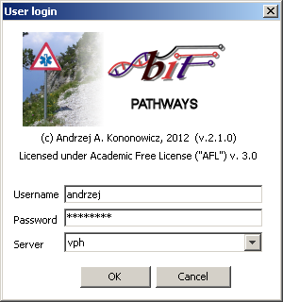

### Running Bit Pathways off-line

An offline version of the software is not available at the current moment due to the necessity of downloading pathway templates from an on-line repository. The feature of buffering of templates to work off-line needs to be implemented.

## Initiating a new pathway

To create a new pathway go to the **Path** menu and select **New path**

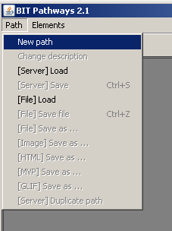

A new pathway window will be opened where you can select, depending on the user account settings, different metadata describing the pathway. Upon selection of the “OK” the pathway is created and the user may start designing the pathway.

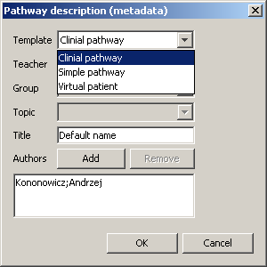

### Template property

A template is a set of attributes (grouped in attribute groups) which are attached to different types of flowchart elements. The number of possible templates is unlimited. Examples of templates already available are Simple pathway, Clinical pathway, Virtual patient. User account administrators decide which templates are available to individual users or user groups.

### Teacher, Group & Topic properties

Bit Pathways is also used as an educational tool. In such case users can be put into students’ groups with predefined topics of pathways, subgroup ids, and instructor names. E.g. the 4-year programme of medicine in year 2012 may have two teachers assigned (“Andrzej”, “Michal”), four groups (“A”,”B”,”C”,”D”), and three topics (“Acute stroke”, “Minor head injuries”, “Lyme disease”). Individual students select their instructor, group and teacher. For all other users these fields are disabled.

### Title property

Title of the pathway as displayed in the window’s title and in the pathway repository.

### Authors property

A list of co-authors of the pathway. Each author is characterised by first and family name. By default the name of the user logged into the system is added automatically to the authors’ list. New users can be added or existing user removed by the “Add” and “Remove” buttons.

You may change the metadata of the pathway at a later stage by selecting **Path** menu, then the **Change Description** item.

## Designing the pathway

After a new pathway has been created the user interface displays three main parts:

* Upper-left corner: **toolbar** with shapes that can be placed in the flowchart
* Centre of the screen: **canvas** – i.e. area for drawings the . The user designs using the drag’n’drop method the topology of the pathway.
* Right side of the picture: **property** **panel** with attributes (properties) describing the selected element (e.g. activity node, branch element or edge). The list of attributes (attribute groups) has been defined in the template selected while creating the pathway.

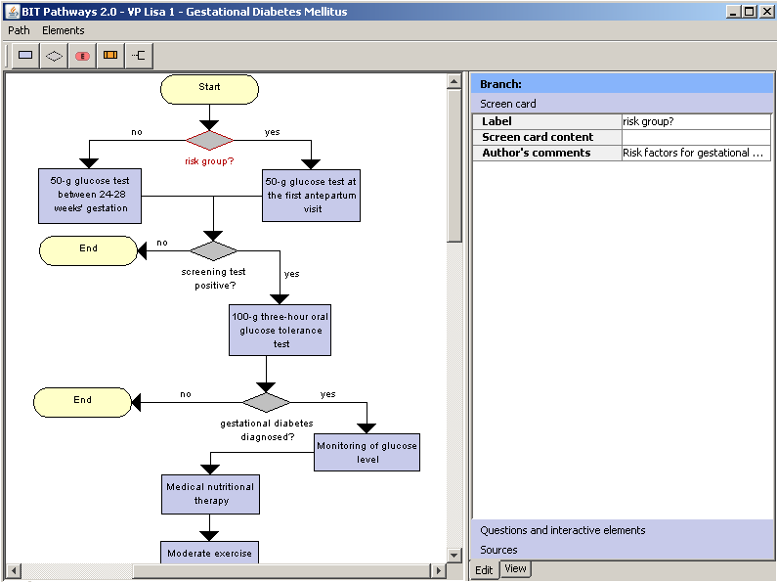

### The toolbar

The toolbar is composed of icons presenting elements (vertices) of the flowchart graph. To add a new element to the canvas make a left-click on one of the icons in the toolbar and click then again on the canvas in the place where would you like to place the element.

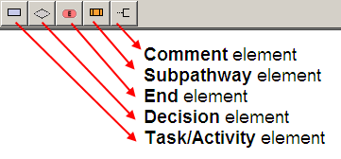

The pathways have always one **start element** that is always present in the pathway, cannot be removed. It is also not permitted to have two start elements in one pathway. Elements may be connected by **edges** with a separate set of attributes defined in the template. The start element cannot have any incoming edges.

Note for advanced users: The list of available shapes is defined in the application’s **context** and can be extended by implementing proper interfaces. This feature is still in development phase and needs to be better documented.

#### Task/Activity element

A rectangular shape usually denotes a task or activity to be carried out. Upon creation of the element the user is asked to provide a name for the element. This name can be changed later on using the property panel. The name of the task element is displayed within the shape.

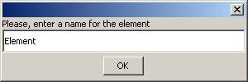

#### Decision element

Decision elements are presented as diamond shapes of fixed size (in contrast to other element cannot be enlarged). Its caption can be set by the label property and is displayed below the shape. A Decision element should have at least one incoming and two outgoing edges. The number of outgoing edges is not limited.

#### End element

A pathway may have several end elements depicted as rounded rectangles. The caption of end elements cannot be changed. The end element cannot have any outgoing edges.

#### Subpathway element

Pathways can be linked to other (sub-pathways) by the rectangular shape with three compartments. Upon creating a pathway the user can selected between:

* Attaching a new pathway – this feature is not working yet
* Attaching an existing path to the current path

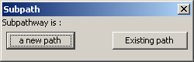

When attaching an existing path the user has to select a pathway from the repository to which (s)he has access right:

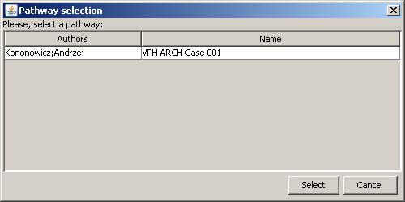

The default label of the subpathway is the title of the attached pathway but it can be changed to a different name.

#### Comment element

The recommended way of describing pathway elements is by their properties. Nevertheless there are sometimes situation in which the user prefers to add on-screen comments of an arbitrary place or element in the pathway.



This element cannot be attached to the other pathway elements using edges.

### The canvas

#### Moving elements

The canvas is fixed on the top and left hand side but can be enlarged by moving the elements to the right or bottom side. Elements placed on the canvas can be moved to different locations upon a left click on their shapes (the shape gets a red surrounding and the resize and edge handles become visible) and dragging it with the left mouse button pressed to a new location. Do not pull edge or resize handle if you would like to move the shape to a new location.

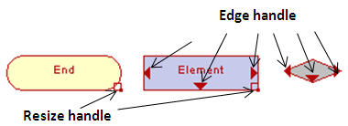

You may move the whole flowchart to a new position by having the Ctrl button pressed, end relocating the graph with the arrow keys.

It is also possible to select a subset of elements (keep the shift button pressed and select elements with the mouse pointer) and then moving them to a new place by pulling the selection (keep the shift button pressed).

#### Connecting elements

An edge can only be placed between two existing elements. Drag the edge handle from the source element and drop it **over** the shape of the target node and **not before** the element as on the right hand side in the figure below.

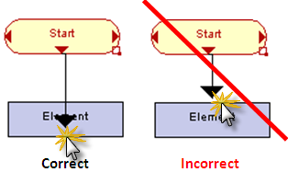

The route of edge is automatically calculated using an internal algorithm. Note: alternative algorithms are in preparation.

#### Changing the size of the elements

To resize an element drag the resize handle after the element was selected. You cannot resize decision elements.

#### Removing elements

Select the element (or edge) to be removed with the right mouse. Select delete from the context menu. You cannot delete the start node. The edge is removed if either the source of target node is deleted.

## The property panel

The attribute panel may be switched either to the **edit mode** (to modify the attribute values) or **view mode** (to see whole description of elements including HTML formatting). To toggle between the views use the tabs below the property panel.

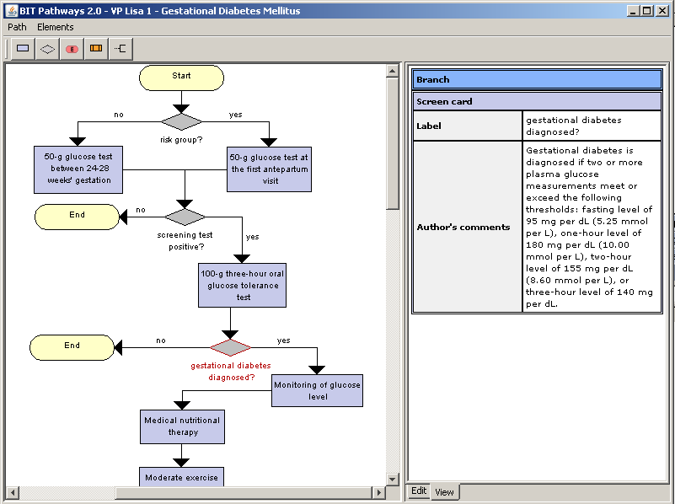

The **first row** in the property panel describes the class of the currently selected pathway component (like Task, Start, Edge, Decision).

There is one special type of element called “**Pathway**” (with only one instance) which is activated upon a left mouse click on the canvas in a place without any other element. This element contains attributes describing the pathway as a whole. The attributes of this element are defined (as for the other element types) in the template.

The property panel contains attributes divided in **attribute groups**. You may switch between them clicking on their names.

  
Three attribute groups

On top of the property panel (just below the class of the currently selected element) is the name of the currently selected attribute group.

The attribute group panel is divided into two columns :

* the left one with **names** of attributes
* the right one with **values** of attributes

If a value is on grey background it is in **read only mode**. Otherwise a double click activates the editor of the attribute.

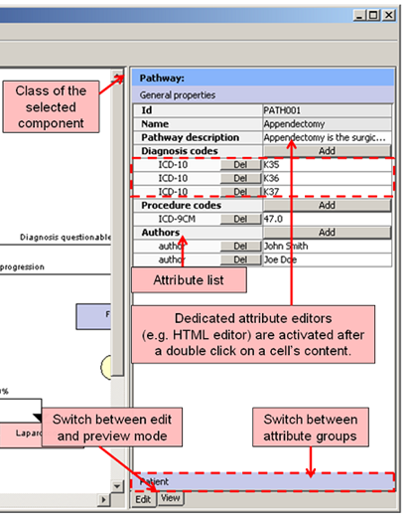

**Attribute editors** are depended of the type of the attribute set in the template. Editors are activated upon a left mouse click on the value box. Some of the editors are displayed “in-line” (like for instance the type “string”). To accept the change of attribute’s value hit on the **Enter** key. Other editors (more advanced) are opened in a separate window. Examples of more advanced editors include editor for MCQ questions, HTML editor, duration editor, citation editor, etc.

Some attributes may be declared **as attribute lists**. If so, the first row of the attribute list value contains the “add” button for adding new items to the list (displayed in the rows below). On the left of the attribute list items is a “Del” button to remove the values from the list.

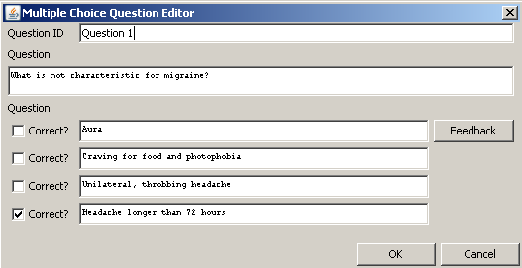

# Saving pathways

## Saving pathways on-line

It is recommended to save pathways on-line. They are stored on the server on which the user logged into. To store a pathways select the Path menu, next **[Server] Save**. T

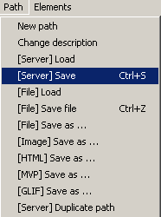

o load a pathway from the server select the Path menu and **[Server] Load**. A plain user has access only the pathways he has created (or those with explicit access permission – this feature needs to be implemented). A superuser (admin) may open all pathways stored on the server.



## Duplicating pathways

A pathway that has been opened may be duplicated on the server. To do so select **[Server] Duplicate path** in the Path menu. When selecting this option the original pathway is stored on the server and closed, and a new pathway is created with exactly the same content as the original one.

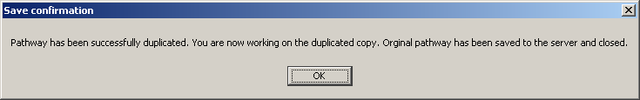

It is recommended to change the name of the new pathway by selecting **Path** -> **Change description**.

## Saving pathways off-line

The pathways can be stored and loaded off-line as XML files with the **[File] Save**, **[File] Save As** and **[File] Load** options in the Pathway menu.

It is also possible to export pathways from the Bit Pathways editor to the following formats:

### PNG image

The flowchart may be stored as a static graphic file in the PNG format. No attributes values will be exported in that form. To export the file as PNG image select **[Image] Save As …** in the **Path** menu.

### HTML page - Hyperflowchart

The pathway stored as a hyperflowchart is a document in HTML format with element descriptions displayed in pop-up windows activated upon clicking on the elements.

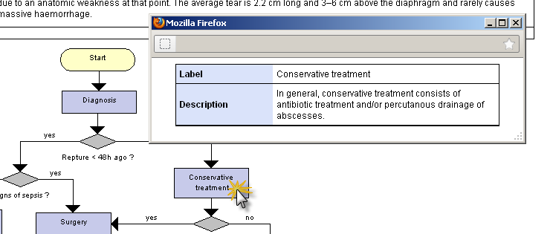

To store the pathway as a HTML page select **[HTML] Save As …** in the Path menu. Then select the folder to which the page will be exported.

The exported pathway consists of:

* HTML page containing all element descriptions. Open this file to view the hyperflowchart
* PNG file with the pathway image
* pics folder with additional images belonging to the pathway (and the Bit Pathways logo)
* css – style sheet defining the graphical layout of the exported pathway

### MVP Package

This option is active for pathways with selected **virtual patient** template. The MedBiquitous Virtual Patient standard (MVP) [<http://www.medbiq.org/working_groups/virtual_patient/index.html>] is a format for exchanging virtual patients data. Bit Pathways supports export of pathways both as linear and branched virtual patient packages

To export the pathway as a branched MVP package do not select any element in the canvas and click on Path menu, next on **[MVP] Save as …**

Saving a linear VP requires selection of a linear path in the editor before selecting the **[MVP] Save as …** option.Select the elements starting from the root and keeping the shift button pressed, select successive nodes.

The MVP package will be exported to a folder selected by the user after clicking the **[MVP] Save as …** menu item.

### GLIF format

This option is active for pathways with selected **clinical pathways** template. The Guideline Interchange Format (GLIF) [http://mis.hevra.haifa.ac.il/~morpeleg/Intermed] is a specification for exchanging computer-interpretable clinical guidelines.

To export the pathway as a GLIF package select **[GLIF] Save as …** and a folder where the package should be stored.

# Pathway repositories

### Bit Pathways Teacher

The Bit Pathways Teacher is a web application for viewing and managing pathways stored on Bit Pathways and requires a separate documentation. This section presents just a short overview of its function.

A test installation of the Bit Pathways Teacher is available under the following web address:

<http://puls.cm-uj.krakow.pl:8080/bpathfaces>

Log into the system using your Bit Pathways account (remember to select the correct server to be connected with). The system is working for user with “teacher” role

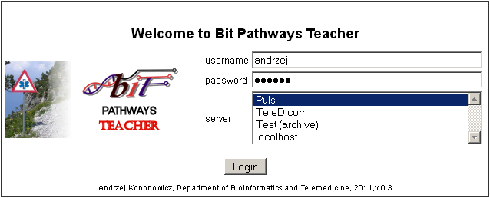

The system enables you to filter pathways

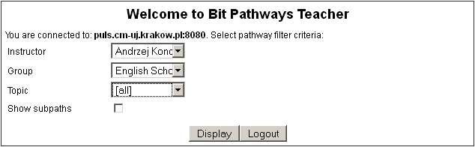

To display the list of selected pathways click on the “Display” button in the filter window.

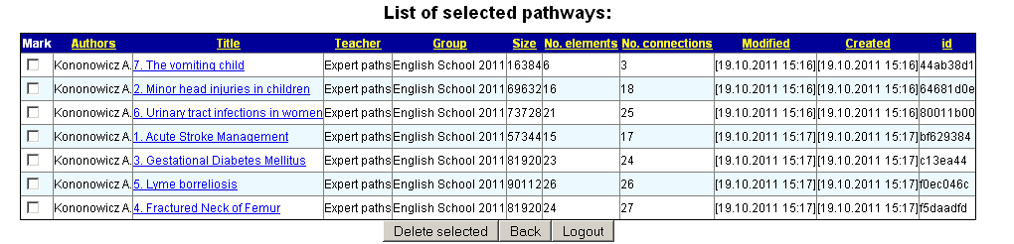

Selected pathways may be deleted after marking them in the first column and pressing on the “Delete selected” button.

After clicking on the title of the path the hyperflowchart view of the pathway will be displayed.

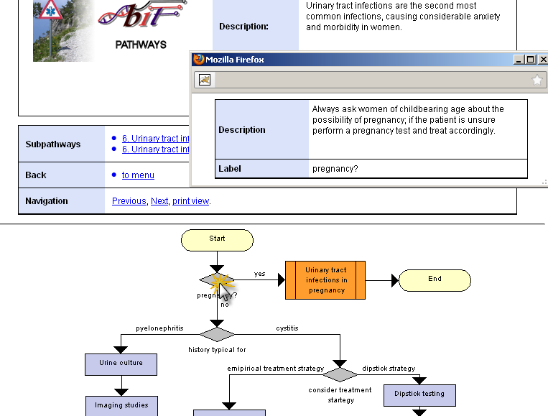

### Installing your own pathway repository

To be documented

# Templates

## Designing your own template

To be documented

## Template repository

To be documented

# To do list

* Alternative algorithms for tracing out edges connecting elements (e.g. simple straight edges connecting the elements, arcs, Bezier curves)
* Adding images to pathways
* Undo button
* Zoom in/out function
* Tool for editing templates

# License

**Academic Free License ("AFL") v. 3.0**

This Academic Free License (the "License") applies to any original work of authorship (the "Original Work")whose owner (the "Licensor") has placed the following licensing notice adjacent to the copyright notice for the

Original Work:

Licensed under the Academic Free License version 3.0

Grant of Copyright License.

Licensor grants You a worldwide, royalty-free, non-exclusive, sublicensable license, for the duration of the copyright, to do the following:

* to reproduce the Original Work in copies, either alone or as part of a collective work;
* to translate, adapt, alter, transform, modify, or arrange the Original Work, thereby creating derivative works ("Derivative Works") based upon the Original Work;
* to distribute or communicate copies of the Original Work and Derivative Works to the public, under any license of your choice that does not contradict the terms and conditions, including Licensor’s reserved rights and remedies, in this Academic Free License;
* to perform the Original Work publicly; and
* to display the Original Work publicly.

Grant of Patent License.

Licensor grants You a worldwide, royalty-free, non-exclusive, sublicensable license, under patent claims owned or controlled by the Licensor that are embodied in the Original Work as furnished by the Licensor, for the duration of the patents, to make, use, sell, offer for sale, have made, and import the Original Work and Derivative Works.

Grant of Source Code License.

The term "Source Code" means the preferred form of the Original Work for making modifications to it and all available documentation describing how to modify the Original Work. Licensor agrees to provide a machine-readable copy of the Source Code of the Original Work along with each copy of the Original Work that Licensor distributes. Licensor reserves the right to satisfy this obligation by placing a machine-readable copy of the

Source Code in an information repository reasonably calculated to permit inexpensive and convenient access by You for as long as Licensor continues to distribute the Original Work.

Exclusions From License Grant.

Neither the names of Licensor, nor the names of any contributors to the Original Work, nor any of their trademarks or service marks, may be used to endorse or promote products derived from this Original Work without express prior permission of the Licensor. Except as expressly stated herein, nothing in this License grants any license to Licensor’s trademarks, copyrights, patents, trade secrets or any other intellectual property.

No patent license is granted to make, use, sell, offer for sale, have made, or import embodiments of any patent claims other than the licensed claims defined in Section 2. No license is granted to the trademarks of Licensor even if such marks are included in the Original Work. Nothing in this License shall be interpreted to prohibit Licensor from licensing under terms different from this License any Original Work that Licensor otherwise would have a right to license.

External Deployment.

The term "External Deployment" means the use, distribution, or communication of the Original Work or Derivative Works in any way such that the Original Work or Derivative Works may be used by anyone other than You, whether those works are distributed or communicated to those persons or made available as an application intended for use over a network. As an express condition for the grants of license hereunder, You must treat any External Deployment by You of the Original Work or a Derivative Work as a distribution under section 1(c).

Attribution Rights.

You must retain, in the Source Code of any Derivative Works that You create, all copyright, patent, or trademark notices from the Source Code of the Original Work, as well as any notices of licensing and any descriptive text identified therein as an "Attribution Notice." You must cause the Source Code for any Derivative Works that You create to carry a prominent Attribution Notice reasonably calculated to inform recipients that You have modified the Original Work.

Warranty of Provenance and Disclaimer of Warranty.

Licensor warrants that the copyright in and to the Original Work and the patent rights granted herein by Licensor are owned by the Licensor or are sublicensed to You under the terms of this License with the permission of the contributor(s) of those copyrights and patent rights. Except as expressly stated in the immediately preceding sentence, the Original Work is provided under this License on an "AS IS" BASIS and WITHOUT WARRANTY, either express or implied, including, without limitation, the warranties of non-infringement, merchantability or fitness for a particular purpose. THE ENTIRE RISK AS TO THE QUALITY OF THE ORIGINAL WORK IS WITH YOU. This DISCLAIMER OF WARRANTY constitutes an essential part of this License. No license to the Original Work is granted by this License except under this disclaimer.

Limitation of Liability.

Under no circumstances and under no legal theory, whether in tort (including negligence), contract, or otherwise, shall the Licensor be liable to anyone for any indirect, special, incidental, or consequential damages of any character arising as a result of this License or the use of the Original Work including, without limitation, damages for loss of goodwill, work stoppage, computer failure or malfunction, or any and all other commercial damages or losses. This limitation of liability shall not apply to the extent applicable law prohibits such limitation.

Acceptance and Termination.

If, at any time, You expressly assented to this License, that assent indicates your clear and irrevocable acceptance of this License and all of its terms and conditions. If You distribute or communicate copies of the Original Work or a Derivative Work, You must make a reasonable effort under the circumstances to obtain the express assent of recipients to the terms of this License. This License conditions your rights to undertake the activities listed in Section 1, including your right to create Derivative Works based upon the Original Work, and doing so without honoring these terms and conditions is prohibited by copyright law and international treaty. Nothing in this License is intended to affect copyright exceptions and limitations (including “fair use” or “fair dealing”). This License shall terminate immediately and You may no longer exercise any of the rights granted to You by this License upon your failure to honor the conditions in Section 1(c).

Termination for Patent Action.

This License shall terminate automatically and You may no longer exercise any of the rights granted to You by this License as of the date You commence an action, including a cross-claim or counterclaim, against Licensor or any licensee alleging that the Original Work infringes a patent. This termination provision shall not apply for an action alleging patent infringement by combinations of the Original Work with other software or hardware.

Jurisdiction, Venue and Governing Law

Any action or suit relating to this License may be brought only in the courts of a jurisdiction wherein the Licensor resides or in which Licensor conducts its primary business, and under the laws of that jurisdiction excluding its conflict-of-law provisions. The application of the United Nations Convention on Contracts for the International Sale of Goods is expressly excluded. Any use of the Original Work outside the scope of this License or after its termination shall be subject to the requirements and penalties of copyright or patent law in the appropriate jurisdiction. This section shall survive the termination of this License.

Attorneys’ Fees.

In any action to enforce the terms of this License or seeking damages relating thereto, the prevailing party shall be entitled to recover its costs and expenses, including, without limitation, reasonable attorneys' fees and costs incurred in connection with such action, including any appeal of such action. This section shall survive the termination of this License.

Miscellaneous.

If any provision of this License is held to be unenforceable, such provision shall be reformed only to the extent necessary to make it enforceable.

Definition of "You" in This License.

"You" throughout this License, whether in upper or lower case, means an individual or a legal entity exercising rights under, and complying with all of the terms of, this License. For legal entities, "You" includes any entity that

controls, is controlled by, or is under common control with you. For purposes of this definition, "control" means (i) the power, direct or indirect, to cause the direction or management of such entity, whether by contract or otherwise, or (ii) ownership of fifty percent (50%) or more of the outstanding shares, or (iii) beneficial ownership of such entity.

Right to Use. You may use the Original Work in all ways not otherwise restricted or conditioned by this License or by law, and Licensor promises not to interfere with or be responsible for such uses by You.

Modification of This License.

This License is Copyright © 2005 Lawrence Rosen. Permission is granted to copy, distribute, or communicate this License without modification. Nothing in this License permits You to modify this License as applied to the Original Work or to Derivative Works. However, You may modify the text of this License and copy, distribute or communicate your modified version (the "Modified License") and apply it to other original works of authorship subject to the following conditions:

(i) You may not indicate in any way that your Modified License is the "Academic Free License" or "AFL" and you may not use those names in the name of your Modified License;

(ii) You must replace the notice specified in the first paragraph above with the notice "Licensed under <insert your license name here>" or with a notice of your own that is not confusingly similar to the notice in this License; and

(iii) You may not claim that your original works are open source software unless your Modified License has been approved by Open Source Initiative (OSI) and You comply with its license review and certification process.