|  |  |
| --- | --- |
|  | FPT ACADEMY INTERNATIONAL  FPT – APTECH COMPUTER EDUCATION |

Centre Name: ACE-HCMC-2-FPT.

Address: 590 Cach Mang Thang 8, District 3, Ho Chi Minh City, Viet Nam.

**[Garden]**

|  |  |  |
| --- | --- | --- |
| Supervisor: | Phạm Thị Lánh | |
| Term: | |  |  | | --- | --- | | T1.2202.M0 |  | | |
| Batch No: | 1 | |
| Group No: | 5 | |
| Order: | Full name | Roll No. |
| 1. | Lê Trịnh Hưng Thịnh | Student1368172 |
| 2. | Vũ Thanh Nam | Student1368165 |
| 3.  4. | Trần Tấn Phong  Vy Thị Ánh Linh | Student1368171  Student1359457 |

# Content

Contents

Content 2

Acknowledge 3

Synopsis 4

REVIEW 1 5

Problem Definition 6

Requirement Specification: 6

Customer Requirements Specifications 8

Architecture and Design of the project 9

Screen shots 11

1.Homepage 11

2.Sign in 13

3.Sign up 14

4.Tips 15

5.Tools 16

6.Decor 18

7. Check Out 20

8. Contact 21

Task Sheet 22

# Acknowledge

As we understand that the eProject is a step-by-step learning environment that closely simulates the classroom and Lab based learning environment into actual implementation. It is a project implementation at your fingertips!! An electronic, live juncture on the machine that allows you to.

✓ Practice step by step i.e., laddered approach.

✓ Build a larger, more robust application.

✓ Usage of certain utilities in applications designed by the user.

✓ Single program to unified code leading to a complete application.

✓ Learn implementation of concepts in a phased manner.

✓ Enhance skills and add value.

✓ Work on real life projects.

✓ Give a real-life scenario and help to create applications more complicated and useful.

✓ Mentoring through email support.

We would like to send a great thank to our professor and others student for the adorable support during the time in the project.

Beside several mistakes we had made in the project, we hope to have more opportunities to widen our knowledge in the web developing world.

We also thank you so much for your information and the “demo” project from India APTECH to help us get more reality experience in this project. Since we have gained more experience from this project, we will not stop learning anything as much as we can to be more successful in the future.

Your Sincerely,Team Group 05.

# Synopsis

- The Objective of this program we aim is to give a sample project to work on real life projects. These applications help us build a larger, more robust application.

- The objective is not to teach us HTML/JavaScript but to provide us with a real life scenario and help us create basic applications using the tools.

- Hence, we can revise the chapters before we start with the project.

- This project The Objective of this program is to give a sample project to work on real life projects. These applications help you build a larger, more robust application.

- The objective is not to teach you the software but to provide you with a real-life scenario and help you create basic applications using the tools.

- You can revise the topics before you start with the project.

- This project is meant for students who have completed the module of HTML5.

- These programs should be done in the Lab sessions with assistance of the faculty if required.

- The website (in this project) is a tool that help the company to access the

international market and gain more and more new customers.

- It is very essential that a student has a clear understanding of the subject.

# REVIEW 1

## Problem Definition

Gardening is the growing of plants such as flowers, shrubs and trees as a hobby or recreation. Some people also grow vegetables or fruit in their gardens. People do gardening outdoors in the soil in their backyard, or in pots or containers on their balcony. Gardens, even those that are man-made, have plants and trees that can reduce the level of harmful carbon in the air, whilst at the same time releasing back oxygen into the atmosphere which we need to survive.

Gardening requires you to do so many activities like pruning, digging, watering the plants, bending, etc. So that makes it a pretty good workout regime as well. Research shows that 3 hours of moderate gardening is equivalent to 1 hour in the gym!

Many people feel interested in gardening but hesitate to start due to lack of knowledge and exact information about plants, how to take care etc etc. Hence you are required to develop a website which will include all basics of gardening with following requirements specification. Kindly note that develop the site which will cater to smaller area gardening like balcony, terrace , home gardens etc and not commercial and bigger ones

## Requirement Specification:

The Web site is to be created based on the following requirements.

1. Home page with suitable logo and related banners/information.
2. There should be menu with submenu (as per requirement)
3. Users should be able to find information regarding various gardening techniques/tips for better gardening
4. There should be list of different tools needed for gardening along with the information as how to use, sample videos.
5. Along with the tools site should also include the information on
   1. Soil & fertilizers
   2. Pesticides for plants
   3. Seeds details
6. There should be a section for selecting proper pots/pot plates, wall mounted/wall hanging brackets , pot hangers, railing brackets etc
7. A section including following accessories should also be there
   1. Miniature garden toys
   2. Gardening accessories
   3. Decorative pebbles
8. There should be a special section where suggestions for buying various related products can be provided.
9. Informative and illustrative videos are welcomed in the website (keep the size limited)
10. There should also be a section where user can check for some related books

## Customer Requirements Specifications

|  |
| --- |
| USER: |
| Input:  ● Input consumer’s address of residence or office  ● Send questions/requests to the company |
| Process:  ● Process consumer’s address data  ● Collect questions/requests sent by consumers |
| Output:  ● Show the store address to consumers  ● Reply to the consumer’s requests/questions |

|  |
| --- |
| WEBMASTER: |
| Input:  ● Control website database, input product information,… |
| Process:  ● Analyse website |
| Output:  ● Website interface, images, forms, …  ● Giving interaction |

|  |
| --- |
| HARDWARE / SOFTWARE REQUIREMENT: |
| Software:  ● Notepad/HTML editor  ● Dreamweaver/Javascript  ● Bootstrap |
| Hardware:  ● A minimum computer system that will help you access all the tools in the courses is a Pentium 166 or better  ● 64 Megabytes of RAM or better |

## Architecture and Design of the project

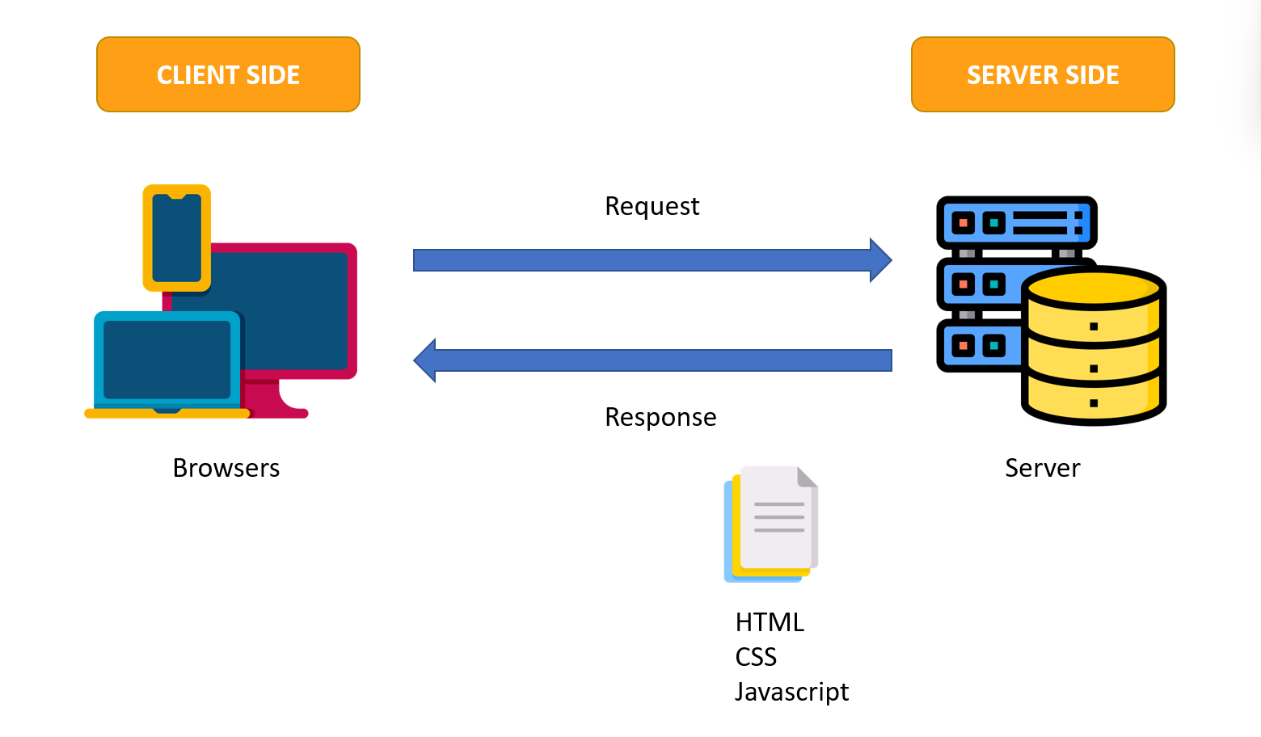

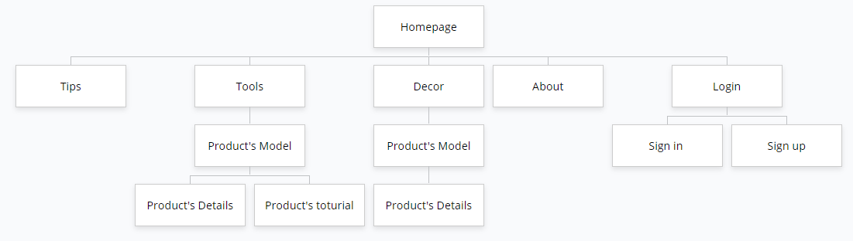

## Screen shots

1.Homepage 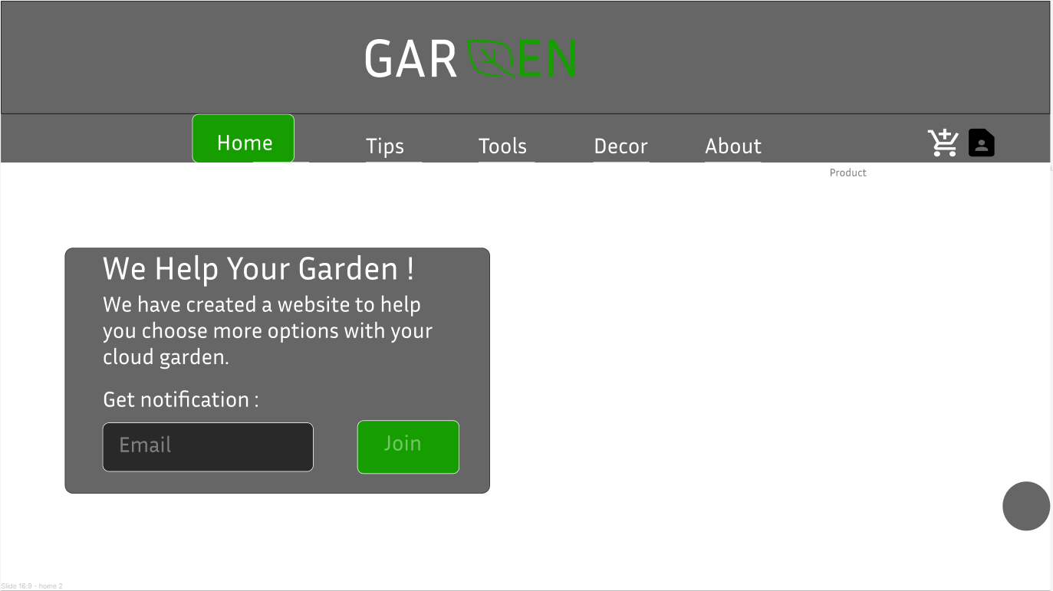

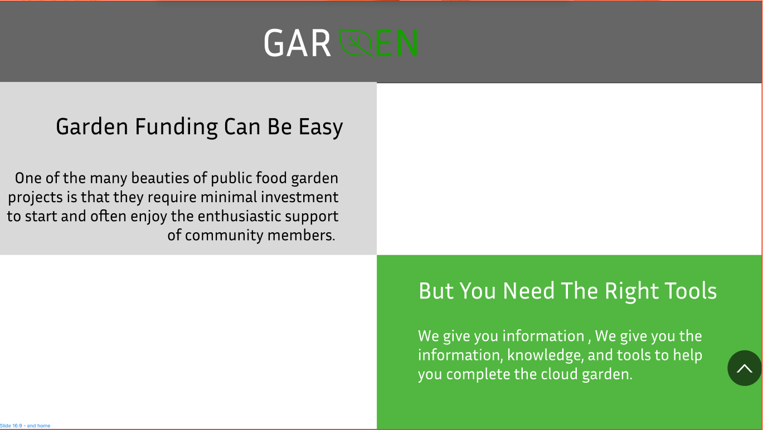

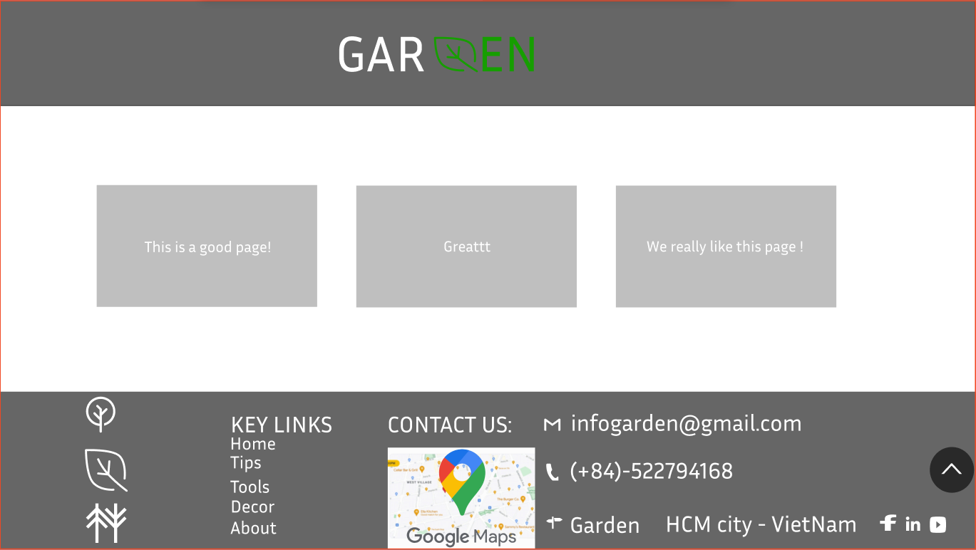

**Description:** This is a homepage of Garden, the top of this page is a header, after that is a navigation bar(sub menu). The main part of a homepage beside the slider also includes 3 sections: get notification, overview and comment. The footer of a homepage has 2 sections: subscribe and link to other information pages or contact information.

### 2.Sign in

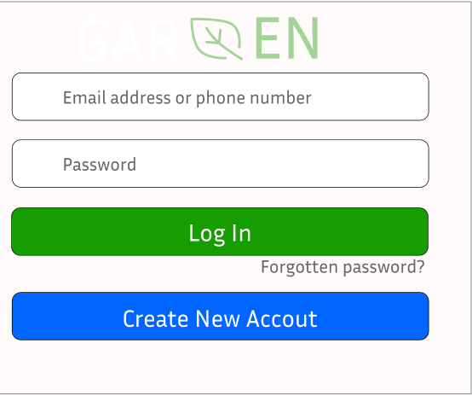

**Description:** When the user clicks on the human icon in the header, it leads to a sign in page. This form requires the user to enter an email address and a password. After clicking the login button, the user will be redirected to the homepage.

### 3.Sign up

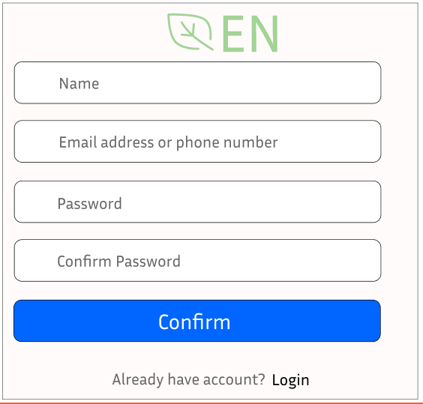

**Description:** If the user hasn’t created an account, he/she can click to Create new account in the sign in page and it will lead to this sign up page. This sign up form requires the user to enter 4 fields: name, email or phone and password. After clicking the sign up button the user will be redirected to the homepage.

### 4.Tips

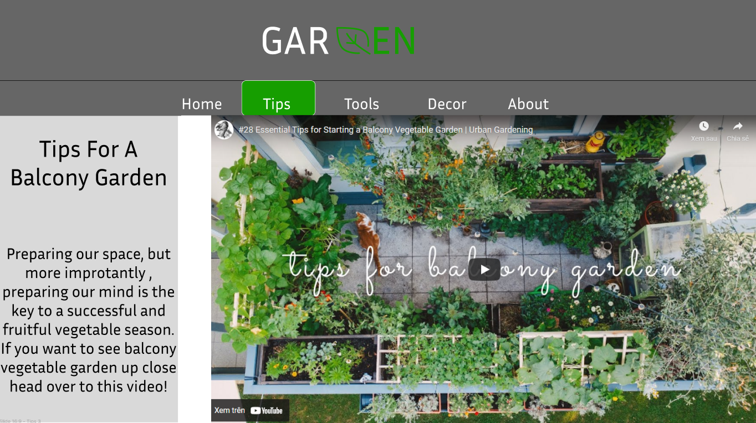

**Description:** When the user clicks on the Tips tag in navigation, it will lead to this page. The main part of this page contains 2 sections: Tips, and video details for some.

### 5.Tools

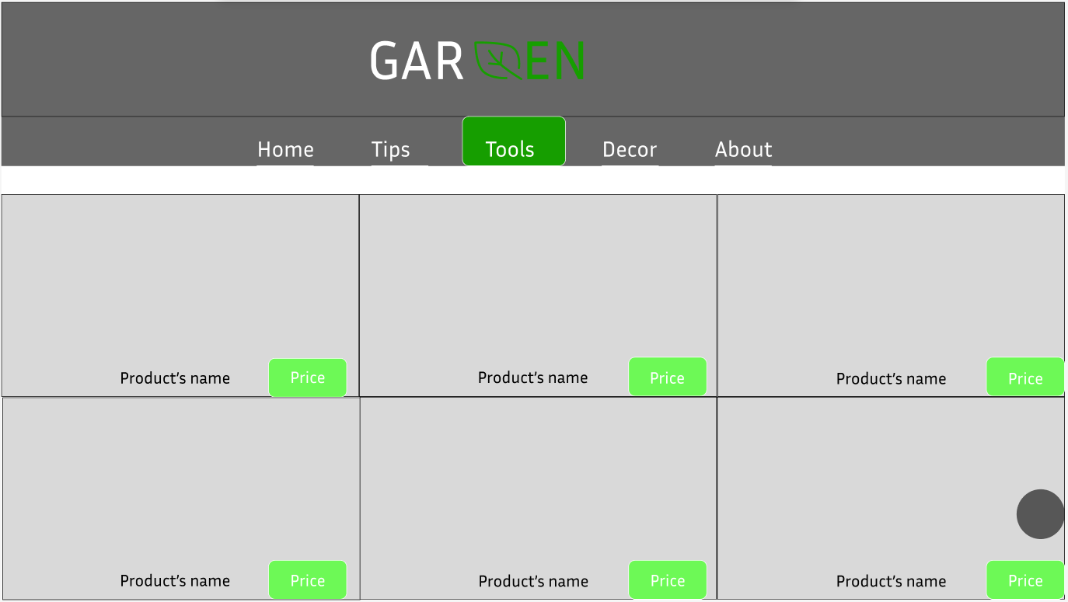

**Description:** When the user clicks on a product’s model it will lead to Product details , and guide for tools.

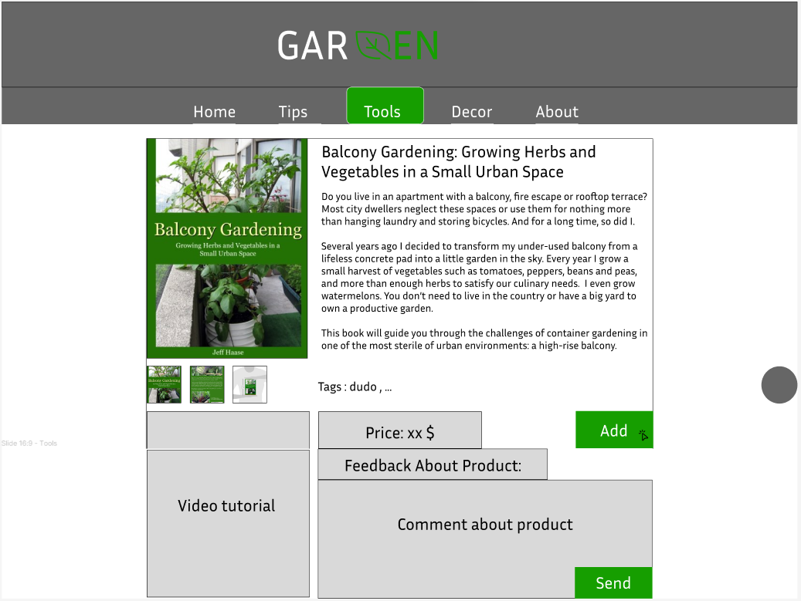

**Description:** When the user clicks on add icon on specific product, this product will be added to comparison,1 perclick . User van view toturial , and send feedback for website.

### 6.Decor

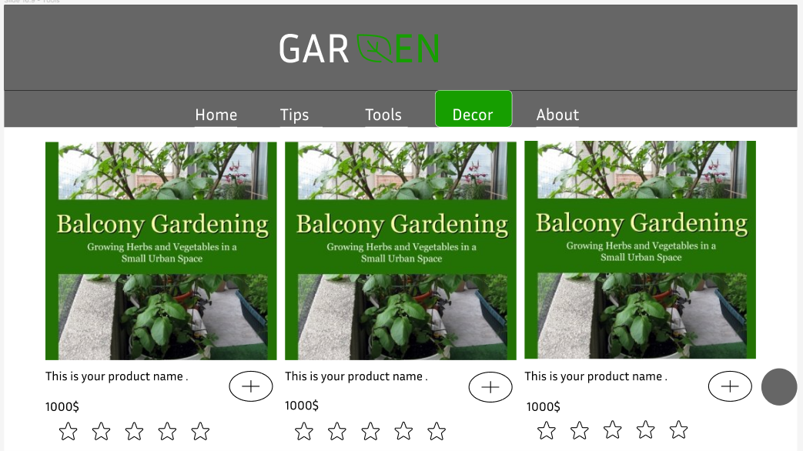

**Description:** When the user clicks on a product’s model it will lead to Product details .Or , user can add product to get information back when they finished shopping.

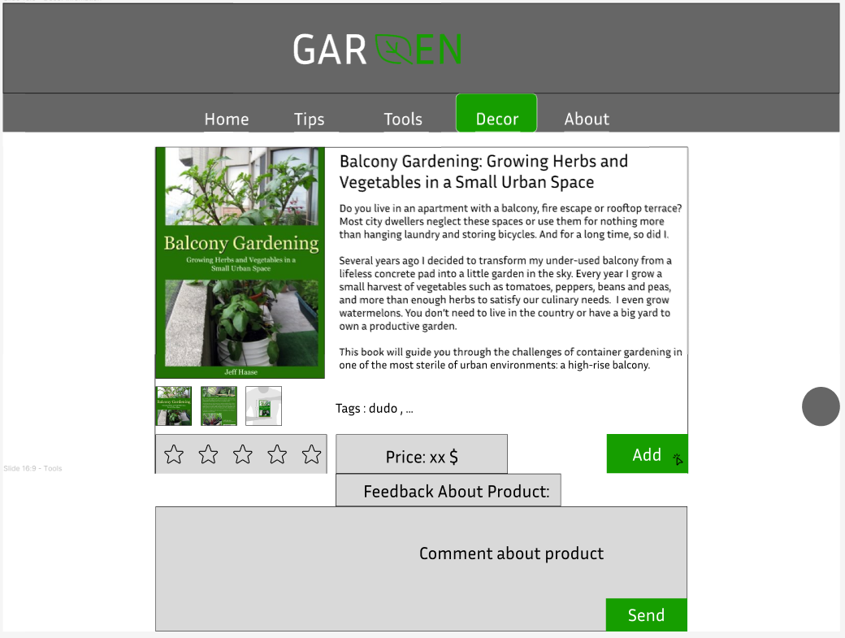

**Description:** When the user clicks on add icon on specific product, this product will be added to comparison,1 perclick . User van rate star for this product , and send feedback for website.

### 7. Check Out

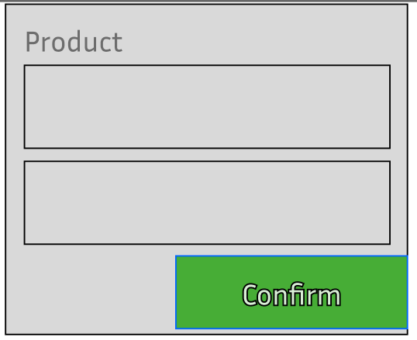

**Description:** After clicking the Shopping icon again , and confirm product user want to get information , and place to own product , web site will sent gmail confirm to your gmail about your product.

### 8. Contact

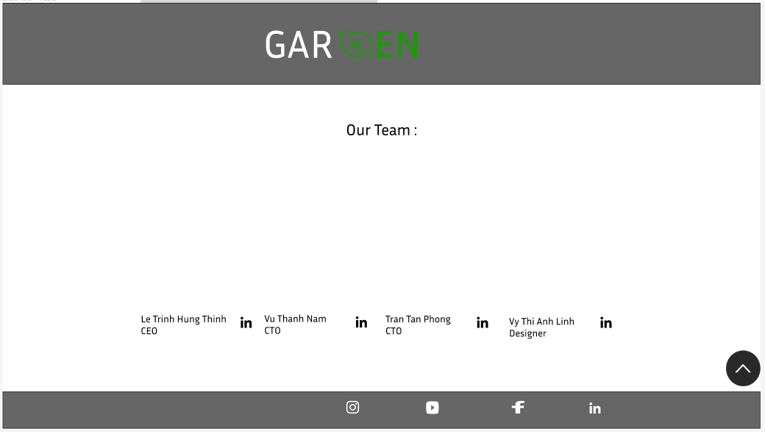

## Task Sheet

|  |  |  |  |  |  |  |
| --- | --- | --- | --- | --- | --- | --- |
| **Project Ref No.** | **Project Title – Ask Me Mobile** | **Activity Plan Prepared by** | **Date of preparation of Activity Plan** | | | |
| **Task** | **Actual Start Date** | **Actual Days** | **Teammate Names** | **Status** |
| Brainstorming ideas for layouts and Project Object | | Thinh , Phong , Linh , Nam | 27/05/2022 | 1 days | Thinh , Phong , Linh , Nam | Completed |
| Draw site maps and architecture design | | Thinh , Phong , Linh , Nam | 27/05/2022 | 1 days | Thinh , Phong , Linh , Nam | Completed |
| Wire framing general page layout | | Thinh , Phong , Linh , Nam | 27/05/2022 | 3 days | Thinh , Phong , Linh , Nam | Completed |
| Collect static assets (pictures, mp4, documentation,…) | | Thinh , Phong , Linh , Nam | 27/05/2022 | 5 days | Thinh , Phong , Linh , Nam | Completed |