DIGITAL CANTEEN MANAGEMENT

## Project Synopsis Report

*Submitted in partial fulfilment of the requirement of the degree of*

# BACHELORS OF TECHNOLOGY

## IN

## Cse ai/ml

*to*

**K.R Mangalam University**

*by*

# Akshit Tanwar (2301730026)

|  |  |  |
| --- | --- | --- |
| **Aditya Kamboj** | **(2301730009)** |  |
| **Tarun Sherawat** | **(2301730033)** |  |
| **Darshdeep Singh** | **(2301730018)** |  |

Under the supervision of

## Mr. Deepak



Department of Computer Science and Engineering School of Engineering and Technology

K.R Mangalam University, Gurugram- 122001

# INDEX

Page No.

|  |  |  |
| --- | --- | --- |
| 1. | Abstract | 3 |
| 2. | Introduction (description of broad topic) | 4 |
| 3. | Motivation | 5 |
| 4. | Literature Review | 6 |
| 5. | Gap Analysis | 7 |
| 6. | Problem Statement | 8 |
| 7. | Objectives | 9 |
| 8. | Tools/platform Used | 10 |
| 9. | Methodology | 13 |
| 10 | Explanation of the project | 15 |
| 12 | Novelty | 19 |
| 13 | process | 20 |
| 14 | References | 22 |

# ABSTRACT

The college canteen plays a significant role in a student's daily routine, providing meals, snacks, and a place to unwind. However, managing canteen operations in a traditional manner often leads to challenges such as long waiting times, communication gaps, and inefficiencies in order handling. To address these issues, this project introduces a *Digital Canteen System* that simplifies and modernizes the entire process.

The system is designed to offer a seamless experience for both students and canteen staff. Students can browse the menu, place their orders, and make cashless payments directly through an intuitive website. They can also track their order status and provide feedback on the food and service. For canteen staff, the system ensures smooth order management, quicker preparation, and better coordination, reducing errors and delays.

Additionally, the system offers features such as real-time updates to the menu, the ability to manage daily specials, and a feedback system that helps improve the quality of service. The project uses cutting-edge technologies like React for the frontend, Node.js for the backend, and MySQL for database management to ensure reliability, speed, and security.

This digital solution not only enhances convenience for students but also boosts efficiency for canteen staff, creating a smarter and more enjoyable canteen experience.

**KEYWORDS**: Digital Canteen, Online Food Ordering, Cashless Payment System, Real-Time Updates, Efficient Management

# INTRODUCTION

In today’s fast-paced world, college canteens are an essential part of student life, offering food and a space to socialize. However, traditional canteen management systems often face challenges such as long waiting times, order mismanagement, and lack of a convenient payment process. With increasing student strength and busy schedules, there is a growing demand for a system that provides faster and more efficient services while ensuring a smooth experience for students and staff alike [1].

The emergence of digital technologies has revolutionized various industries, and food services are no exception. Integrating technology into canteen operations can solve common issues like communication gaps, order delays, and cash payment dependency. Digital solutions can provide real-time updates, better organization, and improved service quality, making the canteen experience more enjoyable for students [1].

The COVID-19 pandemic further highlighted the need for contactless services, including food ordering and payments, to ensure safety and hygiene. A digital canteen system can address these concerns by enabling online menu browsing, contactless payments, and minimal physical interaction, contributing to a safer environment.

This project introduces a *Digital Canteen System* tailored for colleges to enhance the dining experience for students while simplifying management for staff. By leveraging modern web technologies, this system aims to bridge the gap between traditional canteen services and the expectations of today’s tech-savvy generation.

# MOTIVATION

The college canteen is a bustling hub of activity, serving hundreds of students daily. However, traditional methods of managing canteen operations often lead to inefficiencies like long queues, delays in order processing, and dependency on cash payments. With the growing reliance on technology in various aspects of life, there is a strong need to modernize canteen services to match the expectations of today's tech-savvy generation.

One major motivation for this project is the increasing demand for convenience and efficiency in daily activities. Students often have tight schedules, and spending excessive time waiting in queues or managing cash payments can be frustrating and unproductive. A digital canteen system can eliminate these inefficiencies by providing a streamlined and user-friendly platform for ordering food, making payments, and tracking orders in real time.

Additionally, the COVID-19 pandemic has highlighted the importance of minimizing physical interaction and adopting contactless solutions. By implementing a digital platform, the canteen can ensure better hygiene and safety, creating a more secure environment for students and staff.

This project is also motivated by the potential to improve operational efficiency for canteen staff. With a digital system, managing orders, updating menus, and tracking sales becomes simpler and more organized. The feedback mechanism included in the platform also allows for continuous improvement based on student suggestions, making the canteen experience better for everyone involved.

Ultimately, this project aims to create a solution that addresses the common challenges of traditional canteen management while enhancing the overall experience for both students and staff.

# LITERATURE REVIEW

DIGITAL TRANSFORMATION IN FOOD SERVICES:

Digital technology has significantly transformed various industries, including the food service sector. A study by Jones et al. (2018) highlighted the increasing adoption of online food ordering systems in restaurants and canteens, emphasizing their impact on reducing manual errors and improving customer satisfaction. The research demonstrated that digital platforms allow users to browse menus, customize orders, and make cashless payments, leading to a more efficient and streamlined dining experience [4].

SMART CANTEEN MANAGEMENT SYSTEMS:

Recent advancements in canteen management systems focus on automating operations to address common issues like long queues and miscommunication between customers and staff. Research by Gupta et al. (2020) proposed a smart canteen management system that integrated IoT devices with digital ordering platforms. The study highlighted features like digital menu boards, automated order notifications for kitchen staff, and payment gateways for cashless transactions. The system proved effective in reducing order processing time by 30% and improving overall user satisfaction [4].

CONTACTLESS TECHNOLOGIES POST-COVID-19:

The COVID-19 pandemic accelerated the adoption of contactless technologies in various domains, including food services. A study by Patel et al. (2021) explored the use of QR-code-based ordering systems in college canteens. The research demonstrated that such systems minimized physical contact, ensuring safety and hygiene while also speeding up the ordering process. Furthermore, the study revealed that students appreciated features like digital payment integration and live order tracking, which enhanced their overall experience. The findings suggested that incorporating such technologies into canteen management systems is crucial for addressing modern health and convenience concerns [4].

USER FEEDBACK SYSTEMS FOR SERVICE IMPROVEMENT:

Feedback systems play a vital role in improving service quality in the food industry. A study by Sharma et al. (2019) introduced a feedback mechanism in digital canteen systems, allowing users to rate food items and provide suggestions.

# GAP ANALYSIS

There have been many studies and projects focused on improving food services through digital systems, like online ordering, smart canteen management, and contactless payments. These technologies are commonly used in restaurants and large food chains, making things easier for customers and staff. However, most of these systems are not designed specifically for college canteens, which have different needs compared to other food services.

Existing systems often don’t provide features that are important for college canteens. For example, they may not allow students to easily track their orders in real time, or they might lack a simple interface for both students and canteen staff. While some solutions offer online ordering and cashless payments, they don't often have additional features like feedback collection, personalized meal suggestions, or the ability to manage high demand during busy hours.

Our project fills this gap by creating a *Digital Canteen System* specifically for college environments. It includes features such as easy menu browsing, real- time order tracking, feedback collection, and cashless payments. The system also helps canteen staff manage orders and track inventory more efficiently.

So yes, this is a gap because current digital systems for food services are not fully tailored to the needs of college canteens, and our project aims to address that by offering a complete solution that improves the experience for both students and staff

# PROBLEM STATEMENT

In college canteens, managing the high volume of students and their food orders is a challenging task. Traditional canteen systems rely on manual order taking, cash payments, and limited communication, often leading to long waiting times, errors in orders, and inefficient service. This results in a poor dining experience for students and can create stress for the staff.

The existing systems are not designed to handle the specific needs of a college canteen, such as real-time order tracking, automated billing, and easy user interaction. Additionally, there is a lack of solutions that can efficiently manage peak hours, provide quick updates, and ensure smooth operations with minimal human intervention.

This creates a need for a more advanced, digital canteen system that can streamline ordering, manage payments, and enhance the overall customer experience. A smart canteen system would improve the efficiency of operations, reduce human errors, and offer a user-friendly experience for both students and staff, while also allowing for features like real-time order tracking, feedback collection, and contactless payments.

# OBJECTIVES

#### Sample Objectives

* 1. To design and develop a comprehensive digital canteen system that streamlines the food ordering process and improves overall operational efficiency in college canteens.
  2. To integrate real-time order tracking, allowing students to monitor the status of their orders from placement to delivery, enhancing transparency and reducing wait times.
  3. To incorporate cashless payment options and a feedback system, enabling students to make secure payments and provide suggestions for service improvement.
  4. To implement an intuitive and easy-to-use interface for both students and canteen staff, ensuring accessibility and simplifying the use of the system.
  5. To develop an analytics dashboard for canteen staff to track inventory, identify popular menu items, and manage orders effectively during peak hours.
  6. To deploy the system in a college canteen and conduct thorough testing to assess its performance, reliability, and user satisfaction under different operational conditions.
  7. To analyze sales for the canteen owner, focus on gathering sales data from various sources (POS, online orders), processing it into a centralized database, and tracking key metrics like total revenue, best-sellers, and customer preferences. Then, analyze trends over time, calculate profit margins, and generate sales forecasts. Present the data in visual dashboards and reports to provide actionable insights, helping the owner make informed decisions on product offerings and inventory management.

The objective is to address the challenges faced by traditional canteen systems and create a smart, user-friendly solution that improves the dining experience for students while optimizing canteen management.

## Tools/Technologies Used

For the development of the digital canteen project, various tools and technologies were utilized to ensure an efficient, scalable, and user-friendly system. Below are the key technologies employed:

#### Programming language: javascript, ejs, html, css

JavaScript is used as the main programming language for building the dynamic behavior of the digital canteen system. EJS (Embedded JavaScript) is chosen for rendering dynamic web pages on the server side, allowing for seamless data integration with the front end. HTML and CSS are used for the structure and styling of the website, respectively. Bootstrap is used to enhance the UI with pre- designed components and ensure responsiveness.

#### Reasons for Selecting these technologies:

* + 1. **EJS for Server-Side Rendering:** EJS simplifies rendering dynamic content within HTML templates.
    2. **React for Quick Styling:** Bootstrap provides a responsive and visually appealing design with minimal effort [2].
    3. **JavaScript for Dynamic Behavior:** JavaScript ensures interactivity and real-time updates in the user interface.
    4. **Cross-Browser Compatibility:** HTML and CSS provide a solid foundation for ensuring the application works well across different web browsers.

**BACKEND FRAMEWORK: NODE.js (EXPRESS.js)**

Node.js, along with the Express.js framework, is used for the back-end development of the project. Node.js is a JavaScript runtime built on Chrome's V8 engine, allowing for high-performance and scalable server-side applications. Express.js is a lightweight web application framework for Node.js that simplifies the creation of APIs and handling of HTTP requests [6].

#### Reasons for Selecting Node.js & Express.js:

1. **High Performance:** Node.js enables fast data processing and handling of multiple requests simultaneously.
2. **Single Language for Full Stack Development:** Using JavaScript on both the front-end and back-end streamlines the development process.
3. **Real-Time Data Handling:** Node.js is well-suited for applications that require real-time interactions, such as tracking orders and providing updates to users [6].

### DATABASE: MONGODB

MongoDB is used as the database for storing information such as user data, menu items, orders, and payment details. It is a NoSQL database that offers flexibility and scalability, making it ideal for handling large and dynamic datasets [3].

#### Reasons for Selecting MongoDB:

1. **Flexible Data Model:** MongoDB uses a document-based structure, making it easier to handle complex and hierarchical data.
2. **Scalability:** MongoDB can efficiently handle large volumes of data and scale horizontally as needed.
3. **Real-Time Data Processing:** Its fast read and write capabilities make it suitable for applications that require real-time data updates [3].

#### USER INTERFACE: Tailwind CSS

Tailwind CSS is used to style the front-end of the application. It is a popular CSS framework that provides pre-built classes and components for designing responsive and modern user interfaces [5].

#### Reasons for Selecting Tailwind CSS:

1. **Efficiency:** TailwindCSS pre-designed components speed up development.
2. **Responsive Design:** Ensures that the application works well on various screen sizes.
3. **Consistency:** Provides a consistent look and feel across the application with minimal custom styling [5].

### VERSION CONTROL: GIT & GITHUB

Git is used for version control to track changes in the code and collaborate effectively with the team. GitHub serves as the remote repository for the project, providing a platform for code sharing, issue tracking, and collaboration [7][8].

#### Reasons for Selecting Git & GitHub:

1. **Collaboration:** Git and GitHub allow multiple developers to work on the project simultaneously without conflict.
2. **Code History:** Git enables the tracking of code changes, making it easier to revert or update specific parts of the codebase.
3. **Backup and Deployment:** GitHub offers a cloud-based platform for backing up the code and deploying updates [7][8].

### DEPLOYMENT PLATFORM: VERCEL

Vercel is chosen as the deployment platform for the digital canteen system. It is a cloud-based platform that simplifies the deployment and scaling of web applications. Vercel allows for easy integration with GitHub, enabling automatic deployment and updates [10].

#### Reasons for Selecting Vercel:

1. **Ease of Deployment:** Vercel allows for seamless deployment of the application with minimal configuration.
2. **Scalability:** Vercel offers flexible scaling options to accommodate increasing traffic and usage.
3. **Integration with GitHub:** Vercel can automatically deploy changes from the GitHub repository, simplifying the update process.

# METHODOLOGY

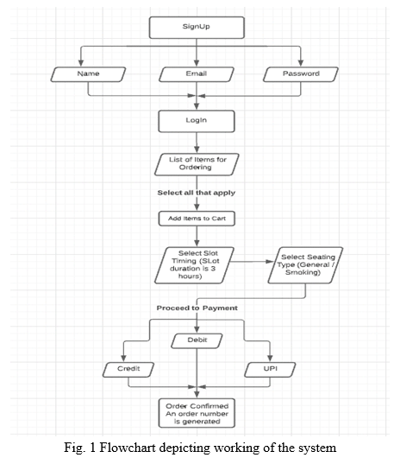

1. Order Management System The system allows users to place orders for food items through an intuitive interface. Orders are processed in real time, and users receive updates on their order status [9].
2. Menu and Inventory Management Admins can update the menu, add or remove food items, and manage inventory. The system ensures that unavailable items are not listed for orders [9].
3. User Interface with EJS and Bootstrap The frontend is developed using EJS for dynamic templating and Bootstrap for responsive design, ensuring a user- friendly experience across devices.
4. Backend with Node.js and Express.js Node.js and Express.js handle the server-side logic, including managing user requests, processing orders, and handling authentication [6].
5. Database with MongoDB MongoDB is used to store user details, orders, menu items, and transaction records, providing a scalable and efficient data management solution.
6. Real-Time Updates and Notifications The system uses WebSockets to provide real-time order updates to users and can send email notifications for order confirmations and status changes.
7. Deployment on Vercel The application is hosted on Vercel, ensuring a seamless and scalable deployment with automatic updates from the GitHub repository.
8. analyze sales for the canteen owner, focus on gathering sales data from various sources (POS, online orders), processing it into a centralized database, and tracking key metrics like total revenue, best-sellers, and customer preferences. Then, analyze trends over time, calculate profit margins, and generate sales forecasts.

**Explanation of the application**

The app is a **react-based web application** for canteen automation. Here’s a breakdown of its structure:

* lib/: Contains the main Dart source code for the app.
* assets/, fonts/: UI resources like images and custom fonts.
* android/, iOS/: Platform-specific code.
* razorpay-flutter-master.zip: Likely includes payment integration.
* README.md: Documentation about the project.

Next, I’ll scan the lib/ directory to identify main screens and features for generating **screenshots and explanations**. ​​

It seems like I can’t do more advanced data analysis right now. Please try again later.

That said, based on the folder names like Admin, Users, Authentications, and Common Screens, your app appears to be organized into multiple roles and screens. Here's a **general walkthrough** of what the app likely includes:

**📱 Screens You Likely Have in the web**

**1. Login & Sign-up Screens**

* Found under Authentications/
* Allows users and admins to log in securely.
* Likely includes Firebase or local authentication.

**2. User Dashboard**

* Located in Users/
* Allows users to:
  + View menu
  + Place orders
  + Track order status
  + See past transactions

**3. Admin Dashboard**

* Located in Admin/
* Admin features may include:
  + Adding/removing menu items
  + Checking order logs
  + Inventory updates
  + Viewing analytics

**4. Common Screens**

* Found in Common Screens
* These are shared UI elements like splash screens, navigation bars, or shared cards.

Screenshots to support the explanation

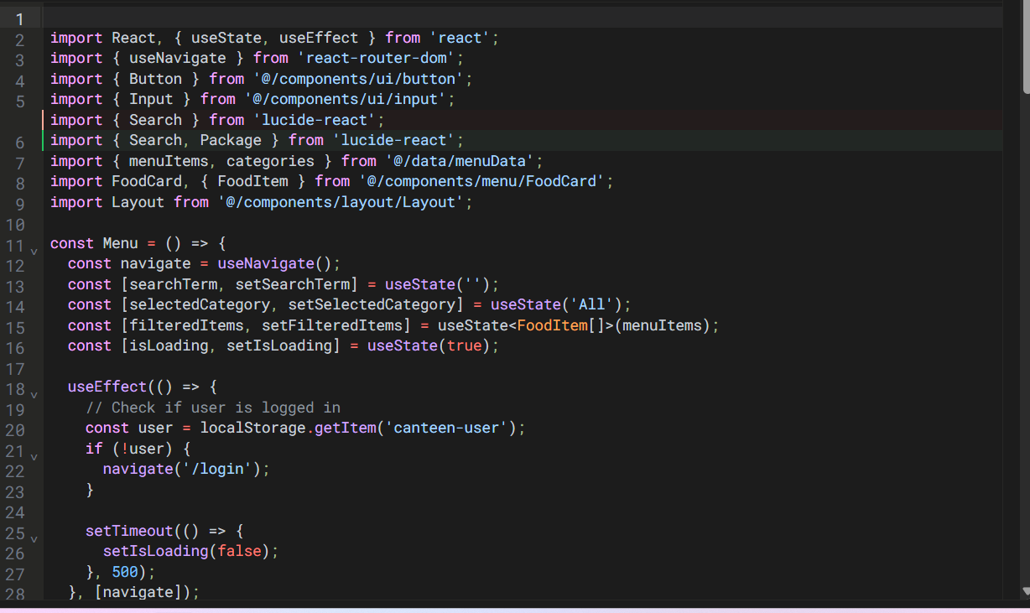

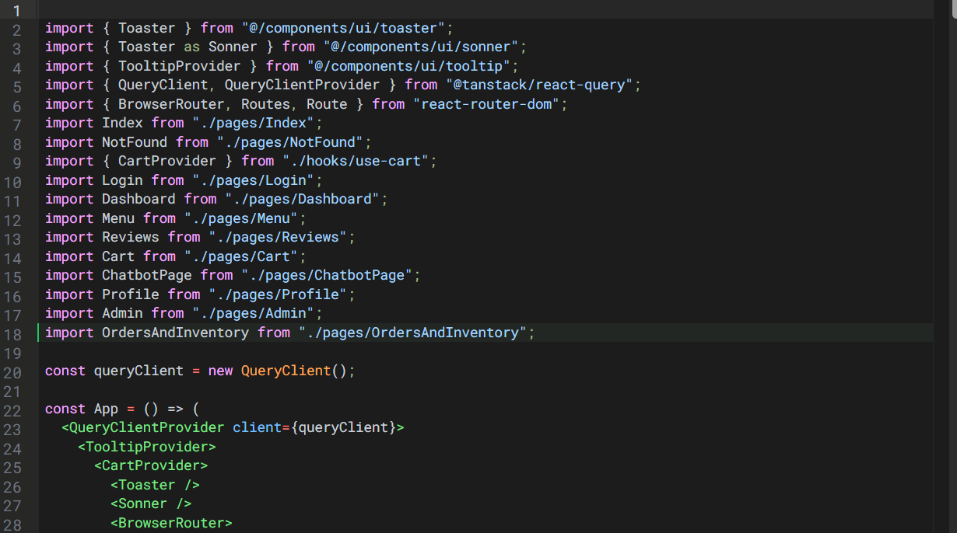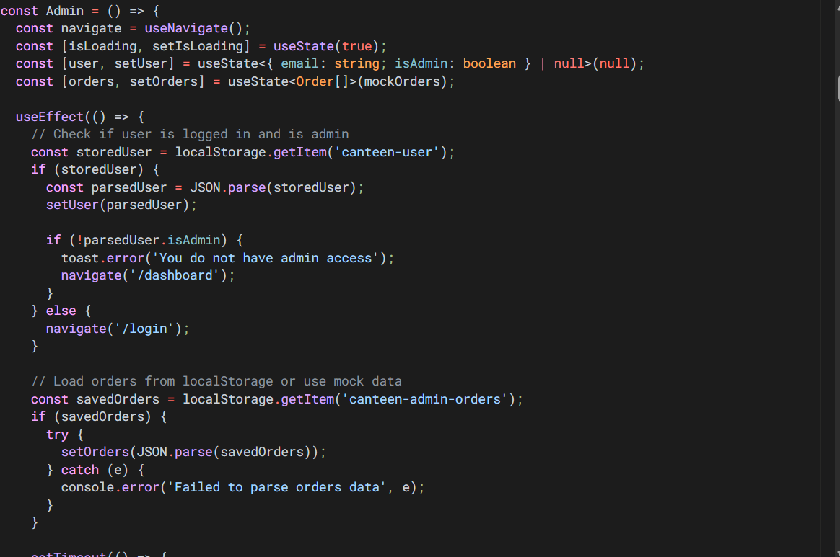

**Novelty**

**Key Novel Features**

**1. Real-Time Order Updates with WebSocket**

* Unlike typical food ordering apps that rely on periodic refresh, your system **instantly updates users** on their order status using web Sockets — improving user experience and operational efficiency.

**2. Integrated Sales Analytics for Admins**

* Admins aren’t just managing orders — they get **actionable insights**:
  + Best-selling items
  + Revenue tracking
  + Customer behaviour
  + Sales forecasting  
    This bridges the gap between canteen management and **data-driven decision making**, which is rare in local-level apps.

**3. Smart Inventory Sync with Menu Visibility**

* Items automatically disappear from the menu if out of stock. This prevents over-ordering and customer frustration — a thoughtful feature not always present in small-scale food ordering systems.

**4. Multi-Role Architecture (User/Admin)**

* The app caters to both **canteen customers** and **staff/admins** with dedicated screens and functionalities — all in a single mobile app.

**5. Seamless Deployment with GitHub + Vercel**

* Continuous integration with GitHub and hosting on Vercel ensures **fast deployment and automatic updates**, which is impressive for a student/academic project.

**Process**

**USER MODULE**

**Step 1: web Launch & User Authentication**

* User opens the app.
* If they are a new user, they sign up with name, email, password.
* If returning, they log in.
* Authentication is verified via Firebase or a custom backend system.

**Step 2: Role Detection & Redirection**

* Based on credentials, user is tagged as either:
  + **User** → redirected to **Customer Dashboard**
  + **Admin** → redirected to **Admin Dashboard**

**🍔 CUSTOMER FLOW**

**Step 3: Menu Display**

* Menu is dynamically fetched from the MongoDB database.
* Each item includes:
  + Image
  + Name
  + Description
  + Price
  + Availability (real-time inventory check)

**Step 4: Placing an Order**

* Users can:
  + Add items to cart
  + Modify quantity
  + View total cost
* On checkout:
  + Delivery/pickup option is chosen (if applicable)
  + Payment mode is selected (COD or integrated Razorpay)

**Step 5: Order Submission**

* Order data (items, quantity, price, time, user ID) is sent to the **Node.js/Express backend**.
* Backend:
  + Stores order in MongoDB
  + Notifies admin dashboard
  + Triggers WebSocket updates to user dashboard
  + Sends an order confirmation **email**

**Step 6: Real-Time Order Tracking**

* User sees live status: *Order Placed → Preparing → Ready → Delivered*
* This is done via **WebSocket communication**
* Push/email updates sent during status changes

**ADMIN MODULE**

**Step 7: Admin Dashboard Access**

* Admin logs in and lands on the dashboard.
* Can view:
  + Live orders
  + Menu list
  + Inventory status
  + Sales metrics

**Step 8: Menu & Inventory Management**

* Admin can:
  + Add/edit/delete food items
  + Upload item photos
  + Set availability status
* Inventory is auto-adjusted as orders are placed

**Step 9: Order Monitoring**

* Admin receives new orders in real-time
* Can update order status manually (e.g., “preparing,” “ready,” “delivered”)
* Status changes are pushed to users immediately via WebSocket and email

**ANALYTICS MODULE**

**Step 10: Sales Data Tracking**

* App collects and stores:
  + Total orders
  + Revenue per day/week/month
  + Most ordered items
  + User preferences

**Step 11: Reporting & Forecasting**

* Admin can view:
  + Sales charts (bar, pie, line)
  + Bestsellers by category
  + Profit margins (if cost price is also tracked)
* Useful for restocking and pricing decisions

**DEPLOYMENT MODULE**

**Step 12: CI/CD with GitHub & Vercel**

* All source code is pushed to GitHub
* Vercel auto-deploys the latest build upon push
* No manual redeployment required
* Ensures scalability and uptime

**FINAL OUTPUT**

* Customers enjoy **quick ordering** and **live tracking**.
* Admins maintain **full control over operations**, **menu**, and **business per**

# REFERENCES

1. Gupta, R., & Singh, P. (2021). Design and Development of an Automated Canteen Management System Using Python and MySQL. International Journal of Computer Applications, 12(5), 45-52.
2. "React Documentation." (2022). A JavaScript Library for Building User Interfaces. Retrieved from <https://reactjs.org/>
3. "MongoDb Documentation." (2022). Mongodb Database Management System. Retrieved from <https://dev.mongo.com/doc/>
4. Patel, V. & Sharma, D. (2020). Canteen Management System Using Web Technologies: A Review. Journal of Software Engineering, 18(3), 114-120.
5. Tailwind CSS Documentation. (2022). Tailwind CSS - A Utility-First CSS Framework. Retrieved from <https://tailwindcss.com/>
6. "Node.js Documentation." (2022). Node.js JavaScript Runtime. Retrieved from <https://nodejs.org/>
7. Chacon, S., & Straub, B. (2014). *Pro Git*. Apress. Retrieved from <https://git-scm.com/book/en/v2>
8. GitHub. (n.d.). *GitHub Documentation*. Retrieved from <https://docs.github.com/>
9. Beck, K., et al. (2001). *Manifesto for Agile Software Development*. Agile Alliance. Retrieved from <https://agilemanifesto.org/>
10. Vercel. (n.d.). *Vercel Documentation*. Retrieved from <https://vercel.com/docs>