UGANDA CHRISTIAN UNIVERSITY

FACULTY OF ENGINEERING, DESIGN AND TECHNOLOGY

COURSE CODE: CSC1202
COURSE NAME: WEB AND MOBILE APPLICATION DEVELOPMENT

PROJECT REPORT

"STUDENT STUDY GROUP FINDER"

PROGRAM: BACHELOR OF SCIENCE IN INFORMATION TECHNOLOGY (BSIT) Y1S2
SUBMISSION DATE: APRIL 2026

1. Introduction
Collaborative learning is a critical aspect of tertiary education, providing students the platform to enhance their academic experiences. Currently, finding and organizing study groups at Uganda Christian University largely depends on informal personal networks and impromptu social media interactions, often limiting broader participation.
The Student Study Group Finder aims to directly address this limitation. It provides a structured, digital platform where students can create, discover, and actively manage academic study groups. This ensures a centralized, accessible, and inclusive environment, promoting academic excellence and collaborative learning across all university faculties.

2. Problem Statement & Objectives

Problem Statement
The challenge students face is the fragmented and isolated nature of forming academic alliances. Without a centralized hub, students missing initial social connections struggle to find study groups tailored to their specific courses, minimizing equal learning opportunities.

Objectives
1. To implement secure user authentication and student profile management.
2. To provide functionalities for the creation, management, and discovery of study groups based on courses and faculties.
3. To enable group leaders to schedule and organize study sessions seamlessly.
4. To implement group communication tools (posts/announcements) for collaborative preparation.

3. Technology Stack & Choices
In line with fulfilling the requirement of a scalable and robust minimal viable product (MVP), the following stack was utilized:
- Frontend Framework: React.js configured with Vite. Selected for fast rendering, component reusability, and efficient state management.
- Styling: Tailwind CSS & Radix UI (shadcn/ui). Chosen for utility-first styling and extremely accessible User Interface components, ensuring a robust responsive design on desktop and mobile.
- Backend Framework / Database: Supabase (PostgreSQL with PostgREST). Chosen for secure JWT authentication out-of-the-box, real-time table capabilities, and reliable relational configurations mimicking standard backend logic.
- Hosting / Deployment: GitHub Pages (frontend delivery).

4. System Architecture
The application leverages a modern Client-Server Architecture utilizing a Backend-as-a-Service (BaaS) infrastructure. This perfectly maximizes UI rendering efficiency by offloading work to the client, while abstracting and standardizing backend API integrations smoothly.
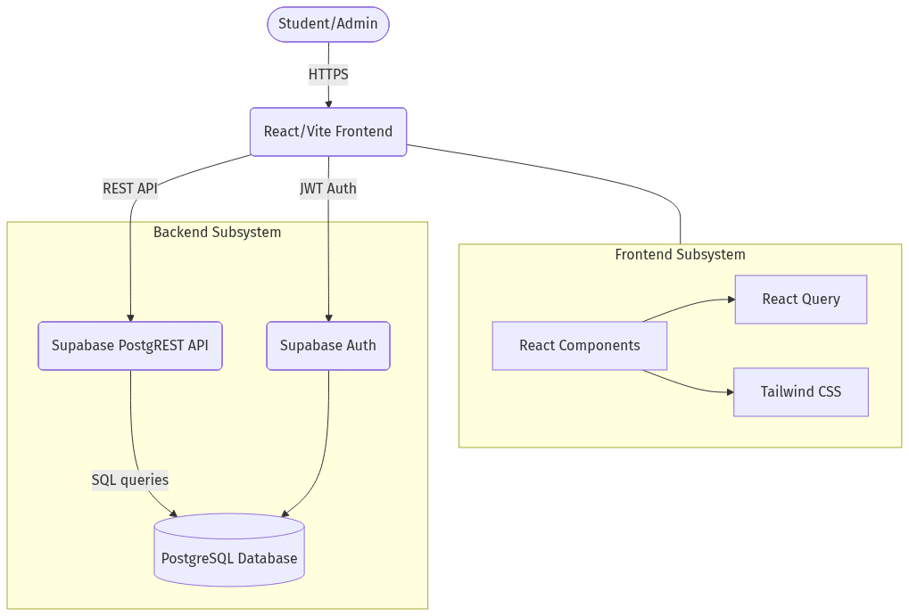
Figure 1: Client-Server Architecture utilizing BaaS Component structure.

5. Entity Relationship (ER) Diagram
The database relies on a highly normalized relational setup leveraging PostgreSQL types to preserve referential integrity across modules.
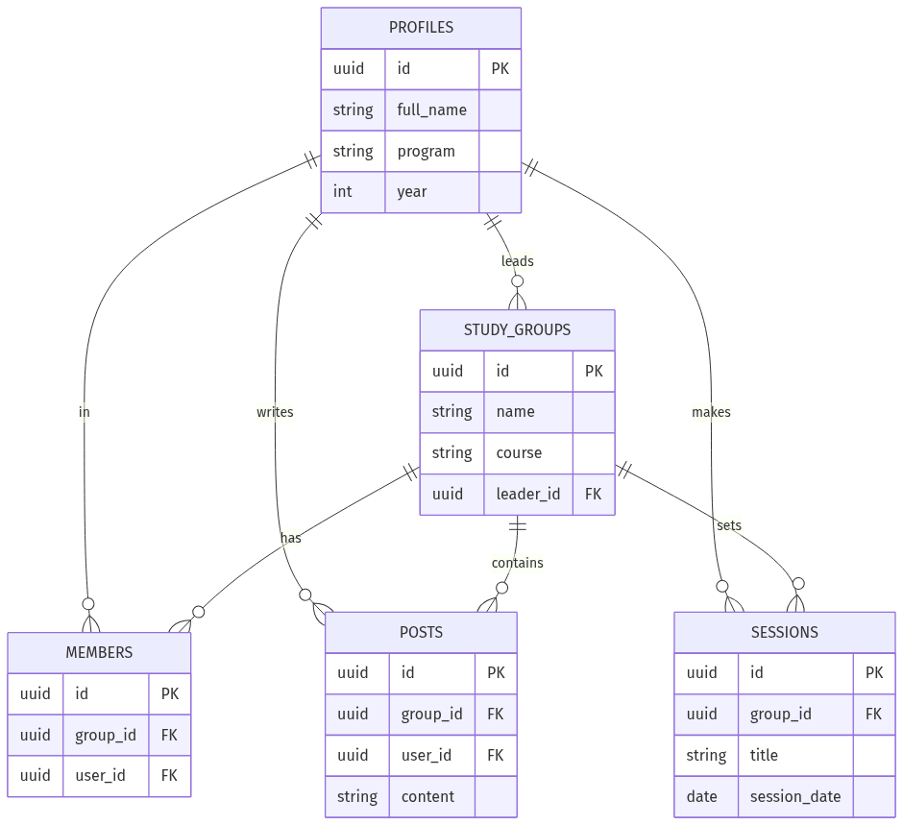
Figure 2: PostgreSQL Entity-Relationship Schema mapping.

6. System Features & User Manual

6.1 Registration and Authentication
- Step 1: Navigate to the web application URL.
- Step 2: Click on Sign Up / Login. Input your correct Full Name, Program of Study, Year of Study, institutional Email Address, and secure Password.
- Step 3: Once successfully verified, visually seamlessly navigate via the populated Dashboards.

6.2 Discovering and Managing Study Groups
- Finding a Group: Under the groups interface, browse the active inventory of academic teams. Utilizing the Search and Filter fields, drill down by specific Course Name or respective Faculty.
- Joining: Verify a group’s intent from its description then click "Join Group" to gain timeline access.
- Creating a Group: In "Create Module", submit crucial configurations (Group Name, Course Code, Description, Location Format). Note: The creator automatically holds default Group Leader privileges.

6.3 Group Hub: Communication and Scheduling
- Scheduling Sessions (Leaders Only): Select "Create Session" in the Hub interface. Establish the Date, precise Time, Physical Location or Virtual Link, and a concise outline of modules to cover. These immediately reflect on member dashboards.
- Interactions: The built-in "Discussion Wall" mechanism tracks inquiries, shared resource linkages, and casual study notifications in a single persistent timeline.

7. API Documentation
The Application Programming Interfaces strictly adhere to well-formatted REST standard methodologies securely orchestrated by PostgREST acting over PostgreSQL, returning normalized JSON payload objects and arrays.
Endpoints & Functions:
1. POST /auth/v1/signup: Student Registration Identity creation.
2. POST /auth/v1/token?grant_type=password: Authentication token exchange.
3. GET /rest/v1/study_groups: Fetch groups; manages filtering queries.
4. POST /rest/v1/study_groups: Create new study ecosystem. (Valid JWT header expected).
5. POST /rest/v1/study_sessions: Write new group study session record entry.
6. GET /rest/v1/group_posts?group_id=eq.[id]: Fetches specific ongoing discussion pipelines.

8. GitHub Collaborative Deliverables
The core repositories encompassing source code and database rules/schemas conform to best practices highlighting detailed commitment traces and collaborative milestones.
- Application Main Repository Filepath (Frontend Logic): https://github.com/evarduwamani-ctrl/Student-Study-Group-Finder
- Backend Environment Pipeline: Systematized and tightly coupled actively running via Supabase integration frameworks. Authentication logic and relational setup exist organically on the database node structure driven identically by the primary repository connections.

9. References
[1] D. Flanagan, JavaScript: The Definitive Guide. 7th ed. Sebastopol, CA: O'Reilly Media, 2020.
[2] "Supabase Official Documentation," Supabase HQ. [Online]. Available: https://supabase.com/docs.
[3] "React - A JavaScript library for building user interfaces," Meta Platforms. [Online]. Available: https://reactjs.org/.
[4] "Tailwind CSS - Rapidly build modern websites without ever leaving your HTML," Tailwind Labs. [Online]. Available: https://tailwindcss.com/.
[5] "IEEE Reference Guide," IEEE, Piscataway, NJ, USA, 2018.

