Microservices-101

Notes made from Microservices: From Design to Deployment

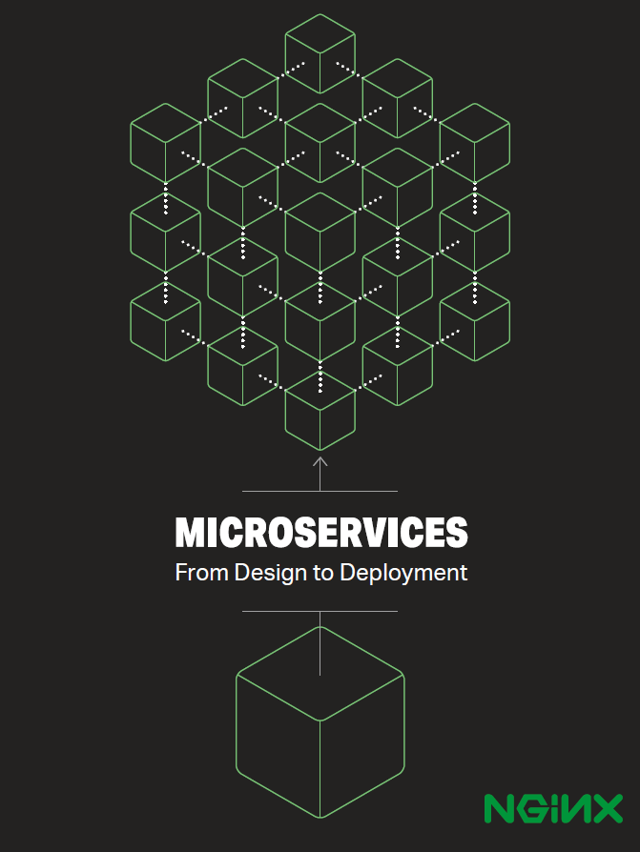

Ref: <https://www.nginx.com/blog/microservices-from-design-to-deployment-ebook-nginx/>

Why microservices?

Because it sounds cooler, rest of the reasons are written below.

With microservices, an application is developed, or refactored, into separate services that “speak” to one another via APIs. Each microservice is self-contained, each maintains its own data store, and each can be updated independently of others.

Moving to microservices-based approach makes app development faster and easier to manage, requiring fewer people to implement more features. An application designed as a collection of microservices is easier to run on multiple servers with load balancing, making it easy to handle demand spikes and steady increases in demand over time, while reducing downtime caused by hardware and software problems.

Introduction to Microservices