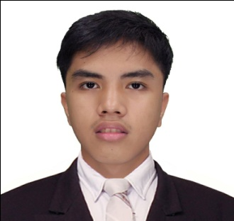**Philip William A. Fabros**

**Blk 2 Lot 23 Seaside Square Tambo**

**Paranaque City**

**09665434559**

[**Mffabilous@yahoo.com**](mailto:Mffabilous@yahoo.com)

**CAREER OBJECTIVES :**  
 Searching for the job opportunity in IT Company as programmer. I am also interested to get database developer job position. I would like to state my computer proficiency and complete dedication for work.

**PERSONAL DATA:**

**Date of Birth**: September 27, 1999

**Place of Birth**: Parañaque City

**Age**: 19 y/o

**Gender**: Male

**Citizenship**: Filipino

**Religion**: Roman Catholic

**Height**: 179.832 cm.

**Weight**: 90 lbs.

**EDUCATIONAL BACKGROUND :**

**School Year**

**Senior High School** Arellano University – Jose 2018-2016  
 Abad Santos Campus

3058 Taft Avenue, Pasay City

**Secondary** Arellano University – Jose 2016-2012

Abad Santos Campus

**Primary** Camp Claudio Elementary School 2012-2006

**SKILLS:**

* Proficient in English
* Computer Literate
* Time Management
* Data Analysis
* Quick Learner
* Multi-Tasking
* Editing
* Resourceful

**WORK EXPERIENCE**

**Company Name Position Month/Year**

N/A N/A N/A

**SEMINAR**

**Topic Theme Month**

N/A N/A N/A

**PERSONAL INFORMATION**

I'm Philip William A. Fabros. I reside in Parañaque city. I am 18 years old. I am currently studying college under the course of BSIT in STI MAKATI as a 1st year student. My dream is to be a programmer, to finish academics, and to travel the world with the use of my profession.

**CHARACTER REFERENCE**

Edmhar A. Fabros Chrismel John A. Harrion

Programmer Student

09161232165 [https://facebook.com/Yandere.Killer](https://www.facebook.com/Yandere.Killer)

Edwin A. Fabros

Family Driver

09562185616

**` PHILIP WILLIAM A. FABROS**

**SIGNATURE**