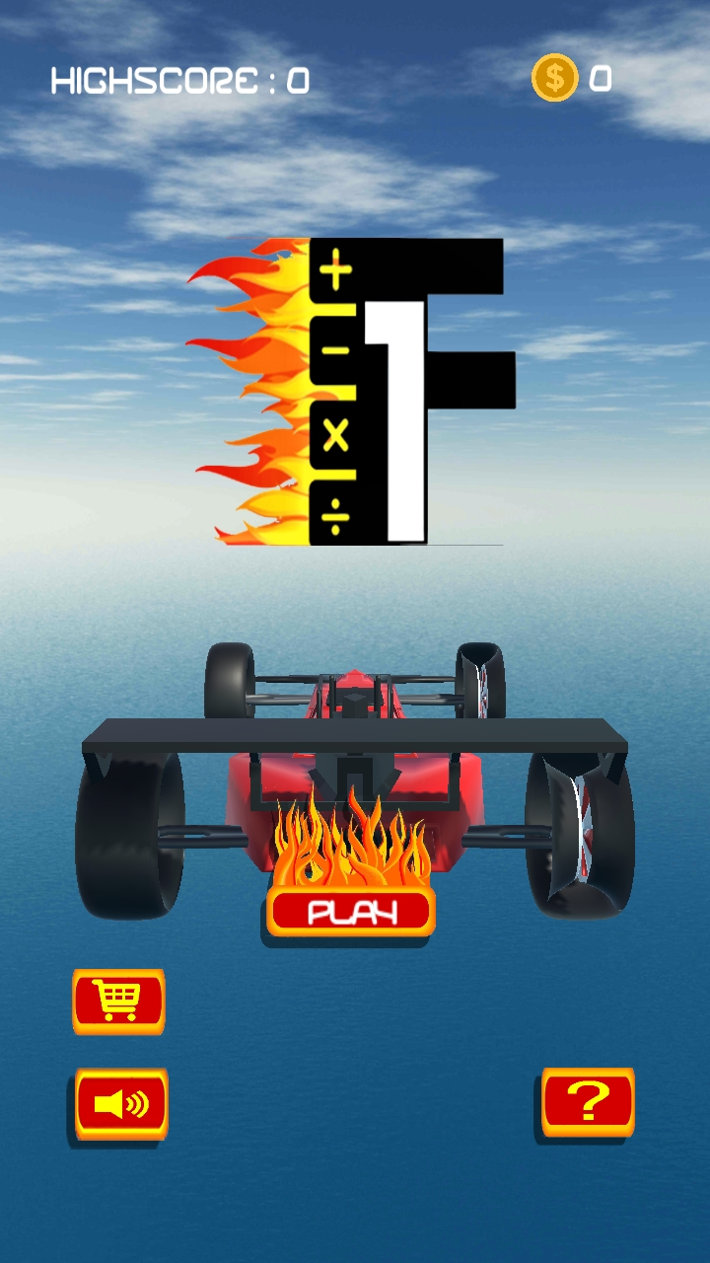

Formula 1

Submitted by:

Leonen, Jack Daniels P.

Submitted to:

Mr. Rn Santos

HCI Instructor

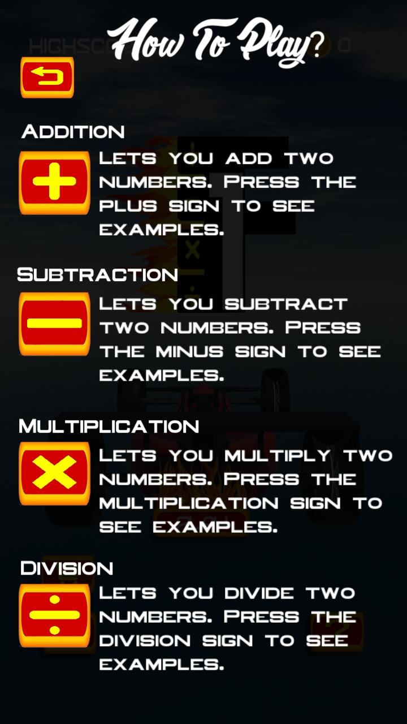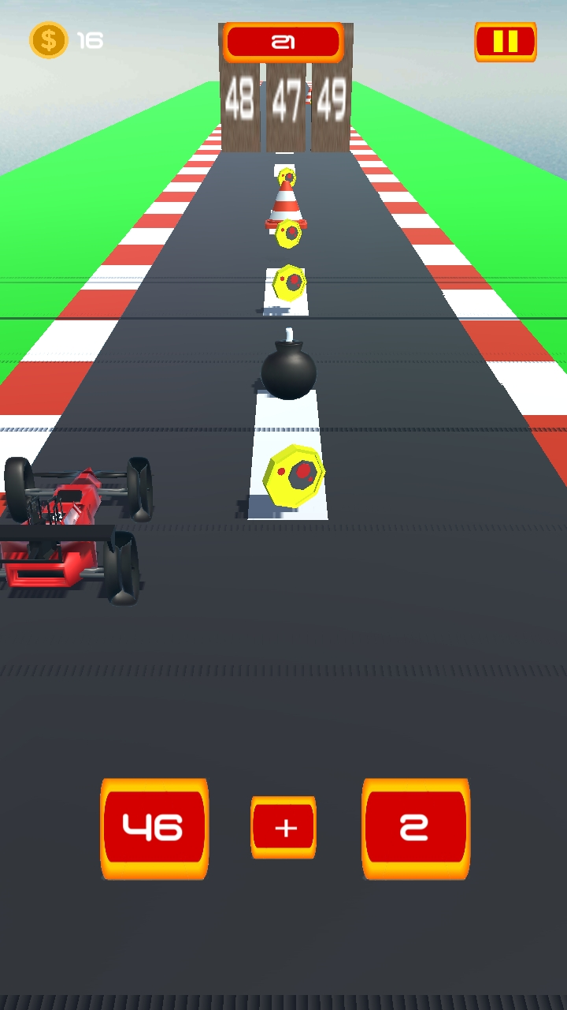

GENRE: ARCADE RACING

EDUCATIONAL

TARGET: AGES 10 – 13

RATING: RATED 10+

NUMBER OF PLAYERS: SINGLE PLAYER

PLATFORM: ANDROID

GAMEPLAY: BEFORE THE CAR STARTS TO MOVE, IT WILL HAVE A 3 SECONDS COUNTDOWN. THE CAR NEEDS TO DODGE THE OBSTACLES AHEAD BY SWIPING FROM LEFT TO RIGHT. IT IS AN ENDLESS GAME, IN ORDER TO SURVIVE, YOU NEED TO BUMB THE RIGHT ANSWER WRITTEN ON THE WALL AND IF THE PLAYER DON’T BUMP THE RIGHT ANSWER, THE CAR WILL BE DESTROYED THUS, ENDING THE GAME. ALTHOUGH THE PLAYER CAN RESTART THE GAME AFTER CRASHING, THE SCORE WILL BE BACK FROM ZERO.