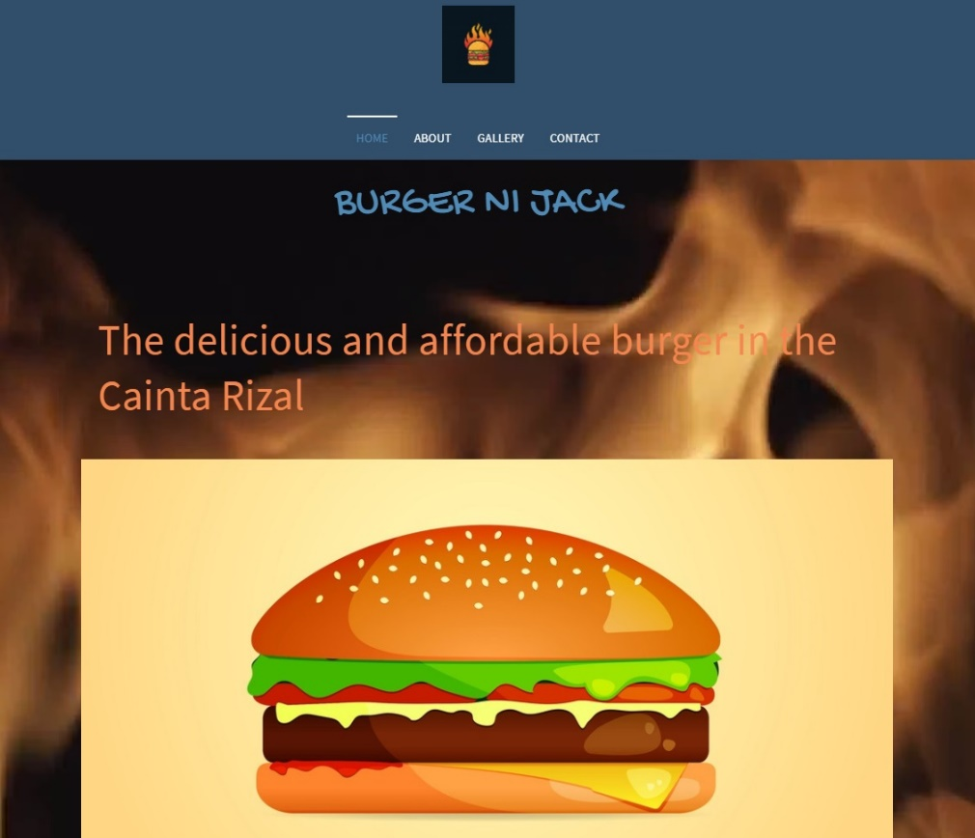HOME PAGE AND ABOUT

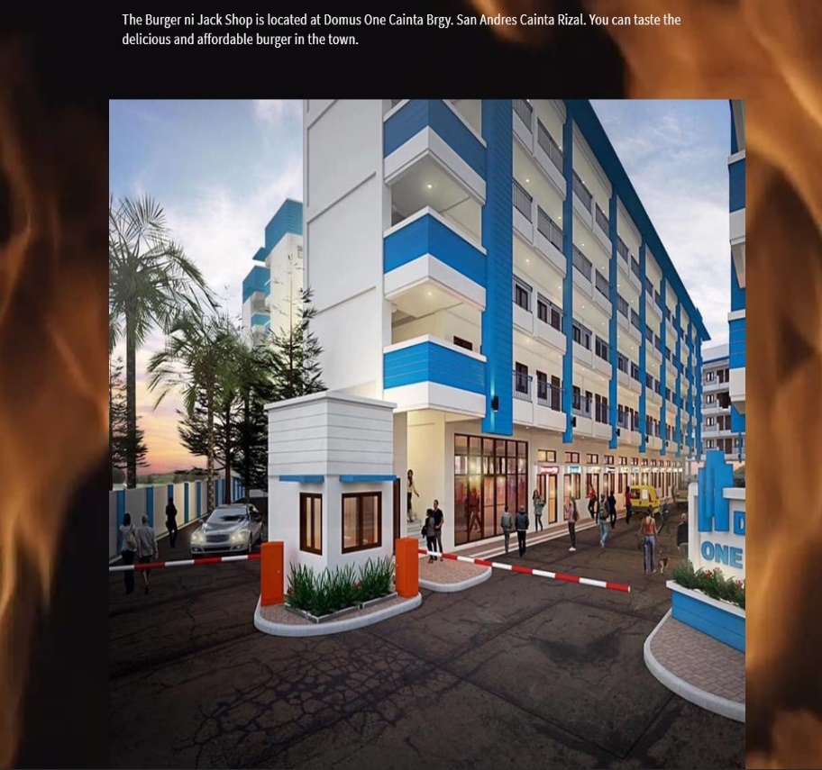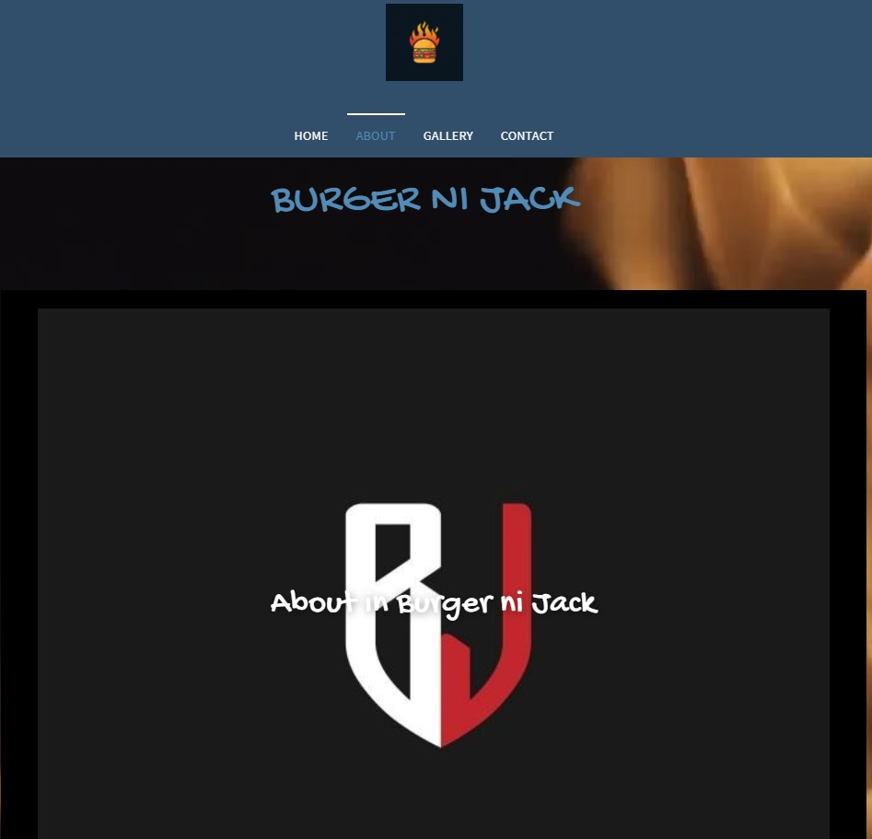

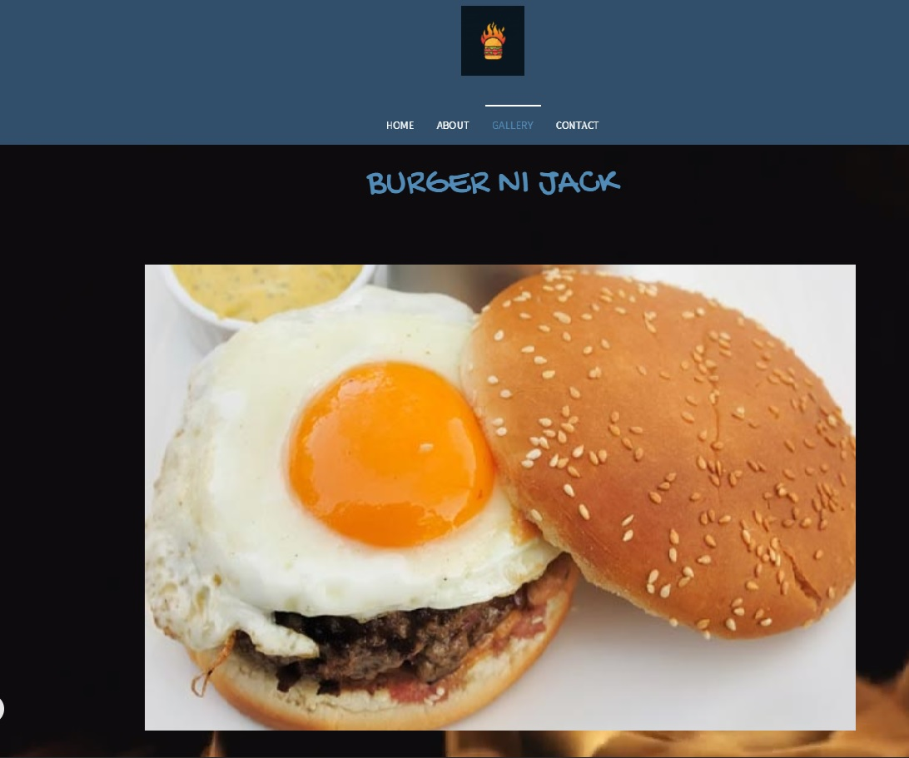

GALLERY

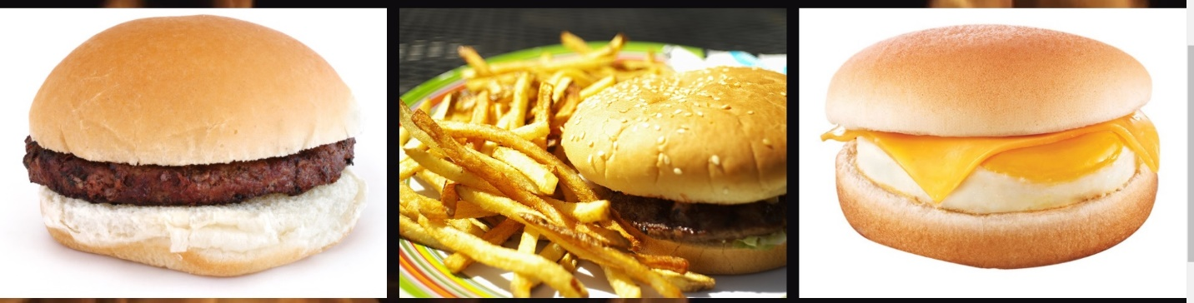

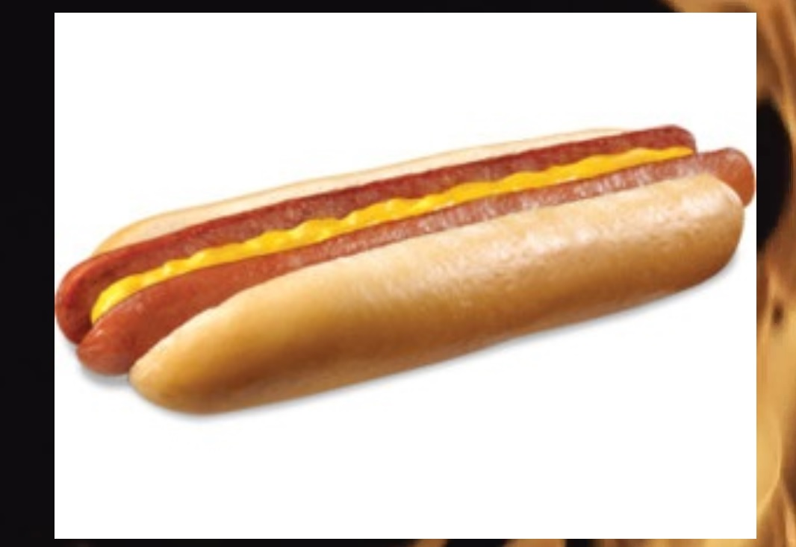

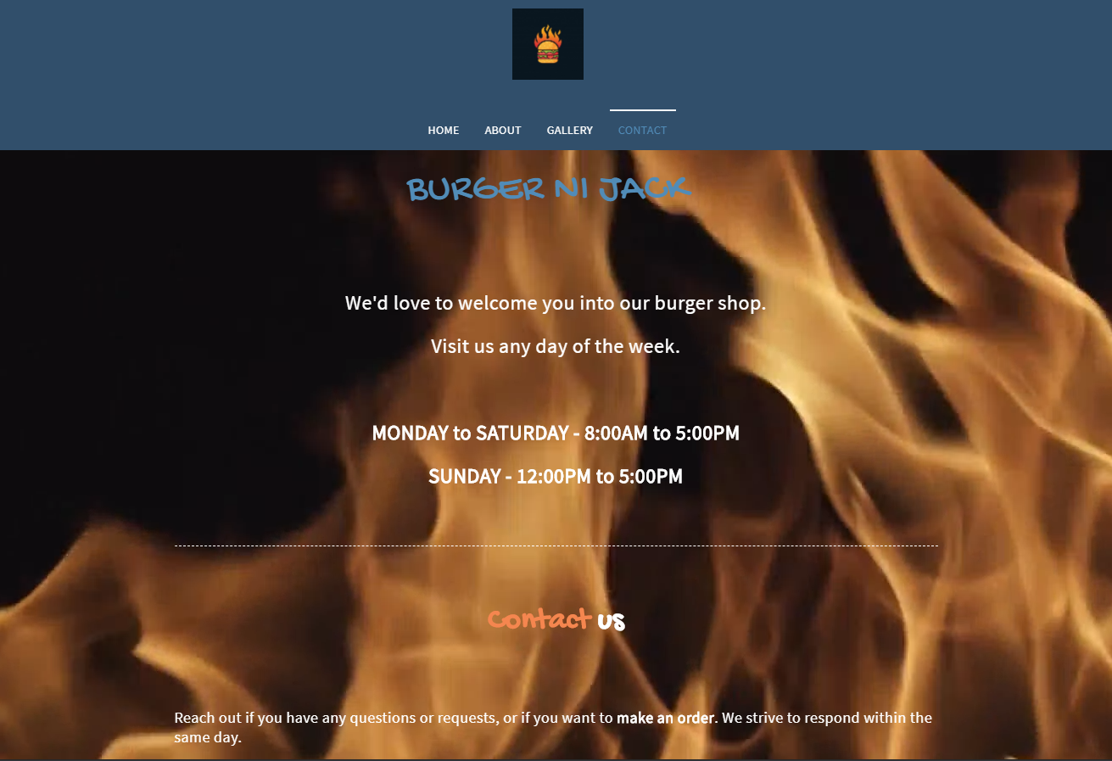

CONTACT

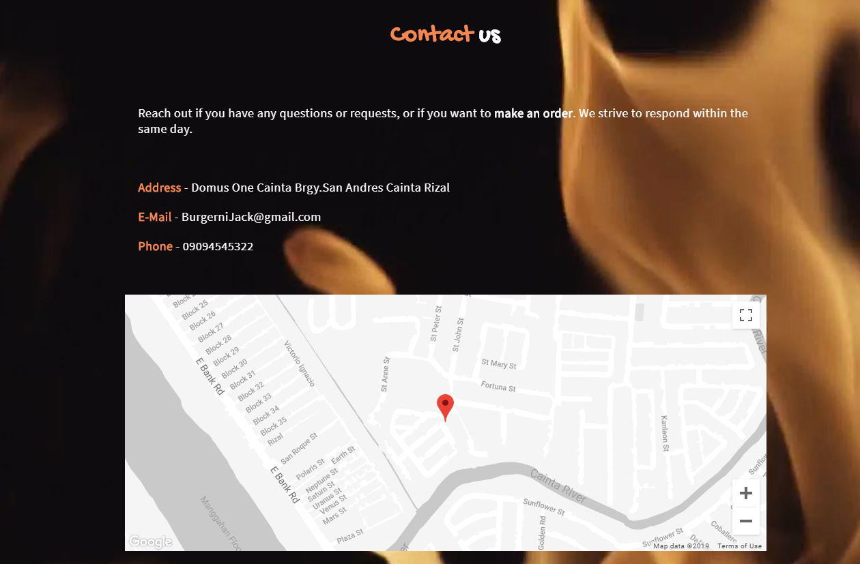

The Website I created is about Burger Business. I created this website because we have this kind of business in our house. I based the color of the website in the color of the ingredients of the burger. The home page where you can find just the logo and the name of the shop. Second is about that indicates the location and the picture of it. Third is Gallery where you can look our offered products in the shop, and last is the contact. If you having trouble in going our shop, there is a service number where you can contact us and we can help you to reach us out and solve your problem immediately.

This website is so simple, if you want to look at it you can search on your chrome [www.burgerko.simplesite.com](http://www.burgerko.simplesite.com) for you to explore at it.