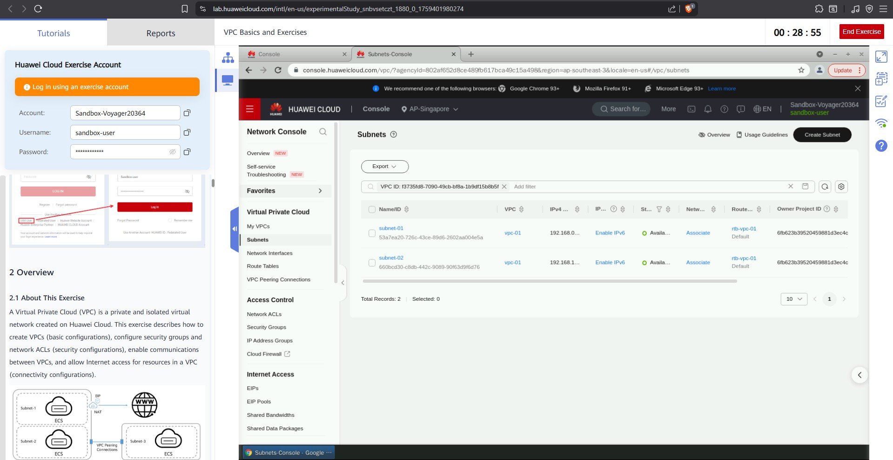9.

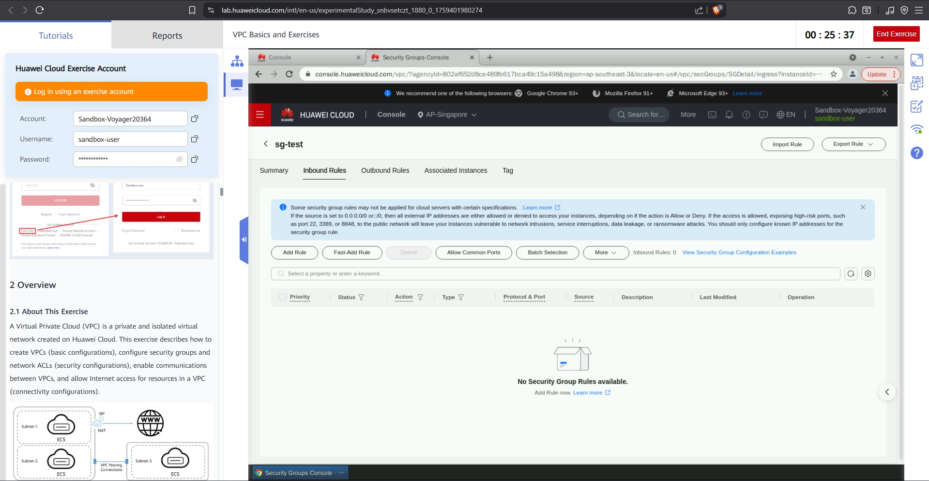15.

Part II

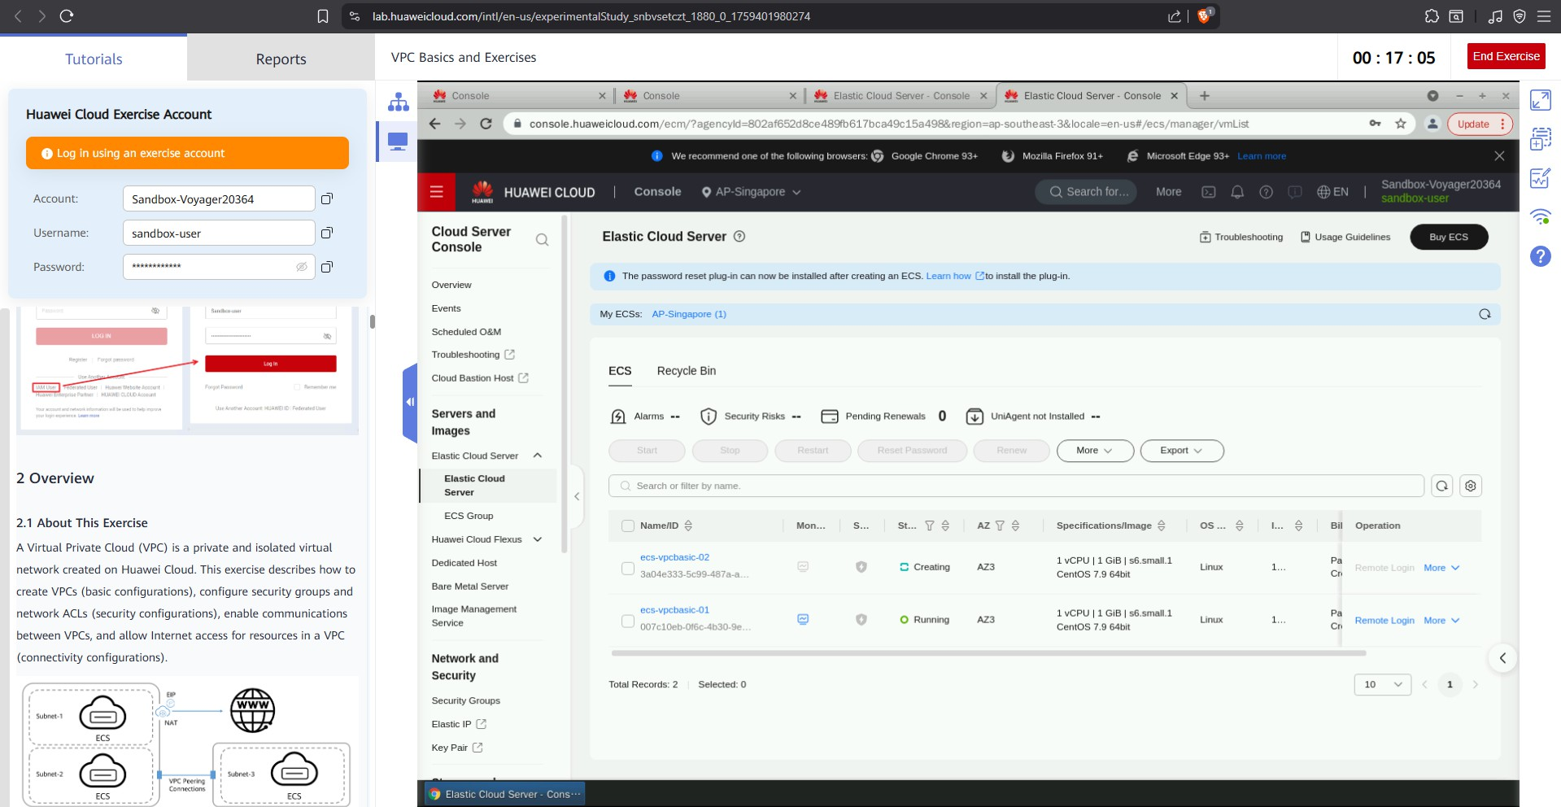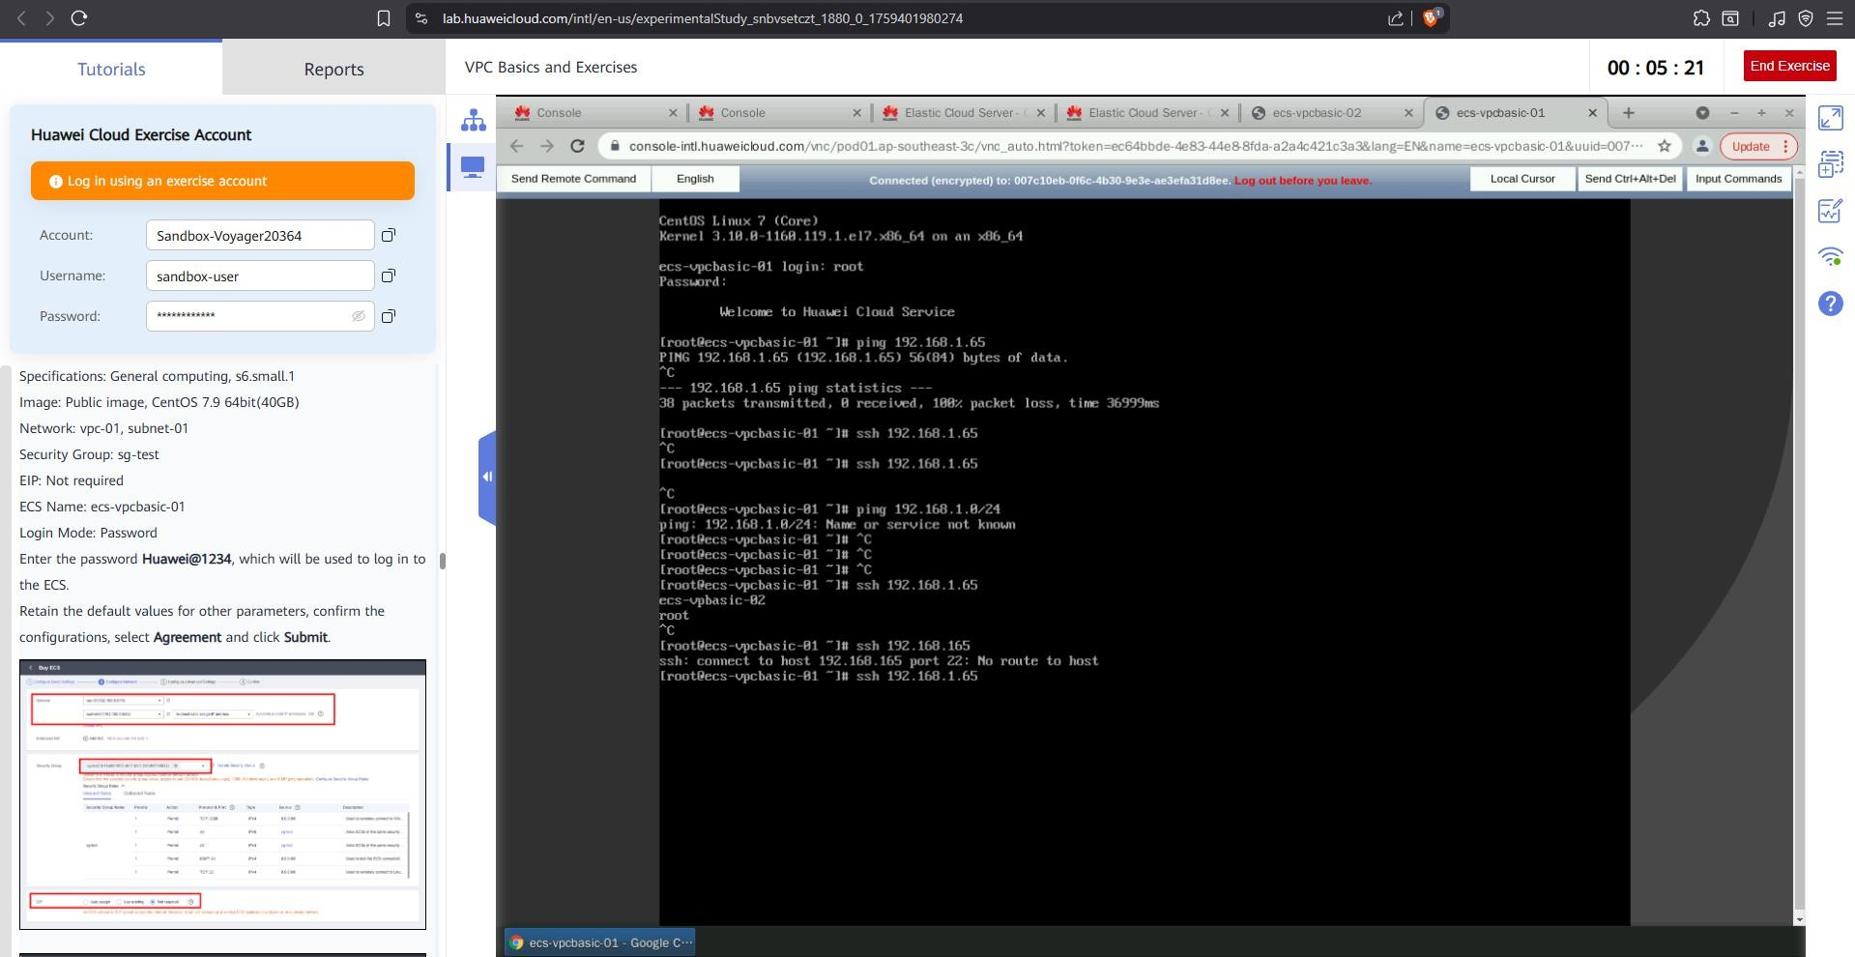5.

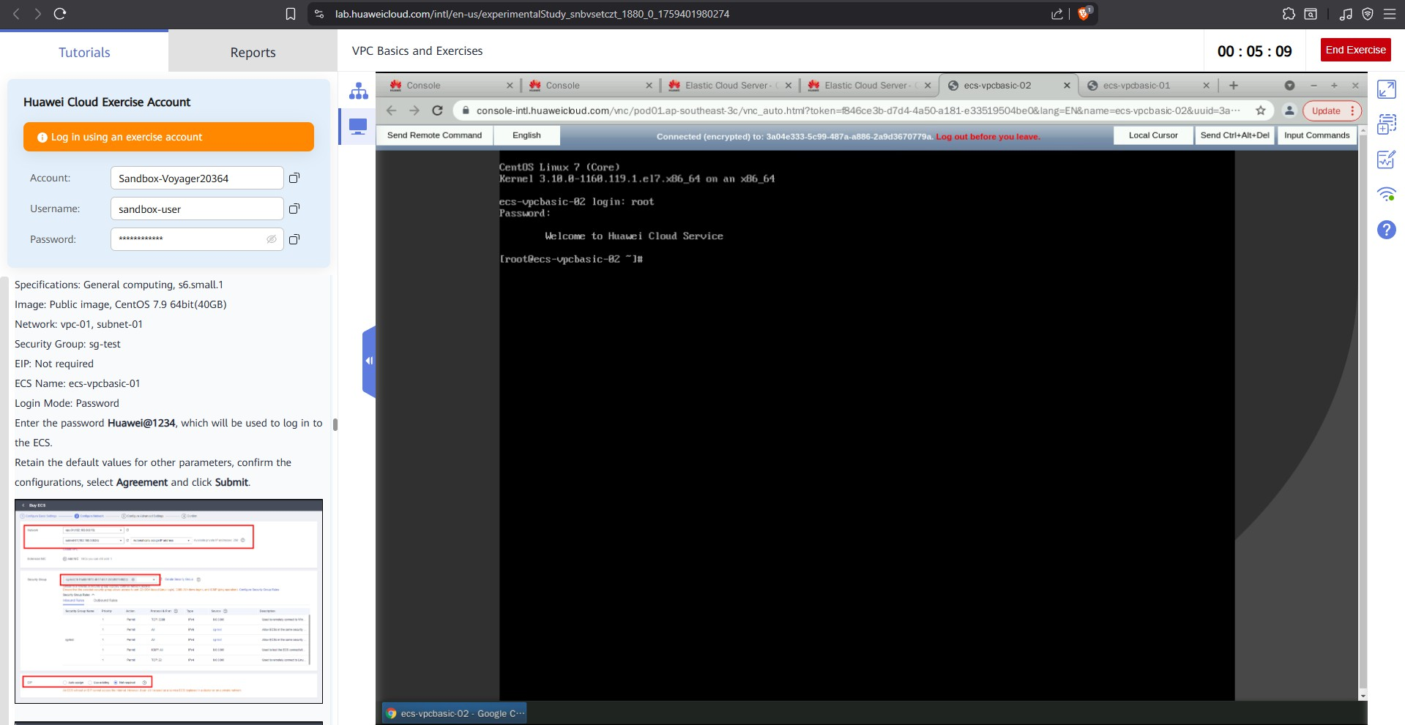

A security group is important because it acts like a virtual firewall that protects your servers from unwanted access. It controls what type of traffic can enter or leave your ECS, keeping your resources safe from hackers. By setting rules, you can allow only trusted connections and block harmful ones. This helps improve security while still allowing your applications to work properly.