
Developer’s manual and Installation manual

Introduction:
The IOCOMx device transmits and receives switch states between sender and receiver, and operates a relay based upon the state of the remote switch. An individual system is capable of both transmission and reception simultaneously.
Additional information may be found at: https://github.com/akostarinc/IOCOM8-Support

Communication Schematic
IOCOMx
IOCOMx
IOCOMx
IOCOMx
Ord # 1
Ord # 1
Antenna
Antenna
TxRx=1
TxRx=1
Ord # 2
Ord # 7
Ord # 8
Ord # 2
Ord # 7
Ord # 8
CAN Bus
CAN Bus
Sw 1 … 8
Sw 1 ..8
Sw 57 … 64
Sw 57 … 64
The IOCOMx system may consist of several, separate devices (modules). Each module can take care of eight individual channels, and up to eight modules can be grouped into a system. This results in total capability of 64 channels. If desired, less modules may be grouped.
The modules receive an ordinal number from configuration, and the ordinal number determines the range of switches this module will represent in the transmit / receive process.

Contents
Table of Contents
Introduction: 1
Communication Schematic 1
Contents 2
I/O allocation description 4
IOCOMx Pairing 5
Technical Details: 5
Simplified Specifications 6
Configuration Button codes: 6
Long Press for Manufacturer’s mode 6
Extra Long Press for deep Reset 6
Button Table 7
Pairing Recovery: 8
Pairing Diversity: 8
Button Based Configuration 8
Querying Configuration with the config button 8
LED indicator codes: 9
Web based Configuration 10
Web Page Setup, Enable Configuration 11
General Configuration: 11
Transmit Power Configuration: 11
Repeat Interval for the ON signal: 11
Repeat Count for the OFF Signal: 12
Network Name Configuration: 12
This part of the page was left blank intentionally 13
Can / Port allocation Page 14
Can Bus Parameters 15
Modes page screen shot 16
IOCOMx Transceiver; Advanced Settings 17
Receiver Configuration: 17
Receiver Logic Selection 17
Receiver Logic Selection list: 17
Modes Description 17
Timed-Off / Timed-On timer settings: 19
Re-trigger Settings 19
This part of the page was left blank intentionally 19
Web Page footers 20
The Command Line 20
The stat and mode commands 21
Stat 21
Mode 21
The Command Line, test and misc. items 23
System Commands 24
Power on process 24
Unexpected Remote power down process 24
Unexpected Local power down 24
The CAN bus 25
CAN Controls 25
The CAN bus, default functions 26
The CAN LED 26
External CAN Control 26
Possible multi control conflicts 27
Reading from / Writing to the CAN bus 27
Controlling local outputs from the CAN bus 27
Controlling remote outputs from the CAN bus 27
CAN control bits 27
IOCOMx CAN bus control via the supplied sample program 28
CAN Bus multi control 28
IOCOMx CAN bus control via the GUI sample program 29
Advanced CAN functions 30
Switch information from the CAN bus 30
Relay information from the CAN bus 30
CAN bus external read examples: 30
CAN read input states 30
CAN read output states 31
Terminology 33
Disclaimer 34
Appendix 1 35
Appendix 2 36
Software deployed for the examples 36
Hardware deployed for the examples 36
Multi platform Notes. 36
Useful Toolkit Keywords: 37
Summary 37

Document Versioning:
Release Name | Version | Initials
Initial Release of predecessor | 1.0 at Thu 29.Apr.2021 | PG
Initial Release of IOCOMx | 2.0 at Thu 15 Jul 2021 | CB PG
Document Additions | Mon 18 Oct 2021 | PG
First Release | Mon 1 Nov 2021 | PG

Firmware Versioning:
Release Name | Firmware | Initials
First Board | Wed 30.Jun.2021 | CB
Initial Release | Thu 15 Jul 2021 | PG
Ready for Product Release | Thu 4 Nov 2021 | CB PG

I/O allocation description
Up to eight IOCOMx modules can be grouped into one system. The following table contains the chart of modules and their corresponding port ranges.
Module Count | Ordinal | Port Total | Port Ranges
1 | 1 | 8 | 1-8
2 | 2 | 16 | 1-8; 9-16;
3 | 3 | 24 | 1-8; 9-16; 17-24;
4 | 4 | 32 | 1-8; 9-16; 17-24; 25-32;
5 | 5 | 40 | 1-8; 9-16; 17-24; 25-32; 33-40;
6 | 6 | 48 | 1-8; 9-16; 17-24; 25-32; 33-40; 41-48;
7 | 7 | 56 | 1-8; 9-16; 17-24; 25-32; 33-40; 41-48; 49-56;
8 | 8 | 64 | 1-8; 9-16; 17-24; 25-32; 33-40; 41-48; 49-56; 57-64;

The IOCOMx receives and decodes signals, and pulls / releases relays based upon the content of the received transmission. The transmission is omnipresent, the reception is selective. This permits that any number of receivers can listen to the transmitting device. It also permits that additional tools to be deployed, which may monitor communications for expansions; ex: like statistics / accounting.
The IOCOMx communication is encrypted, without the proper key and decryption algorithm it is not feasible to decode communications. The communication is also marked by a hash (signature), which makes it secure against tempering. The IOCOMx uses state of the art - industry accepted - algorithms, that are known to be secure and unbreakable at the time of this writing. (Oct, 2021)
There are no system coexistence limits, multiple systems may be deployed in the same airspace. Up to eight IOCOMx modules can be connected to a single bus in a single system.
Please Note that the terms relay on / relay closed is used for ‘relay energized’ and relay off / relay opened is used for relay ‘de-energized’; The words button / switch / input are used interchangeability and denote user input.

IOCOMx Pairing
The IOCOMx system comes paired from the manufacturer. Should (re) pairing be needed, Double click (press 2 times) the configuration button on the face of the Transmitter unit, and triple click (press 3 times) the configuration button on the Receiver unit. The devices will communicate and pair. (Note: the timing of the clicks is similar to the mouse ‘double’ click, but instead of two clicks, click it two or three times)
During the pairing process, the unit's config LED will flash on and off. When the Receiver is successfully paired the pairing LED will flash rapidly five times. If no pairing request is completed, the pairing mode will time-out in 15 seconds.
Note, that this configures the communication one way, from transmitter to receiver. If you would like to configure the devices for bi-directional communication, repeat the process with the order of double click / triple click reflecting the reverse communication direction.
If the receiving unit has no pairing space available (already paired four units) the LED One and LED Two will strobe for 5 seconds.
The pairing process will time out in 15 seconds if no valid pairing information was received. One may retry the pairing process any number of times.
The receiver cannot be paired if the number of devices has reached the pairing limit (the limit is currently: four) The transmitter has no pairing limit.
If you encounter difficulty during the pairing process with the Receiver, long press the configuration button for 10 seconds, and the device will clear all pairing data. This allows a *fresh start for all pairing related operations.
*Note that after the long press all the other devices that where paired to this receiver need to be re-paired, and all modes reed to be reconfigured.

Technical Details:
Encryption and Checksum:

The IOCOMx system communicates with an encrypted data stream. Listening to the data with external devices yields the appearance of random data. As every packet is different, the operational intent is not decipherable without the correct encryption key. The data packet is also protected with a hash / checksum and will reject packets with an invalid checksum.

Simplified Specifications
Name | Description | Notes
Power Input | 110 V AC | Nominal; Versions for 220 / 240 available upon request.
Relay Ratings | 240 V AC, 10 A | With resistive Load
Transmission Distance | 500 feet (150 Meters) | Measured open air, line of sight
Sensor / Switch Input | 110 V AC (Max 240 / 450) | Rated at 110 V AC, tolerant to higher voltages.

Configuration Button codes:
The configuration button can be used to set up most aspects of the IOCOMx system. Even though, the web configuration is much easier to work with, in a few instances, a suitable device may not be available. Button configuration has multiple functions, described below.
A single click wakes up the system, if it is in sleep mode, otherwise it is a no-op (does nothing). A double click starts the pairing process on the transmitter. The pairing process times out in 15 seconds. A triple click starts the pairing process on the receiver side.
This has similar properties as the transmitter counterpart, times out in 15 seconds. A quad click (4 clicks) starts the configuration web page. A second set of quad clicks stops the web configuration process. The web configuration mode stops if there is no web activity for one minute. A Penta click (five clicks) reboots the device.

Long Press for Manufacturer’s mode
Press and hold configuration button for three+ seconds to set the device into manufacturer's mode. In this mode the self test functions and configuration functions become available. Another press and hold will put the device back into its regular mode. Reset and and power cycle will also put the device into normal (communications) mode. The below table references this as Manufacturer's mode.

Extra Long Press for deep Reset
Press and hold configuration button for ten+ seconds to reset the device to manufacturer's defaults. The parameters are reset to their original values, and the Network Name is reset to IOCOM-XXXX where XXXX is part of the MAC address of the device. The network password is reset to 12345678 and all the pairings are erased. One may need to re-pair all previous clients to this unit.

Button Table
Clicks | No. of  clicks | Needs  MANUFACTURER  mode** | Function  Description | Notes
Single Click | 1 | N | No-Op | Does nothing
Double Click | 2 | N | Start pairing | Initiate pairing on the Transmitting side
Triple click | 3 | N | Start listening for pairing | Initiate pairing on the Receiving side
Quad Click | 4 | N | Start configuration | Start on-board configuration Web server
Penta Click | 5 | N | Reboot. The term restart is also used. | Restart the IOCOMx device, soft restart.
Hexa Click | 6 | Y | Start relay test. Relays click one by one ON in succession then click OFF. | Manufacturer / Installer test procedure. This function will cycle one time, and the device resumes normal operation.
Septa Click | 7 | N | Start input to output mirror. This function will reset on restart. | The state of the inputs are mirrored are mirrored onto the output relays.
Octa Clicks | 8 | Y | Switch all relays on. | For testing. This function will reset on restart.
Nine Clicks | 9 | Y | External regression test. This function will reset on restart. | Start the ‘Set – Expect’ cycle. This function is beyond the scope of this manual. See test wire harness in the Appendix.
Ten Clicks | 10 | Y | Start ORD Config, set ORD config mode. | After ORD config mode is activated, the number of presses becomes the ordinal.
Eleven Clicks | 11 | Y | Toggle TxRx | The TxRx flag is toggled; ON will flash LED-s for longer, off will flash LED-s for shorter.
Twelve Clicks | 12 | N | Blink out Ord number | The LED-s blink ordinal number of times. If the ordinal is ZERO, the LED strobes momentarily.
Thirteen Clicks | 13 | N | Blink on TxRx on/off | Strobe LED One on OFF state or strobe two LEDs (Led1 Led2) on ON state
** Also referred to as MANU mode for brevity

Pairing Recovery:
A long press of 10 seconds will reset the device to manufacturer's defaults. Network Name is reset to IOCOM-XXXX and the network password is reset to 12345678. All pairings are lost, and need to be re paired.

Pairing Diversity:
The IOCOMx can be paired with four other devices. With the IOCOMx transceiver device, the pairing direction is established by the button press order: the double click prompts the unit internally as the Transmitter pairing initiate, the triple click is Receiver paring initiate. As one IOCOMx device can accommodate four paired devices, it is possible to configure many combinations of control networks. For instance, up to four transmitters can be configured to control one receiver. In another instance, one transmitter may control four (or more) receivers simultaneously. The combination of control is not limited in any way beyond the receiver's maximum pair count.

Button Based Configuration
While it is much easier to configure the IOCOMx on the web configuration pages, the IOCOMx may be configured with a combination of button presses.
First some basic concepts. a.) The manufacturer’s mode. The device can be set to this mode by clicking and holding the configure button for 3+ seconds. It acknowledges this mode by rapidly flashing LED1 and LED2. This mode does not do anything specific, but enables the changing of the parameters.
b.) The deep reset. If there is anything objectionable in the IOCOMx configuration process, one can start over by executing the deep reset. This is done by holding the configuration button for 10+ seconds. The device is restored to its original, manufacturer’s state.
c.) The soft reset. Resetting the device by pressing the configuration button five times will reboot the device into its default state. This may be useful if one cannot remember or uncertain of the device’s current state. This may also be achieved by a power cycle.
d.) The ordinal setting mode. This is a mode that allows the setting of ordinal number. The steps needed are as follows: 1.) Set the device into manufacturer's mode. 2.) Press the config button 10 times. The LED4 will blink. Press the configuration button as many times as the desired ordinal. Valid ordinals are one to eight. If more button presses are detected, the unit silently ignores the wrong number, and exits from ordinal mode.

Querying Configuration with the config button
The configuration button can also show current parameters. These functions are available
in every mode.

a.) Pressing the button twelve times in succession will blink out the current ordinal. One blink for ordinal one, two blinks for two, and so forth. A freshly manufactured (not yet configured) IOCOMx will have an ordinal of zero, but instead of zero blinks, it strobes momentarily.
b.) Pressing the button thirteen times in succession will blink out the TxRx status. Short strobe
with one LED for TxRx OFF status, long strobe with two LEDs for ON status.

LED indicator codes:
The indicator LEDs have multiple functions. Each LED blink combination represents an event or state. In their fundamental function, an LED will flash when an event occurs. For instance, the RF LED flashes when an RF packet is received. The CAN LED will flash when a CAN packet is received.
The config LED has multiple functions as well. If the device is in pairing mode the LED will flash on and off during pairing process. If the device is in Configuration / Web mode, the LED will flash slowly on and off during Configuration / Web mode. If there are any error conditions, the LED will flash rapidly for a short period of time. (LED strobe mode)
On self test functions, the LEDs follow a blinking process, described in the self test chapters. On manufacturer’s functions the LEDs follow the manufacturer’s blinking process, describe in the configuration chapter.
On power up, all the LEDs lit up momentarily, and one by one the LEDs go out. This allows the confirmation of all LEDs operational state.

This part of the page was left blank intentionally

Web based Configuration
The IOCOMx device can be configured from a web interface. Pressing the configuration button four times will start the on board configuration web server. (quad click) One can connect to this web page via a WiFi access point, under the IOCOM-NNNN name. (NNNN being a unique id for this unit) Please note that every board has its own configuration page.

Below is a partial screen shot of the web interface’s first page.
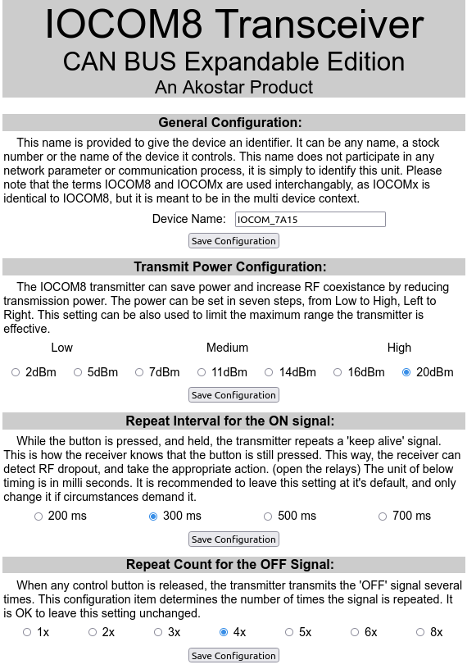 | On the screenshot to the left, pictured are the default settings of the device. They are chosen carefully to match most situations the device may be required to do.  Device Name: this setting is to identify the device. A good name may be the device the IOCOMx is connected to. Like: Crane_1. This setting has no effect on operation.  No change needed here, unless limited range is desired.  No change is needed here, unless slower or faster response is required.  No change is needed here, unless the off signal needs more repetition for safe off state communication.

Web Page Setup, Enable Configuration
The IOCOMx system starts up in transmit / receive mode. To enter configuration mode, quad click the configuration button. (click 4 times) The timing of the clicks are similar to the mouse ‘double’ click, but instead of two clicks, click it four times
The LED will flash on and off slowly to signify that the device is in configuration mode. One may connect to the device's web page, and configure it. If no web communication activity occurs in one minute, the device will terminate the configuration mode, and - after self reboot - resumes in communication mode.

General Configuration:
The IOCOMx device can be named, and this name is provided to give the device an arbitrary identifier. It can be any name, a stock number or the name of the device it controls. This name does not participate in any network parameter or communication process, it is simply to identify this device. A good name choice is the name of the equipment it controls. Changing this name is optional. Please note, that this name may participate in internet connectivity in future versions.

Transmit Power Configuration:
The IOCOMx transmitter can limit its range by reducing transmission power. The power can be set in seven steps, from Low to High, Left to Right.
Low Power | Medium Power | High Power
2 dBm 5 dBm | 7 dBm 11 dBm 14 dBm | 16 dBm 20 dBm

Repeat Interval for the ON signal:
While the button is pressed, and held, the transmitter repeats a 'keep alive' signal. This is how the receiver detects that the button is still pressed. The timing of the interval is in milliseconds. The default is 300 ms.
Manufacturer’s defaults are chosen to work in most situations. One may change this to accommodate a variety of conditions. This setting auto adjusts the 'Auto Release' timing of the receiver to match the transmitter’s delay configuration.
200 ms | 300 ms | 500 ms | 700 ms
Please remember to press the ‘Save Configuration’ button to commit your changes. All Save buttons save items for the whole page.

Repeat Count for the OFF Signal:
When a control button is released, the transmitter transmits the 'OFF' signal several times. This configuration item determines the number of times the signal is repeated. Manufacturer’s defaults are chosen to work in most situations.
1x | 2x | 3x | 5x | 6x | 8x
This setting can be set between 1-8, the factory default for this option is set to 3. Set it to larger values if lost packets are encountered or anticipated.
Please remember to press the ‘Save Configuration’ button to commit your changes. All Save buttons save items for the whole page.

Network Name Configuration:
The network name configuration fields determine the Station Name and Password of this IOCOMx. The device will appear on your WiFi network by this name. For safety and security, the IOCOMx may be configured with a password. The password needs to be at least 8 characters or longer. Please avoid using space, punctuation marks and non ASCII characters. You may use the _ (underscore) - (minus sign) and the + (plus sign). Please note, that the IOCOMx network name and network password is set in one go.

This part of the page was left blank intentionally
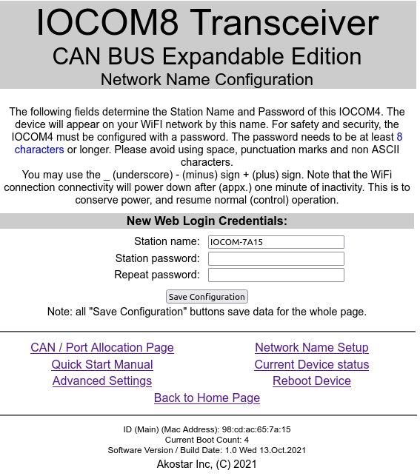 | If you encounter difficulty during the password change process, a long press on the configuration button (press and hold for appx. 10 seconds) will reset the receiver and will clear all passwords. This reset will also clear the pairing data, the existing pairings will need to be re-paired.

This part of the page was left blank intentionally

Can / Port allocation Page
The IOCOMx will Send / Receive data via its RF transceiver. This page allows one to configure which board in the stack is dedicated to transmit / receive. Naturally, the board to be dedicated needs to be equipped with the proper cable / antenna, other than that any of the units can be elected to be the transmit / receive board. This may come handy in an outage, simply reconfigure a different board to be the TxRx board.
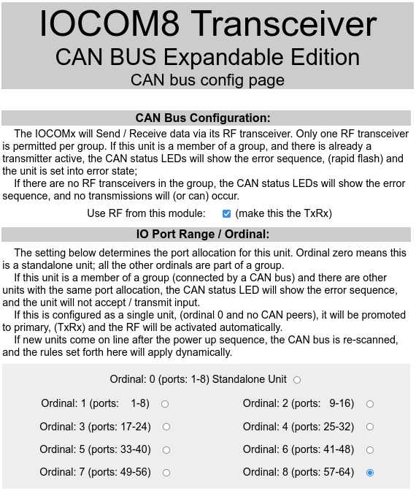 | Dedicate this board as TxRx. Please note that only one board per stack may be dedicated as such.  The ordinals may be discontinuous, provided that there are matching ordinals on the sending / receiving end.  The manufacturer’s reset will default to board zero. (IOCOM 8 standalone unit)

This part of the page was left blank intentionally

Can Bus Parameters
The CAN bus features can be controlled from this section.
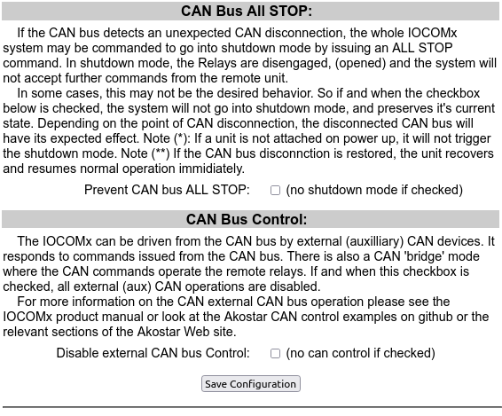 | The CAN bus has an integrity check feature, where the bus is monitored. If a CAN disconnection is detected, all the relays are de-energized.  If this behavior is not desired, and the unit should not go into shutdown mode, check the button to disable this ‘All Stop’ feature.  The IOCOMx can be controlled from an external CAN bus. It is enabled by default. This setting will disable it.

This part of the page was left blank intentionally

Modes page screen shot
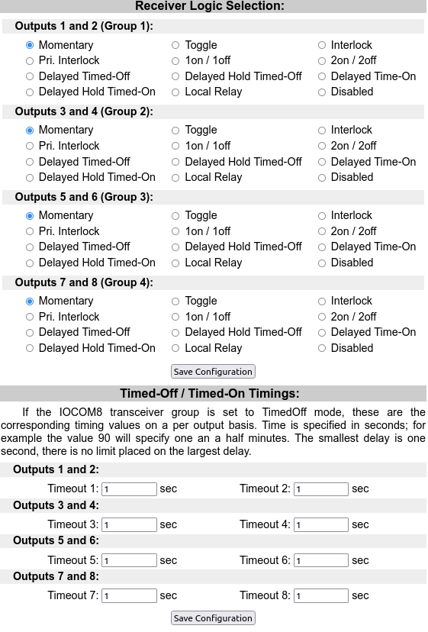 | All the relays / outputs default to momentary mode. This is when the user presses the button, and the relay closes, the user releases a button and the relay opens.  The toggle mode is also a frequently used one. This is where one press / release cycle turns the button on, and the next press / release turns the button off.  Here the delays are configured to one second,  to allow quick testing of the functionality.

IOCOMx Transceiver; Advanced Settings

Receiver Configuration:
The IOCOMx transceiver controls momentary switches by default. The control may be configured to respond in different manners, one pair/group at the time. The grouping is maintained in pairs, for instance ‘Group One’ is Input one and Input two -- with: Relay one and Relay two; ‘Group Two’ is Input two and Input three with Relay two and Relay three .. etc.

Receiver Logic Selection
The receiver can respond to button presses with a variety of actions. These actions depend on the mode that is set on that configuration page. There are a multitude off modes available, below, is a list of the currently available modes.
Please note: that the term relay on / closed is used for ‘relay energized’ and relay off / opened is used for relay ‘de-energized’; The words button / switch / input are used interchangeability, denoting user input

Receiver Logic Selection list:
The following modes are available:
Function | Number | Function | Number | Function | Number
Momentary | 1 | Toggle | 2 | Interlock | 3
Pri. Interlock | 4 | 1on / 1off | 5 | 2on / 2off | 6
Delayed Timed-Off | 7 | Delayed Hold Timed-Off | 8 | Delayed Time-On | 9
Delayed Hold Timed-On | 10 | Disabled | 11

Modes Description
a.) Momentary:
When a Button is pressed, the corresponding Relay is closed, when the Button is released, the Relay opens.
b.) Toggle:
When a Button is pressed the Relay closes, when a Button is pressed again, Relay opens.
c.) Interlock:
Only one of the group outputs are active at any one time; if both Inputs are present, no output is on. This mode is likely used in case of directional control, like forward and reverse; with safety switch off if unexpected button combination is detected.
d.) Pri. Interlock: (Priority interlock)
Only one of the group outputs are active at any one time, if a second Input becomes active, the output which is already active has priority and stays on. This mode is likely used in case of directional control, like forward and reverse; with preserving current action on unexpected button combination.
e.) 1on1off:
Button 1 of the group turns the Relay on, Button 2 of the group turns the Relay off.
f.) 2on2off:
Button one and two pressed together turns on Relay 1 and Relay 2; Button one and two pressed together again turns the Relay off. Most likely used when extra safety is needed for the operation.
g.) On Timed Off:
The Buttons turn the corresponding Relay on, and after a set amount of time, the Relay automatically turns off. The delay time can be specified below, individually on a per Input basis.
h.) On Hold Timed Off:
The Button turns the corresponding Relay on, and on Button release, the hold timer starts, which holds the Relay for a specified amount of time. after which, the Relay automatically turns off.
i.) Timed ON:
When a button is pressed, a timer starts. When the timer is expired, the corresponding Relay will close.
j.) Hold Timed On:
Button is pressed, and then, when released a timer starts. After the timer is expired, the corresponding Relay will close.
k.) Disabled:
The corresponding group's Relays will not activate;

Timed-Off / Timed-On timer settings:
If the IOCOMx transceiver group is set to TimedOff mode, these are the corresponding timing values on a per output basis. Time is specified in seconds; for example the value 90 will specify one an a half minutes. The smallest delay is one second, and there is no limit placed on the largest delay. Following, is the default timeout setting:
Output Number | Timeout Value | Timeout Value
Outputs 1 and 2: | Timeout 1: One sec | Timeout 2: One sec
Outputs 3 and 4: | Timeout 3: One sec | Timeout 3: One sec
Outputs 5 and 6: | Timeout 5: One sec | Timeout 6: One sec
Outputs 7 and 8: | Timeout 7: One sec | Timeout 8: One sec

These settings do not represent any practical value or recommendation, they where meant as quick test or demonstration of the device’s capability.

Re-trigger Settings
If a group is set to 'Delayed Timed On' or 'Delayed Timed Off' mode, the individual Inputs can be configured to re-trigger. This way the duration of the timer can be extended during the hold interval. When the particular Output's box is checked, the timing delay of the Output is expanded like a new timer cycle has started. The re-Trigger mode defaults to OFF, the particular timer is unaffected by successive button presses.

Output Number | Re-trigger Value | Re-trigger Value
Outputs 1 and 2: | Re-trigger 1: disabled | Re-trigger 2: disabled
Outputs 3 and 4: | Re-trigger 3: disabled | Re-trigger 4: disabled
Outputs 5 and 6: | Re-trigger 5: disabled | Re-trigger 6: disabled
Outputs 7 and 8: | Re-trigger 7: disabled | Re-trigger 8: disabled

This part of the page was left blank intentionally

Web Page footers
The web page footers contain useful information about the device itself. The MAC address acts as a globally unique identifier. The Software Version / Build date identities the firmware used in this device. The footer also contains the boot count of the device, which signifies how many times the unit was power cycled. Below is an example footer for an IOCOMx device.
ID (Main) (Mac Address): 98:cd:ac:65:7a:15
Current Boot Count: 5
Software Version / Build Date: 1.0 Fri 20.Aug.2021
Akostar Inc, (C) 2021

The Command Line
The IOCOMx has a serial port on board, that may be used to monitor, configure and operate the device. There is a mirror of all the web functionality, as well as additional commands. Some commands have aliases, which are listed with the command. The following commands are available:

Command | Function | Description | Notes
ord, ordinal, | The position in the stack of CAN connected devices. | 0 = No other device, in standalone operation  1-8 Position on the stack | Must match between sender / receiver.
show | Show paired items | Empty items represented with zero | Mac address of the units paired (see id command)
list | List mode names and mode numbers | For textual context | Configuration helper
pair | Start the pairing process | This command is equivalent of the triple press | 15 sec timeout, or successful pair; whichever comes first
stat, ls, | Show device’s status and configuration | Some testing related items shown as well | The device’s main configuration
Conf | Show device’s configuration | Ordinal, mac, | The device’s abbreviated configuration
reboot | Reboot device | Optional | Resumes normal operations in approximately 800ms
web | Start configuration web server | Equivalent of the quad click | Identical to the four button press action
mode | The output modes | Four groups of two relays | See ‘Modes’ section for more information
txrx | Toggle TX / Rx flag | Allow RF transmission; one unit per stack | At least one unit of the stack in TxRx mde
trig | Re trigger if button pressed while in delay operation | Defaults to OFF | With retrigger enabled, the operation timing restarts like a new cycle
verbose, v | Terminal verbosity | Control the amount of information that goes to the terminal | Verbose defaults to 1; 0 = none 1 = some 2 .. 9 = more info,
allon, alloff | Switch all relays ON / or switch all relays OFF | Mainly for testing | Reboot erases the effect (IOCOMx starts with all outputs off)
id | Show device ID | Basic device info | Same ID used in pairing

The stat and mode commands

Stat
Issuing the stat command results in the following output:
TX params: Repeat Interval: 300 ms
Repeat count: 3 times
RF Power: 20 dBm
TxRx function: 1
Ordinal number: 8
My pairing val: ac:65:7a:15
Modes: Group=0 Mode=1 -> 'Momentary'
Group=1 Mode=1 -> 'Momentary'
Group=2 Mode=1 -> 'Momentary'
Group=3 Mode=1 -> 'Momentary'
Timeouts: ch0=1sec ch1=1sec ch2=1sec ch3=1sec
ch4=1sec ch5=1sec ch6=1sec ch7=1sec
ReTriggers: ch0=0 ch1=0 ch2=0 ch3=0
ch4=0 ch5=0 ch6=0 ch7=0

Please note that the mode lines are zero based on the command line, one based on the web interface. The web interface was crafted to address non technical users, the command line addresses reality as it is.

Mode
The mode command with no arguments yields the following output:

Current modes:
Group=0 Mode=1 -> 'Momentary'
Group=1 Mode=1 -> 'Momentary'
Group=2 Mode=1 -> 'Momentary'
Group=3 Mode=1 -> 'Momentary'

To change a mode, one specifies the group number and the mode number. The mode number can be derived from the table that is presented by the ‘list’ command.

List of modes:
Mode= 1 -> 'Momentary'
Mode= 2 -> 'Toggle'
Mode= 3 -> 'Interlock'
Mode= 4 -> 'Pri. Interlock'
Mode= 5 -> '1on / 1off'
Mode= 6 -> '2on / 2off'
Mode= 7 -> 'Delayed Timed-Off'
Mode= 8 -> 'Delayed Hold Timed-Off'
Mode= 9 -> 'Delayed Time-On'
Mode=10 -> 'Delayed Hold Timed-On'
Mode=11 -> 'Local Mode'
Mode=12 -> 'Disabled'

For example, to change the mode of group 0 to ‘toggle’ issue the following:

mode 0 2

To change all group modes ‘2 on 2 off’ issue the following commands:

mode 0 6
mode 1 6
mode 2 6
mode 3 6

The mode commands take effect immediately, and remembered across boots permanently, until explicit change or long press reset.

This part of the page was left blank intentionally

The Command Line, test and misc. items
The IOCOMx has a serial port on board, that may be used to monitor, configure and operate the device. The following commands are available:

Command | Function | Description | Notes
erase | Manufacturer’s reset |  | Restores original state
dumb | Switch the terminal to dumb mode | The serial port can act as the device controller | This removed the escape sequences from the communication for machine controllable input / output.
dump, candump, | Show device and CAN bus details | Dated, use the cango and rfgo commands | Obsolete
allanim | Turn relays on sequentially, then off sequentially | For manufacturer's test | Mainly for testing
monin | Monitor input | Prints a list of switch states on the controlling terminal | Does not prevail on device reboot
cango, cango2, | Show CAN bus activity on debug terminal | For use with debug and troubleshooting, verbose setting determines message depth | cango for receive operations and cango2 for send operations
rfgo, frgo2, | Show RF activity on the debug terminal | For use with debug and troubleshooting, verbose setting determines message depth | rfgo for receive operations and rfgo2 for send operations
in2out | Switch the in to out node on | Button presses are mirrored onto the relays | Resets to normal mode on reboot, does not prevail.

System Commands
The system commands are not essential to everyday operations, however they are kept in case for the need of further troubleshooting.
Command | Function | Description | Notes
free | Show available memory | Memory level | For testing
heap | Show min available memory | Low watermark | For testing
version | Chip used | Major / Minor versions
restart | Same as the reboot |  | Issued at chip level
tasks | Task currently running | Show system details | Internal to the OS

Power on process
The IOCOMx device powers on quickly. The initialization of the on-board microchip, the RF subsystem and the CAN subsystem completes well under one second.

After the initialization, the IOCOMx scans its inputs, and transmits the current input state to the remote unit. The remote unit then activates the appropriate outputs / relays. If this one second power up delay is longer than desired, it is plausible to keep the IOCOMx units powered up continuously.

Unexpected Remote power down process
If the remote unit loses power, the outputs will de-energize. Upon successive power-up, the remote units will receive the local unit’s state at the first repeat cycle. (default is 300 milliseconds) The remote unit’s power up procedure is boot-up time + 300 ms.

Unexpected Local power down
If the local unit loses power, the outputs on the remote unit will de-energize. Upon successive power-up, the remote units will receive the local unit’s state at the first forced repeat cycle. The local unit’s power up procedure is boot-up time + 100 milliseconds.

The CAN bus
The IOCOMx devices individually can control up to eight I/O ports (relays). In order to control more ports, one may chain them into a larger set via the built in CAN bus.
IOCOMx#1
IOCOMx#2
IOCOMx#2
IOCOMx#...
CAN Bus
Ports: 1-8
Ports: 9-16
Ports: 17-24
Ports: ...
The IOCOMx built in CAN bus may connect multiple IOCOMx devices to send receive data for up to 64 channels. (eight units) The IOCOMx devices must be configured to cooperate on the bus. They all have to have a unique Ordinal, and one - and only one – unit has to be marked as the TxRx unit. If these criteria are not met, the CAN LED will light up in an error sequence.

CAN Controls
The IOCOMx system comes pre - configured from the manufacturer, so the following description is needed only if new units are connected. For example in case of extending the bus, or to assist in troubleshooting.

The IOCOMx system relies on the build in CAN bus to connect multiple IOCOMx devices to send receive data for all 64 channels. The CAN will detect mis - configuration and alerts the user if:
- No IOCOMx module is marked as a TxRx unit
- More than one module is marked as a TxRx unit on the same bus
- More than one IOCOMx module occupies the same ordinal

If the CAN bus detects any of these errors, the CAN LED is on for a longer duration, and blinks OFF for a short period of time. This pattern is different from normal operation, as the normal operation is short on and longer off. Additionally, the error condition is shown on the configuration web page, as well as a command line message is issued on the controlling terminal.

The CAN bus, default functions
The CAN bus communicates between the IOCOMx devices. In its idle state (Ordinal 0) no communication takes place. If the Ordinal is not zero, the CAN bus may emit a heartbeat signal, verifying the integrity of the connected IOCOMx configurations.

The CAN LED
The CAN LED blinks when CAN bus receive activity occurs. The CAN bus is active if and when one of the following events occur: 1.) An input is operated (button press) 2.) A remote signal arrives that operates the output (remote button press) 3.) External CAN Signal received.

External CAN Control
The CAN bus can control all the relays, both local and remote. The control message IDs are:
MSG_RELAYS 0x19EE5503 // Control local relays
MSG_BRIDGE 0x19EE5504 // Control remote relays
The data format of the control is the standard 8 bytes, with extended message ID and 250 KBit bus speed. The first four bytes of the data are significant. The second four bytes may contain arbitrary values, except the CAN2Relay packet contains the repeat period in milliseconds.
BYTE POSITION | DESCRIPTION | NOTES
Byte_0: | Bit Mask of the Switches | 0 = OFF ; 1 = ON  In many places this is called the payload
Byte_1: | Bit Mask of Controls | Which bits to operate on; ex: 0xFF means operate on all bits. 0x1 means operate on bit one. The bit mask allows control from multiple sources.
Byte_2: | Ordinal | Address of the board; values are 1-8, all other values are discarded as invalid data. Ordinal 0 is reserved for standalone board.
Byte_3: | Checksum | Byte_0 XOR 0x55 – Packets that have invalid checksum are discarded.

Possible multi control conflicts
The IOCOMx can be controlled from multiple sources. The bit mask allows operation on specific bits at a time. For instance, the mask 0xF0 operates on the bits 4-7, and the mask 0x0F operates on bits 0-3. It is perfectly normal, - for example - to control some bits from CAN and some bits from RF.
In the IOCOMx, there are no arrangements made to coordinate controls, every command is obeyed from every source. It is the user’s (installer’s) responsibility to coordinate this control. The general rule of control effect is that the last control prevails. For instance switching an output ON from RF, and then switching the same output OFF from CAN, will result in the last controlled state prevailing.
In general, the order of switching (and control) is decided by the control equipment that is attached to the IOCOMx. It is the user’s and installer’s sole responsibility to maintain safe operation, hereby, all liability is disclaimed for the operation IOCOMx.

Reading from / Writing to the CAN bus
The IOCOMx’s CAN interface can receive instructions and control commands from the CAN bus, as well as emit switch information and emit relay information.
The IOCOMx attempts to be a standards compliant. The CAN bus’s bit rate is 250 KBits, and the transmissions are 8 bytes long. The general format of the CAN bus transaction uses the the first four Bytes (32 bits) for control and the second four bytes may contain advisory data.

Controlling local outputs from the CAN bus
One may control the local outputs / relays from the CAN bus. Send data to the CAN bus consisting of the output bits, output bit mask and the ordinal number of the unit. This mode allows one to use the IOCOMx as a CAN to relay device.

Controlling remote outputs from the CAN bus
One can control the remote outputs / relays from the CAN bus. This is done in a similar fashion as the local relay control. One sends data to the CAN bus consisting of the of the output bits, output bit mask and the ordinal number of the unit. This mode allows one to use the IOCOMx as a CAN to RF and RF to CAN relay device. The remote units respond to the CAN commands, but the remote CAN bus can also be monitored for these messages, allowing further automation.

CAN control bits
The bit mask field sent to the CAN determines the scope of the control. Only the bits that are set to one are allowing bit change by the payload. All the other bits in the payload are ignored. For instance, to set Relay 1, one sends the bit mask of 1, and the actual (payload) bit to 1. To reset this same bit, send the bit mask of 1, and the payload to zero (0); All the other bits / outputs are unaffected. This system allows arbitrary bit operations from multiple sources. Please note, that if multiple sources control the same bit, the last operation prevails.

IOCOMx CAN bus control via the supplied sample program
The sample program (supplied via the web) shows an example of the IOCOMx CAN bus control. The program exercises most the external functionality of the IOCOMx CAN interface. Please note that these examples are provided to ease integration, and no explicit fitness for purpose is claimed. The infrastructure for the examples is based on open source. The dependency list of the examples is detailed in Appendix 2.
Akostar CAN test utility. (C) Akostar Inc; See README for copying.
Use: robotell.py [options] bits masks ord [ ... bits masks ord ]
Where options can be:
-V --version print version
-h --help print help
-c --devices print supported devices
-t --timing show timing
-i --interface interface board (default: robotell)
-l --listen listen
-g --bridge bridge
-v --verbose verbose
-p port --port serial port (def: /dev/ttyUSB0)
-b bitrate --bitrate bit rate (def: 250000)
-i message --message message id (def=0x19EE5504 )
-d level --debug debug level
Arguments for short options also needed for the long options.
Use '0x' as hex prefix or '0y' or '0b' as bin prefix.

CAN Bus multi control
The CAN bus receives all communications from all devices, and drives the cooperation between these controlling entities. One may control the system from: a.) The local input b.) Local input via the CAN bus, c.) Remote input via RF d.) An external CAN controller.

The bit mask mechanism gives a distinct scope of control. With the bit mask, one can specify which bits have permission(s) to which subsystem. However, there is no mechanism to filter out control from multiple devices, with possible overlapping bit masks. It is the user’s responsibility to filter out bit mask conflicts.

If the IOCOMx system receives conflicting information with overlapping bit masks, it will execute the commands in the order they arrive. For instance, device ‘A’ switches relay ONE on, device ‘B’ switches relay ONE off, the IOCOMx will follow both switching instructions. This results in the unexpected OFF state from device ‘A’-s perspective. This phenomena is expressed in simple terms of: first come first served; last come, last prevails. This description of operation also serves as a disclaimer: the installer / operator assumes all responsibility for the operation of the device.

IOCOMx CAN bus control via the GUI sample program
The GUI sample can be found at https://github.com/akostarinc/IOCOM8-Support/tree/main/CAN/gui named rtellgui.py. Below, a screen shot of the program, which can be used to control all 64 relays on both the local boards, and (with a checkbox checked, the remote boards). [Remote boards here are interpreted as the boards that are connected by RF to these boards]
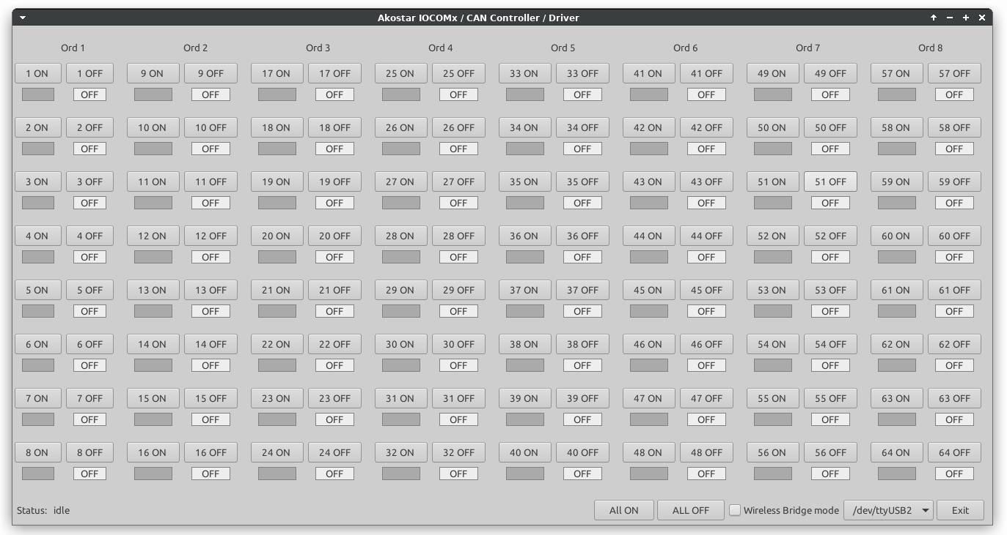
The rtellgui.py contains many functions that can be driven from the command line.
Usage: rtellgui.py [options]
Options:
-d level --debug Debug level 0-10 0 = None; 10 = Noisy;
-p port --port Serial Port to use. Example: /dev/ttyUSB0
-v --verbose Verbose. Print some useful event info.
-b --bridge Verbose. Print some useful event info.
-V --version Print version info.
-q --quiet Quiet. Do not print much to the console.
-h --help. This message

Advanced CAN functions
The CAN bus exposes most of its inter-board communications. One can intercept input / switch change information and output / relay change information.
The exception to the role is the TxRx unit, which does not expose some of its internal workings on the CAN bus, as the TxRx unit processes its operations internally. However, the TxRx unit will broadcast the essential messages required for the interception described below.
The following CAN massages contain useful, observable information:

MSG_SWITCHES 0x19EE5501 // Intra IOCOMx msg to funnel to RF
MSG_RFTOCAN 0x19EE5502 // Intra IOCOMx msg via RF

Switch information from the CAN bus
Every time the IOCOMx device detects an input change in its I/O ports, it sends the unit’s switch bit-mask and ordinal number to the CAN BUS. Reading this information from the CAN bus is just a matter of intercepting / filtering the ‘MSG_SWITCHES’ message. Please note that the initial state of the switches can be read by sending the ‘ MSG_INPUTS’ to the CAN bus, which instruct the IOCOMx devices to broadcast their switch state on the CAN bus.

Relay information from the CAN bus
Every time the IOCOMx receives a relay status change from remote, it sends the current relay bit-mask to the CAN BUS. Reading this information from the CAN bus is just a matter of intercepting / filtering the ‘MSG_RFTOCAN’ message.

CAN bus external read examples:
The demo utility can be found at https://github.com/akostarinc/IOCOM8-Support/tree/main/CAN under the gui_mon subdirectory. This utility has a ‘listen’ option where the IOCOMx CAN bus may be monitored. It is up to the implementer to capture the messages and act on it. The gui_relay subdirectory contains the example on how to intercept relay messages.

CAN read input states
Below, is a screen shot of the monitoring utility. Please note that input four of the units 1, 2, 3, 4, 5 and 6 are active. Also note the CAN device is connected to ttyUSB2 (second USB emulated) serial port, visible on the lower right corner.

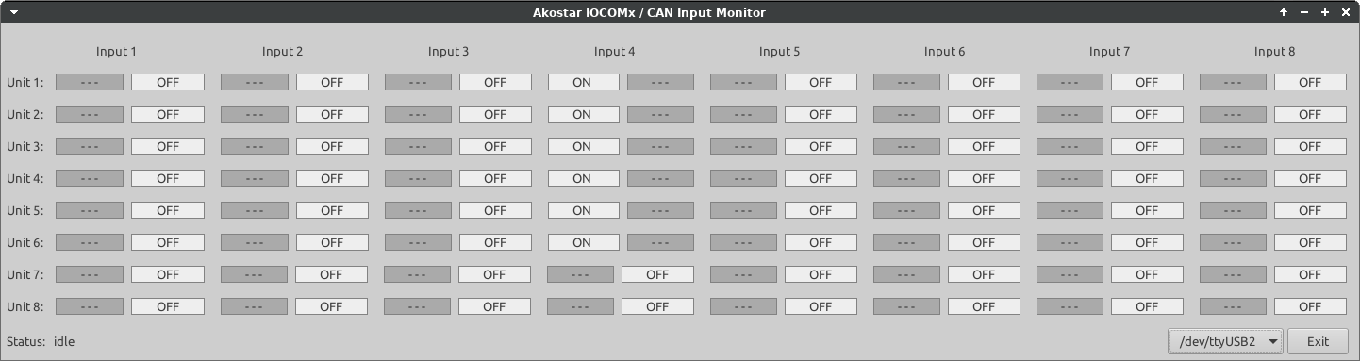
The CAN bus operates on event delta. (Outputs an event when any state changes) When connecting to the IOCOMx, initially; there is no delta occurrence. The switch state display may not be in sync with the state of the switches on the device. Issuing the MSG_INPUTS message will force the IOCOMx units on CAN bus to broadcast their delta, updating the displayed switch states. Please make sure the CAN bus utility is in listening mode before issuing this command.

MSG_INPUTS 0x19EE5505 // Broadcast the status of the inputs

In the can_mon example provided, one can clearly follow the code path for this ‘instruct broadcast’ command in file mainwin.py line 162:

iocomx.send_vals(bus, endval, MSG_INPUTS)

CAN read output states
The output / relay states may be listened to on the CAN bus. On the screenshot below, the status of the relays are featured. Note that output eight has the relays closed on units 1 .. 6;
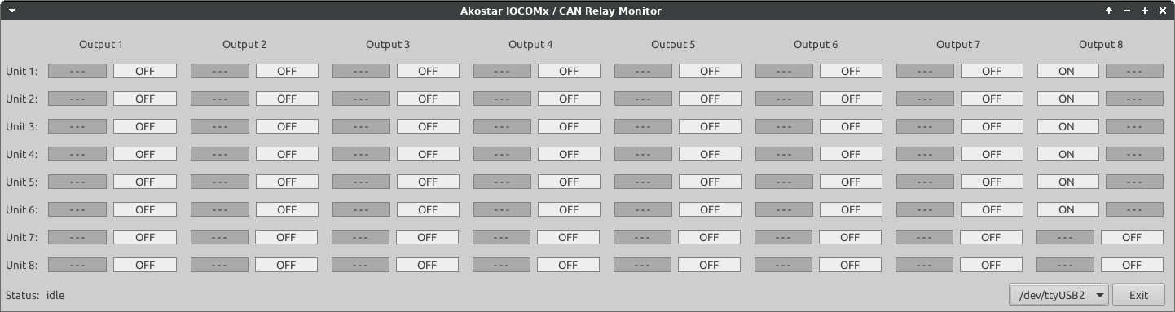
The CAN bus broadcasts the relay state periodically, thus no arrangements need to be made to read the initial state. The CAN bus relays the remote instruction verbatim, as they come in. The display reflects the CAN instructions, not the actual relay state. This is important distinction when the IOCOMx output is set to a mode other than ‘Momentary’. Because the IOCOMx processes remote control instructions on-board, thus modes other then momentary will control the relay by its curremtly active mode. For instance, the mode ‘Toggle’ will operate the relay to ON at the first command, and operate the relay to OFF at the second command. The CAN bus is excluded from this interpretation, one as it only sees the commands.
If detecting relay status is paramount, one may use an additional IOCOMx input, and connect it to the output of the relay. The input signal then can be read from the CAN bus.

This part of the page was left blank intentionally

Terminology
The terminology in this manual reflects words used in the process of development. Other aspect of the deployment (ex: installation) may use a different terminology. This chapter attempts to clarify the intended meaning, and to further disambiguate.
Word | Intended Usage | Used  interchangeably  with | Notes
Relay | The on-board relay | Output, | Dependent on context
IOCOMx | Identifies this device | IOCOM8 | The root device is IOCOM8, it becomes IOCOMx when multiple devices are chained via the CAN bus.
Button / Switch | The sensor input | Input, Button, Switch, Input button | Dependent on context; these are voltage presence detection inputs, but the voltage presence originates via an outside button / switch.
Device | The device in context | IOCOMx, IOCOM8 | IOCOM8 is the base unit, IOCOMx term is used when it is deployed in stack via CAN
Ordinal | The position in the IOCOM stack | Ord, device number | Only applicable in multi device configuration
CAN | The CAN bus |  | As used in industry standard descriptions
Relay ON | The state of the relay | Closed, Energized | Contacts in MAKE position
Relay OFF | The state of the relay | Opened, De-Energized | Contacts in BRAKE position
Control Button | The inputs to the device | Input, Button, Switch | See button / switch
Configuration button | The configuration button located on the side of the device | Config. Button | This is the multi press capability button.
Stack | More than one device connected by the CAN bus |  | 2-8 devices
Unit | One IOCOMx device | Board, IOCOM, Device
User / Installer | The entity that uses / owns / deploys the device, beneficiary of its services / utility. | Customer, Owner, User, Installer, Integrator, System Integrator | Legal entity that represents the device’s ownership or operator.

Disclaimer
The IOCOMx system device consists of several interconnected parts. Some parts communicate via a Wired bus, some parts communicate via Radio Frequency. While all efforts have been made to assure proper operation, due to the nature of technologies involved, Akostar Inc. only warrants operations that are within the limitations of the underlying technologies. It is the user’s and installer's responsibility to operate the device safely.
The IOCOMx system may control equipment that is inherently dangerous. In that case, the user / installer is hereby advised to the complexity of the control, the possibility of multiple control sources, and conflicts thereof. Akostar Inc. explicitly denounces liability arising from the operation of the device.
The sole remedy of the user / installer is the repair / replacement of said device, at the option of the Manufacturer, Akostar Inc.

This part of the page was left blank intentionally

Appendix 1
In earlier chapter, we referred to the test circuitry for cycle testing. The ‘Set – Expect’ test is activated by nine clicks, after activating Manufacturer’s mode. This test was executed as the final regression test of the IOCOMx device. The unit that is put in ‘Expect mode’ is on the left side. It starts an internal timer, and periodically sends and open relay and close relay command to the unit on the right.
The unit on the right then gives a feedback to the tester unit via the ‘Feedback Path’ wires. The tester sees the feedback, and compares it with the expected state. If it has sent an ON instruction, it expects relay ON, and if it has sent an OFF instruction it expects a relay OFF state signal. The comparison takes place in real time, and the tester can measure the time it takes to fulfill the expected states. The measured time is then printed on the controlling terminal.
If this measured time is above a certain threshold, the controlling terminal prints a ‘missing expectation’ message with the time interval of the missing expectation.
IOCOMx
IOCOMx
IOCOMx
IOCOMx
Antenna
Antenna
TxRx=1
TxRx=1
Ord # 2
Ord # 2
In 1
Out 1
Out 1
In 1
Feedback Path
CAN
CAN
Relay
Switch

This test exercises the whole communication path of the IOCOMx system from device input to client unit to CAN and then to RF --- and --- RF to master unit and RF to CAN and Can slave unit to output.
Executing this test was instrumental in developing the IOCOMx. The test showed the IOCOMx meets and exceeds the specified response time, which is in the time magnitude of the button de bounce period. It also showed communication robustness by executing the above procedure as a regression test.

Appendix 2
List of the example code dependencies. The CAN bus read / write examples are developed on Linux with the GTK toolkit, with python3, named PyGobject. Our motivation was to provide a suite of examples that one can use on any platform, without extensive effort and any licensing hurdles.
We chose python because of its advanced language features, but the interface itself is language agnostic. The additional advantage was that the syntax of the ‘C’ language somewhat resembles python, so most of the code can be transformed wit little effort. For instance, the checksum XOR when expressed in both languages are**:
Python: (val^0x55) & 0xff
‘C’: data[3] ^ 0x55

(** The above lines are pasted from working code)

Software deployed for the examples
- Python 3 (open source)
- PyGobject – GUI toolkit (open source)
- python-can (available on pip)

Hardware deployed for the examples
- Commodity PC (AMD-Ryzen)
- Robotell USB to CAN interface;
One may deploy any CAN interface, we used a commonly available one. Our examples can be configured / edited to use the following interfaces: (from python-can)
xxat socketcan slcan canalystii cantact systec nican iscan vector neovi virtual pcan robotell kvaser usb2can seeedstudio serial
This list may be obtained from the command line utility ./robotell/robotell.py –devices
Please note that these examples rely on open source, Akostar Inc can give only limited support for the deployment of these interface examples.

Multi platform Notes.
We used Ubuntu as our Linux distribution, as this proved to be a solid platform for industrial electronics. The examples work flawlessly. We also tested the utilities/examples on Windows; It works without major effort with the help of msys2 subsystem. The native windows PyGobject is somewhat difficult to install, but improvements are continually made in this aspect. We also tested the examples on the Mac, and it proved to be a working sufficiently. PyGObject is available on the brew subsystem, and functions just enough to support the basics. (the background timer did not work, but that can be disabled, as it serves informational purposes only)

Useful Toolkit Keywords:
The open source nature of the examples yield an immense amount of documentation on-line. The following key words may assist in finding it:
Python 3, PyGObject, Gtk, Linux, msys2

Summary
We hope that the IOCOMx line of devices will serve your remote control and automation needs for a long time to come. If you see any feature that is missing, any operation that is producing outcomes that you did not expect, please contact us.

This part of the page was left blank intentionally

End of Document

