The PMC
Preventive Maintenance Counter
User Manual, Integrators and Installation Manual

Introduction
The PMC is a multi-mode device, and will count switch closure cycles (power presence cycles) and will measure the cumulative time a switch is closed (voltage presence duration). Additionally, the PMC will measure analog values, and measure temperature. It can be configured to close relays based upon counter value thresholds, counter duration threshold, and can set relays / alerts on user configurable analog values and user configurable temperature values.

Devices:  - 8 Discrete Inputs with common ground  - Make / break counter, [detecting 110V voltage presence]  - Input power on to off (hold down) time  - 2 Analog Inputs 0 ... 10V (12.8V Max, 24V Absolute Max)  - 2 Temperature probes -40°C … 125°C  - 4 Relays / Alerts  Features:  - Web Interface  - Device Event logging  - Remote logging  - Control / Command / Status Port / Log Port  The PMC can close relays based upon various configurable conditions. Conditions include:  1.) Switch count exceeded  2.) Switch ON time (duration) exceeded  3.) Temperature exceeded threshold,  4.) Analog input voltage exceeded threshold. | 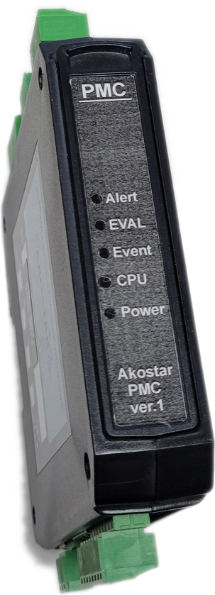

Please note that there is more information on our GitHub page: https://github.com/akostarinc/PMC-Support

Document Revisions:

Fri 12.Feb.2021 | PG | Initial
Tue 11.May.2021 | PG | Added Serial Sub. Sys.
Wed 19.May.2012 | PG | Prep for Doc release
Mon 20.Sep.2012 | PG | New Doc release

Product (Development) Revisions: (will be pruned on release[s])

Mon 21.Dec.2020 | PG | Initial version.
Mon 01.Feb.2021 | PG | Alert Implementation
Tue 11.May.2021 | PG, CB | Board Rev, Manual page update
Wed 19.May.2012 | PG | Firmware freeze
Tue 1.Jun.2012 | PG | Auth admin, bug fixes
Mon 20.Sep.2012 | CB, PG | New board rev, Sw logic and
Wed 22.Sep.2012 | All | Firmware freeze V 1.2

We welcome your feedback at: remotes@akostar.com

Table of Contents
Introduction 1
Deploying the PMC 4
The PMC device subsystems: 4
Alerts: 4
The Web Interface 5
Page Navigation 6
Quick (real time) Status 7
Progress Bar Page 8
Analog Values and Relay Status Page 9
Network Name Setup 10
Count / Alert Duration Alert Configuration 10
Show Logs 10
Description of columns: 10
Analog / Temperature Alert Configuration 11
Analog Sensor calibration 11
Reset Counts Page 11
Relay / Alert Assignments 12
Analog Configuration Page 13
On Device Quick Start Manual 13
Device Reboot 13
Inputs, Counter Counts, Durations 14
Inputs and Counters 14
Inputs and Duration 14
Analog Measurements 14
Triggers, thresholds, filters 14
Measurement Accuracy 15
Measurement Limits 15
Input Specifications 15
Output Specifications 15
Administering the PMC 16
Securing the Admin credentials 16
Input De-bounce Config 16
The SysLog 17
SysLog Extensions 17
Diagnostic Indicator Lights (LED’s) 19
Button Codes 20
Command Line 21
The commands 21
Stat command example 22
Wiring the Serial connection 23
Unexpected power loss procedure 23
Temperature measurement 23
Temperature Probe Performance curve 24
Alert Configuration 25
Assignments / Routing 25
Counter / Duration Alert Routing / Assignment 25
Analog / Temperature Alert Routing / Assignment 26
Remote Event logging 27
The Comma Separated Values (CSV) line 27
Serial Monitor Utility 29
Real time serial outputs 29
Serial Port Connection Pin-out 30
Summary 30

Deploying the PMC
The PMC needs 110Vac power to function. It continuously monitors its inputs, and stores counts and durations. It monitors temperature and analog voltage. It operates the alarm circuits as configured on the alarm(s) and router / assignments pages.

Sw  PMC  110V AC  Sw  Input  Input  1  8  Relay 1  Relay 4  To alert circuit  Temps  Probes  Analogs  Probes  Variable Voltage | The figure on the left depicts a high level overview of the PMC electrical deployment. The actual wiring reflects that the inputs are configured to read the presence of 110Vac signal, these 8 high voltage inputs are opto-isolated from the rest of the circuit  The outputs are relay contacts, dry, volt-free, that are electrically isolated from the power supplied to the PMC  The Temperature and Analog inputs are connected to device ground, which is independent from the frame ground.

The PMC device subsystems:
8 Counter inputs
2 Analog inputs
2 Temperature probe inputs
4 Alert Relays

The current readings of the PMC can be monitored from a web interface. The interface may be accessed with any WiFi capable device. (PC, Android, Mac, iPhone, Tablets) We used Firefox as the browser device, but all other browsers deliver compatible results.

Alerts:
Alert relay(s) may be configured to energize if and when:

- Counter on switch exceeds a configured threshold,
- Cumulative switch ON time exceeds a configured threshold,
- Analog input voltage exceeds a configured threshold,
- Temperature value exceeds a configured threshold,

The Alert actions may be assigned / routed to any of the relays. Multiple Alerts may be assigned to the same relay. Any Alert event can trigger / energize any of the relays, if desired.

The Web Interface
The PMC can be connected to with a browser device. All of the PMC functions can be monitored / Controlled from this interface. The home page of the PMC is presented upon initial connection. To see the PMC page, connect to the WiFi access point named PMC-nnnn (nnnn is the device identifier) use the default pass 12345678) and browse to the page URL 192.168.4.1. Most browsers open this page automatically at successful WiFi connection.

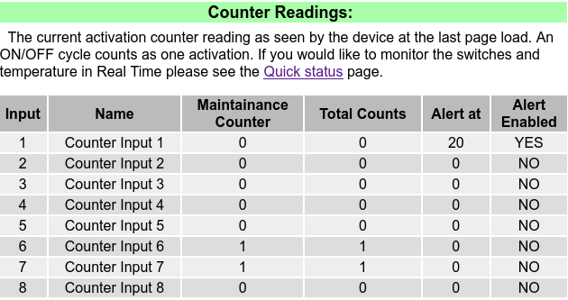 | Part of the home page is presented to the left, depicting the default configuration.  The counters as seen by the PMC at page load.  For real time monitoring click on the ‘Quick Status’ link.

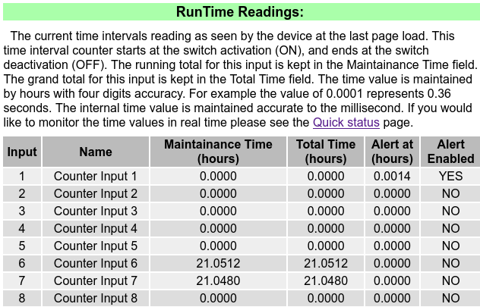 | Part of the home page is presented to the left, depicting the default configuration for Time readings.  In this scenario, the duration Alert is enabled for Counter 1 and the switch is held down on counter input six and seven.

Page Navigation
The PMC has multiple pages one can see status with, monitor the PMC real time, and configure all aspects of measurement and Alert. Below, the page menu with short descriptions of all the functions. (If you have a PMC connected to this computer, the links are live)

Quick (RealTime) Status | Network Name Setup
Count Alert Config | Show Logs
Analog / Temp Alert Config | Reset Counts Page
Relay / Alert Routing Config | Analog Config Page
Relay / Analog Status | Input names Page
Relay Control Page | Progress Bars Page
Quick Start Manual | Reboot Device
Back to Home Page

This part of the page is left intentionally blank

Quick (real time) Status
This page shows the current Activation Counter readings and Activation Time lengths, the Analog input Readings, the Temperature readings and relay States as seen by the device real time. This page is updated regularly in a continuous cycle. Please note, that viewing this REAL TIME page, the page’s automatic update consumes extra data. (appx. 200 bytes / sec)
The counter and interval readings are shown real time.  The analog values have a range of 0 . . 10 V; the 12.xx Volts reading demonstrates the clipping of the analog channel. We chose this as the default display mode, it gives some headroom to the 10V range. (instead of displaying an OOR [OutOfRange] text) | 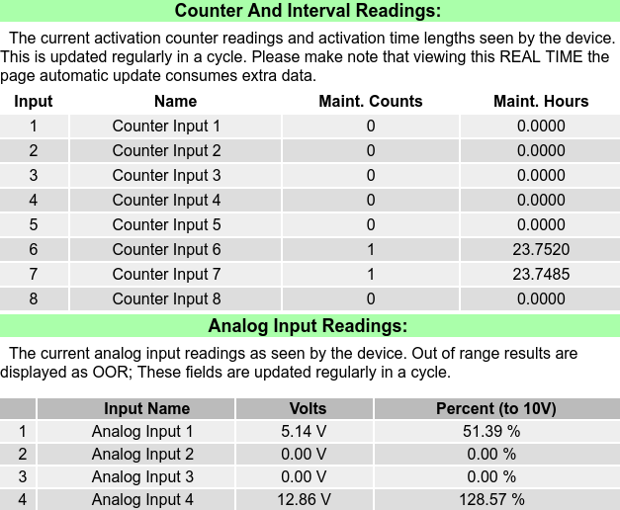

This part of the page is left intentionally blank

Progress Bar Page
The PMC attempts to be visually easy to read. The following chapter there are sample page fragments from the device:

The screenshot on the right presents the counter progress on the bar graph page.  Similar section exists for the time intervals as well. | 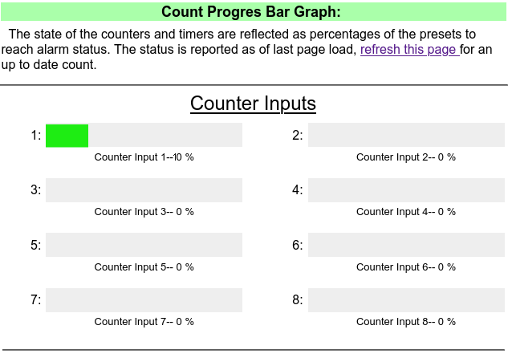

This part of the page is left intentionally blank

Analog Values and Relay Status Page

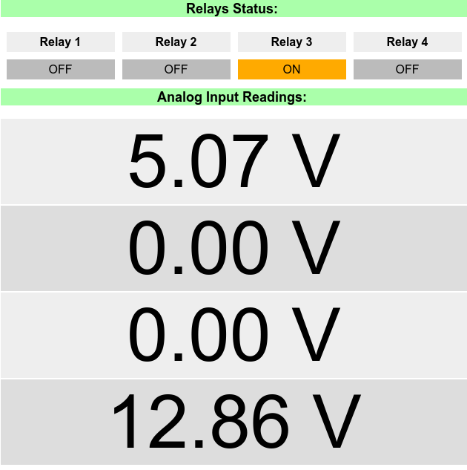 | Keeping with the visual ease of read, a separate page exists for Relay Status and Analog Read.  This page is updated in real time, thus monitoring the PMC is easy and convenient.  This is a picture from the four analog port version, your dispay may be different.  Please note the clipping analog channel. For testing only. (see more info in the analog section)

This part of the page is left intentionally blank

Network Name Setup
This page determines the Station Name and Password of this PMC. The device will appear on your WiFI network by this name. For safety and security, the PMC may be configured with a password of your choosing. The password needs to be at least 8 characters in length or longer. Please avoid using space, punctuation marks and foreign characters. You may use _ (underscore) - (minus) + (plus) sign.

Count / Alert Duration Alert Configuration
This page sets the counter limits and duration limits for all 8 channels / inputs. The alert relay will operate if the counter / duration exceeds a specified value.

Show Logs
Events related to the operation of the PMC are logged into non volatile memory. The PMC logs all Alerts, all switch (power presence) changes, Power ON events, WiFi connection events, Configuration changes. The log stack is 150 deep, events older than that are discarded. Please note, that this log is separate from the main status storage, as that is kept indefinitely.
Boot Count | Event | Params | Notes |  | Time from Boot
59 | LOG_ALERT_CHECK | 1 | Disabled | 12:15:05
59 | LOG_ALERT_TRIG | 1 | Dur-ON | 00:00:28
59 | LOG_ALERT_TRIG | 0 | Cnt-ON | 00:00:23
59 | LOG_WEB_LOGON | 1 | 19 | 00:00:19
59 | LOG_POWER_ON | 0 | None | 00:00:01

Description of columns:
Boot Count: The PMC starts a new log cycle on boot. This can aid in the interpretation of the ‘Time from boot’ field. For instance, if the time of last power on is known, (ex: shift change and/or daily power up) the time of the event can be calculated.
Event: The shorthand notation of the event that happened. The interpretation of the shorthand
is intuitive, for instance the LOG_POWER_ON translates to PMC power on event, LOG_ALERT_TRIG translates to alert event triggered and the parameters/notes denote the alarm source and target; line two in the example above: Alert on Relay channel 1, and Duration-Alarm came ON. Note that the counter input number and relay output numbers are zero based.
Params: The parameter(s) attached to the event. The meaning of the parameter is dependent on the event. For example, in most cases, 1 is a substitute for ‘ON’ and 0 is a substitute for ‘OFF’. In other cases parameter is the numeric value attached to the event. See developer’s manual for more information.
Notes: Additional information about the command. For instance Dur-ON signals that the duration counter has triggered a duration ON alert.

Time from Boot: This field is the time elapsed from boot in HH:MM:SS notation. The actual time of event can be calculated from the last power up time plus the ‘Time from Boot’ field. For instance if the last power up time is known (ex: 8 AM, shift start) and the ‘Time from Boot” field is 01:22:00, the time of the event can be deduced as 9:22 AM.

Analog / Temperature Alert Configuration
The analog sensors may trigger an alert, and the analog threshold may be set here. The alert normally triggers when the analog value exceeds the threshold. The reverse alert triggers when the analog value falls below a certain value. This may be used for sensors that provide reversed interpretations of values. (ex. Distance measurement vs. Proximity sensor)
The temperature sensor triggers an alert, and the trigger threshold can be set here. The alert normally triggers when the temperature exceeds the threshold value. The reverse alert triggers when the temperature falls below a certain value. This may be used for freeze warning or refrigeration monitoring. The temperature Alert's settable range is from -50 ℃ to +120 ℃

Analog Sensor calibration
The measured analog values are accurate to +-1%. The calibration values on this page can improve this, by filling in values that are acquired via empirical observation. The configuration values are interpreted as % deviation in the +-5 % range. If larger values entered, the calibration clips it to +-5%;
The calibration method is a three point deviation adjustment. Permitting ‘low’ medium’ and ‘high’ deviation adjustment. It is possible to calibrate the analog inputs to a degree, to act as a precision voltage measuring device. One simple trick is to open up the calibration page on one browser window and the real time measurement page on another browser window, and apply known voltages to the input.

Reset Counts Page
The counters can be reset at any time. The reset action is committed by pressing the "Save Counter Values' button on the bottom of the page. If Alert is set, after resetting the corresponding counter will clear the Alert. The Alert queue is re-evaluated, and the corresponding Alerts are re-issued. The on-board syslog will create a record of the old count with the input number and the time offset.
When clearing Total Count and Total Hours, an additional Yes/No dialog pops up to confirm clearing of totals.

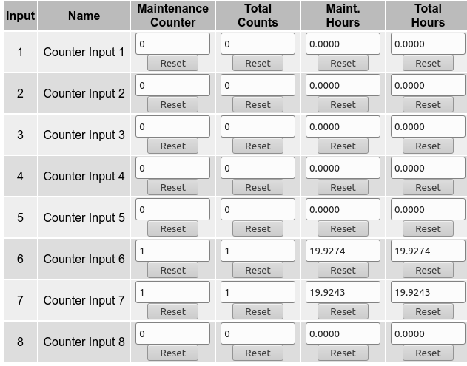 | The table to the left shows a device that has been accumulating time on inputs six and seven.  Resetting the individual Counter / Hours is intuitive, and the items at the Total fields are protected with an additional ‘Are you sure?’ dialog.  When all desired counters are reset, used the ‘Save Counter Values’ button to commit the changes.

Relay / Alert Assignments
The relay configuration page may be used to route / assign alert events to specific relays. Multiple events can be assigned to the same relay. It is the operator's responsibility to assure that the routing is configured as expected.

Routing is a very powerful mechanism to achieve any combination of sensor event to alert route. For instance the four analog inputs can be configured to route to individual relays, giving a four channel analog to relay connectivity. Or one can route any count alert to any relay, or all count alerts to a single relay.

The default configuration is to route:

Count_1 to Relay_1 | Duration_1 to Relay_2 | Analog Input_1 to Relay_3 | Temperature Probe_1 to Relay_4

This permits the user to test all subsystems and routing on an out of box PMC unit.

To further aid initial testing, the PMC comes with the default configuration as stated below. The duration is specified in hours, (0.0014 hours is approximately five seconds)

Relay | Input Condition | Default
Relay #1 | Count Exceeds Alert Value | 20
Relay #2 | Duration Exceeds Alert Value | 0.0014 hours
Relay #3 | Analog Input. Voltage Exceeds | 2.5 V
Relay #4 | Temperature Exceeds | 30 ℃

The temperature value is chosen to allow the user to test the trigger by holding the probe in hand, and after a couple of seconds, probe heats up above the trigger temperature. Letting go will demonstrate the cool down trigger.

Analog Configuration Page
The analog sensors may trigger an alert, and the analog threshold may be set on this page. The alert normally triggers when the analog value exceeds the threshold. The reverse alert triggers when the analog value falls below a certain value. This may be used for sensors that provide reversed interpretations of values. Additional parameters can be found on this page, to tailor the response of the analog sensor.
1.) Adding hysteresis. The trigger point of the analog sensor may be configured with a hysteresis value. This is applied digitally to the current trigger point, increasing it on up slope, decreasing it on down slope. [Much like a Schmitt Trigger] The range of configurable hysteresis is 0 .. 1 V.
2.) Low pass filtering. The input signal can have a low pass filter applied to it to smooth out transients. This is also applied digitally, and the Filter coefficient can be specified. The range of filter coefficients are 1 … 6, with 1 as no filtering, an 6 is maximum filtering. The filter coefficient of 6 yields about 3 seconds settling time. (Measured on up / down slope to 90% of settled diff.)

On Device Quick Start Manual
This page is concise on-device manual to aid the user in setting up and using the PMC.

Device Reboot
Rebooting (restarting) the device has no effect on the counters and relay statuses. These will be restored upon boot. The alerts resume according to the current state of the device. There is a short time period, while the device is booting, where the relays are de-energized. The device boot timing is 600 mSec to chip boot, additional 300 mSec to WiFi readiness op and additional 300 mSec to restoring all status / alert relays.
Please note, that – dependent on the browser device - the PMC may need to be reconnected to the browser to continue viewing the built in web page. Upon reconnection, a page refresh will deliver up to date information, and the real time page will resume delivering data.

Inputs, Counter Counts, Durations
The PMC measures activation count and activation duration. This is achieved by monitoring inputs. The inputs are opto isolated and high voltage tolerant. The input is active when voltage is applied to it. In the remaining of this document, we call this the ON cycle. When the voltage removed, we call it the OFF cycle. One ON / OFF cycle counts as one activation. The counter is incremented at the cycle completion. The log output is delivered on the at the ON cycle.

Inputs and Counters
The current activation counter values as seen by the device. The log output is delivered on the ON part of the cycle. The counter value is kept in the Maintenance Counter field, the total count is kept in the Total Count field. The Total counters have separate reset facilities, so the total count can be retained for the monitored device.

Inputs and Duration
The current time interval reading as seen by the device. This time interval counter starts at the switch activation (ON), and ends at the switch de-activation (OFF). The running total for this value is kept in the Maintenance Time field. The grand Total for this input is kept in the Total Time field. The time value is maintained by hours with four digits accuracy. For example the value of 0.0001 represents 0.36 seconds. This time / duration value is maintained with millisecond accuracy.
The device is capable of generating duration Alerts real time, even in the middle of an ON cycle. This might be useful for inputs that are always ON or mostly ON. The Total durations have separate reset facilities, so the total count can be kept for the monitored device.

Analog Measurements
The two analog inputs have a 12 bit resolution and range from 0 … 10 V; The sampling time is 250 milliseconds. The analog measurement has adjustable hysteresis and a configurable low pass filter. The analog measurements are equipped with threshold detector, which can be assigned to any of the relays. It is feasible to assign the two analog input to any of the four relays, creating a two channel analog alert device.

Triggers, thresholds, filters
The alert can be triggered by voltage exceeding the configured threshold, or - in reverse mode - triggered by voltage lower than the threshold. The trigger has additional options: 1.) hysteresis and 2.) low pass filter. These configuration properties are detailed in the analog configuration section.

Measurement Accuracy
The voltage measurement is accurate to 1%. The voltage calibration is done by the manufacturer as a two point calibration process at 1V and at 10V, covering the whole measurement range.
The voltage measurement accuracy can be improved by a user accessible calibration. This configuration can be done as a three point calibration, refining the measured values and linearity even further.
The open circuit analog inputs display a small fluctuating value of tens of millivolts, consistent of incidental voltage on any probe. It is the same phenomena that is observable on any multimeter / oscilloscope. If this phenomena is undesirable, one may configure the low pass filter of the input for filtration of the artifact. The noise phenomena does not occur if the input is connected to a voltage source.

Measurement Limits
The Analog Input has a nominal range 0 .. 10 V. Enough accuracy to cover the range of 0 .. 5 V with precision. The maximum voltage the Input can measure is 12.5x V (+-0.4V), at which the A2D clips. After the clipping voltage, the A2D saturates and the measured value stays at this clipping voltage. We do not display any ‘out of range’ messages, it is the operators responsibility to interpret the incoming voltage measurement. The A2D linearity is within specification, all the way to saturation.

Input Specifications
Category | quantity | Nominal | Max
Switch inputs: | 8 | 110Vac | as rated
Temperature Inputs: | 2 | (-20 ... 100)°C | as rated
Analog Inputs: | 2 | 0 … 10 Vdc | 12Vdc

Output Specifications
Category | quantity | Nominal | Max
Relay Outputs: | 4 | 110Vac 10 A, Res. | as rated

This part of the page is left intentionally blank

Administering the PMC
The PMC parameters may be viewed by all logged in users. These same parameters can only be changed by logged-in administrators. If you would like to administer the PMC device (like resetting counters, changing counter thresholds ...) please go to the ‘Admin Authentication’ Page and enter the Administrator’s password. (by default, the admin pass is the same as the default WiFi pass)

A shortcut here, is that one may use a different browser tab / window to log in as administrator. Then switching back to the original page allows editing / saving the changed parameters.

Once the PMC Admin is successfully authenticated, all the save buttons become active, and new parameters may be saved. The PMC admin authentication has a two step implementation, step one is browser (submit) button enable/disable, and the second step is the on-device authentication.

Securing the Admin credentials
Securing the PMC administrator's password may be done from the ‘Admin Configuration’ page. On the Admin Config page, a new password can be assigned. Knowledge of the old password is needed, so the admin function authentication is traceable. If the admin credentials have never been changed, the default PMC admin pass is the same as the default WiFi pass.

Please note, that the admin name field is not significant, only the password. However it is stored for future expansion.

Input De-bounce Config
When a switch closes / opens it emits significant amount of mechanically induced bouncing artifacts. This happens as the contacts mate, and bounce as a mechanical resonator. While this bounce is in the milli seconds range, microcomputers are able to respond to this fast artifact. De-bounce filtering is needed to compensate.
As different switches have different properties, the PMC can be adjusted to compensate for longer de-bounce. On the ‘Input De-bounce Config’ page there is a timing adjustment, that accounts for the large majority of switches. The minimum de-bounce delay is 40 mSec and the maximum is 1000 mSec (one second) Please note, the the longer the de-bounce time, the more sluggish the PMC’s input response feels. Please set this to be as short as needed, but not shorter. The manufacturer’s default (50 mSec) has been carefully chosen to accommodate all but the most extreme cases.

The SysLog
The PMC saves the timing of all the major events in its on board syslog. (System Log). The events (among others) that are saved:
LOG_POWER_ON LOG_WEB_LOGON LOG_WEB_LOGOFF LOG_LOG_CLEAR
LOG_CNT_RESET LOG_CNT_CHANGE LOG_ALERT_TRIG LOG_ALERT_RESET
LOG_ALERT_IGN LOG_ALERT_CHECK LOG_PASS_RESET LOG_RESET_COUNT
LOG_RESET_DURA LOG_DEEP_RESET
Because the PMC has no on-board battery and time mechanism, the timing of the event is saved by the following arrangement: a.) time from boot b.) boot count.
This can be translated to real time if the boot time (power on time) is known. For instance, if the power on time was at the start of today’s shift at 8.00 AM, and the syslog time from boot is 01:05:00 the real time of the event is at 9:05 AM.
Below, a sample of the syslog during testing:
95 | LOG_WEB_LOGON | 1 | 71868 | 19:57:48
95 | LOG_WEB_LOGOFF | 0 | 56212 | 15:36:52
95 | LOG_WEB_LOGON | 1 | 50266 | 13:57:46
95 | LOG_WEB_LOGOFF | 0 | 1627 | 00:27:07
95 | LOG_ALERT_TRIG | 3 | Tmp-OFF | 00:09:17
95 | LOG_ALERT_TRIG | 3 | Tmp-ON | 00:08:35
95 | LOG_ALERT_TRIG | 1 | Dur-ON | 00:02:19
95 | LOG_ALERT_TRIG | 0 | Cnt-ON | 00:02:14
95 | LOG_WEB_LOGON | 1 | 16 | 00:00:16
95 | LOG_POWER_ON | 0 | None | 00:00:01

SysLog Extensions
The syslog has new additions in the form of counter backup. If someone erases the counters by way of super long press reset, the syslog makes note of the old values of the counters. This is in case of accidental erasure or an out of order reset.
The logged items (as an example) are:
Boot Count | Event | Params | Notes | Time from Boot
193 | LOG_RESET_DURA | 8 | 0.0000, | 00:41:18
193 | LOG_RESET_DURA | 7 | 0.0000, | 00:41:18
193 | LOG_RESET_DURA | 6 | 0.0000, | 00:41:18
193 | LOG_RESET_DURA | 5 | 0.0000, | 00:41:18
193 | LOG_RESET_DURA | 4 | 0.0064, | 00:41:18
193 | LOG_RESET_DURA | 3 | 0.0000, | 00:41:18
193 | LOG_RESET_DURA | 2 | 0.0047, | 00:41:18
193 | LOG_RESET_DURA | 1 | 0.0868, | 00:41:18
193 | LOG_RESET_COUNT | 8 | 0 | 00:41:18
193 | LOG_RESET_COUNT | 7 | 0 | 00:41:18
193 | LOG_RESET_COUNT | 6 | 0 | 00:41:18
193 | LOG_RESET_COUNT | 5 | 0 | 00:41:18
193 | LOG_RESET_COUNT | 4 | 0 | 00:41:18
193 | LOG_RESET_COUNT | 3 | 0 | 00:41:18
193 | LOG_RESET_COUNT | 2 | 68 | 00:41:17
193 | LOG_RESET_COUNT | 1 | 20 | 00:41:17
193 | LOG_DEEP_RESET | 2477 | Initiated | 00:41:17
193 | LOG_LOG_CLEAR | 2477 | Cleared | 00:41:17

Please pay no mind of the actual values in this table, these where created during test / development.

This part of the page is left intentionally blank

Diagnostic Indicator Lights (LED’s)
The device is equipped with five LED’s visible on the top panel.
The first LED is the Power LED, lit up as soon as power is applied to the unit. There are additional LEDs inside the unit, to aid in diagnostic. This is illuminated when 110V power is present.
The second LED is the ‘Heart Beat’. This turns on and off with an approx one second period. This indicates that the CPU is operational.
The third LED is the event LED. This blinks when an external event is taking place. For instance it blinks when an external voltage is applied, and blinks when an external voltage is removed. The intent of this LED is to have a visual indication on applied events.
The fourth LED is the ‘Configuration’ LED, it blinks when a browser device is connected. The PMC can have four browser devices connected simultaneously. Reading PMC values operates the same as if one browser present, however updating configuration at the same time will result in the last update overwrites all previous ones.
The fifth LED is the ‘Alert’ LED, and it flickers when an alert is triggered. The number of flickers contains a hint of the subsystem that triggered the alert. One blink for Count Alert, two for Duration Alert, three for Analog alert, four for Temperature alert.

This part of the page is left intentionally blank

Button Codes
The push button on the top of the unit may be used to operate different aspects of the PMC. There are three allocated functions that those buttons do. 1.) Soft reset 2.) Hard reset 3.) Device erase;
Following, is a table of button presses and the functionality they map to. Not all button codes have functionality, but this may change in the future.
Button Press Code | Function | Notes
Single Click | No function
Double click (2x)** | No function | May assign functionality in the future
Triple Click (3x)*** | Soft reset | Reboot without any side effects;  Relays restore as the status of the device prescribes it.
Quad Click (4x) | Manufacturer’s Relay Self Test | Relays click ON and then OFF in 500 mSec steps. May be used to test the alarm circuits.
Long click | Reset all settings; WiFi passes and Wifi Access point name. | Hold button for 10+ seconds, then release it; System reboots.
Super Long click | Reset all settings, as above and erase all data from long term on board storage. This function erases everything and restores original manufacturer’s default. | Hold button for 20+ seconds, release it. System reboots. The old counter values are saved in the syslog.

** Like the double click on a computer mouse
*** Like the (double) click on a computer mouse, but three times;

This part of the page is left intentionally blank

Command Line
The PMC can be controlled from the serial port / terminal on board of the PMC. It also responds to status queries, and can emit status change events in the form of a serial string. The command line offers insight to the device’s particulars, allows the user to query the state of the device, and to collect data form the operation of the device. The command line offers a built in help, that lists all the commands and a brief description of its command functions.

The commands
Command name | Description | Notes
help | Print the list of registered commands. | This table is an extract of the frequently used commands. See the real device’s response for a complete, up to date list.
verbose | Set verbosity | Verbosity level (0=None, 10=max) This prints all sorts of internal workings information.
erase | Erase all settings | Will prompt the user for y/n confirmation before deleting anything.
counters | Show counter values | At the time of query
analogs | Show analog values | At the time of query
temps | Show temperature values | At the time of query
Alerts | Show Alert status | Synonym for Relay Status
rtalarm | Toggle Alert real time to serial | By default, the PMC emits a line when an Alert status is changed. This will toggle that message delivery ON/OFF.
rtcounter | Toggle counter real time to serial | By default, the PMC emits a line when a switch status is changed. This will toggle that message delivery ON/OFF.
nvs | Show nvs details | Internal, just for info
stat | Show device details | This is the sum of counters, analogs, temps, Alerts in human readable text form. Please see attached utilities for parsing this string.
conf | Show device configuration | Configuration, this is the list of all alarm thresholds.
smart | Turn on smart command line. Enables command recall, command completion. | This is OFF by default so the serial utilities are not misled by the smart console output / escape sequences. Device reboot will reset this to default.
? | Short help | Displays the a short list of commands available.

The PMC device can be queried in a loop to achieve a similar effect than that of the remote logging. The advantage of the wired communication is increased reliability and simpler implementation. See the logging chapter for more info.
There are additional commands implemented. They can be queried from the command line with the ‘help’ function. The ‘?’ command produces a short list of frequently used commands.

Stat command example
Below, is an example response from issuing the ‘stat’ command:
Current counter values:
Counter 1 Count: 40 Hours: 0.0021
Counter 2 Count: 0 Hours: 0.0000
Counter 3 Count: 0 Hours: 0.0000
Counter 4 Count: 0 Hours: 0.0000
Counter 5 Count: 0 Hours: 0.0000
Counter 6 Count: 0 Hours: 0.0000
Counter 7 Count: 0 Hours: 0.0000
Counter 8 Count: 0 Hours: 0.0000
Current analog values:
Input 1 Value: 2.2495
Input 2 Value: 0.0000
Current probe temperatures:
Probe 1 Value: 25.5000
Probe 2 Value: 25.5000
Current Alert (relay) status:
Relay 1 Value: 1 ON
Relay 2 Value: 1 ON
Relay 3 Value: 0 OFF
Relay 4 Value: 0 OFF

The above values can be parsed easily for individual fields. Pseudo code for parsing: 1.) break into space separated fields. 2.) check for sub-system string in the first field (ex: “Input”) use field two for index, field four for value. (see attached sample code for parsing or on our GitHub page at https://github.com/akostarinc/PMC-Support/ in the serial subdirectory.

Wiring the Serial connection
The serial connection is exposed on the RF board next to the microprocessor. The pin-out of the connection: Pin0→Ground Pin3→Tx Pin4→Rx . The serial port is NOT galvanically isolated from the CPU, but it is isolated from the Power Input Leads and the Counter Inputs. (Naturally, isolated from the relay contacts) The cable (included with the product) is marked appropriately. The port has an orientation pin to make sure it is plugged in correctly.
Rx
Tx
Gnd
+3.3V
Reset

Unexpected power loss procedure
The PMC will save event counts and durations to permanent memory as soon as they occur, and are complete. Incomplete event counts have a timeout expectation of five seconds before they are saved. For instance, when an ON event (without an OFF event) occurs, the duration of the event is logged every five seconds. The unexpected power loss can only effect the time reading - at most - by five seconds.

Temperature measurement
The temperature measurement operates with two DS18B20 devices. These measure temperature in the range of -55 °C to +125 °C with a 0.5 °C accuracy. On the PMC, Probe 1‘s default configuration is set is set to 30 °C, so the temperature alert can be triggered by hand.

The measuring device specifications:

Operating Temperature Range ………………...-55°C to +125°C
Measurement accuracy ……………………….. ±0.5°C from -10°C to +85°C
PMC Alert Temperature Range ……………....-50°C to +120°C
PMC Temperature Meas. Cycle …………….…950 milliseconds / Channel
PMC Temperature Settling Time …………….…530 milliseconds / °C (naked probe)
PMC Temperature Measuring resolution …….. 12 bits full range

Temperature Probe Performance curve
Temperature measurement accuracy performance curve:

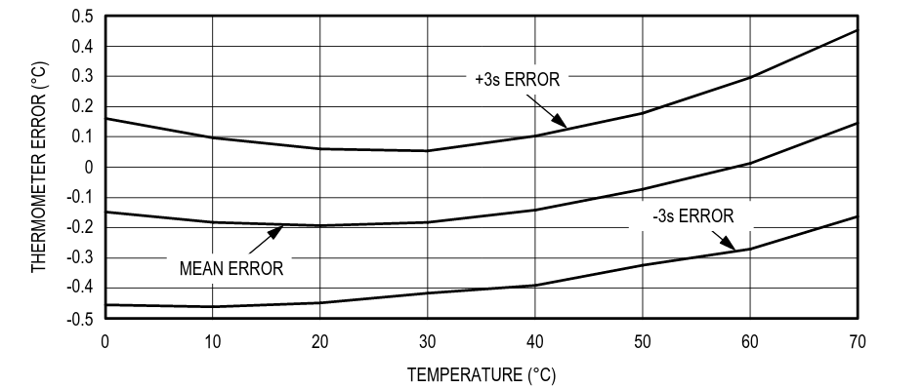

This part of the page is left intentionally blank

Alert Configuration
The Alert events may come asynchronously from four different subsystems, most with multiple sources. To afford the most flexibility, one can assign any of the Alerts to any of the Relays in any combination, including one to one, one to many, and many to one.

Assignments / Routing
The Alert is assigned to four different routing targets, or Relays. The routing table has the capacity to connect any of the Alert sources to any of the Alert targets. The configuration screenshots below depict the default PMC routing configuration.

Counter / Duration Alert Routing / Assignment
When checked (enabled) , the relay is triggered by inputs exceeding configured count. For instance, on the table to the right: Input 1 will trigger Relay 1  The relays may be triggered by any of the inputs exceeding configured duration. On the table to the right, exceeding Duration 1 will trigger Relay 2.  Same interpretation should be applied for all of the inputs / relays. | 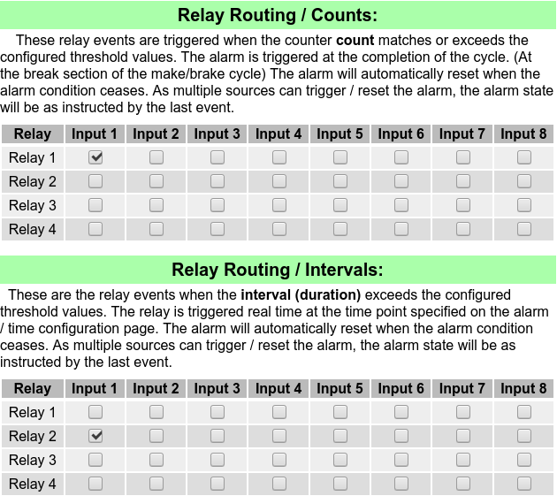

This part of the page is left intentionally blank

Analog / Temperature Alert Routing / Assignment
This screenshot is for the four Analog port version, your image may vary for the two port version.  On this screenshot section, Relay 3 will be energized if Analog 1 exceeds configured threshold.  On this screenshot section Relay 4 will be energized if any of Temp 1 exceeds threshold. | 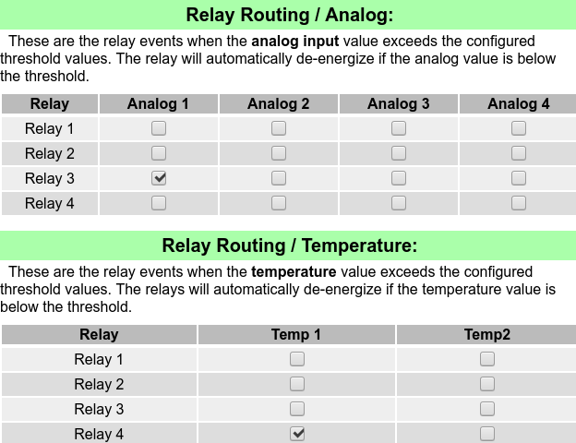

This part of the page is left intentionally blank

Remote Event logging
The PMC has remote event logging capability. Once the PMC is connected to a browser device (Computer … PC/MAC/Linux/Android/IOS) requesting the file ‘csvdata.txt’ contains a current snapshot of the device data. The data can be captured by simply requesting it over HTTP; or can be queried from a script, or queried unattended.
Like below:
wget -q 192.168.4.1/csvdata.txt -O - >> $LOGFILE
(wget is open source and available for all platforms)
The resulting file is pictured below, loaded into a spread sheet. The csvdata.txt delivers one record at a time, and formats it into a friendly, CSV format. (The screen shot below was taken in LibreOffice)
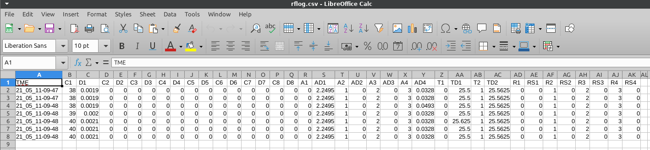
The header of the CSV format is outlined in the first line. This first line contains:
TME, C1, D1, C2, D2, C3, D3, C4, D4, C5, D5, C6, D6, C7, D7, C8, D8, A1, AD1, A2, AD2, A3, AD3, A4, AD4, T1, TD1, T2, TD2, R1, RS1, R2, RS2, R3, RS3, R4, RS4,

The Comma Separated Values (CSV) line
The default output format of the PMC is Comma Separated Values (CSV). This lends itself to easy import / export. It is outputted in a line oriented format, and contains the following fields:
- Current time (of capture) [TME]
- Switch closure Counter values [C1 .. C8]
- Switch hold / Duration time in hours [D1 .. D8]
- Analog Channel Number [A1 .. A4] (please note that the 2 channel version has zeros at the end)
- Analog Channel Data [AD1 .. AD4],
- Temperature channel Number [T1 .. T2]
- Temperate channel Data [T2 .. TD2]
- Relay number [R1 .. R4]
- Relay State [RS1 .. RS4]
The CSV contains one snapshot per line. The lines pictured above are acquired by the following script:

#!/bin/bash
# Script to monitor PMC status, and create a log file
# Written for Linux, but same programs are available for windows.
# Use resulting file in a spreadsheet.
# Results are in LOGFILE

LOGFILE=rflog.csv

# Period of reading is derived from $SLEEP in seconds; can be arbitrary

SLEEP=10

echo TME, C1, D1, C2, D2, C3, D3, C4, D4, C5, D5, C6, D6, C7, D7, C8, D8, A1, AD1, A2, \
AD2, A3, AD3, A4, AD4, T1, TD1, T2, TD2, R1, RS1, R2, RS2, R3, RS3, R4, RS4, > $LOGFILE
echo "Log started, saved to $LOGFILE. Stop with Control-C"
while [ 1==1 ] ;
do
echo -n "`date +%y_%m_%d-%H-%M-%S`, " >> $LOGFILE
# Get the latest table, append to file
wget -q 192.168.4.1/csvdata.txt -O - >> $LOGFILE
# Adjust for desired sampling frequency in $SLEEP (in seconds, floating point OK)
sleep $SLEEP
done
# EOF

Please note that the above script is operating on Linux, the windows version is stated below:

@echo * Log started, saved to rflog.csv - Stop logging with Control-C
:again
rem # Get the latest table, append to file
wget -q 192.168.4.1/csvdata.txt -O - >> rflog.csv
rem # Adjust for desired sampling frequency (in seconds)
sleep 10
goto again
rem # EOF

Serial Monitor Utility
The PMC is equipped with a serial port, and can be monitored with said port. Referring to the ‘Command Line’ section, one can issue several commands that deliver PMC status. For instance, issuing the ‘stat’ command results in the PMC outputs its status on the terminal.
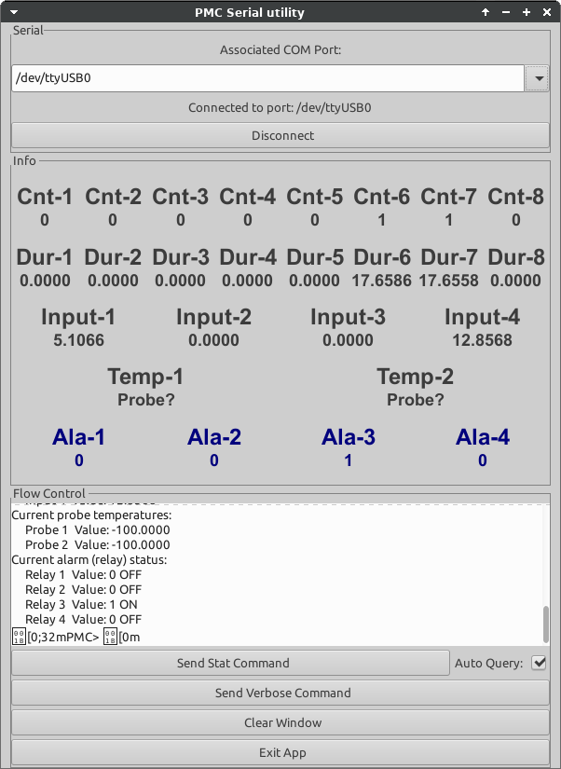 | The screenshot to the left is a picture of a small utility that captures the PMC’s stat output, and outputs it in an easy to read format.  Aside from monitoring it visually, one may print or save any value coming from the PMC. Because the attached computer has a built in time mechanism, the real time occurrence of the event can be noted. This service is similar to the over the air log subsystem, with the distinction of attached physical wires for more reliability.  The logging utility is written in python, and its source is included with the PMC. Please note, that this example code carries no fitness for purpose assumptions, no warranty, delivered as is.  Connecting the serial port is relatively straightforward; only ground, the TX pin and the RX pin is needed. Please be aware of possible ground connectivity issues between the monitor device and the PMC. For qualified personnel only.

The screenshot above was created in Linux, but the used tools are multi platform. One may recreate this utility in Windows, Linux, Mac …. [Source code on attached jump drive]

Real time serial outputs
While the PMC is operating, it outputs the following serial sequences: a.) Count change event b.) Duration change event c.) Relay change / Alert event d.) Analog alert change event e.) Temp alert change event. These then can be parsed, and utilized for logging / control / statistical purpose. For example, operating the PMC at the default settings, the following strings are output:

- Count changed input=0 count: 20
- Alert to relay 0 from Count - 1 ON
- Alert to relay 1 from Duration - 1 ON
- Alert to relay 2 from Analog - 1 ON
- Alert to relay 2 from Analog - 0 OFF
- Alert to relay 3 from Temperature - 1 ON
- Alert to relay 3 from Temperature - 0 OFF

Please note that the counter inputs and relay numbers start form zero.

If required, the command line can enable / disable the emission of these output strings. The ‘rtalarm’ and ‘rtcounter’ commands toggle the display of these real time messages ON / OFF. Below a sample session of turning it off.

PMC> rtcounter
New counter real time serial status: 0 (OFF)

Serial Port Connection Pin-out
To access the debug port for additional information coming out of the PMC, one may connect to the serial header within the device. This header is located next to the on-board processor, and contains the serial port connections. These are standard 1/10th inch (2.54 mm) pitch female pin headers.
Rx
Tx
Gnd
+3.3V
Reset
Please note, the the Rx and Tx are denoted from the chip’s perspective, the Rx Tx lines may need to be cross connected to the DTE device. The other pins can be safely left unconnected.

Terminology
The terminology we used in this document attempt to confirm with industry standards. The following table may disambiguate items of misinterpretation.

Abbreviation | Item | Description
mSec | Milli Second | One thousandth of a second, 1000 mSec is equal to 1 sec.
DTE | Data Terminal Equipment | A computer with a program like putty
Rx Tx | Receive / Transmit (Send) | Dependent on context, receiver of data or sender of data.
PMC | Preventive Maintenance Counter | This device
CSV | Comma Separated Values | Popular format to import to spreadsheets or databases

Summary
The PMC device fulfills many functions aiding scheduled maintenance. If you find a function that misses the intention of the maintenance prediction, or if you think of a function that would improve overall device usefulness, please let us know at remotes@akostar.com

Document Copyright by Akostar Inc.
Wed 22.Sep.2021

